Name  Student ID Number | DEEPINDER SINGH  1813078
Module Title | MANAGING ENTERPRISE IN THE 21ST CENTURY (RESIT)  (RESIT)
Module | BMSW4006
Module Lecturer | AFZAL MUNNA
Word Count | 2619 |  |  | Date Submitted |  | 16/08/2020

MANAGING ENTERPRISE IN THE 21ST CENTURY

TABLE OF CONTENTS
BUSINESS OVERVIEW ……………………………………………………………………..4
PRODUCT AND SERVICE ………………………………………………………………….5 1.0 MARKETING AUDIT ……………………………………………………………………..7
1.1 Market Research ……………………………………………………………………… 7
1.2 SWOT Analysis………………………………………………………………………......8
2.0 ENVIRONMENT ANALYSIS …………………………………………………………...8
2.1 Porter’s Five Force Analysis ……………………………………………………………9
3.0 MARKETING PLAN……………………………………………………………………..10
4.0 ADVERTISING AND SALES …………………………………………………………..11
5.0 MANAGEMENT TEAM …………………………………………………………………12
6.0 FINANCIAL PLAN ………………………………………………………………………..15
CONCLUSION…………………………………………………………………………………19
REFERENCES…………………………………………………………………………………20

BUSINESS OVERVIEW

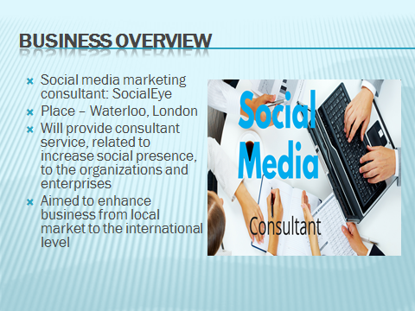
The main aim of business will be providing consultant services to the organizations and individuals as well. The business will be established from waterloo, London with the aim of enhancement of the business to the international level. The demand of organization and enterprises of enhancing the presence on social media will be the greatest opportunity for the expansion of the business (Edosomwan et al., 2011).
Social media marketing is the main base of the social media consulting business. Search engine optimization and internet marketing services are the main players in the social media marketing industry. These players assist and provide expert advice in the field of internet campaigns, integration, social media development, user functionality, web display, and website search. The social media marketing industry is becoming a great share of the economy and by 2023 it will become the most useable business in every sector. The business will start from Waterloo, London by the name; SocialEye. This business will be very beneficial for the organizations and enterprises of the city, as it will serve the consultancy program to the organizations and enterprises. The growth and demand of social media in the current environment are increasing continuously most of the organizations, either small or large, using social media promotional strategies for being in touch with the customers and knowing the demands of the customers. The consultant service of SocialEye will help the organizations in establishing them on social media platforms as well as engaging the customers with the organizations. The expansion of the business from the local market to the national level and from the national level to the international level would be easy because of the presence and growth of social media in the market.

PRODUCT AND SERVICE

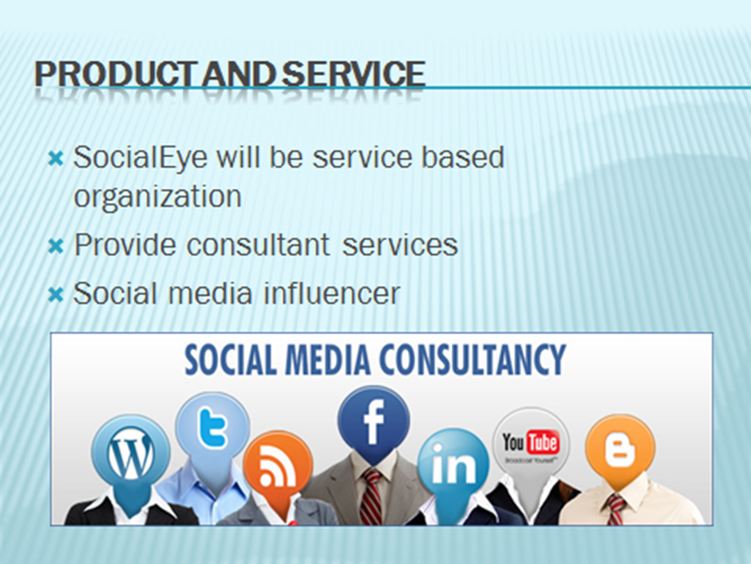

SocialEye will be based on the social media industry, which is a service based industry (Montalvo, 2011). The main service of SocialEye will be providing consulting service to the organization from various industries, such as hotels, restaurants, schools and universities, and small enterprises.
The business of SocialEye is a service type because social media consultant businesses counted in the service type industry. For directly and indirectly influencing the organizations and enterprises, SocialEye has developed social media consulting services. The services that will be included in the portfolio of the business are consulting and advisory service, training service, management service, profile boosting service for clients and organizations, and branding or advertising service along with blogging service. These abovementioned services of SocialEye would influence the overall market and would grow the social media presence of the organizations (Bottles and Sherlock, 2011). The main of SocialEye for establishing the business is maximizing the profits in the social medial consulting industry. SocialEye will work for the organizations and enterprises along with the clients. The services of the firm will ensure a strong social presence.

MARKETING AUDIT

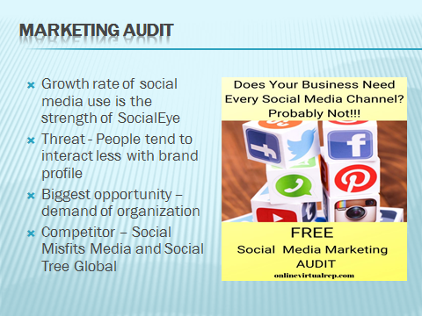

Use of social media platform in London has increased by 66% within one year; 2018 to 2019 (McKeever, 2016). This percentage ensures the growth of the business. The social media has increased the value of promotions of the organization, which in turn increased the opportunity for the organization to enhance the presence on social media. The competition for the organization will be very tough to establish and operate the business in the selected area because of the well-established competitors.

Market Research – the growth of social media coverage in London is continuously increasing and it has expected that in the future the business will depend upon social media coverage and at that time social media consultant will become the crucial business in the world, as the Tourism sector is in the present era. Montalvo 2011 identified that the prospect of the business and the future growth of the business will be prejudiced by the continuously increasing demand for social media platforms. The growth of SocialEye’s business is clear, as it has cleared from the research that from 2018 to 2019 the use of social media in London, UK has increased by 66% (Edosomwan et al., 2011). YouTube is one of the most active social media platforms in London where the percentage rate is above 80%, while Facebook, Whatsapp, Instagram, and Twitter; are also a great contributor to social media platforms. All these platforms are very crucial for SocialEye to grow the business and achieve success.
SWOT analysis
Strengths | Weaknesses
Growth rate of social media platform  Highly proficient social media consultants  Organizations flow towards social media for promotional strategy | Detection of trends swarming in the community  Huge load of traffic come from Pinterest  Attitudes towards user’s privacy
Opportunities | Threats
Social media based customer base  Organizations’ demand for active presence on social media platform  Continuous increment in social media users | Economic downturn  Business models of other social media consultants in that area  People tend to interact less with brand profiles

Customers – the main focus of the business will be on the organizations and the enterprises of the city, as the organizations and enterprises are increasing the demand of the active presence of the business on the social media platform. Individuals who want to increase the presence on the social media platform also be targeted by SocialEye. The users of social media are increasing and also the presence of social media around the world is increasing which in turn increases the business value of Social Medial consultant business (Edosomwan et al., 2011). Organizations that will be targeted by the business will include the hospitality industry’s businesses, corporate organizations, branding, and advertising agencies, schools and universities, and research and development organizations.
Competitors – the business in the social media market requires knowing how to network with key people, how to conduct business, and also requires expertise. The higher competition in social media coverage will be the biggest competition for SocialEye. The main competitors in the preferred location of the business will be Social Tree Global, The Marketing Consulting Group, Social Misfits media, Love Social Media, and Social MediaLtd.
2.0 ENVIRONMENT ANALYSIS
Porter’s Five Force Analysis
Threats of substitutes (LOW) | The service of the organization will run smoothly because the threats of substitutes are lower in the social media market industry.  Threats of substitutes also include buyers propensity to use the service and switching cost of the buyers.
Bargaining power of buyers (HIGH) | Decision making strategy of the buyers can influence the business and the large number of availability of social media consultant induces the higher bargaining power of buyers. Service differences can induce lower force of bargaining power of buyers (Rodriguez et al., 2012).
Bargaining power of suppliers (LOW) | Suppliers required in the industry are not from the technological ways. Thus, the essential products and services could not be utilized or purchased from the suppliers. This induces low power of suppliers. The requirement of suppliers in social media market is low.
Competitive rivalry (HIGH) | The continuous increase in utilization of social media increases the businesses to enter into this industry, which has created more number of competitors. The rivalry from the nearby area will higher.
Threats of New entrants | The threats of new entrants will be higher because of the main two reasons; first one is lower initial capital and the second is continuous increment in the use of social media by individuals and the organizations too for promotional strategies (Bottles and Sherlock, 2011).

3.0 MARKETING-PLAN

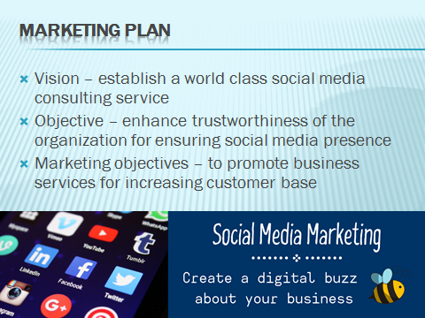

Establishment of the standard and world class consulting services to the organizations and individuals of UK is the vision statement of the SocialEye. For increasing the customer base, promotion of the business service is the part of marketing objective of SocialEye.
Vision – the vision of SocialEye is to establish a world-class and standard social media consulting business whose brand and service will not only be accepted in the UK but also will be adopted in the other parts of the world.
Mission statement – the mission of SocialEye is to build a social medial consulting organization, which can favorably compete with the other leading brands in the social media industry. Another mission of SocialEye is to provide highly creative and professional result-oriented social media services and reaching out to a wide range of potential customers around the world.
Objective – The key objective of SocialEye is to provide services to increase the presence of social media coverage and deliver effective solutions to the problems related the social media presence to the organizations and enterprises along with individuals. Aral 2013 provides opinion on social media business that the organization requires social medial presence for the business growth and the organization will focus on the social media consultants to run the business. Based on this opinion the added objective of SocialEye will be to enhance the trustworthiness of the organizations and individuals to ensure the social media presence.
Value principle – the value principle of SocialEye would be respect to people and innovation in the ideas and technologies. Fair-mindedness, perseverance and integrity would also be the value principle of the Business
4.0 ADVERTISING AND SALES
Promotional strategy | Expected business improvement | Cost | Time period
Social media | Awareness of the organizations and individuals for increasing social media presence | 3000 | 30 days
Visual advertising | Visual influence and delivery of detailed information would help in acquisition of 45% of the total market share | 3200 | 180 days from first day
Printed advertising | Organizations and individuals would get to know the service and mechanism of business along with utilization of market share (Felix et al., 2017). | 350 | 30 days from first day

Sales and marketing objectives
The marketing and sales objectives of SocialEye would be the following:
- To increase the market share by 40% at the end of the second year
- To improve the relationship with the enterprise, organizations, and individuals
- To promote the business services for increasing customer base
- To enhance the business from the local market to the international level
- To evaluate, execute and develop new plans for expanding sales
- To analyze the volumes of transactional data generated by the customers
- To promote the brands of organizations and increase sales forecasts

5.0 MANAGEMENT TEAM



The management team will include many employees and head of various departments but the main focus will be on social media consultant, as these will enhance the business (Rodriguez et al., 2012). The overall base of the business will depend upon the consultant service of the business and the satisfaction of the customers with the service
Business structure - SocialEye is a social media consulting organization that hopes to grow big for competing favorably with leading social media consulting organization within the industry in the UK and around the world (Barker et al., 2012). The virtual presence of the organization and social marking based procedures of the SocialEye enforces for the development of the flat organizational structure. The business will hire people that are ready for working to help in building a prosperous business, and will also hire people who are result-driven, creative, and hardworking.
Management and ownership – the business will be based on social media experts and users of social media. The main management of the business will be based on organizations and enterprises, which are driven by social medial promotional strategies. The ownership of the organization will be on one hand, which means the organization will run by a single person's ownership.

Management team
Job Title | Quantity | Expected staff turnover | Skills required | Time for hiring
Creative director | 2 | 24-30 months | Work directly with the employees  Should be responsible for designing concepts  Should coordinate efforts by establishing procurement | 1 week
Social Media consultants | 8 | 18-20 Months | Creating content that will attract traffic  Engage internet users to get help in leading  Training client how to use social media platforms | 2 weekas
Admin manager | 1 | 18-20 months | Responsible for evaluation of employees and training of the employees  Manage the hiring and retaining process  Enhance the reputation of the organization  Should be able to oversee the administrative tasks and overall organizational operations | 2 weeks
Client Service Executives | 2 | 14-18 months | Capable to handle mails and distribute them to the organization  Provide the best services to the customers  Ensure the overall contacts of the clients with the organization  Manage the administrative responsibilities assigned by administration (Aral et al., 2013) | 1 week

6.0 FINANCIAL PLAN



The pricing strategy of the business will be categorized into two parts first is hourly fees for the special clients, while for the normal clients, fees will be based on weekly or monthly plans. the main financial objective of SocialEye is to increase the profit buy 40% in the upcoming year and repay the loan within three years along with maximizing profit. The initial investment for establishing SocialEye is £174,000.
The initial investment in the industry for establishing the business will influence the overall financial procedure and condition of the organization (Felix et al., 2017). The financial performance of the organization will grow in the upcoming two to three years because of the social media coverage and use of social media in the industrial areas as a promotional strategy to attract more customers.
Financial objectives
- To maximize profit and ensure the cost of business for the upcoming five months
- To repay the loan within three years
- To increase revenue by 40% in the next year and continue for every year
- To increase the profitability of the company

Pricing strategy
The fees for the services will be based on two parts: the first one is flat rates on a monthly or weekly basis and the second one is billing rate per hour basis (Rodriguez et al., 2012). These pricing strategies will also be based on the clients, such as hourly charges for special clients, while for normal clients, regular packages, or plans. The prices of the service will be lower than usual, which will help the business in attracting the customers towards it and enhance the customer base of theorganization.
Source of Finance
The source of funding is used in different situations. These are selected based on the source of generation, ownership, control, and time period.
Equity and Debt are the two main source of financing. Borrowing funds from the creditors with stipulation of repaying the borrowed money and interest at a specific time is termed as debt financing.
Debt Financing
Banks And Other Commercial Lenders – these are famous sources for business financing. Certain lenders need a solid and effective business plan, plenty of collateral, positive track records. Once the business starts and the statements of income and expenses then the organization can be capable to borrow extra funds.
Government Programs – local, state, and federal governments are designed programs to help the financing of new small businesses and ventures (Bottles and Sherlock, 2011). The assistance is frequently in the term of a guarantee from the government of the repayment of the mortgage or loan from conservative lender.
Equity Financing
Personal saving– it took first place for money and it involves early retirement funds, profit-sharing, cash value policies of insurance, and real estate equity loans (Felix et al., 2017). Equity or personal savings are first sources for funding.
Venture Capital – it is referred to the funding that comes from individuals and companies in the form of investing privately in the business. They offer capital to new businesses in share to a business ownership.

Start-up cost
Registrations | Amount | Business Purchases | Amount
Name procedure | 150 | Start-up capital | 174000
Licences | 15000 | Plant and Equipment
Permits | 3000 | Phones | 3000
Trademarks | 11000 | Computers | 8000
Designs | 4000 | Security system(CCTV + Guard) | 2500
Domain names | 250 | Printers | 900
Account fees | 50000 | Office Equipments
Solicitor fees | 55000 | Furniture | 1500
Rental Lease cost | 11000 | Office Fit outs | 200
Computer Software | 7000
Training | 1500
Phone connection | 700
Internet connection | 1500
Sum | 157900
Insurance
Building and content | 5000
Public Liability | 6000
Stationary | 500
Advertising and Marketing | 2800
Assets | 1300
Printing | 500
Total | 174000 | Grand Total | £190,100
(Barker et al., 2012)
Balance sheet
 | Year 1 | Year 2 | Year 3
Current Assets
Cash | 2500 | 3200 | 4500
Inventories | 250 | 300 | 300
Pre-paid Expenses | 180 | 180 | 180
Fixed Assets
Leasehold | 15000 | 15000 | 15000
Property and Land | 7900 | 8300 | 8850
Renovation | 5000 | 5000 | 5350
Furniture | 1500 | 1750 | 2050
Equipment | 6200 | 6200 | 6430
Computer accessories | 6350 | 7400 | 8300
Total Assets | 44880 | 47330 | 50960
Current Liabilities
Account Payable | 6200 | 7000 | 8000
Interest Payable | 830 | 860 | 1030
Accrued Wages | 1900 | 2500 | 3800
Income tax | 6500 | 6500 | 6500
Non-Current Liabilities
Loans | 29000 | 28000 | 24500
Total Liabilities | 44430 | 44860 | 43830
Equity
Profit/Loss | 450 | 2470 | 7130
Total Equity | 450 | 2470 | 7130
Total Liabilities and Equity | 44880 | 47330 | 50960
Net Assets | 1630 | 15070 | 29440

CONCLUSION
This paper has analysed why the Social Eye is investable and profitable entrepreneurial opportunity. The evidence from this study suggests that considering all the opportunities and risks the business would generate profit for the owners and delivers potential augmented customers satisfaction. The Social Eye with a clear vision of the business operation, long-term business plan, time management skills, hardworking team, product differentiation and market segmentation strategy will have a positive effect in the competitive market. However, the strategy of the business has to be planned effectively and the implementation also has to be done in a disciplined manner. The discussion also showed the presence of strong competitors and competitive landscape of the business necessitates that the chosen firm gives high importance to their target customers. The firm would have to ensure that they win the loyalty of their customers and acquire more customers through aggressive marketing and branding.

REFERENCES

Aral, S., Dellarocas, C. and Godes, D., 2013. Introduction to the special issue—social media and business transformation: a framework for research. Information Systems Research, 24(1), pp.3-13.
Barker, M., Barker, D.I., Bormann, N.F. and Neher, K.E., 2012. Social media marketing: A strategic approach. Nelson Education.
Bottles, K. and Sherlock, T., 2011. Who should manage your social media strategy. Physician executive, 37(2), pp.68-72.
Edosomwan, S., Prakasan, S.K., Kouame, D., Watson, J. and Seymour, T., 2011. The history of social media and its impact on business. Journal of Applied Management and entrepreneurship, 16(3), pp.79-91.
Felix, R., Rauschnabel, P.A. and Hinsch, C., 2017. Elements of strategic social media marketing: A holistic framework. Journal of Business Research, 70, pp.118-126.
Montalvo, R.E., 2011. Social media management. International Journal of Management & Information Systems (IJMIS), 15(3), pp.91-96.
Rodriguez, M., Peterson, R.M. and Krishnan, V., 2012. Social media’s influence on business-to-business sales performance. Journal of Personal Selling & Sales Management, 32(3), pp.365-378.

