Lauren Davies 1805567
Travel Review
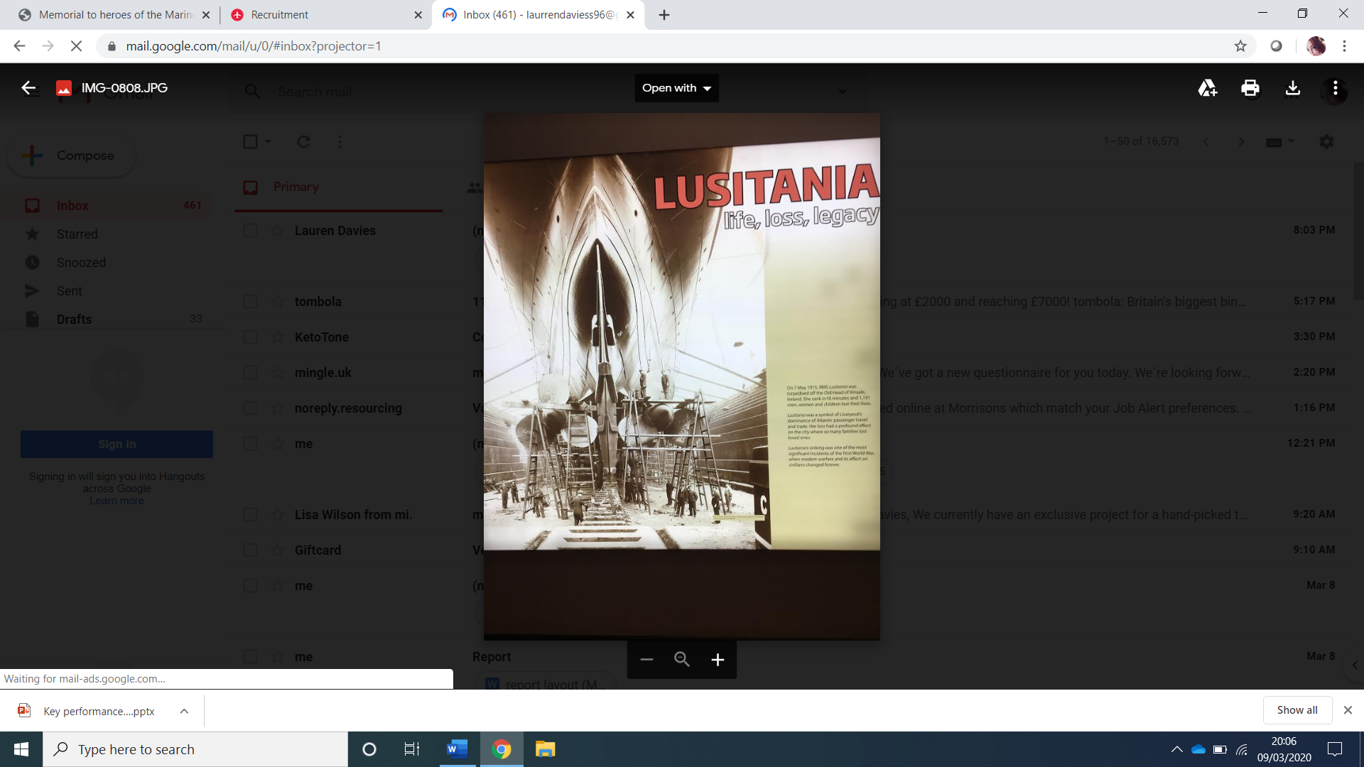
For my excursion in Liverpool I focus on Historical Tourism, the excursions I visited were Merseyside Maritime Museum, Liverpool Museum and the Memorial to Heroes of the Marine Engine room. Within the Merseyside Maritime Museum, I learnt about the sinking of the Lusitania, the Lusitania happened in the First World War In 1914 – 1918 and its still one of most terrible incidents that happen at sea.
After visiting the Merseyside Martine Museum, I went on to the National Museums Liverpool. Within the National Museum Liverpool, I went to various parts, the Global city was intriguing, I learnt about the Chinese Heritage and how fancy goods were imported into Liverpool. Liverpool helped China by buying goods when visiting their country and bringing them home in the 19th Century. When learning about China I had a chance to try on some of the Chinese clothes, the clothing is still being produced to this day and is a tradition in the Chinese culture.
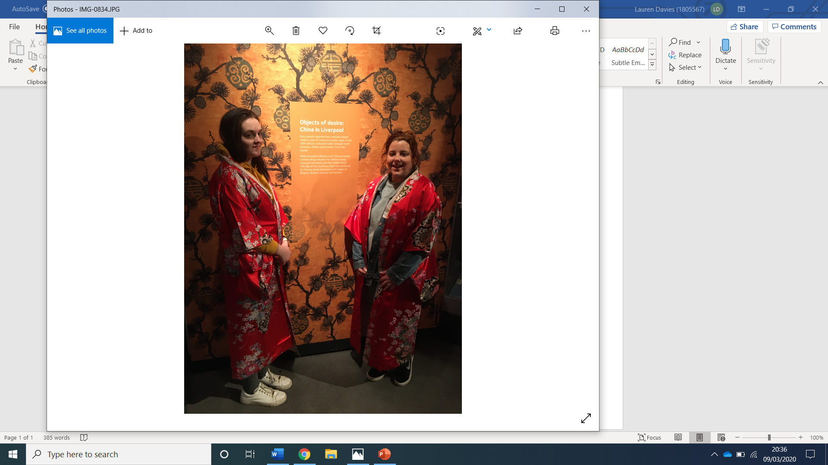

The final place I went to visit was the Memorial to the Engine Room Heroes of the Titanic by Liverpool Doc. The story behind the Memorial to the Engine Room Heroes of the Titanic is on 15th of April 1912 the HMS Titanic Ship sank, this was one of the saddest events that happened. The Memorial is there for people to pay their respect for the Engines of the Titanic. It is very peaceful when visiting the Memorial and the story touches people’s hearts.
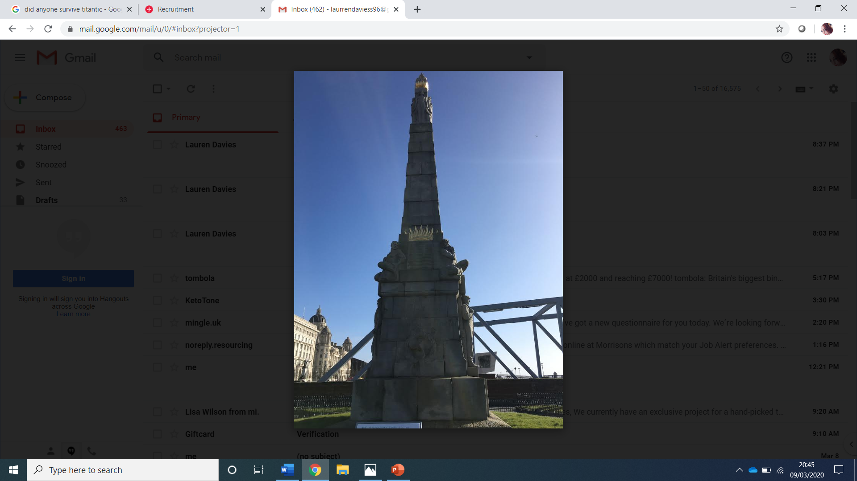
Overall, for my niche market I have learnt a lot about the History within Liverpool. It has been very educational and emotional. Having the chance to visit each place has touched my heart because even though some of it has been lovely to visit some has been sad knowing people lost their lives and family just breaks my heart. Each place has something different to offer and I recommend that if people visit Liverpool these of some of the places they should go.

