
cERULEAN tOWER hOTEL tRAINING pROGRAMME pROJECT fINDINGS
Clyde Carmelo Seisun (2220481)

May 2, 2025
Independent Project (BMTP6015)
Lecturer: Scott James

Contents
Project Findings Overview and Analysis 2
Overview and Analysis 2
Evaluate Success 3
Make Future Adjustments 3
Final Report 5
Introduction 5
Methodology 6
Key Findings 7
Politeness and Professionalism 7
Communication Gaps and Language Barriers 8
Inconsistency in Service Delivery 8
Cultural Expectations and Emotional Intelligence 9
Potential Training Directions (Theoretical only) 10
Outcomes and Reflections 11
Navigating Real-World Constraints 11
The Value of Reflective Practice 12
Deepening Understanding of Hospitality Theory 12
Preparation for Industry Practice 13
Conclusion and Recommendations 14
Conclusion 14
Actionable Recommendations 15
Allow More Time for Industry Engagement 15
Develop a Contingency Plan for Data Collection 15
Strengthen International Communication Strategies 15
Utilise Institutional Support and Networks 15
Incorporate Reflective Frameworks from the Beginning 15
Appendix 17
Bibliography 23

Project Findings Overview and Analysis

Overview and Analysis
The core aim of this consultancy project was to conceptualise a training programme for the front desk team at the Cerulean Tower Tokyu Hotel in Shibuya, Tokyo. The objective was to identify areas for staff development by analysing service quality and guest expectations, ultimately proposing how a training programme could be designed to enhance guest satisfaction while upholding the Japanese principle of Omotenashi, a philosophy centred on wholehearted and selfless hospitality.
Originally, the project was intended to follow a mixed methods research approach, combining interviews with hotel managers and staff alongside surveys distributed to guests and hospitality professionals. However, due to limited industry engagement, strict time constraints, and lack of financial or institutional support, it was not possible to collect primary data. As a result, the project shifted to a theoretical and secondary data approach, reflecting on what could have been implemented under more favourable circumstances.
To ensure the project still generated meaningful insight, publicly available secondary data, namely guest reviews from platforms such as TripAdvisor, Booking.com, and Google Reviews, were analysed to understand perceptions of front desk service at the hotel. This method enabled an alternative perspective, offering a real-world view of recurring guest experiences, feedback, and concerns.
Several key themes emerged through this review analysis. On the positive side, guests frequently commended the front desk team for their politeness, efficiency, and professionalism. Comments such as “smooth check-in experience,” “very helpful,” and “consistently polite staff” were common across multiple platforms.
However, guest feedback also revealed certain recurring challenges. Notably, language barriers were mentioned in several reviews, with some international visitors expressing difficulty when communicating with front desk staff in English. Additionally, a few reviews described inconsistent service delivery, highlighting how guest experiences could vary depending on staff member, shift, or time of visit. These insights underscore areas where a training programme would be beneficial, particularly in standardising service quality and enhancing intercultural communication skills.
While no actual training programme was developed or delivered as part of this project, the process of reviewing guest feedback offered valuable insight into what a future programme might include. For instance, training modules might have focused on improving language proficiency, ensuring consistency in service standards, and deepening cultural awareness among staff when engaging with international guests.

Evaluate Success
In evaluating the success of this project, it is important to consider its context and constraints. Although the project did not achieve its original methodological goals, it succeeded in delivering a reflective, evidence-based analysis of the hotel’s front desk performance through guest reviews. These insights were sufficient to inform theoretical recommendations and demonstrate the potential need for future staff training initiatives.
Furthermore, this project fulfilled key academic objectives. It demonstrated adaptability, critical thinking, and methodological flexibility in the face of real-world research barriers. The ability to pivot from a primary data approach to a reflective, review-based analysis reflects a strong level of problem-solving and academic resilience.
Although a training programme was not created or tested, the reflective process of considering how such a programme might have been designed, if time, funding, and access had allowed, provided a valuable academic exercise in project planning and evaluation. As such, this project served more as a feasibility study than a practical consultancy delivery.

Make Future Adjustments
If this project were to be undertaken again under more favourable conditions, several improvements and adjustments could be made. First and foremost, more time would be allocated for building relationships with hospitality professionals and seeking ethical approval for interviews and surveys. Establishing these connections early in the research process could significantly increase access to meaningful primary data.
Secondly, with adequate funding, a field visit to the Cerulean Tower Tokyu Hotel itself would be ideal. Allowing for direct observation, in-person interviews with staff and guests, and on-site data collection would offer deeper insights into day-to-day operations and training gaps. This would also create the opportunity to co-design a programme with hotel staff, ensuring cultural and operational relevance.
Finally, if implemented in the future, the training programme could be developed iteratively piloted in stages and evaluated using both guest feedback and internal performance metrics. Ideally, this would evolve into a long-term, embedded staff development initiative focused on continuous improvement rather than a one-time intervention.

Final Report

Introduction
This Independent Project was undertaken as part of the final year of study in International Travel and Tourism Management. The project served as a consultancy-style feasibility analysis for a training programme aimed at the front desk team of the Cerulean Tower Tokyu Hotel in Shibuya, Tokyo. The goal was to explore the practical and theoretical considerations involved in designing a culturally sensitive and customer-oriented training programme rooted in the Japanese concept of Omotenashi, a philosophy of heartfelt, anticipatory hospitality that reflects deeply embedded values within Japanese service culture.
Originally, the project was intended to follow a primary data-driven approach, grounded in the use of mixed methods. The plan was to carry out qualitative interviews with hotel professionals, ideally those with managerial or supervisory roles, and to distribute quantitative surveys to both staff and guests. These instruments were designed to uncover real-world perspectives on service gaps, operational challenges, and training needs within the front desk team. The ultimate aim was to co-create a training programme informed directly by the voices of those working in and experiencing the hotel environment.
However, as the project progressed, several significant constraints emerged. Despite proactive outreach to a range of hotel organisations, both in Japan and locally, there was a lack of response and willingness to engage. This was likely influenced by several factors… such as the absence of institutional or professional partnerships to facilitate introductions, time zone and language barriers when contacting Japanese hotels, and the limited timeline available to secure ethical approval and conduct interviews or distribute surveys. Additionally, budgetary restrictions made it impossible to travel to Tokyo to gather data in person, which might have improved access and acceptance for the training programme from stakeholders.
In response to these challenges, the project methodology was adapted. Instead of pursuing primary data collection, the project shifted focus to a secondary data analysis, drawing on publicly available guest reviews from platforms such as TripAdvisor, Booking.com, and Google Reviews. While less direct than the original method, this approach still enabled the collection of valuable insights regarding front desk performance and customer perceptions of service quality.
These guest reviews were examined in detail to identify recurring strengths and areas for improvement in the Cerulean Tower’s front desk operations. The findings were then interpreted through the lens of relevant hospitality theories, including SERVQUAL, Hofstede’s Cultural Dimensions, and principles of Omotenashi in order to explore what kind of training might be beneficial in the context of a five-star, globally oriented Japanese hotel.
Although no formal training programme was designed or implemented as part of this project, the analysis formed the basis for a theoretical and reflective consultancy proposal. It explores what such a training intervention could look like if the project were undertaken under more favourable conditions, namely with greater time, funding, and industry access.

Methodology
The original plan for the project was to adopt a mixed-methods approach, combining:
- Qualitative interviews with hospitality professionals and hotel management, and
- Quantitative surveys with guests and employees.
These tools were intended to capture a range of perspectives on front desk performance, staff training gaps, and service quality from both an operational and customer viewpoint.
However, this primary data collection plan proved unfeasible. Despite efforts to reach out to several hospitality businesses (both in Japan and locally), there was minimal engagement. The barriers to access were multifaceted: the international scope of the hotel in question, language and time zone differences, and a lack of existing professional contacts or organisational support to facilitate introductions.
Rather than abandon the project, an alternative methodology was adopted: a secondary data approach based on publicly available online guest reviews. Platforms such as TripAdvisor and Booking.com and Google Reviews were examined to identify common trends and recurring feedback related to the front desk team at the Cerulean Tower Tokyu Hotel.
In addition to this, the project incorporated hospitality service theories, including SERVQUAL, Hofstede’s Cultural Dimensions, and the philosophy of Omotenashi in order to guide analysis and contextualise findings within an international customer service framework.
The project therefore evolved into a reflective and theoretical exploration, offering insights into service expectations, potential training needs, and what a future, well-funded and fully executed training programme could involve.

Key Findings
This project used online guest reviews as a secondary data source to evaluate front desk service quality at the Cerulean Tower Tokyu Hotel. While the original plan involved collecting primary data through interviews and surveys, the transition to analysing guest feedback allowed for insight into authentic service experiences. The findings were interpreted through several theoretical frameworks including Omotenashi, the SERVQUAL model, Hofstede’s Cultural Dimensions, Gronroos’ Service Quality Model, and Maslow’s Hierarchy of Needs to understand the perceived strengths and weaknesses of the front desk team.

Politeness and Professionalism
The most consistent theme across reviews was the exceptional politeness and attentiveness of the front desk staff, which closely aligns with the Japanese cultural value of Omotenashi. Unlike Western service models, which are often transactional, Omotenashi is based on a selfless desire to serve others, anticipating guest needs without the expectation of reward. This philosophy was visible in guest feedback describing the staff as “gracious,” “professional,” “quietly efficient,” and “deeply respectful.”
From a service quality perspective, this aligns with the “functional quality” component of Gronroos’ Service Quality Model (Grönroos, 1984) which distinguishes between technical quality (what is delivered) and functional quality (how it is delivered). In this case, the “how” — the emotional, respectful nature of service — played a pivotal role in guest satisfaction.
In addition, these findings correspond positively with the assurance and empathy dimensions of the SERVQUAL model (Al Masud, 2024), suggesting that the front desk staff make guests feel secure, cared for, and respected, which are the hallmarks of high-quality hospitality.

Communication Gaps and Language Barriers
Despite high praise for service etiquette, a number of international guests reported difficulty communicating in English, particularly during more complex requests or troubleshooting situations. In a globalised tourism context, language remains a critical factor in service delivery and guest satisfaction. This language barrier presents a training gap that could be addressed through English proficiency development and role-play training in handling unexpected situations.
This issue also intersects with Hofstede’s Cultural Dimensions (Jackson, 2024), particularly individualism vs collectivism and uncertainty avoidance. Japanese communication norms, rooted in collectivist values and high uncertainty avoidance, often prioritise indirectness and risk reduction. This can lead to cautious communication, especially when using a second language. Western guests, typically from more individualistic and low-uncertainty cultures, may interpret this caution as hesitation or lack of confidence, even though the intention is respectful professionalism.
Moreover, Maslow’s Hierarchy of Needs (McLeod, Maslow’s Hierarchy of Needs, 2025) offers a humanistic lens: communication barriers can inhibit a guest’s sense of safety and belonging, which are foundational for a positive travel experience. Clear and confident communication from staff is essential to helping guests feel secure and understood in a foreign environment.

Inconsistency in Service Delivery
While many reviews highlighted strong service delivery, a smaller but notable number mentioned inconsistency depending on time of day or staff member. Some guests described feeling “overlooked” during busy periods or noted that certain staff seemed less engaged than others. This inconsistency signals a potential issue with service standardisation.
From a theoretical standpoint, this variation challenges the reliability dimension of the SERVQUAL model (Al Masud, 2024), which refers to the ability to perform the promised service dependably and accurately. It also touches on Gronroos’ “technical quality” (Grönroos, 1984), suggesting that the outcome of the service interaction (e.g., check-in time, problem resolution) may fluctuate, impacting guest perceptions.
A well-structured training programme, had one been implemented, could address this by promoting standard operating procedures (SOPs) that maintain high standards while allowing space for Omotenashi-based flexibility and intuition.

Cultural Expectations and Emotional Intelligence
Reviews also revealed a subtle but important tension: differences in guest expectations based on cultural background. For example, some Western guests expected more overt friendliness or casual conversation, while Japanese guests valued discretion, quiet efficiency, and professionalism. These differing expectations can lead to misinterpretation of staff behaviour.
This theme reinforces the importance of emotional intelligence in hospitality, particularly the ability to adapt communication styles, read social cues, and regulate responses based on guest preferences. Culturally intelligent service providers can bridge these expectations without compromising brand or cultural values.
This also reinforces the Omotenashi core message: while deeply Japanese in origin, its principles can be adapted to respect the cultural and emotional needs of all guests. A future training programme could therefore benefit from integrating cross-cultural communication models and empathy development exercises, helping staff recognise and respond to diverse guest cues.

Potential Training Directions (Theoretical only)
Although this project did not result in the development or delivery of an actual training programme, the findings clearly pointed toward specific areas where targeted front desk training could be beneficial in the context of Cerulean Tower Tokyu Hotel. If circumstances such as time, funding, and industry access had permitted, a structured training intervention could have been designed to address recurring guest concerns, support staff development, and align with the hotel's existing strengths in Omotenashi-driven hospitality.
Based on the review analysis and supported by academic models, a theoretical training programme might have included three core pillars:
- Language and Communication Proficiency - Enhancing English fluency and confidence in handling non-standard guest requests through scenario-based language workshops and communication drills. This would improve performance in SERVQUAL’s “assurance” and “empathy” dimensions and meet international guest expectations for clarity and responsiveness (Al Masud, 2024).
- Cultural Sensitivity and Emotional Intelligence - Drawing from Hofstede’s Cultural Dimensions (Jackson, 2024), and Goleman’s Emotional Intelligence Framework (Channell, 2021), models would focus on understanding diverse guest expectations, regulating emotional responses, and reading non-verbal cues. This would help bridge the cultural gap between Japanese service formality and international preferences for familiarity and informality.
- Standardised Service Procedures with Omotenashi Flexibility - Using Gronroos’ Service Quality Model (Grönroos, 1984) to balance technical and functional quality, this pillar would offer staff consistent processes while encouraging personalised touches in line with Omotenashi. For instance, a structured check-in process could be enhanced with small gestures—such as remembering guest preferences—that reflect sincere, anticipatory care.
The training could have been delivered through a blended model of interactive workshops, peer-led shadowing, and reflective journaling, culminating in feedback from both staff and guests. The programme would ideally be piloted and revised based on performance outcomes, in line with a continuous professional development approach.
Ultimately, while the training content was not created or tested during this academic project, outlining its potential scope supports the feasibility and relevance of future implementation.

Outcomes and Reflections
This project has been both challenging and enlightening, offering significant personal and academic growth despite limitations in data collection and implementation. While the original aim was to develop a complete training programme for the front desk team at the Cerulean Tower Tokyu Hotel, the project evolved into a reflective and analytical study grounded in secondary data and hospitality theory. This evolution in scope provided valuable insight into the realities of conducting consultancy work, particularly when working across cultural and geographic boundaries.

Navigating Real-World Constraints
One of the most significant outcomes of this project was learning how to navigate real-world research barriers. Despite initial intentions to gather primary data through interviews and surveys, the challenges of international outreach, time differences, and limited responses from industry professionals made this unfeasible. This forced an early turning point in the project — a shift to secondary data in the form of guest reviews. At first, this felt like a compromise, but with further analysis, it became clear that this approach still provided relevant and authentic insights into the guest experience.
This adaptability reflects a key skill in consultancy: the ability to pivot and revise strategies in response to limitations. In many real-world projects, perfect conditions rarely exist, and consultants must work with the resources and access they have. This experience highlighted the importance of resilience, creative problem-solving, and critical thinking — all of which are highly transferable to the tourism and hospitality sector.

The Value of Reflective Practice
In the absence of primary data, reflective practice became central to this project’s process. By analysing real guest reviews and interpreting them through a theoretical lens, I was able to simulate the kind of critical evaluation and insight generation that would take place in an actual consultancy setting. Reflective frameworks such as Gibbs’ Reflective Cycle (McLeod, Gibbs Reflective Cycle, 2025) and Kolb’s Experiential Learning Cycle (McLeod, Kolb’s Learning Styles and Experiential Learning Cycle, 2025) helped guide this process, allowing me to assess not only what was discovered, but how I reacted to challenges and adapted to change.
Through this, I gained deeper awareness of my research capabilities and limitations. I learned to trust alternative methodologies, and to take ownership of my learning even when the original project goals had to be adjusted. This level of personal insight and flexibility is something I will carry forward into future work and academic projects.

Deepening Understanding of Hospitality Theory
Another important outcome of the project was the opportunity to engage deeply with key service and cultural theories. While Omotenashi was the central framework for understanding the essence of Japanese hospitality, expanding the literature review to include SERVQUAL (Al Masud, 2024), Hofstede’s Cultural Dimensions (Jackson, 2024), Gronroos’ Service Model (Grönroos, 1984), Maslow’s Hierarchy of Needs (McLeod, Maslow’s Hierarchy of Needs, 2025), and Emotional Intelligence theory (Channell, 2021) provided a much broader toolkit for analysis.
These models helped to ground the review data in theory and demonstrate how frontline service roles are shaped by both cultural context and guest expectations. This reinforced the importance of theoretical knowledge when designing practical interventions like training programmes, particularly in global hospitality settings where cultural norms and service preferences may vary widely.

Preparation for Industry Practice
Although this was a theoretical project, it simulated the core steps of consultancy work: identifying a client problem, proposing research methods, adapting to real-world challenges, analysing available evidence, and suggesting strategic solutions. In doing so, it prepared me for future roles in hospitality or tourism consultancy, guest services management, or training and development.
Additionally, the project highlighted the importance of soft skills such as adaptability, professional communication, and empathy — all of which are essential in both team and client-facing roles in the industry. The emphasis on Omotenashi also reaffirmed my personal values as a future hospitality professional: empathy, attentiveness, and a dedication to quality service.

Conclusion and Recommendations

Conclusion
This project set out to explore the feasibility of developing a front desk training programme for the Cerulean Tower Tokyu Hotel in Shibuya, Tokyo, grounded in the principles of Omotenashi and informed by service quality theories. While the original aim included primary data collection through interviews and surveys, practical constraints led to a revised, secondary data-focused approach based on guest reviews.
Despite these limitations, the project successfully identified key strengths and areas for improvement in the hotel's front desk operations. The hotel’s strong commitment to Omotenashi values, politeness, and professionalism was consistently praised, reinforcing the cultural underpinnings of Japanese hospitality excellence. However, communication barriers and service consistency issues, particularly from an international guest perspective, emerged as important themes for potential staff development.
Through the use of theoretical frameworks such as SERVQUAL, Gronroos’ Service Quality Model, Hofstede’s Cultural Dimensions, Maslow’s Hierarchy of Needs, and Emotional Intelligence theory, the findings were critically evaluated and connected to broader service and hospitality concepts. This reflective and adaptive project journey not only provided academic insight but also developed essential professional skills such as flexibility, problem-solving, and reflective practice.
Ultimately, while no formal training programme was developed or implemented, the project provides a clear academic foundation for future consultancy initiatives, demonstrating how theory and evidence can be used to inform practical, culturally sensitive training designs in the global hospitality industry.

Actionable Recommendations
In light of the challenges encountered during this project, the following practical recommendations are made to improve the success of similar future consultancy or academic projects:

Allow More Time for Industry Engagement
- Future projects should allocate more time at the start for building relationships with industry professionals, both locally and internationally.
- Early engagement allows for better negotiation of access, securing of interviews or surveys, and obtaining ethical approval where necessary.
- Where possible, contacting potential participants months in advance, supported by a university introduction or reference, may increase response rates.

Develop a Contingency Plan for Data Collection
- Projects relying on primary data collection should prepare a contingency plan outlining secondary data sources or alternative research strategies if initial plans fail.
- Having a “Plan B” would ensure that data analysis can still proceed meaningfully even if interviews or surveys do not materialise.

Strengthen International Communication Strategies
- When working with organisations across different countries and languages, clearer, more culturally sensitive communication strategies are essential.
- Using bilingual messages, scheduling flexibility, and working with local intermediaries or translators could improve engagement success with international contacts.

Utilise Institutional Support and Networks
- Future projects could benefit from more active use of university resources, such as seeking support from lecturers, placement offices, or alumni networks to facilitate introductions to industry professionals.
- Having official institutional backing can increase legitimacy when contacting busy organisations.

Incorporate Reflective Frameworks from the Beginning
- Embedding a formal reflective model, such as Gibbs’ Reflective Cycle (1988) or Kolb’s Experiential Learning Cycle (1984), at the beginning of the project would help guide adaptation to unforeseen challenges.
- Regular reflection checkpoints would allow researchers to assess progress critically and adjust approaches proactively rather than reactively.

Appendix

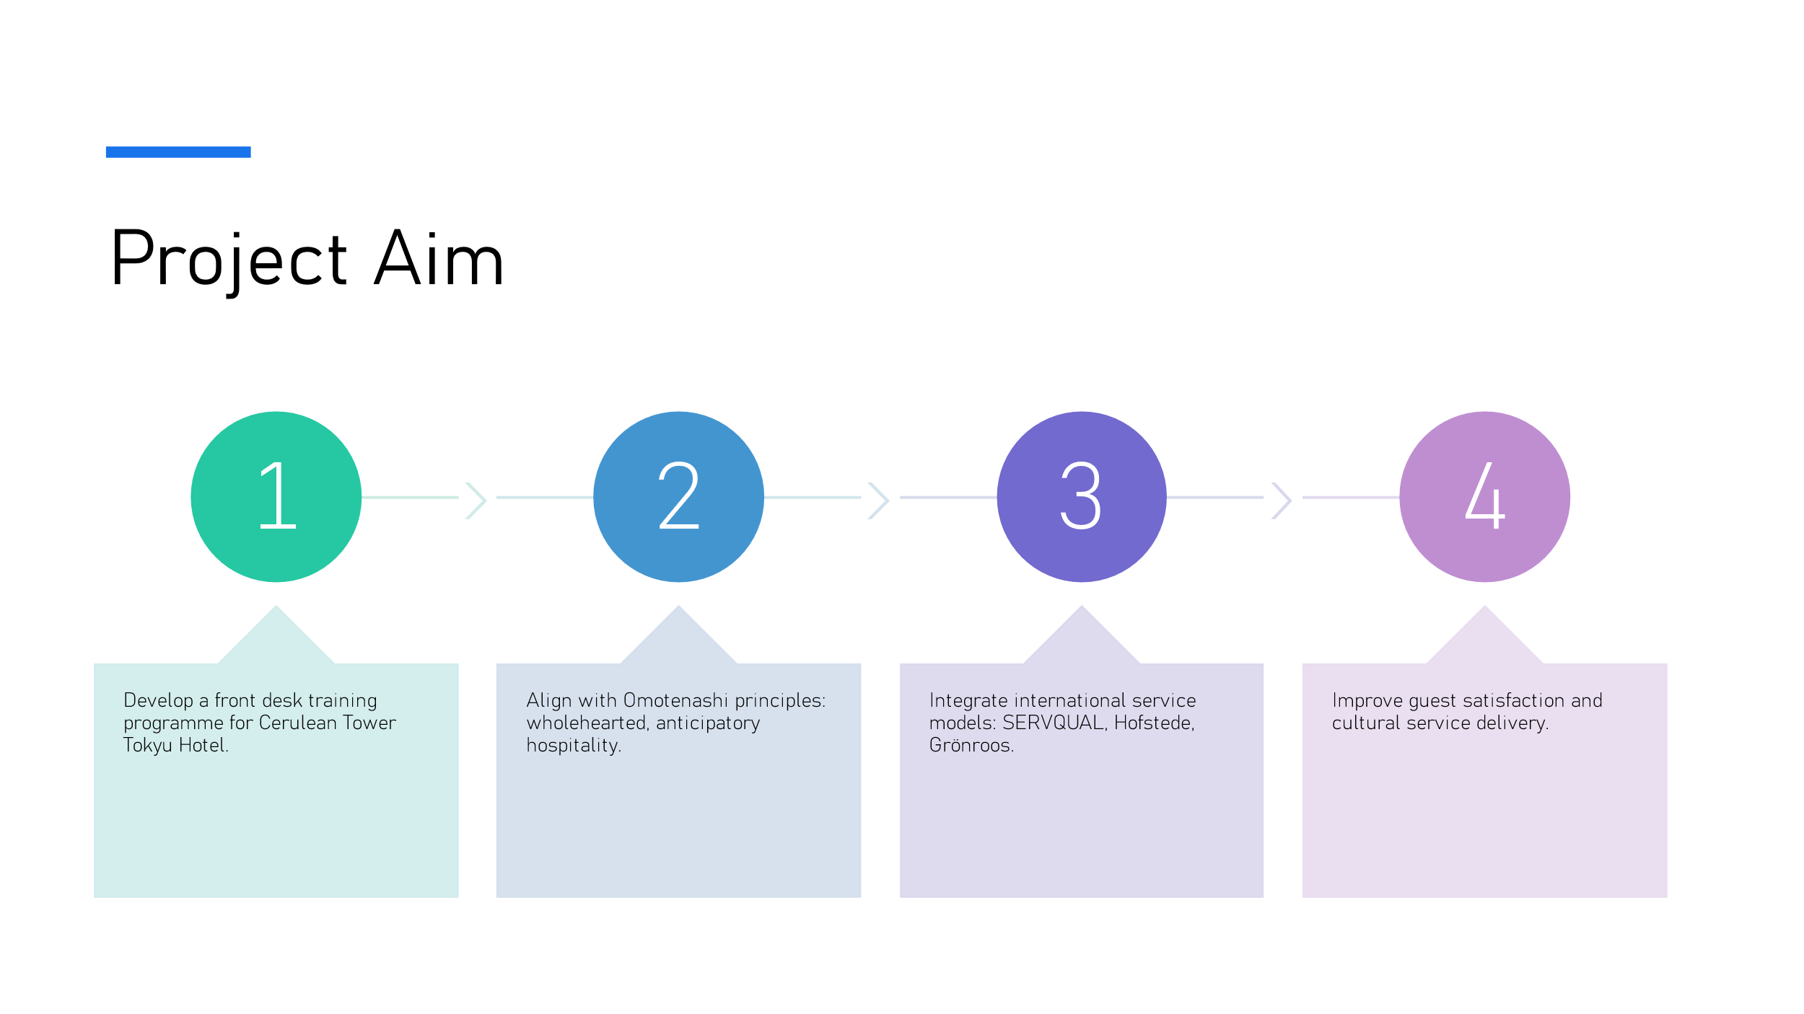
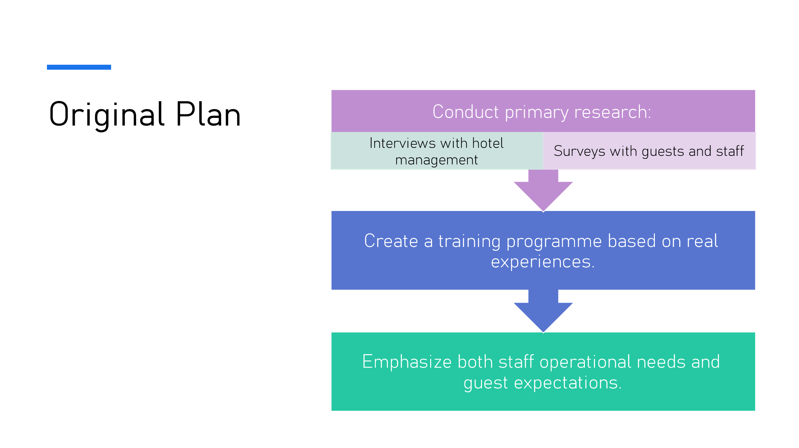
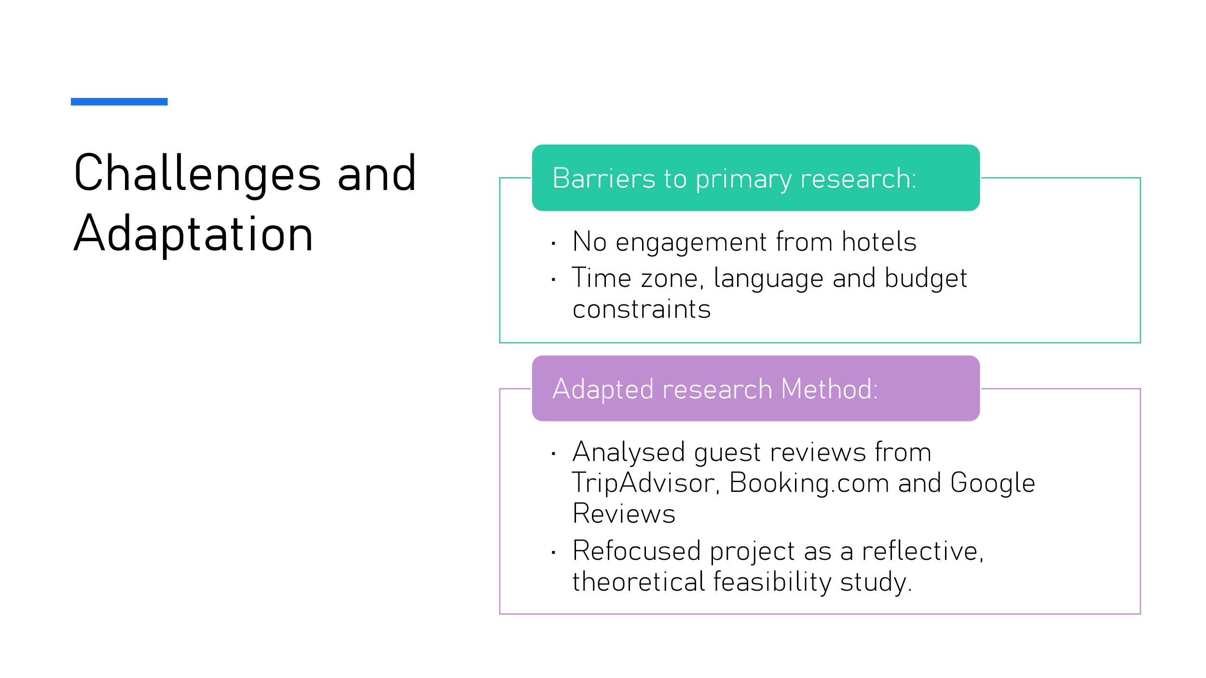
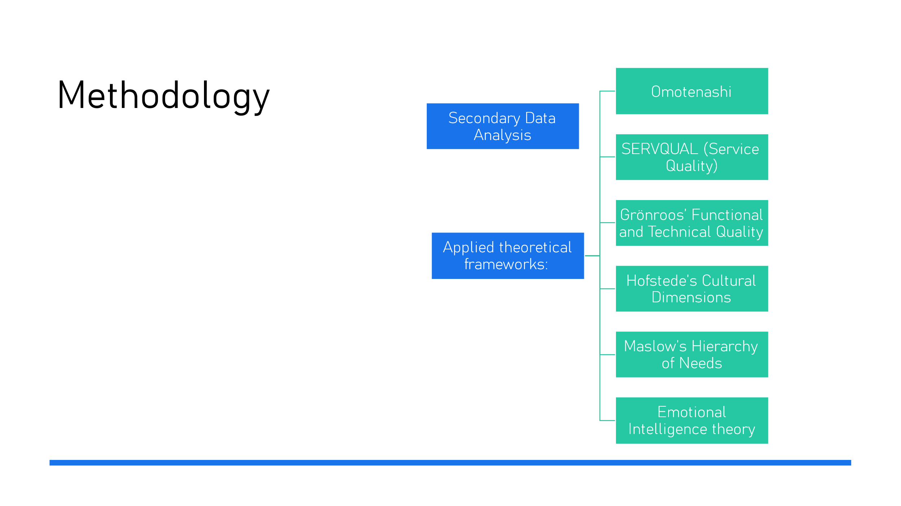
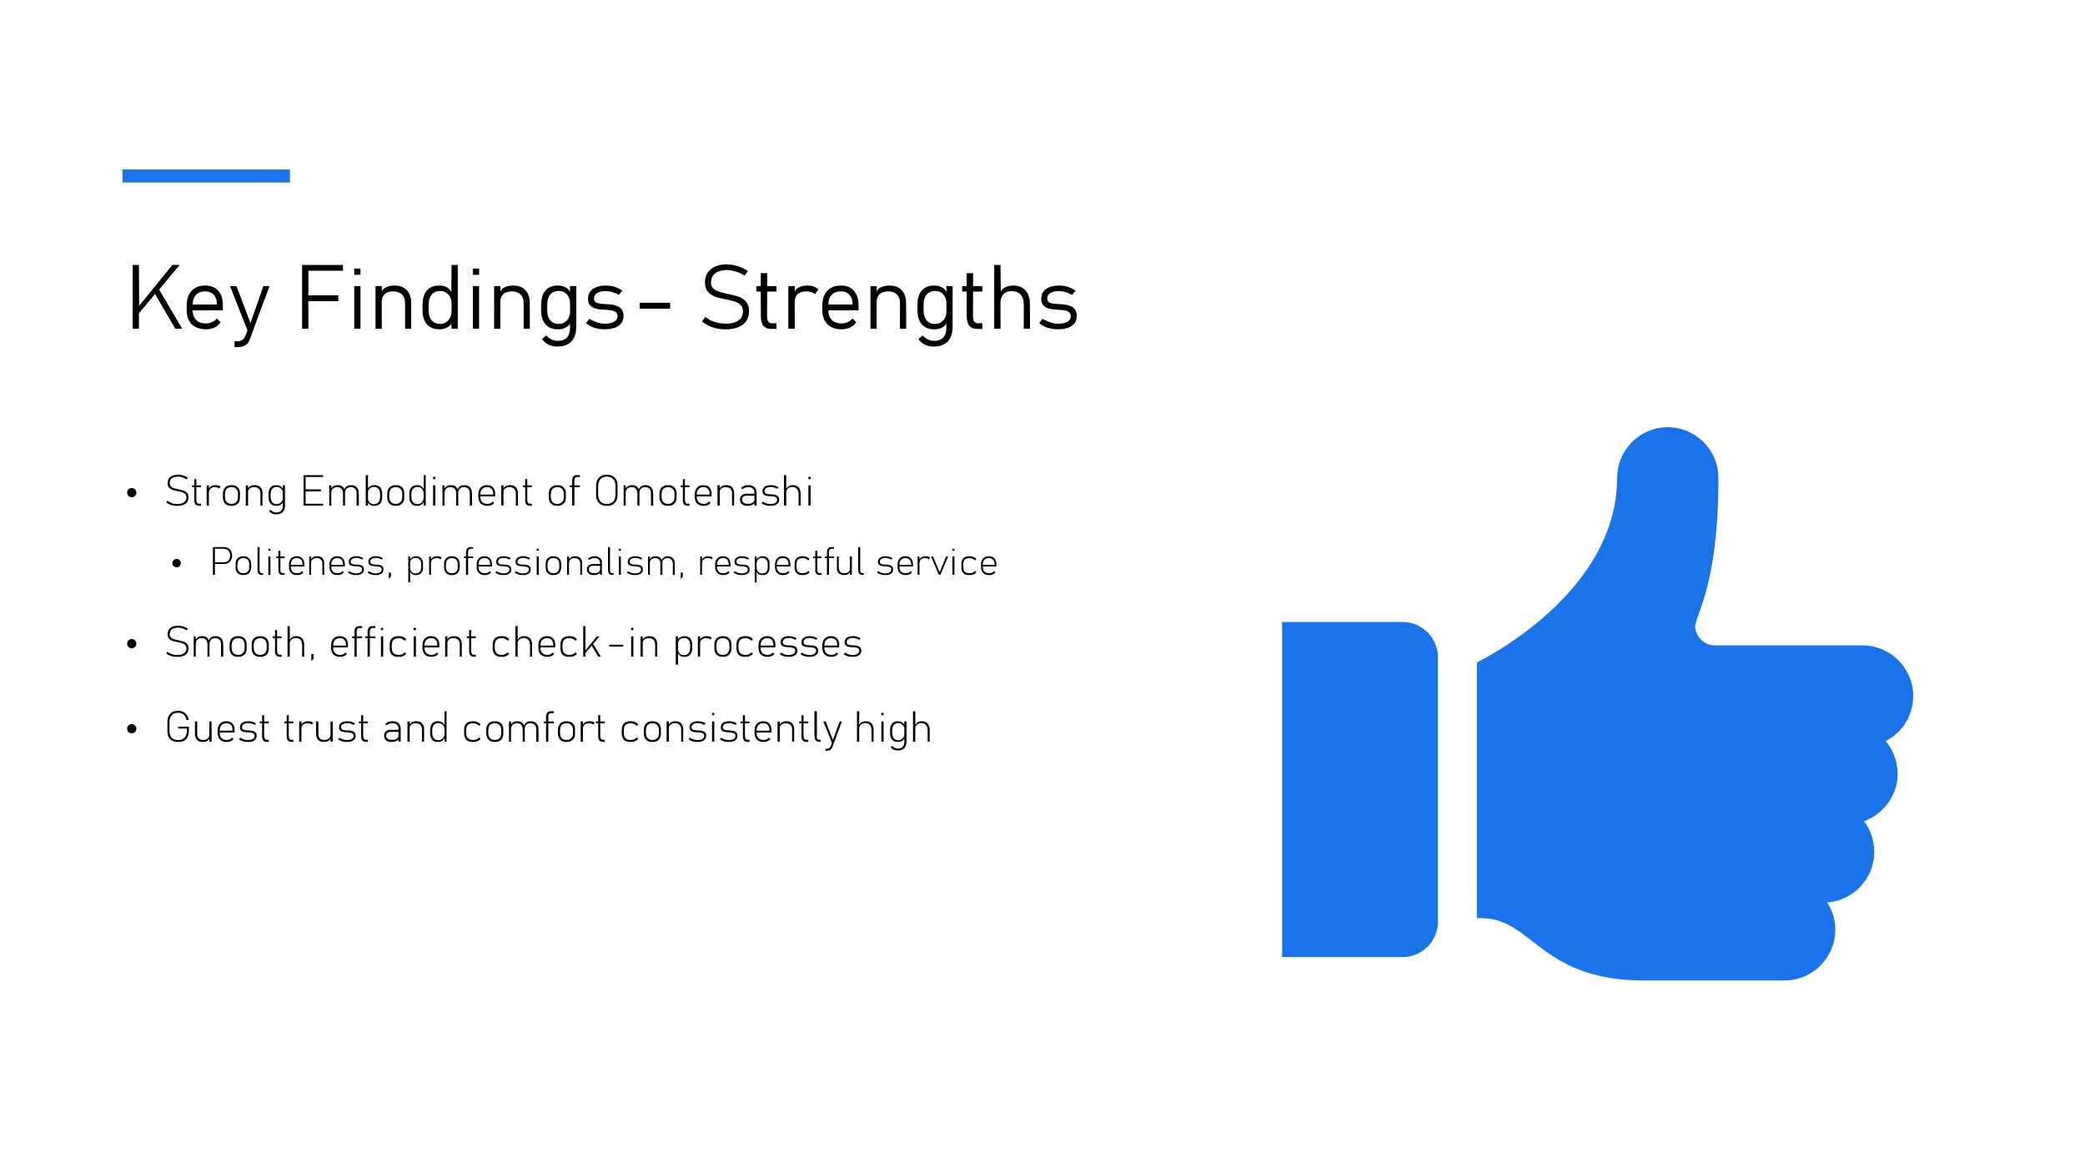
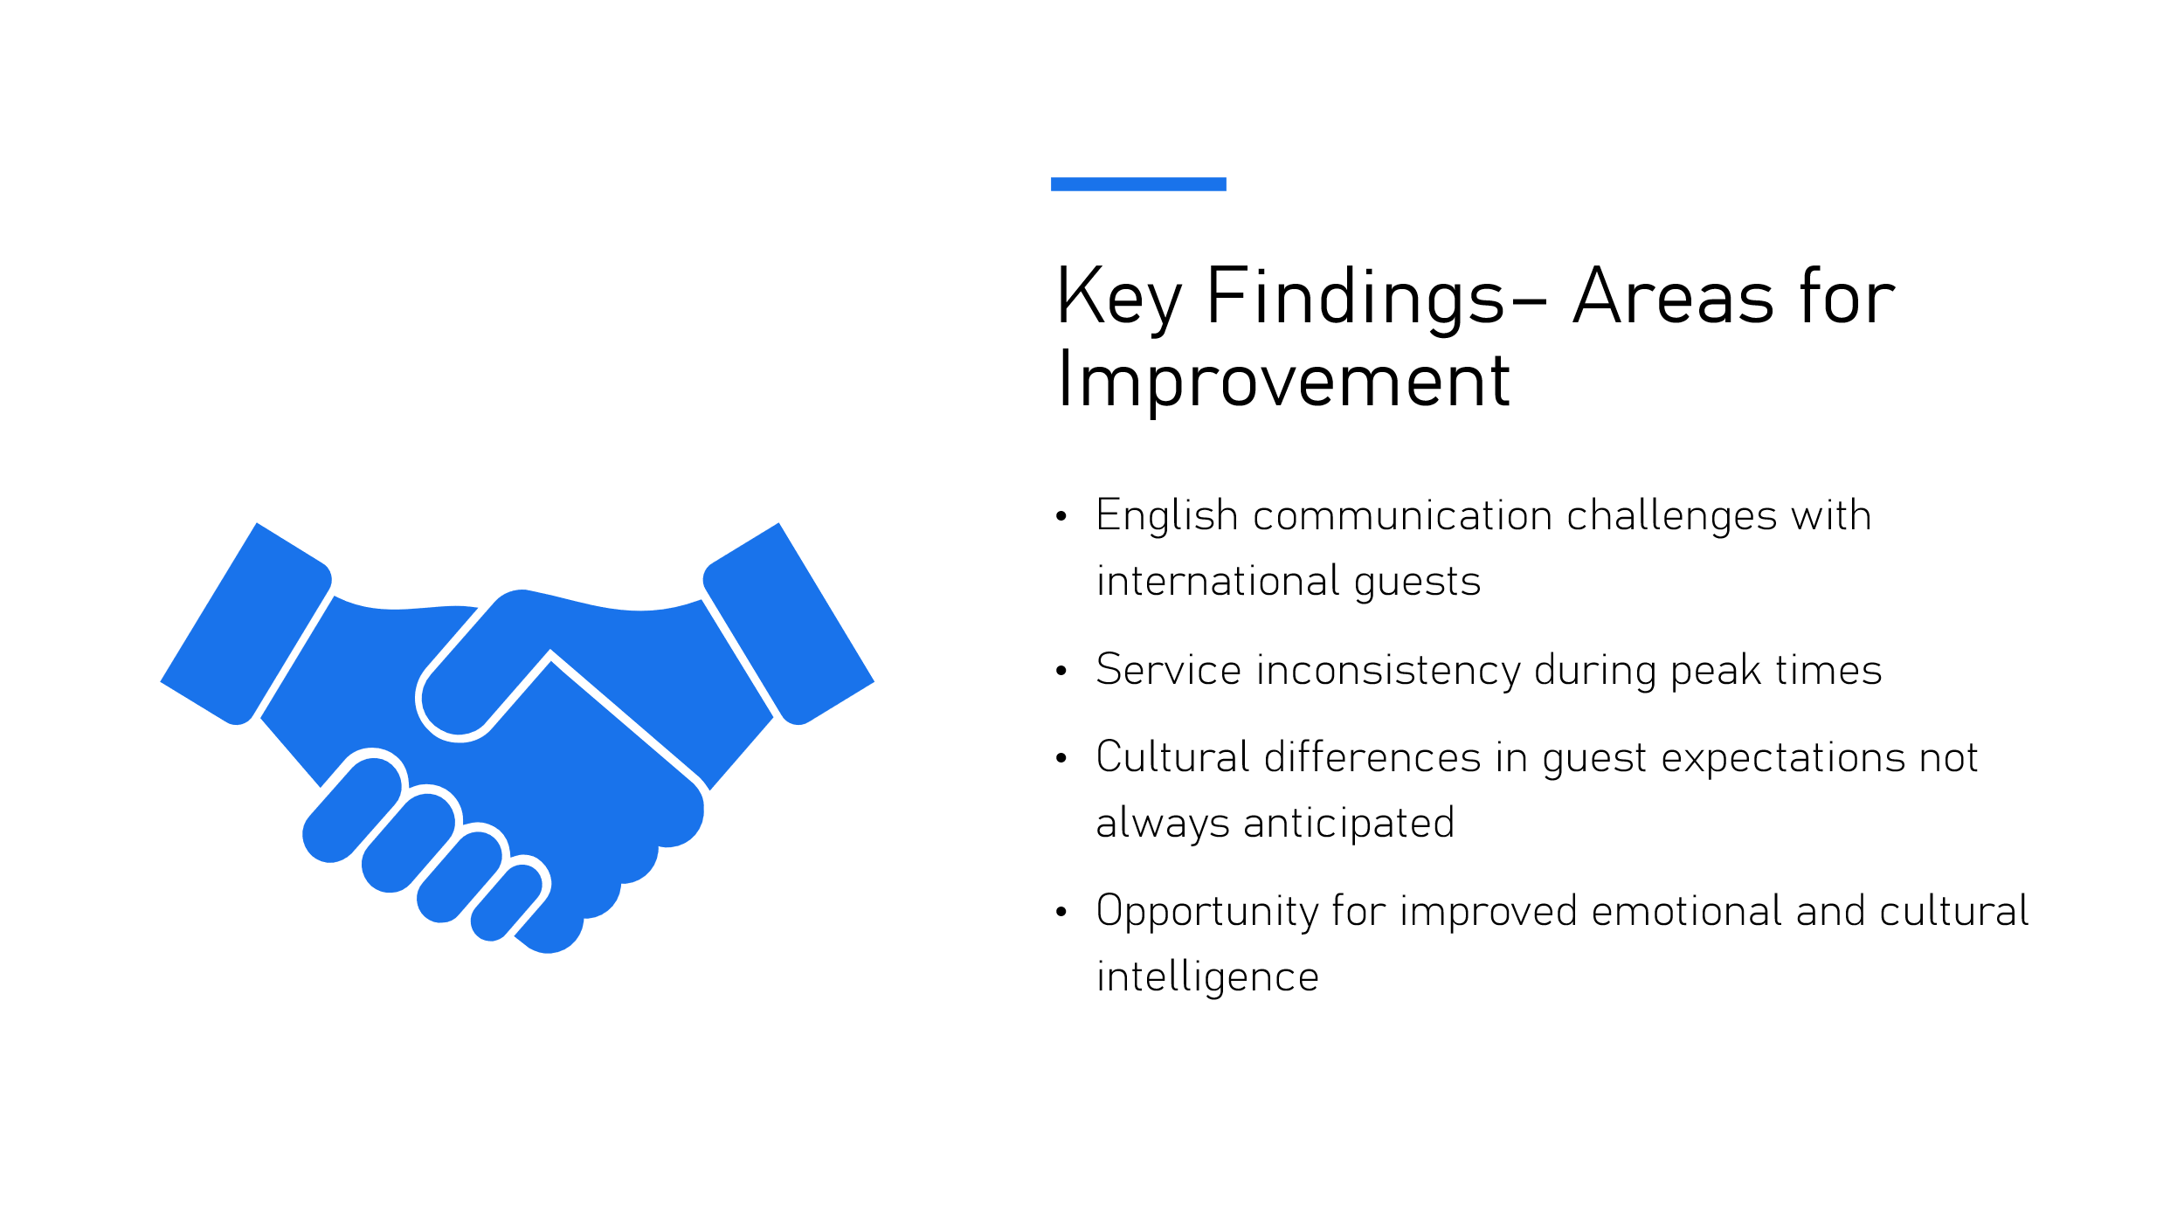
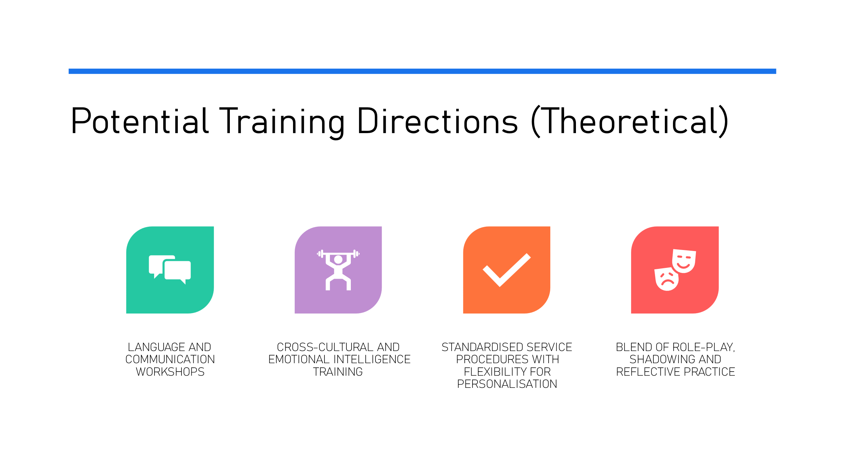
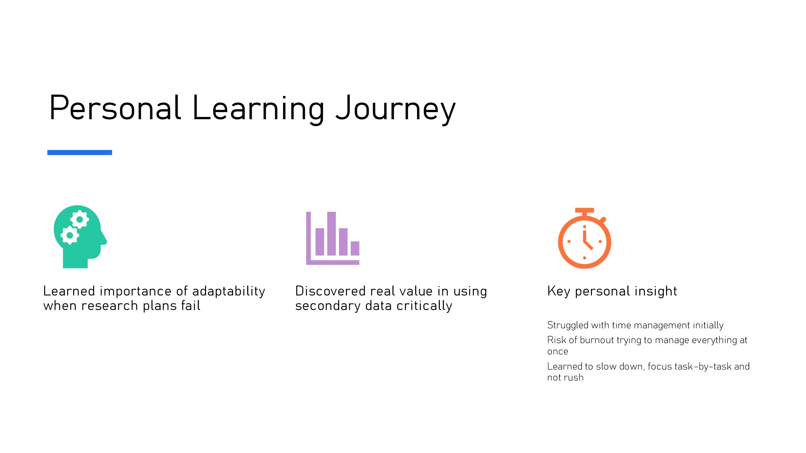
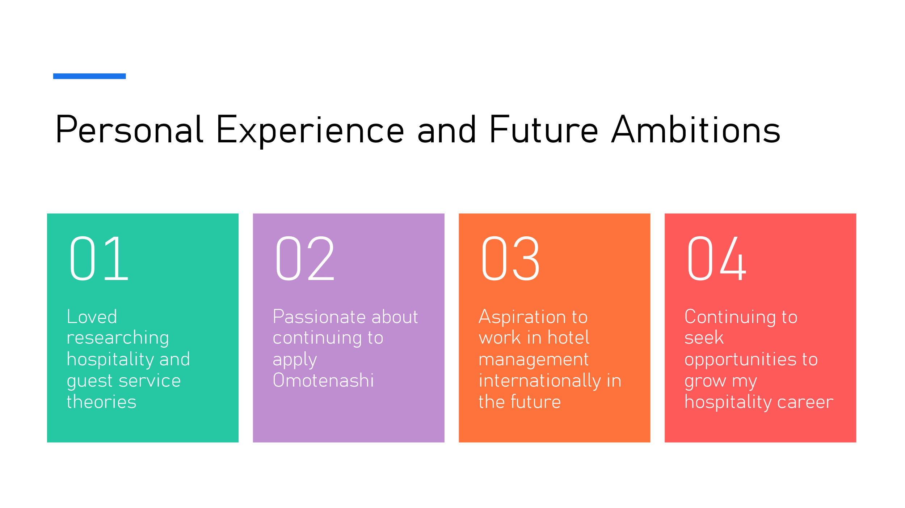
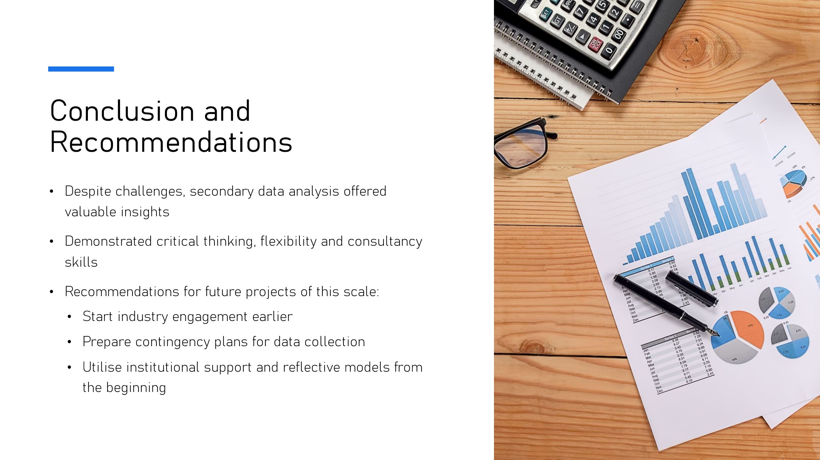


Bibliography
Al Masud, A. (2024, March 7). Servqual: What it Is + How To Understand the Model. Retrieved from https://www.questionpro.com/blog/servqual/
Channell, M. (2021, October 13). Daniel Goleman’s Emotional Intelligence in Leadership: How To Improve Motivation In Your Team. Retrieved from https://www.tsw.co.uk/blog/leadership-and-management/daniel-goleman-emotional-intelligence/
Grönroos, C. (1984). A Service Quality Model and its Marketing Implications. European Journal of Marketing.
Jackson, K. (2024, May). Hofstede's Cultural Dimensions in Today's Global Workplace. Retrieved from https://www.mindtools.com/a1ecvyx/hofstedes-cultural-dimensions
McLeod, S. (2025, March 26). Gibbs Reflective Cycle. Retrieved from https://www.simplypsychology.org/gibbs-reflective-cycle.html
McLeod, S. (2025, March 19). Kolb’s Learning Styles and Experiential Learning Cycle. Retrieved from https://www.simplypsychology.org/learning-kolb.html
McLeod, S. (2025, March 14). Maslow’s Hierarchy of Needs. Retrieved from http://simplypsychology.org/maslow.html

