

Name:
Ionela Vlad
ID:
1905718
Module name:
Foreign Languages & Cultural awareness
Lecturer:
Dr. Olu Adegbite

Content of the report
- Introduction
- What is cultural awareness & importance
- Two countries
- Further advices
- SERVQUAL
- Do’s and Don’ts
- Conclusion
- References

Introduction
The purpose of this assignment is to release information about cultural awareness having under consideration the fact that employees from hospitality industry need guidance in the providing of great services at a high quality, to the international guests. Within the assignment, a great explanation of cultural awareness and the importance of the cultural awareness in the hospitality industry will be released and after this, using two countries that are frequently visited further advices for the personnel will be provided and it will be followed by a model that is supporting all the members of staff to check the quality of the services that are provided.
It Is important to have cultural awareness under consideration and this because of the fact that there are so many tourists coming from the worldwide, some of them coming from cultures that are not as developed so automatically their expectations and their ability of behaving is not in the best condition. As a result it is important to focus on the behaviour that the members of staff have as they should adapt to everything that is happening around them (Shames, 1988)

What is cultural awareness& importance
Cultural awareness is seen as being the ability of adapting to different concepts, perceptions, languages, actions, beliefs, religion, sexual orientation is basically keeping away the discrimination that could appear in the society. It is important to have under consideration cultural awareness in the hospitality industry because if the personnel of hotels are culturally aware then more respect will be showed to the international guests and better ability of recognizing their values, their traditions and better realization of the decision that have been taken will be on place. Therefore, it is important to be cultural aware because the guest will feel the appreciation facing the culture it is coming from and facing them as tourists. To prove great cultural awareness, the members of staff must ensure that they are treating all the guests right and that they are not showing any differences between guests. It important to respect that guest even if it not speaking the best language and even if they have got weird plans for the holiday, it is nothing to affect you as a hospitality worker.
Cultural awareness in hotels is also showing cultural diversity facing a lot of guests that are coming from other countries and cultural diversity is outlining the respect of to the guests that have travelled a long way to be able to arrive in the location they wanted.
Two countries
The two countries chosen for discussion are India and America, two countries with massive differences. India is a country that has a very-well developed hospitality industry and it is a country that highly encourages holidays, technology (Social research institute, 2013) and a lot of services in order to satisfy the guests coming from anywhere. Most of the time the tourists that are going to India are couples or families and there are rare situations in which women are going on their own to India and around, this because India is considered as being unsafe for women (Sood, 2019).
When it comes to America, it is using a massive variety of technology to ensure that the guests are having the best experiences all the time they are coming to the hotels. America is used to having a lot of guests and even because of this they tend to use the profits to introduce newer and newer services all the time to keep surprising the guests that do not stop coming.
There are not too many things to argue in relation to the employee engagement facing international guests, but there are social things that are influencing guests to not come to either America (McConnel, 2020) or India, (Fallen, 2020)

SERVQUAL
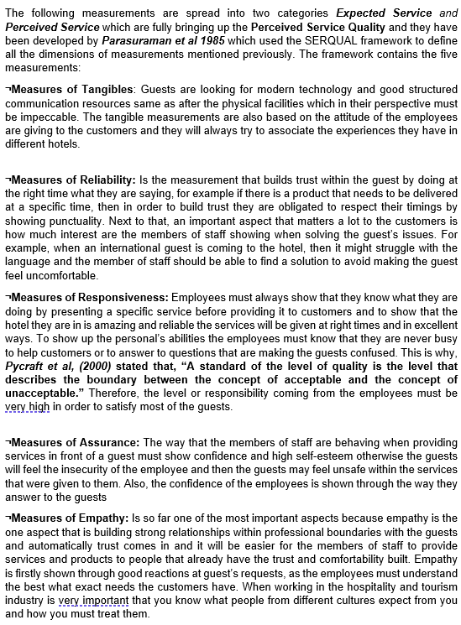

Do’s and Don’ts
Do’s | Don’ts
Make sure that you outline the services such as the broadband in the room so the guest can easily notice their existence | Even if you are busy do never refuse a guest request as most of them cannot tolerate the waiting
Smile in a friendly way once the guest arrives as after a long way the guest will feel welcomed and comfortable | Respect the guest’s preferences especially if it asks for those preferences before coming
Give instructions to the guests as some of the time they may not where to look after things and they may end up without the services they wanted | Get in any guest’s rooms before asking if you are allowed as this can make them feel uncomfortable or in some situations even awkward.
Provide emergency buttons so the guests can easily inform the members of staff when they have issues | consider that all the guests are the same, all of them are different and they must be treated with respect and empathy all the time
Communication is the key so never make a conversation with a guest end quickly only if you have something urgently that needs to be done excuse yourself in a respectful way. | Use passive aggressive language and especially when there are guests from different cultures make sure that you don’t leave a rude impression.
When required, provide information in a way that shows patience especially to people that are coming from different cultures | Do not give the sensation not having any interests when providing services or when speaking with one of the guests .
Inform the guests about such aspects and explain to them how they work including the data protection, breakfast times, prices just to make sure that everyone is aware about the policies and rules. | Do not involve in departments that are not under your duty make sure that you are doing your own work and that you keep the guest interested in the hotel until the responsible colleague is coming.
(Hcareers, 2016)

References
Farrell, D. (2019), “Is it safe to travel to America”, [online]available on: https://www.nomadicmatt.com/travel-blogs/united-states-travel-safety/ accessed on: 31/07/2020
Hcareers, (2016), “Do’s and Don’ts of hotel management”, [online] available on: https://www.hcareers.com/article/career-advice/dos-and-donts-of-hotel-managementaccessed on: 31/07/2020
McConnel, K. (2020), “What to avoid when getting to India”, [online] available on: https://www.beerandcroissants.com/how-to-avoid-getting-sick-in-india/ accessed on: 31/07/2020
Social research institute (2013), “Knowing the customer in India”, [online] available on: https://www.tourism.australia.com/content/dam/assets/document/1/6/w/s/o/2002056.pdf accessed on: 31/07/2020
Shames, G. (1988), “Service management as if culture exists”, viewpoint in International J. Hospitality, Vol.7
Sood, V. (2019), “Toursim and Hospitality India”, [online] available on: https://www.investindia.gov.in/sector/tourism-hospitality accessed on: 31/07/2020

