Title Of The Report | Report 1  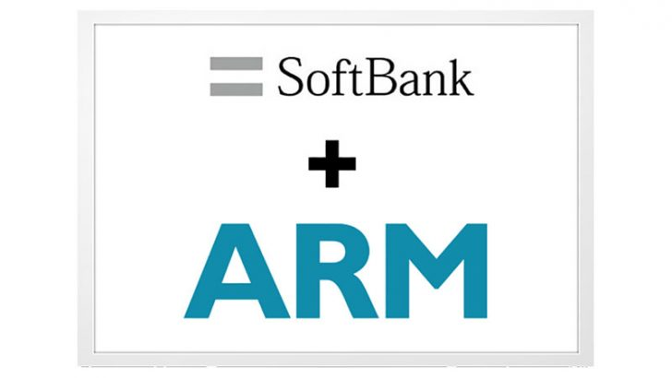
Module Name | STRATEGIC CHANGE AND ORGANISATION
Name of the Tutor | Dr. Gladius kulothungan
Code of the Module | LCDB7005
Student ID | 1812015
Submission Deadline | 20-09-2019

Table of Contents
Introduction 3
Background of the report 3
Strategic imperative behind the acquisition: 4
Softbank strategy behind the merger 4
Market leadership 5
Agreement with the shareholder 6
Strategic management model 6
Changes in strategy 7
Cultural changes 8
Organisational structure changes 8
Changes in operation 8
Conclusion 9
Reference list 9

Introduction
This report analyse the acquisition between the Soft bank and ARM holding. The first part of the analysis elaborates the rational and strategic imperative behind the acquisition. The second part of the analysis evaluate the change implication from the view point of Softbank and ARM holding. Moreover, the £24.3bn deal between Softbank and arm holding considered to be the largest deal in Europe. Through this acquisition Softbank has diversified its business from telecom industry to mobile chip technology. Furthermore, Softbank’s strategy behind this acquisition has been clearly articulated in this report. Market leadership, Softbank agreement with the stakeholder and strategic management model has been discussed. After the acquisition the changes took place within the Softbank has been identified. Finally the strategic management model has been clearly established to analyses the business strategy and business changes (Softbank Plc, 2018).

Background of the report
According to financial times Softbank acquires Arm holdings for £24.3bn (FT. com, 2018). The soft bank which is a Japanese company has agreed to buy Arms holding with the aim of helping in the technology market. The UK Cambridge based company Arms holding employees 4000 people and was founded in 25 years ago. The acquisition between Arms holding and Softbank predicted to be the largest acquisition technology business in the Europe. After the negotiation between ARM holding and soft bank, Softbank acquires the share from the Arm holding per share £17 each.
Softbank group is established company with a broad range of investment in internet related companies which currently has positive trend and huge potential to the market. It owns majority of Japanese telco Softbank Japanese ISP yahoo, US telco sprint and has diverse investment in e commerce. ARM holding PLc focuses on the licencing and development for microprocessors and microprocessors cores, system chip leveraging and software platforms (The Telegraph, 2017).
Softbank expected to use to ARM deal to boost the internal thing plan. In addition, Softbank has long term strategy plan into the market to grow bigger with the deal with ARM holding. Moreover, ARM holing produced 15 billion chips and almost half of them were used for mobile device.

Strategic imperative behind the acquisition:
To become the global leader in intellectual property and to be the leader in R&D. Softbank has a long term plan to add value to the per device. In addition, Softbank believes that the acquisition will help the company in retaining talent and significant opportunity and innovation ahead (Jung et al, 2017).
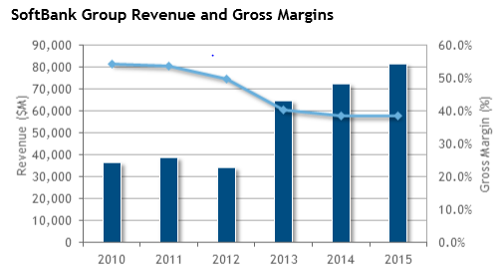
Figure 1: Softbank group revenue
Above table shows that although the revenue was slightly down from 2010-2013 but since then the revenue margin is consistent.

Softbank strategy behind the merger
According to the BBC analysis (2017) one of the main reason for the Softbank to acquire ARM holding to add IT and telecommunication together in their innovation. In addition, the CEO of the Softbank suggests that rather than merging with a smartphone manufacturer, merging with chip designer is a good strategy. In this strategy, there will not be an overlap between two companies. Furthermore, ARM expected to be a centre for the IT revolution. This aims to bring paradigm shift in human history. Most important factor on the Softbank strategy is, this will help them acquire ideas in IT industry besides telecom service. In a statement, ARM holding CEO stated that, the acquisition between Softbank and ARM holding is an integral part of the transaction. Softbank intend to double the number of the employees in the UK in the next five years. This suggests that business expansion is also another business of the Softbank (Lee, 2017).
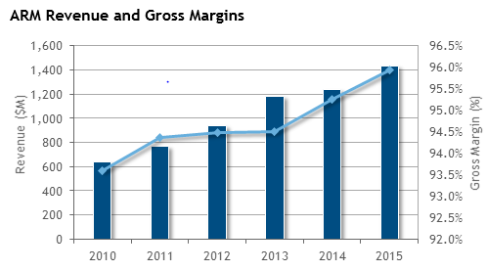
Figure 2: ARM Holding revenue
Above table shows that the revenue of ARM holding is in upper trend since 2010. This is one of the key reason for the Softbank for the acquisition with the ARM holding.

Market leadership
Market leadership is another significant factor which motivated Softbank to acquire ARM holding. To become an intellectual property in the market Softbank pledged to acquire ARM holding. ARM holding is largest chip designer in the UK and already in a good position in the market. This allows the Softbank to become more popular in with the fact with largest ever acquisition in the Europe and the innovative and established company.
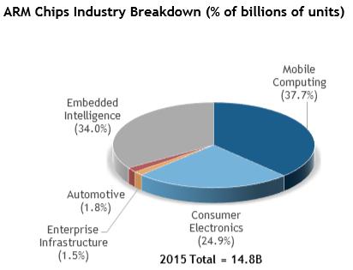
Figure 3: ARM holding Market leadership

Agreement with the shareholder
As per the shareholder contribution to the acquisition, the deal between two companies would be much difficult if there was disagreement between shareholders. In addition, shareholder in ARM holding have overwhelmingly backed a £24bn deal. However, there was a concern amongst the shareholder about the lingering the deal. Moreover, (Kodama, 2017) suggests that shareholder is one of the key parts in any acquisition, hence in the case of Softbank and ARM holding shareholder played a vital role. In the case of Softbank acquisition, 95 %of the shareholders of the ARM holding voted in favour for the deal. On the other hand during the acquisition there was a concern from the Softbank shareholder about whether company is making the right decision.

Strategic management model
This part of the analysis will establish the strategic management throughout the acquisition process between Softbank and ARM holding. This model refers to the company’s vision, transform and strategic management activities. In addition, above discussion suggests that, acquisition between the Softbank and ARM holding was a strategic management change. Therefore the below strategic management model is going to establish the strategic management of Softbank and ARM holding (Ondrus et al, 2018)
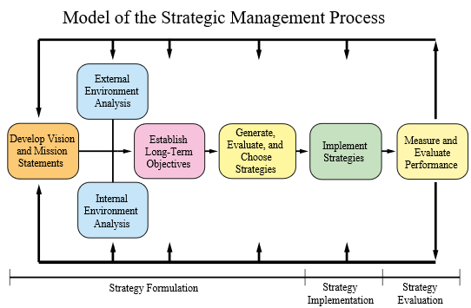
Figure 4: Strategic management model

Both Softbank and ARM holding management expressed that both companies will be excellent strategic fit and there will be a significant opportunity to be market leader in telecom and chip design industry. In addition, the investment makes a strong commitment to the UK in terms of the committing to help to advance the technology and doubling the number of the employees. This clearly suggest the clear strategic vision by the Softbank management.
As per the external environment analysis concern, since both companies become one together company is rapidly transforming into the operation. Mostly in the telecommunication sector, company is setting their long term plan to compete with their competitors. Moreover, beside the customer based expansion company is has strengthen their network and invented the new innovation called internet of thing. Furthermore, (Alina, 2018) articulated that through working with the ARM holding company is bringing the innovating products to the market. This allowing them to dominate the market over their competitors. From the competitors point of view, acquisition of the ARM holding was a right strategic move by the Softbank which allowing the Softbank to dominate the market with their innovation.
As per the internal environment analysis concern, there has double number of employee’s increment after Softbank took over the ARM holding. From the strategic imperative point of view, through the acquisition with ARM holding there has been lots of decline in the team.
There has been significant changes in both company’s strategies, structure and organisational culture. In addition, above discussion shows that there has been significant changes in business strategy of Softbank. Innovation, new product line, increase in profitability, increase in size of the business are some of the major changes took after the acquisition of ARM holdings.

Changes in strategy
From the Softbank point of view they clearly wanted to bring diversity and to add to technology in their industry. ARM holding had its long reputation and artificial intelligence and business tenant in their industry. It has been found that from the statment of the CEO of Softbank that due to long term Vision Company decided to acquire ARM holding. Keep the ARM holding head office to the Cambridge is another strategic move by the Softbank. Since the place is already technologically advanced therefore it was easy for the Softbank to operation from there. Company rather reinvested there for extra employees Singh, (2018).

Cultural changes
There has been lots of ideas shared by the both Softbank and arm holding during their acquisition process. In addition, as Softbank located in japan and ARM holding located in the UK there was significant cultural differences. The advantage through this are both companies could gather artificial intelligences, market strategies, individual intelligences and market tactics. The disadvantages from this could be the cultural gap between two countries. For instance considering the environment and cultural differences the operational activates could be different. Most importantly the law of this two countries are different (Thomas, 2019). As the acquisition took place to the UK and the ARM holding still located in the Cambridge there the company will govern by the UK rule and regulation. Finally this may impact Japans Softbank if they are to operate their operation from oversees.

Organisational structure changes
There has been significant changes in between two companies. The most important changes is the changes of ownership where soft bank acquires ARM holding for £24.3 BN. Therefore changes of ownership is one of the major factor in the acquisition. Business transformation is one of the main changes in organisational structure changes. After the acquisition the organisation has changed in terms of its size. For instance Softbank has hired addition 2000 staff. Additionally, company has also added substantially its overseas staff which increased to 3540 for 2845 meaning company now have more than 6000 employees. This suggests that acquisition could change the operation process for which company needs to hire additionally staffs in house and overseas (Ft.com 2018).

Changes in operation
Before the acquisition both companies had their own operational activities. Since the acquisition took place company shares their intellectual property in operation activity. Moreover, the major operational changes is the significant investment to the R&D. despite softback and ARM holding are the large company merging two companies operational activities together was the challenging part. Furthermore, Zhang (2018) argued that as Softbank decided to keep the ARM holding into the Cambridge there will not be much operational changes.

Conclusion
In the sum up it is important to conclude whatever has been discussed in the report. The acquisition between ARM holding and Softbank was one of the largest deal in Europe. The central idea behind his deal for a long term business plan in growing technology sector. ARM profit margin analysis suggests that since 2010 company is consistently making profit and company become significantly popular in the market. Likewise Softbank has also established their position in Japan. This allows both companies to come along for the negotiation and finally made the acquisition. Although there were some disagreement between shareholders but at the end due to getting higher share price all shareholder agreed for the acquisition. After the acquisition operational and cultural changes was one of the critical factor. To cope up with the large operational activity company appoint additional 2000 in ARM holding Cambridge. Finally, the analytics suggests that Softbank has good business prospects future because of their positive strategies.

Reference list
Alina, V., 2018. The Evolution of Transnational Mergers and Acquisitions. Ovidius University Annals, Economic Sciences Series, 18(1), pp.117-121.
BBC news 2016. ARM chip to be bought by (online) [Available at Softbank https://www.bbc.co.uk/news/business-36822806
ARM holding PLc 2017(online) [Available at: http://www.annualreports.co.uk/Company/arm-holdings-plc [Access date: 15-09-2019]
ARM holding PLc Annual Report 2016(online) [Available at: http://www.annualreports.co.uk/Company/arm-holdings-plc
ARM holding PLc Annual Report 2017 (online) [Available at: http://www.annualreports.co.uk/Company/arm-holdings-plc
ARM holding PLc Annual Report 2018 (online) [Available at: http://www.annualreports.co.uk/Company/arm-holdings-plc
Ft.com 2018 (online) [Available at:https://www.ft.com/content/235b1af4-4c7f-11e6-8172-e39ecd3b86fc] [Access date: 07-09-2019]
Jung, J.C. and Xiong, X.G., 2017. SoftBank’s Acquisition of Sprint Nextel Corporation. Asian Case Research Journal, 21(02), pp.377-392.
Kodama, M., 2017. Corporate Innovation Based on Holistic Leadership: A Case Study of SoftBank', Developing Holistic Leadership.
Lee, J., 2017. The current barriers to corporate takeovers in Japan: Do the UK Takeover Code and the EU Takeover Directive offer a solution?. European Business Organization Law Review, 18(4), pp.761-783.
Ondrus, J., Gannamaneni, A. and Lyytinen, K., 2015. The impact of openness on the market potential of multi-sided platforms: a case study of mobile payment platforms. Journal of Information Technology, 30(3), pp.260-275.
Softbank group.com 2018 (online) [Available at: https://cdn.group.softbank/en/corp/set/data/irinfo/presentations/investors/pdf/2017/investor_20170524_01.pdf [Access date: 05-09-2019]
Softbank group.com Annual report 2016 (online) [Available at: https://group.softbank/en/corp/irinfo/financials/annual_reports/ [Access date: 07-09-2019]
Softbank group.com Annual report 2017 (online) [Available at: https://group.softbank/en/corp/irinfo/financials/annual_reports/ [Access date: 05-09-2019]
Softbank group.com Annual report 2018 (online) [Available at: https://group.softbank/en/corp/irinfo/financials/annual_reports/ [Access date: 15-09-2019]
Softbank group.com Annual report 2015 (online) [Available at: https://group.softbank/en/corp/irinfo/financials/annual_reports/ [Access date: 10-09-2019]
Singh, P.N., 2018. Impact of Mergers and acquisition on Management and Employees. Journal of Management Science, Operations & Strategies (e ISSN 2456-9305), 2(1), pp.32-37.
THOMAS, H. and BHATTACHARYA, L., 2019. ARM Holdings: IP licensing to internet of things.
The Telegraph (online) [Available at: https://www.telegraph.co.uk/technology/2018/05/13/arm-profits-halve-softbank-ownship/[Access date: 05-09-2019]
Zhang, Q., 2018. Financing and Regulatory Frictions in Mergers and Acquisitions (No. EPS-2018-428-F&A).

