
Looking at the Software and Displaying data on the MapInfo Window
MapInfo Tutorial 1

Beverley Holland

Looking at the Software and Displaying data on the MapInfo Window (Tutorial 1)

In this lesson you will learning how to
- open a MapInfo table
- view your data in both a Map window and a Browser window,
- how to manipulate these windows to display the data the way you would like.
- how to create your own subset of data from an existing data set (querying the data).
- save your work session in a Workspace file.

Objectives
- View a Map
- View Tabular Data
- Create a Subset of Data
- Save a Subset of Data
- Save a MapInfo Session in a workspace

Viewing a map is an integral part of every MapInfo function.

To Open the UK table in a Map window:
1. Start MapInfo
2. Choose Open a Table from the home tab.
3. Press Open. Then Open Table from the dialog displays.
The data for this class is located in the directory Tutorial Data.
The Tutorial Data folder contains several folders that are used throughout the class:
4 . Open the Tutorial Data folder.
5 . Open the US folder.
6 . Choose UK ( C\Tutorial Data\World\Europe\UK ).
7 . Press Open.
You will see a window display with a map of the Uk. This window is called a Map window and map tab.
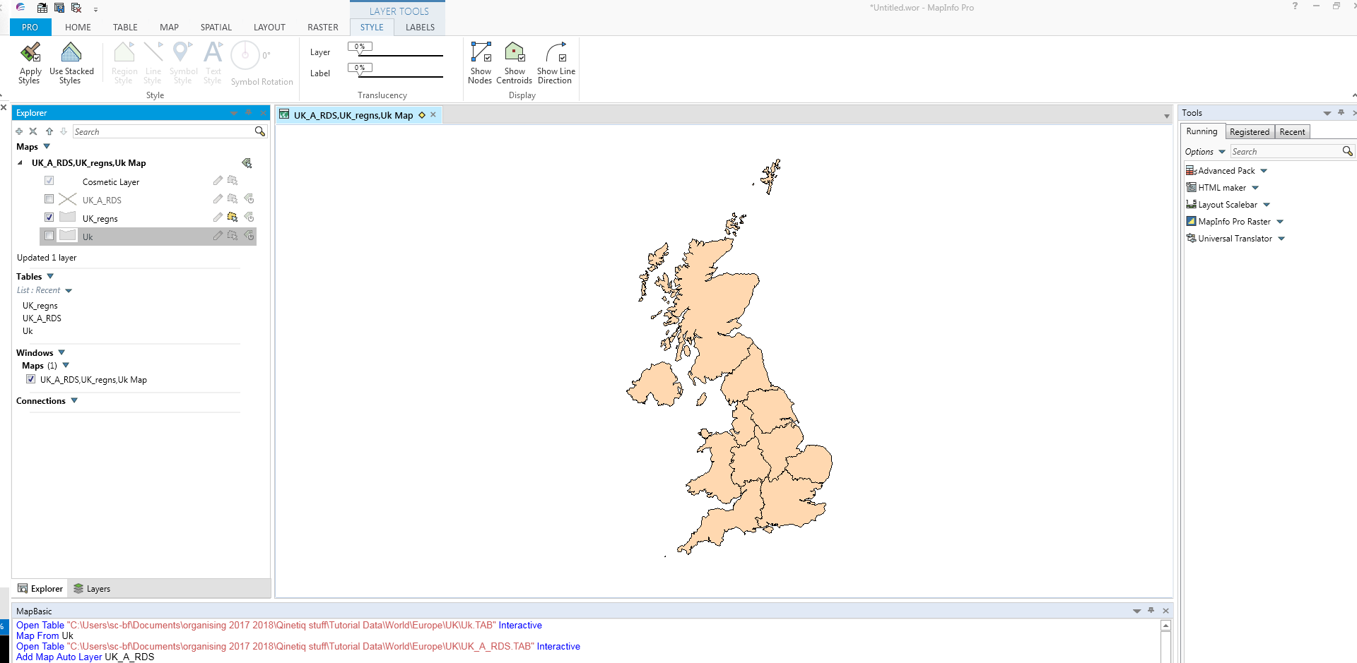
The software works on the layer system and you should notice that as you add layers the layer tool becomes active this will allow you to change the appearance of the layer. If you click on the group layer list you should now see that the map is the active tab.

You may want to see your data as text, in database or spreadsheet form.

To display the database information in the UK_regns table, we use a Browser Window which is used to show the tabular view of your table.
To view the UK_regns table in a Browser window:
1. Choose the table tab on the menu bar.
2. Choose New Browser Window.

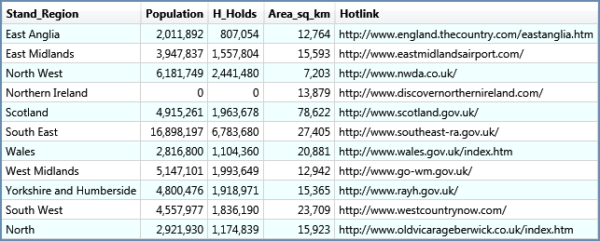

The tabular information associated with the UK_regns table displays.
Glance at the menu at the top of the screen. Note that Browse has replaced Map and we have two new tabs for the active windowns.

You may only want to display certain parts of your table. This may be necessary because tables can hold extremely large amount of data, and some of the analysis you do may only require a specific subset of that table. To view only a portion of data from a table, we make a selection. A selection is a temporary table used to store a chosen subset of records from your table and can be viewed separately from the rest of the table.

In MapInfo it is possible to work with an entire table at once, or with a subset of that table.
For example, let’s say we want to create a new map of wales and the west
1. Make sure the Select button is chosen from the map menu tab.
2. On the map, point and click on three regions.
3. Hold down the SHIFT key and click to select more than one region.
Notice that an additional table appears in the in the table list called selection.

4. Switch to the Browser window and you should see that the areas that you have selected are now highlighted
5. From the menu, choose Map
6. Choose Selection and press OK. A new Map window will be displayed.
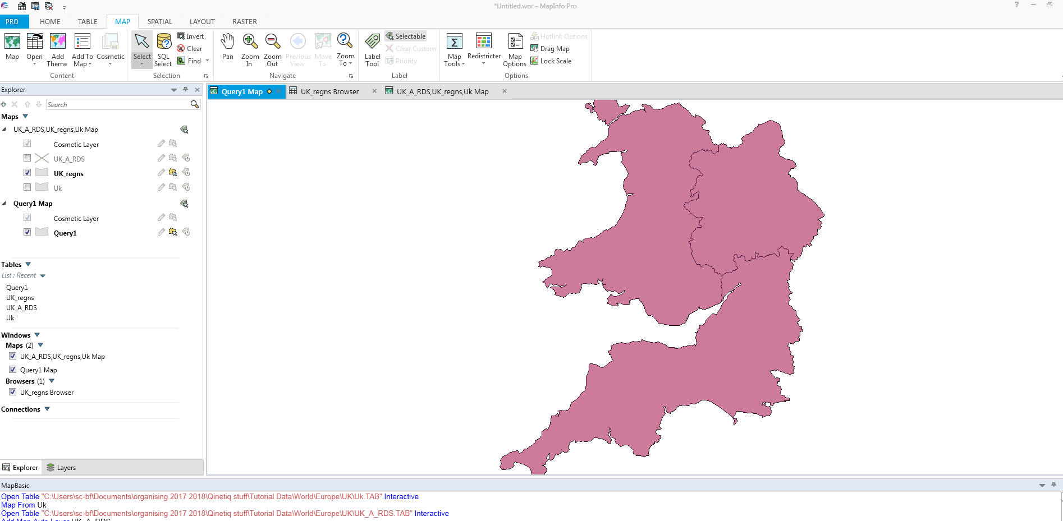

Notice that whether you select from the Browser window or from the Map window, the selection is made in both windows. In a MapInfo table, the database information is hot-linked to the map..

Click back onto the original window and add some additional layer to your map.

Finally open the Ocean layer you should notice that several layers have now disappeared. We now need to save the work.

Saving a MapInfo workspace allows the user to continue work done at a previous time.

1. Choose File on menu bar.
2. Choose Save Workspace
3. At the File Name box, type Lesson1.
4. Choose the folder to save your workspace.
5. Press Save.
Note that rather than explicitly typing Lesson1.WOR we only typed Lesson1. Because MapInfo knows that we are saving a Workspace, it appends the .WOR extension.

Now that we have saved our workspace, let's close all open tables.
1. Choose File menu on menu bar.
2. Choose Close All.
Now, let's open the workspace we just saved.
1. Choose File on menu bar and Open.
2. Navigate to the directory you saved your workspace.
3. From the Files of Type drop down, choose Workspace (*.wor)
4. Choose LESSON1
5. Click Open.

Any windows that you had on your screen when you saved the LESSON1 workspace, now display. A workspace is simply a text file of instruction that MapInfo reads to recreate your work session. These instructions tell MapInfo which tables to open and what windows to display on your screen. A workspace is not the data you are working with; it just opens those tables for you.

