

Programme: Certificate in Higher Education Skills for the Workplace

Module code and name: BMSW 4006_ Managing Enterprise in the 21st Century

Name of the Students and ID Numbers:
Ivaylo Georgiev _ 2128090
Aneliya Georgieva _ 2125657
Slavina Stoyanova _ 2127720
Petko Petkov _ 2125440

Name of Group: Group 2
Lecturer Name: Umar Sadaat
Title: Business plan _ Street food Industry

Table of contents:
1. Overview of the business idea, product and/or service……………………………………...…3
2. Legal format of the startup company and Management of the company………...………...…4
3. Evaluation of the business idea by using the SWOT analysis model………………………...5
4. Assessment of the current external environment by using the PESTEL analysis model.….7
5. Explanation of the target market and the marketing strategies the company will adopt to reach their customers…………………………………………………………………………….….9
5.1 Market segmentation…………………………………………………………………….……9
5.2 Target marketing…………………………………………………………………….….…....10
5.3 Market strategy” The taste of the Balkan Yummies” ………………………….…………11
6. Identification of the key marketing factors by using the 4Ps of marketing model…………12
6.1 Funding …………………………………………………………………………………...….13
7. A cash flow forecast for the first 12 months……………………………………………………14
8. Reference List ……………………………………………………………………………………15

Overview of the business idea

Our idea is to start a street food business that serves a variety of delicious and healthy traditional Balkan food (Figure 1) to customers in public spaces. The business will aim to attract a diverse range of customers, including office workers, students, tourists, and local residents.
According to our research, in the Midlands, there is only one Street food truck, that serves up authentic Balkan cuisine, called “Balkan Bites”, located in Birmingham. Our product has a unique blend of flavours that is not commonly found in the UK and a price, affordable for people on a budget. In addition, The Balkan community in the UK is growing constantly lately, which could increase the demand for authentic Balkan food.
.
Figure 1. Traditional Balkan food
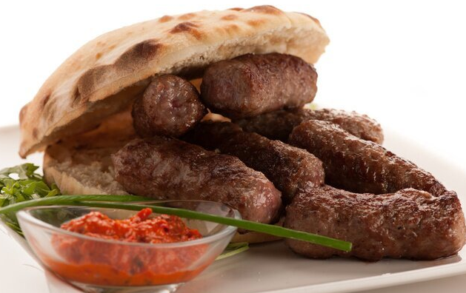
Source: https://myloview.de/sticker-photo-of-cevapi-cevapcici-traditional-balkan-food-delicious-nr-A89A3B1

Legal format of the startup company and Management of the company

BG Group 2 Ltd. will be registered as a limited by shares company, with corporate headquarter Stafford, 1 Sandon Road, ST123 AA, with the UK government’s official register of companies Company House. A limited company is an entity that "has separate finances from our personal ones" and it is "legally separate from the people who run it “(Gov.uk., 2021). According to government’ statistic, at the start of 2022, there were around 2,1 million companies (37 % in total in the private sector), as 932000 with no employees.
The company will have a flat organizational structure( Figure 2), and will be owned 25% by Ivaylo Georgiev, Director and Accountant, with seven years’ experience as a small team leader and a company’s owner; 25% by Petko Petkov, Driver and Buyer, with established reliable positive relationships with the local farm owners; 25% by Aneliya Georgieva, keen Cook and Seller, with ten years cooking experience; and 25% by Slavina Stoyanova, Food preparer and Cashier, enthusiastic environmentalist with vast knowledge in healthy eating.

Figure 2. Organizational structure of the business

3. Evaluation of the business idea by using the SWOT analysis model

SWOT analysis is a common tool, used for defining internal and external environments of the business and it is used for “support for a decision situation.” (Kartika et al., 2000). The model helps a start-up to reduce risks and increase the chances of success, and to “identify the gap between what customers want and what customers get”. (Tsitsiloni et al., 2013)

Figure 3. SWOT analysis of the business
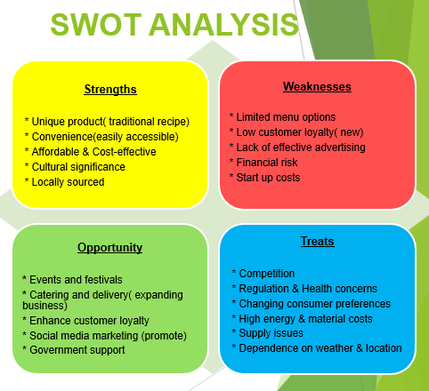
Applying a Swot analysis (Figure 3), we assess our company’s position on the existed market:
Our strengths:
- Balkan cuisine is unique and less widely available in the UK, offering a competitive advantage for the business, which could help our business to differentiate from others.
- A street food truck can be more flexible and cost-effective than a traditional restaurant, allowing the business to operate in multiple locations and adjust to customer demand.
- Balkan street food can be marketed as a healthier alternative to traditional fast food, appealing to customers looking for healthier options.
Our weaknesses:
- Balkan cuisine may be unfamiliar to some customers, which may require additional marketing efforts
- Low customer loyalty, being a new entry in the business
- Start-up costs e.g., purchasing a truck, refrigeration equipment and legal fees to fulfil basic permit requirements
- Limited menu options: it may not be suitable for people with dietary restrictions or preferences.
Opportunities:
- The Balkan Street food market may be less saturated in the UK, offering opportunities for the business to stand out and establish itself as a unique culinary experience.
- The food truck can be used to attend food festivals and events, helping to increase brand awareness and reach new customers.
- The business might be expanded by offering delivery or catering services, targeting corporate and private events.
Threats:
- Economic downturns and uncertainty could impact discretionary spending, which may negatively impact the street food market and the business's revenue.
- Supply chain disruptions could impact the profitability of the business.
- Increased competition from other street food vendors or traditional restaurants.
- As with any street food business, the weather and the location could impact the business's earning potential.

  - Assessment of the current external environment by using the PESTEL analysis model

The PESTEL framework, is applied for understanding the macro-environmental factors that could impact our business (Figure 4), and also, it “serves as the foundation for identifying opportunities and threats” (Vokhta, 2022).
Figure 4. PESTEL analysis of the business
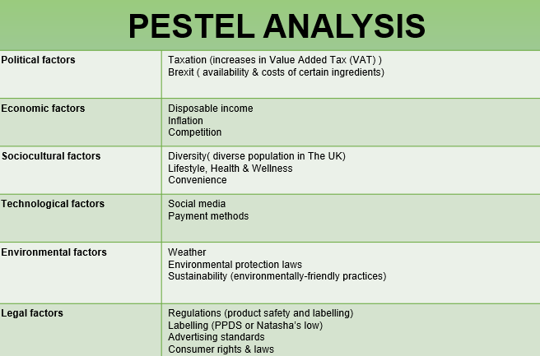
Political factors:
- Taxation: increases in VAT or border taxes could lead to higher costs for consumers, potentially impacting sales.
- Brexit: Changes in trade and immigration policies could affect the availability and cost of certain ingredients.
Economic factors:
- Income: The level of disposable income of consumers would impact their willingness to purchase street food.
- Inflation: Inflation rates might affect the cost of ingredients and the pricing strategy.
- Competition: The level of competition in the street food market can impact prices and sales.
Sociocultural factors:
- Diversity: The UK's diverse population might influence the types of cuisine that are in demand.
- Health and wellness: Consumers might be increasingly interested in healthier food options.
- Convenience: Street food's convenience and on-the-go nature may appeal to consumers who are busy or on-the-move.
Technological factors:
- Social media: It could be used to promote offerings and reach a wider audience.
- Payment methods: The availability of mobile payment methods might make it easier for consumers to purchase street food.
Environmental factors:
- Sustainability: Consumers are increasingly interested in environmentally friendly practices, such as compostable packaging and using locally sourced ingredients.
- Weather: Inclement weather may impact the demand for street food.
Legal factors:
- Intellectual property: Street food vendors must be aware of intellectual property laws and ensure they are not infringing on anyone else's trademarks or patents.
- Regulations: around food safety, hygiene, labelling, and preparation that street food vendors need to comply with. Under Natasha's Law or PPDS (2021), allergen information must be provided in a clear and consistent format, including using the bold or highlighted font for allergens.
- Licensing: business may need to obtain licenses to operate in certain areas or during specific times.
- Employment laws: The company must comply with employment laws, such as minimum wage requirements.

  - Explanation of target marketing and marketing strategies

5.1. Market segmentation

Before continuing with explanation for our target market narrow down and market segmentation let’s have a quick look what Market segmentation is. Marketing segmentation is decisive marketing strategy. The main purpose is to identify and mark out market segments or “sets of buyers” which can become in target for the companies.
The market can be subdivided to four main factors: geographic, demographic, behavioural and psychographic. (Figure 5)

Figure 5. Marketing segmentation

5.2. Target Marketing
Target marketing is a technique which identify group of people, who share common needs. It can be said that they are potential customers for a product because they share characteristic like income, age, lifestyle.
Target market will help us to define our customers. Our street food business whit logo “The taste of Balkans - grill & chips” looking for working- and middle-class people who has lack of time to prepare food for themselves due to a busy schedule and also those who identify with the cultural note of our food.
According to the FAO definition given “street food is made from food and drink prepared for consumption, prepared and sold on the street or in other public places such as markets and / or exhibitions, often sold on counters or through temporary vans and carts street vendors” (FAO, 2009).

We offer:
- Good quality food – by using only fresh products, never unfrozen food.
- Fast service – with my colleague Aneliya (she has ten years’ experience with cooking). She will mainly chief, and I will prepare food.
We will be looking for:
- Families with children - in this group we will looking for all ages group children ages 2-14, teenagers, middle-aged people (25-50).
- Single adults - all adults group.
- Student – most of time our location will focused on city centre near to Stafford College.
- New customers – we will be looking for people who do not trust the quality of street food;
- All ethnic origin – group of people accompanied the eating habits of human since ancient times.
- Tourist – all people visited our town for very first time.
- People looking for tasty and fast snack – food dishes that all must try, good quality, good price and delicious taste;
- Busy, working people – people in hurry, with busy schedule have not time for cooking.
- Cultural note people of our food

5.3. Market strategy “The taste of the Balkan Yummies”

Marketing strategy content a goal for the company would like to achieve with marketing efforts which have to return into plan. Companies’ goals shape strategy. Every marketing strategy and business goals must go hand-by-hand. We will introduce our strategy to achieve our goals to effective fast-food business:
- We can demonstrate fast-food marketing strategies and some ideas for profitable ideas.
- We can offer meal and special price on meal – bundles and combos.
- One of our marketing strategies will be to create a kid’s menu.
- To improve our goals, we will offer promotion - for example if customers order two burgers will receive one free drink;
- We can create a loyalty program – here we will offer our customers who is with us long time with special price, promotional.
- We will design and share the fliers all the town and Staffordshire region to introduce our delicious food. In the fliers we will have a QR code, and all our client can scan it and browse our menu;
- By using social media (Facebook, Tik-Tok, Instagram) we can reach our customers online to organizing gateways and contents. People following us can invite their friends who can follow our page, and, in this way, we will reach many new customers.
- Eco- friendly packing
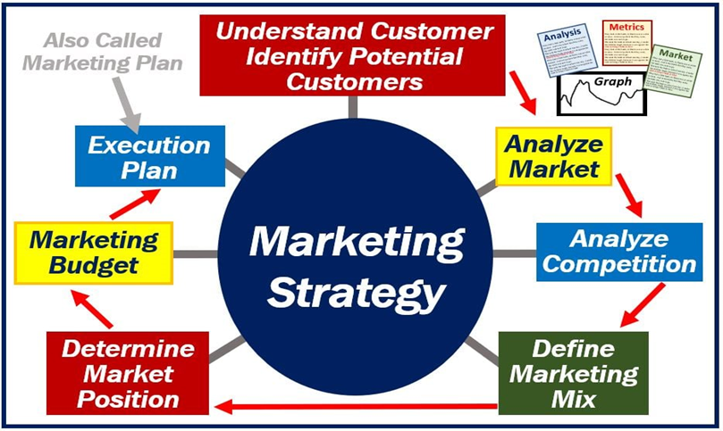
(Source: https://marketbusinessnews.com/financial-glossary/marketing-strategy/)

6. Identification of the key marketing factors by using 4P’s Marketing model

Product
Everyone will be familiar with our product, but people from eastern European backgrounds will know it best, includes traditional Balkan and Eastern European dishes like dinner kebab, barbecue ("skara"), and many more. Balkan Yummies is a brand, packaged properly for fast food. “People may visit such destinations from short distance to enjoy authentic food.”
Price
Although prices will change as the business develops, the initial cost of the goods will remain constant. Low-cost pricing. Payment can be made with cards and cash. We will mainly emphasize volume and profit. Family and children's menus are discounted and available at our street food van.
Place
Business is based in Birmingham, Stafford/Staffordshire, Coventry, Tamworth to begin with we will attend occasional social and public events covering the local county area. “In fact, more sellers do not exactly know the regulations on urban and commercial planning” (Herr and Ruoff, 2014).
Promotion
In terms of promotion, we have planned and prepared a Facebook and Instagram page to begin with. We have also talked about how to reach out to people in our community by word of mouth. If we haven’t sold in the last hour of the working day, we put 30 percent on all products discount for the last hour. This is very eco-friendly and by wasting less food we keep our part in protecting the planet and humanity. “Promotion is a vital part in having a business” studies about business of (Goi and Muala, 2011-2012).

6.1 Funding

Main sources of funding.
1. Government business loan – £9 000
2. Savings – £5 500 from each of the 4 shareholders
In total we have gathered £31 000
What permits are required to launch a street food enterprise?
- We have a food business license.
- We are a licensed street trader.
- We are a part of the National Market Traders Federation.
- We and any employees have Level 2 certifications in food safety.
- all gas equipment on site complies with gas safety regulations.
Our annual license fee for street trading will be £555.
7 days per week.
We will pay £210 for a dual membership with the National Marketing Trading Federation of the United Kingdom.
The company will need an estimated £30,000 in start-up funding, and we.
collected $31,000.
What is required to start for a month is:
Inventories, supplies, and van: £18 000.
£1000 is the loan repayment amount.
£1500 is allocated for other expenses.
£1000 for increased advertising or popularity.
$400 for utilities.
500 pounds worth of insurance.
Replacements and repairs cost £1000.
£500 in accounting costs.
We have left a £3500 pounds buffer just in case. Total: £27,500.
Unexpected events take place. “The growth of foodservices in tourism is witnessed with the demand for international travel. Street food is a foodservice operation that operates in public places, which include food stalls/hawkers, local markets, roadsides, and festivals.” (Jeaheng, 2023).
Festivals and local events are exactly where we are planning to begin growing our business not only for the Balkan food lovers but also for other people from other background.
7.A cash flow forecast for first 12 months:

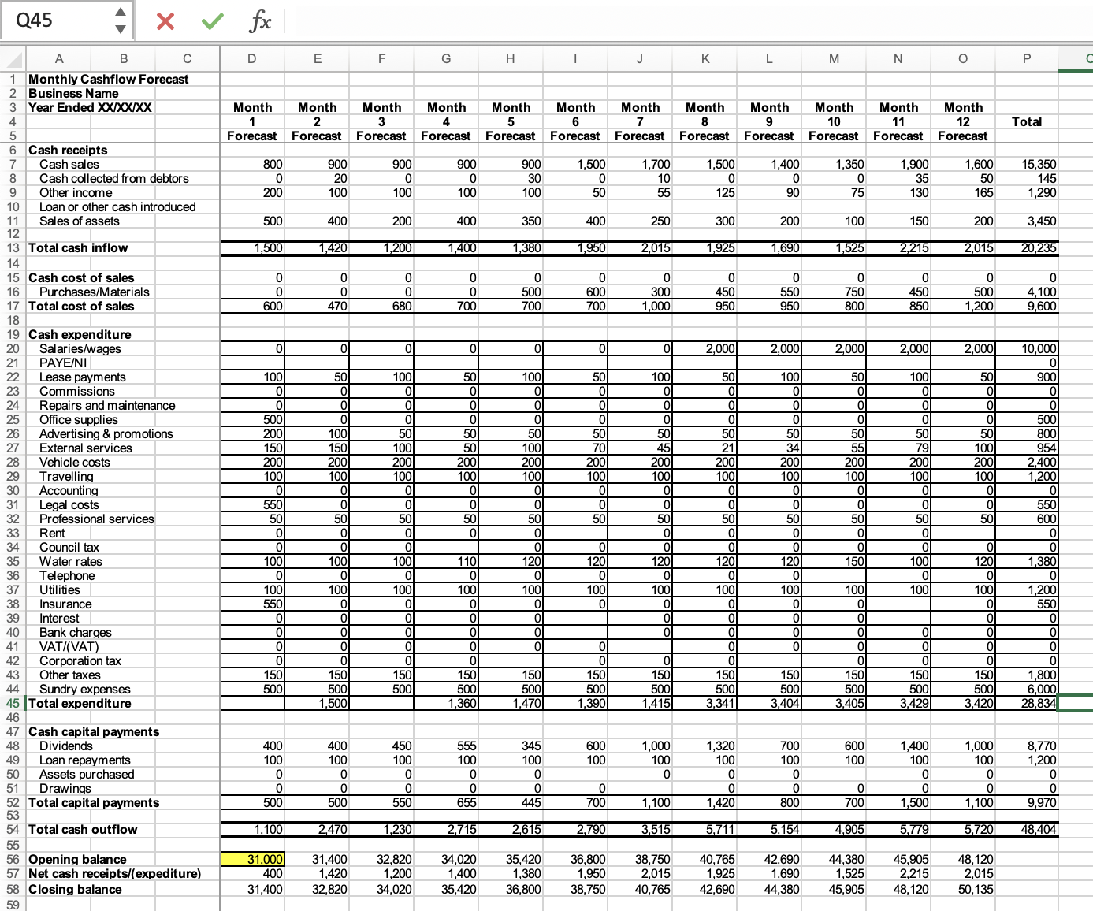

References:

Bellia, C., Pilato, M. and Seraphin, H., 2016. Street food and food safety: a driver for tourism?. Calitatea, 17(S1), p.20.

Business and self-employed (UK) (2021). Setting up a limited company. Available at: https://www.gov.uk/limited-company-formation (Accessed:04/03/23)

Chayada, P., (2017). The Role of Street Food vendors on Tourism Development in Bangkok, Thailand.

Department for Business, Energy & Industrial Strategy (UK) (2022) Business population estimates for the UK and regions 2022: statistical release (HTML) Available at: https://www.gov.uk/government/statistics/business-population-estimates-2022/business-population-estimates-for-the-uk-and-regions-2022-statistical-release-html#legal-form (Accessed: 13/03/2023)

Jeaheng, Y., Al-Ansi, A., Chua, B.L., Ngah, A.H., Ryu, H.B., Ariza-Montes, A. and Han, H., (2023). Influence of Thai Street Food Quality, Price, and Involvement on Traveler Behavioral Intention: Exploring Cultural Difference (Eastern versus Western). Psychology Research and Behavior Management, pp.223-240.

Kartika, M., Pesonen, M., Kangas, J. and Kajanus, M., (2000). Utilizing the analytic hierarchy process (AHP) in SWOT analysis—a hybrid method and its application to a forest-ertification case. Forest policy and economics, 1(1), pp.41-52.
Available at: https://doi.org/10.1016/S1389-9341(99)00004-0 (Accessed: 26/02/23)

Pradiptarini, C., (2011). Social media marketing: Measuring its effectiveness and identifying the target market. UW-L Journal of Undergraduate Research, 14(2), p.2.

Privitera, D. and Nesci, F.S., (2015). Globalization vs. local. The role of street food in the urban food system. Procedia Economics and Finance, 22, pp.716-722.

Tsitsiloni, M., Grigoroudis, E. and Zopounidis, C., (2013). Service quality evaluation in the tourism industry: A SWOT analysis approach. In Optimization Theory, Decision Making, and Operations Research Applications: Proceedings of the 1st International Symposium and 10th Balkan Conference on Operational Research (pp. 249-266). Springer New York., p.5

Tynan, A.C. and Drayton, J., 1987. Market segmentation. Journal of marketing management, 2(3), pp.301-335.

Vokhta, A., (2022). External Communication Strategy for International Student Recruitment at Karelia University of Applied Sciences., p.9

