Effective Team Working and Communication (BMSW4002)
Student: sERGEY KAMBUROV (2133450)

module leader: Anita Nan

UWTSD

2023

Introduction……………………………………………………………………………2

- Models of communication……………………………………………2
- Types of communications……………………………………………4
- Advantages and disadvantages of technical communication.…...6

Conclusion…………………………………………………………...………………..7

References ……………………………………………………………………………8

Introduction
This report discusses the different models of communication, communication skills, and the advantages and disadvantages of communication. Communication involves a sender, a message, and a receiver. Communication skills refer to the ability to effectively communicate, understand, negotiate, and achieve goals.
Models of communication
K. Shannon and W. Weaver model
The K. Shannon and W. Weaver model, developed in 1948, is a mathematical theory of communication that aimed to separate background noise from the useful information that is transmitted by the source. According to Shannon, overcoming noise can be achieved through the use of signal redundancy, which involves the repetition of parts of the message to prevent communication failure. This model is based on the idea that communication is a linear process consisting of a sender, a message, a channel, a receiver, and feedback. It is commonly used in technical and scientific contexts to analyze the transmission of information in communication systems.
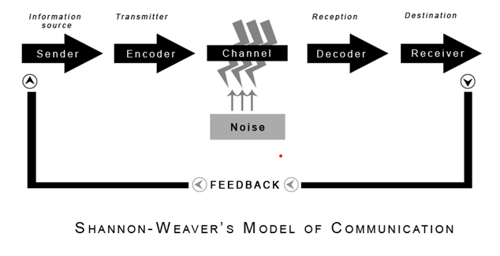
Img. 1 (communicationtheory, n.d.)
In the case studying example of Maria and Pedro conversation we can see that Pedro is working on construction site and could not understand what was Maria said to him when she called and ask to buy chicken, because of the noise coming from the background which explains by Shannon-Weaver’s model when noise is distracting the channel.
An example from my work, when I am driving a conversation on the phone with my manager complicates the noisy operation of the car engine and the noise coming from passing vehicles so that sometimes I do not understand what they are trying to say to me and ask to say that again several times. (communicationtheory, n.d.)
Berol’s communication model
Berlo's communication model was developed by David Berlo in 1960. This model emphasizes the sender and receiver's communication skills and their ability to encode and decode messages effectively. The model consists of four elements:
Source: The person who initiates the communication process is the source. The source is responsible for encoding the message in a way that the receiver can understand it.
Message: The message is the information that the source wants to communicate to the receiver. The message can be verbal or nonverbal, and it can be delivered through various channels, such as speech, writing, or gestures.
Channel: The channel is the means by which the message is transmitted from the source to the receiver. The channel can be a face-to-face conversation, a phone call, an email, or any other medium.
Receiver: The receiver is the person who receives the message from the source. The receiver is responsible for decoding the message and understanding its meaning.
Berlo's model also includes several factors that can influence the communication process, such as the sender's and receiver's attitudes, knowledge, social system, and culture. The model suggests that effective communication requires the sender and receiver to have similar attitudes and knowledge, to understand each other's social systems, and to be aware of each other's cultural backgrounds. (Janse, 2018)
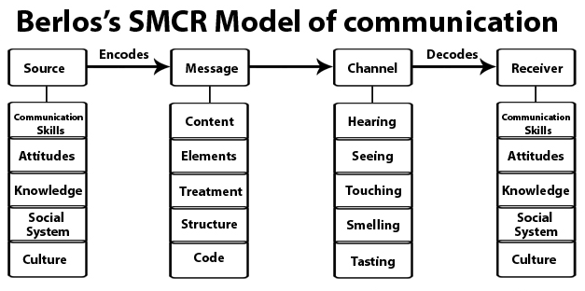
Img. 2 (communicationtheory, n.d.)
In the example of the story about the professor and people from the village, we can come to the conclusion that when the professor tried to ask for help he used words that were not familiar to them. And they didn’t help him continuing doing what whey were doing. The misunderstanding happened because professor used words to explain that he is in trouble to non-educated people. If he explained with simple words he would get helped.

Osgood-Schramm circular model

The Osgood-Schramm circular model of communication is a model that emphasizes the interactive and circular nature of communication. The model consists of three elements: the source (sender), the receiver, and the feedback. According to this model, communication is a circular process that involves encoding a message by the sender, who then transmits it through a channel to the receiver, who decodes the message. The receiver then provides feedback to the sender, which completes the communication cycle. The model emphasizes that communication is a two-way process, with feedback being an essential component of effective communication. The feedback allows the sender to adjust their message, ensuring that it is understood by the receiver. Additionally, the feedback also allows the receiver to provide information to the sender, which can be helpful in further improving the communication process.
Overall, the Osgood-Schramm circular model of communication emphasizes the importance of feedback in the communication process, highlighting that communication is a continuous and circular process.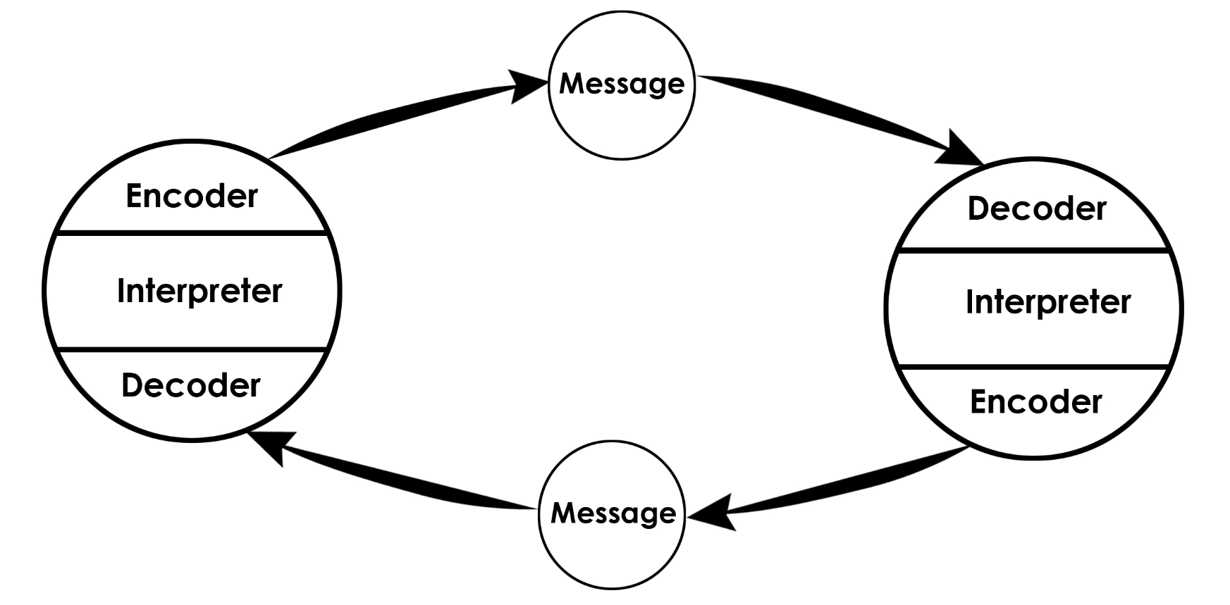
Img. 3 (communicationtheory, n.d.)
The main encoding device is the human brain. Here, the encoder and decoder are not separated from the communicator. The very process of communication means the ability of the communicator to use the language. (communicationtheory, n.d.)
Types of communication
Verbal communication
Verbal communication is the transmission of messages through spoken or written words. It is a way of exchanging information, ideas, and feelings between people using language. Verbal communication can take many forms, including face-to-face conversations, phone calls, video conferencing, lectures, speeches, presentations, and written communication such as emails, letters, memos, and reports. Effective verbal communication involves clear and concise messaging, active listening, and appropriate feedback. It also requires an understanding of the audience and the context in which the communication is taking place. Good verbal communication skills are essential in many settings, such as business, education, healthcare, and social interactions. (skillsyouneed, n.d.)
Non-verbal communication
Nonverbal communication refers to the use of body language, facial expressions, tone of voice, and other forms of communication that do not involve spoken or written words. It is an important aspect of human communication as it often conveys emotions, attitudes, and intentions more effectively than verbal communication alone. Examples of nonverbal communication include facial expressions, gestures, posture, eye contact, touch, and tone of voice. For instance, a smile can convey happiness, a nod can indicate agreement, and a frown can express disapproval. Similarly, a handshake or a hug can communicate warmth and affection, while a pat on the back can signify support or encouragement. Nonverbal communication can also vary across cultures, as different gestures and facial expressions may have different meanings in different societies. For example, while direct eye contact is seen as a sign of respect and attentiveness in some cultures, in others it can be considered impolite or confrontational.
Overall, nonverbal communication plays a significant role in interpersonal interactions, helping to establish rapport, convey emotions, and enhance the effectiveness of verbal communication. (skillsyouneed, n.d.)
Active listening
Active listening is a communication skill that involves fully concentrating on, understanding, and responding to what someone else is saying. It involves paying attention to both verbal and nonverbal cues, asking clarifying questions, and providing feedback to ensure that the speaker feels heard and understood.
Active listening is an important skill in both personal and professional relationships, as it can help build trust, improve communication, and prevent misunderstandings. It requires setting aside distractions, being patient, and showing empathy for the speaker's perspective. By actively listening, we can create a more positive and supportive environment for communication, leading to more effective problem-solving, decision-making, and collaboration. (studycorgi, n.d.)
Formal communication
Formal communication is a type of communication that is official, planned, and follows a prescribed format or structure. It is often used in a business or organizational setting, where communication needs to be clear, concise, and well-structured to ensure effective communication between different levels of employees or departments.

Formal communication typically follows a chain of command or hierarchy, where information flows from top to bottom or from one department to another in a prescribed manner. It is usually documented and can be in the form of reports, memos, emails, letters, or meetings. The language used in formal communication is often more structured and formal, with specific rules and guidelines to follow.
Examples of formal communication include company policies, employee handbooks, job descriptions, meeting agendas, and annual reports. It is important to note that formal communication is different from informal communication, which is more casual and unstructured and typically occurs between colleagues or friends outside of work settings. (Team, n.d.)
Types of Formal Communication
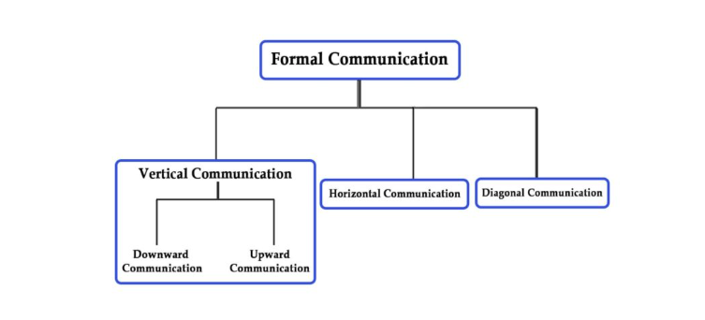
Img. 4 (parsadi, n.d.)
Informal communication
Informal communication refers to the exchange of information, ideas, and feelings among individuals or groups that do not follow a formal structure or established rules of communication. It is also known as "grapevine communication" because it spreads quickly and informally, like a grapevine.
Informal communication can occur in various forms, such as face-to-face conversations, phone calls, text messages, social media, and email. It usually happens spontaneously and is not planned in advance. In organisations, informal communication can serve several purposes. It can provide employees with social support, foster team cohesion, and help individuals understand the informal norms and culture of the workplace. However, it can also lead to the spread of rumors, misinformation, and gossip. Therefore, it is important for organizations to manage and monitor informal communication to ensure that it does not interfere with the formal communication channels and the achievement of organizational goals.
Advantages and disadvantages of technical communication
Technical communication refers to the exchange of technical or specialized information between two or more people. Some common forms of technical communication include manuals, reports, memos, and presentations. Here are some advantages and disadvantages of technical communication:
Advantages:
Clarity: Technical communication aims to provide clear and concise information that is easy to understand. It helps to ensure that everyone is on the same page and that there is no confusion or misunderstanding.
Accuracy: Technical communication is usually based on facts and figures, which ensures that the information provided is accurate and reliable.
Efficiency: Technical communication helps to save time and effort by providing specific instructions or information that can be easily followed.
Consistency: Technical communication helps to maintain consistency across different departments or teams by providing a standardized format and structure for communication.
Record Keeping: Technical communication provides a permanent record of information that can be used for future reference or in legal disputes.
Disadvantages:
Complexity: Technical communication can be complex and difficult to understand for people who are not familiar with the subject matter.
Jargon: Technical communication often involves the use of technical jargon and specialized terminology that can be confusing for non-experts.
Lack of Personalisation: Technical communication is often formal and lacks the personal touch that is present in informal communication.
Time-Consuming: Creating technical communication materials can be time-consuming and may require specialized skills and knowledge.
Limited Audience: Technical communication is usually targeted at a specific audience, which may limit its usefulness to others who are not part of that audience.
Overall, technical communication is an important tool for conveying specialized information and ensuring clarity and accuracy. However, it also has some drawbacks that should be considered when deciding whether to use it. (graduateway, n.d.)
Conclusion
In conclusion, communication is a crucial aspect of our lives, both in personal and professional settings. Effective communication can lead to better relationships, understanding, and success in achieving goals. There are various models of communication that can help individuals and organizations understand the different elements involved in the communication process. It's important to consider both verbal and nonverbal communication when communicating, as well as the context and audience. Additionally, there are different types of communication, including formal and informal, that can impact the effectiveness of communication. Technical communication has both advantages and disadvantages, and it's important to consider the specific context and audience when using this form of communication. Ultimately, being able to communicate effectively is a valuable skill that can lead to success in various areas of life.

References
Anon. (n.d.) Nonverbal communication [Online]
Available at: https://www.skillsyouneed.com/ips/nonverbal-communication.html
(Accessed: 7 October 2022).
Anon. (n.d.) Berlos smcr model of communication, communicationtheory.org. [Online]
Available at: https://www.communicationtheory.org/berlos-smcr-model-of-communication/
(Accessed 06 11 2022).
Anon. (n.d.) osgood schramm model of communication, communicationtheory.org. [Online]
Available at: https://www.communicationtheory.org/osgood-schramm-model-of-communication/
(Accessed 06 11 2022).
communicationtheory (n.d.) shannon and weaver model of communication, communicationtheory.org. [Online]
Available at: https://www.communicationtheory.org/shannon-and-weaver-model-of-communication/
(Accessed 05 11 2022).
graduateway (n.d.) advantages and disadvantages of communication technology, graduateway.com. [Online]
Available at: https:// graduateway.com/advantages-and-disadvantages-of-communication-technology/
(Accessed 10 11 2022).
Janse B., 2018. communication methods berlos smcr model of communication, toolshero.com. [Online]
Available at: https://www.toolshero.com/communication-methods/berlos-smcr-model-of-communication/
(Accessed 06 11 2022).
parsadi (n.d.) formal communication, parsadi.com. [Online]
Available at: https://parsadi.com/formal-communication formal-communication /
(Accessed 08 11 2022).
skillsyouneed (n.d.) verbal communication, skillsyouneed.com. [Online]
Available at: https://www.skillsyouneed.com/ips/verbal-communication.html
(Accessed 07 11 2022).
studycorgi (n.d.) active listening method of communication, studycorgi.com. [Online]
Available at: https://studycorgi.com/active-listening-method-of-communication/
(Accessed 16 11 2022).
Team, I. E. (n.d.) formal communication, indeed.com. [Online]
Available at: https://www.indeed.com/career-advice/career-development/formal-communication
(Accessed 07 11 2022).

