
Skills for the Workplace
Module Assignment Submission
Student Name: | Alison Louise Price
Student Number: | 2007432
Module No: | BMSK4008
Module Title: | Academic and Research Skills

Statement of Confirmation of Authenticity
By the act of making this submission, the student declares that this is the work of the student named above. The work has not, in whole or in part, been knowingly presented elsewhere for assessment, or where assessment has been built on a previous assessment, this has been identified. Where materials have been used from other sources it has been properly acknowledged. If this statement is untrue, the student acknowledges that an assessment offence has been committed.
Attention is drawn to the plagiarism and unfair practice policies of both the University and of ILM.
Permission for ILM to use this script
ILM uses learners’ submissions – on an anonymous basis – for assessment standardisation. By submitting, both the centre and the learner agree that ILM may use this script on condition that identifying information is removed. However, if you are unwilling to allow ILM use this script, please refuse by ticking the box: □

Table of Contents
Managing Remotely: Is it the Way Forward? 3
Part 1 3
1.1 Introduction 3
1.2 Research 3
1.3 Findings 3
1.4 Conclusion 4
Part 2 4
Personal Reflection on Managing Remotely 4
2.1 Description 5
2.2 Feelings 5
2.3 Evaluation 5
2.4 Analysis 5
2.5 Conclusion 6
References 7
Appendix 1 8
Appendix 2 9

Managing Remotely: Is it the Way Forward?

Part 1

Introduction

Managing remotely has become more popular over the past year with many employees setting up office at home whilst the pandemic continues to roll out. I am currently working from home myself and have found it a challenge if anything due to having to juggle childcare and adjusting everyday life, I do however have access to everything I need thanks to the use of emails, instant messenger, and the cloud data storage.
For the purpose of this report, I have conducted some research on the topic at hand to see if I could gain an understanding on how everyone is coping working remotely including pros and cons, possible obstacles to overcome and any inconveniences which I seem to have faced myself.
Working remotely can be a great way of staying in touch with colleagues and for me, patients with the use of answering a phone from home. I am a dental nurse in a busy NHS practice but am working remotely due to being on maternity leave; my employers have generously granted me the use of a laptop and a phone from home so i can still help out with admin and reduce phone line congestion back at the practice. This is a great benefit for me as i can still earn money whilst being at home where I am not at risk of patient contact with the ongoing Covid pandemic which has caused a lot of disruption with all businesses worldwide.
The way in which I am able to work from home for example, is via the use of Team Viewer. In order to access this from home I have this installed on the laptop I was provided with and can mirror information from a computer in practice by popping in a secure password. This enables me to access my log in and perform tasks from home that I would be able to do in practice such as patient records, email systems, instant messenger service and referral portal.

Research

I have carried out some research online with regards to managing remotely and was surprised to see how many businesses were currently operating from home. According to Naval Ravikant, even before Covid lockdowns remote work has grown by 140% since 2005. Pre-COVID, over 4.3 million employees (3.2% of the workforce) were already working from home at least half the time according to Global Workplace Analytics. According to State of Remote Work 2019, Owl Labs, eighty percent of employees want to work from home at least some of the time whereas according to the Federal Employee Viewpoint Survey 2018, only 12% of federal employees say they would not want to work from home at least some of the time. The MIT Sloan School of Management’s Executive Education Department reported in their Quality of Life Survey that when an employee has a supervisor that’s open to flexible (i.e. partially remote) work, that employee is more likely to stay with the company.
MIT’s Dr. Peter Hirst of the same department used those findings as inspiration to pilot a flexible work program, with the goal of changing the way his team perceived remote work. He wanted to see what would happen when the team’s perception of remote work was changed from a rare privilege to a common opportunity any on the team could take advantage of.
I have found that employees working from home have also reported lack of one on one with their supervisor. From an employee’s point of view, I understand this completely as it is so easy to be left alone whilst working remotely. If it weren’t for the fact I have to have things double checked (referrals, emails forwarded etc) then there would be hardly any contact between myself and my manager. It is important to build a rapport with employees and colleagues as it keeps a connection when things are not completely normal due to current circumstances around Covid-19.
I have come to realise it is important to now take advantage of modern technologies especially given the circumstances with the current pandemic. The use of Microsoft teams and Zoom for example are being used more with remote working statistics up by 140% according to a site I have cited previously. I have found that in terms of popularity, Microsoft teams seems to be a winner with big groups of workers as well as smaller groups, it offers a lot of extras such as group chat options along with camera and microphone access. I have come to the conclusion that people prefer to see one another when it comes to meetings as there is more of a personal touch and they can gage the reactions better. I personally prefer to see people whilst in a meeting as it can become lonely and isolating when working from home alone all day. Zoom, from what I can gather seems to be a good go to site for a quick meeting as you get so many minutes free until you must register and pay for longer and doesn’t seem to be as popular as the leading Microsoft teams.
Remote work becomes more efficient and satisfying when managers set expectations for the frequency, means, and ideal timing of communication for their teams. For example, using videoconferencing for daily check-in meetings, but use instant messenger when something is urgent. It is important to manage expectations and monitor the workload given to employees to ensure it is not too much or maybe even not enough. By monitoring the work load you can also gage any expectations of work for example, someone with kids at home may get less done than a single employee with quiet office space. It is also important to be considerate with employees when they have pets in the background as it can’t always be helped, I know myself have been on a phone call to a business with employees working from home and there has been background noise, it is to be expected.

1.3 Findings

With regards to the research in which I have conducted, I have come across a lot of statistics which state loneliness and isolation is a big part of working remotely and is a downfall of working from home. Plus points however, include spending more time with family in some cases, comfort of working from your own home, reliability in terms of not having to sort childcare, less childcare costs, less fuel costs etc. I have also found though, that being from home causes distractions and not having childcare can sometimes be a burden with trying to juggle work and home life in the same environment. A low percentage of people have struggled with connection which is something I know I have struggled with myself. Certain rooms in my house have weaker WIFI connection so I tend to be confined to one room which can become quite compact after so long, it is important to take breaks and allow some time out however hard it can be to remove yourself from the environment sometimes.
Referring back to a previous assignment in which I have recently completed, I talked about the pros and cons of modern technology, one being WhatsApp for example. As i am working within a team of 22 others, things will get missed from time to time so a broadcast message to all is sometimes what is needed. The reason I have mentioned this is that I previously stated how hard it is to switch off and not take work home with me which I have found recently is hard to distinguish work and home life working remotely. As I have personally struggled with this I was already aware that it may well be a factor for others too and have come to the conclusion that it is. Many people have been working more hours due to remote working and are considerably happier as a result.
I have found a few charts and pictures of interest that I have slotted into Appendix 1.

1.4 Conclusion

In conclusion, many people working remotely are happier than when they had to travel to work but I have come across the percentage of people who say they miss working from a base. I can relate to both parties as I have pros and cons of both working remotely and touching base in practice. There does, however, seem to be a rise in job satisfaction as people seem to be getting more done and putting in more hours, perhaps from less distractions but in some cases, more distractions can come from working remotely.
From what I can gather, most employers have been accommodating with regards to communication aids to work remotely, providing phones and laptops etc. I know personally my employers have been most generous and seem to be a general consensus of this with the percentage of happy workers from home (I have discussed percentages from research in findings to back up my claims of this).
I have found in most cases; communication is important between colleagues and management as you tend to lose the connection when everything is done in email or instant messenger in some cases. People have enjoyed video calls as a way of staying in touch and having a personal touch on an isolated working day. There is a huge rise in remote workers the past year as the world has slowed down due to Covid-19 but seems to be working well with statistics of happy employees up and a better flow of workload, people putting in more hours and being happier etc.

Part 2

Personal Reflection on Managing Remotely


Gibbs (1988)

2.1 Description

In order to complete this report, I was able to access a number of sites which helped me gain information on managing remote working. It would seem that remote working may be the way forward in the future having a huge number of the population working from home. I did research further into statistics as I feel as though the number of remote workers has gone up due to the Covid-19 and to a certain extend I was correct however numbers were rising anyway.
I was able to relate to this report, working from home myself and felt as though I could write about this from a personal point of view as well as the information I have gained from researching.

2.2 Feelings

Initially, my thoughts were that there would not be as many people as there are, working remotely. I was surprised to find that a lot of people work perfectly fine from home and have done for several years where as personally, I would rather touch base and build a report face to face. My thoughts on managing remote workers have changed as I have researched further into the topic. When I initially think ‘remote working’ I think of an office worker sending emails and completing admin tasks, but I have realised that there is a plethora of jobs in which can be completed remotely thanks to the use of modern technology also.
Due to the current pandemic and working remotely myself, I have run through several feelings personally including loneliness, frustration, distraction, and lack of motivation. I feel as though I miss the people I work with as your colleagues often become people you see more than your own family on occasions but will be nice when I return to work when the world tried to balance into ‘the new normal’. Frustration stemming from not being able to get as much done as I initially planned. I like to set myself goals like doing so much in a block before taking a break. However, this leaks into distractions where I sometimes have my daughter at home so can sometimes take a little longer to get things done.
In terms of being less than motivated on times, I tend to set my workplace up and keep my mind busy with phone calls between emails to break my working day up. I do feel as though, by sending emails all day I am losing the personal touch of having a rolling conversation with people who I may even know or have conversed with previously so feel as though it is nice to stay in touch.

2.3 Evaluation

In order to complete this report, I carried out a lot of research into a subject I am particularly interested in as it is highly relatable. I feel as though I have found myself agreeing with several things I have read online and not disagreed with much. Differences occurred in terms of feelings around working from home due to different circumstances but a lot of people working remotely have discussed similar issues as myself.
I do believe that working remotely will be on the rise in the future, I already know of a lot of online small businesses which I have supported for the benefit of friends to thrive and have helped share posts on social media etc. I have also seen a rise in businesses that were not initially online heading into the digital world as a lot of places have been temporarily closed due to lockdown, some even permanently closed due to not being able to survive financially which is sad.

2.4 Analysis

In order to analyse this report, I have broken it down into several parts in which I have researched. Remote working has become more and more popular due to the current pandemic around Covid-19, that is a fact in which I have come across via statistics and national data. It has come to my attention that people are enjoying working from home and have felt a sense of freedom as a result. I personally have found that remote working has had me tied to my desk more than if I were to be in the office, so I was surprised to see so many different results.
During the process of constructing this report, I have noticed that a few students on my course are also working from home and have had conversations with them about their feelings and have also had some mixed answers, some being happy to work from home as they are finding it easier than going to work and others that are eager to get back to normal.
I was also surprised to see that managers and supervisors for example, have had a little extra on their plate having to check in on remote workers. In my line of work, I am able to access a portal and pick emails to reply too and referrals to respond too so my management can see what I am doing and how much I have done. I have come to realise that this is not the case everywhere and some have to work to targets, which is not always a bad thing. Personally, I would prefer to work to a target so I know when I have done enough, it can be so easy to respond to one more email or do one more task because I am already at home, discussing with others it would seem I am not the only one that feels this way with regards to remote working.

2.5 Conclusion

In conclusion to this report, remote working is the way of the future as who knows how long the Covid-19 pandemic will run out for. Not only that, it would seem even before this remote working was up and coming with more and more businesses being able to employ people remotely. With todays use of modern technology and so many people having access to laptops, computers, tablets and internet access, it would seem that the majority of people are able to work from home to some extent and more jobs are becoming available to access from home.
When I first heard the words ‘remote working’, I instantly thought it was going to be a no from me but putting it into practice it is not so bad. I do, however, prefer to work from a base and liaise with colleagues as making phone calls to ask questions or seek advice is not the same. I have also read about managers saying that they have struggled to build rapport with employees due to not seeing them face to face or having to deal with them over the phone. A good way around this for me, and from what I can gather from others, has been the use of zoom, Microsoft teams, WhatsApp calls etc.

References

Gibbs, G. (1988) Learning by doing; A guide to teaching and learning methods. London: FEU
Ravikant, N, 11 Tips for managing remote employees. (Accessed 18/02/2021)
GlobalWorkplaceAnalytics.com (Accessed 18/02/2021)
Federal Employee Viewpoint Survey 2018 (Accessed 18/02/2021)
State of Remote Work 2019, Owl Labs (Accessed 18/02/2021
Global Workplace Analytics’ special analysis of 2016 ACS data (Photo appendix 1) (Accessed 18/02/2021)
Hirst, P - . The MIT Sloan School of Management’s Executive Education Department - Quality of Life Survey (Accessed 18/02/2021)
Gleeson,B. (2020) Working remote (Accessed 18/02/2021)

Appendix 1

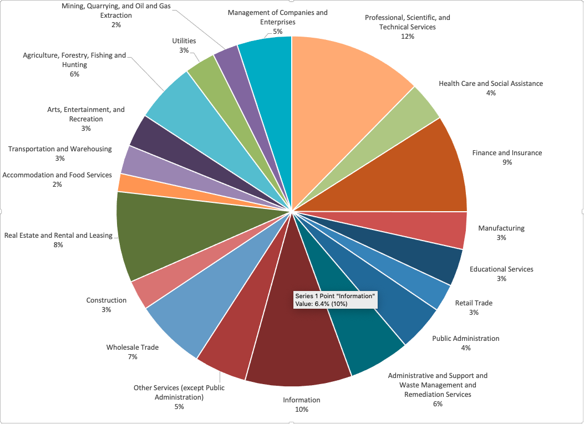

Appendix 2

