

Name: Parekh Sainil
Student ID: 2532294
Module Name: Marketing Management
Module Code: LCMB7024
Program: Master of Business Administration
Title: Tesla Eco Ride: A Sustainable Brand Extension for Urban Mobility
Submission Date: 14 August
Word Count: 2500 words

Contents
Introduction: 3
Element 1: Sustainable Brand Extension Tesla Eco Ride 4
Element 2: Segmentation, Targeting, Differentiation & Positioning (STDP Analysis) 5
Segmentation: 5
Targeting: 6
Differentiation: 6
Positioning: 6
Element 3: Marketing Mix – 4Ps 7
Product: 7
Price: 7
Place: 8
Promotion: 8
Element 4: Reflection 9
References: 9

Introduction:
This portfolio considers the brand extension approach to achieve the development of a sustainable brand extension for Tesla, which can be considered an opportunity for the company’s further development. Tesla has formed strong associations between the brand, mobility and technology, sustainable energy, which makes the creation of a new brand extension in the urban mobility sector reasonable and justified. The proposed brand extension, which is called Tesla Eco Ride, represents a high-quality smart electric bicycle that should help people who live in cities and need to use alternative ways of commuting. This product is supposed to help people to find an alternative way to move around cities and reduce their dependence on traditional ways of moving at relatively short distances. The proposed idea is analysed using Segmentation, Targeting, Differentiation and Positioning (STDP) and 4Ps of Marketing Mix Portfolio.

Element 1: Sustainable Brand Extension Tesla Eco Ride
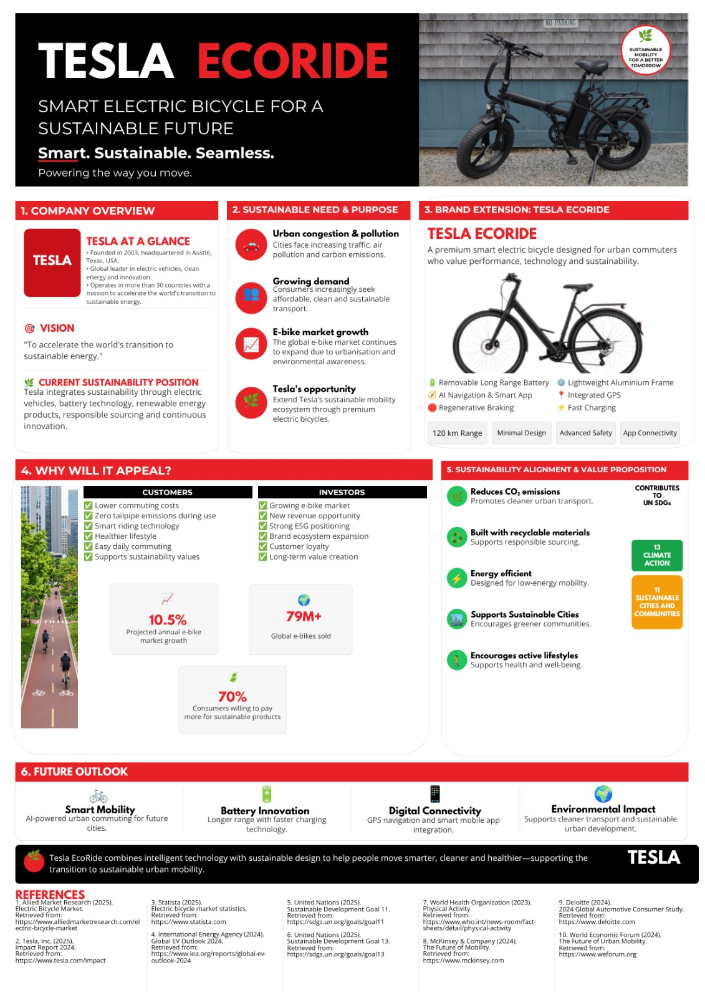
Tesla is an innovator-driven firm that has already positioned itself with regards to electric mobility and sustainable energy products. Tesla’s started goal is to hasten the shift to sustainable energy in the world, but Tesla’s ongoing operations range from electric vehicles, energy production to energy storage (Tesla, 2025). Given this existing positioning, the creation of a sustainable brand extension towards urban micro-mobility appears quite logical. The proposed brand extension from Tesla is an urban micro-mobility vehicle – Tesla Eco Ride, which is a premium smart electric bicycle.
The case is underpinned by research that suggests the use of e-cycles could bring about advantages like ease in effort, increased speed, and enhanced accessibility despite the issue of high purchase costs bring about advantages like ease in effort, increased speed, and enhanced accessibility despite the issue of high purchase costs (Department for Transport, 2024). There is also evidence that suggests that e-cycles could help shift individuals’ travel habits from using private cars to using e-cycles. Eco Ride is thus an extension of the electric mobility product of Tesla on a more local scale.
The new product will consist of electric propulsion, smart connectivity, security from GPS, sustainable materials, and minimalist design. This proposal is supposed to help in value creation to the customers through the use to technology and also provide Tesla with business opportunities. Nevertheless, sustainability should not be just an added-on factor. Consideration needs to be put into the manufacture of batteries, materials, production process, and even disposal process.

Element 2: Segmentation, Targeting, Differentiation & Positioning (STDP Analysis)
The brand development through extension is not limited to associating the known name with a newly developed product. Brand extensions include developing a product in a new category under an existing brand name, and earlier studies reveal that the perception about the degree of fit between the parent brand and the extended product plays a major role in deciding about the extension success (Aaker and Keller, 1990). Similarly, Volckner and Sattler (2006) list perceived fit as the most important determinant of brand extension success. The development of the Tesla Eco Ride should, thus, be seen as a legitimate development of Tesla’s brand image.

Segmentation:
Market segmentation helps organisation appreciate that consumers have different needs, motivations, and behaviours instead of seeing the market as homogeneous (Wedel and Kamakura, 2000). In the case of Tesla Eco Ride, the market can be studied based on geographic, demographic, psychographic and behavioural segmentation. From a geographic perspective, the first step would be to examine major urban centres in the UK such as London, represents an ideal location where commuting, congestion, and short distances create a demand for flexible urban mobility solutions. According to the review by the Department for Transport, e-cycles can help serve various travel needs and some movement away from private cars and public transportation. However, there are limitations to the UK evidence base presented in this review (Department for Transport, 2024).
Demographically, the key market is made up of adults aged 25-40 years, especially professionals working in urban settings. Medium to high levels of disposable income are relevant because Eco Ride aims to offer itself as an upscale product. Nonetheless, both of these variables will not be enough to segment the market because consumers with similar demographics can have entirely different views on cycling and sustainability issues. Psychographically, the greatest opportunity lies within consumers that appreciate technology, convenience, responsibility for the environment, innovation, and personal wellbeing. Research about the factors driving consumer’s attraction to e-bikes includes enjoyment, convenience, as well as the ability to move around farther and faster (Mine et al., 2024). Eco Ride can therefore go after consumers for whom technology and sustainability complement each other.
In terms of behaviour, the market will consist of frequent commuters, current cyclists, e-bikes riders, as well as customers using vehicles and public transportations for shorter distances. The most receptive segment may be those customers who understand the issue that the Eco Ride aims to solve. The Department for Transport further specifies that another critical barrier in adopting e-cycles is the cost of purchase (Department for Transport, 2024).

Targeting:
Given the above analysis, the main target market for the medium to high disposable income ranging from age 25 – 40 that are commuting regularly. This target market definition is more specific and goes beyond just defining “people interested in e-bike” and will give more synergy with the current branding of the company. This is an attractive market segment since it includes both the mobility need and purchasing power. The potential customer will find the time saving, convenience, digitalisation and premium design to be interesting attributes and the fact that this bike is sustainable can be another reason to consider the product. However, having a premium target market is also an issue for the company since the high purchasing power will make the product interesting from a business perspective, but at the same time limit access of people to the sustainable mobility solution.
Other potential secondary segments would be postgraduate students earning enough money, eco-friendly customers and customers already owning e-bikes who are in need of a technologically advanced product. However, all these segments must not be targeted at first, since too wide targeting may dilute the proposition. The initial launch of the product will enable Tesla to emphasize its value before thinking about the broader audience.

Differentiation:
The differentiation strategy should rely on a set of benefits and not on a technology alone. The differentiation strategy of Tesla Eco Ride will rely on the following technological capabilities: smart technology, premium design, sustainable product development and also being consistent with the overall technology identity of tesla. These features will differentiate Eco Ride as a product close to smart mobility rather than a traditional bicycle.
However, the idea od sustainability would also help the company to differentiate, but in a manner that is credible. Tesla must think about using materials that are sustainable in terms of either their recycling or their lesser impact, as well as durability, reparability, and sustainability does not imply consumer preference automatically. According to Luchs et al. (2010), sustainability could impact consumer preference differently based on which benefits consumers care about in a certain product category. Therefore, Eco Ride needs to emphasize its functional consumer benefits first.

Positioning:
It follows that the positioning of this product should convey a high-quality, innovative, intelligent and sustainable image. The positioning statement fits in well Tesla in terms of brand fit. The current brand equity of Tesla has been formed in connection with electric mobility, technology and sustainable energy, and now this association will be passed on to a narrower category of urban mobility. According to the customer-based brand equity theory of Keller (1993), positive associations with a strong brand will have an impact on consumer behaviour towards marketing efforts.

Element 3: Marketing Mix – 4Ps

Product:
Product strategy must ensure that the Eco Ride positioning is turned into a specific offering which offers both tangible and intangible benefits. According to Kotler, Keller and Chernev (2024), a key point is to create customer value via a holistic marketing offering rather than looking at each particular marketing decision separately. Therefore, Eco Ride must offer a real solution to the urban mobility challenges. The core benefit provided by Eco Ride is convenient urban mobility in a lower-carbon way. The product itself would be a premium quality electric bike, equipped with a light frame, electrical engine, battery management system and urban-oriented design. Some suggested additional features are GPS tracking capabilities, connectivity with mobile applications, theft notifications, ride monitoring and information about the status of the battery. Moreover, it would have lights and other commuting-related equipment included.
The augmented product will be equally as important. Tesla may provide complete warranties, online customer services, servicing, software upgrades, and battery management services. That will allow differentiating Eco Ride from its less expensive competitors since the customers will purchase the experience of receiving services along with the tangible bike.
Sustainability must be applied to all stages of the product life cycle. The suggested bicycle must be as durable, repairable, made out of responsible materials, and batteries must be recoverable. Such as approach is in line with the principles of sustainability marketing where sustainability issues have to be considered in the wider context of the value proposition (Peattie and Belz, 2010). But Eco Ride being completely free from environmental impacts should be avoided by Tesla. This is because the production of batteries and electronics uses resources, and transport and end of life processes contribute to the environment too. Thus, a better approach for Tesla will be to highlight how much sustainable change has been brought about.

Price:
Price is particularly important because Eco Ride is positioned as a premium product. A purely cost-based approach would focus on production and distribution costs before adding a margin, but this would not fully reflect the value created by Tesla’s proposed brand associations, technology and customer experience. A value-based pricing approach would be more suitable because customers could be paying for a combination of transportation, technology, convenience, design and sustainability.
The recommended launch price is approximately £2,999, subject to further market testing. This price is strategically positioned above many mass-market e-bikes while remaining below some high-end premium alternatives. For examples, specialized currently lists Turbo Vado models in the UK at prices ranging from approximately £2.499 to more than £5,000 depending on specification, while Trek’s UK Allant + range includes models around £2,953-£4,025. This indicates that a £2,999 proposed price would place Eco Ride within an existing premium commuter-biker range rather than making it completely unrealistic.
This could reinforce the right perception of quality and innovation and even give better margins that would help in the development of the technologies and provision of after-sales services. Nevertheless, this bring in another weakness in the marketing strategy. According to the Department for Transport, purchase cost is seen as a hindrance to e-cycle adoption (Department for Transport, 2024). To overcome this, Tesla could consider staged payments or even purchase schemes that involve financing where necessary. The strategy should aim at retaining the premium positioning while minimizing the financial hurdle at the outset. Consequently, promotional discount should be sparingly used since discounting too much could compromise the positioning.

Place:
The initial approach to distribution should involve an Omni channel strategy that integrates both the benefits of a digital approach and those of a physical one. The initial channel for sales can be set up via Tesla’s official website, giving Tesla total control over prices, customer information, and the sales process. The customer would be able to do the specification, configuration, scheduling of a test ride, and placing the order all online. However, the purely online approach would constitute the weakest link in the distribution chain due to fact that the product is relatively expensive and physical. The potential buyer would need to try the bike to check how comfortable it is, how it fits his body and operates. The third aspect would include appropriately chosen specialist cycling service partners. While direct distribution affords better control, specialist retailers could provide technological know-how and local service provision capabilities. Hence, Tesla would be required to find a balance between control and accessibility.
The proposed customer journey would be:
Digital awareness – Online research – Physical test ride – Online purchase – Local servicing – Digital customer relationship
The strategy is also an indicator of the importance of technology in the field of retailing. According to Grewal, Roggeveen and Nordfalt (2017), technology, customer engagement, and data have become more relevant than ever in contemporary retail settings. As such, Eco Ride can use technology not just for the sale of the product, but also for its ownership.

Promotion:
In regards to promotion, there needs to be a consistent integrated communication approach whereby the same positioning is communicated through both digital and physical media. The main message needs to revolve around ‘smarter urban mobility’ rather than being centered on the environmental aspect alone. The digital promotion needs to be aimed at urban individuals who like electric mobility, technology, riding and leading a sustainable lifestyle. Instagram, TikTok, and YouTube social networks can be used to showcase Eco Ride through commute videos, product technology explanation and customer’s testimonials. YouTube would be especially helpful to showcase product because customers looking at a purchase worth £2,999 are expected to need more information.
Influencer marketing can also be selective. Instead of using only lifestyles influencer, Tesla can use reliable cyclists and technologists who would showcase the real performance of the bike. The independent testing of the product would help to boost the level of credibility since potential buyers will get not only Tesla’s advertisements. Experiential marketing would prove to be highly effective in this situation. Tesla can hold Eco Ride Urban Test Days in London, Manchester, and Birmingham where people will be able to experience the bike themselves in the environment that resembles commuting. The approach helps to overcome one of the main challenges related to the purchase of a new unfamiliar product – uncertainty about its performance and suitability. Sustainability communication should be properly managed. Misleading statements can negatively affect consumer perception and reputation. For examples, recent research on greenwashing proves that misleading environmental claims negatively affect perception of corporate social responsibility. Tesla should not make general claims like “the greenest bicycle” unless it can be substantiated. Instead, promotional materials should include facts about recycled materials, expected life cycle of the product, battery recovery, and reparability.

Element 4: Reflection
The development of the Tesla Eco Ride concept provided an understanding of how the theoretical aspects of marketing can be used in practice when making a decision related to brand extension. Indeed, it would have been relatively easy before the development of the project to focus on whether the innovation is innovative and sustainable or not. However, while developing the project, I understood that in order to be successful, brand extension should be based on a much better connection between the existing brand, customer requirements, market potential and the innovation. Thus, one of the key lessons that I have learned is the issue of brand fit. Indeed, initially the brand extension of Tesla to electric bicycles seemed to be very straight forward. However, when analysing it more carefully, I realised that the brand extension should make sense to the customer. In particular, Tesla is associated with innovations in electric mobility, technologies and sustainable energy, which creates the basic for such brand extension. However, customers can also have doubts whether the company can provide the required credibility in designing and producing the bicycle.
The STDP analysis also turned out to be very educational. At first, I was looking at a general market of potential consumer of electric bicycles, but then it became obvious that there should be an explicit target audience. The choice of urban professional interested in technologies and sustainable transportation became more useful for designing the product, pricing and promotion. Segmentation is not only about defining features of potential customers, but it is also about finding the differences that may help to make marketing decisions. The marketing mix became helpful in understanding the interrelations between different decisions related to marketing. For examples, the premium positioning determined the suggested price - £2,999. This, in turn, necessitated offering test rides, excellent customer service and trustworthy promotion of the brand. Sustainability had an impact on other elements of the mix as well – on product design, on price, on distribution and on promotions. It became evident that sustainability should be considered as part of the marketing strategy and not only as an additional promotional message.
If I were to develop the same project once more, I would improve the concept by carrying out some primary research. Specifically, I would conduct a survey of urban commuters in order to know their attitude towards purchasing an e-bike, desired characteristics and their budget limits. Moreover, I would carry out test of concept to find out whether consumers regard Tesla Eco Ride as an authentic product of the company. All in all, the assignment has helped me improve my skills in relating marketing theory to strategic decision making. It has also underscored the need for empirical validation of hypotheses. For future marketing assignments, I should pay more attention to hypothesis validation prior to making any strategic decisions.

References:
Aaker, D.A. and Keller, K.L. (1990) 'Consumer evaluations of brand extensions', Journal of Marketing, 54(1), pp. 27–41.
Grewal, D., Roggeveen, A.L. and Nordfält, J. (2017) 'The future of retailing', Journal of Retailing, 93(1), pp. 1–6.
Keller, K.L. (1993) 'Conceptualizing, measuring, and managing customer-based brand equity', Journal of Marketing, 57(1), pp. 1–22.
Kotler, P., Keller, K.L. and Chernev, A. (2024) Marketing Management. 16th edn. Harlow: Pearson. The 16th edition was published by Pearson in 2024.
Luchs, M.G., Naylor, R.W., Irwin, J.R. and Raghunathan, R. (2010) 'The sustainability liability: Potential negative effects of ethicality on product preference', Journal of Marketing, 74(5), pp. 18–31.
Mina, G., Bonadonna, A., Peira, G. and Beltramo, R. (2024) 'How to improve the attractiveness of e-bikes for consumers: Insights from a systematic review', Journal of Cleaner Production, 442, 140957.
Peattie, K. and Belz, F.-M. (2010) 'Sustainability marketing – An innovative conception of marketing', Marketing Review St. Gallen, 27(5), pp. 8–15.
Tesla (2025) Impact Report 2025. Tesla.
Tesla (2025) Additional Resources – Tesla United Kingdom. Tesla.
Department for Transport (2024) E-cycles Rapid Evidence Assessment. London: Department for Transport.
Department for Transport (2024) National E-cycle Programme Evaluation. London: Department for Transport.
Völckner, F. and Sattler, H. (2006) 'Drivers of brand extension success', Journal of Marketing, 70(2), pp. 18–34.
Wedel, M. and Kamakura, W.A. (2000) Market Segmentation: Conceptual and Methodological Foundations. 2nd edn. New York: Springer.

