Multilingualism, multi-thinking
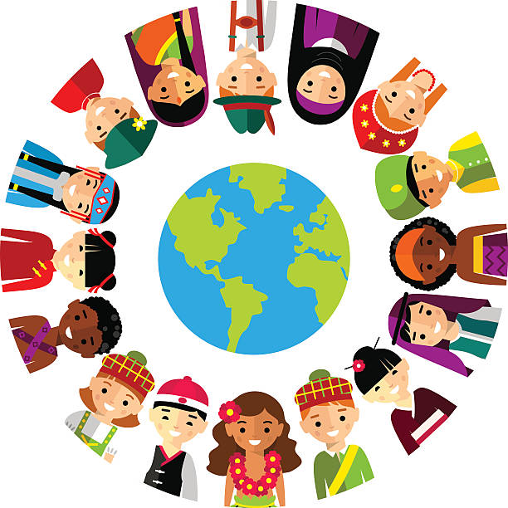

(Source: Google images A, no date)

This paper will look to discuss the benefits of bilingualism and multilingual. There are many benefits of being able to speak more than one language, as Smidt (2016) supports that children use language every day to communicate. When children can speak more than one language they have improved memory, problem solving and critical-thinking skills. Being bilingual enhances children’s concentration and their ability to multitask. It also helps to develop children’s listening skills. Being bilingual helps children to understand and connect with the world around them. When children learn more than one language they are able to connect and communicate effectively with others around the world. Being bilingual and multilingual provides children with more opportunities later in life. This means better chances for employment (Bonfiglio, 2017). Baker (2011) explains that bilingualism can either be simultaneous (from birth) or sequential (from age three), this is usually developed through education. Baker (2011) also suggests that children who are sequentially bilingual have no problem absorbing both languages at a young age. Bonfiglio (2017) suggests it is important to nurture children’s communication skills as they develop, so they are capable of expressing themselves, clearly and confidently. This will encourage children to communicate with others around them and help others understand their wants and needs. Children who are bilingual have additional words at their disposal which enables them to be more able to multitask. Children can communicate by observing and listening to their parents, and then begin to mimic their words and actions (Lindon, 2012). Lindon (2012) discusses how children communicate by observing and listening to parents and other key role models. This is supported by Vygotsky (1974) who explains how the more knowledgeable other (MKO) supports and extends children’s learning. This theory suggests that adults/practitioners who support children with English as an additional language (EAL) and Welsh as an additional language (WAL), should be confident and motivated to support children to develop and extend their use of language, and provide children with activities that are well planned and appropriate to their ability to further develop their understanding (WAG, 2015). Kotodziej (2012) identifies how Bandura suggests that children learn within a social context, from one another through observation, imitation and modelling. His theory recognised the importance of observational learning. Children will learn languages easily with positive role models. The Foundation Phase framework, as set out by The Welsh Assembly Government (2015) supports this statement that practitioner’s model tasks to the children bilingually on a daily basis. To encourage and extend children’s learning practitioners add bilingual tasks to the enhanced areas for children to have a go independently. This helps develop new skills. The Welsh Assembly Government (2015) states that all schools and settings within the foundation phase will implement a programme for the Welsh language this will be implemented across the curriculum for children three to seven years old. The Foundation Phase supports children’s development and aims to ensure all children have the best start in life, by giving children the best opportunities in order for them to grow and develop (WAG, 2015).
Similarly the Welsh Government (2003) aims that the Curriculum Cymreig is integrated into all school’s curriculum planning and that it is inclusive to all children. When practitioners are planning, other subjects can be brought together by themed topics. Children should be given opportunities to develop and apply their knowledge and understanding of cultural, economic, environmental, historical and linguistic characteristics of Wales. The UNCRC (no date) Article 30 supports the curriculum Cymreig – if you come from a minority group you have the right to enjoy your culture, practice your own religion and use your own language. Children who attend Welsh medium education follow the immersion method, which is supported by Mudiad Meithrin (no date) that children are exposed to the Welsh language and should be used concisely by practitioners with and around the children in the setting. Activities are carried out only through the use of Welsh. When children are exposed to the Welsh language through the immersion method, children develop their Welsh language skills naturally through activities and play. Practitioners respect children’s right to respond in the language of their choice.
Research by Bonfiglio (2018) has suggested that the brain of bilingual children is different to children who speak one language. When children speak one language their brain works harder to focus on a single word. Being bilingual enables children to switch from one language to another; this is known as code switching. Baker (2011) supports this and suggested that children have the capacity to store two or more languages, and that a child can switch from one language to another with ease. He believed that as well as parents at home, nurseries and schools play an important role in supporting children to acquire a second language. Children who speak a second language have a cognitive enhancement which helps develop problem solving skills and enables them to make better decisions. This supports Donaldson’s (2015) stance where he discusses the need for young children to be confident, critical thinkers, who can communicate effectively using both Welsh and English. Children should be equipped with the skills and knowledge to manage everyday life independently. This enables them to lead fulfilling lives as valued members of society and have a successful future. Bilingual children are more efficient at higher-level brain functions.
Research by Kulh (2012) has suggested that children who are bilingual or multilingual can communicate effectively with different cultures. Being bilingual has a positive cognitive effect on children, therefore having a greater capacity to; problem solve, think creatively and understand word concepts. Children have better adaptability, mental flexibility and verbal intelligence. The bilingual brain has better attention and task-switching capacities than the monolingual brain, and has developed the ability to inhibit one language while using another. Children who are bilingual and multilingual are able to demonstrate higher order thinking. This is line with current suggestions as discussed by Donaldson (2015) and his ambition is that children have a successful future. Children should be ambitious, capable learners who are ready to lead fulfilling lives.
Research shows that Carmarthenshire has the highest number of Welsh speakers in any of the counties in Wales. Being bilingual is the ability to use two languages confidently switching from one to another. Speaking two languages provides you with more opportunities. Being able to speak Welsh gives you a strong identity and belonging. In Carmarthenshire children are encouraged to speak Welsh by speaking different languages this encourages children to be more tolerant towards other cultures (Carmarthenshire County Council, 2018). The UNCRC (no date) Articles 7 and 8 supports this and states that Children have the rights to a name and nationality, and the right to an identity. Children are encouraged to use Welsh everyday through stories, songs and rhymes. By simple repetition, rhyme and singing, children with WAL can be supported by Practitioners to develop and use Welsh language daily. Practitioners set up activities that can be easily accessed by children support their understanding and development of the Welsh language. The Welsh Assembly Government (2015) supports this and suggests that children in the foundation phase in English medium schools/ settings should be given the opportunity, through play, as well as story and structured activities, to encourage and develop a positive attitude towards Welsh and encourage further language learning. This approach is not supported by the immersion method as used by Myriad Meithrin (no date), as for some children, the sandwich method is more suitable and helps children develop the Welsh language at their own pace. Children will be developing their language skills in a language that is different to what they speak at home. Practitioners in schools using Welsh as an additional language should put a particular emphasis on speaking and listening activities for part of the day in order to increase children’s familiarity with language patterns in Welsh (WAG, 2017).
Therefore it is important that practitioners create learning environments that are fun, stimulating and safe that encourage them to develop. Maslow (1943) suggests children should be shown that they are valued and respected in the classroom, and the teacher should create a supportive learning environment. Children with a low self-esteem will not progress academically at an optimum rate until their self-esteem is strengthened. According to the Welsh Assembly Government (2015), The Foundation Phase Framework outlines that children should have access to a well-planned and organised environment that helps them develop and learn. It should be fun, exciting, stimulating, and safe.
Similarly The Welsh Assembly Government (2017) aims for one million people to be speaking welsh by 2050, supporting the work that practitioners are carrying out in schools. The reason behind this is to secure the vitality of the language for future generations.
“A nation without a language is a nation without a heart” (Glyn, 2019).
“The Welsh language is one of the treasures of Wales. It is part of what defines us as people and as a nation” (WAG, 2017).

