BA SOTAH – International Hotel Management
Module- Financial Management for the Hotel Industry
Module Level- 5
Module code- BMIH5007
Lecturer- Dale Clarke

Assignment title: Assignment 2 Marriott International
Student Name : Syed Jahangir Bakth
Student ID: 2026520

Table of Contents
Introduction 3
Discussion 4
The trends seen in its key financial ratios of Marriott International Inc. and conclusion supporting with graphs and charts 4
Investigating limitations of ratio analysis and reasons behind the necessity of understanding ratios and their fluctuations for Hotel management supporting with the information in financial statements 8
Ratio Analysis and its importance in decision making 10
Conclusion 11
References 12

Introduction
Ratio analysis is an important tool in the financial management of an organisation like Marriott International which is a multinational company and has greater operations worldwide. The report will discuss on the trends of key financial ratios by focusing on the overall performances and conditions of the organisation in the hospitality industry. The limitations of ratio analysis will be highlighted here along with the necessity of understanding ratios and their fluctuations in the context of hotel management. The importance of ratio analysis in decision making within hotel along with explanation regarding this will be also discussed throughout the report.

Discussion

The trends seen in its key financial ratios of Marriott International Inc. and conclusion supporting with graphs and charts
Financial ratio refers to the concept of selecting two numerical values of financial statements of an organisation in order to evaluate the overall financial condition (Barnes, 2019). These ratios are used as the benchmark for the business organisations. The comparison of present performance of a business organisation can be easily measured by through this ratio analysis (Chen and Shimerda, 2019). The level of progress in business is also better understood using this useful tool of ratio analysis through which the organisation takes further initiatives to keep the progress continued or do better for achieving expected business performances.
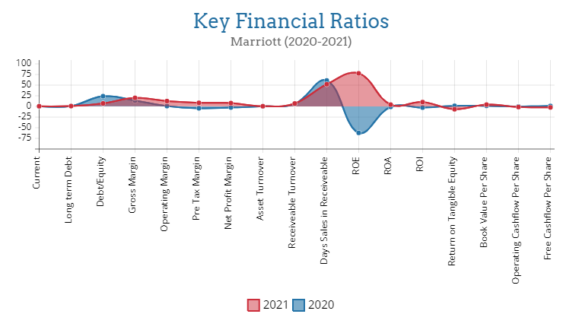
The projected figure above is about financial performance of Marriott from the year 2020 to 2021 by showing the trends of financial ratios. The detail discussion is provided below regarding the key financial ratios and trends seen within the ratios in the context of Marriot International.
Debt to Equity Ratio: This debt to equity ratio shows the level of debt in a business compared to investor equity. The ratio helps to measure if the company is borrowing much than their ability to repay (Nuryani and Sunarsi, 2020).

According to the debt to equity ratio chart of Marriot International, it can be seen that the ratios are greater than 1 in both 2020 and 2021. This interprets that Marriot is in debt in both years. The difference between two year’s ratios has been also spotted from 24.1302 to 7.1697 which mean Marriot International has been paying their debt quickly along with borrowing less.
Gross Profit Margin and Net Profit Margin: Gross profit margin indicates the successful profit generation over the cost incurred within business. Beside this, net profit margin indicates how much of revenue becomes profit (Nariswari and Nugraha, 2020). Highlighting on the financial statements of Marriott, gross margin has been seen about 13.8019 in 2020 and 20.2136 in 2021 which is indicates the higher profit generation. The focus should be on enhancing the net profit margin because the gross profit margin tend to higher than this ratio as the gross profit margin does not take account the costs like administrative cost, interests, tax charges etc. which net profit margin counts. The net profit margin was about -2.5258 in 2020 and the changes spotted in 2021 by 7.931 which can be considered profitable situation of the business of Marriott than the previous year.
Current Ratio: The ratio indicates the level of liquid assets within organisation like cash and short-term assets which can be converted into cash in rapid manner. The current ratio less than 1 indicates that the company is shortage of cash for covering their short term obligations and situation is frightening for the large multinational company like Marriott International (Husna and Satria, 2019).
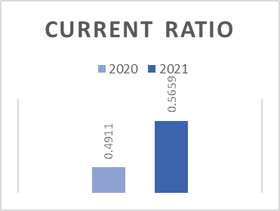
According to the financial statement of Marriott, the current ratio of 2020 and 2021 were below 1. Though the condition can be interpreted as risky for Marriot, the trend of current ratio from 2020 to 2021 has been seen to go upward which indicates the organisation has achieved quicker inventory turnover or repaid their debt.
Return on Assets: This financial ratio indicates about how well the business organisation is using their total assets for generating profits (Husna and Satria, 2019). For investors, this ratio can be used as the promising stock possibilities. According to the financial statement of Marriott, the return on asset (ROA) ratio has been seen to increase from -1.0809 to 4.3009 within a year indicating the success of company while boosting its earnings with each investment by Marriott International.
Long-term Debt to Capital Ratio: This ratio is a variation of traditional debt to equity ratio which indicates the financial leverage of a firm. The ratio less than 1.0 is regarded as healthy condition of business organisation (Hein, 2016).

The long term debt to capital ratio of Marriott has been spotted as lower than 1.0 in the financial statement meaning that the organisation is strong, bearing debt of reasonable amount considering the organisation’s situation and also without any financial issues while operating business.
Return on Equity Ratio: The financial ratio shows the state about how well the organisation is managing the capital invested by the shareholders of the organisation (Khaddafi and Ummah, 2018). The return on equity ratio of Marriott has been seen to increase from -62.093 to 77.7228 between the year of 2020 and 2021 meaning that the organisation has profitably managed the capitals of shareholders and enhanced the value of shareholders within organisation.
Asset Turnover Ratio: The ratio indicates the efficiency of organisation’s asset in generating revenues or sales (Fairfield and Yohn, 2019). The greater asset turnover ratio indicates that the organisation is utilising their assets in effective manner.

According to the figure sourced from the financial statement of Marriott, the asset turnover has been seen to increase from 0.428 to 0.5423 within the period of 2020 to 2021. The growth of value indicates that the organisation has moderately utilised their assets in generating revenues for the organisation.

Investigating limitations of ratio analysis and reasons behind the necessity of understanding ratios and their fluctuations for Hotel management supporting with the information in financial statements
Ratio analysis is a crucial task to conduct in the context of business organisations to know the performance level of organisation by comparing with the performance from previous years of the same organisation or with other organisation (Salmi, T. and Martikainen, 2019). Ratio analysis not only measures organisational performances but also measure the liquidity, profitability and debt of the organisation. Even being such a useful tool for business organisation, ratio analysis has some limitations as well which are discussed below in order to prevent organisation from drawing wrong conclusion through ratio analysis:
Historical information: The result presented in ratio analysis is based on the historical data of company which is one of the limitations of ratio analysis and may not accurately measure the present performances of the organisation (Faello, 2019). The future performance of organisation also cannot be measured through the ratio analysis.
Inflationary effects: Inflation has greater effect on ratio analysis which provides inaccurate value while measuring condition of the organisation (Lesakova, 2017). The inflation occurred between the periods of financial statement release affect the whole ratio analysis which cannot be used in measuring performances of organisations.
Changes in operations: The changes in operational structure of an organisation affect the ration analysis. It is impossible to compare financial condition of organisation before and after the operational change which is another limitation of ratio analysis.
Manipulation in financial statement of company: Company may present their report by manipulating it by positive figures than the actuals which lead the result of ratio analysis to draw wrong conclusion.
In the context of Hotel management, it is important to understand the ratios and their fluctuations because these support organisation greatly while operating business in successful manner in the competitive market like hospitality industry. The reasons behind understanding ratios and their fluctuations are provided below with the analysis of Marriott’s financial statement:
- The initiatives for the future performances can be taken by getting the insight of comparison between the past and present performances of the organisation.
- The decision making process of Marriott will be easier while considering the value of ratio analysis and fluctuations of value within particular period of time (Babalola and Abiola, 2018).
- The performances of competitors in the market can be known which is effective for Marriott to maintain their competitive advantage in the marketplace.
- The financial issues can be easily spotted by the ratio analysis which helps the organisation like Marriott International to know their issues and resolve those as soon as possible because it may lose greater sales and revenues for this multinational company.

Ratio Analysis and its importance in decision making
Ratio analysis is a qualitative method by which the investors and analysts assess the financial condition of an organisation with the insight of company’s liquidity, profitability and operational efficiency presented in the financial statements of the organisation (Horrigan, 2019). The conclusion and decision for the company can be taken by analysing the present and past records of financial activities of the company. Shareholders can analysis on the return on equity ratio prior to taking decision of investing on Marriott International so that they can be ensured to have greater value from the organisation. The investors can easily apply the tool of ratio analysis by inserting company data from the financial statement which will help them to know the overall condition, performance, liquidity, operational efficiency, profitability, level of debt and asset utilisation level of the company etc.
In the context of decision making within organisation like hotel, the ratio analysis is used by the managerial authority of organisation as the decision making tool. The investors and shareholders are notified about investing capitals in the hotel by using this tool and presenting effective insights to them. In the context of managing hotel, the importance of ratio analysis in decision making is that the hotel organisation can decide upon the period of monitoring the business operations for improving the certain factor like liquidity and profit margin of the organisation (Babalola and Abiola, 2018). The organisation can decide on taking effective steps to lower the level of debt through analysing the long term debt to capital ratio so that the hotel can sustain in the market place without any financial issues and also with lower amount of debt. The ratio analysis is also important to take decision on increasing the net profit margin of the organisation beside gross profit margin because the gross profit margin excludes a greater number of costs that lessen the profits of the hotel organisation.

Conclusion
Financial statements of the organisation provide information regarding the state of business within marketplace and financial ratio analysis presents the insight of the organisation’s performance which is easy to understand and evaluate by the investors and shareholders. Ratio analysis tool is highly useful tool for the business organisations with some limitations which can be minimised by the careful observations of the organisations and stakeholders while drawing any conclusion about the organisation and making decision for the successful operations in the marketplace.

References
Babalola, Y.A. and Abiola, F.R., 2018. Financial ratio analysis of firms: A tool for decision making. International journal of management sciences, 1(4), pp.132-137.
Barnes, P., 2019. The analysis and use of financial ratios. Journal of Business Finance dan Accounting, 14(4), p.449.
Chen, K.H. and Shimerda, T.A., 2019. An empirical analysis of useful financial ratios. Financial management, pp.51-60.
Faello, J., 2019. Understanding the limitations of financial ratios. Academy of accounting and financial studies journal, 19(3), p.75.
Fairfield, P.M. and Yohn, T.L., 2019. Using asset turnover and profit margin to forecast changes in profitability. Review of accounting Studies, 6(4), pp.371-385.
Hein, E., 2016. Interest, debt and capital accumulation—a Kaleckian approach. International Review of Applied Economics, 20(3), pp.337-352.
Horrigan, J.O. (2019). A short history of financial ratio analysis. The Accounting Review, 43(2), pp.284-294.
Husna, A. and Satria, I., 2019. Effects of return on asset, debt to asset ratio, current ratio, firm size, and dividend payout ratio on firm value. International Journal of Economics and Financial Issues, 9(5), p.50.
Khaddafi, M. and Ummah, A., 2018. Influence analysis of return on assets (ROA), return on equity (ROE), net profit margin (NPM), debt to equity ratio (DER), and current ratio (CR), against corporate profit growth in automotive in Indonesia Stock Exchange. International Journal of Academic Research in Business and Social Sciences, 4(12), p.101.
Lesakova, L., 2017. Uses and limitations of profitability ratio analysis in managerial practice. In International Conference on Management, Enterprise and Benchmarking (pp. 1-2).
Nariswari, T.N. and Nugraha, N.M., 2020. Profit growth: impact of net profit margin, gross profit margin and total assests turnover. International Journal of Finance & Banking Studies (2147-4486), 9(4), pp.87-96.
Nuryani, Y. and Sunarsi, D., 2020. The Effect of Current Ratio and Debt to Equity Ratio on Deviding Growth. JASa (Jurnal Akuntansi, Audit dan Sistem Informasi Akuntansi), 4(2), pp.304-312.
Salmi, T. and Martikainen, T., 2019. A review of the theoretical and empirical basis of financial ratio analysis. News Group, (_001).

