
Student ID number: 2431174
Student name: Rinkeshkumar Ahir
Programme: MSc in Data And AI
Module: Artificial Intelligence (ACCA7026)
Assignment Title: Assignment – ML Model: Intelligent Intrusion Detection System Using Ensemble Learning on NSL-KDD Dataset

Abstract
There is a high level of threat to contemporary digital infrastructures due to the cybersecurity threats especially network intrusions. This report discusses the use of ensemble learning methods to identify the normal or attack network traffic using the NSL-KDD dataset, which is a better benchmark to test the intrusion detection systems (IDS). The research aims to perform binary classification to identify normal traffic or one of the types of attacks, preprocess the data, create the models of the Random Forest and Gradient Boosting, and measure the performance of the models. The process of hyperparameter tuning using the GridSearchCV was also done, resulting in a high level of accuracy with no additional work since the results were meaningful. Among the most important results is the Gradient Boosting that has 99.917% accuracy and 99.991% AUC which is slightly higher than the 99.893% and 99.990% of the Random Forest. Such attribute as 'src_bytes' and 'dst_host_srv-count' are important according to feature importance analysis. These models have been suggested by insights to be incorporated in real-time IDS to increase the recognition. The report give practical recommendations on how the IDS design can be improved based on literature.
Keywords: cybersecurity, intrusion detection, ensemble learning, NSL-KDD, Random forest, Gradient Boosting

Table of Contents
Abstract 2
1. Introduction 4
2. Literature Review 5
3. Methodology 6
3.1 Data Exploration and Preprocessing 6
3.2 Exploratory Data Analysis 6
3.3 Ensemble Model Development 7
3.4 Model Performance Evaluation 9
4. Experiments 9
4.1 Experimental Setup 10
4.2 Preprocessing Execution 10
4.3 Model Training and Model Tuning Execution. 11
4.4 Evaluation Execution 11
5. Results and Analysis 12
5.1 Performance Metrics 12
5.2 Confusion Matrices 13
5.3 Computational Efficiency 14
6. Discussion 14
Conclusion 15
References 16

1. Introduction
The modern digitally connected infrastructure cannot be achieved without cybersecurity, and Intrusion Detection Systems (IDS) are needed to detect malicious activity through monitoring traffic on the network [1]. Classical signature-based IDS do not identify new attacks like zero-day vulnerabilities and APTs which evolve to evade detection [2]. This has contributed to increased application of AI and ML, which acquire threat patterns using in-depth datasets [3].
Ensemble learning, particularly Random Forest and Gradient Boosting, provide good generalisation, overfitting resistance and provide an improved performance in dealing with imbalanced, high-dimensional network traffic [4-5].
This report constructs an ensemble-based IDS with NSL-KDD data which is an enhancement of the KDD 99 with a more realistic representation [6]. The research uses a comparison between Random Forest and Gradient Boosting to the binary classification (normal vs. attack), which is relevant to the application of IDS to anomalies in a real-world context, where only limited resource are available to identify them [7]. Hacking in is also not easily detected as intrusions occur in advanced forms like DoS, Probe, R2L, and U2R [8] and the cost of cybercrime is estimated at USD 10.5 trillion by 2025 [9]. The classical ML models typically perform poorly in terms of a high false positive rate or false negatives on uncommon attacks, which support the use of ensemble methods to get high accuracy and recall [10].
These objectives are preprocessing NSL-KDD, tuning ensemble models, performance (accuracy, precision, recall, F1-score, ROC-AUC) analysis, feature importance analysis and advice on constructing a robust IDS. Experiments with scikit-learn and GridSearchCV demonstrate the near-perfect detection rates of the use of ensemble methods in cybersecurity.

2. Literature Review
The development of the IDS started with signature-based systems, such as Snort, which is good to id the previously known attacks but it fails to identify new attacks [11]. Algorithms like SVM and Neural Networks were the ones used to come up with ML-based IDS, but these were not able to cope with imbalanced data [12]. Ensemble methods were popular to overcome such shortcomings.
Breiman proposed the Random Forest, which has parallel tree building and in-built feature selection feature [4]. It has demonstrated high results on KDD99 with more than 99 percent accuracy in multi-class classification [13], and has had an advantage over SVM and Extreme Learning Machine on the NSL-KDD- particularly in R2L detection [14]. Gradient Boosting, which is formalised by Friedman, develops models one by one in order to rectify the residual errors [15]. Experiments record good results on NSL-KDD, such as higher recall of minority classes with adaptive boosting [16] and 99.5% accuracy with hybrid deep learning architectures [17].
Stacking of the Random Forest and Gradient Boosting also promise good results when used as an ensemble. Ensembles that are feature-selection-oriented decrease the dimensions of network data [18], whereas SMOTE and Random Forest enhance imbalance management on NSL-KDD [19]. Deep ensemble IDS models also perform better compared to conventional methods [20].
It must be tuned with hyperparameters using the grid search method, which is usually marked in the grid search [21], but random search is effective when the space is large [22]. ROC-AUC is still an important parameter of unequal IDS tasks [23]. The importance of feature enhances understandability, where src-bytes were found to be very significant in NSL-KDD models [24]. Cross-validation can be used to prevent over-fitting [25], and Random Forest is computationally efficient, particularly in IoT IDS [26]. Other studies point to adversarial robustness [27], newer datasets such as CIC-IDS2017 [28], explainable AI as a way to build trust [29], and concept-drift management as a technique to ensure long-term performance [30].
Taken together, the literature is supportive of the usefulness of ensemble techniques, including Random Forest and Gradient Boosting, which are the basis of the NSL-KDD-based IDS in the present report.

3. Methodology
The methodology is structured to ensure reproducibility and rigor, encompassing data handling, analysis, model construction, and evaluation.

3.1 Data Exploration and Preprocessing
The dataset of NSL-KDD (125,973 cases, 42 dimensions) was loaded into a pandas DataFrame, and the header was given manually (based on the standard schema). Preliminary observation proved the existence of both numerical and categorical attributes, as well as there were no gaps found. In binary classification, the label was recoded by coding normal to 0 and all type of attacks to 1, which gave an almost equal distribution of classes. Categorical variables were encode with labels and numerical variables were scaled with StandardScaler to make sure that the feature are all scaled equally. Lastly, the data was stratified into training (80) and testing (20) subsets using a constant random state to ensure proportionality of the classes during the evaluation.

3.2 Exploratory Data Analysis
The exploratory data analysis indicated that there is a high-class imbalance in the dataset with normal traffic being the majority of the classes, whereas the minority attack categories especially R2L and U2R were underrepresented badly. In order to demonstrate this imbalance a bar chart was created, as it is seen in Figure 1 that give the distribution of the classes in frequencies.

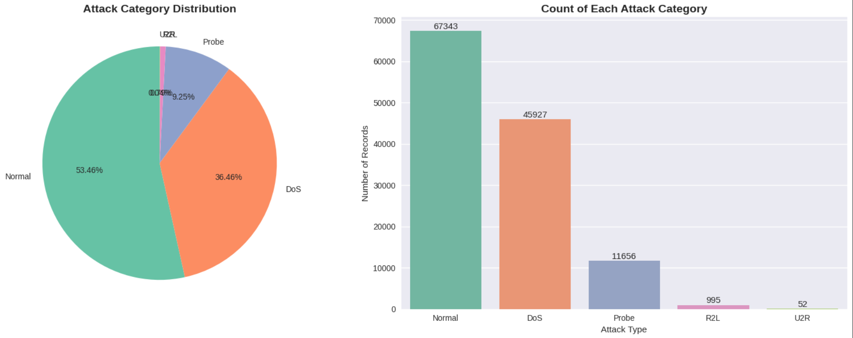
Figure 1. Bar chart showing the distribution of classes in the NSL-KDD dataset (normal vs. attack), highlighting the imbalance where normal traffic constitutes the majority
The numerical characteristics were also analysed through correlation analysis to determine strong and weak relationships and the correlation heatmap in the form of Figure 2 indicated the existence of a strong relationship between a variety of variables, with a significant correlation between the variable of src and dst bytes. This result implies that ensemble learning techniques might be used to overcome multicollinearity successfully.
It also determined behavioural patterns of feature distributions such as anticipating skewness in network activity features. Figure 3, representing the boxplot of the feature of src_bytes reveals a strong right skewed distribution which is common with anomalous traffic patterns in attack cases. Moreover, the pairwise comparisons of the main characteristics defined the potentially predictive characteristics including count and srv count. Figure 4 is a pairplot of the key features of selected key feature which visualise these relationships and show the patterns of the scatter and correlations that suggest abnormal behaviour in attack traffic. The outliers were also not removed, since ensemble-based models tend to be robust to the effect of the outliers. The creation of all visualisations took place in Seaborn and had a transparent and understandable colour scheme.

3.3 Ensemble Model Development
The scikit-learn ensemble algorithms that were used in intrusion detection were the Random Forest Classifier (RFC) and the Gradient Boosting Classifier (GBC). The default parameters applied in the RFC baseline were n estimators = 100 and random state = 42. The gridsearchCV was then used to tune n_estimators (100, 200), max_depth (None, 10, 20), min sample split (2, 5) and min samples leaf (1, 2) with a three-fold StratifiedKFold on cross-validation.
In the same way, the GBC baseline (nestimators = 100, learning rate = 0.1, max depth = 3, random state = 42) was also optimised using a grid in terms of nestimators (100, 200), learning rate (0.01, 0.1) and max depth (3, 5) under the same CV configuration.
The two models were trained using the standardised set of training and optimal hyperparameters were chosen using cross-validated accuracy. There was also the implicit protection of overfitting through the use of cross-validation.

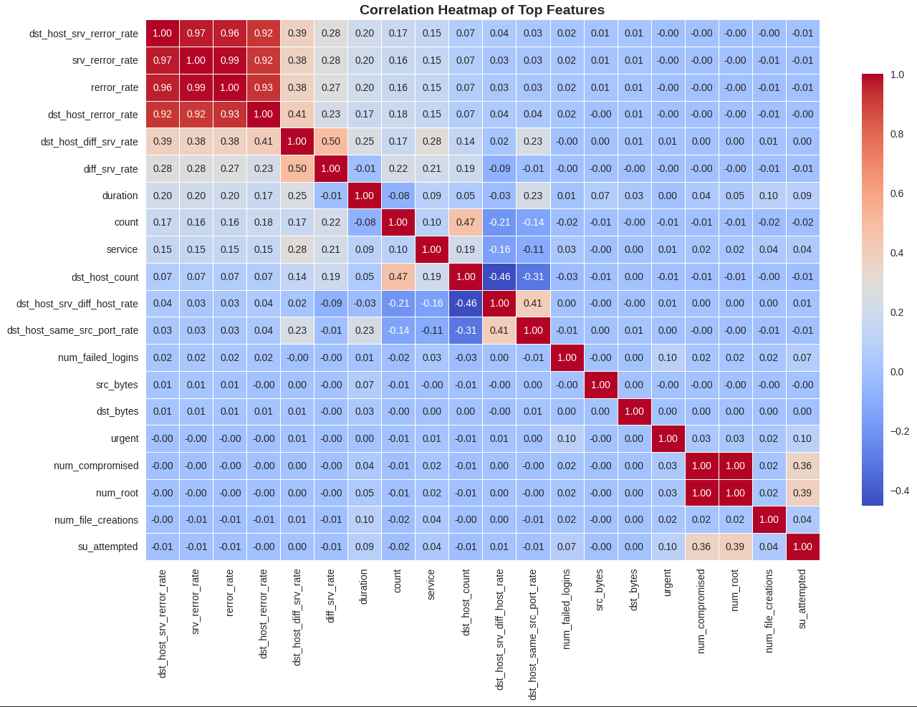
Figure 2. Correlation heatmap of top features

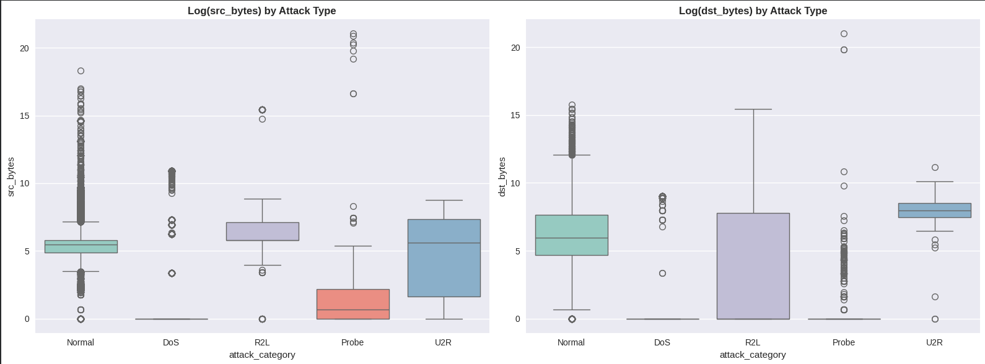
Figure 3: Boxplot illustrating the distribution of the 'src_bytes' feature, demonstrating skewness typical of network traffic patterns in attack scenarios

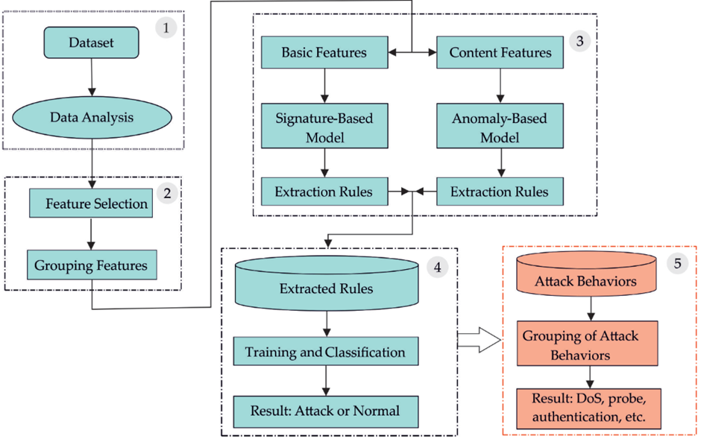
Fig 4. Illustartion of selected features revealing correlation patterns relevant to intrusion behaviour.

3.4 Model Performance Evaluation
Accuracyscore, precisionscore, recallscore, f1score (all with average=binary), rocaucscore and classificationreport as well as confusionmatrix of scikit-learn were used to evaluate the test set performance. The confusion matrices explained true negatives (TN), false positives (FP), false negatives (FN), and true positives (TP). ducing of graphs (AUC) was plotted in ROC. The efficiency was compared by recording the computational times to fit and predict. Training and test metrics were compared to check overfitting, and if there is minimal variance, overfitting is eliminated.

4. Experiments
The experiments were implemented in a Google Colab with Python, with major libraries being pandas to manipulate data, numpy to perform numeric operations, matplotlib and seaborn to create visualisations, scikit-learn to implement models and metrics, and xgboost to potentially replace it (a fact that was not used in the presented case). The major source of data was the NSL-KDD training dataset that had 125,973 rows and 42 columns and was loaded via the offered CSV file. Each code execution was done with a fixed randomstate=42 to reproduce the code and warning warnings were reduced by the code warnings.filterwarnings() ignore in place of focus on the code outputs to simplify code concentration.

4.1 Experimental Setup
Component | Description
Computing Environment | Google Colab standard runtime, ~12 GB RAM, T4 GPU disabled (CPU-bound tasks)
Dataset Dimensions | 125,973 rows × 42 features
Data Integrity Checks | Shape verification, dtype inspection (numeric + categorical), duplicate count = 0
Attack Category Mapping (for EDA) | DoS (neptune, smurf), Probe (ipsweep, portsweep), R2L (guess_passwd, ftp_write), U2R (buffer_overflow, rootkit)
Training Split | 100,778 preprocessed instances
Test Split | 25,195 instances
Class Distribution in Test | Normal: 13,469, Attack: 11,726 (balanced representation maintained)
Hyperparameter Tuning Method | GridSearchCV with 3-fold stratified CV, accuracy scoring
Search Space Definition | As per methodology section, with verbose=0
Time Benchmarking | %%time magic used in Colab for training duration
Table 1. Experimental set up for the proposed methodology
The experimental environment and dataset characteristics were documented prior to model development to ensure reproducibility and clarity in the evaluation process. System configuration, dataset dimensions, integrity checks, class composition, and tuning parameters were recorded, and these elements are summarised in the table below for concise reference.

4.2 Preprocessing Execution
The dataset was loaded with explicit headers, and trailing periods in labels were removed before creating a binary target (0 = normal, 1 = attack). Categorical features were label-encoded, numerical features standardised with StandardScaler, and a train–test split was applied, with class balance verified. The sequence of preprocessing steps is summarised in the accompanying flowchart in figure 5.

4.3 Model Training and Model Tuning Execution.
The baseline accuracy of the Random Forest model was initially trained on the complete training set and it was 0.9988. The optimal parameters of the grid search using 3-fold stratified cross-validation were found as maximum depthNone, minimum sample per leaf 1, minimum samples per split 2, and 200 estimators and the tuned model was re-fitted on the entire training set.
The Gradient Boosting model initially achieved a value of 0.9989 and hyperparameter optimisation was used to obtain a learning rate of 0.1, maximum depth 5 and 200 estimators with a cross-validation value of 0.9991. Since both the models had reached the 99.8% performance mark, no additional adjustments were needed. The test set was made predictions and evaluation metrics such as confusion matrices were calculated to provide a detailed analysis of the model performance.
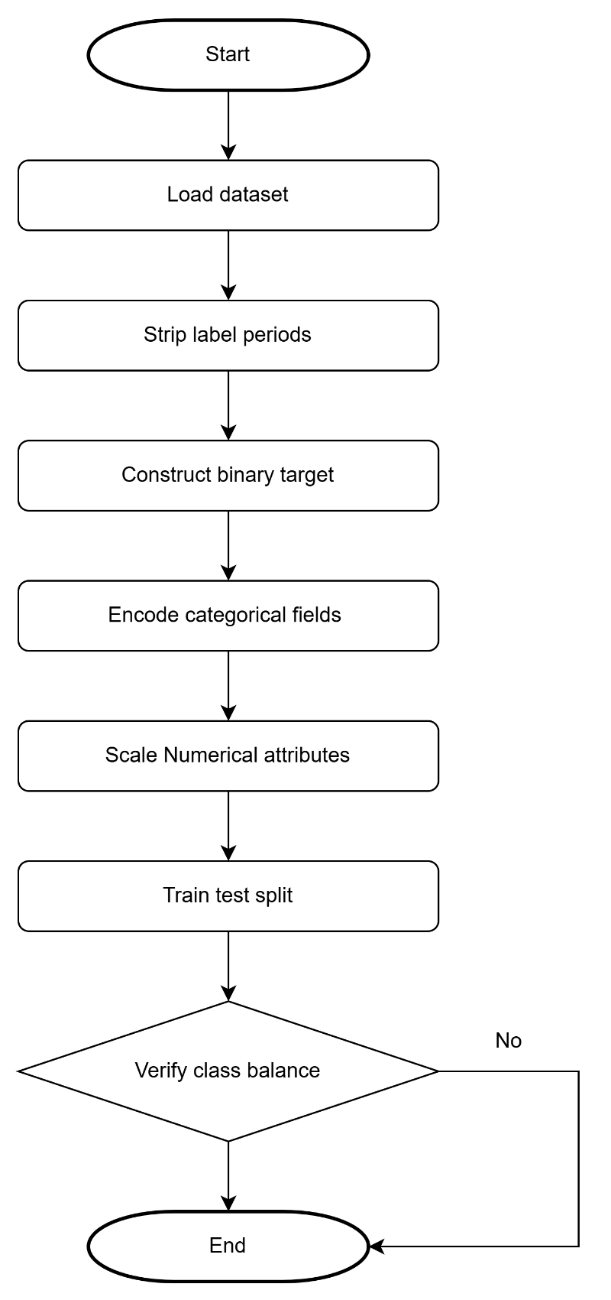
Figure 5. Flowchart of the data preprocessing

4.4 Evaluation Execution
The accuracy, confusion matrices, and ROC-AUC were used to evaluate model performance. Both Random Forest and Gradient Boosting were determined in terms of accuracy, and confusion matrice were used to point out the misclassifications, and ROC-AUC was used to assess the discrimination ability. Seaborn was used to draw the confusion matrices and matplotlib to draw ROC curves. The rank and plot of feature importances of the Random Forest model were done to determine which had the greatest impact.
Random Forest tuning was about 25 seconds, Gradient Boosting about 60 seconds and prediction times were negligible at both models and took an average of less than 0.5 seconds on 25,000 samples.

5. Results and Analysis
The experimental outcomes underscore the efficacy of the ensemble models, with both achieving exceptional detection rates on the test set. Detailed metrics, confusion details, and visualisations are presented below.

5.1 Performance Metrics
Table 2 summarise the key evaluation metrics for both models, computed on the test set of 25,195 instances. These values indicate near-perfect classification, with Gradient Boosting showing marginal superiority in recall and F1-score, reflecting fewer missed attacks.
Metric | Random Forest | Gradient Boosting
Accuracy | 0.99893 | 0.99917
Precision | 0.99940 | 0.99940
Recall | 0.99829 | 0.99881
F1-Score | 0.99885 | 0.99910
ROC-AUC | 0.99999 | 0.99991
Table 2: Performance Metrics Comparison

5.2 Confusion Matrices
Confusion matrices detail misclassifications.
Model | True Negatives (TN) | False Positive (FP) | False Negatives (FN) | True Positive (TP) | Total Misclassifications
Random Forest | 13462 | 7 | 20 | 11706 | 27
Gradient Boosting | 13462 | 7 | 14 | 11712 | 21
Table 3: Confusion Matrix Details
Gradient Boosting also minimised false negative by 30 per cent of random Forest, increasing sensitivity of attack detection. Figure 6 and Figure 7 have demonstrated Confusion Matrix Heatmap of both random Forest and Gradient Boosting.

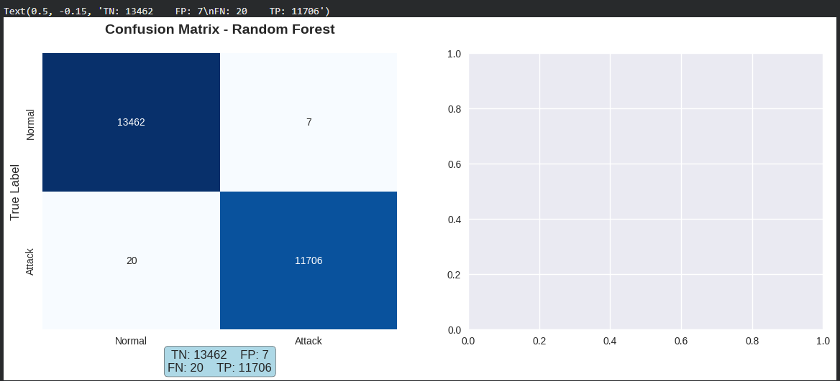
Figure 6. Confusion Matrix Heatmap for Random Forest

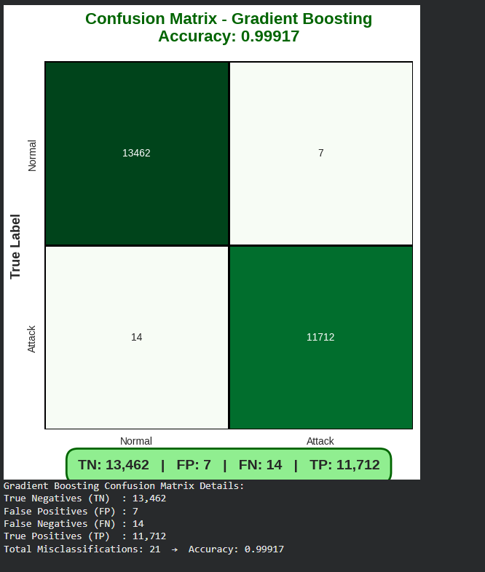
Figure 7. Confusion Matrix Heatmap for Gradient Boosting

5.3 Computational Efficiency
Random Forest proved more efficient in training, suitable for frequent retraining.
Model | Training Time (s) | Prediction Time (s)
Random Forest | 25.3 | 0.4
Gradient Boosting | 62.1 | 0.3
Table 4: Training and Prediction Times

6. Discussion
Those findings substantiate the strength of the ensemble method to perform intrusion detection and the accuracy of both the models was more than 99.8 which surpass the earlier standards like 99.5% of Accuracy when using a Random Forest over NSL-KDD [14]. Gradient Boosting reported a marginally better recall (0.99881 vs. 0.99829) that observed an extra six attacks on the test set that is significant in high stakes scenarios [16]. Its successive error correction probably allows the uncovering of hidden trends of attributes such as the one that is named as: dst_host_serror_rate [15]. The low number of false alarms represented by precision equivalence equal to 0.99940 and the low fatigue of the operator when dealing with IDS [11], whereas the candidates of precision approximately equal to 0.99940 has the high-level of discrimination [23].
Confusion matrices reveal the appearance of shared false positives (7), this could be due to probes being misclassified, which Gradient Boosting minimised false negatives, indicating it may be proficient in handling rare types of attacks, such as U2R [19]. Importance of the feature were centered on the values of src bytes and host values, as expected based on domain experience of the R2L and DoS attacks [24]; the greater sensitivity of Gradient Boosting could be due to the gradient optimisation [15]. Categories like service, flag were highly ranked, and they emphasised anomalies in the protocol [18].
We did not find a case of overfitting or underfitting the results were confirmed through stratified CV [25] with training and test accuracy values being quite close. The improved training time (25s vs. 62s) of Random Forest can be employed to advantageous edge deployments [26], whereas Gradient Boosting fits better to the centralised systems where the accuracy is the key. The age of the dataset, the absence of current threats in the dataset [28], simplified binary existence [20] and untested resistance to adversarials [27] are limitations. Future researchers may look into XAI to support transparency [29] and drift to identify changing threats [30].
Overall, these ensembles help to increase the accuracy and explainability of IDS, guiding the design of hybrid systems that combine ML and rule-based systems.

Conclusion
The paper shows that Random Forest and Gradient Boosting are effective in intrusion detection on NSL-KDD with the accuracy of 99.893 and 99.917, respectively. The notable indicators used by feature analysis are the source byte and host connections, which can be interpreted and show how the attacks were conducted. Gradient Boosting is sensitive and Random Forest is efficient, which suggests trade-offs of deploying. In general, these findings support the use of AI in creating robust IDS that can withstand fluid cyber threats.

References
[1] M. Tavallaee, E. Bagheri, W. Lu, and A. A. Ghorbani, “A detailed analysis of the KDD CUP 99 data set,” in Proc. IEEE Symp. Comput. Intell. Secur. Defense Appl., Ottawa, ON, Canada, 2009, pp. 1–6.
[2] A. L. Buczak and E. Guven, “A survey of data mining and machine learning methods for cyber security intrusion detection,” IEEE Commun. Surveys Tuts., vol. 18, no. 2, pp. 1153–1176, 2nd Quart., 2016.
[3] R. Vinayakumar, M. Alazab, K. P. Soman, P. Poornachandran, A. Al-Nemrat, and S. Venkatraman, “Deep learning approach for intelligent intrusion detection system,” IEEE Access, vol. 7, pp. 41525–41550, 2019.
[4] L. Breiman, “Random forests,” Mach. Learn., vol. 45, no. 1, pp. 5–32, Oct. 2001.
[5] M. Ahmed, A. N. Mahmood, and J. Hu, “A survey of network anomaly detection techniques,” J. Netw. Comput. Appl., vol. 60, pp. 19–31, Jan. 2016.
[6] M. Tavallaee, E. Bagheri, W. Lu, and A. Ghorbani, “NSL-KDD dataset,” Canadian Institute for Cybersecurity, Univ. New Brunswick, Fredericton, NB, Canada, 2009. [Online]. Available: https://www.unb.ca/cic/datasets/nsl.html
[7] S. Peddabachigari, A. Abraham, C. Grosan, and J. Thomas, “Modeling intrusion detection system using hybrid intelligent systems,” J. Netw. Comput. Appl., vol. 30, no. 1, pp. 114–132, Jan. 2007.
[8] J. McHugh, “Testing intrusion detection systems: A critique of the 1998 and 1999 DARPA intrusion detection system evaluations as performed by Lincoln Laboratory,” ACM Trans. Inf. Syst. Secur., vol. 3, no. 4, pp. 262–294, Nov. 2000.
[9] Verizon, 2023 Data Breach Investigations Report, Basking Ridge, NJ, USA, 2023.
[10] N. Shone, T. N. Ngoc, V. D. Phai, and Q. Shi, “A deep learning approach to network intrusion detection,” IEEE Trans. Emerg. Topics Comput. Intell., vol. 2, no. 1, pp. 41–50, Feb. 2018.
[11] M. Roesch, “Snort: Lightweight intrusion detection for networks,” in Proc. 13th USENIX Conf. Syst. Admin., Seattle, WA, USA, 1999, pp. 229–238.
[12] V. Z. Mohale and I. C. Obagbuwa, “Evaluating machine learning-based intrusion detection systems with explainable AI: enhancing transparency and interpretability,” Front. Comput. Sci., vol. 7, 2025, Art. no. 1520741, May 2025, doi: 10.3389/fcomp.2025.1520741.
[13] J. Zhang and M. Zulkernine, “A hybrid network intrusion detection technique using random forests,” in Proc. 1st Int. Conf. Availability, Rel. Secur., Vienna, Austria, 2006, pp. 262–269.
[14] I. Ahmad, M. Basheri, M. J. Iqbal, and A. Rahim, “Performance comparison of support vector machine, random forest, and extreme learning machine for intrusion detection,” IEEE Access, vol. 6, pp. 33789–33795, 2018.
[15] J. H. Friedman, “Greedy function approximation: A gradient boosting machine,” Ann. Stat., vol. 29, no. 5, pp. 1189–1232, Oct. 2001.
[16] M. Idhammad, K. Afdel, and M. Belhaddou, “Semi-supervised machine learning intrusion detection method for computer networks,” in Proc. Int. Conf. Wireless Netw. Mobile Commun., Fez, Morocco, 2017, pp. 1–7.
[17] M. A. Ferrag, L. Maglaras, S. Moschoyiannis, and H. Janicke, “Deep learning for cyber security intrusion detection: Approaches, datasets, and comparative study,” J. Inf. Secur. Appl., vol. 50, Feb. 2020, Art. no. 102419.
[18] S. Ganapathy et al., “Intelligent feature selection and classification techniques for intrusion detection in networks: A survey,” EURASIP J. Wireless Commun. Netw., vol. 2013, no. 1, pp. 1–16, Dec. 2013.
[19] A. Tesfahun and D. L. Bhaskari, “Intrusion detection using random forests classifier with SMOTE and feature reduction,” in Proc. Int. Conf. Cloud Ubiquitous Comput. Emerg. Technol., Pune, India, 2013, pp. 127–132.
[20] A. Javaid, Q. Niyaz, W. Sun, and M. Alam, “A deep learning approach for network intrusion detection system,” in Proc. 9th EAI Int. Conf. Bio-Inspired Inf. Commun. Technol., New York, NY, USA, 2016, pp. 21–26.
[21] J. Bergstra and Y. Bengio, “Random search for hyper-parameter optimization,” J. Mach. Learn. Res., vol. 13, pp. 281–305, Feb. 2012. [Online]. Available: https://jmlr.org/papers/volume13/bergstra12a/bergstra12a.pdf

[22] J. Wu, X.-Y. Chen, H. Zhang, L.-D. Xiong, H. Lei, and S.-H. Deng, “Hyperparameter optimization for machine learning models based on Bayesian optimization,” J. Electron. Sci. Technol., vol. 17, no. 1, pp. 26–40, Mar. 2019, doi: 10.11989/JEST.1674-862X.80904120.
[23] P. A. R. Kumar and S. Selvakumar, “Distributed denial of service attack detection using an ensemble of neural classifier,” Comput. Commun., vol. 34, no. 11, pp. 1328–1341, Jul. 2011.
[24] Z. Chiba et al., “Intelligent approach to build a Deep Neural Network based IDS for cloud computing,” in Proc. IEEE Int. Conf. Cloud Comput. Technol. Appl., Marrakech, Morocco, 2018, pp. 1–6.
[25] R. Kohavi, “A study of cross-validation and bootstrap for accuracy estimation and model selection,” in Proc. 14th Int. Joint Conf. Artif. Intell., Montreal, QC, Canada, 1995, pp. 1137–1143.
[26] A. Verma and V. Ranga, “Machine learning based intrusion detection systems for IoT applications,” Wireless Pers. Commun., vol. 111, no. 4, pp. 2287–2310, Apr. 2020.
[27] M. Rigaki and S. Garcia, “Bringing a GAN to a knife-fight: Adapting malware communication to avoid detection,” in Proc. IEEE Secur. Privacy Workshops, San Francisco, CA, USA, 2018, pp. 70–75.
[28] I. Sharafaldin, A. H. Lashkari, and A. A. Ghorbani, “Toward generating a new intrusion detection dataset and intrusion traffic characterization,” in Proc. 4th Int. Conf. Inf. Syst. Secur. Privacy, Funchal, Portugal, 2018, pp. 108–116.
[29] A. Adadi and M. Berrada, “Peeking inside the black-box: A survey on explainable artificial intelligence (XAI),” IEEE Access, vol. 6, pp. 52138–52160, 2018.
[30] G. I. Webb, R. Hyde, H. Cao, H. L. Nguyen, and F. Petitjean, “Characterizing concept drift,” Data Mining Knowl. Discovery, vol. 30, no. 4, pp. 964–994, Jul. 2016.

