Student Name: Ashleigh Steel
Assignment: Building EUC system
Course: Applied Computing
Modula: End User Computing
Submission Date: 10/05/2019

Table of Contents
EUC “Your Teeth Our Smile” 3
Introduction 3
Requirements 3
Excel or Access solution 3
Assumptions 4
User Guide 5
Dashboard 5
Patient Info 6
Room Info 7
Treatment Info 7
Dentist Info 8
Booking Info 9
Booking Data 11
Invoice Creator 12
Word Implementation / Invoice 13
Conclusion 14
Creation 14
Excel over access 14
Usability 14
Validation 14
Future 15
Bibliography 16
Appendix 17

EUC “Your Teeth Our Smile”

Introduction
I have been task to implement a prototype solution using a form of Microsoft software to allow them to work better at their dentistry. I’ll have to make sure after deciding on one, to at least use another software type for example us word for invoices to show its possible functionality. So using my previous assignment investigation I will design a prototype for “Your Teeth Our Smile” dentistry. Also as this is being used by users that may not have a great understanding of ICT or the chosen application this will be as user friendly as I can make it and will provided a user guide below to help instructed if any problems occur.

Requirements
- User Friendly
- Validated (prevent human error)
- Patient / Dentist System
- Booking System
- Invoice system
- Use of Excel or Access front end
- Illustration of Microsoft Word

Excel or Access solution
As spoken about in my last report, [1]Excel is better for more of a spreadsheet solutions while access is database orientated, so after beginning to design my prototype using excel and [2]access (see appendix image 1 - 2 referring to these images) I spent my first moments figuring out whether or not excel or access would be the better solution. First of all I stuck with access and build a mini functional input database (see appendix image 1) which access provides this quite easy to do features, then (See appendix image 2) created a relationship diagram to link all the tables to gather and its relevant, after this it came to displaying a format like calendar with bookings recorded, which at first I thought a simple quire would be the solution but ended up not being functional way of displaying this and so I turned to excel to see if the spreadsheet like system would be a better solutions and as I have had more experience using excel took on the using excel over access for now, but I would like to point out for the future of this system, once it the data storage becomes a problem, implementing a database alongside would be a create solution to this problem and would allow the system in building to see be relevant and extremely useful just as a front end source. So because of the design idea I had in mind, it looked more like a spreadsheet solution currently so Excel will be my chosen development path, but later on in its use, after accumulating mass amount of data, implementing a database software alongside this like access would be a good solution.

Assumptions
While developing this prototype I would like to point out a few assumptions along the way I have had to make due to not having contact with the dentistry:
- First of all I assume as this is a small dentistry and only have 10 rooms, there is only currently 10 dentist and so have tided them individually to each room, changes to the names are allowed via the dashboard and more rooms/dentist can be added if necessary if this could be a problem or plans to expand.
- [3]Next I have gathered common dentistry treatments from a website to show functionality in my prototype, these treatments and prices can be easily change via the dashboard encase any of these figures are way inaccurate or for future reference needed changing.
- Length of treatments are settable, and I have left it up to the user how long a treatment is rather than a set length as this could be there second or third visited and could just be a check-up or may require more time than what’s recorded in the treatment table, the length as be left their for ruff guidance for the receptionist, but for further bookings, times can be edited for each room.
- I have assumed the earliest the dentist begin to treat is from 8 AM and latest being 5pm for now, so changes after the prototype can be done in the room info sheet for each room.
- I am assuming for use of another software such as word, I have used word to illustrated printing invoices, so they are able to format the text, layout how they like. Request to change this after development can be done but for now I have assumed this was their intention.
- Lastly I have kept private rooms for overnight separate from the normal booking as this looks like this is provided if the patient has a late appointment and won’t be able to leave the dentistry due to their current treatment, so this could be added as a treatment so during the invoice the patient can be charge appropriately.
This is a prototype and I feel my assumptions are justified and any changes can be made during or after installation if needed with minimal effect required as I feel I have covered most, if not all bases of a dentistry database needs.

User Guide

Dashboard
First of all on launch you will be greeted with a dashboard that will allow you to navigate around the spreadsheet (image below). Each page will contain a button to allow you to go back to dashboard so you can continue to navigate the spreadsheet.
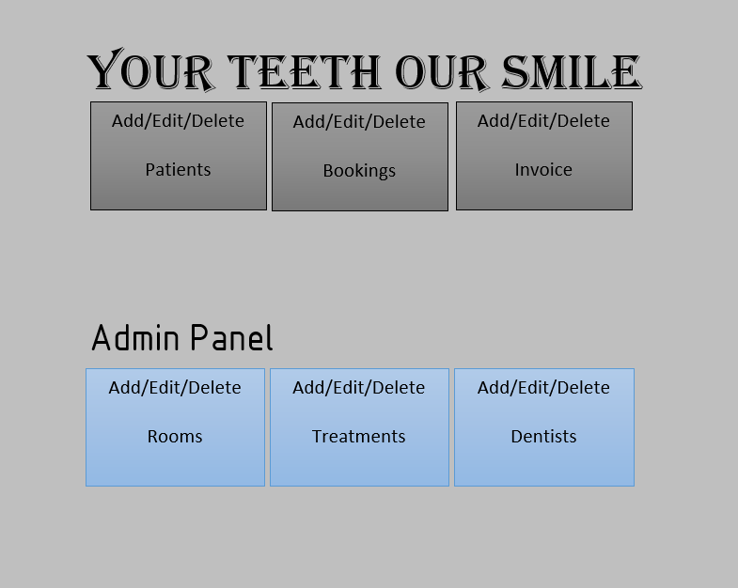

Patient Info
Next starting with Patient, you will be able to insert more patients using the “Add” button, “edit” to edit existing records after selecting them and “Delete” after selecting them, not selecting a record or inputting one of the data field incorrectly such as not using an “@” in an email will prevent the user from going on unless fixed (prevent input errors, you will find this throughout the Spreadsheet to prevent human error as much as possible).
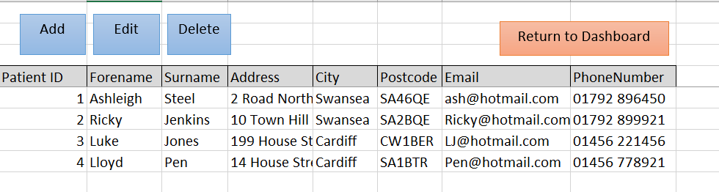
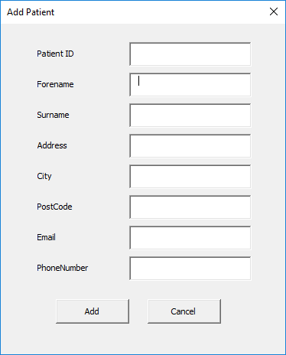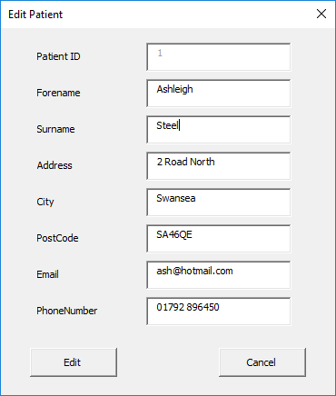
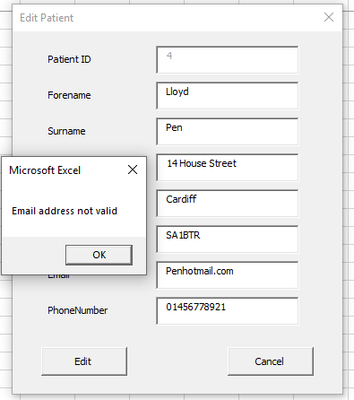

Room Info
Room will allow you to increase on the number given to me “10” currently encase you expand or would like to specific rooms differently, I have also allowed rooms to have a start time use and end time, with how long appointments will be in each room separately so currently I have made some example data to show this, but change this to how you see fit, this will allow you to add say your extra surgery room, and show for example below Room 7 will only have two for one booking Due to its length it takes to have said treatment and so on, “Edit”, and “delete” command will allow you to edit and delete theses as you see fit.
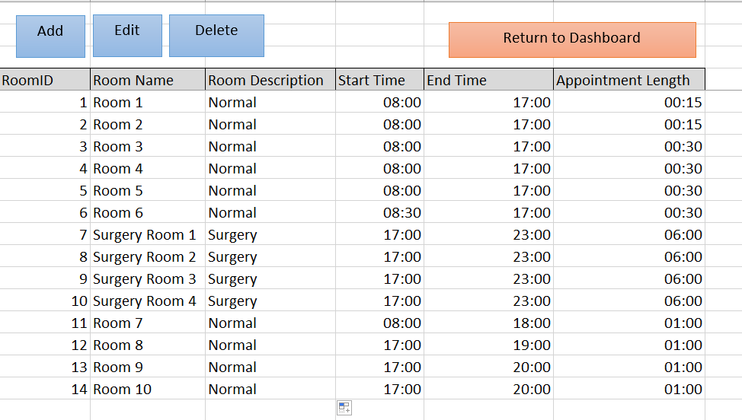

Treatment Info
Treatments will allow you to add all your treatments you provide at “Your Teeth Our Smile” with the same “Add”, ”Edit” and “Delete” functions, I know prices may change often, due to deals and so on so allowing the edit function is there to make such changes. The relevant use of keep this data sorted is to access it when creating any invoice after someone has had an appointment/treatment.
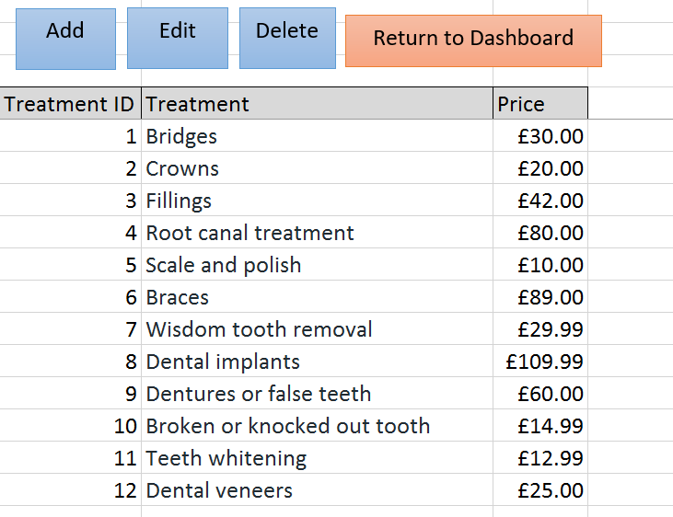

Dentist Info
Similar to patients, being able to insert the dentist Information here, allowing to add more, edit current or delete no more employed dentist, We have only required their email and phone number to allow this to be added to the Invoice section, So if the patient has any queries after appointments / treatments they will have a way to get hold of “Your Teeth Our Smile” more directly with those that provided the treatment.
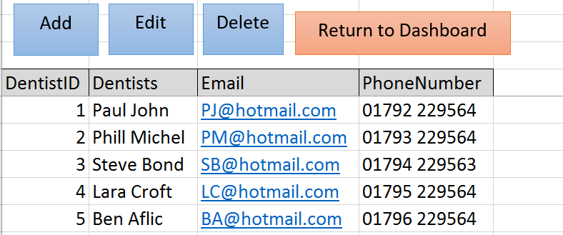

Booking Info
Here you will be able to first select a date and room for this appointment via “Select Date and Room” which will then populate the spreadsheet shown below with all the available times of the rooms and any bookings that are already taken (number of records will vary based on your information about the room). Date is in UK standard (validated was made to fix this, only happens if you run an American version of excel).
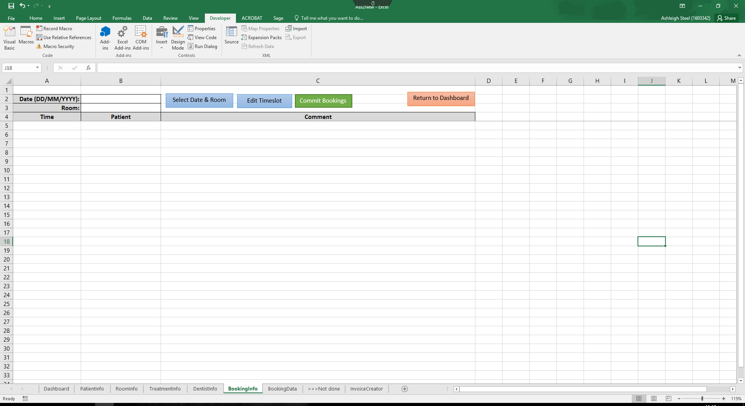
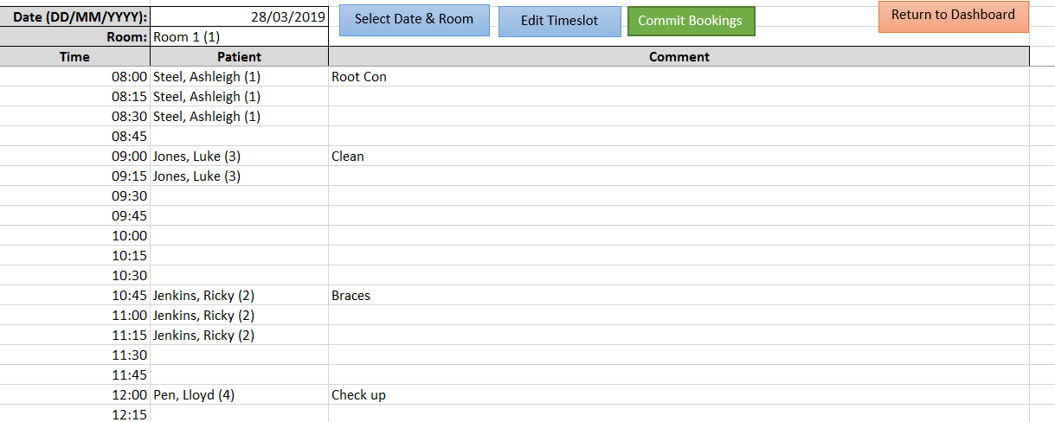
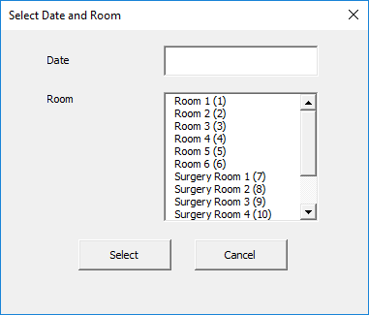
These can then be edited using “Edit Time Slot” based on what time you selected below (clicked) you can amend or add a booking to the time table. Once done clicking “Commit Booking” will save any changes made and will be stored in a separate sheet that can be called to again at any time.
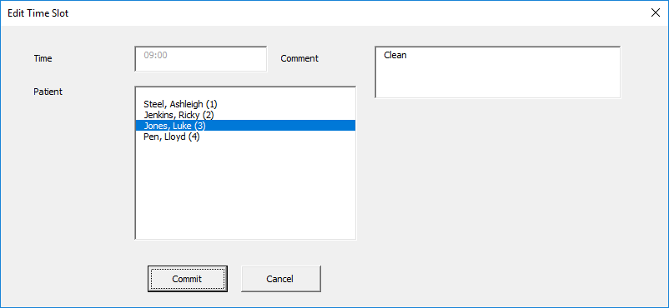
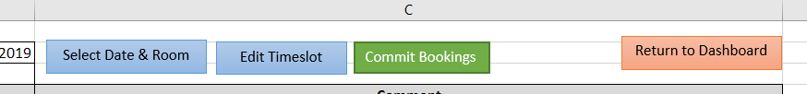

Booking Data
Here is where the data is stored after you “commit booking” any records, this will not be accessible normally unless you’re a developer, so I wouldn’t worry about this, your able to retrieve any data you want from the this sheet (bookings) using “Booking Info”.
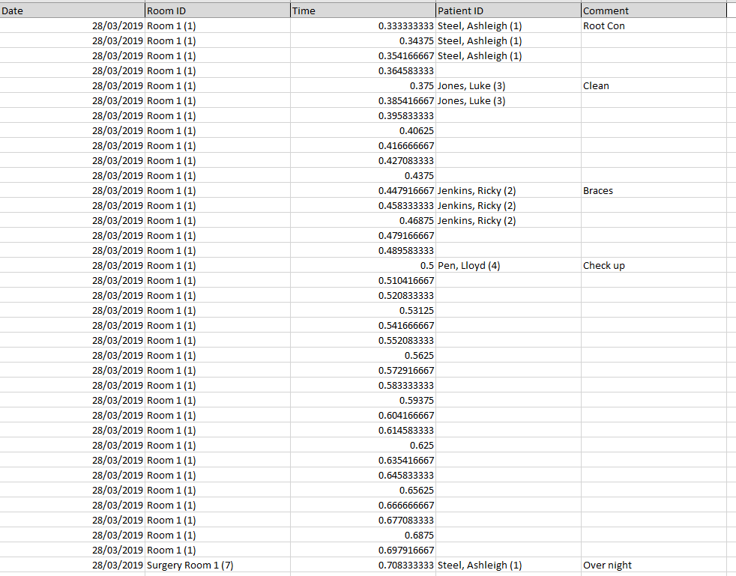

Invoice Creator
Here your able to select the patient, dentist and treatments they have had using the “create” button, this will retrieve all the relevant data needed to create an invoice and will total up the cost of all their treatments. Once inserted, print will take you to a word document where you then can save, print or use as you see fit as this was a required feature and how I feel you would like to store invoices.
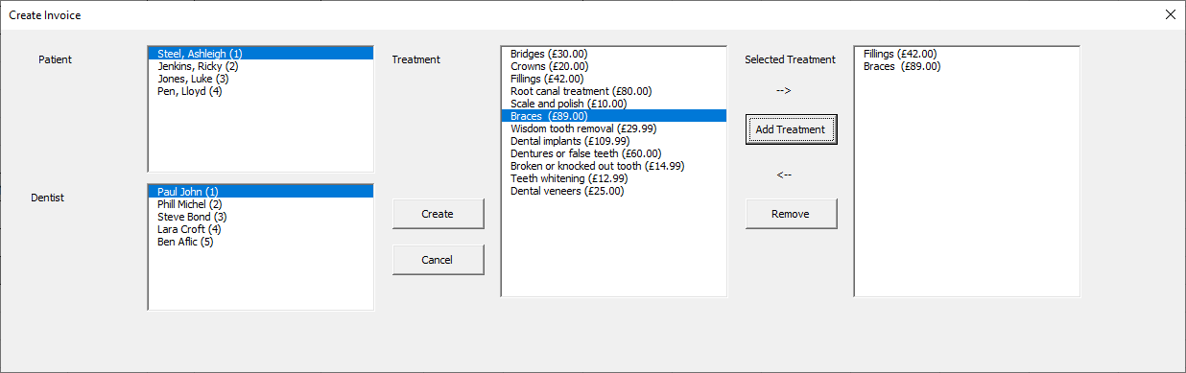
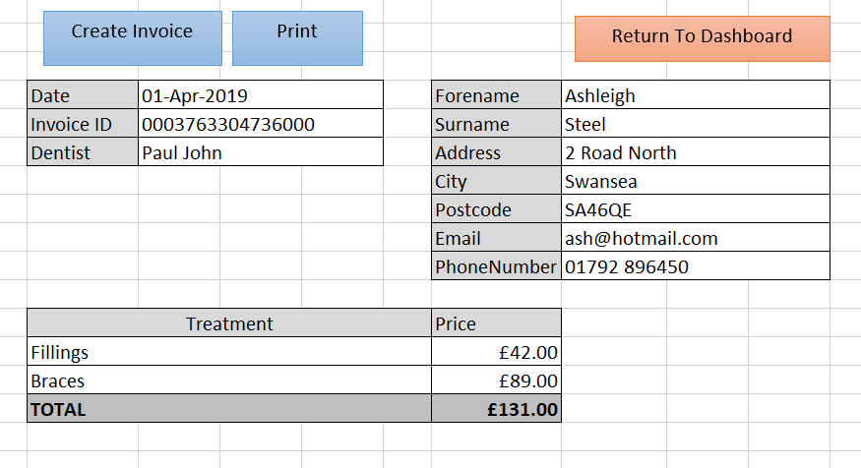

Word Implementation / Invoice
After clicking Print on the Invoice spreadsheet it will take you to a new Word document that the user can use to how they feel fit, perhaps implementing a formatting on word page and using this data across, this will always paste all the information selected prier on the spreadsheet
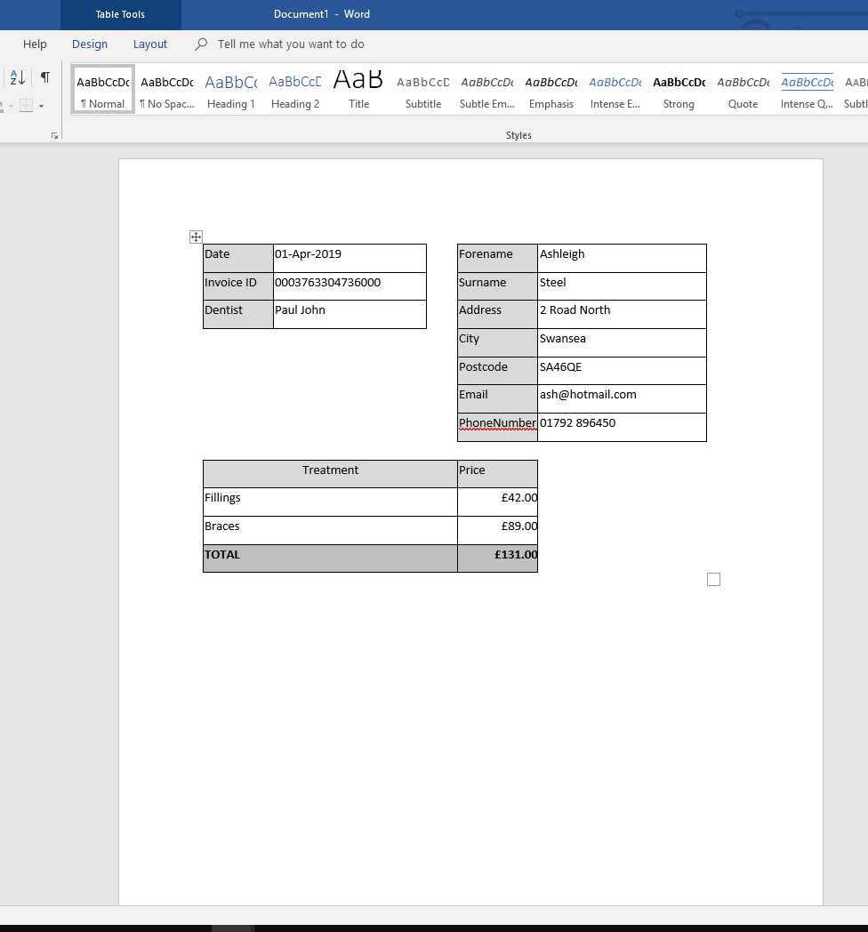

Conclusion

Creation
During the creation, I spent a lot of time choosing between accesses and excel, so after picking to stick with excel, I’m satisfied with what I have created, and feel this has plenty of future worth even once it begins to have problems with memory storage, implementing a backend storage would be the fix to this, leaving excel as the front end, access to the database. While using access or perhaps [4]SQL or any other relevant database solution (what’s available, price and so on) wouldn’t be a problem just more implementation would be needed.

Excel over access
I also feel using excel was a better choice for me in particular as I have more experience using this program and has used its coding features such as [5]VBA before while my access knowledge is a bit limited, this allowed me more time to make sure everything functions correctly and allow for further implementation if someone else was to use after I give this over (plenty of comments and quotations).

Usability
I have made this as [6]user friendly as possible by limiting the users input into the cells directly in excel and used forms which contain validation when relevant to prevent common human error, I have also allowed “ID” to increment on their own to prevent the user to create any duplicate data. Also when the data would continue to grow I introduced Freeze (see appendix image 3-4 for demonstration) so when having to scroll down mass amount of data, the title will still be shown so you can more easily tell what data is. Also with the implementation of word for the invoices, creating one document which then only changes based on the patient dentist and treatments made will save the user a lot of time having to manually change each thing and also help prevent human error, I have left the saving, printing functions to the basics of word as this is already a feature provided by the product.

Validation
During the creation, limiting human error is key feature when developing any user input system, so I implemented Validation when appropriate. I did have a few problems with validating a few input fields, and tried my best to make a work around, or try to prevent them for input incorrect data by making it only “text” or “number” or an input mask like (appendix image 5).

Future
The feature of this allows them to expand on this using a database behind it but also cause I’m allowing them to increase the number of rooms (more or less every forms of the dentistry) if they were to relocated or expand, the tools are already there to allow them to expanding on the database, room number, dentist’s and so on.
I feel if I had more time for implementing this system, and found a way to do this using access, the fact it’s a database solution would allow this to last longer without implementation, but I do feel other problems would have accrued [7]like the number of users accessing the system at once, access only allows a certain numbers to use assess before the system cant coupe anymore, while excel will just be saved regularly after use regardless of the number of people accessing it from a server.
Also if more experience with a dentistry and how it works may have change how I implemented this, from my current understanding on how “your Teeth Our Smile” will work, I feel I have covered what was required from me, but if I was able to speak to the users and see how they work, possible a better solution could have been made (perhaps a more user friendly system based on their feedback and so on).
Also before final implementation, settings are needed to be taken like hiding all the outside tools of the spreadsheet so the users only have access to all the tools I provided to them. Lastly If I was to continue improvements on this design, it would be to add less input fields for example have (see append image 6) Start time and End time could have been a drop down, so my validation problems could be solved much easier as a result, and this would reduce the use from imputing the same data for example “08:00” start for each room continuously.

Bibliography

[1] | Microsoft, “Excel,” Microsoft, ?? ?? ????. [Online]. Available: https://www.microsoft.com/en-gb/p/excel/cfq7ttc0k7dx?=&OCID=AID737190_SEM_htWEQ3a5&MarinID=shtWEQ3a5%7c328787878542%7c%2bexcel%7cb%7cc%7c%7c60301126743%7ckwd-715492038&lnkd=Google_O365SMB_Mixed&gclid=EAIaIQobChMIwc7s95yl4QIV77ztCh0a9Q5CEAAYASAAEgKeJPD_BwE. [Accessed 28 03 2019].
[2] | Microsoft, “Access,” Microsoft, ?? ?? ????. [Online]. Available: https://products.office.com/en-gb/access. [Accessed 28 03 2019].
[3] | Y. O. Health.ca, “Common dental procedures,” Ontario Dental Association, ?? ?? ????. [Online]. Available: https://www.youroralhealth.ca/dental-procedures98/common-dental-procedures. [Accessed 14 03 2019].
[4] | MySQL, “SQL,” MySQL, ?? ?? ????. [Online]. Available: https://www.mysql.com/. [Accessed 28 03 2019].
[5] | Excel easy, “VBA,” Excel easy, ?? ?? ????. [Online]. Available: https://www.excel-easy.com/vba.html. [Accessed 28 03 2019].
[6] | Techterm, “User Friendly,” Techterm, 29 01 2014. [Online]. Available: https://techterms.com/definition/user-friendly. [Accessed 28 03 2019].
[7] | RossBrinson, “Access Concurrent Users Limitation Solution?,” Microsoft, 08 07 2016. [Online]. Available: https://answers.microsoft.com/en-us/msoffice/forum/all/access-concurrent-users-limitation-solution/af4c6cbb-da4b-480d-93b3-0939989f5059. [Accessed 28 03 2019].

Appendix

1.
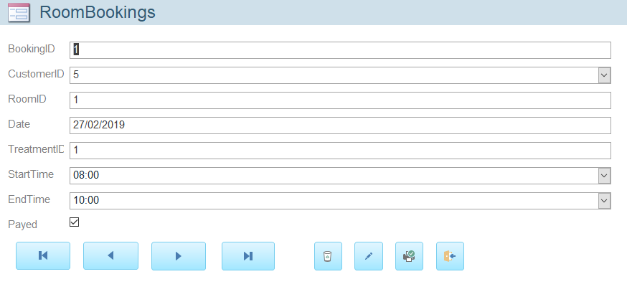
Here is access basic form layout to input data (records)
2.
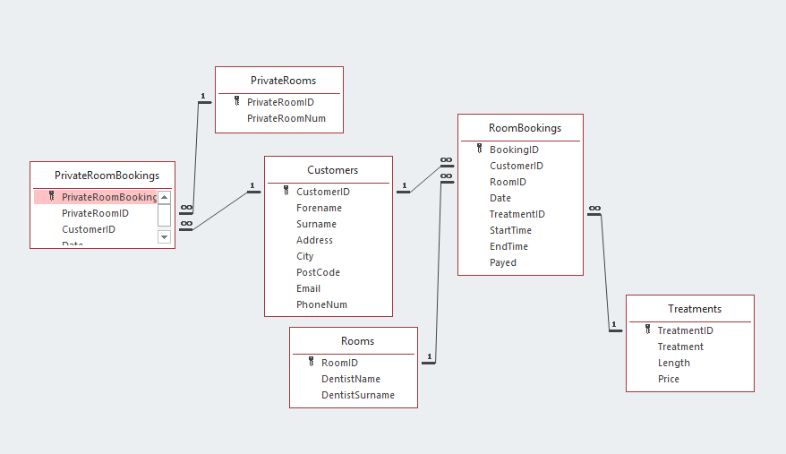
Here is showing the relationship built using access

3.
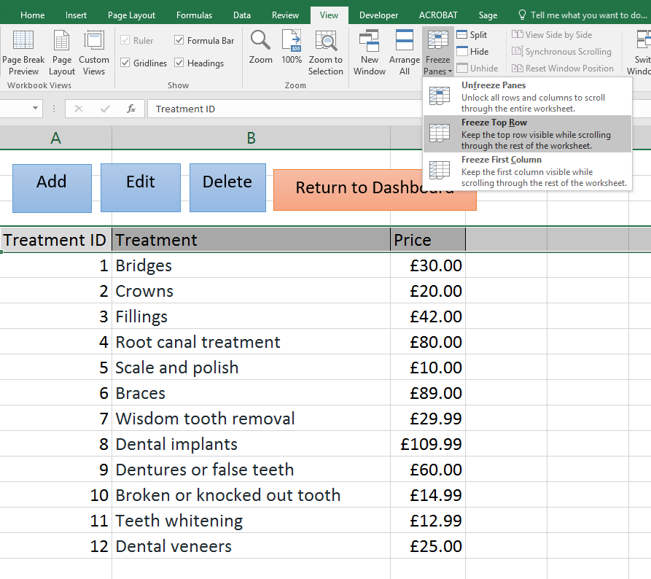
Before Freeze Panes
4.
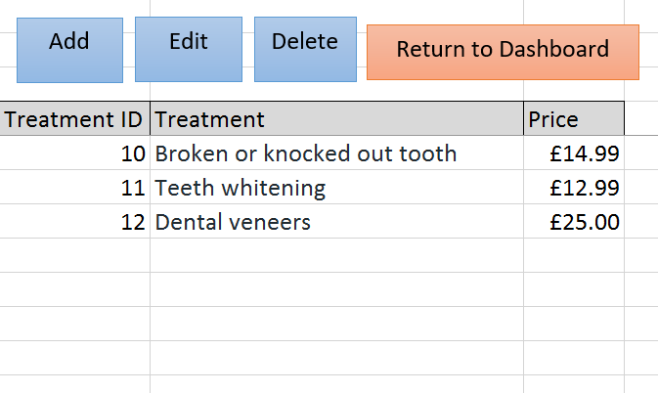
After keeps headers visible so data can still be understood

5.

6.
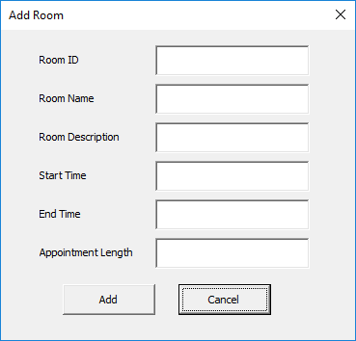
Start and End time could have been drop down, as this is a repetitive field, while appointment length could be perhaps calculated to fix a certain number of appoints etc.

