Lecturer: Dr Hossein Sokri

Student ID: 2009466

Assessment 1

Environmental Analysis of an industry

Contents
Introduction 3
Major forces that are affecting the Fashion industry because of the Pandemic 4
PESTEL Analysis of H&M 4
Political factors and Economic factors 4
Social factors and Technological factors 5
Environmental factors and Legal factors 6
Porter’s Five Forces Analysis of H&M 7
Rivalry 7
Threats of new entrants 7
Bargaining power of suppliers 8
Bargaining power of customers 8
Threats of substitute products 8
Opportunities and challenges in the fashion industry during the pandemic 8
SWOT Analysis of H&M 9
Strengths 9
Weaknesses 9
Opportunities 10
Threats/Challenges 10
Conclusion 11
References 12

Introduction
The current Covid-19 pandemic which was identified in Wuhan has created difficulties for the fashion industry. Most of the major players of this industry are facing a shortage supply of raw materials, less customer demand, etc. The fashion industry refers to the industry where the primary focus is to make clothes and deliver them to the customers. Since the fashion industry highly depends on individual customer demand, the industry has to face many difficulties in providing the optimal fashion to each customer. This trait has a positive impact as well since the businesses have to focus on individual customer demand, the demand is massive which means the businesses have wider opportunities of making a good profit. Everything was running smoothly until the current pandemic raised and the government had to close down all sort of business activities so that they can stop the spreading of the Virus. For this reason, the industry is facing challenges since the customers are not being able to purchase any products from the vendors (Chadha, 2020). Moreover, the manufacturers are not being able to produce anything because of the closure of all sort of manufacturing plants. This report is going to identify those factors that are impacting the industry because of the current pandemic and global market.

Major forces that are affecting the Fashion industry because of the Pandemic
The current pandemic has brought about the closure of every sort of manufacturing activities due to the lack of fabric availability and there have been many order cancellations throughout the pandemic. Since China is one of the major players that supply almost 50% of raw materials of this industry, the supply chain management has broken down since China is at the core of this Virus attack. Moreover, the distribution channel has broken down because of the retail stores' closure and the government has announced stay at home to keep the people safe from the virus (Black, 2020). Therefore, the customers are not being able to come out and purchase their desired products. Besides all the events that are based on promoting fashion products are not taking place for which the designers have no work to do which has forced them to design and to show their presence through online streaming which has been taken place without any live audiences. This current pandemic is going to reshape the fashion industry since many traditional retail stores have been closed down and the tendency of purchasing clothes frequently have become lower. Although there are some opportunities since the people have started using face mask all around the glove and the fashion brands are producing different style face marks and delivering them to the customers (Vybohova, 2020).

PESTEL Analysis of H&M

Political factors and Economic factors
The government of the UK announced a lockdown throughout the country for which all sort of stores and manufacturing plants have been closed down. Besides, the lockdown has brought about disruption in terms of supply of materials which is impacting the fashion industry much. The producers used to purchase their raw materials from China and some other countries what they cannot do now. Moreover, there has been massive job losses in this industry because of the store and manufacturing plants closure as a result of Governmental lockdown. The income level of consumers has become lower and they have less intention of purchasing frequently. In addition, the whole world is going through an economic recession where most of the countries are not being able to generate positive GDP growth rather than surpassing the previous year growth rate (McGinn, 2020).
Since the H&M is one of the major players in this industry and they tend to source the fashion items from countries like Bangladesh, Pakistan, Ethiopia, China, etc. the current lockdown imposed by those countries’ government have highly impacted the supply chain and the current economic downturn has brought about massive sales decline.
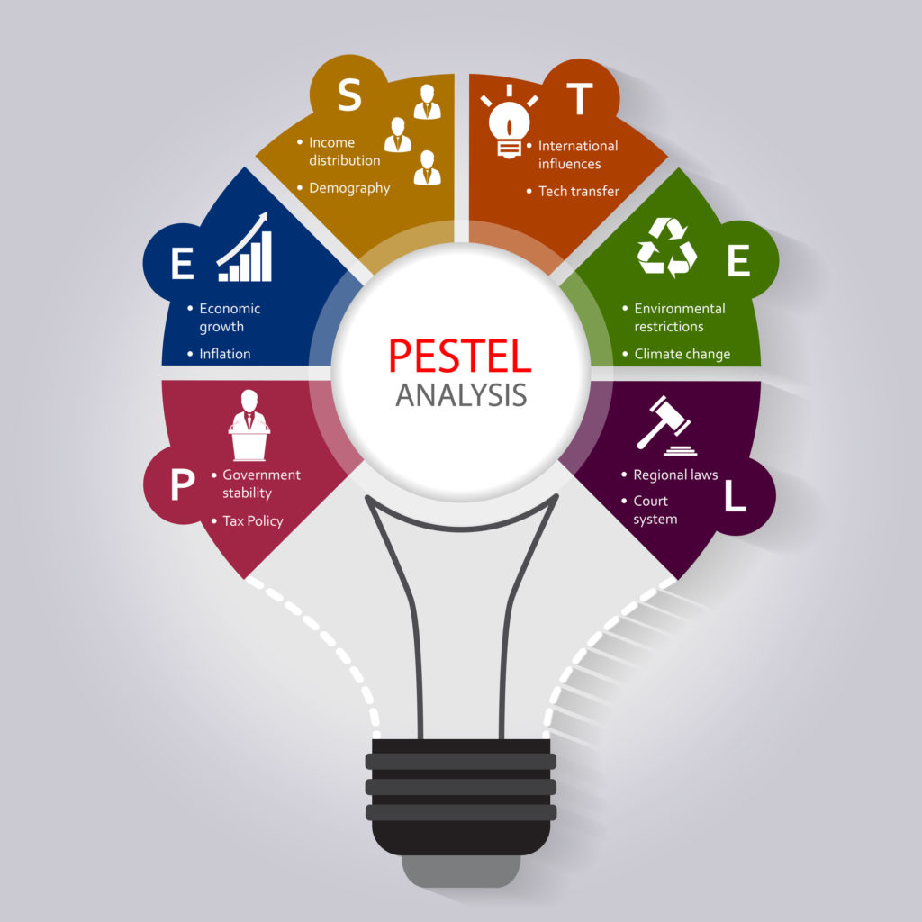
Figure 1: PESTEL Analysis (Bivolaru and Andrei, 2016)

Social factors and Technological factors
The current pandemic has a greater psychological impact on the customers’ mind which is forcing them to believe that the pandemic is not going soon and therefore there is a pessimistic market environment throughout the market. Moreover, the people are not going out because of the fear of getting infected and the current lockdown. The current job losses are forcing them to save money for the rainy days rather than spending the money by purchasing clothing items (BBC News. 2020). The technological industry has become reshaped in this pandemic since all the customers are staying at home and placing their orders online. This behaviour is forcing businesses to adopt online-based supply chain management. The businesses have to deliver the products to the customers’ home and so all of them are increasing their online presence to gain competitive advantages. Those who had an online presence before the pandemic are enjoying greater sales volume and greater customer satisfaction (v Stanciu and Radu, 2020).
Being a major player in this industry, H&M has both online and offline presence before the pandemic. This online presence has given leverage to the company. However, the current customer behaviour of saving money by reducing purchasing clothes frequently is impacting negatively to the business.

Environmental factors and Legal factors
During the lockdown, all the manufacturing plants were closed and so there was no pollution for which the environment became fresher which upgraded the environmental health. This scenario has made the stakeholders realise more clearly how dangerously the manufacturing plants of different industries were polluting the environment. So all sort of environmental organisations and concerned people are putting pressure on the fashion industry since this industry causes almost 60% of the world’s environmental pollution. The pandemic has also brought about many legal aspects such as hacking, e-commerce fraud, DDoS attack, etc. Since the businesses have adopted the online selling platform where the hackers have got opportunities to attack, the businesses are increasing their data security (Luomala, 2020). Moreover, the customer data and banking information are at a risk which the companies are trying to mitigating adopting various legal actions.
H&M sources its products from different under developing countries where the manufacturers do not bother about complying with the environmental and other legal aspects which is generating pressure to H&M since they are helping those manufacturers by sourcing items from them. Moreover, they have higher risks since currently, they are selling their products online and storing customers’ data and banking information that could be hacked.

Porter’s Five Forces Analysis of H&M
Porter’s five forces model describes a thorough understanding of various external factors that affect the company directly or indirectly (Cohen and Cyert, 2017).
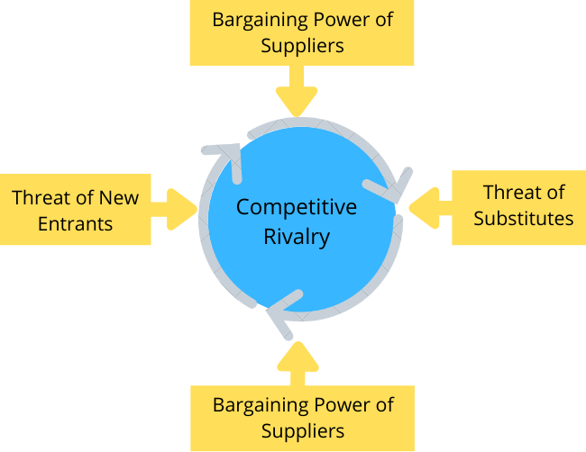
Figure 2: Porter’s Five Forces Analysis (Blundell, 2019)

Rivalry
Since the demand has fallen because of the current pandemic, all the major players of the fashion industry are going after the small group of customers to attract them to purchase from them. Therefore, the competition among the rival firm has increased dramatically. Moreover, due to the pandemic, fashion brands like H&M is not incurring any fixed cost in the form of warehousing or machinery depreciation what they use in terms of delivering items. So, the overall cost has declined so many companies are being able to deliver products at a convenient price. So, the competition among rival firm is intense in this case (Gabbott and Hogg, 2018).

Threats of new entrants
Previously the newcomers needed massive investment and due to the economies of scale of major market players, their chance in this market was less. However, in this pandemic, the online business has seen its peak and it does not need massive investment and therefore more new businesses are coming to the market and have made threats for the fashion brands like H&M.

Bargaining power of suppliers
Because of the current lockdown, all the manufacturing activities are closed down in every country which has made the suppliers of H&M more powerful. They have increased the price and the brands have nothing to do without purchasing the products with the demanded price. So, the bargaining power of suppliers has increased in this pandemic (Luomala, 2020).

Bargaining power of customers
During the pandemic, many new businesses have entered the market because of the easy investment opportunity with the help of the online market. Since the customers have numerous options, their bargaining power has increased. Although H&M is an established brand, their products’ price is higher and in this current situation, customers are not willing to spend more money in purchasing clothes with the higher price. So, from an H&M point of view, the bargaining power of the customers is high which the brand has to face by adopting different designs and trends (Belhadi and Kamble, 2020).

Threats of substitute products
The threats of substitute products in the fashion industry vary among numerous segments of the market. For instance, H&M, M&S is in the high-end segment where the brand Zara has a pricing strategy for the lower-income customers mainly. Currently, Zara is marketing high-end products due to the success in their segments which creates threats of substitution.

Opportunities and challenges in the fashion industry during the pandemic
Opportunities and challenges can be identified by using the popular tool named SWOT analysis. Which will describe these aspects that the companies are facing currently (Bivolaru and Andrei, 2016).

SWOT Analysis of H&M
SWOT analysis of H&M describes the internal strengths and weaknesses as well as the external opportunities and threats. All these aspects in terms of the current pandemic have been outlined below:
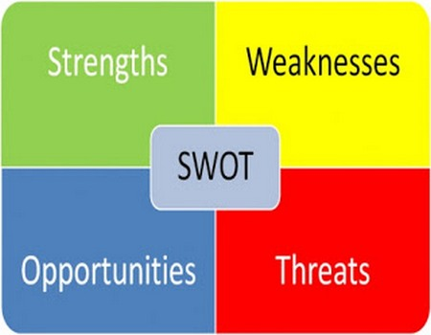
Figure 3: SWOT Analysis (Bivolaru and Andrei, 2016)

Strengths
H&M has a massive amount of investment which gives the brand a strong financial position in the market. Moreover, the brand has a large number of stores throughout the UK that are generating much profit each day although currently, those stores are mostly closed. Its main strength is its brand name for which the customers make their purchasing decision. H&M always responses to the current trends and fashions which has given the brand a competitive edge (Belhadi and Kamble, 2020).

Weaknesses
H&M has much involvement in the manual process rather than technology adoption which is the primary weakness of the brand. Most of the sales are incurred through offline stores which in this pandemic cannot be possible. Moreover, the brand cannot penetrate the foreign markets since it is concentrated in the UK highly. If any changes have occurred in the behaviour of the UK customers, they will be in great trouble since they have limited operation outside the UK (Stanciu and Radu, 2020).

Opportunities
H&M has the opportunity to strengthen its online presence since the future market will be based online. The brand can boost its sales through social media marketing since almost every customer uses social media several times a day. Besides, due to the current business environment, the government of the UK is allowing businesses to take the loan with a lower interest rate which the brand can utilise (Chadha, 2020). H&M has the opportunity in terms of investing in augmented/virtual reality since people do not have any option to know how well they look after wearing certain clothes and currently the customers are purchasing from staying at home. So, if the brand can establish this feature, it will be able to attract more customers.

Threats/Challenges
Because of the current pandemic, the disposable income of the people has decreased dramatically since people are becoming jobless. This decline in income is a challenge for the brands line H&M since the people are not spending much by purchasing clothes. Moreover, because of the circular economy, all the shareholders are thinking that the brand will lose its profitability which will hamper them much. Besides, managing the workplace in this current pandemic is the key challenge for H&M since all the employees are working from home. Since many tasks need the physical presence of the employees, they are facing trouble to accomplish such tasks (Black, 2020).

Conclusion
The Pandemic has revamped the fashion business thus both the CHM and clients' demand has changed significantly. For instance, the interest in garments that are utilized on exceptional events like weddings, get-away, meetings and so forth have diminished since individuals are remaining at home and tackling their errands sitting at their home. The fashion designers are adjusting with creating and displaying their style things through the online introduction and now and again having no live crowds. In April 2020 The British Fashion Council declared that the committee would coordinate a digital cultural fashion week where the fashion designers would have the option to show their plans and forms without organizing any design show. Shanghai and Moscow have likewise coordinated such advanced introductions that have changed the sector

References
BBC News. (2020). Coronavirus: H&M to close 250 shops as Covid drives sales online. [online] Available at: <https://www.bbc.com/news/business-54369802> [Accessed 6 April 2021].
Belhadi, A., and Kamble, S., (2020). Global supply-chain effects of COVID-19 control measures. Journal of Marketing, pp.2-9.
Bivolaru, E., and Andrei, R., (2016). International business. Sage.
Black, S., (2020). Will COVID-19 support the transition to more sustainable fashion industry? Journal of European Business Research, 16(1), pp.231-258.
Blundell, R., (2019). Consumer behaviour & marketing strategy. 13th ed. London: Pearson, pp.121-138.
Chadha, D., (2020). The Impact of COVID-19 On the Fashion Design Industry. [online] Entrepreneur. Available at: <https://www.entrepreneur.com/article/350190> [Accessed 6 April 2021].
Cohen, K.J. and Cyert, R.M.., (2017). Controlling for competitiveness: Strategy formulation and implementation through management control. Copenhagen Business School Press DK.
Gabbott, M. and Hogg, G., (2018). Supply chain strategies in the UK fashion industry—the competition among major players. Journal of Management Professionals, 3(7), pp.423-458.
Luomala, H.T., (2020). Governance of sustainable supply chains in the fast fashion industry during the Covid-19. Journal of Global Apparel, 14(1-3), pp.109-132.
McGinn, D., (2020). What Did 2020 Do to Retail? [online] Harvard Business Review. Available at: <https://hbr.org/2020/12/what-did-2020-do-to-retail> [Accessed 6 April 2021].
Stanciu, S., and Radu, R.I., (2020). Impact of Covid-19 on consumer behaviour: Will the old habits return or die? Journal of Business Research, 114, pp.241-263.
Vybohova, M., (2020). Council Post: Adapting To Uncertainty In The Fashion Industry. [online] Forbes. Available at: <https://www.forbes.com/sites/forbesbusinesscouncil/2020/10/13/adapting-to-uncertainty-in-the-fashion-industry/?sh=f4a6c7f4706e> [Accessed 6 April 2021].

