James Dunhill

Internet Technology and Security

Internet Technology and Security

Abstract 3
Introduction 3
CHAPTER 1 4
Types Of Policy 4
CHAPTER 2 6
Data Flow Diagram 6
CHAPTER 3 8
Cisco Packet Tracer 8
Advantages and disadvantages 9
Advantages 9
Disadvantages 9
CHAPTER 4 10
What If & How? 10
Conclusion 11
References 12

Abstract
This report is focused on security policies and BYOD (bring your own device). These two go together and are mentioned throughout the core topic of this report. One of the first stages of developing a company's security is to have a thorough policy in place. This report will talk about the importance, and the concerns that is addressed to security policies in this study. There will also be examples on how poor writing can result in misleading users and the way systems are operated.

For the BYOD (bring your own device) section, This report will examin in detail how it can be an advantage and a disadvantage to a company or organisation trying to support this new method, it will take into consideration or various factors with wired connections and wireless connections as well as the security. However, the focus of this topic and this research paper is looking at the security policies for bringing your device.

Introduction
Security policies are critical to a company and are crucial for ensuring the security of the network is kept safe. Computer networks are typically built from the policies specifically written for it. when they started this way, they are entirely in line with everything the policy mentions. This is the fundamentals of the network. There is a table of context above showing the layout of this report. Chapters 1 till 4 contains all of the information for this report. It has been broken down nicely to show different sections that would be more fitting for its area to read.

CHAPTER 1

Types Of Policy
Inside any company of size, you'll find different types of policies. For example, user policies, device management policies and the most important, security policy. Together these are the most common policies found and make a massive difference inside of the organisation.

What is a security policy? [1] This describes what policy is to its most exceptional core.

“A security policy is a document that states in writing how a company plans to protect the company's physical and information technology (IT) assets.”

Depending on the company and the organisation that the security policy is placed in, can very on the contents inside for the reason of it can't be defined to every company. As each company has their standards and rules that they follow. Although they should still follow a common ground for what the policy built on that every policy should contain, below is a list of bullet point that contains some things that would be at the core of the policy.

- Availability - Access to the system with authorisation allowing full-time connectivity.
- Confidentiality - Protecting the documents and resources from unauthorised users
- Integrity - Protecting that all information with resources that is done correctly with an authorised user.

The security policy is referred to as a living document, and the reason for this is because it continually updates with new policies. This is down to having new laws that are coming from the government which has ruled companies to update their policies. For example, the new GDPR forces companies to update their documents to be compliant with the law, but there is a specification to this of any company policy that is made, and they should address the following[2].

- Intention
- Scope
- Particular Goals
- Responsibilities

Security policies are designed to try and cover a lot of the company's network and systems in place, but they cannot be designed to fit everything into one policy. This is why there are multiple policies created for a different area in particular.

IT Governance, Risk, and Compliance - This is a compliance policy that you find inside the company and uses to defend them self in any situation against that concerns the law.

Project and Change Management - When any changes to roles whether the staff member is being promoted/demoted or even leaving the company, the permissions for the person in question must also change to ensure that they have access to the correct level of data that is relevant to what their role is within the business.

Availability management - This policy covers disaster recovery areas and business continuity to make sure operations continue to work in case of situations that may cause disruption.

Acceptable Use - This policy is used to cover internal email and computer usage. This is what new employees would sign when they start working with a company, so they do not abuse their company privileges.

Information Security - This has already been discussed, but it primarily Focuses on maintaining and managing the protection of the information on the network that belongs to the organisation.

Information Management - This Focuses on managing data that is used and maintained by the company such as its retention and destruction.[3]

When looking into the security policies, a part of the policy for most companies of any size has a section that talks about employee training on security, this would be training given to employees to show them how to use their devices safely in a working environment. The main idea is to stop them from causing viruses or malicious intent allowed into the network stopping them from taking the network down or potentially making a spam network.

CHAPTER 2

Data Flow Diagram
This data flow diagram is used to show the process of when a wireless device has connected to a network and the steps it has to follow for it to allow granted access. This is a dfd that has been designed for the company hyper-fort to show how it could protect their network from outside devices, This would also include their employees when bringing their devices to work.

The process is straightforward as it automatically asks for a username and password when they request to log into the network. If their details are not correct it should ask the user again to log back in and retry. With the correct details it should give them success to log in, then it prompts the user to install software that checks the system against criteria that would be in policy from the company.
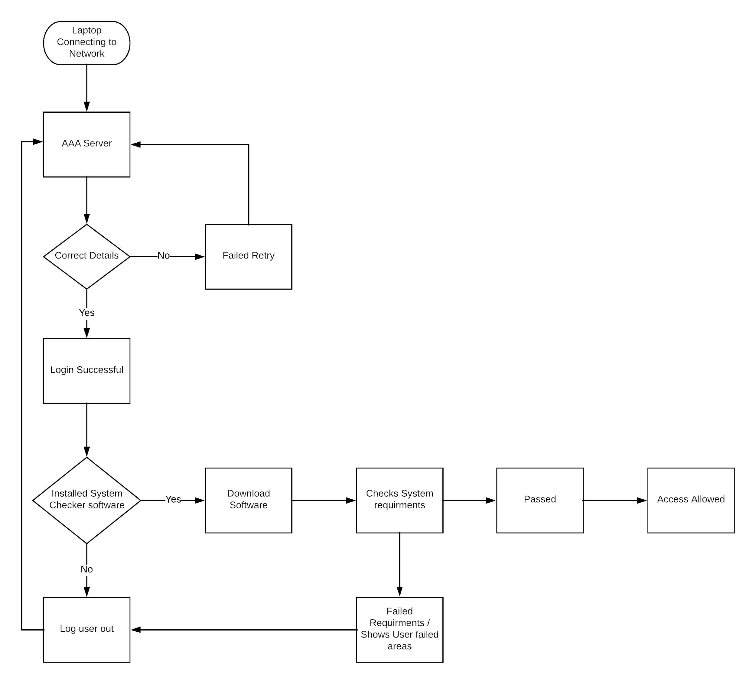
The system software checks for vulnerabilities in the system, making sure the operating system is up to date and has anti-virus installed. If no viruses or other threats are detected, and have all the right tools for their department, it then grants them access to the network. If it should fail, it logs them out, but also show them a list of things they need to follow to get access into the network.

CHAPTER 3

Cisco Packet Tracer
A packet tracer file was created and uploaded separately with this document. The packet tracer file contains a network design that would meet the requirements of what the company has asked for, in addition to this there are also extra areas that have been added for demonstration and purposes only, but the main focus is on the Hyper-Fort network that has been applied.

Packet tracer is showing that the network is developed to support Cloud services for external companies. As part of the bring your own device, some services should be disabled while in work, for example, personal email blogging having social interactions with people on social media sites. This could be achieved by making them create a new account, having that as a work only account, or merely having the device which is connected to the network and using the software to disable everything until they leave the network. These are personally two different options that the company could take when coming to restrict users from using services that could affect their work inside the work hours of a company.

When the practice of bringing your own device to work meant that employees could work from home and in the office with the same device, brought around a concern with security. The reason for this is at home, the company has no control over your device protection. It could get infected, and when connected back to the company network, it would infect the whole system. The mobile device management software became a popular option for companies that have this practice inside their organisation.

When it comes down to picking mobile management software, there is a variety to pick from, and it can make it very difficult to decide which one you want. You'll have a lot of similar features but also some very independent features, which can make it difficult to choose. [4] The recommendation would be Cisco Meraki for a few good reasons that follow in bullet point:

- The Cisco software can be integrated with its hardware better,
- It can be configured across all devices and work from a central point in the network
- It contains an onboard content management
- It allows for scalability
- It can analyze the network with automatic reporting and email delivery
- A new type of device that connects apply policies to certain devices
- It applies a strong encryption service

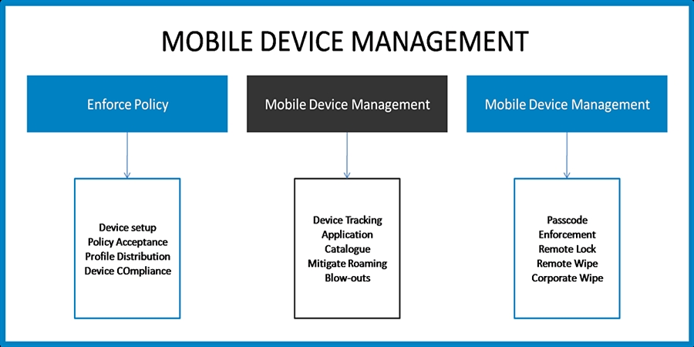
Credits: Nestweaver.com

Advantages and disadvantages

Advantages
- Cost Effective - Companies that employ staff to bring their own devices to take full advantage of how cost effective is it for users to run their own devices without them having to spend money on computers and maintenance.
- Flexibility - Employees that can work around the clock are a great resource for employees and this allows them to work more efficiently as well giving them a better workflow.
- Increased Productivity - Having employees use their own devices should increase productivity by a significant amount for the reason of they can use their own devices whenever they want. Which includes working out of hours and could feel more comfortable doing work on their own device. This means there could be more productivity for the company. [5]

Disadvantages
- Security - This is one of the most significant problems that a company has to face when dealing with BYOD, For example, If the user loses the device, the user has their device hacked from a home network, or the device has been stolen. These could cause the company big problems as this would come under a breach of data.
- Supporting Various Devices - If there are many users bringing their own devices, this would lead to the network having to support various devices from different brands and manufacturers, and it would unlikely be able to support every one of them leaving some employees unable to bring their own devices, defeating the entire point.
- A large Amount of growth - With large amounts of users on the network potentially adding at least three to four devices, most companies would not be able to support this amount of devices as their infrastructure would not be able to cope with the amount of data going through, This would lead to bottlenecking or crashing making downtime.[6]

CHAPTER 4

What If & How?

The information that the device retains from the network is local files that would document Microsoft Office Word or Excel files, potentially project files from group projects and emails that are being sent around from employees. All so any software that the company has given the user to work with on their device as well.

When an employee leaves the office with their device, there is a chance of losing or having that device stolen the moment they walk out the door. There is a significant potential data breach as they instantly have lost all their data for work; also they could get a virus from the home network which is potentially less secure than the office network.

When it comes to using personal devices in the office, there should be two accounts on the user's computer. The work account and a pleasure account.This way they can disable all social and other services on the work account and have the pleasure account with all the services enabled this allows them to have a work environment with no distractions from their personal life.

Dealing with different brands that have different devices of the same type can make it difficult to work with, this is why the company use a universal software package so that it should be able to cover a majority of the devices. This way it should be able to catch at least 95% of the items in the network. The rest can be filtered out by policy only allowing certain devices into the network making employees use certain devices that the company can operate with, but also at the same time being fair by picking the most significant brands that are the most common to come across. It would also cover operating system platforms as well and deal with applications on other devices the software management tool would be able to handle a majority of these problems.

Before devices are allowed to be taken out of the office building, all laptops are encrypted, with the work data that's on. If the device goes missing, the worker has protection on the device which will make it very difficult for thieves to try and gain access, and if it does fail they should be able to try and gain the backups from the work side of the PC, but all personnel would be down to the employee responsibility. If the employee does leave the organisation and no longer works with them in any way, they have to have their computer scanned and checked for any data that could be left behind from the company. Moreover, The work account on the PC will be deleted and removed and the PC should go back to the employee with just a personal account on it meaning that the PC is no longer a work PC, but just for the employee's usage. This would include all licensed software and license keys that may be attached to that computer as well that they have primarily been granted access for work.

Conclusion
This report has concluded on enough research to display that security is very important inside a company and looking into this, it is clear to see that bringing your own device to work is much more work on the company in term of keeping every device safe. The research into the mobile software has displayed an understanding that there are options out there to make devices secure on the network and it is possible to run this type of workspace and environment.

For the company to run this type of workspace environment, it needs to put forth a good policy on Internet Security. This is crucial for maintaining a secure network by using the mobile software management tools that helps all the devices on the network be more secure.

- Strong policies
- Advanced management software for mobile devices
- A good floor plan for the network design in security
- Having good backup procedures
- Employee training

References
[1]
M. Rouse, “What is security policy?,” searchsecurity techtarget, 01-May-2007. [Online]. Available: https://searchsecurity.techtarget.com/definition/security-policy. [Accessed: 22-Dec-2018].
[2]
“What is an IT Security Policy? - Palo Alto Networks,” Paloaltonetworks.com, 01-Jan-2018. [Online]. Available: https://www.paloaltonetworks.com/cyberpedia/what-is-an-it-security-policy. [Accessed: 22-Dec-2018].
[3]
Michalsons, “Types of IT Policies,” Michalsons, 01-Jan-2016. [Online]. Available: https://www.michalsons.com/focus-areas/information-technology-law/types-of-it-policies. [Accessed: 22-Dec-2018].
[4]
FinancesOnline, “20 Best Mobile Device Management Software in 2019 - Financesonline.com,” Financesonline.com, 14-Dec-2018. [Online]. Available: https://financesonline.com/mobile-device-management/. [Accessed: 23-Dec-2018].
[5]
B. Roth, “EZComputer Solutions,” EZComputer Solutions, 05-Feb-2018. [Online]. Available: https://www.ezcomputersolutions.com/blog/the-pros-cons-of-byod/. [Accessed: 23-Dec-2018].
[6]
Optimus Learning Services Limited, “The Advantages and Disadvantages of BYOD - Optimus Learning Services,” Optimus Learning Services, 04-Sep-2013. [Online]. Available: https://www.optimuslearningservices.com/practical-ld/advantages-disadvantages-byod-in-learning/. [Accessed: 23-Dec-2018].

