

Assessment 2

Student name:​ Jamal Sesay
Student ID: ​1919235
Module name: Mental Disorders and Psychopathology​
Module code: BMHP6006
Lecturer name: Bianca Sanfilippo ​

Table of Contents
Introduction 3
General Anxiety Disorder 4
Schizophrenia 7
Autism 11
Definition 11
Conclusion 14
References 14

Introduction
There are different types of diseases that affect the people and hamper their daily lives. It has been known widely to look for the different possibilities which has been affected because of the situation and concepts of these diseases have a long-term effect. With a view to develop such prosperities it has been known to secure the position of the people who have been affect by any of the disease and living a hard time in their life. The purpose of this report is to investigate the matters that are related to the main three mental illness such as general anxiety disorder, schizophrenia and autism. All these are equally harmful, and it needs to be relieved to have been developed under the correct opinions.

General Anxiety Disorder
It is one of the most common disorders that is found in the people nowadays. Day by day the chances are increasing, and it has been on the alarming rate for the overall situation that is to be linked for the better conditions and situations in a new level. Throughout the conditions and the challenges, the meetup conditions are related to maintain throughout the possibilities to work as the detailed situation to which the general anxiety which has become a decent criterion in this field that the outcome may have been secured to get through the best during the situation to look into the matters that are most suited to this unique platform (Ahern, K. R., Dittmar, A. K., 2012).
What is general anxiety disorder
In simple words, the expressions are most suited to make through the best of the actions and there are some options to be linked during the connections which have been made in this portion. The options that are fully selected in the anxiety disorder that it affects the mind of the person and there may be some possibilities to ensure the proper usages which is to be directed and selected for the situation to look after. This happens because of the current situation which is mostly because of the surrounding platforms that are connected to make the way through the most suited platform and learn from the general anxiety disorders (Egan, J,, 2004).
People suffering general anxiety disorder in the UK
In UK there are many people who are suffering from the condition of anxiety and day by day it is only increasing at different situations. By the platforms and estimated time connections the overall responsibilities to make the difference in the suffering situation of people has been increasing. It has been a wide variety of option to look into the positive matters that is best suited to look for the progressive matters and the situation of anxiety has been a downfall for different part of the nation.
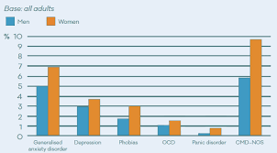
Figure: Percentage of people suffering from anxiety (Cook, R. A., Hsu, C.H.C and Taylor, L. L., 2018)
Cause of anxiety
There are different causes to anxiety, and all these are depended on the person based on the characteristics. It is variant in different nature as it helps to understand different features which will set the stages of anxiety in different situations. Based on the early stages the main causes of anxiety are as –
- Difficult situation or experience in the childhood.
- Faced trauma in the early live and affecting the present lives.
- Incident or accident that had affected the previous life.
Apart from these there may be some other forms of anxiety as these are not the only reasons for such occurrence in human lives.
Signs and symptoms of anxiety
When a person is affected by the anxiety there are symptoms of signs he will show. By close observations it is possible to have looked at the situation of anxiety and therefore make sudden decisions that are best suited to make the reasoning behind the anxiety (Linked in, 2015). The main symptoms are as follows –
- The person will show symptoms like fear and loss different postures.
- He is likely to be afraid at every situation and may even make harsh decisions at some points.
- Looking for spaces to hide out and then make the improper decisions that is not acceptable at any rate.
By observing these decisions, it is possible to locate and find the reasoning of anxiety which is best suited to enhance such issues and challenges in due time.
Current treatment of anxiety
There are some specific points which are used as the treatment methods of anxiety in the present world. These treatment methods are mainly for the solo purpose of developing towards the achievement of making the people happy so that they can live their live free from the situation of anxiety (Kotler, P. and Armstrong, G., 2009). The platforms and other decisions that are mostly because of such approaches have been well developed to meet the standards and this is to locate the current treatment policies under the right actions which may be taken seriously during the whole treatment methods. The basic situation is to use of the modern technologies that are best suited to have been brought and make the fullest concentration to use the connections that are benefitting the aspects of current treatment methods. Overall, some aspects to deal and maintain the connectivity’s have been brought to the situation where the treatment policies are taken fully to understand the criteria and maintain the conditions which is most suited to avail the possibilities to make position in current selections. The treatment methods are in the proper order, and it has been increasing to change and meet some challenges to which the anxiety disorder to make positive responses together (Tucker, 2011).
Recommendation for improvement of anxiety
The current situation is not a good enough to discuss as there are different possibilities to make the position fully understandable and formidable while changes have been made. Under the jurisdiction and the payment selections it has been recommended to make the certain changes which is to make the situation developed to secure and maintain the improvements that has been done. The anxiety changes are a long-term process, and this takes a lot of time to occupy the present situation which is the main frame under the events to look for the purposes on a different matter (Tucker, 2011). These recommendations are made to change the situation of anxiety affected people and give them the opportunity to make any changes to their ongoing lives which is most suited to such platforms.
Principles of care for people with anxiety
The main principle is to locate the people who are affected with anxiety and give them the best care possible. Due to the additional changes and modifications that has been brought to such platform are marked under the correct conditions it has been selected to meet certain criteria to judge the position of people and take the changes which are best suited in this platform (Peate. I, 2011).

Schizophrenia
This is another mental illness that has been a burning question in recent times. The overall challenges and sequences that are laid to the possibilities which is because of such expenses have been developing the natural constrains under various sections. This is type of mental illness that affects the individual and the people who are surrounding the person. Overall situation has been developing to meet and greet the challenges that are taken to be precise in nature and get the most effective results throughout the connections which will be termed for the mental illness of Schizophrenia (Kotler, P. and Armstrong, G., 2009).
Definition
The definition of Schizophrenia in simple words may be stated as the mental illness that is disrupted because of the lack of the process, perceptions, logics etc. in human mind. The overall possibilities that affect the core value of Schizophrenia is to understand and maintain the changes which is mostly suited to have been brought together and meet certain directions that is to locate the continuous changes which has been observed in the human minds. This state of mind is generally termed in long term and affects the patient’s mental status in more than one way to which the overall situation and benefits must be planned to look for any decisive matters to understand the definition of Schizophrenia.
Percentage of people affect by Schizophrenia
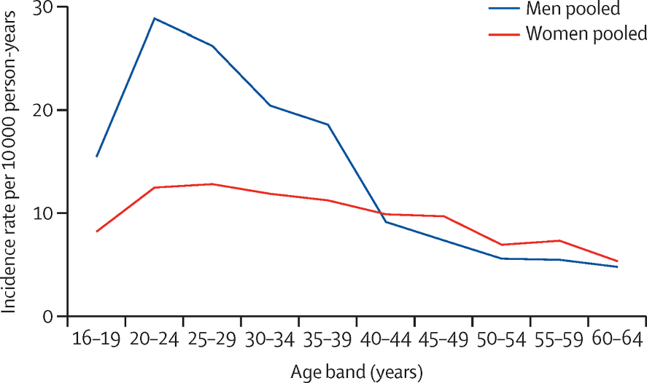
Figure: Percentage of Schizophrenia patient in world and UK (Tucker, 2011)
From the above-mentioned people, it is completely clear that the number of people who are affect by Schizophrenia have been on the increasing part. Day by day it has been increasing and it is becoming difficult to maintain the good relationship with the people who are aged between 20 to 30 years. This age group is the maximum number affected by the terms of Schizophrenia. This kind of percentages are on the verge to develop as the current issues are ongoing and it has been developed to the next stage where the number of patients who are affected by Schizophrenia has been only increasing (Waugh, 2014).
Classification of Schizophrenia
The mental illness Schizophrenia may be divided into some specific categories which are depended on the person who has been affected. Based on the characteristics of the patient and other behaviour outputs it can be mentioned to secure the possibilities that the Schizophrenia is divided into the category of ICD – 10 which is of great importance to handle and maintain also. As per the regulations that has been brought by ICD – 10, it is secured to understand and maintain the connectivity’s which are in proper order to maintain the course of actions to benefit from the situations for Schizophrenia patients (Ashburton, . and Doherty,, 2015).
Causes of Schizophrenia
Schizophrenia is a mental illness that has a negative impact on the mind of the patient and there are several aspects that may led the patient to some extreme conditions which will be regarded because of the satisfying condition to relive. The main causes of Schizophrenia are as given –
- It may be caused because of the genetical reasons.
- Due to some structural changes in the brain people may suffer from Schizophrenia.
- If there are any chemical changes in the brain, the Schizophrenia may affect people.
- Even childhood trauma may be the cause of Schizophrenia in such regards.
Apart from these, there may be various other reasons which cause Schizophrenia to the people, and it must be changed accordingly in this regard to causes of Schizophrenia.
Signs or symptoms of Schizophrenia
When any patient is affected because of Schizophrenia, then there are some signs which allows others to know about that person and aid him as needed. These are the major characteristics that occurs to any person when he is affected by Schizophrenia.
- He is likely to have a lot of illusion going on in front of his eyes.
- There are lots of unnecessary things going in front of his eyes and he is likely to suffer from these.
- Sometimes, his behaviour will be extreme and abnormal in different scenes as well.
But some other symptoms may also appear to the person depending on their respective characteristics they have been following in different manners. Some of these are the crucial factor to determine the overall situation which has been selected to meet and aid the people who need it (Peate. I, 2011).
Diagnosis of Schizophrenia
The diagnosis of Schizophrenia patients varies from each other as they have their crucial points to discover and hamper the outcomes which is affected because of the different characteristics whichever is needed in the first place.
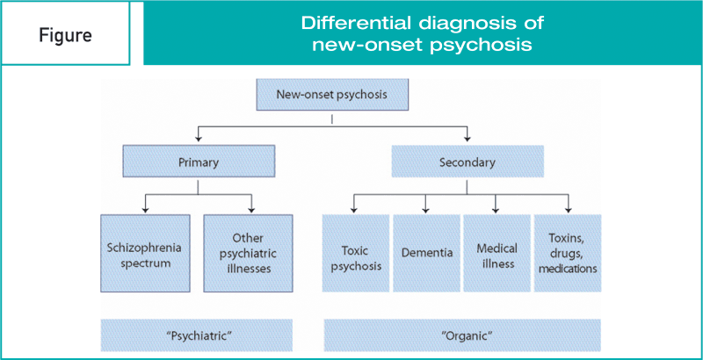
Figure: Different diagnosis of Schizophrenia (Kotler, P. and Armstrong, G., 2009)
By the solo achievement it has been brought to maintain and secure the possibilities that is mostly because of the diagnosis that has been done. This leads to the point of judgement that is done to settle and maintain the constrains by the conditions of Schizophrenia whichever is the higher point to catch.
Current treatments of Schizophrenia
There are no specific treatments for Schizophrenia as this varies from patient to patient. But some medications are given to the affected people as this helps them to keep pace with the sudden changes which are going around them and to prevent the manipulation of their minds as well. these treatments are not enough, and it needs to be developed to the criteria which matches to the requirement of the people who are getting affected every day by this mental illness.

Recommendations on Schizophrenia
Schizophrenia is such a mental illness that cannot be cured at one day. It takes a lot of time for the patient to get used to the normal life and make changes to the previous scenario. Depending on the characteristics the best option is to make the conditions fully understandable to the people and the recommendations are given to them so that they can make the changes in their actual lives and comply with different situations that are best suited them in different conditions which have to be performed for better achievements throughout the habitation process (Peate. I, 2011).

Autism
Most of the people get confused with autism and they think this is disease. But its reality autism is not a disease rather than this is a state of mental issue which the person bears with him since his birth. From this point of view, the conditions to establish the presence of autism to be present has been difficult and it is becoming a hard task to complete. But the positive side of this part is that people are getting used to the term autism and they would likely to be changed as per the plans which are being taken over in different situations to be exactly selected the affected autism peoples (Peate. I, 2011).

Definition
The normal definition of autism may be termed as the lifelong disorder that has been caused by neurological issues before the age of three. The autism has a long-term effect on the person which has been affected before the age of three and it is likely to make the person suffer a lot because of the characteristics that he must follow for the rest of the life as well. Specific definition of autism is not limited to some words only, rather it has a huge corresponding situation that affects the human mind and causes problems in some major series of activities of human behaviours (Peate. I, 2011).
Classification of autism
The term autism may be classified under a mental illness category and then take the necessary steps to involve the situations under the proper order to benefit and secure the challenges that comes to the point for autism as well.
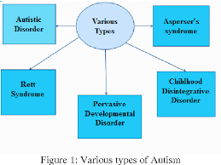
Under this category it helps to understand and maintain the course of action which has been selected to meet the processing actions and it helps others to process the valuation in different matters. The adjective and the conditions that are best suited to have been brought are under the classification of ICD, F80-F89. These are the main factors which are to be take closely for the benefits and has been distributed accordingly to the classification o autism.
Percentage of children and people with autism
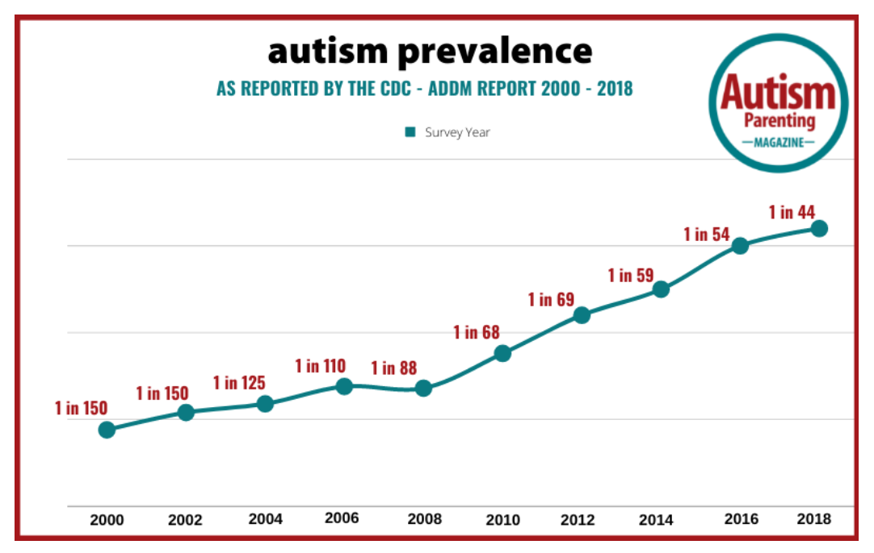
Figure: Percentage of children and people with autism statistical data (Egan, J,, 2004)
This data is the representation of number of autism children who are affected every year. This has been developed to understand and make through the best of the process which is to be settled for the usages of different performances and it needs to be changed as per the situation to relied on to make the section of autism fully understandable to the people (Tucker, 2011).
Causes of autism
Autism may be caused from early life and there may be some problems in the early stage of the childhood which may result into autism in the later life. The causes may be different but the significant changes which are to be avoided and made possible are to be as per the situation and notations to make the current causes and modify the natural conditions that have about autism to be taken care of.
Signs or symptoms of autism
There are different signs and symptoms that may indicate to autism in any child. The main symptoms are as –
- Disability to talk properly or communicate with others properly
- Not able to expression the feelings to others.
- Disable to understand different points at the same point.
- Lack of focus in any event.
These are not the only points or symptoms that the autism children have. The symptoms differ from each other, and they provide different options based on their different characteristics as well.
Diagnosis of autism
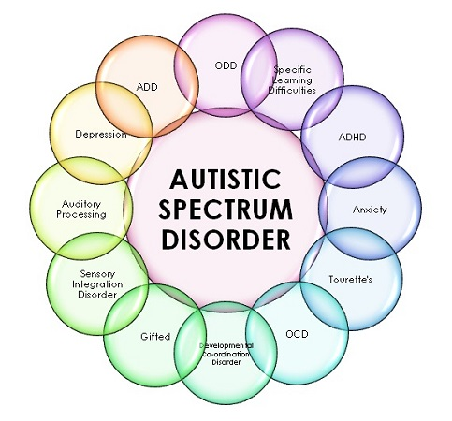
Figure: Different diagnosis of autism (Peate. I, 2011)
There are different forms of diagnosis of autism, and they depend on the surrounding possibilities to make the best option. A clear and through diagnosis gives the opportunity to make the people understand about autism so that they may be able to take on the possibilities to enhance the situation and make the arrangements properly to get the best option in the form of diagnosis for the people. This is termed as some of the experience parts and have been widely known to be precise about the whole situation that is to be taken seriously for the purpose of diagnosis in different ways.
Current treatments of autism
The current treatment methods are gradually developing, and they are trying their best to come with innovative and corrective measures to keep the pace with autism children. Since the last decade, the number of treatment methods have been changed and it has been a wonderful situation for the people to learn about autism and to make their way towards achieving the best option there is for the treatment methods.

Measurement of rehabilitation for autism
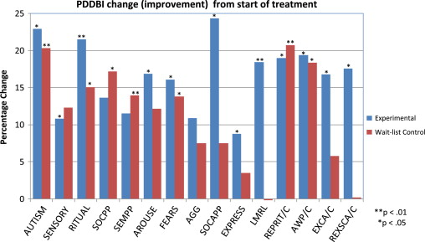
Figure: Measurement of rehabilitations for autism (Tucker, 2011)
In the recent years, the success rate has been promising and this has helped a lot of autism children to keep up their lives with. Some of the specific points and features that success most of these success conditions are part of the whole rehabilitation part and it is increasing day by day to keep the changes with the surrounding possibilities under proper monitoring conditions.
Recommendation on autism
There have been improvements in the field of autism, but the situation has not been changed in most of the developing countries. It is best to perform the ideal conditions which are suited to understand and maintain the conditions where the autism children get their most desired cares so that they may live their lives happily like others do.

Conclusion
Most of the mental illness are ignored by the people but it has a negative impact on the mind who are affected. It is the duty of the normal people to understand them and make the choices that are best suited to the mentally ill people in their future daily lives.

References
Ahern, K. R., Dittmar, A. K., 2012. The changing of the boards: The impact on firm valuation of mandated female board representation.. Quarterly Journal of Economics, pp. , 127, 137-197.
Ashburton, . and Doherty,, 2015. Towards the Formulation of a ‘Best Practice” Framework for Benefits Realisation in IT Projects. lectronic Journal of Information Systems Evaluation, 6(2), pp. 1 - 10.
Brudan, A., 2016. Rediscovering performance management: systems, learning and integration. 14(1), 109-123. Measuring Business Excellence, , 1(12), pp. 109 - 123.
Collins, E. I.M., Thomas J. M., Robinson, E., Aveyard, P., Jebb, S.A., Herman,, 2019. Two observational studies examining the effect of a social. 122-130 ed. Appetite: 132.
Cook, R. A., Hsu, C.H.C and Taylor, L. L., 2018. Tourism: the business of hospitality and travel, 6th ed. London. London: Pearson.
Egan, J,, 2004. Relationship Marketing: Exploring Relationship Strategies in Marketing. Financial. s.l.:s.n.
Frank F. D., C.R. Taylor, 2004. talent management: Trends that will shape the future’ Human Resource Planning, 27 (1) (2004), pp. 33–41. s.l.:s.n.
Guirdham M, 2015. Work Communication. 1-12 ed. s.l.:s.n.
Hayes J, 2018. The Theory and Practice of Change Management. 1-21 ed. Kortest: Custom Pages.
Kotler, P. and Armstrong, G., 2009. Principles of Marketing, 13th Ed, Pearson: Harlow. s.l.:s.n.
Kotler, P. and Armstrong, G, 2009. Principles of Marketing, 13th Ed, Pearson: Harlow. s.l.:s.n.
Krueger, N. F., 2016. Critical Perspectives on Social and Human Life. s.l.:Sage publishers.
Linked in, 2015. Race, ethnicity and social stratification. [Online]
Available at: https://www.linkedin.com/pulse/race-ethnicity-social-stratification-osama-al-mahdi
[Accessed 12 11 2018].
Peate. I, a. N. M., 2011. Fundamentals of Anatomy and Physiology for Student Nurses. 1st ed. s.l.:Wiley-Blackwell.
Tucker, L., 2011. An Introductory Guide to Anatomy & Physiology. 5th ed. s.l.: EMS Publishing.
Waugh, A. &. G. A., 2014. Ross and Wilson Anatomy and Physiology in Health and Illness. 12th ed. s.l.:Churchill Livingstone.

