

Name - Christopher Thomas
Student number – p151891
Module – human resource management
Lecturer – carl singleton
Assignment title - Employee Development

1.0 Introduction
This report will first define training and development. Cole and Kelly (2004) discusses that training should be a continuous process especially where material handling equipment is being used it is important that all employees equipped with the relevant skills to go about their work without any barriers, and by doing so Stredwick (2000) believes it can have a beneficial impact. The report will look at the five key concepts in regards to training and development as discovered by Marchington, Wilkinson (2012), and Cole and Kelly (2004), and discover the training cycle and how employers can use it.
Its 2019 and it is important for any future employee to realize what skills are desirable for a company. As The Balance Careers (2019) discusses employers are looking for both soft, and hard skills. The report will explain the difference between the both, and how they can be gained.
The next section will focus on what programs are available to gain relevant skills as discovered by Stredwick (2000). With many training programs available this report will choose three to discuss. One of which will be apprenticeships, and degree apprenticeships and the differences between the two.
Wales are a country that has many policies to aid in training & development as Gov.wales (2019)
Designed to aid the country develop skills that are going to be need in the future, which is shown in the Further and Higher Education Governance and Information Wales Act 2014, which gives wales control over training and development. Swansea also takes the T&D very seriously as shown in their policy as discovered by Training and Development policy (2019) the report will look at E- learning.

2.0 Defining Training & Development
Cole and Kelly (2004) believes that the training & development of the workforce is very important in regards to the success of the company, in fact the function is crucial. They also go onto say that training & development should not only apply at the stage of employment, but throughout the employee tenure with the organisation, especially with the ever changing workplace environment in regards to new equipment being utilized safely such as materials handling equipment, and changes to process within the company due to the evolution of technology including IT skills. It is important that all employees are able to go about their daily duties safely, and productively for the success of the company’s strategy. Stredwick (2000) also believes that by helping employees progress with their development will also have a positive impact on the company, however the training & development depends on the company’s policies and strategy as explained by Cole and Kelly (2004) some companies favor the approach of employing a candidate with the skills which they desire instead of taking the time and money in developing a current employee, it all comes down to their strategy, and keeping training and development costs to a minimum. As discovered by Marchington, Wilkinson (2012), and Cole and Kelly (2004) there are many differences between training, development, and education.
3.0 Key concepts
3.1 Education- is a system that is used to develop a person’s interglacial capacity, often taught in a class room setting, and often happens before employment. Even though many companies offer off site training such as first aid, or a two-day course in negotiations skills this is not classed as education, unless it is recognised as a professional qualification, such as a MBA.
3.2 Training- the process of training occurs in preparation for a specific job, and it is used to make employees more effective in their role. Training is job orientated, and not personal to the employees. Training can be thought as being narrow in concept only focusing on a certain aspect.
3.3 Development- on contrast development can be seen as more of an inter-personal approach process, with the company taking a vested interest in the individual in regards to personal development in areas such as confidence, and their understanding.
3.4 Learning- Cole and Kelly (2004) suggest that learning it underpinned by the previous three concepts, and it is the process of developing knowledge, understanding, skills, and values in order to acclimate to one’s environment. The learning process depends on the individual, their intelligence and motivation to succeed.
3.5 Competence- some employees might have the relevant training, but have never needed to perform the task. They have the knowledge to do the task, but they may not have the competence to do so. There is a difference between knowing how and doing a process. This can be combated with the introduction of competence based training.
Even though it should be remembered that in today’s society many of the sections above are not so clear, an example of this is a student who is completing many concepts at the same time, such as education, training and development, but might lack the competence to complete tasks due to it being in a learning environment.

4.0 The training cycle
Stredwick (2000) explains the training cycle comes down to four stages as shown below in figure 1.
(figure 1) The four-stage training cycle
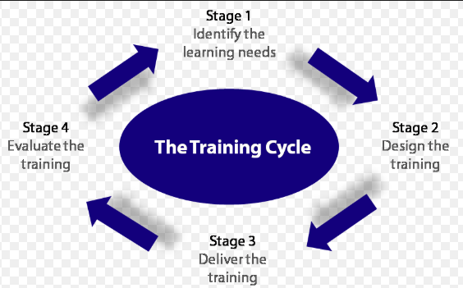
(Stredwick, 2000)
4.1 stage 1 identify the learning needs
This is often done when a company employs new employees, the company can carry out an analysis of the job requirements, against the skill of the employee, and determine where training is needed. Even when employees are promoted, or transferred within training is needed.
4.2 Stage 2 planning and carrying out the training
After the completion of stage 1 there will be questions that will need to be answered, such as where should the training take place on site or off site, and if the company should outsource the task to a training provider. Another consideration should also be made towards which techniques should be used, such as role-play or group discussion.

4.3 Stage 3 styles and techniques of training
at this stage the company will decide which options are best for their employees to get their desired skills, such as;
    - E-Learning - Can help the employee to work through their training program at their own pace, and offers the ability to have instant feedback.
    - Group discussion – this method can prove to be useful in small groups, and if lead well it can be very useful for the employee to learn from one another.
    - Job rotation – this option is used to get employees familiar with different activities with a company, and is best used with the full cooperation of the employees.
4.4 Stage 4 evaluating the training
This stage is important to discover if the training has added value or not. The training can be evaluated in two ways, subjective and objective.
    - Subjective evaluation- this can be achieved by communicating with the training provider to discover how the training materialized.
    - Objective evaluation- by asking the trainee the employer will be able to gauge how well the process was. Questions such as where can you implement the skill you were taught in training would be a starting point. Observations can also be done to evaluate if there has been any improvement.

5.0 Desirable skills in 2019
as discussed by The Balance Careers (2019), and shown below in figure 2 when it comes to skills an employee will assess two areas. Firstly, soft skills, which are more aimed towards the personality of the individual, and assessing if they have the desired skills, such as social cues, and the wiliness to succeed, which is very important when communicating with customers and employees. Another benefit of soft skills is that they are transferable making the employee very adaptable, and are often used in customer based jobs. The second area is hard skills, which are skills specific to that field of expertise, and can usually be found in the job description. Hard skills can be acquired through education programs, such as university, NVQ, OR Apprenticeship scheme.
(figure 2)
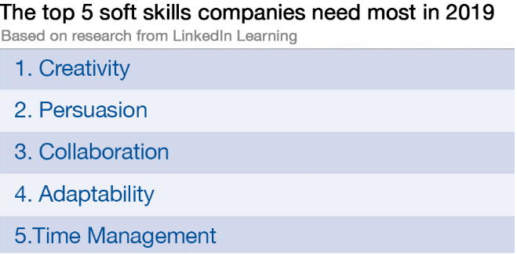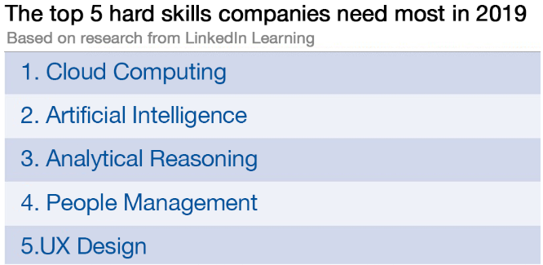
(World Economic Forum, 2019)
As shown above in figure 1 the need for employees to be trained in dealing with the ever growing sector of artificial intelligence is going to become problem for many organizations as shown below in figure 3. As shown below more than half of the employees needs some sort of re-training times varying from one month, with ten percent needing training of over one year.

(figure 3)
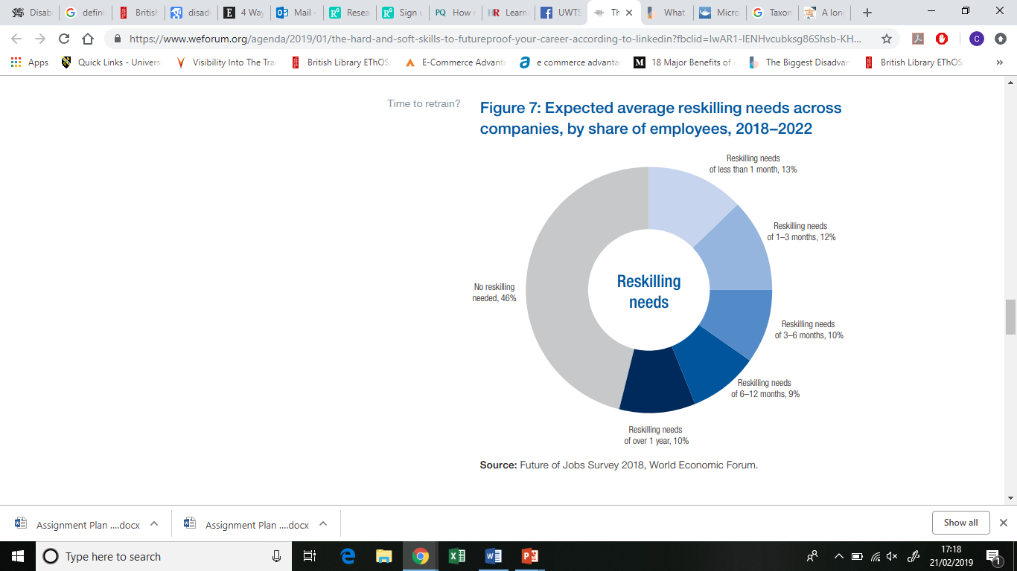
(World Economic Forum, 2019)
Figure 4 below clearly shows that the increases on robots in the work force are forcing employees out of work, or needing to engage in training & development to gain a new hard skill to adapt to the change.
(figure 4)
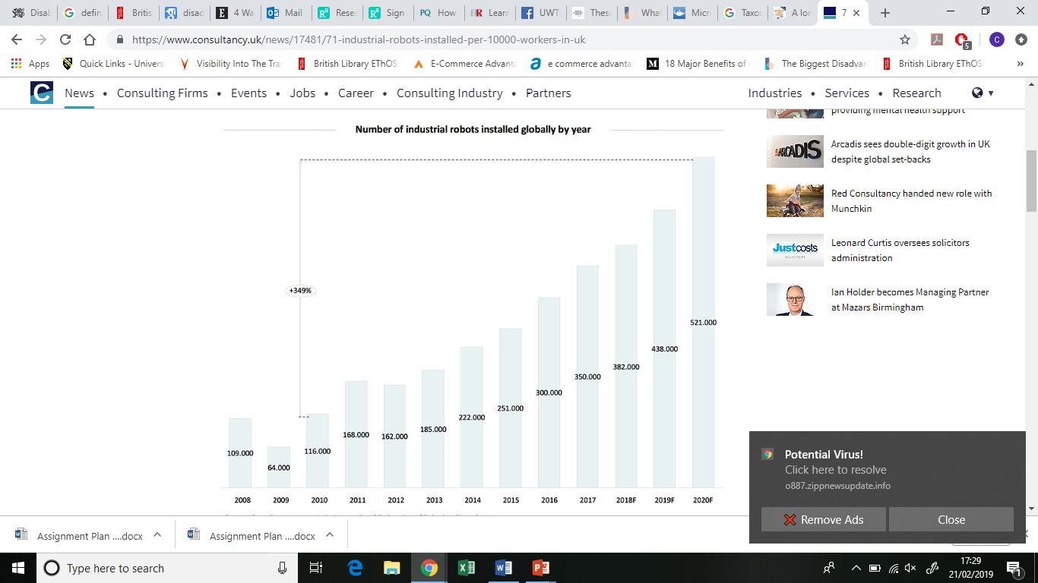
(Consultancy.uk, 2019
(figure 5)
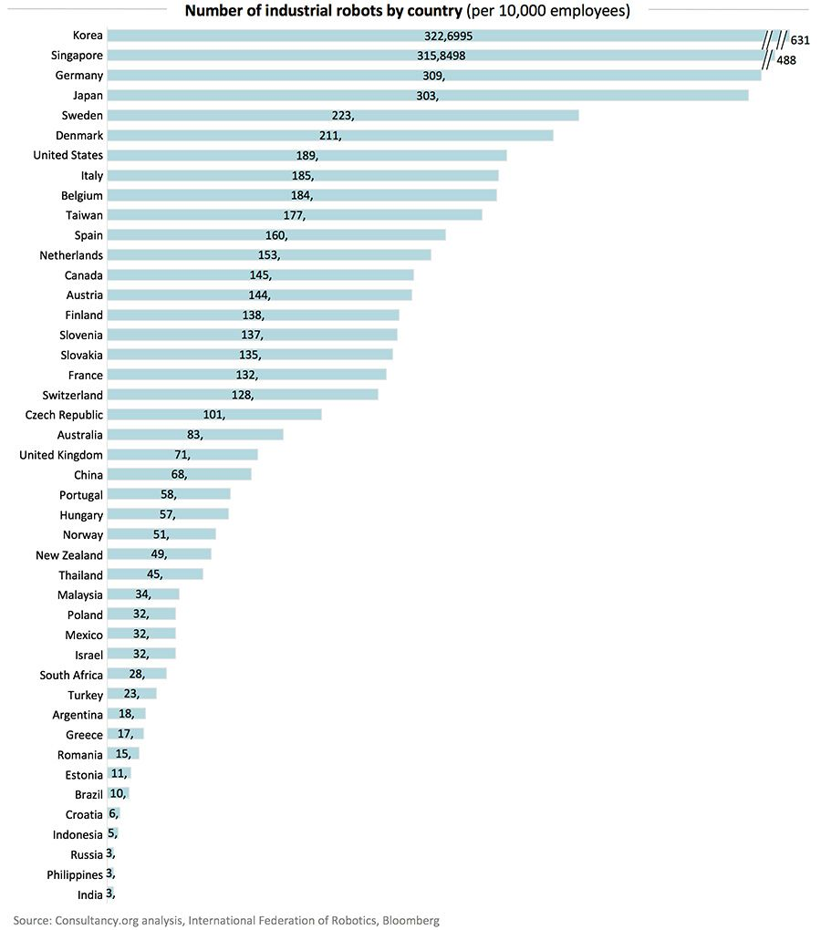
(Consultancy.uk, 2019)
Figure 5 above clearly show that the skills which are desired by employees are correct. For every 10,000 workers in the United Kingdom there are 71 robots which is above the global average. Consultancy.uk (2019) believes that the logistics sector will be one of the hardest hit sector with 40% of low skilled worker will be obsolete, and predictions of 60% of work being automated is becoming a reality.
6.0 training & development opportunities
As Stredwick (2000) explains government initiatives are nothing new, and first became apparent during the 60’s, and 70’s which included placing a levy on companies. The money raised would then be distributed back to the company to fund approved training programs. This method was used to encourage companies to develop their own talent instead of pouching from other organizations. This method was later abolished by a conservative government after the program showed no sign of improved quality of the training being received. This was only the beginning of the training schemes that are in place today such as;
6.1 National Vocational Qualifications (NVQ)- this scheme is based on occupational standards, which are put in place so that the person receiving the training is taught to be competent through practical training and classroom taught usually both elements are received in collage. The qualification also helps by teaching what changes may acre in the future as discussed by Cityandguilds.com (2019).
6.2 Apprenticeships- Stredwick (2000) believes that this scheme has been implemented for hundreds of years for example Medievalists.net (2019) explains that during medieval times a blacksmith would have several trainees. The concept is the same today as it was then to produce competent employee that will be valued by the employee. It should also be remembered that it is at no cost to the trainee funding is received through government and the employee. According to Assets.publishing.service.gov.uk (2019) the government has tried to encourage business with a turnover of 3 million and above to invest in the future through the apprenticeship levy, which charges companies 0.5% of salaries paid, by doing so all apprentices will get funded by the levy, but if a company’s workforce exceeds 50 they will be asked to help with the costs of the program and contribute a further 10% of the costs of training. Even with the levy employers are not taking advantage as shown in figure 6 below
(figure 6)
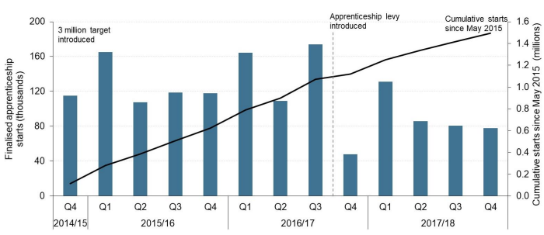
(Assets.publishing.service.gov.uk, 2019)
As the figure shown 2015/2016 the number of apprentices stood at 173,800 on comparison the full year of the introduction of the levy in 2017/2018 that number fell by 48,000 to 118,800. Butler (2019) clarifies that even though intermediate level of apprenticeships fell there was a rise of 27% increases in degree apprenticeship over the same period. The decrease has been credited to the complexity of the funding, and many companies seeing the levy as just another tax to pay, and can no longer offers apprenticeships.
6.3 Degree apprenticeship
There are not many differences between both types of apprenticeships, they both offer on the job experience as well as theory, but with a few difference including the qualification that would be gained. With the degree apprenticeship the student would gain either a Bachelors degree or masters, which are highly sought after by employees. Another advantage is that the same qualification would be gained as a classroom based degree, but with More in work experience ultimately increasing their competence, and the student would not have to worry about the debt that a classroom based student encores. It could be said that this option is becoming more favorable for employees and employer.
7.0 Welsh policy
Wales is a country that takes training and development very seriously as show in The Further and Higher Education Governance and Information Wales Act 2014, which Gov.wales (2019) explains that through the Act the welsh government has gained more power over its higher education programs giving them the ability to make any changes they see necessary for the benefit of the country, instead of being governed parliament. As discussed by Beta.gov.wales (2019) with wales having the ability to ability to shape their own apprenticeship schemes giving more people the tools to reach their full potential, and also help employers meet the skills level that they desire to get or remain productive, all of which will help the welsh economy. When discussing training & development it is vitally important that it should be done with equality in mind something which the welsh government has done. Not only does wales want the average person succeed they are also helping the disabled members of society fulfill their potential through the inclusive apprenticeship. As shown in Beta.gov.wales (2019) the welsh government believes that having the option to succeed is a right that every person should aspire to achieve, no matter their physical or learning difficulties. As shown below in figure 7 the past four years have shown a rise on the amount of disabled learners who have entered into an apprenticeship.
(figure 7)
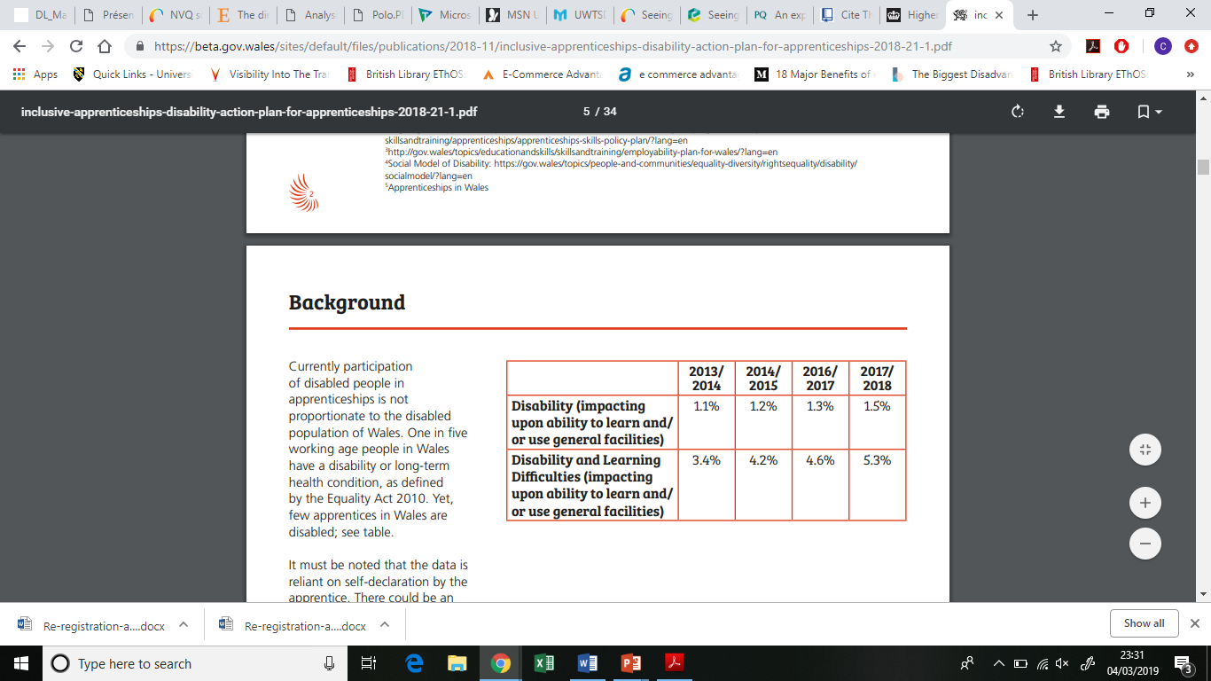
(Beta.gov.wales, 2019)

8.0 Inclusive Apprenticeships - Nicholas D’Cruz
As discovered in Beta.gov.wales (2019) Nicholas D’Cruz is 25 and lives in Swansea. He also suffers from autism, which affects his ability to communicate with others, and live or work independently. Nicholas was living in a care home, but had a goal of moving into a supported housing to become more independent, this is important for his wellbeing. After seeking advice his social worker helped him put a plan in place to help him increases his skills needed to live alone, and shortly after he started a placement at a local café. After a successful placement Nicholas is now completing a level 2 foundation apprenticeship in hospitality. By Nicolas having this option to get into work has given him the money to enjoy life, and also sense of belonging.
9.0 Swansea councils approach to training & development
9.1 Policy statement – Swansea council’s policy statement stats that they are fully committed in the training & development of their employees in order to deliver a consistent service to its clients, and customers as shown in Training and Development policy (2019). The goal of the organisation it to embrace best practice, and are showing this by investing in its people, and all employees will be given the opportunity to receive appropriate and relevant training. There are many advantages for doing so as Training and Development policy (2019) explains that by being proactive in regards to T&D it helps create a flexible workforce, and utilise the existing staff more efficiently, and more importantly it helps improve performance by improving skills with the hope of retaining the employees.
9.2 E-learning
One such method of training that is used is E-learning. This method of training has many benefits including cost and convenience for the employee. They go onto say that the method is not meant to replace the traditional face to face training, but to aid it. Employees can complete the E-learning beforehand, and gain a good understanding before moving forward.
10.0 Disadvantages of training and development
As discussed by Asset Wisdom (2019) there are two main reason companies shy away from investing in employees, firstly time this is usually taken out of the working day, which could have a negative impact upon productivity, which leads onto the second reason, which is cost. Although in house training may often be free, but when an external training provider is needed it comes at great financial cost, but the full cost may not be visible straightway. After employees gain more skills and qualification they may seek some form of a reward in the form of a pay rise which may not be possible, which could ultimately lead to losing the employee to another company after investing in their training.
11.0 Advantages of Training & Development
Dcvmn.org (2019) discusses that there are many reasons for training & development. One of those reasons is to retain employees, they go on to say that a characteristic to help retain staff is to give them the opportunity to improve their skills. The paper discuses that where manager help develop their employees the staff turnover is reduced by up to 50 percent. Several managers credited the training of their employees to having a benefit to their retention. They also go on to discuss how the performance of the organisation is affected. Dcvmn.org (2019) discovered that the investment in the workforce can be justified by the impact on the individuals and the organizational effectiveness.
12.0 Conclusion
The report looked at how training and development is defined, and should be an on-going process throughout employment in a company as discovered by Cole and Kelly (2004). This can be seen as essential where material handling equipment is being used. All employees should have the relevant skills need to complete their daily routine to the best of their ability.
Marchington, Wilkinson (2012), and Cole and Kelly (2004) discovered the five key concepts of T&D and how they are implemented, also how many of the concepts are interlinked, as shown with the learning concept.
Next the report discovered the training cycle and how the four stages help employers realize when training is required, and if it’s been money well spent, which will be discovered in the final stage where management will evaluate the training. As discovered by The Balance Careers (2019) the skills that are desirable by employers are changing with more companies looking for skills relating to artificial intelligence. As shown in figure 5 there is plenty of room for the United Kingdom to grow in sector. The skills need can be taught through several training schemes such as national vocational qualifications, apprenticeships, or degree apprenticeships. as Stredwick (2000) explained apprentices have been used for hundreds of years, but Assets.publishing.service.gov.uk (2019) show’s in figure 6 the number are falling. By looking at figure 6 the implementation of the levy has looked to have a negative impact on apprenticeship levels.
Wales have shown that they are fully committed to provide the people of wales with a training and development policy that helps grow wales as a whole, as shown with their policy on inclusive apprenticeships as discussed by Beta.gov.wales (2019) this policy has changed many lives for the better all-around wales, where before it would not have been possible. Keeping with wales Swansea are an organisation that by looking at their policy on T&D look to strive for both the employee and the clients.

References
Asset Wisdom. (2019). Employee Development: The Pros & Cons of Training Staff - Asset Wisdom. [online] Available at: https://asset-wisdom.com/2018/06/28/employee-development-the-pros-cons-of-training-staff/ [Accessed 16 Feb. 2019].

Assets.publishing.service.gov.uk. (2019). [online] Available at: https://assets.publishing.service.gov.uk/government/uploads/system/uploads/attachment_data/file/766962/Apprenticeship-and-levy-statistics-December-2018-2.pdf [Accessed 4 Feb. 2019].

Beta.gov.wales. (2019). [online] Available at: https://beta.gov.wales/sites/default/files/publications/2018-03/aligning-the-apprenticeship-model-to-the-needs-of-the-welsh-economy.pdf [Accessed 2 Feb. 2019].

Beta.gov.wales. (2019). [online] Available at: https://beta.gov.wales/sites/default/files/publications/2018-11/inclusive-apprenticeships-disability-action-plan-for-apprenticeships-2018-21-1.pdf [Accessed 4 Feb. 2019].

Butler, S. (2019). Fall in apprenticeships may force 'radical rethink' of UK policy. [online] the Guardian. Available at: https://www.theguardian.com/education/2018/jan/25/fall-in-uk-apprenticeships-may-force-radical-rethink-of-policy [Accessed 16 Feb. 2019].

Cityandguilds.com. (2019). NVQs and SVQs | City & Guilds. [online] Available at: https://www.cityandguilds.com/qualifications-and-apprenticeships/qualifications-explained/nvqs-svqs-keyskills-vocational-skillsforlife [Accessed 4 Feb. 2019].

Cole, G. and Kelly, P. (2004). Management theory and practice. 6th ed.

Consultancy.uk. (2019). 71 industrial robots installed per 10,000 workers in UK. [online] Available at: https://www.consultancy.uk/news/17481/71-industrial-robots-installed-per-10000-workers-in-uk [Accessed 21 Feb. 2019].

Dcvmn.org. (2019). [online] Available at: https://www.dcvmn.org/IMG/pdf/3947-5999-1-pb.pdf [Accessed 14 Feb. 2019].

Gov.wales. (2019). Welsh Government|Further and Higher Education (Governance and Information) (Wales) Act 2014. [online] Available at: https://gov.wales/topics/educationandskills/publications/guidance/further-and-higher-education-governance-and-information/?lang=en [Accessed 4 Feb. 2019].

Marchington, M., Wilkinson, A. and Marchington, L. (2012). Human resource management at work. 3rd ed. London: chartered institute of personnel and development, pp.237-238.

Medievalists.net. (2019). [online] Available at: http://www.medievalists.net/2018/11/role-blacksmith-medieval-society/ [Accessed 3 Feb. 2019].

Stredwick, J. (2000). An introduction to human resource management. Boston: Butterworth-Heinemann.

The Balance Careers. (2019). What Are Soft Skills?. [online] Available at: https://www.thebalancecareers.com/what-are-soft-skills-2060852 [Accessed 21 Feb. 2019].

Training and Development policy. (2019). [ebook] Swansea. Available at: http://file:///C:/Users/User/Downloads/Training_and_Development_Policy__February_2018_%20(1).pdf [Accessed 17 Feb. 2019].

World Economic Forum. (2019). These are the 10 most in-demand skills of 2019, according to LinkedIn. [online] Available at: https://www.weforum.org/agenda/2019/01/the-hard-and-soft-skills-to-futureproof-your-career-according-to-linkedin?fbclid=IwAR1-lENHvcubksg86Shsb-KHWVi1Wk9Lqunke3jdBu-_iEK3HJVTWShrXQU [Accessed 21 Feb. 2019].

