

Student name: Emelyn Dipadua Flores
Student ID: 2515007
Module name: Introduction to Health and Social Care
Module code: LCHS400
Lecturer name: Dr. Muhammad Aliyu
Content page
POSTER ……………………………………………………………. Page

RESIDENTIAL CARE HOMES
Emelyn Dipadua Flores, Cert. Health and Social Care



Residents in Residential Care Homes
Older Adults with Age-Related Frailty

Individuals with Physical Disabilities

People with Mild to Moderate Cognitive Impairment

Adults Requiring Ongoing Social Care Support

Reference
Thane, P. (2000) Old Age in English History: Post Experiences, Present Issues. Oxford University Press. Accessed: 08 March 2026
Bach-Mortensen, A., Goodair, B. and Degli Esposti, M.,2024. Involuntary closures of for-profit care homes in England by the Care Quality Commission. The Lancet Healthy Longevity, 5(4). pp.e297-302. Accessed: 10 March 2026
Challenges faced by the service
Rising Demand Due to Ageing Population
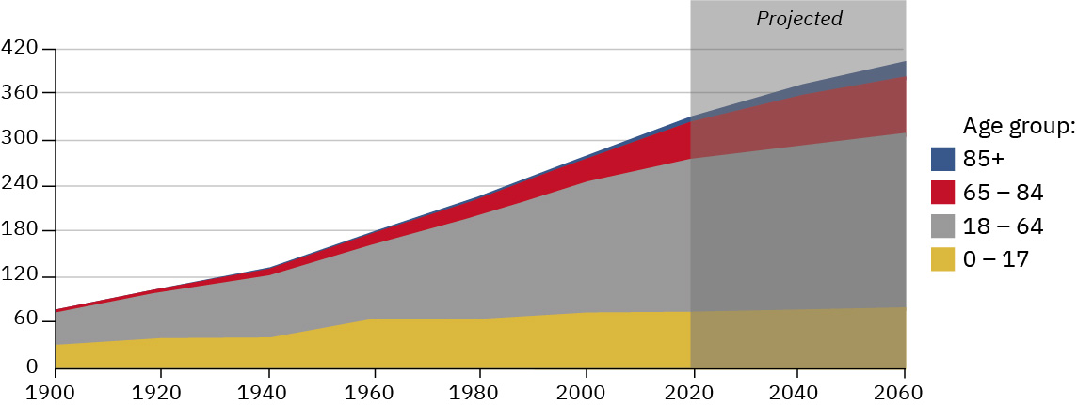
Workforce Shortages


Residential Care Homes
Is a long-term care home that offer residential services and personal assistance to those people who cannot live independently. Residents live in the in the home a full-time and staff help with day-to-day activities, the home is run on the person-centred model whereby individual preferences are considered and the enhancement of dignity, independence, emotional wellbeing, and social interaction are encouraged. Subsequently, residential care homes are important in serving the ageing populations and relieving the burden on the hospitals and the community healthcare services (Bach, 2024).
I

Brief History of Residential Care Homes
Residential care homes have evolved with time. In the past vulnerable people have been taken care of by religious groups, charities, and poorhouses. In 19th century, older people who were unable to support themselves financially were housed in workhouses. In 1948, The National Assistance Act shifted the burden of workhouses with residential care homes in which they provide personal care, support and accommodation. Now residential care homes focus on safety, dignity, and person-centred care (Thane,2000).

Current Functioning of Residential Care Homes
Residential care homes are social care environments, in which the residents are under constant care and as much autonomy as possible is enforced. These services have various elements in their day-to-day operations such as:
Personal Care Assistance (Bathing, Dressing, Grooming)
Meal Preparation and Nutritional Support
Medication Administration and Monitoring
Mobility Assistance and Fall Prevention
Social and Recreational Activities
Emotional and Psychological Support

PHARMACY SERVICES
Introduction
The services of pharmacy are significant to the contemporary healthcare, which provides drugs, clinical consultation and preventive services. The service is an essential component of modern healthcare systems. They involve the safe supply of medicines, patient’s counselling, clinical advice and public health interventions delivered by trained pharmacists. Pharmacists are very accessible and also a part of a primary care in the UK, being closely related with the NHS since 1948. Their scope of work has been expanded to include dispensing in addition to vaccination, chronic disease management and independent prescribing. This report discusses the history of pharmacy services and their present operations, as well as the effects of their services on the quality life of the service users (NHS, 2025).

HISTORICAL ORIGINS AND DEVELOPMENT OF PHARMACY SERVICES
Pharmacy services originated to medieval Europe when apothecaries made and sold medicinal ingredients from herbs and natural products. In England, early pharmaceutical practices were linked to merchants in spices and medicinal components known as Spicers who later developed into specialised apothecaries during the thirteenth century (Anderson, 2020). These practitioners were responsible for illnesses and preparing medicines for patients.
The pharmacy activities have developed into a formalised profession as opposed to the traditional medicine preparation through herbs. Drug stores evolved in the medieval period especially in the Middle East and later Europe. The first move towards professionalising in the UK started with the Pharmaceutical Society of Great Britain in 1841 that set education, standards and regulation (RPS, 2026). With the establishment of NHS in 1948, pharmacy became part of the healthcare system, and the accessibility of medicines was increased. The end of 20th century transformed pharmacy to a patient-centred approach, where pharmacists are involved in medication review, chronic illness monitoring, and health promotion that signifies the multidisciplinary and preventative care trends (Hindi, 2019).

Current Functioning of Pharmacy Services
The UK pharmacy services are used both in the community and the hospital to provide a variety of clinical and pharmaceutical services. Healthcare is easily accessible with pharmacies well distributed throughout the community with more 85% of the population within a mile of a pharmacy. Pharmacists provide services such as dispensing of prescription, optimisation of medicines, vaccines, minor illnesses, health check-ups, and safe medications. More than 80% of them offer clinical services including chronic illnesses monitoring. Its workforce is ever increasing with 28,763 pharmacists serving in community pharmacies in England in 2024. But lack of funding and manpower have led to shutdowns in hours, posing a threat to a long-term viability (Anderson,2024).

Significance of pharmacy services in enhancing Quality of life
Pharmacy services play a crucial role in enhancing the health status of patients and the quality of life in general. Pharmacists contribute to safe medication use thereby minimizing medication errors and enhancing treatment adherence. The prevention health services, such as vaccinations and screening, are used in the early detection of diseases and assist in decreasing the number of medical issues in the long run. More so, community pharmacists enhance the accessibility of health care by offering a walk in where no appointment is needed and hence, treatment is accessed services faster as opposed to general practitioner services. This access is especially useful with vulnerable groups like elderly patients, people with chronic conditions and the population of underserved communities. Pharmacy services also help in promoting population health and efficiency in the health care system through supporting disease prevention, medication safety and health education.

Conclusion
Finally, pharmacy has been transformed into a necessity of a contemporary healthcare system rather than a mode of preparing a medicine as it is used to be before. Their growing clinical role reveals their vital role in providing staff to the delivery of accessible, preventative, and patient-centred healthcare. While challenges like workload pressures and not equal access remain, pharmacy services greatly contribute to improving medication safety and enhancing the quality of life of service users and continue to evolve, pharmacists will remain vital delivering safe and effective patient-centred care.

References
Anderson,M.and Francetic, I.,2024. Adoption of clinical pharmacist roles in primary care: longitudinal evidence from English general practice. British Journal of General Practice. (Accessed: 26 February 2026).
Hindi, A.M., Schafheutle, E,I. and Jacobs, S., 2019. Community pharmacy integration within the primary care and pathway for people with long-term conditions: a focus group study of patients’ pharmacists’ and GPs’ experiences and expectations. BMC family practice, 20(1), p.26. (Accessed: 26 February 2026).
NHS (2025) NHS choices. Available at: https://www.nhs.uk/nhs-services/pharmacies/
RPS (2026) The history of the Royal Pharmaceutical Society, RPS brandmark.
Available at https://www:rpharms.com/history

