  Component One: Student Journal (learning log) 750 words +/- 10%  Contribution to Overall Module Assessment: 25% | Student No: | 2233365
 | Module Title: | Hotel Administration and front office operations
 | Module Code: | BMIH4004
 | Lecturer: | Daniel Payne
A lot of people aspire to develop a career within the hospitality industry, and there are many clear reasons why. They open a door to the world, and the skills learned are ‘’readily transferable.’’ Through hospitality, employees can enrich their own life experiences and reflections by exploring and discovering people belonging to different cultures and traditions.
It takes a lot of personal and intellectual skills to be a successful front desk team member, such as being a brilliant communicator who not only provides guests with accurate information but also knows how to professionally deal with difficult customers and complaints. I got to know this from my own personal experience at the Marriott Hotel London Marble Arch, where I went through all the departments in a hotel and learned how they cooperated with each other to provide accurate and exceptional customer service. I was not expecting that I would find the receptionist job the most challenging of all departments. The receptionists are the main employees that are communicating face-to-face with guests during check-in, check-out, and whenever a guest requests information or additional service. That means that the front desk team member should be attentive to guests, always smiling and being positive, and ready to respond to both positive and negative feedback. Being tenacious, brave, curious, and independent are key personal skills for that role, as you will have to deal with guests alone very soon after your initial training and ensure they are experiencing great hospitality. Time management is crucial for the successful completion of this job. A certain level of multitasking and prioritising tasks is required, as receptionists also carry the responsibility of monitoring and managing the demands of screening calls, making appointments, following rates, making adjustments to reservations, and more. While you will have friendly and positive guests with whom you will have smooth experiences, you will also encounter some very demanding guests, who could be very extreme and rude if they think their expectations haven't been met in the most appropriate way. Dealing with them could be challenging, as from what I observed, sometimes there is not an immediate resolution to the customer’s complaint, and things can get very uncomfortable for the receptionist who is trying to solve the situation for them. I can say that it really requires great self-control to perform in certain situations, especially if you are a more emotive and sensitive person in general than I am.
There was this young lady one day at the reception in the hotel where my internship was who came and wasn’t a guest but was wanting to book a room for an older man who was with her on the phone at the time. The receptionists on shift couldn’t accommodate her and his request, as they stated that the man should be there himself if he wants to book in person, or he can alternatively book online. After hearing that, the woman became unnecessarily rude and started making offensive and very disrespectful statements about the hotel employees by basically indicating that they are useless and less than her as people because they are just hotel staff, and she is much more than that. The front desk manager was called, and I was amazed by the professionalism with which she dealt with the situation. With a smile on her face, she explained to her that third parties cannot make a reservation for somebody else. Being sent away like that, the woman made a very unhappy face and made a hand gesture before she left that was again quite disrespectful. Her hostile behaviour or accusations were not addressed to me, and yet I felt offended, angry, and so small as a person because someone thinks we are stupid, and we cannot even confront them and defend ourselves but instead have to continue smiling. I immediately asked myself if I’m ever going to be able to swallow the offence and respond the way my manager did, and if this position is even for me at all due to my high sensitivity. Frankly, my colleagues did not seem as hurt as I was, and after repeating the scene in my mind a few times, I concluded that what happened really wasn’t personal. People behave in certain ways for many reasons, and if they are constantly rude, they usually have an issue with themselves, or in this case, the lady and her partner were probably expecting better service from Marriott in general, as she said she never heard what they said to her in another Marriott branch. As people, we should be prepared for all sorts of situations in our professional and personal lives and try to face them with strength and accuracy, as these events help shape our personalities.

References
7 receptionist skills that can impact an entire company (no date) English. Available at: https://www.roberthalf.com/au/en/insights/career-development/7-receptionist-skills-can-impact-entire-company (Accessed: November 18, 2023).
Receptionist (no date) Gov.uk. Available at: https://nationalcareers.service.gov.uk/job-profiles/receptionist (Accessed: November 18, 2023).
Vizito, B. V. (no date) The top 10 receptionist skills [Updated 2023], Vizito.eu. Available at: https://vizito.eu/blog/the-top-10-skills-that-every-receptionist-needs/ (Accessed: November 18, 2023).
(No date a) Indeed.com. Available at: https://uk.indeed.com/career-advice/career-development/hotel-receptionist-duties (Accessed: November 18, 2023).
(No date b) Indeed.com. Available at: https://uk.indeed.com/career-advice/starting-new-job/how-to-be-a-good-receptionist (Accessed: November 18, 2023).

Component Two
Contribution to Overall Module Assessment: 25%
Trip Advisor Review Response 150 words +/-10%
Dear Brian
Thank you for your feedback and loyalty with London Marriott Marble Arch. We are extremely pleased, and it really brings smile to our faces to read about your wonderful past stays in our hotel. It makes us happy to hear that you have enjoyed all the aspects throughout your time here including the quality of our hotel rooms, prices, location, and the service provided from staff members.
We are working very hard to always perfrom exceptional service and the recognition from our guests is a very special moment for us.
I want to express my gratitude for calling London Marriott Marble Arch your home away from home, this makes us proud that we have fulfilled all your expectations and made you feel comfortable and at home.
We are looking forward to having you back here with us soon.

Warmest regards
Polina Karlikova
Front Desk manager London Marriott Marble Arch

Screen shot of referenced Trip Advisor review used:
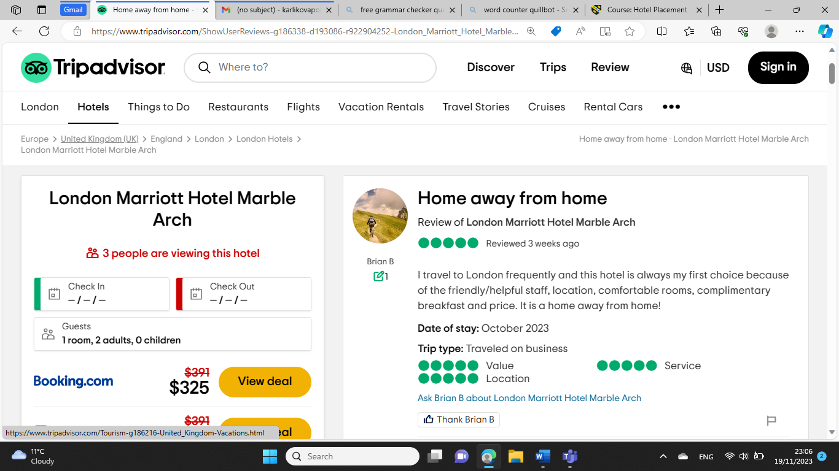
Letter of complaint response 500 words +/- 10-%
Dear Mr Hendricks
Thank you for your feedback. It saddens me to hear that your recent stay at our hotel felt short of your expectations.
Foremost I want to apologise for the poor experience and cold food you had at breakfast. We usually receive good feedback from guests about the quality of our breakfast buffet so I will address the issue with the Food and Beverages department who is responsible for providing fresh, warm, and delicious breakfast, and investigate what could have possibly gone wrong that morning when you went to have your breakfast meal. As a result, we should try and avoid any future guest dissatisfaction. I also completely understand your frustration and I am sorry that you were having trouble sleeping due to a baby noice coming from the neighbouring room. I am sorry that you didn’t came at reception addressing the issue and give us the opportunity to possibly move you to another, quieter room until the rest of your stay, where you could get a satisfactory rest. Finally, I want to sincerely apologise for the poor hygiene in your allocated room. Our housekeeping team is responsible for the daily cleaning and maintenance of all rooms so I will inquire as to why they didn’t maintain the same quality of service for your room. Additionally, I’m happy to share with you that we are implementing some brand-new amenities in our rooms that will make it easier for our housekeepers to maintain and make the guests stay more pleasant.
We want to reassure you that we are taking your comments very seriously and your experience in the hotel is not what our guests usually receive. We are planning on taking all the needed measures to amend the conditions in the hopes of having you back as a happy, satisfied guest.
Should you decide to give us a second chance and book with us again please do not hesitate to contact me directly and I will be more than happy to personally look after you.
I am at your complete disposal for questions and clarifications.

Polina Karlikova
Front Office Manager

References
Elphick, D. (2023) How to respond to negative hotel reviews, Little Hotelier. Available at: https://www.littlehotelier.com/blog/running-your-property/best-ways-respond-to-negative-hotel-reviews/ (Accessed: November 18, 2023).

How to Handle Hotel guest complaints and Deal With Angry Guests (2020) eZee Absolute. Available at: https://www.ezeeabsolute.com/blog/how-to-handle-hotel-guest-complaints/ (Accessed: November 18, 2023).

Penaflorida, R., II (2022) Effective positive review response examples for any brand, ReviewTrackers. Available at: https://www.reviewtrackers.com/guides/positive-review-response-examples/ (Accessed: November 18, 2023).

Revinate (2022) How to respond to negative hotel reviews, Revinate. Available at: https://www.revinate.com/blog/how-to-respond-to-negative-hotel-reviews/ (Accessed: November 18, 2023).

Component Three:
Contribution to Overall Module Assessment: 50% (1000 words +/- 10%)
Writing in essay format

Element 1 – Pre-Arrival

The hotel guest cycle is all the various stages that guests go through during their relationship with a hotel.
The first stage that comes is pre-arrival. This is the time when a guest chooses a hotel to stay, and his or her choice could be affected by different reasons, including hotel reviews, word of mouth, previous experience at the property, referrals, hotel brand name, and the hotel loyalty membership program. It could also influence future guests’ decisions on where to book according to the speed of the reservation process and the dialogue between the reservation agent and guest. Guest data is being collected through this stage, which could also help receptionists complete the pre-registration process, which includes assigning rooms and organising the room rate to be charged to the guest’s folio. It is recommended that the hotel get in touch with the guest three days before their arrival, remind them of the amenities and activities they could use during their stay, and provide them with a short guide to the city’s attractions so that they can keep them excited for their upcoming trip. Therefore, reservations play the most vital role in the pre-arrival activity stage.
Once the reservation is accepted by the hotel, the guest cycle begins. After it follows, collect the guest’s data to note any special arrangements required throughout his or her stay in the hotel. This helps provide personalised guest service, which is highly appreciated by customers.

Element 2 – Arrival

Arrival is the stage where the hotel receptionists are facing the guest for the first time, and a good first impression is crucial for the whole stay. People without a booking, known as walk-ins, are also welcome, as everything is an extra source of income and business for the hotel. After acknowledging the guest before they step at the reception and saluting them with a warm smile, the hotel staff should do the next steps, which are requesting the booking confirmation number and ID check, registering the guest, repeating to the guest the number of nights they have booked, confirming the check-out date, collecting their method of payment or deposit (if applicable), assigning the guest to their accommodation, informing them about breakfast or dinner, lounge access, checkout time, and finally kindly directing them to their room. At this stage, there are more additional things that could be done to enhance the customer experience, such as walking the guest around the property or giving them special treatment by providing personalised service. This extra attention can do a lot of good, as it makes customers feel valued. This is a crucial moment where guests are being informed about the hotel standards and services that they are going to be offered while they stay at the premises. That suggests that the front office is the one responsible for explaining all the different features and facilities that are available in the hotel. After a successful registration process, a guest will receive a registration card that includes a reservation number, the number of passengers, an email address, contact details, and billing instructions. It is mandatory to take the guest’s signature on the registration card.

Element 3 – Duration of stay

It is highly important the manner in which the front desk staff communicate with guests, as they are the ones responsible for providing information and coordinating different guest requests (telephone calls, concierge, currency exchange, mail, printing, laundry) throughout the guest occupancy. The focus of the front office should be to provide exceptional service, create a wow moment, and exceed customer expectations. The more satisfied a guest is, the more likely it is for them to come back or to recommend the accommodation to others.
The front desk should also be mindful and follow the standard procedures for handling the hotel and guest keys, the safe deposit boxes, and guests' personal property.
During the stay, many charges could occur, such as restaurant charges, internet, and travel desk charges, which will be added to the guest’s folio and affect his hotel account. This is the most important stage of the guest cycle, where the guests experience the facilities and amenities, and it is vital that they have a good impression of that as it will generate repeat business and positive reviews.
The front desk, which is the main department that experiences face-to-face interactions with guests, should always coordinate well with other departments so they can ensure guests are provided with well-organised service.
If a complaint from a client occurs, the front desk should handle it promptly and professionally, trying to ensure the guest that the problem will be solved as soon as possible and apologising for any inconvenience caused.

Element 4 – Departure

The checkout process should be optimized to eliminate guest frustration or dissatisfaction. That is the stage where the guest vacates the room, receives the bill settlement, returns the room keys, and leaves the hotel. The bell desk could also assist the guest with their luggage and get them down to the reception.
Once the payment is done, the guest should receive a feedback form where his or her feedback is collected.
Before saying a fond farewell, the receptionist must make sure the guest doesn’t require a taxi or a shutter service, and if they do, the staff should arrange that for them.
When all that is completed, the front desk notifies the housekeeping department and updates the availability of the system software.
It is with high importance that all staff members perform their job with positive attitude and absolutely avoid getting involved in a feud with a guest.

References
Alemar, S. (2022) “The hotel guest cycle & why it matters,” Canarytechnologies.com, 12 April. Available at: https://www.canarytechnologies.com/post/the-hotel-guest-cycle-why-it-matters (Accessed: November 20, 2023).

Ben (2022) What is the Guest Life Cycle in Hotels?, Q4Launch. Available at: https://q4launch.com/blog/guest-life-cycle/ (Accessed: November 20, 2023).

Gaur, K. (2020) “What is Guest Cycle in a Hotel?,” Hotelier Lifestyle - Hotel Management Notes. Blogger, 27 November. Available at: https://www.hotelierlifestyle.com/2020/11/what-is-guest-cycle-in-hotel.html?m=1 (Accessed: November 20, 2023).

“Guest Cycle: What it is and How it works” (2012) Setupmyhotel.com. Setupmyhotel.com, 10 March. Available at: https://setupmyhotel.com/train-my-hotel-staff/front-office-training/131-the-guest-cycle-in-hotel.amp.html (Accessed: November 20, 2023).

GUEST HANDLING (no date) The hotel industry provides food and lodging to guests. It is the responsibility of hotels to ensure that their guests do not face any kind of problem during their entire stay at the hotel. There are various stages or phases of interface between a guest and a hotel -, Ihmshimla.org. Available at: https://ihmshimla.org/wp-content/uploads/2020/03/UNIT-2-Guest-Cycle-FO-Notes-By-Priya-Sharma-March-2020.pdf (Accessed: November 20, 2023).

Kumar, P. (2018) “Introduction to guest cycle,” hmhub. Prince Kumar, 9 February. Available at: https://hmhub.in/introduction-to-guest-cycle/ (Accessed: November 20, 2023).

Neskuba, A. (2023) 10 hospitality customer service examples, Intellectsoft Blog. Available at: https://www.intellectsoft.net/blog/customer-service-in-hospitality-industry/ (Accessed: November 20, 2023).

The guest cycle in the hotel (2021) HOTELIER LIFE | All About The Hotel Industry. Hotelier Life. Available at: https://www.hotelierlife.com/the-guest-cycle-in-the-hotel/ (Accessed: November 20, 2023).

(No date a) Study.com. Available at: https://study.com/academy/lesson/the-guest-cycle-in-hotels.html#:~:text=Arrival%20occurs%20when%20a%20guest,fully%20completing%20his%2Fher%20stay. (Accessed: November 20, 2023).

(No date b) Roomraccoon.co.uk. Available at: https://roomraccoon.co.uk/blog/hotel-guest-experience/ (Accessed: November 20, 2023).

