Nazish Shazady
2224320
LCHS7002
MSc Public Health and Social Care in Practice
Health Care System Organisation and Leadership
Fahad Khan
Case Study Analysis

Content Page
- Introduction ................................................................................................................... 3
- Identifying the Problem and System Context ........................................................... 4
2.1 Overview of Safeguarding Challenges .......................................................... 4
2.2 Global, National and System Pressure Data ................................................ 5
2.3 Organisational and System Failures ............................................................... 6
2.4 Systems Thinking and Rich Picture Analysis ................................................ 7
- Centralisation and Decentralisation in safeguarding system ................................. 9
3.1 Structure of Safeguarding Systems ............................................................... 9
3.2 Impact on Decision-Making and Accountability ......................................... 10
3.3 Critical Evaluation of System Structure ....................................................... 11
- Leadership Theories and Application in Practice .................................................. 12
4.1 leadership of Models and Theoretical Approaches ................................... 12
4.2 Leadership Failures and Thier Impact on Safeguarding Practice............ 14
4.3 Critical Evaluation of Leadership in the Baby P Case ............................... 15
- Organisational Improvements and Lessons Learned .......................................... 16
5.1 Policy and Practice Changes Following Baby P ........................................ 16
5.2 Evaluation of Effectiveness ............................................................................16
5.3 Ongoing Challenges in Safeguarding ......................................................... 17
- Recommendations ................................................................................................... 18
- Conclusion ................................................................................................................. 19
Reference List ........................................................................................................... 21

Leadership, Governance and System Failure in Safeguarding: A Critical Analysis of the Baby P Case

- Introduction
The safeguarding of children is a fundamental responsibility within health and social care systems, requiring effective leadership, strong governance, and coordinated multi-agency working. Despite the development of comprehensive safeguarding policies in the United Kingdom, serious failures continue to occur, raising concerns about the effectiveness of current systems. Globally, child maltreatment remains a significant public health issue, with the World Health Organization estimating that up to one billion children aged 2–17 years have experienced some form of abuse or neglect (WHO, 2022). Within England, over 400,000 children are currently identified as ‘children in need’, with abuse or neglect accounting for most cases (Department for Education, 2025). These figures highlight the scale of safeguarding challenges and the importance of effective leadership and system coordination in preventing harm.
For this report, key concepts such as leadership, governance, and systems thinking are central to understanding safeguarding outcomes. Leadership can be defined as the ability to influence and guide individuals and teams towards achieving safe and effective care (West et al., 2015). Governance refers to the structures, processes, and accountability mechanisms that ensure organisations operate safely and effectively (Goodwin et al., 2017). Systems thinking involves understanding how different components within a system interact and influence one another, rather than viewing issues in isolation (Meadows, 2008). These concepts are particularly relevant in safeguarding, where multiple agencies must work together to manage risk and protect vulnerable individuals.
This report will focus on the case of Baby P (Peter Connelly), a significant safeguarding failure that exposed serious weaknesses across health and social care organisations. The case demonstrated failures in communication, decision-making, and professional accountability across multiple agencies, resulting in tragic consequences (Haringey Local Safeguarding Children Board, 2009). As such, it provides a relevant case study through which to examine how leadership and system factors influence outcomes within complex care environments.
In response to the assignment question, this report will explore the key factors that contributed to safeguarding failure, including leadership approaches, governance structures, and the organisation of services. It will examine the role of centralisation and decentralisation in shaping decision-making and accountability and consider how leadership theories can be applied to understand professional practice within the case. A systems thinking approach will be used to analyse how interconnected factors contributed to failure, before evaluating the effectiveness of organisational changes implemented following the case. Finally, the report will present evidence-based recommendations to improve leadership, system coordination, and safeguarding practice within health and social care.
- Identifying the Problem and System Context
2.1 Overview of Safeguarding Challenges
Safeguarding within health and social care refers to the processes and responsibilities aimed at protecting vulnerable individuals, particularly children, from harm, abuse, and neglect. In the United Kingdom, safeguarding is underpinned by a legal and policy framework that requires coordinated multi-agency working across local authorities, healthcare services, and the police (HM Government, 2018). Leadership and governance play a leading role in ensuring that these systems operate effectively, with clear accountability, information sharing, and decision-making processes. However, safeguarding systems are inherently complex, involving multiple organisations with shared responsibilities, which can increase the risk of fragmentation and inconsistency in practice (Hudson, 2007; Atkinson et al., 2007).
At a global level, child maltreatment remains a significant concern, with organisations such as UNICEF highlighting the widespread and ongoing nature of abuse and neglect across different countries (UNICEF, 2021). Within England, safeguarding demand continues to rise, placing significant pressure on services and increasing the likelihood of system strain (Department for Education, 2025). As safeguarding systems become more complex, professionals are required to interpret risk within uncertain and evolving contexts, rather than relying solely on procedural guidance (Munro, 2011). This creates conditions in which information exchange failures, weak leadership, and unclear accountability can lead to breakdowns in safeguarding practice.
Therefore, safeguarding failures should not be understood as isolated incidents, but as the result of interconnected system weaknesses involving leadership, governance, and organisational culture. This highlights the importance of adopting a systems thinking approach to understand how different components interact and influence outcomes within complex care environments (Meadows, 2008). Such an approach provides a foundation for analysing safeguarding failures in greater depth, particularly in high-profile cases such as Baby P.
2.2 Global, National and System Pressure Data
Child maltreatment represents a significant and persistent global issue, reflecting widespread challenges within safeguarding systems. Estimates from UNICEF indicate that up to one billion children aged 2–17 years have experienced violence or neglect (UNICEF, 2021), while global prevalence studies report consistently high rates of abuse across different regions (Stoltenborgh et al., 2015). These figures prove that safeguarding risks are not isolated to individual cases but reflect a broader systemic issue requiring coordinated intervention. Evidence from the Canters for Disease Control and Prevention further highlights that adverse childhood experiences are strongly associated with long-term physical and mental health outcomes, reinforcing the importance of effective early safeguarding responses (CDC, 2023).
Within England, national data reflects similar and sustained pressures on safeguarding systems. Over 400,000 children are currently identified as ‘children in need’, with abuse or neglect recorded as the primary concern in many cases (Department for Education, 2025). In addition, there were over 620,000 referrals to children’s social care, with re-referral rates of approximately 23% within one year (Department for Education, 2024). This shows that a considerable proportion of children re-enter the safeguarding system after initial intervention, suggesting limitations in the effectiveness and continuity of support. Data from the Office for National Statistics further supports this, showing that experiences of abuse and neglect remain prevalent across the UK (ONS, 2022).

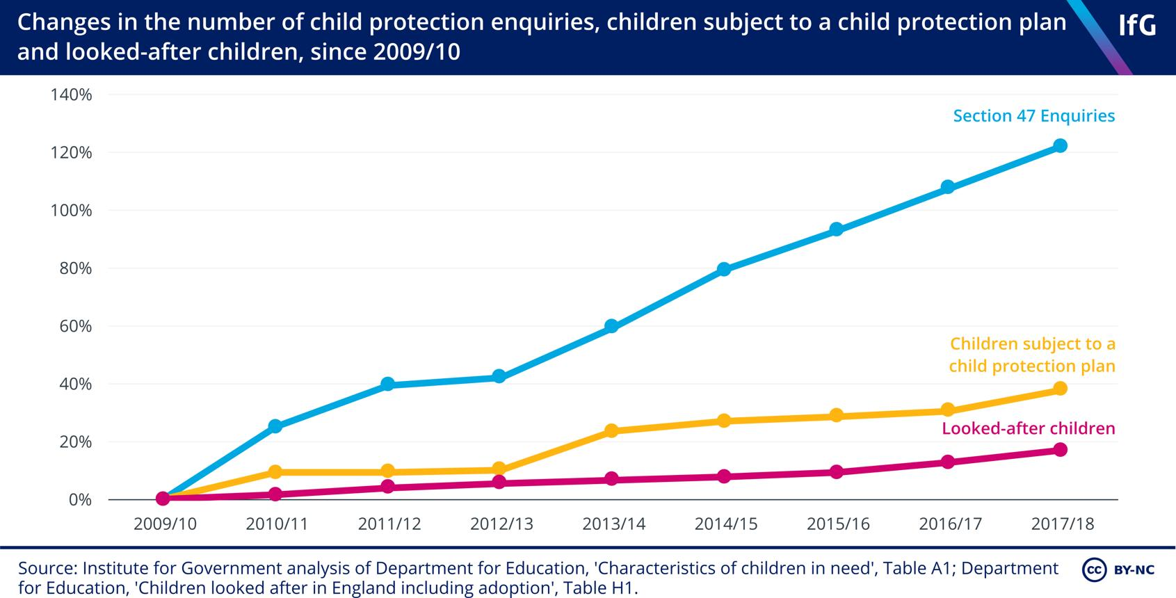
Figure 1: Children in Need in England (Department for Education, 2025).

Figure 1 illustrates the consistently high number of children identified as ‘children in need’ in England, reflecting sustained pressure on safeguarding services. This trend suggests increasing demand on social care systems, which may contribute to delays in decision-making and increased risk of oversight in complex cases.
2.3 Organisational and System Failures (Baby P Case)
The case of Peter Connelly (Baby P) represents a critical example of systemic safeguarding failure, where multiple agencies did not identify and respond effectively to escalating risk. The central problem was not a lack of contact with services, but a failure in how information was interpreted, shared, and acted upon. Despite extensive involvement from social workers, healthcare professionals, and police, the Serious Case Review found that professional responses were characterised by a limited of urgency, insufficient thoroughness, and a failure to exercise authoritative intervention (Haringey Local Safeguarding Children Board, 2009). This highlights a significant breakdown in safeguarding practice, where warning signs were present but not effectively recognised or escalated.
A key systemic weakness identified in the case was breakdown in inter- agency coordination and information sharing between agencies. Evidence indicates that critical medical findings were not effectively communicated across services, resulting in fragmented assessments of risk (Care Quality Commission, 2009). This absence of coordination reflects broader challenges within decentralised safeguarding systems, where responsibility is shared across multiple organisations, but accountability can become unclear. Similarly, findings published in the BMJ emphasised that professionals failed to fully understand the level of danger the child was facing, suggesting limitations in both risk assessment and professional judgement (Wise, 2009). These failures demonstrate that safeguarding breakdowns are often rooted in organisational and cultural issues, rather than isolated professional error.
From a governance perspective, the failure occurred primarily at a local level, involving Haringey Council and its partner agencies. However, it also reflects wider national safeguarding challenges, particularly in the implementation of statutory duties under the Children Act 1989 and guidance such as Working Together to Safeguard Children (HM Government, 2018). While these frameworks set up clear responsibilities for protecting children, the Baby P case demonstrates a gap between policy and practice, where legal duties were not effectively translated into action. Reports at the time also suggested that the child had been “failed by all agencies,” reinforcing the extent of systemic breakdown (BBC, 2010).
Overall, the case illustrates how organisation failures arise from interconnected weaknesses in collaborative interaction, leadership, governance, and professional practice. The inability to challenge parental explanations, escalate concerns, and coordinate effectively across agencies reflects deeper systemic issues, highlighting the need for a systems-based approach to understanding safeguarding failure. This case reflects wider patterns identified in serious case reviews, where failures often involve poor inter-agency coordination and weak professional challenge (Brandon et al., 2012).
2.4 Systems Thinking and Rich Picture Analysis
Systematic failures such as the Baby P case are best understood through a systems thinking perspective, which focuses on how different components within a system interact rather than viewing events in isolation. Systems thinking recognises that outcomes are shaped by interconnected factors, including people, processes, structures, and organisational culture (Meadows, 2008). In complex safeguarding environments, multiple agencies operate simultaneously, and the effectiveness of intervention depends on how well these components are coordinated. As highlighted by Munro (2011), child protection systems require professionals to make judgements under conditions of uncertainty, where risk is not always immediately visible, increasing the potential for error when information sharing and leadership are weak.
In the Baby P case, a systems thinking approach (Checkland, 1999; Senge, 2006) highlights how failures occurred across multiple levels rather than within a single organisation. The interaction between social services, healthcare professionals, and the police was characterised by fragmented communication, inconsistent risk assessment, and limited professional challenge. Information was not effectively shared, leading to incomplete understanding of the child’s situation, while decision-making processes did not exhibit coordination and urgency (Haringey Local Safeguarding Children Board, 2009; Care Quality Commission, 2009). These issues demonstrate how dependencies between agencies can become points of failure when systems are not effectively integrated.
Figure 2: Rich Picture illustrating systemic safeguarding failures in the Baby P case (adapted by author)
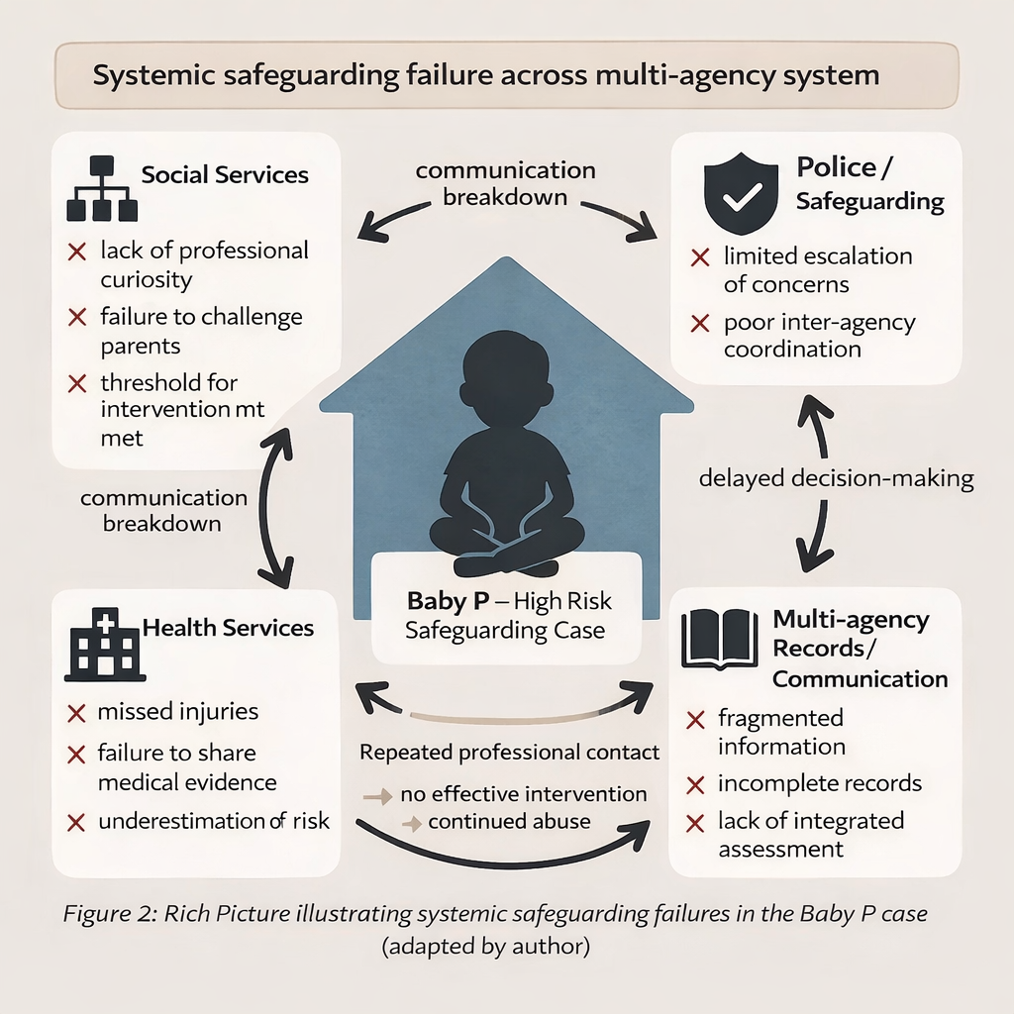
As shown in Figure 2, safeguarding failures in the Baby P case resulted from fragmented communication, weak leadership, and ineffective multi-agency coordination. The diagram also illustrates how repeated professional contact did not lead to effective intervention, demonstrating a feedback loop in which risk was repeatedly identified but insufficiently acted upon. This reinforces the argument that failure arose not from a single professional omission, but from weaknesses across the wider safeguarding system.
3. Centralisation and Decentralisation in Safeguarding Systems
3.1 Organisational Structure of Safeguarding Systems
Safeguarding systems in England run through a hybrid structure combining centralised governance with decentralised service delivery, reflecting the complexity of multi-agency working. Centralisation refers to decision-making authority being guided by national legislation and statutory frameworks, while decentralisation involves the distribution of authority across local agencies and frontline professionals (Hudson, 2007). For example, Working Together to Safeguard Children (HM Government, 2018; 2023) sets clear expectations for information sharing and inter-agency collaboration, while the Children Act 1989 establishes a legal duty for local authorities to investigate suspected harm. This proves how centralised governance provides a structured framework for safeguarding practice.
Moreover, centralised systems promote consistency and accountability by ensuring that safeguarding responsibilities are clearly defined. However, reliance on procedural frameworks may limit professional judgement in complex cases, particularly where strict thresholds delay intervention (Munro, 2011). This suggests that centralisation alone does not guarantee effective safeguarding outcomes, especially when implementation at a local level is inconsistent.
In contrast, safeguarding is delivered through a decentralised system in practice, where responsibility is shared across social services, healthcare professionals, and the police. In the Baby P case, multiple agencies were involved in assessing risk, yet decision-making was fragmented, with no single agency assuming full responsibility. Furthermore, the Serious Case Review found failures in inter- agency coordination, resulting in inconsistent risk assessment and missed opportunities for intervention (Haringey Local Safeguarding Children Board, 2009; Care Quality Commission, 2009). This highlights a key limitation of decentralisation, where flexibility can lead to diffused accountability when coordination is weak.
Overall, while centralised systems provide structure and legal accountability, decentralised delivery enables flexibility in responding to individual cases. However, the effectiveness of this hybrid model depends on strong leadership, clear information exchange, and coordinated decision-making. Without these, safeguarding systems become vulnerable to fragmentation and failure, as showed in the Baby P case.
3.2 Impact of System Structure on Decision-Making and Accountability
The decentralised structure of safeguarding systems has a significant impact on decision-making processes (Taylor, 2013; Helm, 2016) and accountability, particularly in complex, high-risk cases such as Baby P. In theory, decentralisation allows professionals to exercise judgement and respond flexibly to individual circumstances. However, in practice, this distributed model can lead to inconsistencies in decision-making, especially where lack of system integration between agencies are weak (Hudson, 2007). In the Baby P case, despite repeated contact with services, decision-making was fragmented across multiple agencies, resulting in a failure to recognise and respond effectively to escalating risk.
Moreover, evidence from the Serious Case Review shows that professionals did not sufficiently challenge parental explanations or escalate concerns, reflecting inadequate of authoritative decision-making (Haringey Local Safeguarding Children Board, 2009). This suggests that the decentralised system contributed to diffused responsibility, where no single professional or organisation assumed clear accountability for safeguarding the child. Furthermore, findings from the Care Quality Commission found that healthcare professionals did not fully assess and cooperate the severity of injuries, highlighting weaknesses in both clinical judgement and inter-agency information sharing (Care Quality Commission, 2009). These failures illustrate how decentralised structures can undermine effective decision-making when coordination mechanisms are insufficient.
Additionally, national safeguarding data reinforces these concerns. High re-referral rates, estimated at 23% within one year, say that initial safeguarding interventions are often not effective in resolving underlying risks (Department for Education, 2024). This suggests that decision-making processes within the absence of system consistency and continuity, particularly where multiple agencies are involved. Furthermore, increasing demand on safeguarding services, with over 400,000 children identified as ‘children in need’, places other pressure on professionals, potentially contributing to delayed or risk-averse decision-making (Department for Education, 2025). This reflects broader systemic challenges, including high caseloads and limited organisational capacity.
However, it is important to recognise that decentralisation is not inherently flawed. When supported by strong leadership, clear information integration, and effective governance, it can enable responsive and context-specific decision-making (Munro, 2011). Nevertheless, the Baby P case demonstrates that in the absence of these conditions, decentralised systems can hinder crisis management by delaying intervention, weakening accountability, and reducing the likelihood of decisive action. Therefore, the impact of system structure on safeguarding outcomes is highly dependent on the effectiveness of coordination, leadership, and accountability mechanisms within the system.
3.3 Critical Evaluation of System Structure
A critical evaluation of safeguarding system structures suggests that neither centralisation nor decentralisation alone is sufficient to ensure effective safeguarding outcomes. Instead, the interaction between these approaches figures out the effectiveness of crisis management, decision-making, and accountability. Centralised systems provide a clear legal and policy framework, ensuring consistency and defined responsibilities across services. For example, legislation such as the Children Act 1989 and statutory guidance including Working Together to Safeguard Children establish clear expectations for intervention, information sharing, and multi-agency collaboration (HM Government, 2018; 2023). Moreover, centralisation enables oversight and regulation, which are essential in supporting smallest safeguarding standards across organisations (The King’s Fund, 2018).
However, despite these advantages, the Baby P case proves that centralised frameworks do not guarantee effective practice. Although statutory duties were in place, professionals failed to act decisively, suggesting a gap between policy and implementation. Furthermore, research says that an over-reliance on procedural compliance can lead to a ‘tick-box’ approach to safeguarding, where professionals prioritise process over critical judgement (Munro, 2011; Parton 2014). This highlights a key limitation of centralisation, where rigid structures may not capture the complexity of real-life safeguarding situations.
In contrast, decentralised systems are designed to promote flexibility and professional autonomy, allowing social workers and practitioners to respond to individual needs. For example, social workers in the Baby P case had the authority to assess risk and make safeguarding decisions; however, the Serious Case Review found that this autonomy did not translate into effective intervention (Haringey Local Safeguarding Children Board, 2009). Moreover, studies of multi-agency safeguarding highlight that decentralisation can lead to fragmented information flow and inconsistent decision-making, particularly where roles and responsibilities are unclear (Atkinson et al., 2007; Hudson, 2007). This was clear in the failure of agencies to share critical information and challenge assumptions, resulting in missed opportunities to protect the child.
Furthermore, evidence from professional practice suggests that social workers operate under significant pressure, including high caseloads and organisational constraints, which can affect decision-making quality (Fitzpatrick, 2009). Data showing high re-referral rates within children’s services further supports the argument that safeguarding systems struggle to support effective, consistent interventions (Department for Education, 2024). Therefore, while decentralisation offers adaptability, it also increases the risk of diffused accountability, where responsibility is shared but not clearly owned.
Overall, the Baby P case proves that organisational failure in child protection was not caused by a single structural issue, but by the ineffective integration of centralised and decentralised elements. Centralised policies provided a framework, yet decentralised delivery lacked coordination, leadership, and accountability. Therefore, the effectiveness of safeguarding systems depends not on the structure alone, but on how well leadership, communication, and governance mechanisms connect various parts of the system. Without these, even well-designed structures are vulnerable to failure. Effective safeguarding requires alignment between policy, leadership, and frontline practice, highlighting the importance of integrated governance systems (Goodwin et al., 2017).
Similar safeguarding breakdowns have been seen across England, indicating recurring systemic weaknesses rather than isolated incidents (Sidebotham et al., 2016).
4. Leadership Theories and Application
4.1 Leadership Models and Theoretical Approaches
Leadership plays a critical role in safeguarding systems, particularly in ensuring effective decision-making, accountability, and coordination across multi-agency environments. In complex cases such as Baby P, failures in leadership can significantly contribute to organisational breakdown, as safeguarding outcomes are highly dependent on the ability of leaders to manage risk, support professionals, and ensure clear case information flow (West et al., 2015). Therefore, applying leadership theories provides a framework for understanding how leadership influenced the failures seen in this case.
One relevant theoretical perspective is transformational leadership, which focuses on inspiring and motivating professionals to achieve shared goals while promoting a strong organisational culture (Bass, 1985). In safeguarding contexts, transformational leadership encourages professional curiosity, critical thinking, and proactive intervention. However, in the Baby P case, there is limited evidence of such leadership being effectively demonstrated. For example, the Serious Case Review highlighted a lack of challenge among professionals and a failure to question parental explanations (Haringey Local Safeguarding Children Board, 2009). Practitioners may rely on incomplete information when assessing risk, increasing the likelihood of misjudgement (Helm, 2016). Moreover, weak leadership at management level contributed to insufficient oversight and supervision of frontline staff, suggesting that transformational leadership principles were not embedded within the organisation.
Furthermore, transactional leadership, which is based on structured processes, rules, and performance monitoring, is also relevant in safeguarding systems (Burns, 1978). While this approach can support accountability and ensure compliance with procedures, it may lead to a focus on administrative tasks rather than critical judgement. In the Baby P case, professionals followed without fully recognising the severity of risk, writing down a reliance on procedural compliance rather than reflective decision-making (Munro, 2011). This highlights a key limitation of transactional leadership in complex safeguarding environments, where rigid adherence to process can hinder effective intervention.
Additionally, distributed leadership is particularly relevant in multi-agency safeguarding systems, where responsibility is shared across different organisations and professionals. This approach emphasises collaboration and shared responsibility; however, it also requires professional dialogue (Bolden, 2011). In the Baby P case, distributed leadership was evident in the involvement of multiple agencies, yet this did not translate into effective action. Instead, the deficiency in clear leadership resulted in fragmented decision-making and diffused accountability, reinforcing the limitations of distributed leadership when governance and coordination are weak.
Overall, the Baby P case demonstrates that leadership is a critical factor in safeguarding effectiveness. While different leadership approaches offer potential benefits, their success depends on how they are applied in practice. The absence of strong, coordinated leadership contributed to failures in breakdown in inter-agency coordination, decision-making, and accountability, highlighting the need for leadership models that balance structure, flexibility, and professional judgement within safeguarding systems.
4.2 Leadership Failures and Their Impact on Safeguarding practice
Leadership failures played a vital role in the breakdown of safeguarding practice in the Baby P case, particularly in relation to decision-making, oversight, and professional accountability. Effective safeguarding requires strong leadership to coordinate multi-agency responses, challenge lack of system cohesion, and ensure timely intervention (West et al., 2015). However, evidence from the Serious Case Review shows that leadership within Haringey’s safeguarding system was inadequate at both operational and managerial levels (Haringey Local Safeguarding Children Board, 2009).
One of the most significant leadership failures was the insufficiency of effective oversight and supervision (Brandon et al., 2012; Sidebotham et al., 2016). Senior managers did not critically review frontline decisions or name escalating risk, resulting in missed opportunities for intervention. Moreover, social workers were not sufficiently challenged or supported in their assessments, showing weaknesses in supervisory leadership. This reflects a failure of authoritative leadership, where leaders did not provide clear direction or intervene decisively in a high-risk situation.
Furthermore, there was a clear failure to promote a culture of professional curiosity and challenge. Professionals accepted parental explanations without sufficient scrutiny, despite repeated signs of abuse. Research highlights that safeguarding leadership must actively encourage critical thinking and challenge assumptions to prevent risk from being underestimated (Ferguson, 2011). However, in this case, leadership failed to set up such a culture, contributing to passive and compliant professional behaviour.
In addition, failure of information sharing mechanisms reflects weaknesses in distributed leadership across agencies. Although multiple organisations were involved, there was no clear leadership structure to ensure effective information sharing or coordinated decision-making. Findings from the Care Quality Commission say that health professionals did not adequately communicate concerns, further demonstrating a lack of leadership in managing inter-agency collaboration (Care Quality Commission, 2009). This resulted in fragmented decision-making and an incomplete understanding of the child’s situation.
Moreover, leadership failed to ensure accountability and ownership of decisions. Responsibility for safeguarding was diffused across multiple professionals, with no individual or agency taking decisive control of the case. This limited of accountability contributed to delays in intervention and reflects a broader leadership failure in establishing clear roles and responsibilities within the system (Goleman, 2000).
Overall, the Baby P case proves that critical safeguarding lapse were not solely the result of individual professional errors but were significantly influenced by weaknesses in leadership. The absence of effective oversight disjointed professional responses, shortfall in challenge, and unclear accountability created conditions in which critical decisions were delayed or avoided. Therefore, strong, and coordinated leadership is essential in safeguarding systems to ensure prompt, decisive, and accountable intervention in high-risk cases.
4.3 Critical Evaluation of Leadership in the Baby P case
A critical evaluation of leadership within the Baby P case suggests that systematic failure was not simply the absence of leadership, but the absence of effective and integrated leadership across organisational levels. While multiple agencies, including Haringey Council, health services, and the police, were involved, leadership was not sufficiently coordinated to ensure a unified safeguarding response. This writes down that the issue was not structural presence, but functional effectiveness.
Rather than focusing solely on leadership styles in isolation, it is necessary to consider how leadership was enacted within a complex system. Research highlights that effective safeguarding requires systems leadership, where leaders operate across organisational boundaries to ensure alignment, shared understanding, and coordinated action (The King’s Fund, 2018). In the Baby P case, there was limited evidence of such leadership, as agencies used within their own frameworks without integrating decision-making processes. This resulted in fragmented risk assessment and inconsistent responses, showing a failure to lead across the system rather than within individual organisations.
Moreover, leadership in safeguarding must actively manage risk under conditions of uncertainty, requiring both professional confidence and organisational support. Studies of child protection practice suggest that decision-making is often influenced by organisational culture, workload pressures, and fear of accountability (Ferguson, 2011). In the context of Haringey Council, leadership did not sufficiently support practitioners in making assertive decisions, which may have contributed to risk-averse behaviour and delayed intervention. This highlights the importance of leadership in shaping not only processes, but also the confidence and judgement of frontline professionals.
Additionally, evidence from safeguarding reviews says that effective leadership must ensure clarity of roles and accountability, particularly in multi-agency contexts (Child Safeguarding Practice Review Panel, 2022). In the Baby P case, responsibility was distributed across agencies, yet leadership failed to set up clear ownership of decision-making. This suggests that distributed leadership, without strong coordination mechanisms, can weaken accountability rather than strengthen collaboration.
A further consideration is the role of adaptive leadership, which emphasises the ability to respond flexibly to complex and evolving situations (Heifetz, 1994). Safeguarding cases are inherently unpredictable, requiring leaders to move beyond procedural responses and engage in critical, context-specific decision-making. The Baby P case proves that such adaptive leadership was lacking, as professionals did not adjust their responses despite repeated indicators of escalating harm. This reinforces the argument that effective safeguarding leadership must balance structure with adaptability.
Overall, the Baby P case highlights that effective leadership in safeguarding is not defined by a single model, but by the ability to integrate direction, coordination, and adaptability within a complex system. Leadership must work across organisational boundaries, support professional judgement, and ensure clear accountability. Where these elements are absent, as proved in this case, safeguarding systems become fragmented and ineffective.
5. Organisational Improvements and Lessons Learned
5.1 Policy and Practice Changes Following the Baby P Case
The Baby P case prompted significant reforms in safeguarding policy and practice, particularly in strengthening accountability, inter-agency coordination, and professional standards. The Laming Progress Report (2009) introduced key recommendations aimed at improving leadership oversight, supervision, and information sharing across agencies. These reforms were reflected in later updates to Working Together to Safeguard Children, which reinforced expectations for multi-agency collaboration and clarified safeguarding responsibilities (HM Government, 2018; 2023). Government strategies have emphasised early intervention and prevention as key components of safeguarding improvement (Department for Education, 2018).
Moreover, structural changes were implemented to strengthen workforce capability, including the establishment of the Social Work Task Force, which focused on improving training, supervision, and professional development (Department for Children, Schools, and Families, 2009). These changes recognised that safeguarding effectiveness is intricately linked to workforce competence and organisational support. In addition, inspection frameworks were strengthened, with Ofsted playing a vital role in monitoring safeguarding performance and holding local authorities accountable (Ofsted, 2023).
5.2 Evaluation of Effectiveness
While these reforms have improved safeguarding frameworks, their impact has been uneven. Increased clarity in policy and inspection has strengthened accountability and raised professional awareness (The King’s Fund, 2018). However, ongoing evidence suggests that structural improvements have not fully resolved underlying system challenges.
For example, re-referral rates of approximately 23% indicate that safeguarding interventions do not consistently address long-term risk (Department for Education, 2024). Furthermore, national reviews from the Child Safeguarding Practice Review Panel continue to identify recurring issues, including weak communication, limited professional challenge, and leadership gaps. This suggests that while policy frameworks have improved, implementation is still inconsistent (National Audit Office, 2016).
However, these reforms can be critiqued for focusing on structural compliance rather than addressing deeper cultural and leadership issues within safeguarding practice (Parton, 2014).
5.3 Ongoing Challenges in Safeguarding
Safeguarding systems continue to face persistent challenges, particularly in relation to multi-agency coordination, workforce capacity, and decision-making under pressure. Inter-agency working remains complex, with differences in organisational processes and fragmented information flow contributing to response (Horwath and Morrison, 2007).
Increasing demand on children’s services continues to place pressure on safeguarding systems, affecting the consistency of intervention (National Audit Office, 2016).
Additionally, workforce pressures, including high caseloads and resource constraints, continue to impact safeguarding practice, limiting the ability of professionals to carry out thorough assessments (Ferguson, 2011). The increasing complexity of cases, often involving multiple risk factors such as domestic abuse and mental health, further compounds these challenges. As a result, safeguarding systems remain vulnerable to the types of breakdowns observed in the Baby P case.
6. Recommendations
To improve safeguarding outcomes, it is essential to strengthen leadership and accountability within multi-agency systems. Clear ownership of decision-making should be proven in high-risk cases to reduce ambiguity and ensure prompt intervention. Senior leaders within local authorities, including safeguarding leads, must take an active role in overseeing complex cases, providing challenge, and ensuring that concerns are escalated appropriately. This would address the inadequate of decisive leadership saw in the Baby P case.
Furthermore, improving inter-agency communication and information sharing is critical. The development of integrated digital safeguarding systems would enable professionals across social services, healthcare, and law enforcement to access and update relevant information in real time. In addition, clearer protocols should be implemented to ensure that critical information is consistently shared and acted upon, reducing the risk of fragmented assessments and missed warning signs. Safeguarding reforms have also been shaped by legislative developments, including the Children Act 2004, which strengthened inter-agency responsibilities and accountability. The Care Act 2014 further reinforced safeguarding duties, particularly in relation to protecting vulnerable individuals across health and social care systems.
There should also be a stronger emphasis on promoting professional curiosity and reflective practice within safeguarding environments. Training programmes and supervision structures should encourage practitioners to question assumptions, challenge parental explanations, and actively assess risk. This cultural shift is necessary to move beyond procedural compliance and support more effective decision-making.
Finally, addressing workforce pressures and organisational capacity is essential for improving safeguarding practice. High caseloads and staff shortages limit the ability of social workers to carry out thorough assessments and support consistent engagement with vulnerable families. Investment in staffing, supervision, and retention strategies would enhance the capacity of professionals to respond effectively to safeguarding concerns and reduce the likelihood of oversight in complex cases. Funding constraints have also been identified as a key factor affecting safeguarding capacity and service delivery, limiting the ability of services to respond effectively to complex cases (Public Accounts Committee, 2019). In addition, social work decision-making is often shaped by uncertainty and organisational pressures, which can weaken effective risk assessment unless supported by strong supervision and leadership (Taylor, 2013).
7. Conclusion
This analysis shows that the organisation failure in child protection the Baby P case was produced by the interaction of organisational structure, leadership practice, and multi-agency dynamics rather than by isolated professional error. While England’s safeguarding system is underpinned by robust statutory frameworks—most notably the Children Act 1989 and Working Together to Safeguard Children—the evidence shows that the existence of policy does not ensure effective practice (Munro, 2011; Gilbert et al., 2009). The case illustrates a persistent implementation gap, in which formal governance structures do not translate into coherent, risk-sensitive action at the frontline.
From a structural perspective, the decentralised nature of safeguarding—designed to enable professional autonomy and responsiveness—contributed to fragmented decision-making and ambiguity in accountability. This aligns with research suggesting that distributed systems, when insufficiently coordinated, can dilute responsibility and weaken escalation pathways (Atkinson et al., 2007; Horwath and Morrison, 2007). In the Baby P case, hierarchical oversight within the local authority, including Haringey Council, did not function as an effective mechanism of governance. Instead of reinforcing accountability, leadership hierarchies failed to challenge practice or synthesise information across agencies, allowing risk to remain unrecognised despite repeated professional contact.
Moreover, the analysis of leadership highlights that safeguarding effectiveness depends not on the presence of leadership roles, but on the quality and integration of leadership across system levels. The absence of adaptive and systems-oriented leadership limited the capacity of professionals to interpret risk dynamically and act decisively (Heifetz, 1994; West et al., 2015). This supports wider evidence that child protection failures often arise where leadership does not actively shape organisational culture, support critical judgement, or ensure alignment between agencies (Ferguson, 2011).
Although policy reforms following the case have strengthened accountability and inter-agency expectations, recurring findings from national safeguarding reviews indicate that similar patterns of failure persist (Child Safeguarding Practice Review Panel, 2022). This suggests that safeguarding systems remain constrained by enduring challenges, including workforce pressures, complexity of need, and inconsistencies in professional practice. Consequently, safeguarding effectiveness is contingent not only on system design, but on the continuous alignment of governance, leadership, and practice.
Overall, the Baby P case offers a critical insight into the limitations of safeguarding systems when structural arrangements, leadership hierarchies, and inter-agency processes run in isolation rather than as an integrated system. It underscores the necessity of moving beyond procedural compliance towards a model of safeguarding that is coordinated, accountable, and responsive to complexity.

Reference List:
Atkinson, M., Jones, M. and Lamont, E. (2007) Multi-agency working and its implications for practice: A review of the literature. Slough: National Foundation for Educational Research.
Bass, B.M. (1985) Leadership and performance beyond expectations. New York: Free Press.
BBC News (2010) ‘Baby Peter “was failed by all agencies”’, BBC News, 26 October. Available at: https://www.bbc.co.uk/news/education-11621391 (Accessed: 22 March 2026).
Bolden, R. (2011) ‘Distributed leadership in organisations: A review of theory and research’, International Journal of Management Reviews, 13(3), pp. 251–269.
Brandon, M., Sidebotham, P., Bailey, S., Belderson, P., Hawley, C., Ellis, C. and Megson, M. (2012) New learning from serious case reviews: A two-year report for 2009–2011. London: Department for Education.
Burns, J.M. (1978) Leadership. New York: Harper & Row.
Care Quality Commission (2009) Review of the involvement and action taken by health bodies in relation to the case of Baby Peter Connelly. London: Care Quality Commission.
Checkland, P. (1999) Systems thinking, systems practice. Chichester: John Wiley & Sons.
Child Safeguarding Practice Review Panel (2022) Annual report 2021–2022. London: HM Government. Available at: https://www.gov.uk/government/organisations/child-safeguarding-practice-review-panel (Accessed: 21 March 2026).
Department for Children, Schools, and Families (2009) The protection of children in England: A progress report (Lord Laming). London: The Stationery Office.
Department for Education (2018) Working Together to Safeguard Children. London: HM Government.
Department for Education (2024) Children in need of help and protection, England 2023–2024. Available at: https://explore-education-statistics.service.gov.uk (Accessed: 24 March 2026).
Department for Education (2025) Characteristics of children in need in England, 2024–2025. Available at: https://explore-education-statistics.service.gov.uk (Accessed: 25 March 2026).
Ferguson, H. (2011) Child protection practice. Basingstoke: Palgrave Macmillan.
Fitzpatrick, M. (2009) ‘The lessons of Baby P’, British Journal of General Practice, 59(566), pp. 862–863.
Gilbert, N., Parton, N. and Skivenes, M. (2009) Child protection systems: International trends and orientations. Oxford: Oxford University Press.
Goleman, D. (2000) ‘Leadership that gets results’, Harvard Business Review, 78(2), pp. 78–90.
Goodwin, N., Smith, J., Davies, A., Perry, C., Rosen, R., Dixon, A., and Dixon, J. (2017) Integrated care systems and governance: The future of health systems. London: The King’s Fund.
Haringey Local Safeguarding Children Board (2009) Serious case review: Child A (Baby Peter). London: HLSCB.
Heifetz, R.A. (1994) Leadership without easy answers. Cambridge, MA: Harvard University Press.
Helm, D. (2016) ‘Sense-making in child and family social work: Learning from a case study’, British Journal of Social Work, 46(4), pp. 1175–1191.
HM Government (1989) Children Act 1989. London: The Stationery Office.
HM Government (2004) Children Act 2004. London: The Stationery Office.
HM Government (2014) Care Act 2014. London: The Stationery Office.
HM Government (2018) Working Together to Safeguard Children. London: The Stationery Office.
HM Government (2023) Working Together to Safeguard Children. London: The Stationery Office.
Horwath, J., and Morrison, T. (2007) ‘Collaboration, integration and change in children’s services: Critical issues and key ingredients’, Child Abuse & Neglect, 31(1), pp. 55–69.
Hudson, B. (2007) ‘Pessimism and optimism in inter-professional working’, Journal of Interprofessional Care, 21(1), pp. 3–15.
Local Government Association (2019) Children’s services funding and safeguarding pressures. Available at: https://www.local.gov.uk (Accessed: 20 March 2026).
Meadows, D.H. (2008) Thinking in systems: A primer. London: Earthscan.
Munro, E. (2011) The Munro Review of Child Protection: Final report. London: Department for Education.
National Audit Office (2016) Children in need of help or protection. London: National Audit Office.
Office for National Statistics (2022) Child abuse in England and Wales: Year ending March 2022. Available at: https://www.ons.gov.uk (Accessed: 23 March 2026).
Ofsted (2023) Children’s social care annual report 2022–2023. Available at: https://www.gov.uk (Accessed: 21 March 2026).
Parton, N. (2014) The politics of child protection: Contemporary developments and future directions. Basingstoke: Palgrave Macmillan.
Public Accounts Committee (2019) Children’s services funding. London: House of Commons.
Senge, P.M. (2006) The fifth discipline: The art and practice of the learning organisation. London: Random House.
Sidebotham, P., Brandon, M., Powell, C., Solebo, C. and Koistinen, J. (2016) Pathways to harm, pathways to protection: A triennial analysis of serious case reviews 2011–2014. London: Department for Education.
Stoltenborgh, M., Bakermans-Kranenburg, M.J., Alink, L.R.A. and van IJzendoorn, M.H. (2015) ‘The prevalence of child maltreatment across the globe: Review of a series of meta-analyses’, Child Abuse Review, 24(1), pp. 37–50.
Taylor, B. (2013) Professional decision making and risk in social work. London: SAGE.
The King’s Fund (2018) Leadership and leadership development in healthcare: The evidence base. London: The King’s Fund.
UNICEF (2021) Violence against children. Available at: https://www.unicef.org (Accessed: 22 March 2026).
West, M., Eckert, R., Steward, K., and Pasmore, B. (2015) Developing collective leadership for healthcare. London: The King’s Fund.
Wise, J. (2009) ‘Systemic failings in NHS contributed to death of Baby P’, BMJ, 338, b1298.
World Health Organization (2022) Child maltreatment. Geneva: World Health Organization.
Canters for Disease Control and Prevention (2023) Adverse childhood experiences (ACEs). Available at: https://www.cdc.gov (Accessed: 24 March 2026).

