
Skills for the Workplace
Module Assignment Submission
Student Name: | Anamaria Bock
Student Number: | 2114314
Module No: | BMSK4006
Module Title: | Managing Enterprise in the 21st Century

Statement of Confirmation of Authenticity
By the act of making this submission, the student declares that this is the work of the student named above. The work has not, in whole or in part, been knowingly presented elsewhere for assessment, or where assessment has been built on a previous assessment, this has been identified. Where materials have been used from other sources it has been properly acknowledged. If this statement is untrue, the student acknowledges that an assessment offence has been committed.
Attention is drawn to the plagiarism and unfair practice policies of both the University and of ILM.

Table of Contents
Introduction 3
1.Interpersonal communication skills 4
2.Research skills 5
3. Time management 5
4. Organisational skills 6
5. Entrepreneurship 7
6. Planning skills 8
7. Strategic planning 8
8. Professional writing 8
9. Decision making 9
10. Kolb learning cycle 10
11. Personal Development plan 11
12. SWOT analysis 11
12. References 12

Introduction
This assignment, also called reflection on the business plan I have done, will be about the skills that I have developed during this module. So, you will find in it the most important skills that every person needs for employability such as research skills, organisational skills, entrepreneurship, strategic planning, time management, communication skills, decision making and professional writing.

1.Interpersonal communication skills

Communicating is the way that two people can understand better what exactly is going on in a situation, they can get things better and solve any problems if the communicate. If people do communicate efficiently that is the key to success in any team and they’ll get through everything.
As Peter Morgan wrote in his book, “the ability to communicate in a way that ensures a message is understood in the way you intend is critical to being able to perform well in nearly every job role. Yet it is the one thing that tends to cause the most problems in employment (and personal) relationships. Poor communication with others- or even an unwillingness to communicate (and an awareness of when or why not to communicate) – is important to get right.” , it is very important to know when and how to communicate effectively so the person receiving the message is getting it right. During this module, when writing the business plan, I have realised that I am communicating effectively with my partner and we know exactly when and how to transmit a certain message, we know even when not to communicate in critical moments when silence is the best antidote.

2.Research skills

I must admit that I was never good at research, I was not even aware that I might possess this kind of skill, better said I never thought that you need skills to do research. During this whole year of university, I found out that I am not that bad at researching, and I have managed to develop the skills needed to do some real research, I have learned how to CRAP test the sources and take what’s best from a book or article or website. Also, very important it is to know how to use the information and where, always give credit to the author.

3. Time management
“Managing time is about achieving balance. Most of us have to work and earn a living. This means getting the most from the working day, feeling that we have achieved something and getting the recognition we deserve.” (Warren Wint)
To know how to organise your time, it is crucial in any workplace, from supervisor to manager or just a simple worker, any employees should have time management skills. It is very important to consider Covey’s matrix as it is showing us how to organise better, what to do first when you have a bucket list of things waiting to be done. It is extremely helpful, I have learned so many things about time management that really helped me, not just in my workplace but also in a daily lifestyle basis.

4. Organisational skills
When saying organisation skills, we refer to all the abilities that help us stay focused to achieve a certain task. So, the better we organise, the greater results we will get in a short time. This set of skills include time management, I have already mentioned this above, communication, planning, prioritising.
During this project I have developed many organisational skills as learning how to make the workplace comfortable and organising everything in such way that we know where exactly everything is helping us in saving time and serving the customers so quick that they are impressed.


5. Entrepreneurship
When comes to entrepreneurship, I certainly know that our vision was already formed before starting our business, we did not had to do too much research because we knew everything about the business itself, the brainstorm came when we decided to do more, and add more items to attract more customers, the strategy was to keep the loyal customers coming to us even if the name of the store has changed and manage to attract new customers , our price was slightly smaller, even if we decided to add the 200% mark-up, and our goal is to grow the business and open more stores and save as much money as we can to buy a house for our family (this is more like our motivation let’s say). We decided to embrace every challenge and we are looking forward to succeeding.
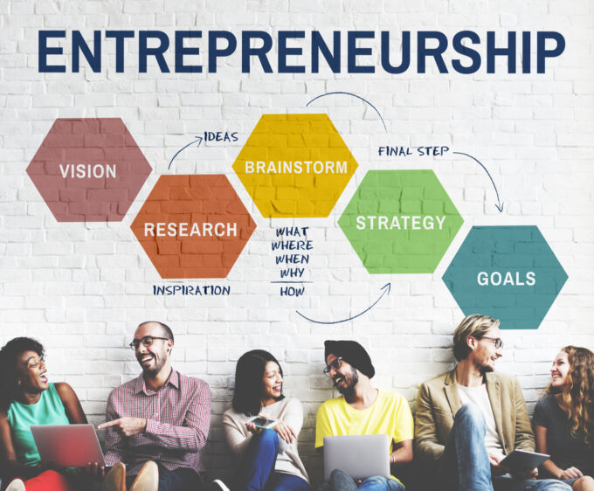

6. Planning skills
Planning skills are very important in a business because they will help you to reach your goal by using the right resources and managing your time effectively. The skill that will help you do a successful business plan is critical thinking. When saying critical thinking we don’t refer to something negative but being able to identify the needs of a business, clearly see the details that could make a difference and make your business grow.

7. Strategic planning

“Strategic planning is the art of creating specific business strategies, implementing them, and evaluating the results of executing the plan, in regard to a company’s overall long-term goals or desires.” So, let’s start from here, if you do have the organisational skills, then you are one step closer to achieve strategic planning skills. If you are well organised and have well determined goals and you work hard to achieve them, knowing exactly how to plan your next move, is essential to get you closer to success. So, for a strategy to work we first must analyse the strengths and weaknesses of the business but also opportunities and threats (SWOT analysis) and after having the result then we can decide where to start from, what is best to do to have only positive results.

8. Professional writing
Developing professional writing skills is an essential for academic and professional success. So, no matter how you are trying to send a message, by email, business letter, report, you must sound credible, and this is the reason why your writing should be professional.
To be able to write professional you must have an incredible attention to detail, must be accurate and precise, you have to focus on grammar and syntax, you have to be efficient, try to express the whole idea in as few words as possible so you keep the person reading interested rather than bored.

9. Decision making
“Decisions as rational choices
Virtually all of modern economics and large parts of the rest of social science, as well as the applied fields that build upon them, embrace the idea that human action is the result of human choice, and that human choice is intendedly rational. Rational theories picture decision making as based on four things:
A knowledge of alternatives. Decision makers have a set of alternatives for action.
A knowledge of consequences. Decision makers know the consequences of alternative actions, at least up to a probability distribution.
A consistent preference ordering. Decision makers have consistent values by which alternative consequences of action can be compared in terms of their subjective value.
A decision rule. Decision makers have rules by which they select a single alternative of action on the basis of its consequences for the preferences.”
Making a decision will never be easy, so we should always consider many options and choose the one that best suits the situation and will bring the best results.

10. Kolb learning cycle
Now let’s reflect on what I have learnt during this whole business plan experience using the Kolb learning cycle.
Concrete experience
I have been working in this industry for 3 years, so I have learnt exactly how to do it.

Testing new concepts
Having everything ready to start, I have realised that this new concept with be a success.

Concluding
With just few improvement people will love the new concept and new face of the business.
Observe and reflect on it
I have gathered all the information needed and I think I can do my own business shaped like this.

11. Personal Development plan
Goal | How to achieve it | Resources needed | Deadline | How does success look like
To grow a successful business and achieve all the skills needed to keep it growing. | Planning everything step by step, do the as much research needed to get it right. | Money to buy everything to start (the van all equipped, etc) approval from council, raw material. | One year from start date. | To brake even in the first year and keep growing the business in the next couple of years.

12. SWOT analysis
Strengths | Weaknesses | Opportunities | Threats
Experience in customer service  Having already our loyal customers  The best donuts in town | Can’t do longer opening times due to outlet’s management. | To add more products to the menu.  To grow our business by adding more stores. | The competition, prices going up or maybe rent can be really concerning for us.

13. References
GöpferichS., Imke Neumann, & Peter Lang Gmbh. (2016). Developing and Assessing Academic and Professional Writing Skills. Frankfurt Am Main Lang, Peter Frankfurt.
Morgan, P. (2017). Business Student’s Guide To Study And Employability. Sage Publications.
Neugebauer, J., & Evans-Brain, J. (2016). Employability : making the most of your career development. Sage.
Shapira, Z. (Ed.). (1996). Organizational Decision Making (Cambridge Series on Judgment and Decision Making). Cambridge: Cambridge University Press. doi:10.1017/CBO9780511584169
Simon, J. B. (2010). Using Kolb’s experiential learning cycle to develop a structured approach for accounting and business research methods. Hull University Business School.

