Database Analysis and Design
Student Name: Timothy Edwards, Student number: 2004445, Course name: Computing (Software Engineering), Module name: Introduction to Web and Database Concepts (ACCA4023), Submission Date: 05/05/2021

Contents
Introduction 2
Database design 3
Context Diagram 3
Data Flow Diagram – DFD level 0 3
Entity Relationship Diagram – ERD 4
User guide 5

Introduction
The purpose of this introduction is a means of introducing the purpose of this document. For this assignment it was asked that a total of 4 tasks to be completed for Celtic Caterers. These 4 tasks were to make a Context diagram, develop the Context Diagram into a DFD level 0, and an Entity Relationship Diagram. The final task was to make a database based on the design documentation. The flow for the document is then set, first will be a discussion about the context diagram, then the DFD level 0, then the ERD, finally would be a user guide on the final database.

Database design

Context Diagram
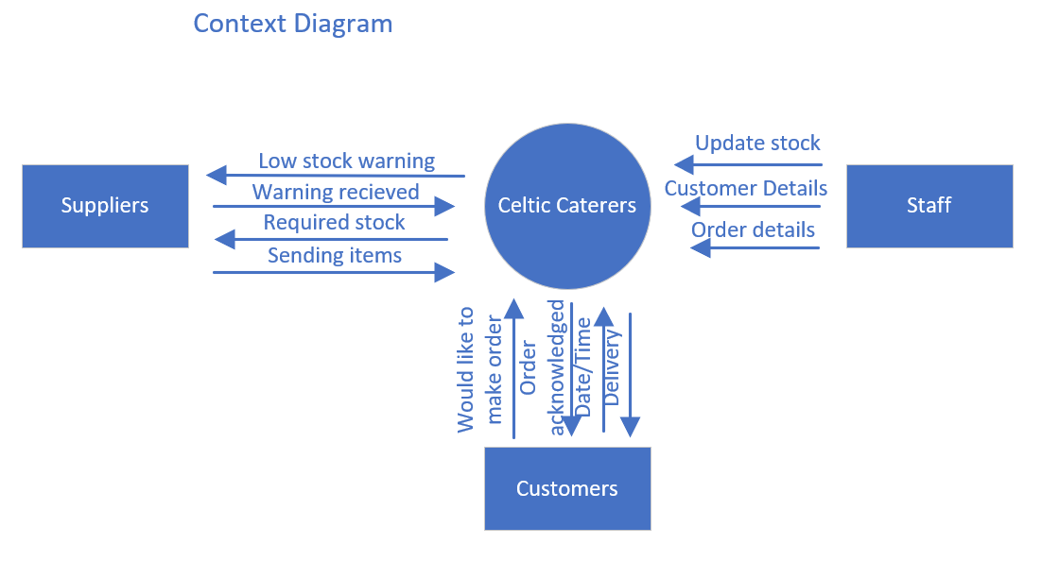
Above is the context diagram which was designed for the assignment. The diagram shows the outside contributors to the database that is in the middle. The staff each update the stock, input customer details and any order details. The customers request to make an order, the company would then acknowledge the order and alert the user as such, the user would then give the date/time that they would like the order, and the business will then deliver the order. The suppliers will get a low stock alert from the company’s database, the supplier would then respond to the alert, the database will then send the stock needed and the suppliers will then send the necessary stock.

Data Flow Diagram – DFD level 0
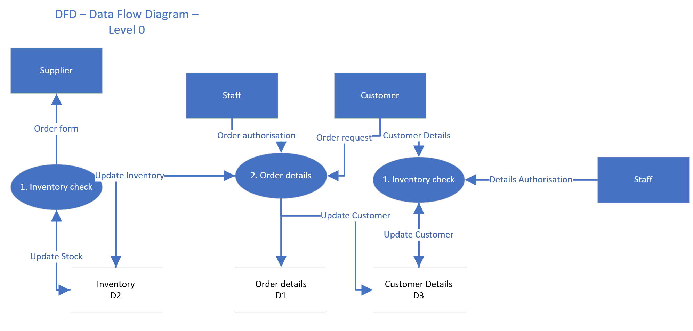
Above is the DFD level 0 designed for this assignment. Despite the lack of arrows on the design in comparison to the context diagram before. The DFD is a more fleshed out design. The idea however remains much the same. The staff are there as a means of authorising the orders or the details set in by the customer. The customer then submits the data, the data is then stored into their respective data bases, Customer details are stored in D3, Customer Details, while the Order details are stored in D1, Order details. The process box for order details updates the D2, Inventory as needed. The process box for Inventory check will see the inventory, if the inventory is running low it will update the suppliers.

Entity Relationship Diagram – ERD
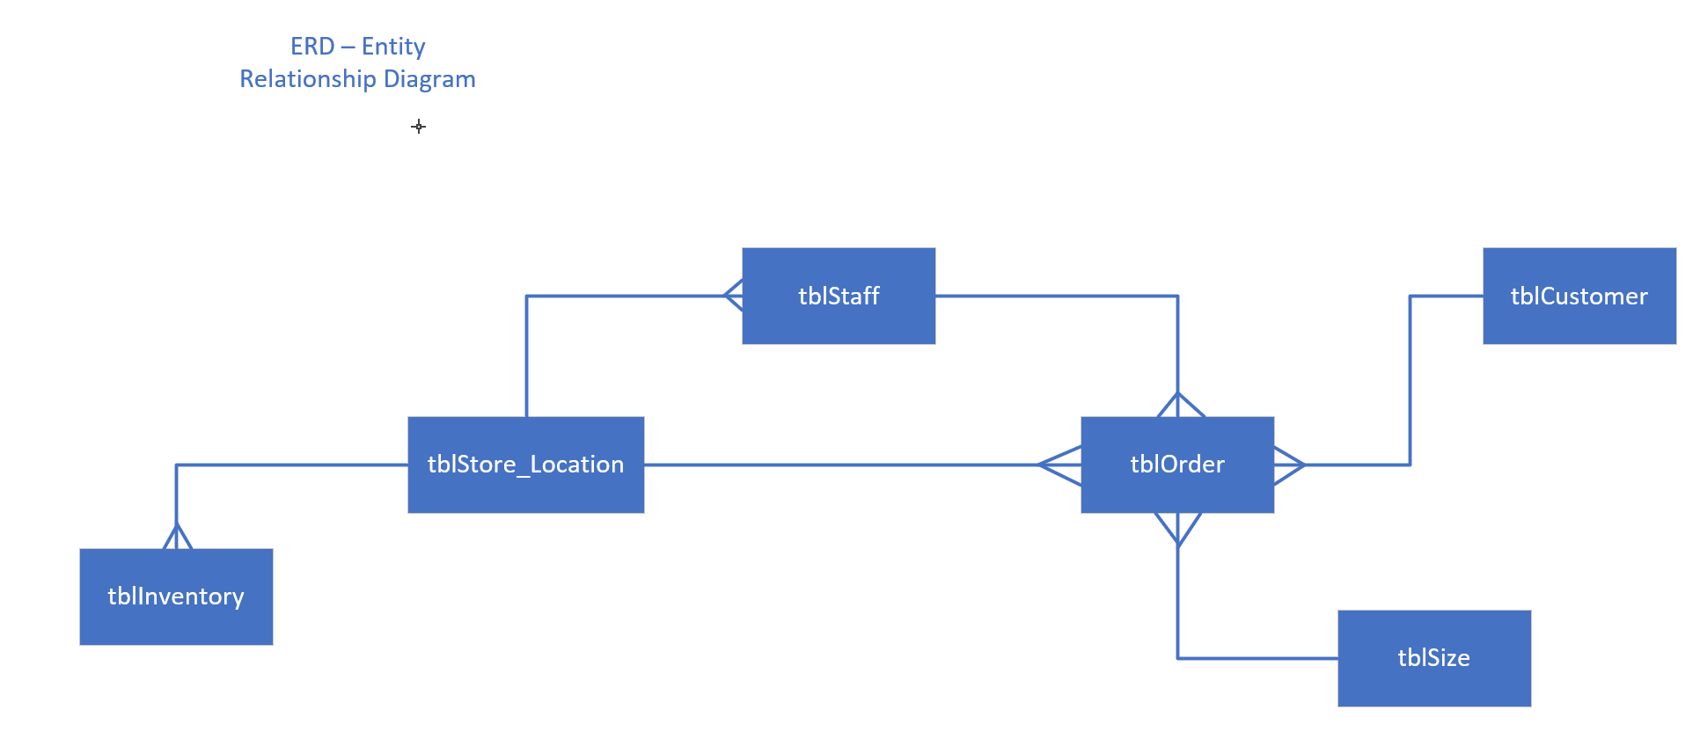
The above is the final section of the design, the ERD or Entity Relationship Diagram. The ERD, shows the relationships of the database. How the tables in the database will link up. The tblOrder being the main hub if you’d like as the table houses the most foreign keys. Each table has its own primary key and from which makes all the foreign keys, these primary keys are all unique IDs.

User guide
For this section we will take a look at the database made for this assignment. To start us off we will look at the relationships, this will not only show us the primary keys but also the foreign keys. It will also show the fields in one place.
- Relationships
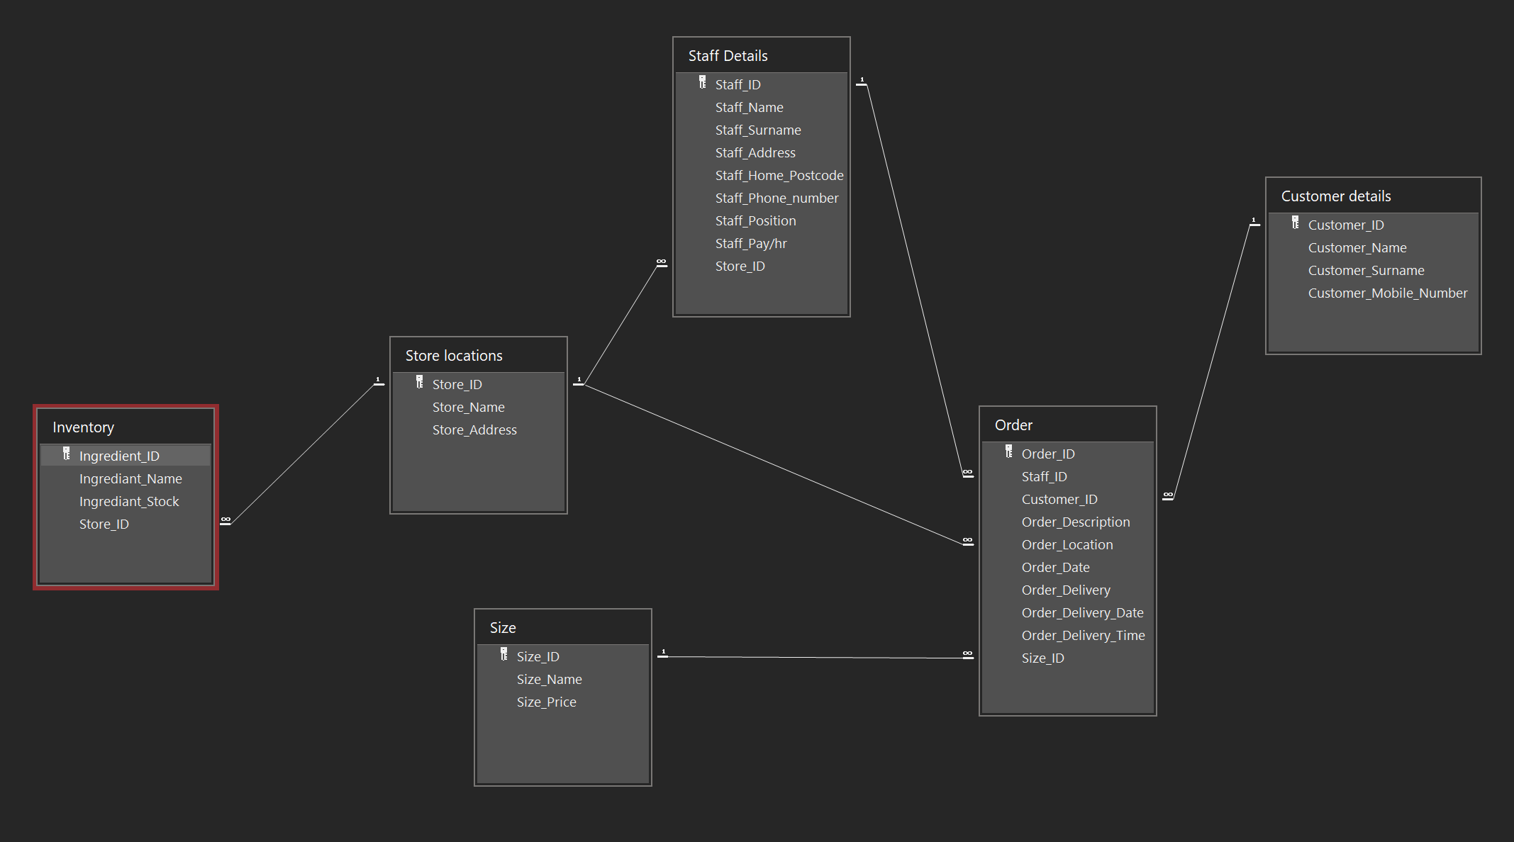
Above is the relationships as seen in the database. Admittedly, a little untidy, but thanks to this we can see that all tables have a primary key. And as the design phase had dictated the order form has many foreign keys to help fill out the information in the table.
- Customer Details -table
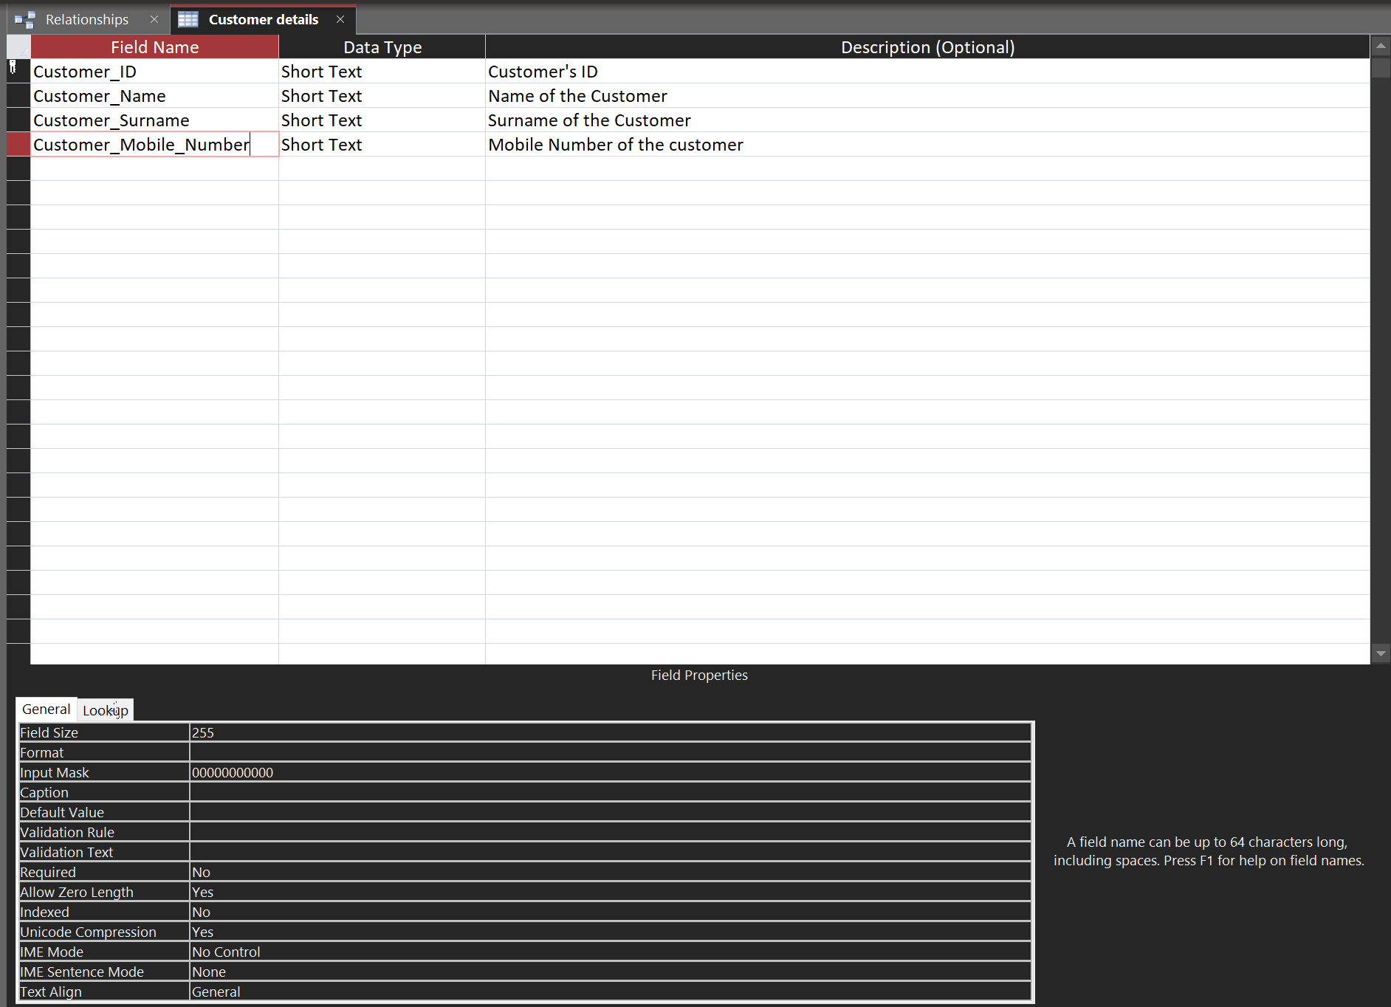
Above is the customer details table. The two things to not about this table is the customer_ID is the primary key and the Customer_Mobile_Number. Let’s talk about that, the Custumber_Mobile_Number has an input mask that allows for 11 numbers to be inputted into the cells this is so that if the user tries to input a letter it won’t be added, in fact only numeric values may be added.
- Inventory -table
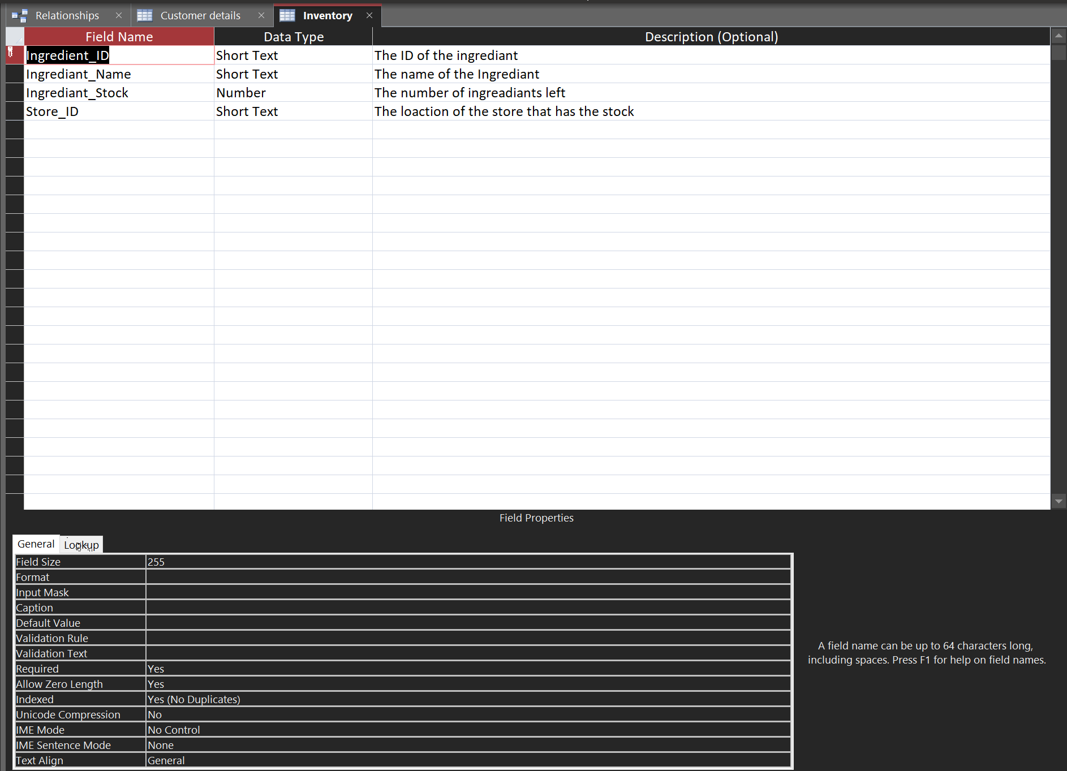
This is the table to store the ingredients that are necessary to bake the cake. Store_ID is there as a foreign key, while also giving context as to which store has the stock, allowing each store to keep track of their own stock. The Ingredient_ID is the primary key in this table.
- Order -table
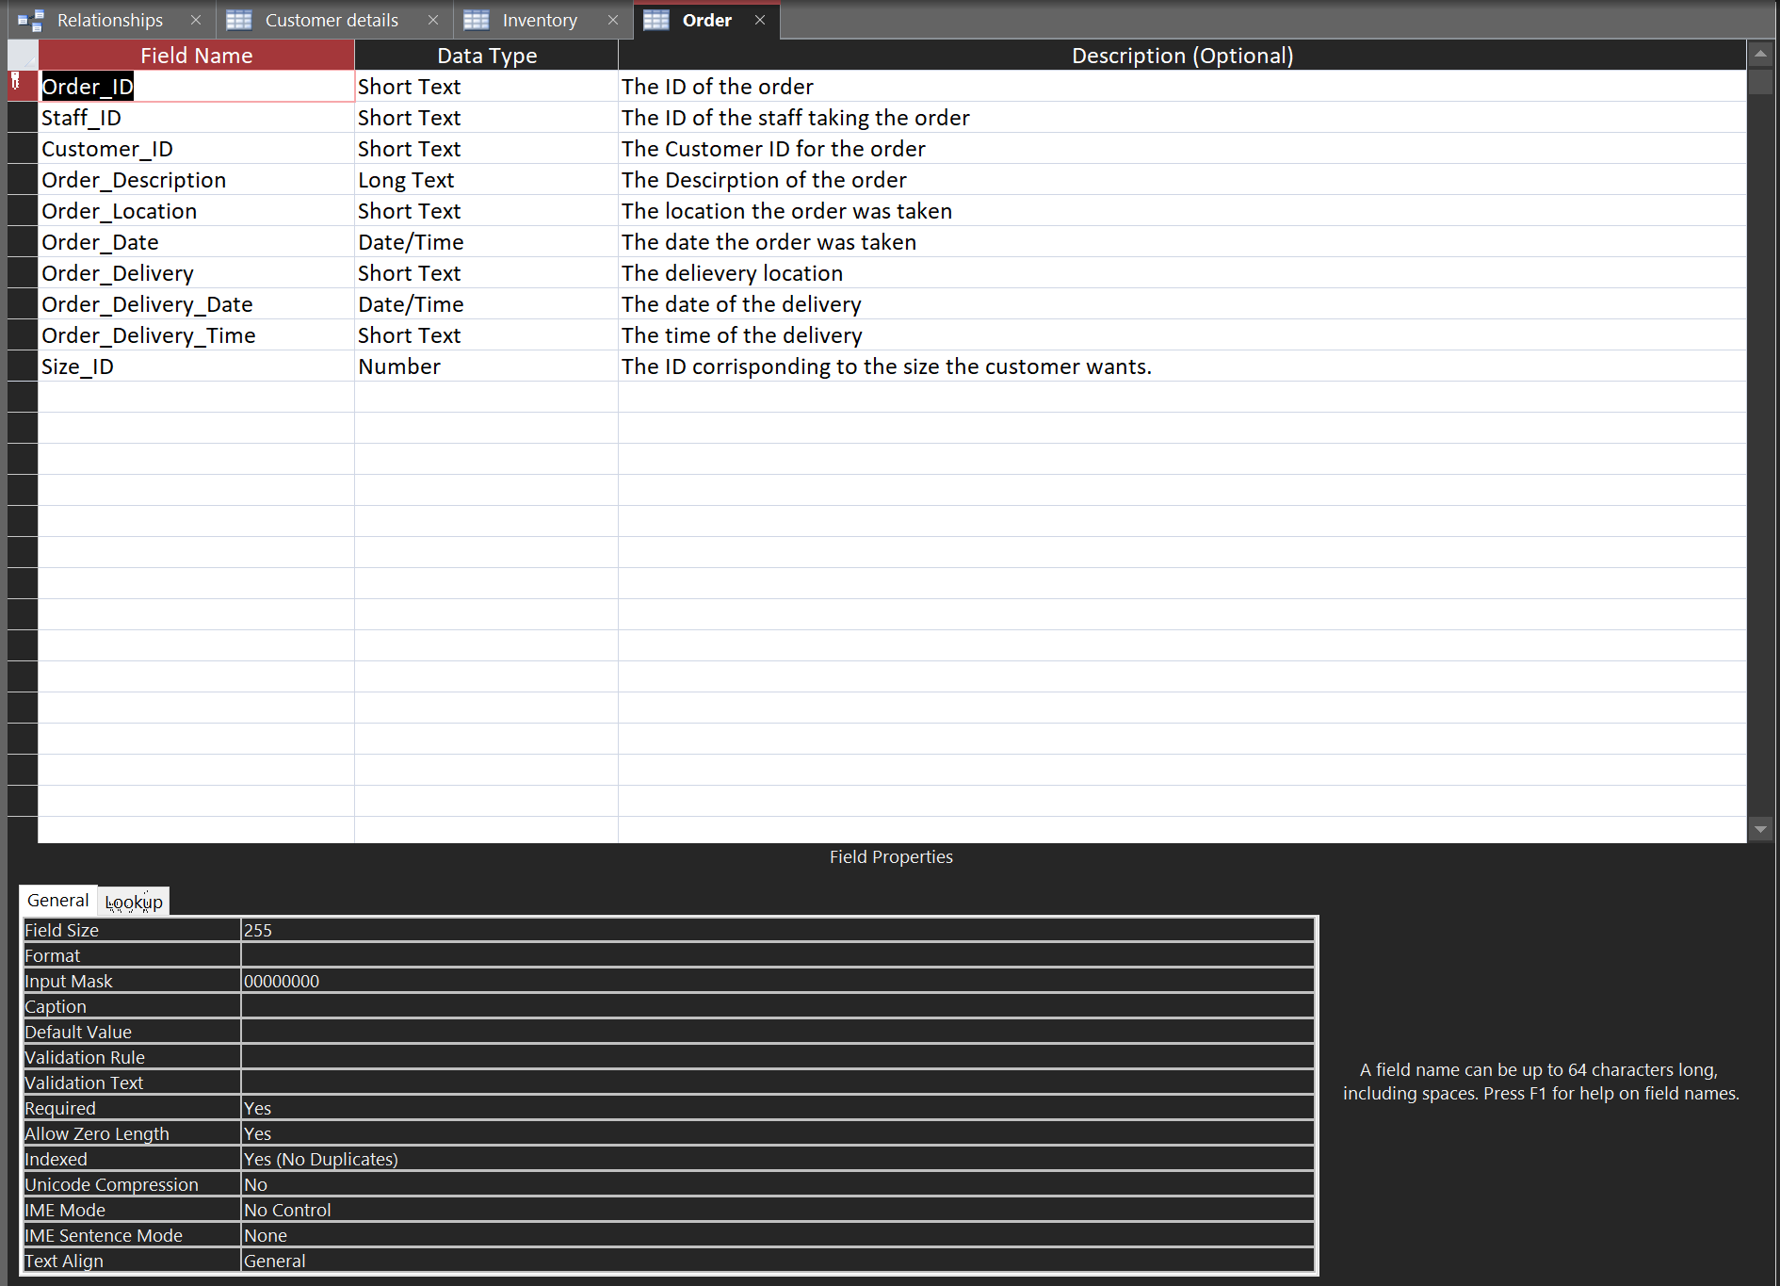
This table has many foreign keys on it, all IDs at that, the reason for this to ensure that no mistakes would be inputted on the order form. The order_ID is the Primary key.
- Size -table
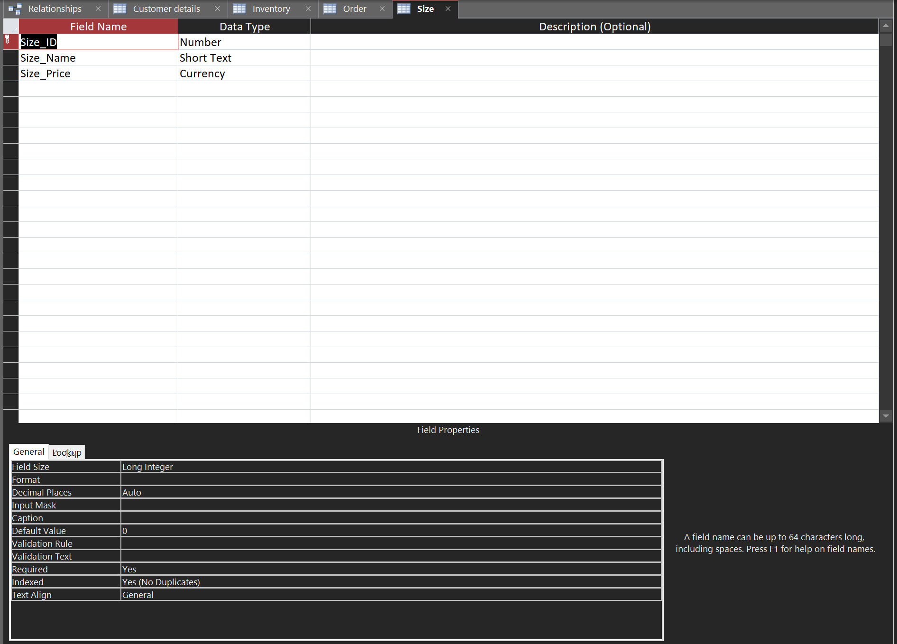
This table is made for the various sizes of cake available, this would not only save the person calculating the price searching for the price, but it will also allow for the varying sizes to be available in one location.
- Staff Details -table
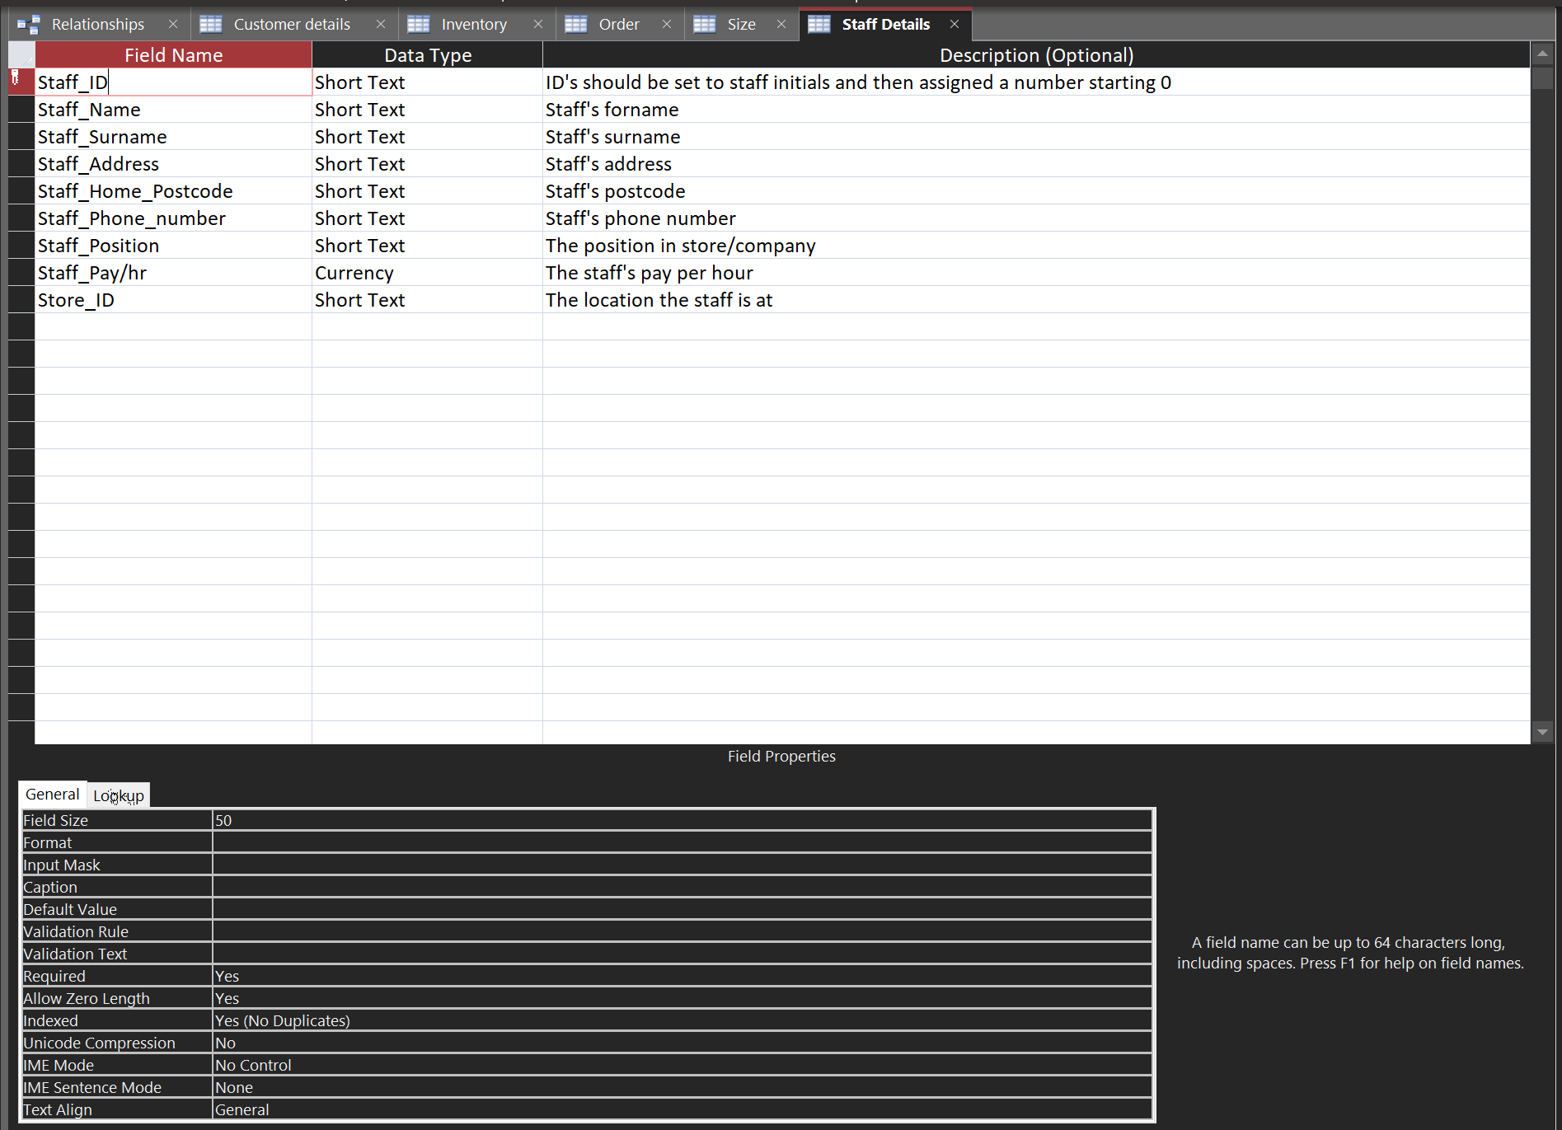
This table is the means of keeping track of the staff members. The primary key on this is Staff_ID and there is a foreign key for Store_ID.
- Store locations -table
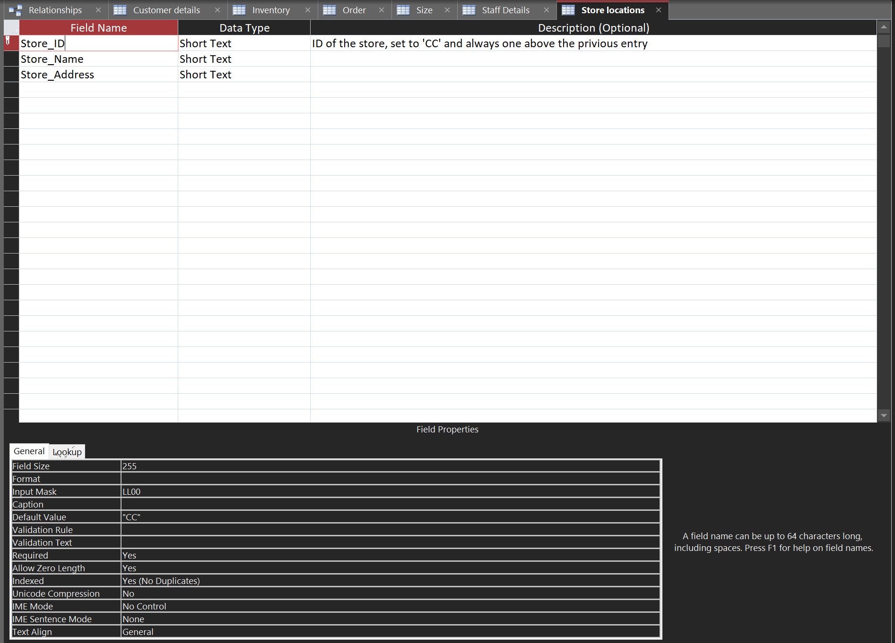
This table features arguably one of the more important fields, the Store_ID is not only the primary key, but is also a foreign key in nearly all tables. The ID has an input mask that will allow the user to input two letters and two numeric values. The Default value for Store_ID is “CC” which stands for Celtic Caterers.
- Delivery schedule for a particular date Query -query

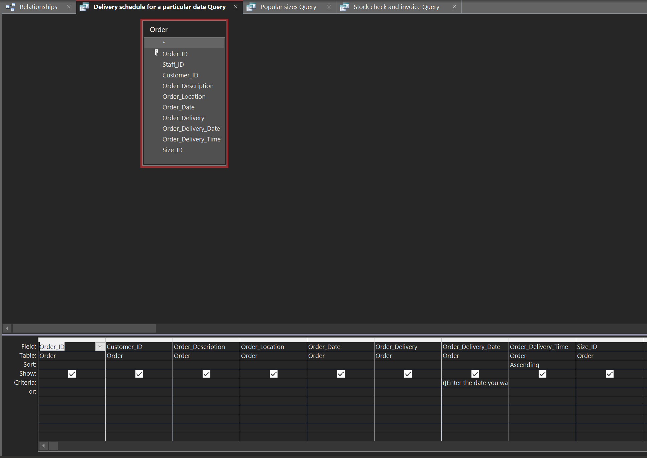
This query is to see the orders that need to be delivered on a particular day. To know when each delivery happens, the Order_Delivery_Time is sorted into ascending order.
- Popular sizes Query -query
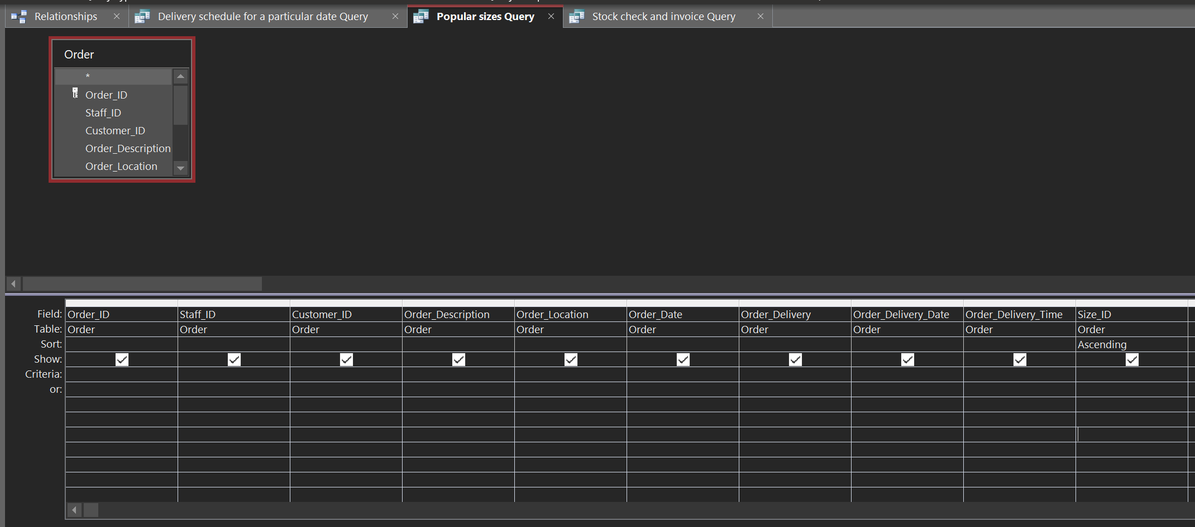
For this query, the system finds the most popular size of cake. As this will help with marketing purposes. To find this Size_ID was sorted into ascending order.
- Stock check and invoice Query -query
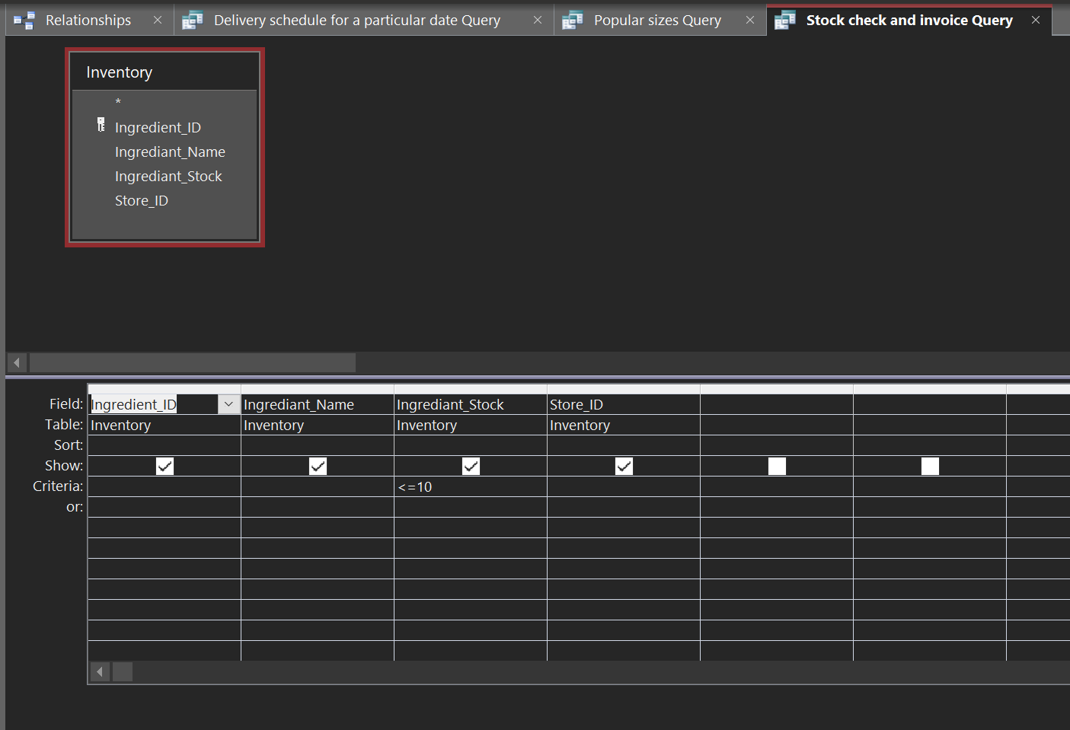
This is the query to find a lack of stock. This will help make the invoice ready to send to the supplier as it will update with any stock that goes under 10, as seen with the criteria. For the criteria in Ingredient_Stock, if something falls under or equal to 10 it will be alerted.
- Customer Details -form
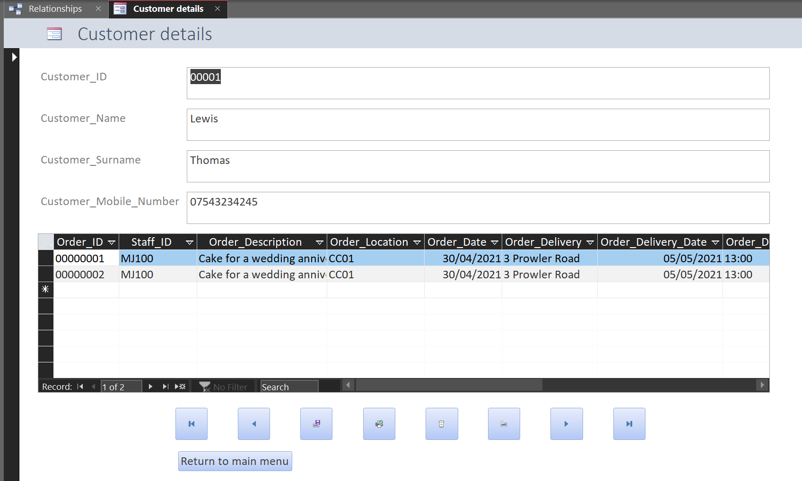
This form is for the customer details. The form itself contains labels and textboxes for the table. The table underneath is from the order table, it shows what the customer has ordered in the past.
The buttons all have an effect on the form. The button on the furthest left will take the user back to the first entry on the table, the button next to that will take the user to the previous entry. Next to that the button to save the entry the user is on, this will help greatly when it comes to adding new entries. The button next to that is the button to print the form. The button next to that is to delete the current entry. The button next to this is the add new entry. The button next to this is the button to go to the next entry, and finally the button at the end of this row will take the user to the last known entry. The button on the bottom will take the user to the main menu. The buttons on the forms, excluding the main menu, are the same.
- Inventory -form
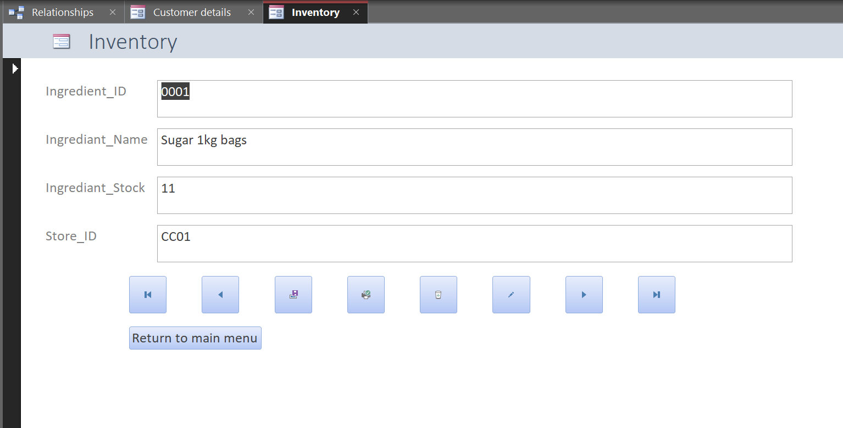
This form is for the inventory. The form itself contains labels and textboxes for the table.
- Order -form
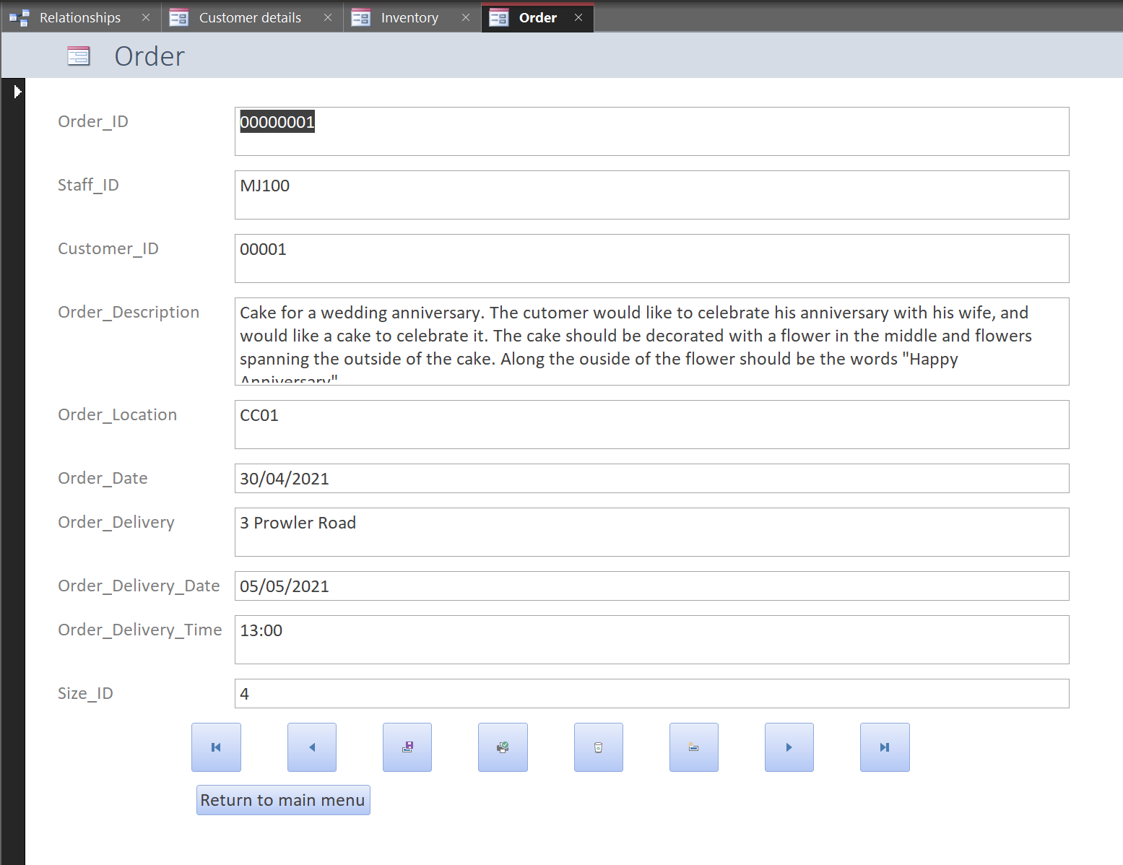
This form is for the Order. The form itself contains labels and textboxes for the table.
- Size -form
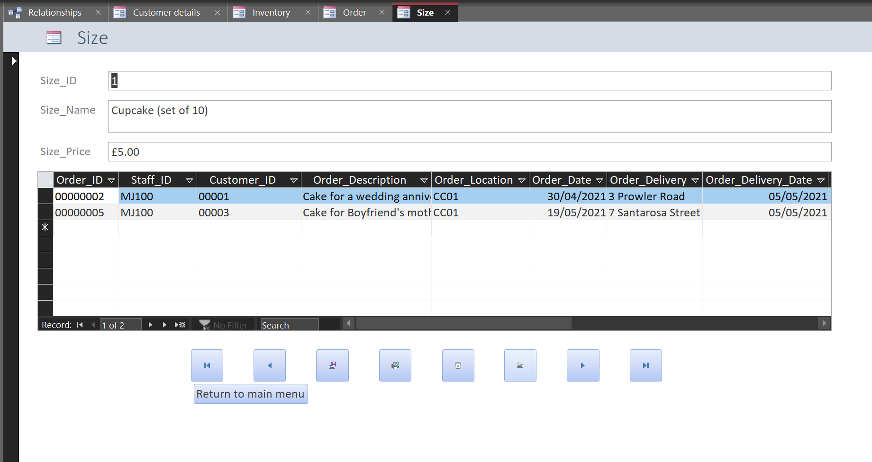
This form is for Size. The form itself contains labels and textboxes for the table. The table underneath is from the order table, it shows where the size in question has been used in the past.
- Staff Details -form
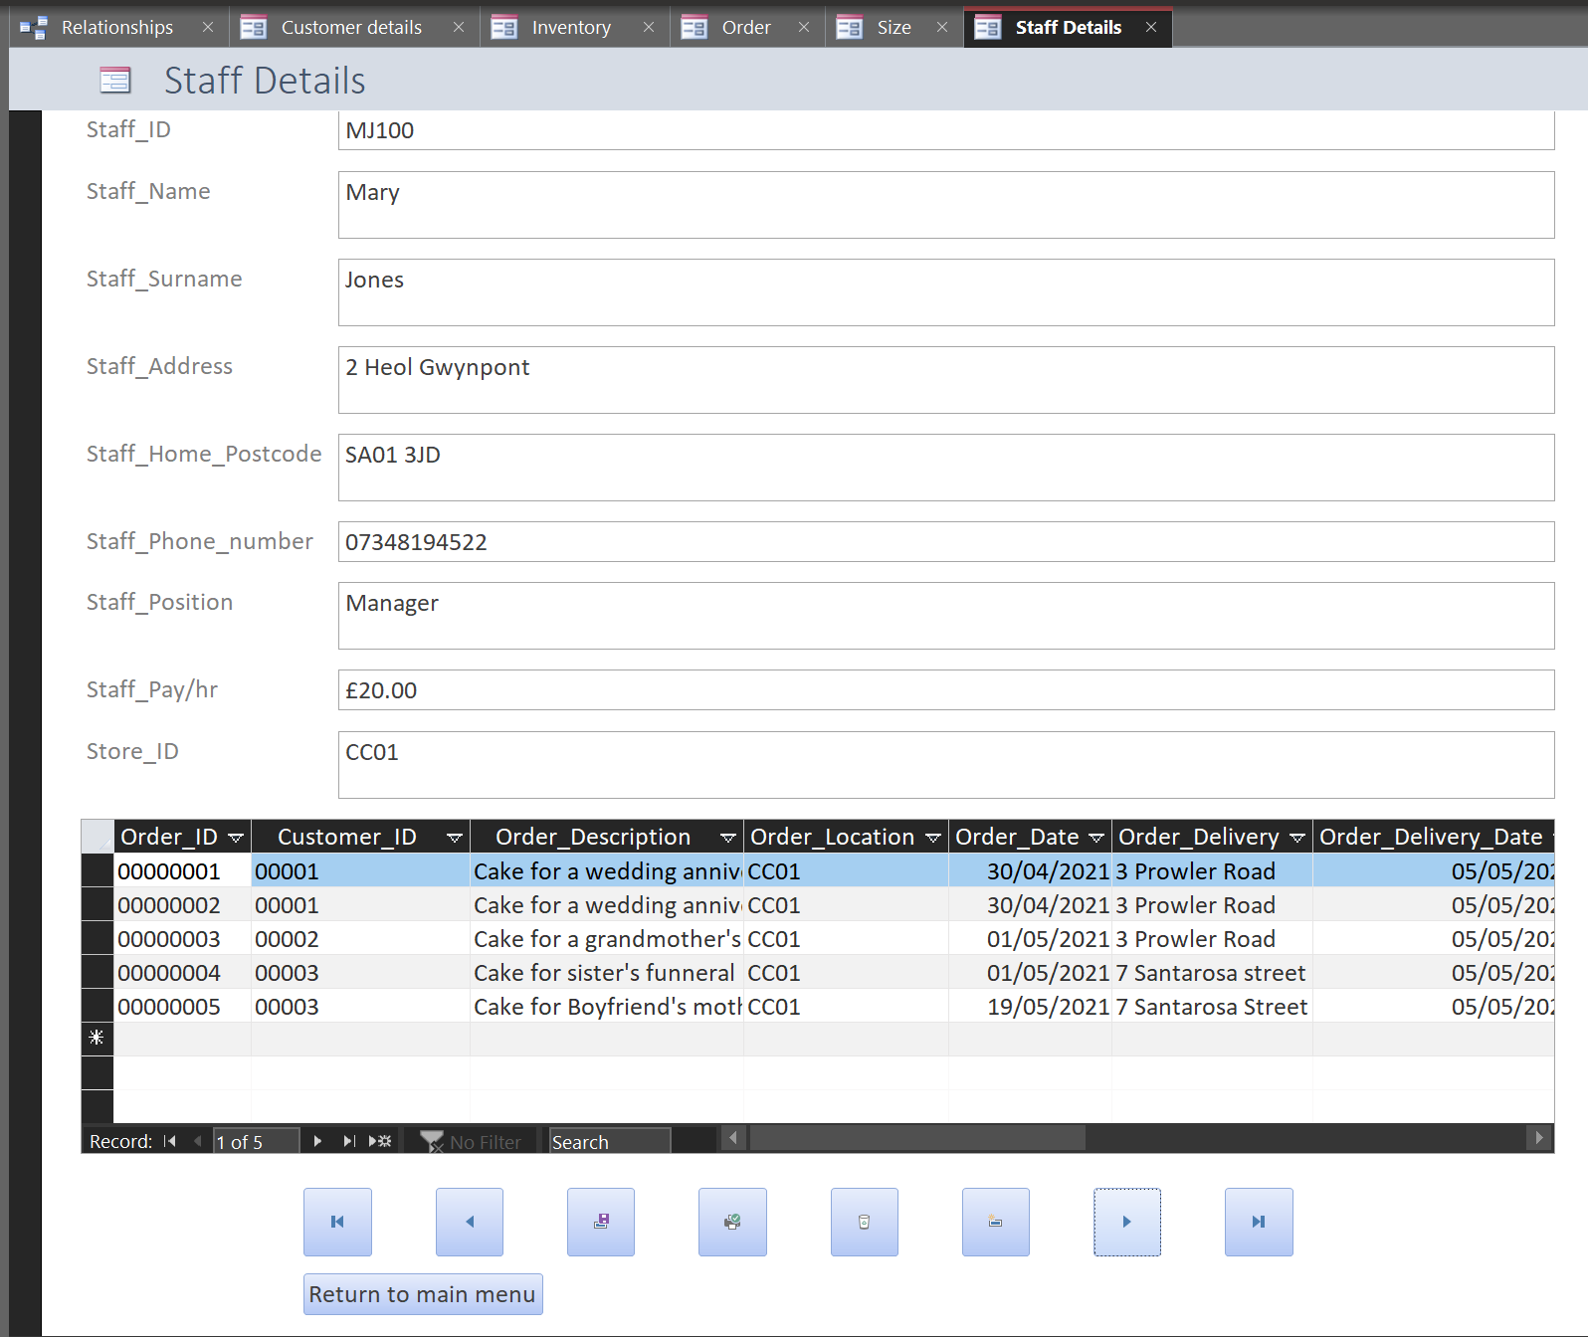
This form is for Size. The form itself contains labels and textboxes for the table. The table underneath is from the order table, it shows which orders the staff member had taken in the past.
- Store locations -form
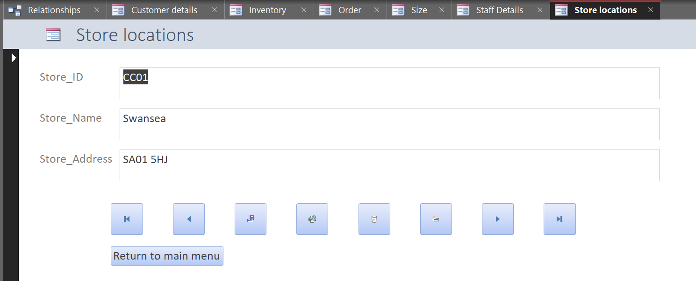
This form is for the Store locations. The form itself contains labels and textboxes for the table.
- Main Menu -form
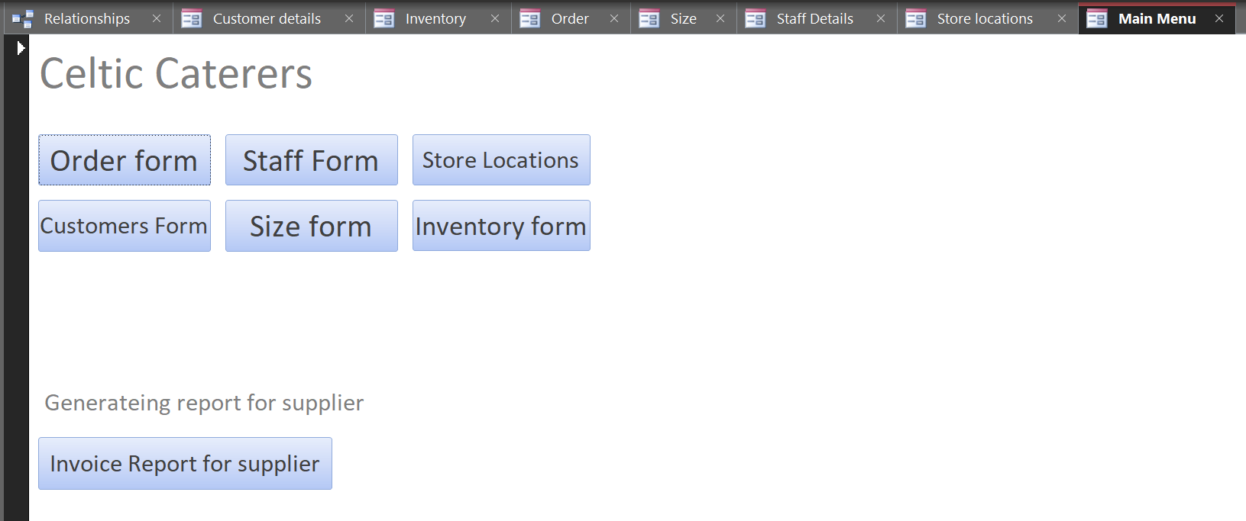
This form is mainly comprised of buttons, as the main hub that the user will be taken to when they load into the database, each of these buttons will take the user to the necessary form. Celtic Caterers at the top is made from a label. At the bottom there is a label that states that it is generating a report, the button underneath is the button that will take the user to the report, to view.
- Stock check and invoice Query -report
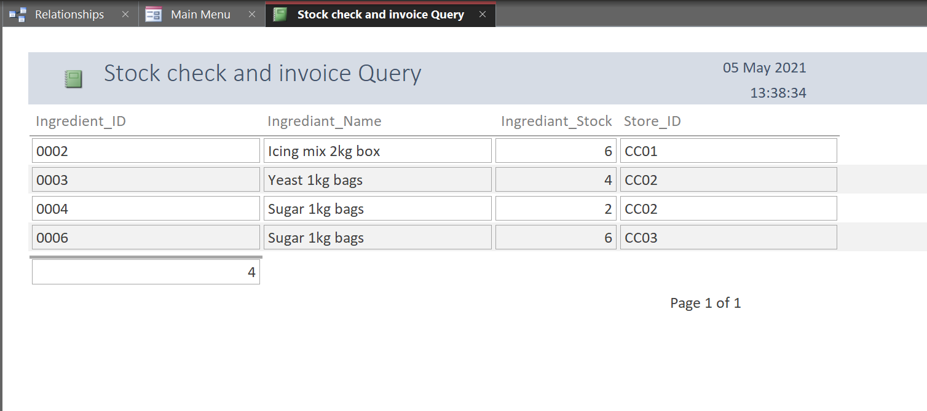
This report will show the results from the query of the same name. The report is made up of multiple rows each containing the values of the stock that is running low. On the bottom is the number on the list of items running low on stock.
- Autoexec -Macro
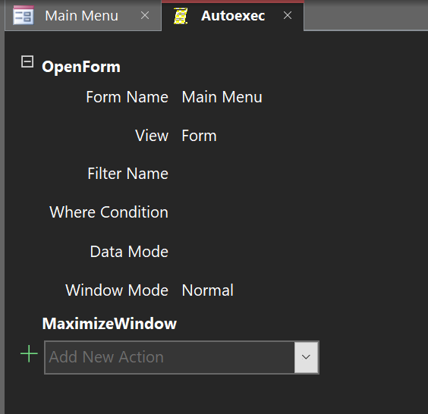
Above is a macro that will immediately trigger when the database loads. The purpose of Autoexec is to load the Main Menu.

Conclusion
At the beginning of this assignment, the task set was rather simple, design and implement a working system. At the end of the assignment, the task has been completed, the system is functional, the report needed has been made, the forms are all in place, there is a macro to load the main menu, etc.

