

LOCATION: Swansea | LLEOLIAD: abertawe
LEVEL 6 | LEFEL 6
EXAMINATION PERIOD | CYFNOD ARHOLIADAU
December 2019 | Rhagfyr 2019

MODULE CODE: ACCA6010
COD Y MODWL: ACCA6010
ADVANCED ROUTING AND SWITCHING SOLUTION

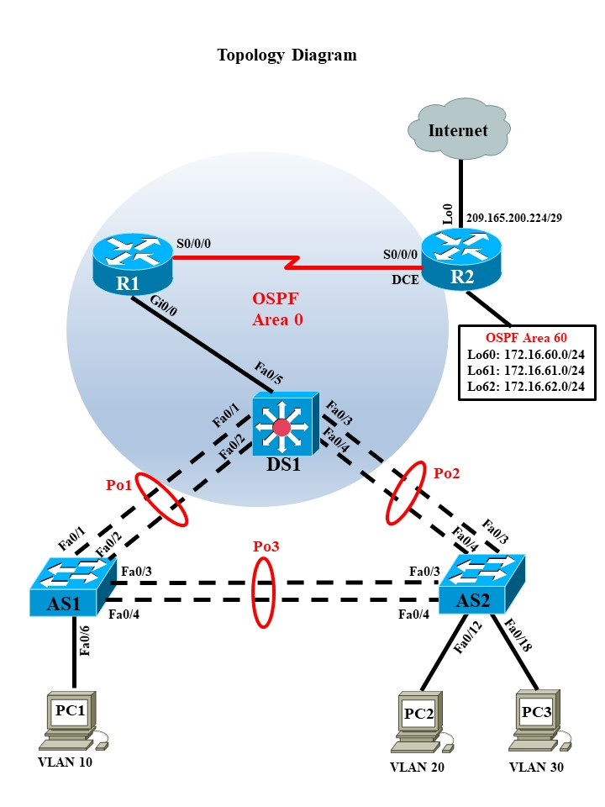

VLANs

VLAN | Name | Network
10 | Student | 192.168.10.0/24
20 | Staff | 192.168.20.0/24
30 | Guest | 192.168.30.0/24
99 | Management and Native | 192.168.99.0/24

Port Assignments

DS1 (VTP Server)
Ports | Assignment | IP Address
Fa0/1 – 0/5 | 802.1q Trunks (Native VLAN 99) | 192.168.99.2

AS1 (VTP Client)
Ports | Assignment | IP Address
Fa0/1 – 0/4 | 802.1q Trunks (Native VLAN 99) | 192.168.99.3
Fa0/5 – 0/11 | VLAN 10 (Student)
Fa0/12 – 0/18 | VLAN 20 (Staff)
Fa0/19 – 0/24 | VLAN 30 (Guest)

AS2 (VTP Client)
Ports | Assignment | IP Address
Fa0/1 – 0/4 | 802.1q Trunks (Native VLAN 99) | 192.168.99.4
Fa0/5 – 0/11 | VLAN 10 (Student)
Fa0/12 – 0/18 | VLAN 20 (Staff)
Fa0/19 – 0/24 | VLAN 30 (Guest)

Final configuration

R1#sh run
Building configuration...
Current configuration : 1350 bytes
!
version 15.1
no service timestamps log datetime msec
no service timestamps debug datetime msec
no service password-encryption
!
hostname R1
interface GigabitEthernet0/0
no ip address
duplex auto
speed auto
!
interface GigabitEthernet0/0.10
encapsulation dot1Q 10
ip address 192.168.10.1 255.255.255.0
!
interface GigabitEthernet0/0.20
encapsulation dot1Q 20
ip address 192.168.20.1 255.255.255.0
!
interface GigabitEthernet0/0.30
encapsulation dot1Q 30
ip address 192.168.30.1 255.255.255.0
!
interface GigabitEthernet0/0.99
encapsulation dot1Q 99 native
ip address 192.168.99.1 255.255.255.0
!
interface GigabitEthernet0/1
no ip address
duplex auto
speed auto
shutdown
!
interface Serial0/0/0
ip address 1.1.1.2 255.255.255.252
!
interface Serial0/0/1
no ip address
clock rate 2000000
shutdown
router ospf 1
log-adjacency-changes
network 1.1.1.0 0.0.0.3 area 0
network 192.168.99.0 0.0.0.255 area 0
network 192.168.10.0 0.0.0.255 area 0
network 192.168.20.0 0.0.0.255 area 0
network 192.168.30.0 0.0.0.255 area 0
!
ip classless
!
end

R2#sh run
Building configuration...
Current configuration : 1260 bytes
!
version 15.1
no service timestamps log datetime msec
no service timestamps debug datetime msec
no service password-encryption
!
hostname R2
interface Loopback0
ip address 209.165.200.225 255.255.255.248
!
interface Loopback60
ip address 172.16.60.1 255.255.255.0
!
interface Loopback61
ip address 172.16.61.1 255.255.255.0
!
interface Loopback62
ip address 172.16.62.1 255.255.255.0
!
interface Serial0/0/0
ip address 1.1.1.1 255.255.255.252
clock rate 64000
!
interface Serial0/0/1
no ip address
clock rate 2000000
shutdown
!
interface Vlan1
no ip address
shutdown
!
router ospf 1
log-adjacency-changes
network 1.1.1.0 0.0.0.3 area 0
network 172.16.60.0 0.0.0.255 area 60
network 172.16.61.0 0.0.0.255 area 60
network 172.16.62.0 0.0.0.255 area 60
default-information originate
!
ip classless
ip route 0.0.0.0 0.0.0.0 Loopback0
!
end

DS1#sh run
Building configuration...
Current configuration : 2375 bytes
!
version 12.2(37)SE1
no service timestamps log datetime msec
no service timestamps debug datetime msec
no service password-encryption
!
hostname DS1
!
spanning-tree mode rapid-pvst
!
interface Port-channel1
switchport trunk native vlan 99
switchport trunk allowed vlan 10,20,30,99
switchport trunk encapsulation dot1q
!
interface Port-channel2
switchport trunk native vlan 99
switchport trunk allowed vlan 10,20,30,99
switchport trunk encapsulation dot1q
!
interface FastEthernet0/1
switchport trunk native vlan 99
switchport trunk allowed vlan 10,20,30,99
switchport trunk encapsulation dot1q
channel-group 1 mode active
!
interface FastEthernet0/2
switchport trunk native vlan 99
switchport trunk allowed vlan 10,20,30,99
switchport trunk encapsulation dot1q
channel-group 1 mode active
!
interface FastEthernet0/3
switchport trunk native vlan 99
switchport trunk allowed vlan 10,20,30,99
switchport trunk encapsulation dot1q
channel-group 2 mode active
!
interface FastEthernet0/4
switchport trunk native vlan 99
switchport trunk allowed vlan 10,20,30,99
switchport trunk encapsulation dot1q
channel-group 2 mode active
!
interface FastEthernet0/5
switchport trunk native vlan 99
switchport trunk encapsulation dot1q
switchport mode trunk
!
interface FastEthernet0/6
shutdown
!
interface FastEthernet0/7
shutdown
!
interface FastEthernet0/8
shutdown
!
interface FastEthernet0/9
shutdown
!
interface FastEthernet0/10
shutdown
!
interface FastEthernet0/11
shutdown
!
interface FastEthernet0/12
shutdown
!
interface FastEthernet0/13
shutdown
!
interface FastEthernet0/14
shutdown
!
interface FastEthernet0/15
shutdown
!
interface FastEthernet0/16
shutdown
!
interface FastEthernet0/17
shutdown
!
interface FastEthernet0/18
shutdown
!
interface FastEthernet0/19
shutdown
!
interface FastEthernet0/20
shutdown
!
interface FastEthernet0/21
shutdown
!
interface FastEthernet0/22
shutdown
!
interface FastEthernet0/23
shutdown
!
interface FastEthernet0/24
shutdown
!
interface GigabitEthernet0/1
!
interface GigabitEthernet0/2
!
interface Vlan1
no ip address
shutdown
!
interface Vlan99
mac-address 00d0.d33a.2401
ip address 192.168.99.2 255.255.255.0
!
ip classless
!
line con 0
!
line aux 0
!
line vty 0 4
password cisco
login
end

AS1#sh run
Building configuration...
Current configuration : 2899 bytes
!
version 12.2
no service timestamps log datetime msec
no service timestamps debug datetime msec
no service password-encryption
!
hostname AS1
!
spanning-tree mode rapid-pvst
spanning-tree extend system-id
!
interface Port-channel1
switchport trunk native vlan 99
switchport trunk allowed vlan 10,20,30,99
switchport mode trunk
!
interface Port-channel3
switchport trunk native vlan 99
switchport trunk allowed vlan 10,20,30,99
switchport mode trunk
!
interface FastEthernet0/1
switchport trunk native vlan 99
switchport trunk allowed vlan 10,20,30,99
switchport mode trunk
channel-group 1 mode active
!
interface FastEthernet0/2
switchport trunk native vlan 99
switchport trunk allowed vlan 10,20,30,99
switchport mode trunk
channel-group 1 mode active
!
interface FastEthernet0/3
switchport trunk native vlan 99
switchport trunk allowed vlan 10,20,30,99
switchport mode trunk
channel-group 3 mode active
!
interface FastEthernet0/4
switchport trunk native vlan 99
switchport trunk allowed vlan 10,20,30,99
switchport mode trunk
channel-group 3 mode active
!
interface FastEthernet0/5
switchport access vlan 10
switchport mode access
shutdown
!
interface FastEthernet0/6
switchport access vlan 10
switchport mode access
spanning-tree portfast
spanning-tree bpduguard enable
!
interface FastEthernet0/7
switchport access vlan 10
switchport mode access
shutdown
!
interface FastEthernet0/8
switchport access vlan 10
switchport mode access
shutdown
!
interface FastEthernet0/9
switchport access vlan 10
switchport mode access
shutdown
!
interface FastEthernet0/10
switchport access vlan 10
switchport mode access
shutdown
!
interface FastEthernet0/11
switchport access vlan 10
switchport mode access
shutdown
!
interface FastEthernet0/12
switchport access vlan 20
shutdown
!
interface FastEthernet0/13
switchport access vlan 20
shutdown
!
interface FastEthernet0/14
switchport access vlan 20
shutdown
!
interface FastEthernet0/15
switchport access vlan 20
shutdown
!
interface FastEthernet0/16
switchport access vlan 20
shutdown
!
interface FastEthernet0/17
switchport access vlan 20
shutdown
!
interface FastEthernet0/18
switchport access vlan 20
shutdown
!
interface FastEthernet0/19
switchport access vlan 30
shutdown
!
interface FastEthernet0/20
switchport access vlan 30
shutdown
!
interface FastEthernet0/21
switchport access vlan 30
shutdown
!
interface FastEthernet0/22
switchport access vlan 30
shutdown
!
interface FastEthernet0/23
switchport access vlan 30
shutdown
!
interface FastEthernet0/24
switchport access vlan 30
shutdown
!
interface GigabitEthernet0/1
!
interface GigabitEthernet0/2
!
interface Vlan1
no ip address
shutdown
!
interface Vlan99
mac-address 0003.e436.7701
ip address 192.168.99.3 255.255.255.0
!
line con 0
!
line vty 0 4
password cisco
login
line vty 5 15
login
end

AS2#sh run
Building configuration...
Current configuration : 2761 bytes
!
version 12.2
no service timestamps log datetime msec
no service timestamps debug datetime msec
no service password-encryption
!
hostname AS2
spanning-tree mode rapid-pvst
spanning-tree extend system-id
!
interface Port-channel2
switchport trunk native vlan 99
switchport trunk allowed vlan 10,20,30,99
switchport mode trunk
!
interface Port-channel3
switchport trunk native vlan 99
switchport trunk allowed vlan 10,20,30,99
switchport mode trunk
!
interface FastEthernet0/1
switchport trunk native vlan 99
switchport trunk allowed vlan 10,20,30,99
switchport mode trunk
channel-group 2 mode active
!
interface FastEthernet0/2
switchport trunk native vlan 99
switchport trunk allowed vlan 10,20,30,99
switchport mode trunk
channel-group 2 mode active
!
interface FastEthernet0/3
switchport trunk native vlan 99
switchport trunk allowed vlan 10,20,30,99
switchport mode trunk
channel-group 3 mode active
!
interface FastEthernet0/4
switchport trunk native vlan 99
switchport trunk allowed vlan 10,20,30,99
switchport mode trunk
channel-group 3 mode active
!
interface FastEthernet0/5
switchport access vlan 10
shutdown
!
interface FastEthernet0/6
switchport access vlan 10
shutdown
!
interface FastEthernet0/7
switchport access vlan 10
shutdown
!
interface FastEthernet0/8
switchport access vlan 10
shutdown
!
interface FastEthernet0/9
switchport access vlan 10
shutdown
!
interface FastEthernet0/10
switchport access vlan 10
shutdown
!
interface FastEthernet0/11
switchport access vlan 10
shutdown
!
interface FastEthernet0/12
switchport access vlan 20
spanning-tree portfast
spanning-tree bpduguard enable
!
interface FastEthernet0/13
switchport access vlan 20
shutdown
!
interface FastEthernet0/14
switchport access vlan 20
shutdown
!
interface FastEthernet0/15
switchport access vlan 20
shutdown
!
interface FastEthernet0/16
switchport access vlan 20
shutdown
!
interface FastEthernet0/17
switchport access vlan 20
shutdown
!
interface FastEthernet0/18
switchport access vlan 20
spanning-tree portfast
spanning-tree bpduguard enable
!
interface FastEthernet0/19
switchport access vlan 30
shutdown
!
interface FastEthernet0/20
switchport access vlan 30
shutdown
!
interface FastEthernet0/21
switchport access vlan 30
shutdown
!
interface FastEthernet0/22
switchport access vlan 30
shutdown
!
interface FastEthernet0/23
switchport access vlan 30
shutdown
!
interface FastEthernet0/24
switchport access vlan 30
shutdown
!
interface GigabitEthernet0/1
!
interface GigabitEthernet0/2
!
interface Vlan1
no ip address
shutdown
!
interface Vlan99
mac-address 00e0.b04c.db01
ip address 192.168.99.4 255.255.255.0
!
line con 0
!
line vty 0 4
login
line vty 5 15
login
end

