Cloud-Based Web Services
ACCA6024 – Assignment 2
Connor Ellement 1803452
Web Development

Contents
1) Introduction 3
2) Cloud Computing 3
2.1) Background 3
2.2) Infrastructures 4
2.2.1) IaaS 4
2.2.2) PaaS 5
2.2.3) SaaS 5
2.3) Benefits 6
2.4) Drawbacks 7
2.5) Costs 7
2.5.1) Costs for users 8
2.6) Scenarios/Examples 9
2.6.1) Amazon Web Services (AWS) 9
2.6.2) Netflix 9
2.6.3) Google Stadia 10
2.7) Reliability & Scalability 10
2.7.1) Reliability 10
2.7.2) Scalability 10
3) Virtualization & Containerization 11
3.1) Virtualization 11
3.2) Containerization 11
3.3) Docker 11
4) Development Evaluation 12
4.1) TypeScript 12
4.2) NodeJS 12
5) Conclusion 12
6) Bibliography 12

Introduction
In this report, the term Cloud Computing will be looked into to determine and explain what is, and where it came from, along with looking into the advantages and drawbacks into the IT sector. The overall costs for users and businesses to use the technology with also be delved into and explained, and some examples and scenarios of cloud computing will be described.
Further on, research and explanations with be done and produces on the methods of Cloud Computing being Virtualization and Containerization. These methods will be described in terms of what they are and the differences between them, and long with this, the software Docker will also be studied, and the main driving force behind its creation and adoption will be detailed.

Cloud Computing
To put simply, Cloud Computing is a metaphor for the internet, and is the process of being able to use applications, save files, receive processing power, and other computing services over the internet and on the go. Services such as the ones mentioned and more are offered through on-demand services from companies and businesses, and usually are offered using a pay-as-you-go payment model, however a lot of services have free trials for their service or have a limit a user can use for free before venturing into the paid side of service. This allows users of these services to not actually need to own or buy a physical instance of a specific service, and instead access it on an as-needed basis. Cloud Computing has become a very popular option for businesses and people for a variety of reasons like its ease of access and efficiency.
Cloud Computing is currently operating in a wide variety of services. These services will be delved into and explained more later on in the report, but as an idea, the services can include storage of files, media streaming and power sharing.

2.1) Background
The initial concept of Cloud Computing was originally discussed by a gentleman by the name of Joseph Carl Robnett Licklider (J.C.R) in 1969. J.C.Rs’ idea revolutionised computing at the time, and later the same year using his idea, Bob Taylor and Larry Roberts developed ARPANET, which stands for Advanced Research Projects Agency Networks, which was a very early form of what the internet is today.
The years that followed on from ARPANETs’ creation led to the creation of Virtual Machines (VM) by large companies such as IBM. Soon after, Virtual Private Networks (VPN) started to hit the markets. The term ‘Cloud Computing’ was coined in 1996. The phrase refers back to old diagrams of computer systems where the internet was displayed as a cloud bubble.
[Figure 1] [1]
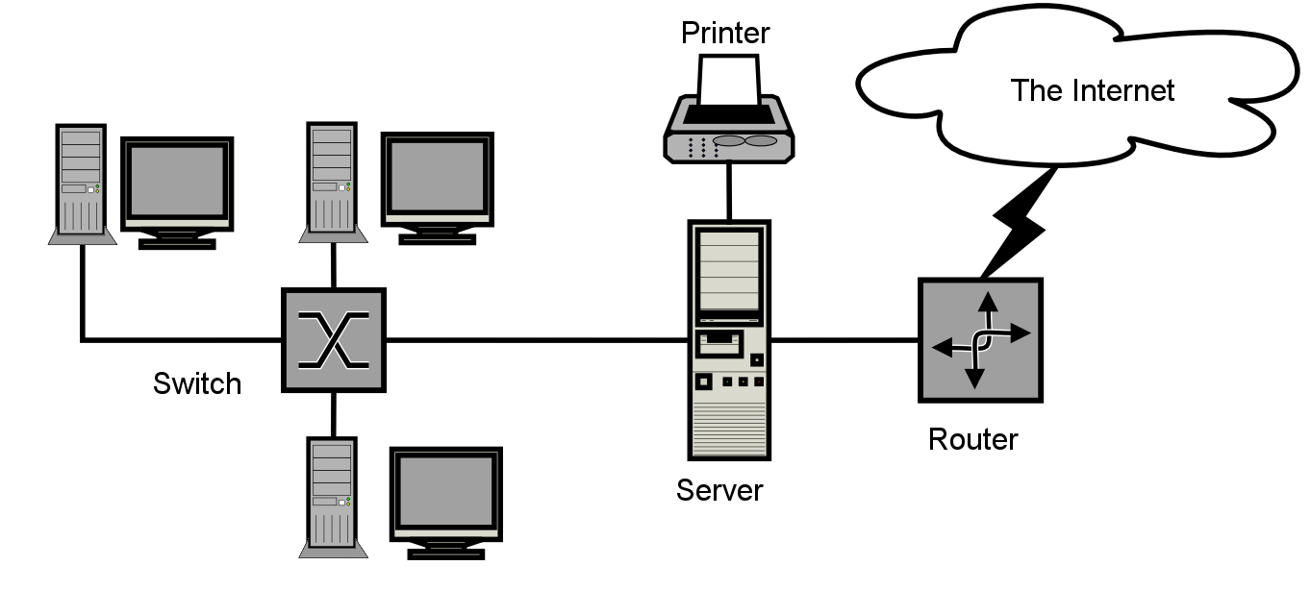

2.2) Infrastructures
When it comes to Cloud Computing, there are three different main service models for offering services. These are Infrastructure as a Service (IaaS), Platform as a Service (PaaS) and Software as a Service (SaaS). Between all three, they are able to offer businesses different things in the way of services they can offer.

2.2.1) IaaS
IaaS is the most common infrastructure used out of the three Cloud Computing models due to its flexibility. IaaS is able to offer instant storage resources, virtual servers, networks and more [2]. By being flexible, it allows businesses to have the reliability, flexibility, and scalability they many want and require. Making sure your infrastructure is secure is a vital element to any IT environment. With most IaaS providers, extra security measures are taken into consideration and deployed, with multiple having strict guidelines to their physical locations and multiple forms of authentication [3]. Payments for IaaS is typically on a pay as you use basis, which means your usage of the IaaS is calculated against a fee for every time a user uses it rather than having to pay a standard rate every month. If a business uses IaaS, that business can grow and shrink on demand with very little risk. For instance, if a business’s website gets a lot of extra traffic one day, IaaS will handle the increase in traffic. [2] [4]
Advantages [3] [4]
- Pay as you use.
- Scale up and down with ease.
- Increased security.
Disadvantages [2] [4]
- Lack of support.
- Little customization.
- Broadband dependency

2.2.2) PaaS
A company who is a PaaS provider provides software and hardware tools through the Cloud online via the internet [5]. People then use these tools to create and develop applications. What this means is that a developer could use a PaaS provider to create and develop their application without having to install software on their own device, essentially meaning even if they has a 12year old laptop on the verge of electronic death, as long as they has a decent broadband connection, they could still develop their application [6]. Like IaaS, PaaS providers tend to offer a pay as you use plan. PaaS offers dynamic scaling, which means when a user is in need for a stronger infrastructure, they can scale it up for the time needed, and scale it back down when no longer required.
Advantages [6] [7]
- Highly available.
- Dynamic Scaling.
- Tools available without stress of installing software, minimum requirements e.tc
- Pay as you use.

Disadvantages [7] [5]
- Vendor lock in.
- Data Security.
- Runtime issues.

2.2.3) SaaS
SaaS delivers applications controlled and managed by a third-party vendor over the internet. Due to the fact most SaaS applications run through a user’s browser, it eliminates the need for downloads and installations [8]. What this also means, is that the vendor who distributes the SaaS controls and manages all issues with the application such as servers, storage, middleware and more. SaaS greatly reduces the amount of time and money spent of downloads and installations [6]. With the extra time, it allows the technical help/experts to focus more on pressing matters within the company. Unlike IaaS and PaaS, SaaS usually runs on a subscription basis, meaning payments are usually monthly or annually, no matter how much a user uses it. Due to the subscription services, providers often have different tiers of subscriptions meaning a user can scale up and down easily, however scaling up usually costs more.
Advantages [9] [10]
- Accessibility.
- Quick and Easy set-up.
- Scalability
Disadvantages [11]
- Security concerns.
- Controlled by third-party.
- Higher tiers of subscriptions can get expensive.

2.3) Benefits
By looking at the brief investigation done into the infrastructures of Cloud Computing we can see that with them alone there are a variety of benefits to using Cloud Computing. Cloud Computing does is getting more and more popular with businesses over the last decade, but it is still important to way up the pros and cons to determine whether you are ready for the step.
- Accessibility – One of the biggest upsides to using Cloud Computing is that a user can access it and the features it is offering pretty much anywhere in present times. As long as a user has a good broadband or mobile data (3g/4g/5g) connection, they can access the Cloud.
- No hardware – Due to the fact that everything gets hosted inside the cloud, it means that no physical hardware is needed. It is advised that a backup is set-up in the case of a disaster and the cloud goes down, as it can leave a user’s or businesses productivity and efficiency at an all time low.
- Costs – Overhead costs for clouds are usually kept pretty low, which allows businesses who choose to implement Cloud can put their time and resources into improving other areas of the business. Most providers who offer Cloud services have a variety of payment methods by using different tier subscriptions or pay as you use.
- Reliable – Cloud Computing is very reliable, and one of the biggest benefits. User’s and businesses can get updated on any changed to the service instantly.
- Scalability – Every Cloud service has a good form of scalability so businesses and users can scale up and down their service as and when needed.

2.4) Drawbacks
- Data Confidentiality – With data being stored online and, on the Cloud, means that there is a risk that it can be accessed by other people such as hackers.
- Downtime – Despite being reliable, there are always going to be instances of the network going down due to technical issues. This means if a user or business is dependant on Cloud, any downtime could considerably affect their amount of workflow and productivity.
- Performance Variation – Cloud services run on a server. This means over consumption of the service or server can affect the performance of the service.
- Dependency – Despite the internet being pretty much everywhere now, like the Cloud services in general, there will some internet failure, so if a user’s internet goes down and they cannot get a connection, then their productivity is halted.
- Lack of support – A lot of Cloud service providers don’t have a great amount of support for their users, and get them to rely of FAQs for answers, which can be unhelpful and tedious.

2.5) Costs
Cloud Computing hosts everything on the internet, so the opposite to this would be an on-premises server location, to which both have vast difference in prices. First of all, to set-up an on-premises server, all the hardware needs to be bought by the provider which is already quite a heavy expense for any business, let alone having to have it set-up. Also, if an on-premises server fails, or a component breaks, then part of that overall cost must be paid again. Cloud Servers can be hosted all on the web and overall cost a lot less. SherWeb did a recent analysis and created a scenario where a business would purchase a server of each kind and replace every 5 years. On average, they were able to calculate that by using a Cloud Server, a company could save up to a whopping 80% on their IT budget [12] [13].
[Figure 2] [12]
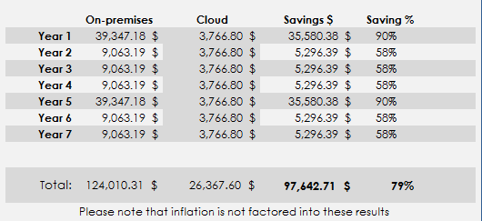
In the same report, SherWeb were also able to calculate that on average, an on-premises server would be around $1,500 (£1,085.66) a month. This is a huge difference on the amount calculated for a Cloud host per month, which they calculated to be at $313 (£227.26) per month.
[Figure 3] [12]
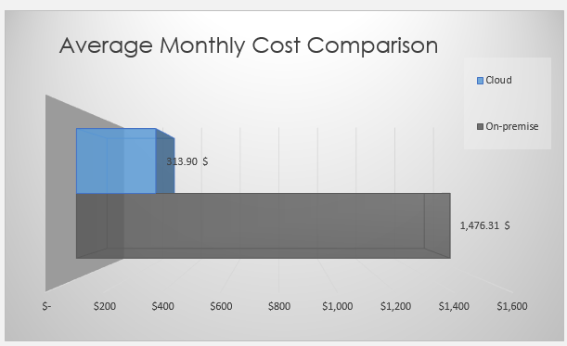

2.5.1) Costs for users
As mentioned previously, a large majority of the Cloud Computing providers have easy payment systems for users. A lot of them use Pay as you use (Or Pay as you Go) plans, where the user only pays for the amount of usage they have racked up, for example, if a customer is using an online storage system which costs 30p for every file uploaded, and they upload 10 files, they are charged £3. Some providers choose to use subscriptions where the prices are different dependant on the subscription tiers. Once again using the online storage example, a provider might have a Bronze tier that allows a user 50 files a month for £3, a Silver tier that allows 100 files a month for £5 and a Gold tier that allows unlimited files for £7.

2.6) Scenarios/Examples
As discussed earlier on, Cloud Computing has become very popular over the past decade and is probably the biggest buzz world for the last 10 years. Due to this fact, many services have come about. These services can range from Online Storage, Software Development, Media Streaming and much more.

2.6.1) Amazon Web Services (AWS)
One of the biggest cultivators in the Cloud Computing industry over the years has been Amazon. In 2006, Amazon launched AWS, and began offering a variety of different services over the internet via the way of Cloud Computing. Since its conception, Amazon have reported that the number of people who have used AWS exceeds 1,000,000. AWS is open and flexible for users to use. Once an account is created, the user can choose from the range of services that they offer (Backup & Storage services, Content Delivery, Website hosting, Databases with many more, and too many to list) that best suits the user’s needs, and then they choose how to use the services they have chosen. Also, as it is a Cloud based service, it offers great efficiency to users, and can be used anywhere with a connection. AWS is secure as well, as their services and data centres have multiple layers of online security measures as well as physical measures.

2.6.2) Netflix
Another example of Cloud Computer use is the huge film and tv streaming service, Netflix. In fact, Netflix actually runs off AWS, and provides its service to different customers all around the world. Netflix uses AWS for hosting, storage, and media sharing. Netflix has a massive library of films and tv shows stored on its Cloud Servers (again, that are hosted by AWS) so that consumers are able to watch their favourite entertainment, and due to it being hosted on the Cloud, users can access it pretty much anywhere. Netflix also gives users the option to download files from their servers, so users are still able to enjoy their film/show, even if offline. Netflix uses a monthly subscription payment model, that can be changed for a variety of needs, such as extra quality or users.

2.6.3) Google Stadia
Stadia is a Cloud based gaming service created and developed by Google. As a service, Stadia works very similarly to how Netflix does. Stadia has a library of games that they are able to stream to a user’s device as long as said user has an internet connection of some kind. However, on top of this, users do not even need to use their own high-end equipment. Stadia provides the processing power as well, meaning a user could stream a Triple A title on their smartphone. Also, like Netflix, they also use a subscription service that offers a different amount of games dependant on tier chosen.

2.7) Reliability & Scalability
Reliability and scalability in Cloud Computing are very important aspects to consider when thinking about the switch over to cloud. Reliability is all about how well the service works for a user, and scalability is about how well a service can grow or shrink depending on the usage required.

2.7.1) Reliability
When a user has access to any kind of service or app, it is fair to assume that the user would expect the app/service to run properly, to be accessible, and to be available as and when they need. In an ideal world, applications and services would be available 100% of the time and people would not have to worry about any downtime, however, unfortunately this is realistically unattainable. [14]
As a whole, Cloud Computing is considered to be fairly reliable. There will always be some issues with factors such as performance, connectivity etc, and usually these faults can be put on Cloud Computing itself, but there are some faults that can be put down to the users. As with most faults, if a fault comes up with Cloud Computing, there is usually a solution, it just needs to be identified along with its cause.
Overall, Cloud Computing is pretty reliable, however it is always smart to have back up options just in case. Most Cloud service providers have Service Level Agreements, where they attempt to have a 99% up-time rate, and if they fail to provide this, the user usually gets service credit as a peace offering [15].

2.7.2) Scalability
Scalability is measured within Cloud Computing by determining how well an application or service can adapt to a user’s requirements. Think of it this way, if you own a business, overtime it is safe to assume that your business will grow. During this growth, you will want to make additions to your companies’ resources without delay and loss of quality. Depending how well a Cloud service can offer this, depends on its scalability.
Horizontal Scaling
Horizontal scaling is a scaling method that builds out systems by adding extra resources to a system. This is good practice within Cloud Computing because these resource additions can be made typically without much effecting the system, and these additions make a system more reliable.
Vertical Scaling
Vertical scaling is what was summarised earlier on in the report. This is the process of scaling up or down a specific service. For instance, if a user has 15GB of Cloud storage, but needs 20GB, then a user can simply scale up their subscription, or pay more for their extra usage on Pay as you go models.

3) Virtualization & Containerization

3.1) Virtualization
Virtualization is the concept of being able to use a virtual instance of a service or system. The most common use of virtualization is the ability to be able to run multiple operating systems (OS) on one computer system at the same time [16]. Virtualization does this by creating what is deemed an abstraction later over a computers hardware, that can then be split into different virtual computers, and this is what is referred to as a virtual machine. Virtualization is a huge driving force behind Cloud Computing and allows Cloud service providers to offer hardware for a user’s already existing hardware [16].

3.2) Containerization
Containerization is seen as a direct alternative to Virtualization, however, can be used as a partner to it as well [16] [17]. The process of Containerization is packing code and all its dependencies in a way so that it can be unpackaged and run on any system. A good metaphor for this would be think of it as sending the code to a zip file, then storing it on a USB, and then unzipping it on another person’s computer. Where Virtualization allows a user to run multiple OS on a system, Containerization allows a user to run a variety of applications at the same time on a single virtual machine or server [16].

3.3) Docker
Containerization plays a big part into what Docker is, and even its inception. Due to this, it is safe to say that Containerization is the main driving force being the adoption of Docker in this modern era of technology. Docker offers advantages over traditional Virtualization [16]. Although both Docker and VMs have advantages over hardware devices, typically Docker tends to be the more efficient out of both due to resource utilization. Ultimately, it comes down to how VMs are built and made. Obviously, emulating a physical infrastructure of a system requires less than actually having the hardware device, however compared to Docker, VMs just have to much fat at their cores. Also, when it comes to speed, Docker just takes the cake. A VM can take minutes to fully boot and be ready to use, however Docker can do this in mere seconds, maybe faster [16] [17].

4) Development Evaluation
A containerized application was developed using methods like TypeScript, NodeJS, Docker, Express and Axios. Some of these methods will be explained further to what they are, and their advantages.

4.1) TypeScript
TypeScript is a coding language that was created and currently maintained by Microsoft. TypeScript is open-source and builds on the JavaScript (JS) language by allowing static type definitions. [16]Types in coding are a way of describing an asset or object inside that development, and in Typescript, writing out these types is optional. TypeScript allows for bugs and errors in a piece of code to be spotted easily as it detects around 15% at the compile (Start-up) stage. Also, TypeScript is great at retaining initial types, as everything stays as it was initially defined, meaning that a string does not become an int. TypeScript also has compatibility with Object Oriented Programming (OOP) [16] [17].

4.2) NodeJS
Similarly, to TypeScript, NodeJS is open-source, and is a JavaScript environment located in the backend on a website. NodeJS allows JavaScript code to be executed outside of a web browser, where JS was intended to only be run the browser. Both JS and NodeJS run on the V8 JS engine [18] [19].What this engine is able to do is take the JS code and convert it into machine code. The converted machine code is considered low-level which makes it easier to read by computers and increases efficiency. NodeJS is very fast compared to other environments and offers high performance for websites and the executable code. One of the biggest positives about NodeJS is that is very easy to learn. [18]

5) Conclusion
The purpose of this report was to be able to describe in detail what Cloud Computing is. By detailing Cloud Computing’s background, delving into what Cloud Computing does and offers, along with evaluating its advantaged and disadvantages, the author believes this has been achieved. Through research and reading of the report, it is clear that Cloud Computing is becoming more popular within businesses and for good reasons with its increased work productivity and accessibility, on top of that, keeping costs down.
Containerization and Virtualization was also researched and detailed. By doing research into these topics, it has been helpful to the author to review the differences, and understand how by Docker being developed, the improvements that have been made in this sector of IT.

Bibliography

[1] | E. Griffith, “What Is Cloud Computing?,” PCMag, 2020.
[2] | CompTIA, “What is IaaS?,” CompTIA, [Online]. Available: https://www.comptia.org/content/articles/what-is-iaas. [Accessed 2021 05 01].
[3] | F. P. G. U. G. S. G. T. Anca Apostu, “Study on advantages and disadvantages of Cloud Computing – the,” University POLITEHNICA of Bucharest, Bucharest, 2017.
[4] | IBM Cloud Education, “IaaS (Infrastructure-as-a-Service),” IBM, 2019.
[5] | C. Pahl, “Containerization and the PaaS Cloud,” Containerization and the PaaS Cloud, vol. 2, no. 3, pp. 24-31, 2015.
[6] | T. Hou, “aaS vs PaaS vs SaaS Enter the Ecommerce Vernacular: What You Need to Know, Examples & More,” BigCommerce.
[7] | M. J. Karvis, Architecting the Cloud: Design Decisions for Cloud Computing Service Models (SaaS, PaaS, and IaaS), John Wiley & Sons, 2014.
[8] | S. Watts and M. Raza, “SaaS vs PaaS vs IaaS: What’s The Difference & How To Choose,” BMC, 2019 06 2019. [Online]. Available: https://www.bmc.com/blogs/saas-vs-paas-vs-iaas-whats-the-difference-and-how-to-choose/#ref2. [Accessed 2021 05 01].
[9] | J. Y. Lee, J. W. Lee, D. W. Cheun and S. D. Kim, “A Quality Model for Evaluating Software-as-a-Service in Cloud Computing,” in 2009 Seventh ACIS International Conference on Software Engineering Research, Management and Applications, Haikou, 2009.
[10] | S. Satyanarayana, “Cloud Computing: SaaS,” Sri Venkateswara Institute of Science & Information Technology, 2012.
[11] | T. Short, “What is SaaS? 10 FAQs About Software as a Service,” SoftwareAdvice.com, 12 02 2020. [Online]. Available: https://www.softwareadvice.com/resources/saas-10-faqs-software-service/. [Accessed 2021 05 01].
[12] | SherWeb, “Cost of server ownership: on-premise vs. IaaS,” SherWeb, 2019.
[13] | T. Collins, “Cloud vs. Dedicated Server Cost: Which Is The Better Deal?,” Alantech, 2018.
[14] | N. Antonopoulos and L. Gilliam, Cloud Computing, 2010.
[15] | CloudHealthTech, “How Reliable Is Cloud Computing?,” CloudHealthTech, 16 10 2018. [Online]. Available: https://www.cloudhealthtech.com/blog/how-reliable-is-cloud-computing#:~:text=Reliable%20cloud%20computing%20connectivity&text=Most%20cloud%20service%20providers%20offer,to%20deliver%2099.9%20percent%20uptime.. [Accessed 2021 05 03].
[16] | IBM, “Virtualization,” IBM, 19 06 2019. [Online]. Available: https://www.ibm.com/cloud/learn/virtualization-a-complete-guide. [Accessed 04 05 2021].
[17] | A. Strong, “Containerization vs. Virtualization: What's the Difference?,” BurwoodGroup.
[18] | IBM, “Containerization,” IBM, 15 05 2019. [Online]. Available: https://www.ibm.com/uk-en/cloud/learn/containerization. [Accessed 04 05 2021].
[19] | Docker, Docker, [Online]. Available: https://www.docker.com/. [Accessed 04 05 2021].
[20] | Opensource, “What is Docker?,” Opensource.com, [Online]. Available: https://opensource.com/resources/what-docker. [Accessed 04 05 2021].
[21] | TypeScript, TypeScript, [Online]. Available: https://www.typescriptlang.org/. [Accessed 04 05 2021].
[22] | Altexsoft, “The Good and the Bad of TypeScript,” Altexsoft. [Online]. [Accessed 04 05 2021].
[23] | Altexsoft, “The Good and the Bad of Node.js Web App Development,” Altexsoft, [Online]. Available: https://www.altexsoft.com/blog/engineering/the-good-and-the-bad-of-node-js-web-app-development/. [Accessed 04 05 2021].
[24] | NodeJS, “About Node.js,” NodeJS, [Online]. Available: NodeJS. [Accessed 04 05 2021].
[25] | E. Baciu, “ADVANTAGES AND DISADVANTAGES OF CLOUD COMPUTING,” Bucharest, 2015.
[26] | Y. Xing and Y. Zhan, Virtualization and Cloud Computing, Zhenjiang: Jiangsu University.

