27/01/2025
Jamie Leung
2217778
Computational Methods
2D Diffusion Equation model using the Explicit Finite Difference Method

Contents
1 Introduction 3
2 Constitutive Equation of Problem 4
3 Explicit finite difference form of the constitutive equation. 5
3.1 Taylor Series 5
3.2 Forward Difference 5
3.3 Backward Difference 6
3.4 Central Difference 6
3.5 Central Difference to Second Derivative 7
3.6 Explicit Finite Difference Scheme 7
3.6.1 Temporal First Derivative by Forward Difference Approximation 8
3.6.2 Spatial Second Derivative by Central Difference Approximation 8
3.7 Discretise the spatial domain 8
3.8 Discretise the temporal domain 9
3.9 Derive the Explicit Finite Difference Form Introducing the Fourier Number 9
3.9.1 Fourier Number 9
3.10 Define the Stability Criterion 10
4 The Initial, Boundary Conditions and Analytical Solutions 10
4.1 Initial Conditions 10
4.2 Boundary Conditions 11
4.3 Analytical Solution 12
5 The code details and explanations 12
12
6 Validation of the code 17
7 Sensitivity Analysis of Code 18
7.1 Grid Spacing Influence 19
7.2 Time Step Influence 20
7.3 Tolerance Influence 21
8 Limitations of the model 22
8.1 Limitations due to the Numerical Method 22
8.1.1 Round Off Errors 22
8.1.2 Complex Geometry 22
8.1.3 Truncation Errors 22
8.2 Limitations due to the Coding 22
9 Improvements - Future Developments 23
10 Conclusion 23
11 References 24
12 Appendix 24

Table Of Figures
Figure 1 - Initial & Boundary Conditions 12
Figure 2 - Analytical Solution 13
Figure 3 - Sectin 1 MATLAB Code 13
Figure 4 - Section 2 MATLAB Code 13
Figure 5 - Section 3 MATLAB Code 14
Figure 6 -Section 4 MATLAB Code 14
Figure 7 - Section 5 MATLAB Code 14
Figure 8 - Section 6 MATLAB Code 15
Figure 9 - Section 7 MATLAB Code 15
Figure 10 - Section 8 MATLAB Code 16
Figure 11 - Section 9 MATLAB Code 17
Figure 12 - Numerical Solution Results 18
Figure 13 – Numerical Solution Map 18
Figure 14 - Analytical Solution Results 18
Figure 15 - Analytical Solution Map 18
Figure 16 -Difference Between Analytical and Numerical Solutions 18
Figure 17 - Table & Graph of Grid Spacing Against Time Taken to Reach Thermal Equilibrium 19
Figure 18 - Table & Graph of Time Step Against Time Taken to Reach Thermal Equilibrium 20
Figure 19 - Table & Graph of Tolerance Against Time Taken to Reach Thermal Equilibrium 21

Introduction
The primary focus of this paper will be on a MATLAB-created heat diffusion model. The report's first section will examine the problem's governing equation, introducing the heat equation and providing some background information on its significance. The next part examines the numerical approach that will be utilised to discretise the governing equation, with the forward, backward, and centre differences being derived using the Taylor series as a starting point. The report's following section will examine the explicit finite difference scheme, as well as the temporal and spatial domains.
The MATLAB code will be examined in the second half of the report along with screenshots and explanations. The findings of the code will also be validated and analysed. The code will be validated by comparing the thermal equilibrium temperature map, and the code will be analysed to see how tolerance, time step, and grid spacing affect the code's output. Additionally, any model constraints relevant to the numerical approach and the coding are discussed in the last section of this report along with recommendations for model enhancements.

Constitutive Equation of Problem
A formula known as the "heat equation" explains how heat disperses in a substance over time. In order to comprehend how heat moves through a material from a warmer area to a colder one, Fourier first developed this partial differential equation.
French mathematician Joseph Fourier demonstrated heat conduction in his 1922 book The Analytical Theory of Heat. Fourier established the basis for current heat analysis by introducing the belief that heat flow can be calculated using equations (Dirk Jan Struik, 2019).
The heat equation is crucial in real-world scenarios where creating secure and effective systems is essential. This equation allows scientists, engineers, and designers to forecast how temperatures will vary over time in various materials. For instance, it may be used to analyse heat loss via windows in a new building to develop an energy-effective house.
$$\frac{∂^{2}T}{∂x^{2}}+\frac{∂^{2}T}{∂^{2}T}=\frac{p⋅C_{p}}{k}⋅\frac{∂T}{∂t}$$
Two-dimensional parabolic heat equation (Croft D.R, Lilley D.G, 1977),

In terms of x, y, and t for time, T in the equation above denotes the temperature distribution as a function of position. The material density is represented by p, the material's thermal conductivity by k, and the specific heat is defined by cp. The provided heat equation is a two-dimensional heat conduction equation that is commonly applied when heat transmission takes place in a material.

The following equation is without the heat source.
$$\frac{∂^{2}T}{∂x^{2}}+\frac{∂^{2}T}{∂y^{2}}=\frac{1}{a}⋅\frac{∂T}{∂t}$$

Explicit finite difference form of the constitutive equation.

Taylor Series
The Taylor series is now used to generate difference approximations for the first and second derivatives. The Taylor series expansion will also be used in the forward, backward, central approximations.
The Taylor series expansion of a function ƒ(x) around the point x0 can be seen below.
$$f\left(x\right)=f\left(x_{0}\right)+\frac{f^{'}\left(xO\right)}{1!}⋅{\left(x-xO\right)}^{1}+\frac{f"(x0)}{2!}{\left(x-x0\right)}^{2}+…\sum_{n=0}^{∞}{\frac{f^{\left(n\right)}\left(x_{0}\right)}{n!}{\left(x-x_{0}\right)}^{n}}$$

Forward Difference
The forward difference approximation can be derived from the Taylor series expansion above by focusing on the first order term and making ƒ’ the subject of the equation.
$$f\left(x_{0}+h\right)-f\left(x_{0}\right)=f^{'}\left(x_{0}\right)h+f''\left(x_{0}\right)\frac{h^{2}}{2!}+…\sum_{n=0}^{∞}{f^{\left(n\right)}\left(x_{0}\right)\frac{h^{n}}{n!}}$$

The equation can then be rearranged by dividing by h:

$$\frac{f\left(x_{0}+h\right)-f\left(x_{0}\right)}{h}=f\left(x_{0}\right)+f'\left(x_{0}\right)\frac{h}{1!}+f"(x_{0})\frac{h}{2!}+…$$

Seen below is the final forward difference approximation for the first derivative.

$$f^{'}\left(x_{0}\right)≈\frac{f\left(x_{0}+h\right)-f\left(x_{0}\right)}{h}$$

Backward Difference
For the backward difference approximation, the same process applies as section 3.2 however the main major difference is that ƒ(x0-h) due to the equation being backwards and not forwards.
$$f\left(x_{0}-h\right)-f\left(x_{0}\right)=f^{'}\left(x_{0}\right)h+f''\left(x_{0}\right)\frac{h^{2}}{2!}+…\sum_{n=0}^{∞}{f^{\left(n\right)}\left(x_{0}\right)\frac{h^{n}}{n!}}$$
The following equation then illustrates how the equation is once more divided by H.
$$\frac{f\left(x_{0}-h\right)-f\left(x_{0}\right)}{h}=f\left(x_{0}\right)+f'\left(x_{0}\right)\frac{h}{1!}+f"(x_{0})\frac{h}{2!}+…$$

The equation below represents the backwards difference approximation
$$f^{'}\left(x_{0}\right)=\frac{f\left(x_{0}\right)-f\left(x_{0}\right)}{h}$$

Central Difference
The forward and backwards difference approximations can now be both used for the central difference approximation. In this equation the expansions ƒ(𝑥0+h) and ƒ(𝑥0-h ) will be used.
$$f\left(x_{0}+h\right)=f\left(x_{0}\right)+{hf}^{'}\left(x_{0}\right)+\frac{h^{2}}{2!}+f''\left(x_{0}\right)+\frac{h^{2}}{3!}f'''\left(x_{0}\right)…$$
$$f\left(x_{0}-h\right)=f\left(x_{0}\right)-{hf}^{'}\left(x_{0}\right)+\frac{h^{2}}{2!}+f''\left(x_{0}\right)+\frac{h^{2}}{3!}f'''\left(x_{0}\right)…$$

Both equations will then equal to this:
$$f\left(x_{0}+h\right)-f\left(x_{0}-h\right)={2(hf}^{}\left(x_{0}\right)+\frac{h^{3}}{3!}f'''\left(x_{0}\right)+…)$$

This equation can then be simplified by dividing by 2h.
$$\frac{f\left(x_{0}+h\right)-f\left(x_{0}-h\right)}{2h}=f'{(x}_{0})+\frac{h^{2}}{3!}f'''\left(x_{0}\right)+…$$

The Central Difference Approximation can now be seen below:
$$f^{'}\left(x_{0}\right)≈\frac{f\left(x_{0}+h\right)-f\left(x_{0}+h\right)}{2h}$$

Central Difference to Second Derivative
Similarly to section 3.4 above the same process occurs to for the central difference approximation for the second derivative of a heat transfer equation.
$$f\left(x_{0}+h\right)=f\left(x_{0}\right)+{hf}^{'}\left(x_{0}\right)+\frac{h^{2}}{2!}+f''\left(x_{0}\right)+\frac{h^{2}}{3!}f'''\left(x_{0}\right)…$$
$$f\left(x_{0}-h\right)=f\left(x_{0}\right)-{hf}^{'}\left(x_{0}\right)+\frac{h^{2}}{2!}+f''\left(x_{0}\right)+\frac{h^{2}}{3!}f'''\left(x_{0}\right)…$$

For:
$$f\left(x_{0}+h\right)-f\left(x_{0}-h\right)=2{(f}^{'}\left(x_{0}\right)+\frac{h^{2}}{2!}2f^{''\left(x_{0}\right)}+\frac{h^{4}}{4!}f''''+…)$$
The equation can then be rearranged into:

$$\frac{f\left(x_{0}+h\right)-2f\left(x_{0}\right)+f\left(x_{0}-h\right)}{h^{2}}=f''{(x}_{0})+\frac{h^{2}}{12!}{{f^{''}}^{''}}^{}\left(x_{0}\right)+…)$$

Which gives the final central difference approximation for a second derivative:

$$f^{'}'\left(x_{0}\right)≈\frac{f\left(x_{0}+h\right)-2⋅f\left(x_{0}\right)+f\left(x_{0}+h\right)}{h^{2}}$$

Explicit Finite Difference Scheme
The following section will include looking at the Temporal and Spatial domains by the different difference approximations. The equation below is a form of a heat equation that will be used.
$$\frac{∂^{2}T}{∂x^{2}}+\frac{∂^{2}T}{∂y^{2}}=\frac{1}{a}⋅\frac{∂T}{∂t}$$

Temporal First Derivative by Forward Difference Approximation
The equation that will be utilised to substitute the temporal first derivative using forward difference approximations is shown below. The temperature variations over a certain time period are shown by the equation.

$$\frac{∂T}{∂T}=\frac{Tp^{t+Δt}-Tp^{t}}{Δt}$$

Spatial Second Derivative by Central Difference Approximation
Finite difference approximations of the spatial diffusion of temperature for the X and Y axis are represented by the two equations below. By using the central difference approximation, it will take the place of the spatial second derivative in the Heat equation. A numerical solution strategy for temperature evolution in a 2D domain is created by combining equations with the time derivative.

$$\frac{∂^{2}T}{∂x^{2}}\frac{-T_{E}^{t}-2⋅T_{p}^{t}+T_{W}^{t}}{h^{2}}$$

$$\frac{∂^{2}T}{∂y^{2}}\frac{-T_{N}^{t}-2⋅T_{p}^{t}+T_{S}^{t}}{h^{2}}$$

Discretise the spatial domain
A key component in numerical simulations is discretising the spatial domain. This is crucial for several techniques, such as the Finite Difference Method (FDM), which estimates derivatives by using differences between grid points. Temperature variation across space can be computed using spatial discretisation. The space is divided into discrete points, called nodes, where temperature is measured, instead of working with continuous data. This approach simplifies complex problems by approximating continuous values at these discrete nodes, allowing for easier computation and analysis where typically a uniform grid spacing is used.

Discretise the temporal domain
Discretising the temporal domain entails not viewing time as a continuous flow but rather dividing it into smaller or distinct steps and computing the temperature at each one. Time is separated into discrete time increments in numerical simulations. Since it might affect the simulation's accuracy, the time step size is very important (Barrett et al., 2019). To guarantee stability and accuracy in the simulation, the time step size is usually selected to be proportionate to the grid spacing.

Derive the Explicit Finite Difference Form Introducing the Fourier Number

The equation below is a form of a heat equation that will be used which is also shown in section 3.6.
$$\frac{∂^{2}T}{∂x^{2}}+\frac{∂^{2}T}{∂y^{2}}=\frac{1}{a}⋅\frac{∂T}{∂t}$$

The equations derived can now be substituted back into the heat equation above:

$$\frac{T_{ε}^{t}-2T_{p}^{t}+T_{w}^{t}}{h^{2}}+\frac{T_{N}^{t}-2T_{p}^{t}+T_{S}^{t}}{h^{2}}=\frac{1}{a}.\frac{T_{p}^{t+Δt}-T_{p}^{t}}{Δt}$$
The spatial domain can be seen in this equation below by introducing h2.
$${\frac{1}{h^{2}}(T}_{E}^{t}+T_{W}^{t}+T_{n}^{t}-T_{s}^{t}-{4T}_{P}^{t}){=T}_{p}^{t+Δt}-T_{p}^{t}$$

Fourier Number
The Fourier number shows how the aluminium plate's retention and heat transport rates relate to one another. The equation below may now be used to introduce the Fourier number, where Fo stands for the Fourier:
$$F_{0}=\frac{a.ΔT}{h^{2}}$$
Substituting into heat equation:
$$f_{0}\left(T_{E}^{t}+T_{W}^{t}+T_{N}^{t}+T_{S}^{t}+{4T}_{P}^{t})+\frac{1}{F_{0}}T_{P}^{t}=T_{p}^{t+Δt}\right)$$

Rearrange for final heat equation derived which uses EFDM:
$$T_{P}^{t+Δt}=f_{0}\left(T_{E}^{t}+T_{W}^{t}+T_{S}^{t}-\left(4-\frac{1}{F_{0}}\right).T_{P}^{t}\right)$$

Define the Stability Criterion
A stability criterion in a mathematical model is a collection of requirements that guarantee a system stays bounded or reaches equilibrium. The simulation will become unstable if the stability criterion's requirements are not fulfilled.

Equation for the Stability Criterion can be seen in the following.
$$0<F_{0}≤\frac{1}{4}$$

The Initial, Boundary Conditions and Analytical Solutions

Initial Conditions
This rectangular aluminium plate's starting conditions are shown below. According to the equation, the temperature in the area denoted by the coordinates x and y is zero everywhere at the beginning time t. The plates dimension is represented by X and Ydim.

$$T\left(x,y,0\right)=0 0<x<x_{\dim{ }} 0<y<Y_{dim}$$

Boundary Conditions

Both boundary conditions below have no heat flux which means no heat transfer will occur across to the other boundary. The first equation below represents the West boundary where the initial domain temperature is 0 degrees.
$$\frac{∂T\left(0-y,t\right)}{∂x}=0$$
The second equation represents the East boundary:
$$\frac{∂T\left(Xdim,y,t\right)}{∂x}=0$$
The conditions apply for 0 < y < Ydim and 0 ≤ t ≤ Thermal equilibrium up until thermal equilibrium is reached.
The North boundary condition can be seen below:

$$T\left(x, Ydim, t\right)=To$$

The South boundary condition can be seen below:

$$T\left(x,0,t\right)=-To$$
Both North and South boundary conditions seem to be fixed at position 0≤𝑥≤𝑋𝑑𝑖𝑚 𝑎𝑛𝑑 0≤𝑡≤𝑡ℎ𝑒𝑟𝑚𝑎𝑙 𝑒𝑞𝑢𝑖𝑙𝑖𝑏𝑟𝑖𝑢m for temperature.

The following boundary conditions for the four areas can be seen below:
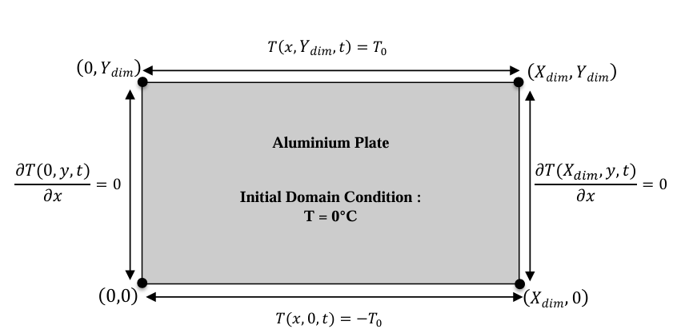
Figure 1 - Initial & Boundary Conditions

Analytical Solution
The analytical solution of the temperature at thermal equilibrium, as displayed in Figure 2, will be used to validate the code. This equation represents variation along the X & Y axis using a variety of functions, including linear, sine and cosh. An analytical solution for modelling temperature in a two-dimensional domain is formed by these functions.

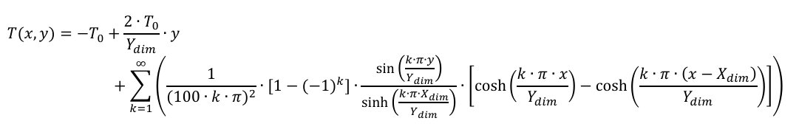
Figure 2 - Analytical Solution
(Chang C.Y., Ma C.C., 2001)

The code details and explanations
The Matlab code will be looked at in this section of the report.
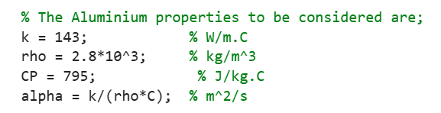

Figure 3 - Section 1 MATLAB Code

The code's first section, which is displayed in Figure 3, displays the aluminium plate's attributes, including the values of CP for specific heat, rho for density, and k for thermal conductivity.
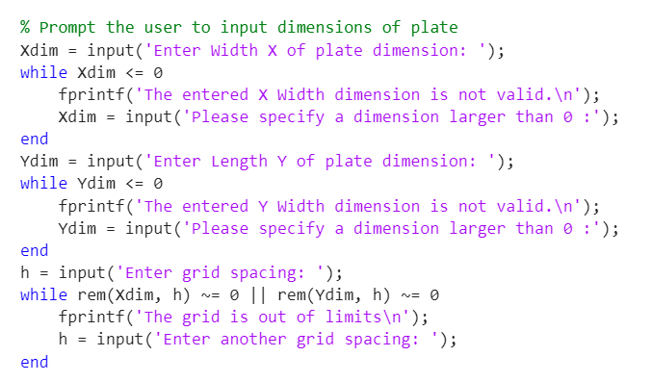
Figure 4 - Section 2 MATLAB Code

The user is prompted to enter the plate's measurements along the X and Y axis and a grid spacing of h in the following section above. A while loop function makes sure the value supplied is larger than 0 once the user provides the width dimension X, which is represented by Xdim = input. A warning notice appears, and the user is asked to input again if the number is less than or equal to 0. The Y dimension of the plate is then subjected to the same logic.
The user is asked to enter the grid spacing h once again, and a while loop verifies that the grid splits equally into the X and Y dimensions.
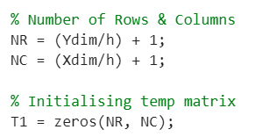
Figure 5 - Section 3 MATLAB Code

The number of rows and columns is determined in the next section of the code, which will be seen in Figure 5. The overall length of the plate divided by the grid spacing provides the number of rows. Boundaries are taken into account by adding 1. Additionally, initialising the temperature matrix for T1 is demonstrated. The grid points store values in an initialised matrix of zeros.
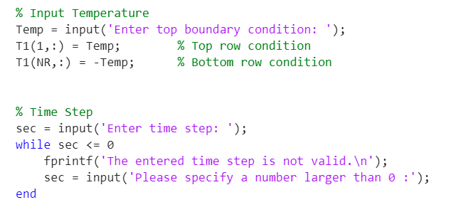
Figure 6 -Section 4 MATLAB Code

Figure 6 asks the user to provide the temperature's upper boundary condition. All columns in the first row are referred to as T1(1, :) = Temp, which allocates the given temperature reading to the top row of the matrix. T1(NR, :) = -Temp applies the negative of the specified temperature data to the bottom row of the matrix. The user inputs a time step value, and a while loop function is used again to check if the value is valid.
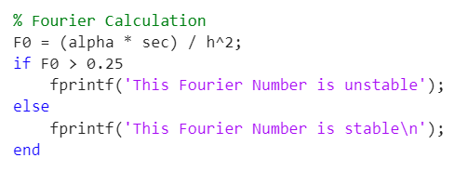

Figure 7 - Section 5 MATLAB Code

Both the "if" and "else" methods are utilised in the code that is demonstrated in Figure 7. A message with the Fourier number is stable will appear if the value is more than 0.25. However, an alert stating that the number is unstable will appear if the value falls below 0.25. Together, the "if" and "else" functions enable the code to execute two different code blocks based on the situation.
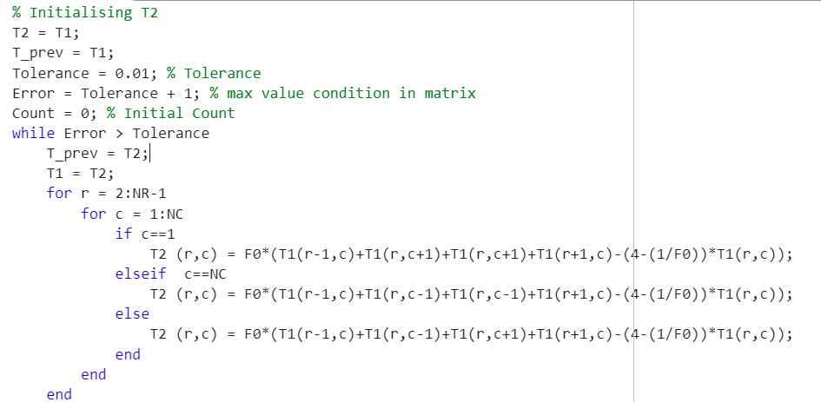
Figure 8 - Section 6 MATLAB Code

The starting point in Figure 8 is to initialise T2 as the current temperature matrix T1, while recording the initial temperature in T_prev. section. Additionally, the error is determined to begin the loop after examining T2. The tolerance is set at 0.01.
Until the maximum error is less than the specified tolerance, a while loop function is used. In the next phase of the code, the temperature at each grid point (r, c) is updated using the explicit finite difference method. For instance, T1)r-1,c) is above.

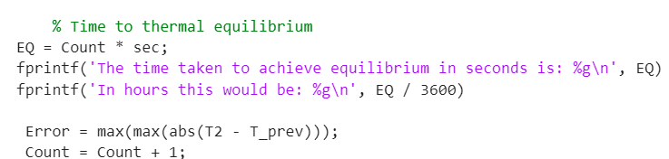
Figure 9 - Section 7 MATLAB Code

The code's following part highlights the largest temperature change. It is computed using MATLAB's "max" and "abs" tools. The difference among the current (T2) and prior (T_prev) temperature matrix is calculated to determine the error. The 'count' line in the code shows how the iterations number is increased. Furthermore, the code shows theamount of time in seconds and hours needed to reach equilibrium.

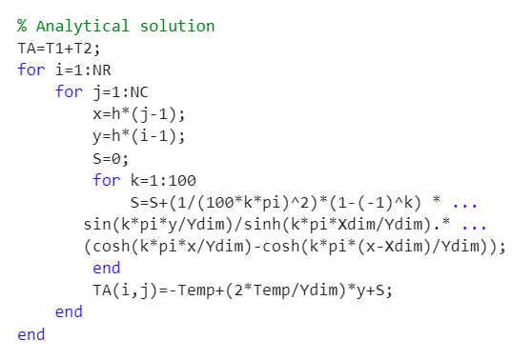
Figure 10 - Section 8 MATLAB Code
The analytical solution to this heat problem is displayed in Figure 10. Initialising TA, which is the sum of the matrices T1 and T2, is the first step in this process. The grid's row and column counts are shown by the NR and NC, while the spatial coordinates are highlighted by the x and y. It will take one hundred iterations to finish this loop procedure.
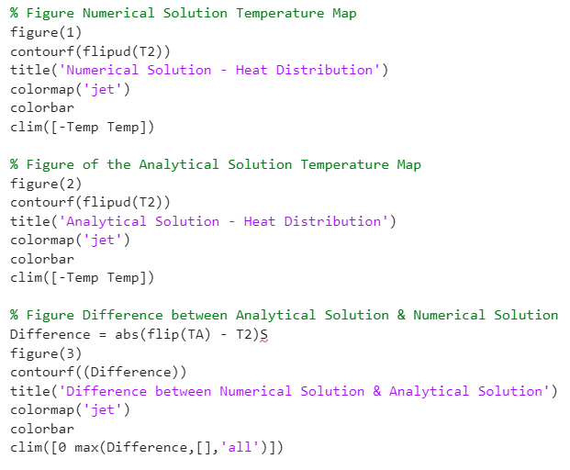

Figure 11 - Section 9 MATLAB Code

Three graphs are produced, the numerical/analytical solution and comparing the difference between the solutions. Every single part of this code has a distinct purpose; for instance, "figure(1)" opens a new window displaying the graph. Similar to the figure of the analytical solution and the temperature map of the numerical solution, these tools enable the code to make a figure by adding a title, establishing the colour scheme, adding a colour bar to the side that shows the temperature, and displaying the temperature.
Lastly, the absolute difference involving the analytical solution and the numerical solution is calculated using the formula Difference = abs(flip(TA). The colour limits in this sector are set from 0 to the highest value in the Difference matrix using the Clim function.

Validation of the code
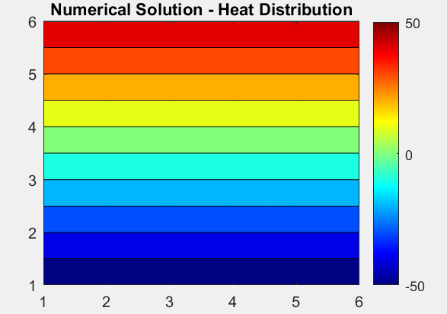
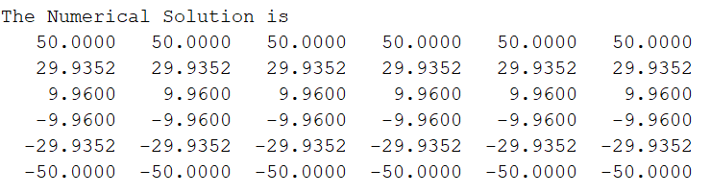
The temperature maps at thermal equilibrium and the analytical solution will be compared in the two primary parts. The established parameters of X & Y dimensions of 5, grid spacing of 1, timestep of 1500, and temperature of 50 were utilised to get the following outcomes.

Figure 12 - Numerical Solution Results
Figure 13 – Numerical Solution Map
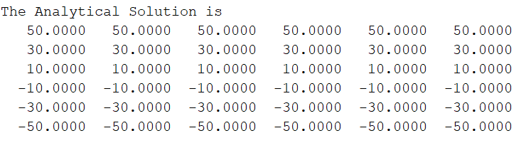
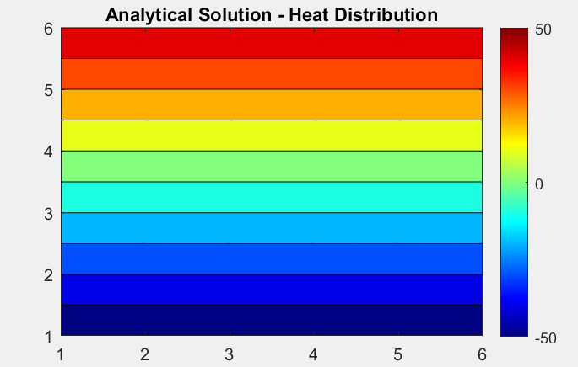

Figure 14 - Analytical Solution Results

Figure 15 - Analytical Solution Map
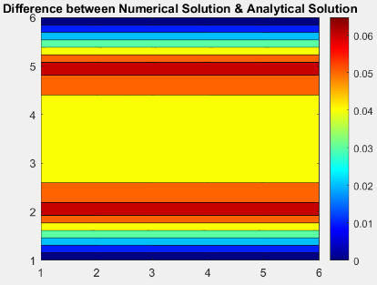
Similar outcomes are shown by both matrices which result in comparable patterns of heat distribution throughout the plate. A smooth gradient of temperatures over the domain is illustrated across both temperature map visualisations, with higher temperatures shown in red and cooler ones in blue. Visually, the two graphs' tight alignment indicates that the numerical answer is accurate. Due to computational constraints, there could be some variations, but this is to be expected in any numerical method.

Figure 16 -Difference Between Analytical and Numerical Solutions

The third temperature map displayed in Figure 16 shows the difference between the numerical solution and Analytical Solution.

Sensitivity Analysis of Code
The sensitivity analysis of the mathematical simulation model will be examined in the following sections of the report. The primary focus will be on how the code is impacted by grid spacing, time step, and thermal equilibrium tolerance.

Grid Spacing Influence
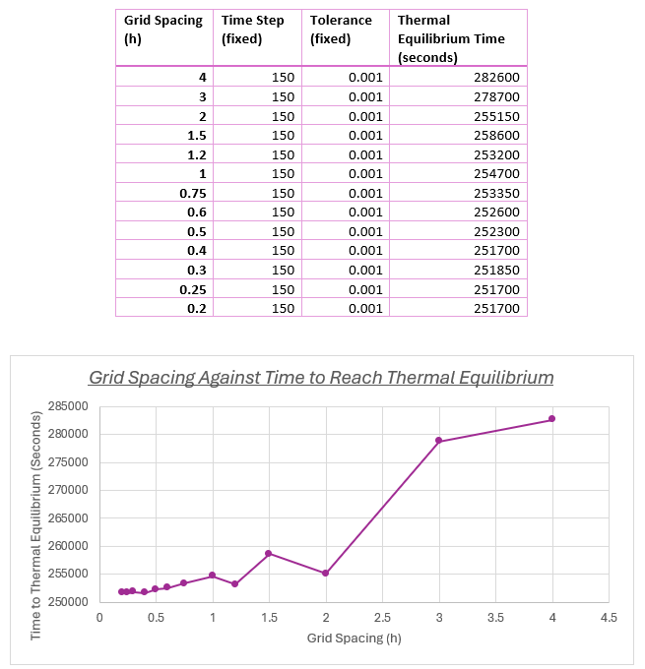

Figure 17 - Table & Graph of Grid Spacing Against Time Taken to Reach Thermal Equilibrium

The above analysis focuses on the influence of grid spacing, where the time step and tolerance is fixed. When the grid spacing is less than 2, the graph displays a nonlinear trend with a fairly stable time to thermal equilibrium. The time it takes to attain equilibrium begins to rise sharply when grid spacing increases above 2. As a result, it demonstrates that when grid spacing is reduced, the time required to attain thermal equilibrium decreases. A more realistic model is produced by reducing grid spacing since it adds more structure and detail (Giunta et al., 2019). Furthermore, grid spacing may have an impact on numerical errors such as Truncation errors which will be looked at in section 9.1.2.

Time Step Influence
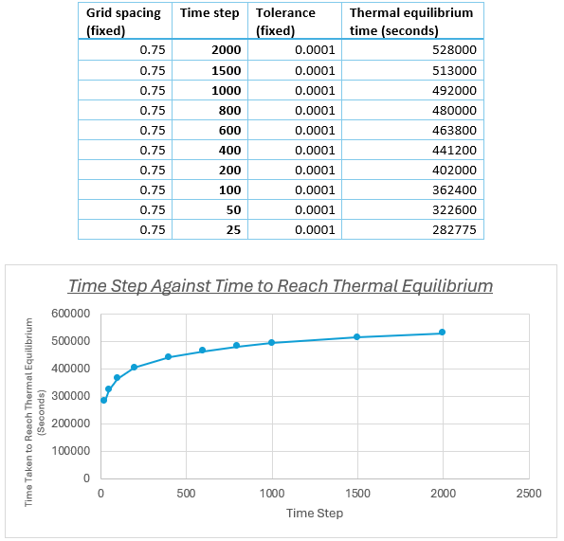
Figure 18 - Table & Graph of Time Step Against Time Taken to Reach Thermal Equilibrium

The correlation between the time step size and the simulation's time to thermal equilibrium is seen in this graph above. The influence of a time step can be observed, where a greater time step increases the time required to attain equilibrium but may also result in instability or numerical errors. According to Page (2015), findings are more reliable and stable when the time step is lower.

Tolerance Influence 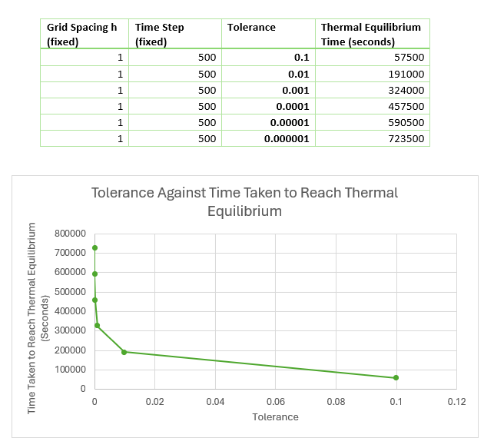
Figure 19 - Table & Graph of Tolerance Against Time Taken to Reach Thermal Equilibrium

This graph demonstrates how tolerance and the amount of time required to get to thermal equilibrium are associated while maintaining a fixed time step and grid spacing. When tolerance decreases, the time to equilibrium increases sharply. More iterations are needed when tolerance drops, resulting in greater precision but longer computation times because the simulation takes longer to achieve equilibrium. Therefore, the results indicate that the code is extremely sensitive to the tolerance value.

Limitations of the model

Limitations due to the Numerical Method

Round Off Errors
A mathematical error known as round-off error occurs when there is a discrepancy between the precise value of a number and its approximation employed in computation. This is because the system cannot calculate outcomes with infinite accuracy. This is one of the model's drawbacks, which means that the findings may not be entirely accurate in computations (Tu, Yeoh and Liu, 2018).

Complex Geometry
Since discretising the domain into a grid is a common practice in numerical techniques, it becomes challenging to accurately represent the geometry using a structured grid when the domain is in a complex shape, increasing processing cost.

Truncation Errors
Another limitation is Truncation errors. Truncation error is defined as the difference between analytical derivative of a function and its derivative numerical approximation (Neill and M Reza Hashemi, 2018). These Truncation errors can appear in a lot of places in the model where discretisation of equations is applied to the grid.

Limitations due to the Coding

One limitation to the coding side is the way thermal equilibrium is modelled. Establishing thermal equilibrium in a simulation as the difference between two temperature maps has various drawbacks such as premature termination. If the system reaches a state where the rate of temperature change falls below the specified tolerance the simulation may stop before reaching true equilibrium.

Improvements - Future Developments
The code might be improved in a number of ways, including by applying the Finite Element Method (FEM). In contrast to the Explicit Finite Difference Method (EFDM), which depends on structured grids, FEM might be used to represent complicated geometries in order to overcome the drawbacks of current simulation techniques and increase accuracy (Cyprien, 2017). Additionally, the ability to compute solutions for an unstructured mesh is another reason why FEM may be employed, but EFDM has this constraint. FEM has the benefit of making it simple to "increase the order of the elements," which allows for a very accurate approximation of the physics field (Sjodin, 2016).

Since the Implicit Finite Difference Method (IFDM) is often regarded as the most reliable and precise numerical technique, it may potentially be used in the future. For linear problems, IFDM is unconditionally stable, in contrast to explicit techniques. This implies that stability won't be compromised when handling greater time steps (Rebelo, Morgado and Ford, 2015).
Avoiding premature simulation termination, which was one of the restrictions in sections 8.2 to enhance thermal equilibrium models, would be another improvement. According to ManageEngine (2024), adaptive tolerance thresholds can function by dynamically modifying criteria or limitations in response to a system's observed behaviour over time. Therefore, a system with adaptive tolerance would be a good idea.

Conclusion
In conclusion, the distribution of temperature in an aluminium plate has been effectively modelled using EDFM. Taylor Series expansions were used to discretise the governing equation. This made it possible to apply the forward, backward and central difference approximations using different derivatives.

After successfully analysing the MATLAB code and providing explanations for each section, the findings pertaining to tolerance, time step, and grid spacing were further examined. Although it may require higher computing costs, smaller grid spacing and time increments improved simulation accuracy.
Finally, EFDM was examined, and the code's flaws and enhancements were thoroughly examined. Among the restrictions were complicated forms, truncation problems, and round-off errors.

References

Barrett, A.I., Wellmann, C., Seifert, A., Hoose, C., Vogel, B. and Kunz, M. (2019). One Step at a Time: How Model Time Step Significantly Affects Convection‐Permitting Simulations. Journal of Advances in Modeling Earth Systems, 11(3), pp.641–658. doi:https://doi.org/10.1029/2018ms001418.
ByJu's (2017). Derivation Of Heat Equation With Simple Steps And Explanation. [online] BYJUS. Available at: https://byjus.com/physics/derivation-of-heat-equation/ [Accessed 14 Jan. 2025].
Chapra, S.C. (2018). Applied numerical methods with MATLAB for engineers and scientists. New York, N.Y.: Mcgraw-Hill Education.
Cyprien (2017). FEA for All. [online] FEA for All. Available at: https://feaforall.com/difference-between-fem-and-fdm/ [Accessed 26 Jan. 2025].
Dirk Jan Struik (2019). Joseph Fourier | French mathematician. In: Encyclopædia Britannica. [online] Available at: https://www.britannica.com/biography/Joseph-Baron-Fourier [Accessed 14 Jan. 2025].
Giunta, G., Salerno, R., Ceppi, A., Ercolani, G. and Mancini, M. (2019). Effects of Model Horizontal Grid Resolution on Short- and Medium-Term Daily Temperature Forecasts for Energy Consumption Application in European Cities. Advances in Meteorology, [online] 2019, p.e1561697. doi:https://doi.org/10.1155/2019/1561697.
Kenton, W. (2021). Rounding Error Definition. [online] Investopedia. Available at: https://www.investopedia.com/terms/r/rounding-error.asp [Accessed 12 Jan. 2025].
ManageEngine (2024). ManageEngine Log360. [online] ManageEngine Log360. Available at: https://www.manageengine.com/log-management/siem/what-is-adaptive-threshold.html [Accessed 26 Jan. 2025].
Neill, S.P. and M Reza Hashemi (2018). Fundamentals of ocean renewable energy : generating electricity from the sea. [online] London: Academic Press. Available at: https://www.booktopia.com.au/fundamentals-of-ocean-renewable-energy-neill/prod9780128104484.html [Accessed 21 Jan. 2025].
Page , A. (2015). The Significance of Time Step Size in Simulating the Thermal Performance of Buildings. [online] Available at: https://www.researchgate.net/publication/283203305_The_Significance_of_Time_Step_Size_in_Simulating_the_Thermal_Performance_of_Buildings/links/56b9153308ae39ea9905c67d/The-Significance-of-Time-Step-Size-in-Simulating-the-Thermal-Performance-of-Buildings.pdf [Accessed 20 Jan. 2025].
Rebelo, M., Morgado, M.L. and Ford, N. (2015). An implicit finite difference approximation for the solution of the diffusion equation with distributed order in time. ETNA - Electronic Transactions on Numerical Analysis, [online] 44, pp.289–305. Available at: https://www.researchgate.net/publication/280042379_An_implicit_finite_difference_approximation_for_the_solution_of_the_diffusion_equation_with_distributed_order_in_time [Accessed 26 Jan. 2025].
Sjodin, B. (2016). What’s The Difference Between FEM, FDM and FVM? [online] Machine Design. Available at: https://www.machinedesign.com/additive-3d-printing/fea-and-simulation/article/21832072/whats-the-difference-between-fem-fdm-and-fvm [Accessed 26 Jan. 2025].
Tu, J., Yeoh, G.-H. and Liu, C. (2018). CFD Solution Analysis: Essentials. Computational Fluid Dynamics, [online] pp.211–253. doi:https://doi.org/10.1016/b978-0-08-101127-0.00006-4.

Appendix

clc;
clear;
close all;
% The Aluminium properties to be considered are;
k = 143; % W/m.C
rho = 2.8*10^3; % kg/m^3
Cp = 795; % J/kg.C
alpha = k/(rho*Cp); % m^2/s

% Prompt the user to input dimensions of plate
Xdim = input('Enter Width X of plate dimension: ');
while Xdim <= 0
fprintf('The entered X Width dimension is not valid.\n');
Xdim = input('Please specify a dimension larger than 0 :');
end
Ydim = input('Enter Length Y of plate dimension: ');
while Ydim <= 0
fprintf('The entered Y Width dimension is not valid.\n');
Ydim = input('Please specify a dimension larger than 0 :');
end
h = input('Enter grid spacing: ');
while rem(Xdim, h) ~= 0 || rem(Ydim, h) ~= 0
fprintf('The grid is out of limits\n');
h = input('Enter another grid spacing: ');
end

% Number of Rows & Columns
NR = (Ydim/h) + 1;
NC = (Xdim/h) + 1;

% Initialising temp matrix
T1 = zeros(NR, NC);

% Input Temperature
Temp = input('Enter temperature boundary condition: ');
T1(1,:) = Temp; % Top row condition
T1(NR,:) = -Temp; % Bottom row condition

% Time Step
sec = input('Enter time step: ');
while sec <= 0
fprintf('The entered time step is not valid.\n');
sec = input('Please specify a number larger than 0 :');
end

% Fourier Calculation
F0 = (alpha * sec) / h^2;
if F0 > 0.25
fprintf('This Fourier Number is unstable');
else
fprintf('This Fourier Number is stable\n');
end

% Initialising T2
T2 = T1;
T_prev = T1;
Tolerance = 0.01; % Tolerance
Error = Tolerance + 1; % max value condition in matrix
Count = 0; % Initial Count
while Error > Tolerance
T_prev = T2;
T1 = T2;
for r = 2:NR-1
for c = 1:NC
if c==1
T2 (r,c) = F0*(T1(r-1,c)+T1(r,c+1)+T1(r,c+1)+T1(r+1,c)-(4-(1/F0))*T1(r,c));
elseif c==NC
T2 (r,c) = F0*(T1(r-1,c)+T1(r,c-1)+T1(r,c-1)+T1(r+1,c)-(4-(1/F0))*T1(r,c));
else
T2 (r,c) = F0*(T1(r-1,c)+T1(r,c-1)+T1(r,c+1)+T1(r+1,c)-(4-(1/F0))*T1(r,c));
end
end
end

% Time to thermal equilibrium
EQ = Count * sec;
fprintf('The time taken to achieve equilibrium in seconds is: %g\n', EQ)
fprintf('In hours this would be: %g\n', EQ / 3600)

Error = max(max(abs(T2 - T_prev)));
Count = Count + 1;
end

% Analytical solution
TA=T1+T2;
for i=1:NR
for j=1:NC
x=h*(j-1);
y=h*(i-1);
S=0;
for k=1:100
S=S+(1/(100*k*pi)^2)*(1-(-1)^k) * ...
sin(k*pi*y/Ydim)/sinh(k*pi*Xdim/Ydim).* ...
(cosh(k*pi*x/Ydim)-cosh(k*pi*(x-Xdim)/Ydim));
end
TA(i,j)=-Temp+(2*Temp/Ydim)*y+S;
end
end

disp('The Analytical Solution is')
disp(flip(TA))
disp('The Numerical Solution is')
disp(T2)

% Figure Numerical Solution Temperature Map
figure(1)
contourf(flipud(T2))
title('Numerical Solution - Heat Distribution')
colormap('jet')
colorbar
clim([-Temp Temp])

% Figure of the Analytical Solution Temperature Map
figure(2)
contourf(flipud(T2))
title('Analytical Solution - Heat Distribution')
colormap('jet')
colorbar
clim([-Temp Temp])

% Figure Difference between Analytical Solution & Numerical Solution
Difference = abs(flip(TA) - T2)
figure(3)
contourf((Difference))
title('Difference between Numerical Solution & Analytical Solution')
colormap('jet')
colorbar
clim([0 max(Difference,[],'all')])

