Breaking Barriers

How does the absence of accessibility for disabled performers in performance education institutions influence their experiences, limit their opportunities, and affect their representation within the realm of performing arts?

Kia Elise Breckon (2000102)
BMus Vocal Performance
Wales Academy of Voice and Dramatic Arts
University of Wales Trinity Saint David
ADPA6000 Independent Project
Supervisor: Dr Benjamin Davis
Submitted: 18th April 2024

Word Count: 10,613
Table of Contents
Introduction 2
Acknowledging my own bias 2
Literature Review 6
To disclose, or not to disclose… 7
Intersectionality and Disability 9
The Power of Activism 10
Methodologies 14
Interviews 15
Institute Disability Policies 18
Funding Reports 19
Research and Findings 20
Disability Policy Findings 20
Interview Results 23
Interview with Rachel Stelmach: 24
Interview with Kaite O’Reilly: 26
Interview with Ffion Harries: 29
Funding 33
Conclusion 34
Reference List: 38
Bibliography: 44
Appendices 51

Introduction

There is evidence to suggest that the foundations of arts education institutes and the music profession are rooted in the practice of exclusion despite the ever-growing awareness of the lack of equality and accessibility within the arts sector (Lubet, 2011. p.64). Although the issue of equality for those of different races and genders has seen significant changes in recent years, the problem of both equality and accessibility for those who have a disability has been somewhat neglected (ABLE2UK, 2023). This harms the representation of disability within the realm of performing arts as it limits opportunities and sustains disparities in visibility and participation. There are many possible causes of this issue which will be explored throughout this dissertation through various means of research including interviews with members of the disabled artists community, analysis of relevant data in institution disability policies and case studies and studying online video material. I have done these things in the hope of providing a multifaceted understanding of the complex factors which influence the underrepresentation of disability in performing arts. As a disabled student, my research has sent me on a quest for justice, not only for myself but for everyone with a disability who may be training in a performance institution, those who feel they cannot apply to train in performance because of their disability and those who feel underrepresented within the arts sector.

Acknowledging my own bias

In October 2020, I had an unfortunate accident at the place I was working, causing me to lose 80% of function in my left hand, which has led me to now be classed as having a long-term, physical disability. I feel that my disability is not as severe as a lot of other physical disabilities but, when I was told my hand would never regain 100% function I was immediately sent into a spiral of thinking ‘How am I going to make this work?’, ‘How will this affect me at university?’, ‘How will this affect how people see me as a performer?’, ‘Will this hinder my performance career?’ – all these questions had never crossed my mind until this unfortunate experience. It was these questions that led me to want to do further research on the experiences that disabled musicians have, whether they’re instrumentalists or vocalists, in performance institutions and the profession and whether they feel their disability has influenced their experience, their opportunities and their representation or whether it was the absence of accessibility within both of these settings.

The accident took place at the restaurant I was working at, I was the only waitress on the shift that night (it was a relatively small restaurant, but we were very busy that night) and I had just taken a drinks order for a table, they ordered a bottle of white wine with two glasses, and as I was serving the drinks I tripped on the stairs. I let go of the wine in my right hand, which was in a cooler but unfortunately, I did not have time to let go of the two wine glasses in my left hand before catching myself on the floor which caused them to smash on impact and cut into my palm. I was immediately taken to the hospital to be examined, where I spent 6 hours waiting to be told that I had to be sent to a different hospital the next day because I needed surgery to repair the tendons and the nerves which I had severed. I received my first surgery, and I was told it was successful and that I would receive an appointment for physiotherapy for the following week to start my recovery treatment. I was optimistic that I would soon be able to return to my usual activities and return to work. This optimism was unfortunately short-lived as at my physiotherapy appointment I was told that I would need a second surgery because the first hadn’t gone as it was supposed to which would hinder my recovery. The second surgery went ahead the next day and was considered successful by both the surgeon and the physiotherapist thus began the ‘12-week recovery program’.

I was faced with many uncertainties during my early recovery; ‘Will I be able to cook for myself again?’, ‘Will I be able to look after myself properly?’, ‘Am I going to be as independent as I was before?’ and I felt humiliated having to ask for help with things like dressing myself and washing my hair. I was always told I had nothing to be embarrassed about but after so long of being independent I couldn’t help it. That feeling ate away at me every day, so I forced myself to adapt to life with one fully functioning hand, while the other was in a cast, knowing that it would be this way for the rest of my life.
I became quite pessimistic following my accident, especially after finishing physiotherapy and seeing the results of my second surgery were not significantly different from the results of the first. The restaurant was small with very few employees, and I received no support from my workplace at that time. Furthermore, I was not yet aware of the support services that the university had in place as I did not feel the need to get in touch with them until I started attending. The lack of support from my workplace took a toll on my mental health and I now had fears I had not had before and the ones I did have got significantly worse. Being a female was a hurdle in itself because there are so many females training and working in the arts as performers but now being classed as disabled caused a great feeling of dread when it came to thinking about my future career in performing because I no longer knew how I’d be perceived as a performer (because of my disability) or what my chances of being accepted into the arts sector were.

When starting my degree in 2021, I wasn’t sure what to expect in terms of what academic support I would receive and if I would receive any at all because I did not know if my disability was ‘severe’ or ‘life-changing’ enough to apply for support. I started to look into Disabled Students Allowance (DSA) (GOV.UK, 2023) and my first concern was whether I was eligible to apply for it. The GOV.UK website describes Disabled Student’s allowance as:

Disabled Students’ Allowance (DSA) is support to cover the study-related costs you have because of a mental health problem, long-term illness or any other disability. This can be on its own or in addition to any student finance you get. The type of support and how much you get depends on your individual needs - not your household income.
(GOV.UK, 2023)
After searching the page for answers on what physical disabilities were eligible, the words “physical disability, for example, if you have to use crutches, a wheelchair or a special keyboard” (GOV.UK, 2023) were highlighted and it was still unclear to me whether I could get any help because I didn’t need to use crutches or a wheelchair and I didn’t know if I needed to use a special keyboard because I hadn’t needed to before. The only clarity I had was the fact that my disability is classed as ‘long term’ so there was a chance my application would be accepted. The application process was lengthy. I had to provide proof of my disability which my doctor also had to sign off on. When the proof was accepted, I had to have an interview over the phone, where someone determined whether my disability was somewhat ‘worthy’ of support for my degree. I felt extremely grateful when I was given some technical support as my DSA because although I was starting a Vocal Performance degree, I would be able to do all of my written assignments comfortably and with technology that would allow me to use dictation software if I felt it was necessary. I also looked to my university's Disabilities Services for support to see if there was anything that they could help me with during my degree. After going through another lengthy application process in which I had to prove I was receiving support from DSA I was told I would receive extra time on assignments if I felt that I needed it and, in that moment, it felt like a triumph.
Two years into my degree, I found out that students with neurological disorders such as Dyslexia and Attention Deficit Hyperactivity Disorder (ADHD) - “a condition that affects people’s behaviour… can seem restless, may have trouble concentrating and may act on impulse.” (NHS, 2021) - who have applied for support through the university receive weekly sessions with a Learning Support Tutor to discuss and work through any written work they have ensuring they meet the deadlines and produce a high quality of work, aligning with what the university disability policy considers as a ‘reasonable adjustment’ (University of Wales Trinity Saint David, 2023). This led me to think about what kinds of support others with physical disabilities receive in other performance institutions or on performance courses which ultimately inspired me to write my dissertation on this subject because I believe there is a considerable difference in the support that physically disabled students receive to those with neurological disabilities; however, this study does not focus on those differences because there is a more pressing argument to make when advocating for all disabilities rather than opposing them which I will set out throughout this study.

Literature Review

This literature review includes the review of studies of intersectionality and what it can teach us about under-representation, evaluations of how activism can change experiences and representation, academic studies and both arts organisations and non-arts organisations reports on disability disclosure. Analysing intersectionality gives us a valuable understanding of the under-representation of disability and other communities such as the LGBTQ+ and Black communities. Academic Studies provide theoretical frameworks and empirical evidence, sharing insight on the factors influencing accessibility and the effectiveness of approaches aimed at promoting inclusivity. Additionally, arts organisation and non-arts organisation reports provide insight into whether disability is under-represented in professional work and the issues surrounding disability disclosure. By studying these information sources, this literature review aims to provide a broad understanding of the complexities surrounding the representation of disability in the arts sector. It is noted that some references are dated more than 5 years ago. However, although some ideas on disability are outdated, like the language used to speak about and to disabled people (Andrews, Powell and Ayers, 2022), I believe that the research done on disability representation still holds relevance in understanding the historical context and progression of disability representation in the arts sector.

To disclose, or not to disclose…
There is reason to believe that the disclosure of a disability is a large source of the issue with the lack of inclusivity in the arts sector. In the 2018 ‘Making A Shift Report’, Arts Council England said:
“… monitoring data suggests that disabled people are significantly under-represented in the Arts Council-funded workforce. Just 4 per cent of staff in National Portfolio Organisations … self-defined as disabled, although there is a high volume of ‘unknown’ and ‘prefer not to say’ responses.”
(Arts Council England, 2018)
However, in the 2019/20 Executive Summary, Arts Council England stated that there was a 1% increase in disabled people working across the National Portfolio Organisations (NPOs) to 7%, with 8% of those working in Theatre and Visual Arts, but there were still a high number of non-disclosures at 29% (Arts Council England, 2020). There is no evidence provided by (ACE) like the ‘Making A Shift’ report which poses the question of where the increase in disabled employees in NPOs came from between 2018 and 2019. This data suggests that people with disabilities may choose not to disclose their disabilities (if not visible) to employers for fear of not being hired or being treated differently.

Disability isn’t only under-represented in the arts sector but in many other sectors too, so when delving into the statistics of disabled employees outside of the arts sector, NHS England reported that in a survey completed by 255,000 staff in 2014, 17% disclosed having a disability (Appendix A). The motivation for this research was to explore ‘what issues and measures a Workforce Equality Standard for Disability should comprise, focusing on the experiences of staff with disabilities working within the NHS’ (Passman and Milton, 2015). In addition to this data, TUC issued the report ‘Jobs and pay Monitor – disabled workers’ which looks at the gap in pay and employment that disabled people face to non-disabled people in different sectors. They said the data they collated showed that “disabled people are over-represented in lower-paid occupations and industries and under-represented in high paid occupations and industries” (TUC,2022) however, the data itself shows that, overall, disability is still widely under-represented across all sectors (see Appendix A).

When asked to describe or name a disability, the majority of people will describe a physical disability over any other type of disability (Krennemer,1997). The fear of discrimination when disclosing a disability not only affects people looking for employment but also those in education. It is no secret that societal attitudes toward disability are barriers for disabled people whether they are conscious or unconscious biases and, people are now more likely to hide these biases in fear of being discriminative (Freidman and Owen, 2017). It could also suggest that nondisabled people may answer as “prefer not to say” when disclosing that information because of the backlash arts institutions and organisations have received for their lack of inclusivity. For example, in 2017 research on this subject conducted by the charity Act For Change that showed out of 473 final-year students from across 17 different major drama schools in England, not a single one stated that they were disabled. In this article, disabled writer, director, and actor Jamie Beddard states that drama schools are “part of the problem rather than the solution”. He then goes on to say:

“Drama schools have traditionally hidden behind the contrived excuse that a lack of employment prospects for disabled performers across the wider industry would mean training is setting people up to fail…”
(Disability News Service, 2017).

Does this ‘excuse’ force disabled people into not disclosing their disability to drama schools? Or does it add to the societal barriers disabled people feel that they have to work their whole lives to overcome? (Alexandrin, Schreiber and Henry, 2008, p.377)

In the 2013 TEDxAlbertopolis ‘Sole Determination’ talk, Nicholas McCarthy, the only one-handed pianist to graduate from the Royal College of Music, London (McCarthy, 2019), reflects on when he was 15 years old and he had a conversation over the telephone with the headmistress of a specialist music school he wanted to audition for (which he did not name) and when he disclosed his disability to her, she stated she didn’t understand how he could play the piano and promptly hung up the phone. He then goes on to discuss how after feeling deflated for a few days, he stumbled upon the Guildhall School of Music and Drama. He decided to apply but to not disclose his disability on the application form and to only disclose it to the panel when he auditioned (TEDx Talks, 2013). It is possible that McCarthy’s decision not to disclose his disability straight away influenced the attitudes of the audition panel as it did not leave them any time to make any pre-judgements towards him and his ability to play the piano. The stigma around disability raises important questions about societal attitudes and perceptions that prompt us to think about unseen and unheard biases. Why is there such a stigma around disclosing disabilities? What are the attitudes that we are unaware of? What are the tactics disabled people use to overcome biases? Can these questions be asked and used to create a more accepting society?

Intersectionality and Disability

Intersectionality is “the interactivity of social identity structures such as race, class, and gender in fostering life experiences, especially experiences of privilege and oppression”. The idea was conceptualised over the twentieth century by numerous supporters of black feminism such as Patricia H Collins (Gopaldas, 2013). It can help us to understand the needs and experiences of people and how the way that they are perceived influences these things (Wickenden, 2023). In my research, I have found that disability is often grouped with ethnicity and gender in studies of intersectionality and in terms of support in education. In recent decades, the intersectionality framework has broadened to encompass social class, age, ethnicity, sexuality, nationality, religion, and numerous other social attributes (Brown and Moloney, 2019). “Everyone has multiple identities with different statuses, and some people identify as being a member of one or more marginalised identities” (Wickenden, 2023). Although this rings true to me, as a disabled woman, people within those communities will have very different experiences. I have found myself asking, why is it that they are grouped together? People who identify with more than one of these communities may find that their experience of exclusion and discrimination is heightened compared to people who self-identify with only one community. Belonging to more than one of these communities can also intersect and interact to shape experiences. In an age where being a woman is widely associated with systematic inequalities (Newman et al, 2023), gaining employment as a woman with a disability has been perceived to be more difficult than a woman who doesn’t have a disability (Brown and Moloney, 2019).
According to Deimer, Gerstein and Regester (2022), in the female and Black populations, people are statistically either misdiagnosed or diagnosed with neurodivergent disabilities later than the male and White populations because of their ability to conceal characteristics of the disability. In line with this perspective, “disability is like race” is an analogy often used to compare disability inequality to racial injustice (Frederick and Shifrer, 2019). It implies that both disability and race are social constructs that lead to marginalisation, inequality, and prejudice. This comparison underscores the intersectionality of the need to address inequality and discrimination, whether it is a conscious or unconscious bias which could lead to more barriers to the advancement of accessibility and participation, especially in the arts sector. Intersectionality has helped inform my research and my methodologies because it has enabled me to further understand the complexities surrounding the under-representation and inequality of disability in the arts sector.

The Power of Activism
In efforts to address the inequalities of under-representation of both intersectional communities, activism plays a crucial part in advocating for change and social justice. It has been said that within the disabled community, there has been much change since the 1960s in social responses to disability due to the activism that has taken place throughout the United Kingdom (Barnes, 2007). Although it is clear that there has been a change in how disabilities and people with disabilities are treated, is it enough to change the level of representation in the arts sector?
The landscape of disability activism seems to lack prominent figures who have acquired widespread recognition and influence comparable to those in other social justice movements (Louise, 2020). In recent years, there have been societal activism movements for the LGBTQ+ community as well as the Black community and for Women’s Rights. Events such as the Stonewall Riots of 1969, which is one of the most well-known events historically where LGBTQ+ community organisers fought back against police brutality (Stein, 2019), and the murder of 17-year-old Trayvon Martin in 2012, which sparked the US Black Lives Matter movement (Whiting, 2022). Another important event is the Suffragettes that was founded by Emmeline Pankhurst (Marlow, 2015). There have been countless leaders emerging from these communities. Marsha P. Johnson, known as ‘the Saint of Christopher Street’ (Ashley and Sanchinel, 2023) was a Black transgender woman and one of the leaders of the Stonewall Riots. Johnson’s involvement created a legacy that had a significant and “undeniable” impact “that without Johnson, queer people would not have the rights they do now” (Teppo, 2022). The significance of these events and the ‘noise’ made by them has led to yearly events such as ‘Pride Month’ which happens in June and is celebrated by pride events all over the United States of America and the United Kingdom (Tandon and Rao, 2021). Thinking about the significance of these events has led me to think about the impact and visibility of disability activism. These events, such as pride, often receive widespread media coverage. Many of the largest disability organisations in the UK advocate for change however, many of them focus on just singular impairments rather than disability (Evans, 2022) and similar initiatives to elevate disability activism and amplify the voices of the disabled community are comparatively scarce. This could lead one to ask: what type of media coverage is the disabled community getting?
The media are constantly being accused of disability discrimination whether they are presenting the disabled community as something to pity, ridicule or “inspiration porn” (Disability News Service, 2023). “Inspiration porn” is:
“the representation of disability as a desirable but undesired characteristic, usually by showing impairment as a visually or symbolically distinct biophysical deficit in one person, a deficit that can and must be overcome through the display of physical prowess.”
(Grue, 2016)
This problematic portrayal maintains harmful stereotypes and reinforces ableist attitudes that undermine the dignity and agency of individuals with disabilities. Moreover, the prevalence of “inspiration porn” in the media detracts from genuine efforts to promote inclusivity and equality by reducing complex lived experiences to simplistic narratives of triumph over adversity (Ayers and Reed, 2022). For example, talent shows such as The Voice, X Factor, and Got Talent seemingly have at least one disabled contestant each year such as ‘Lost Voice Guy’ who won Britain’s Got Talent in 2018 (Disability Horizons, 2018). As an audience, we are introduced to these contestants with outside footage which often includes childhood photos and emotional voice-overs (Cheng, 2017). This is the first part of the process of instant audience charisma. Albeit in ways that initially evoke feelings of inspiration and admiration, these portrayals risk turning the very disabled performers into vessels for pity that reflect the tokenism and stereotypes of disability as a boundary to be broached or ‘overcome’ rather than an element of diversity and integral part of human experience. Ableist tendencies to sensationalise disability for ‘inspiration porn’ (or, ‘Inspiration Porn’) purposes overshadow the primary task of appreciation for and attention to these performers’ live, onstage, or recorded talent and contributions, and the accompanying narratives of triumph by, among other things, ignoring the myriad systemic barriers to entertainment industry entrance and success as well as encroaching societal barriers faced by disabled individuals navigating boundaries (Cameron, 2018). Everywhere we look in the media, it is (mis)represented in ways that pathologise and/or dehumanise disability while distancing the public from disability. Simply put, our media has a lot of work to do. Far better representations of disability and recognition and inclusion of all kinds of diverse peoples with all types of diverse bodies and identities must be a fanfare in the media. Making media more responsible: the solution? If we pay close attention to the media circa 2020-23, we see that it is not only our media, but also how we all determine or discover our attitudes towards issues and people, and in the case of disability, what types of responses are deemed applicable. Disability is, first and foremost, a social problem. Attitudes about disability reflect this truth. The social and medical models of disability are themselves attitudes towards disability. The social model of disability (see Appendix B) shows that disability is primarily a result of societal barriers and discrimination rather than inherent individual impairments (Union of the Physically Impaired Against Segregation, 1975, p.3.). In contrast, the medical model (see Appendix C) emphasizes individual impairments and medical interventions as the primary factors influencing disability (Areheart, 2008, p.186). These contrasting perspectives often intersect and interact to influence societal perceptions and responses to disability. In a recent conversation I had at work, about this study, a colleague said, “Disabled people might need more help with learning lines or a person with Autism may need help with stage presence and that might be why they don’t get hired.” I was quite shocked by what he said but I then proceeded to tell him that this was a form of discrimination to which he did not understand why until I explained the social model of disability. I was met with a lot of “yes, but you know what I mean” whilst trying to explain how what he had just said was an attitude that society had presented him with, and he had chosen to believe it and take it on as his own. I went on to explain that the assumption that disabled people need ‘more help’ is damaging to the disabled community as it reinforces societal attitudes which can cause more exclusion for disabled people (Babik and Gardner, 2021).
I believe that for the “noise” that disability activism makes to be heard, like the “noise” made by LGBTQ+ and Black Lives Matter movements, it's essential to engage in various approaches that amplify the voices and experiences of disabled individuals while raising awareness about disability rights and issues. This involves fostering community engagement through events, improving media representation to challenge stereotypes, educating the public through campaigns, advocating for policy changes at all levels, recognising the intersectionality of disability with other social identities, leveraging digital platforms for activism, and building partnerships with other advocacy groups. By adopting such strategies, disability activists could effectively advocate for systemic change and promote a more inclusive and equitable society.

Methodologies

My research aims to explore the impact of the accessibility barriers disabled people face in both performing arts institutes and the performing profession. Specifically, it seeks to create an understanding of how the lack of accessibility affects the experiences, opportunities, and representation of disabled performers.
A mixed methods approach is undertaken to investigate accessibility barriers disabled performers experience in performance education institutes and the performing arts professions due to the complex nature of the issue and its need to integrate insights from multiple perspectives and forms of data collection. These decisions were guided by the realisation that my research question necessitates a multi-pronged exploration using both quantitative and qualitative the performing arts sector faces and what can be done to ensure access for disabled performers. The combination of quantitative data analysis with qualitative approaches allows for a deeper level of understanding when studying the experiences of disabled people given that a researcher could gain different levels of insights from the same set of data depending on which questions are asked. Relying solely on quantitative approaches would not be suitable to measure the lived experiences and perspectives of disabled people. Also, relying solely on qualitative research methods would limit my ability to meaningfully contextualise their experiences against its background. The use of mixed methods approaches brings together quantitative approaches which are better suited to mapping disability policies implemented across performance education institutes and the statistical data (if any) those policies provide to add context and indicators of levels of accessibility as well as representation, and qualitative approaches better suited to understand the lived experiences and perspectives of disabled people working both within the performing arts sector through interviewing them and exploring their transcriptions in the form of discourse analysis.

Interviews

By doing interviews as part of my research I understand that there are limitations to both the quality and quantity of data which I can collect. Due to only interviewing three people, the number of perspectives I have on my research is limited and all three of the participants have different experiences and answered different sets of questions which means that I have no differing views to compare my data to (Hobson and Townsend, 2015). Although it may be difficult to see a pattern in the data that I was able to collect, to me, there is a clear bias that disability is under-represented within the arts sector.
When looking for participants for interviews I knew that I wanted to interview someone who identified as disabled and was also currently attending a performing arts education institute, specifically doing their training in classical music or opera. At first, I wanted to look outside of my university for someone who fit these criteria as I thought it would be interesting to see how their experience being a disabled student was both similar and different to my own. I did not know where to look and tried my luck with a post on a score-sharing group on Facebook. A student from America who had attended the University of North Carolina School of The Arts as a Violin Performance major quickly got in touch with me and told me that she would be willing to participate. She explained that she is a neurodivergent student who has experience studying at a conservatoire and university. A conservatoire is “a specialist institution, which trains students in music and performing arts” (Leeds Conservatoire, 2018). Although we were both keen to have this interview, our schedules unfortunately often clashed which ultimately led to us not being able to do the interview. I felt frustrated at this but came to the realisation that there is a student on the same course that I am on and although we are doing the same course, we have different disabilities, therefore, our experiences will be similar but different. It was also at this point in my research that I decided that advocating for all disabilities would create a stronger argument rather than opposing them.
Ffion Harries is at university studying Vocal Performance and has ADHD and dyslexia. Up until starting university, she was unaware she had either disability, and she was diagnosed just before the second year of her degree started. Her diagnosis came from having a conversation with one of her tutors who suggested she utilise the university disability services to be tested for both dyslexia and ADHD. As mentioned earlier in this study, it is not uncommon for females to be diagnosed with ADHD and autism later in life. Ffion has said her diagnosis came as a huge relief to her as she finally understood why she sometimes struggled with things such as her writing skills, listening and concentration. The university has provided her with a Learning Support Tutor whom she speaks to weekly to discuss her academic work which she has said she finds helpful. I approached Ffion in person and asked if she would be willing to participate in an interview for this study to which she agreed. Finding time to conduct the interview was, in this case, extremely easy as we are on the same course, so we were both available at similar times. Moreover, because I had already written questions for a musician, I was able to edit them so that they were customised to Ffion, as a singer, which helped create a more personalised interview. I felt that the interview with Ffion went extremely well because she answered the questions the way I hoped she would, and she gave me a good insight into her experience as a disabled student and what she thinks of the representation of disability in the arts sector. If I could do the interview again, I would re-word the questions so that they were clearer for her as she expressed she had some difficulty understanding what I meant with some of them.
In doing my research, I thought it would be valuable to interview someone who provided training in disability equality training because I wanted to gain insight into how this type of training is conducted and to reinforce how important it is in arts organisations.

Rachel Stelmach is the Training and Funding Officer at Disability Arts Cymru (DAC) (Disability Arts Cymru, n.d.), and she also identifies as disabled. Disability Arts Cymru is a disabled-led arts organisation in Wales that works with organisations and individual artists to celebrate and develop Disabled & Deaf art and culture (Disability Arts Cymru, n.d.). I initially found her online through the DAC website after searching for ‘disability training’. After reading the brochure on the training that they provide (see Appendix D) I used the company contact details to ask about an interview with Rachel which is when she emailed me personally to arrange a time and date. After confirming the interview with Rachel, I began to research more into what a disability equality officer does and who they might provide training for so that I could cater my questions to her job role. The interview with Rachel left me feeling somewhat unsatisfied, as I did not gather as much information as I had hoped. However, upon reviewing the transcript, I realise there is a lot of relevant content for my study. This interview was the first of the three that I conducted, and it taught me a lot about how I might conduct the other interviews that I had. Following this interview, I changed how I conducted the others so that they felt more like a conversation, making them a more comfortable experience for both me and the participant.

My final interview was with Kaite O’Reilly who has visual and physical impairments. She is a writer, dramaturg, and disability rights activist. I first met Kaite when she was hosting a masterclass about disability arts. During a short break, I approached Kaite and asked if she would be willing to do an interview with me for this study. I explained why I was doing it, to which she expressed her enthusiasm, and she encouraged me to persevere with this study as it is an important topic in theatre in this day and age. When deciding on a date and time over email, Kaite also told me about a research and development opera that she had worked on that had a full cast and creative team of disabled performers. This new information made me feel incredibly excited as I had never heard of any opera having a full cast and creative team of disabled people and I knew from that moment that my interview with Kaite would be beneficial to this study. I then researched her background and used what she had talked about in the masterclass to create the questions I wanted to ask. After the interview, I felt very positive about the information I had collected because it gave me invaluable insight into disability arts and how disability is (under)represented in the arts sector. It also reinforced that there is a place in the arts sector for disabled performers and creatives.
Throughout the interview process, I made sure to inform all the individuals I interviewed about their rights during our discussions. At the start of each interview, I posed a series of questions to obtain their consent enabling them to decide whether they wished to proceed with the conversation. Additionally, I reassured them that they had the option to withdraw from the interview at any point if they desired. To safeguard their privacy, I asked whether they preferred to remain anonymous or were comfortable being identified in the study. I also informed them how I would store the data that was collected during the interview and when I would discard it.

Institute Disability Policies

Understanding disability policies helps gain insight into how performing arts institutes and organisations address accessibility issues. These policies state the institution's dedication to access, inclusion, and support for disabled people. Analysing them unveils strategies used to tackle barriers faced by disabled performers. This allows for examining how much disability inclusion is prioritised. Additionally, it reveals if the support services offered are adequate and aligned with accessibility standards. Reviewing disability policies highlights gaps and inconsistencies in practices related to disability accommodation, enabling the identification of areas needing improvement. When looking for disability policies, I went directly to each institute’s website, aiming to locate dedicated sections or documents addressing disability accommodation and support services. These policies were often found within sections related to student services, diversity and inclusion, or equal opportunity. Additionally, I searched for official documents such as accessibility plans, diversity statements, and institutional policies related to disability rights and accommodations.
After gathering disability policies from various performing arts institutions, the next step involved a comprehensive analysis of these documents to extract valuable insights. Each policy was carefully reviewed and scrutinised to identify recurring themes, underlying principles, and approaches to addressing accessibility barriers. This process involved categorising the content to discern commonalities and differences across policies. Additionally, attention was paid to any gaps or inconsistencies within the documents. Despite challenges such as varying terminology and levels of detail among policies, the analysis provided valuable insights into the strategies and measures adopted by performing arts institutions to promote accessibility and inclusivity. Through cross-validating the policy analysis findings with interviews, and academic works, I have established a broad insight into the accessibility landscape, from performing arts institutions to theatres. The integrated approach has, therefore, enhanced the quality of the research findings and allowed for a more detailed examination of the challenges and possibilities for disabled performers in the sector.

Funding Reports

The analysis of disability policies led me to question whether funding affected the accessibility of the arts sector and performing arts institutes. Are disabled-led arts organisations receiving similar funding to non-disabled-led arts organisations? Could this be why there is an accessibility issue within the arts sector? These questions are what led me to look for funding reports from art councils in both England and Wales. The reports were easy to find on their websites and after downloading them, I quickly started looking through the information they provided. By looking at these reports, I discovered valuable insights into the financial landscape of the arts sector and the allocation of resources to disabled-led and non-disabled-led organisations. This data allowed for a deeper understanding of the potential relationship between funding levels and accessibility initiatives within the sector. The findings from these reports, combined with the analysis of disability policies, have provided a comprehensive picture of the challenges and opportunities for improving accessibility in the arts sector.

Research and Findings
This section presents the study's results in hopes of answering the research question. This includes a thorough analysis of research methods and research data, as well as the main discoveries that can be drawn from the study. By analysing institute disability policies, conducting interviews with disabled individuals from within the arts sector and, evaluating arts council funding data, this study attempts to uncover the possible influences of the under-representation and barriers faced by disabled people in the realm of performing arts. Through this comprehensive exploration of accessibility barriers and their impact on disabled performers, this research aims to contribute to the ongoing dialogue on disability inclusion in the performing arts sector and to advocate for positive change that promotes equality and accessibility for all individuals, regardless of ability.

Disability Policy Findings
Firstly, I would like to present and discuss my findings on the various institute disability policies that I have analysed. Disability policies provide insight into what performing arts education institutes have in place for disabled students. After an extensive study of disability policies across the various performing arts education institutes, several key findings have emerged. It was evident that while the institutions have implemented policies aimed at supporting disabled students, the extent and effectiveness of these policies remain unclear.
A commonality between all the institute policies I found was the ‘reasonable adjustments’ section of the policy. This section often appeared at the very beginning of the policies and often started with a definition discrimination under of the Equality Act 2010:

“Under the Equality Act 2010 (previously the Disability Discrimination Act), discrimination against people with disabilities can take place in either of two ways by:
a. treating them less favourably than other people, or,
b. failing to make reasonable adjustments when they are placed at a substantial
disadvantage compared to other people for a reason relating to their disability.”
(RADA, 2021)
This is also the same definition that the Guildhall Student Reasonable Adjustments Policy and Guidance gave (2023). This is completely expected as it is the law under the Equality Act 2010 to have these policies in place (GOV.UK, n.d.). While the inclusion of the ‘reasonable adjustment’ section in all institute policies reflects well on legal requirements, there was a noticeable similarity in what a ‘reasonable adjustment’ may look like. However, there was not a list of what a ‘reasonable adjustment may look like instead, in an attempt to demonstrate a proactive approach to implementing ‘reasonable adjustments’, both of the policies mentioned above used the same example of providing a “professional quality dual muff headset” to a student who has a hearing impairment (see Appendix F – highlighted in yellow). The only different part was what course the student was on. This immediately set off alarms in my head – why is there no definitive list of what a ‘reasonable adjustment is? Could this possibly be making it easier for performing arts institutes to say an adjustment is not reasonable because it may cost too much, or it could affect the other students negatively? Could this discourage disabled students from applying to these institutions? What else is the same in these policies?
As I read further into these policies, I found more similarities in the examples that were used for case studies in disclosing disabilities. It describes a student with a long-term medical condition that affects their ability to control their bladder and their resistance to tell other staff members and students other than the ‘course leader’/’head of department’. What is concerning about this case study is that it is the same wording in both policies (see Appendix G – highlighted in yellow). The only two differences in this paragraph are the titles of the course leader/head of department and the order in which they appear. To someone who has not studied these policies I have, they may question why I feel this is problematic. However, the almost identical language raises a question of the individualised consideration given to given to the needs of disabled students within the institution. It also suggests a lack of tailored approaches and potentially undermines the effectiveness of policies in addressing the specific challenges faced by disabled performers.

It's surprising to note that among all the institutions that I looked at, only one mentions accessible accommodation and teaching locations in their disability policy. As a disabled student, this sends a message that this institution values diversity and is dedicated to providing an environment where everyone can fully participate. It also suggests that the other institutions may not have such things in place which could hinder students’ progress and well-being because of the barriers they have created, which may have been consciously or unconsciously created (Oliva, 2016). I believe that unless disability does not affect people first-hand, they do not believe it affects them. So, the need for accessible buildings for accommodation and teaching goes unnoticed which creates an unconscious bias. Acknowledging how accessible an institution is could create a more positive reputation for current and future students and staff members alike. I have found myself asking - is it barriers like this which are causing an imbalance between disabled to non-disabled students in performing arts institutions? In 2019, the London Academy of Music & Dramatic Arts (LAMDA) released its ‘Access and Participation Plan’ (2020-21 to 2024-25)’ which showed a clear imbalance in disability disclosure between two courses in terms of applications, offers and enrolment (See Appendix H) (London Academy of Music & Dramatic Arts, 2019). It acknowledges the imbalance of students who disclose their disability on application and the number of disabled students that enrol. It then states “One of the key parts of this five-year plan will be to interrogate that phenomenon and to address it” but gives no direction as to how they will do that. Is it possible that LAMDA has stated this because they are going to make the effort to address this imbalance or just because it looks good in the report? Figures like these are very easily accessible through the LAMDA website but when looking for other institutes APPs, they do not provide this type of data.

Interview Results

Through conversations with disabled individuals in the arts, I uncovered important themes and insights that illuminate the struggles and triumphs of disabled performers. These discoveries enhance our knowledge of the obstacles in the performing arts and offer valuable insight into the solutions and support systems required to overcome them. In the upcoming sections, I will explore the central themes from the interviews, highlighting the experiences and viewpoints of the participants while analysing their significance for promoting disability inclusion in the arts sector.

Analysis
During the analysis of the interview transcripts, a two-step approach was taken. First, each line of the transcript was carefully reviewed to find exploratory codes related to content, description, and language. These codes highlighted specific details within the data. Next, overarching themes or patterns were uncovered to reveal common topics talked about by the participants. This analysis sought to uncover valuable insights from the data, offering a thorough understanding of the interview content. The goal of this thorough analysis was to fully grasp the interview information, guaranteeing credibility, thoroughness, and clarity in interpretation. It should be noted that there could be other valid interpretations of the data.

Interview with Rachel Stelmach:

Because Rachel is the Training and Funding Officer at DAC (Disability Arts Cymru, n.d.), our conversation focused on the equality training that she provides through DAC. There were three overriding themes of our conversation, and they were training, accessibility and the barriers disabled people face.

To start our conversation, I asked Rachel to provide an overview of the training she provides at DAC so that I could gain an understanding of what equality training entails. Rachel explained the various modules covered in the training sessions which emphasize the importance of disability equality.

Rachel: So, we talk about the social model, where it came from, what it means, why, you know, it's not our impairments that disable us. So that's important. Also, in one way or another, we talk about language and not sort of individual ways and phrases and why some of them are problematic, but also just the power of words to change people's understanding of what they're looking at.

The language used to describe disabled people is often negative, pitiful, or associated with ‘inspiration porn’ (Andrews et al, 2019). The importance of language in influencing perceptions and attitudes towards disability is highlighted in this statement. Rachel's training sessions seek to confront stereotypes and encourage a more inclusive and respectful conversation about disability. She then goes on to explain how she uses her module ‘Accessibility 101’ (see Appendix D) to emphasise the importance of taking away barriers disabled people may face before they are created.
Rachel: Then I talk about barriers and what makes up barriers and what you are supposed to do about barriers, and then it all goes into the sort of accessibility 101 … for instance, if it's a festival organisation, I go through why you need to include access in your funding and all the different steps along the way, the booking forms, the marketing, the site, everything, how you go about doing that.

By equipping participants with practical knowledge and strategies for creating accessible environments, Rachel's training sessions empower organisations to actively address barriers and promote inclusivity. This not only enhances the organisation's capacity to accommodate the needs of disabled individuals but also fosters a culture of accessibility and diversity within the arts sector. Through these efforts, organisations can contribute to dismantling systemic barriers and advancing disability equality, ultimately creating more inclusive spaces for all participants.
Following on from discussing the training she provides I asked Rachel if she believes there is resistance among educators and performing arts education institutes to utilise training courses like the one at DAC.
Rachel: … there's definitely been kind of peaks and troughs depending on you know what was going on in the legislation, what was going on like you know the ecology act, the economy, all sorts of things make a big difference to how what people want and if they want to …
The language used in Rachel’s response underscores the dynamic nature of attitudes and priorities within educational institutions and highlights the need for ongoing advocacy and awareness-building efforts to promote the adoption of inclusive practices.
I was made aware in this conversation that DAC does not do any marketing for these courses (see Appendix I – highlighted in green) and when looking back at the transcript, I realised the importance of probing further into this matter. This revelation prompted me to reflect on the potential implications of the lack of marketing efforts for disability equality courses. It raised questions about the visibility of such training opportunities and the extent to which educational institutions and arts organisations are informed about the resources available to them. This insight emphasised the need for proactive outreach and communication strategies to ensure that stakeholders are aware of and engaged with initiatives aimed at promoting disability equality and accessibility in the performing arts sector. Because of this I then emailed Rachel to ask why they don’t market the training courses provided at DAC. Rachel explained that the reason they don't actively promote their courses currently is due to past experiences where marketing efforts did not yield positive results. She recalled a time when they hired someone to handle marketing for the courses, particularly after the ‘DETonate’ course concluded, but it was not successful. Following this, there was a period of economic recession and the enactment of the Equality Act 2010, which shifted the demand towards more comprehensive equality training rather than single-issue courses. It was only in recent years, with the transition to online training during the pandemic, that there has been renewed interest. Despite the current lack of marketing, Rachel acknowledged that there may still be opportunities to do more in this regard (see Appendix I – highlighted in blue).

The interview with Rachel Stelmach revealed the significance of equality training in promoting disability representation in performing arts. By challenging stereotypes and empowering organisations to create accessible environments, such training initiatives contribute to dismantling systemic barriers and fostering a culture of inclusivity. Additionally, the interview highlighted the need for ongoing advocacy and awareness-building efforts to address dynamic attitudes and priorities within educational institutions. Overall, the insights gleaned from this interview underscore the potential for proactive initiatives to enhance disability representation and promote inclusivity within the arts.

Interview with Kaite O’Reilly:

Kaite discusses the various aspects of accessibility and inclusion in arts education and cultural institutions in her interview. Drawing from her own experiences and expertise, she highlights three key themes that illuminate the obstacles and possibilities for disabled individuals in the pursuit of artistic endeavours. These themes are discrimination and inclusivity in education, disability policy credibility, and attitudes towards applying to arts education courses as a disabled person. These themes offer important perspectives on disability representation in the arts and emphasise the continual work required to build truly inclusive cultural environments.
During my conversation with Kaite O’Reilly, we delved into the struggles faced by disabled individuals in both mainstream education and the performing arts industry. Kaite recounted her own journey through mainstream education, where she encountered numerous obstacles in a system that was not designed to accommodate her visual impairment.

Kaite: I struggled all the way through education just being told from that kind of medical model perspective that you know, what’s the matter, you know, are you blind? Why can’t you… why are you falling over all the time? Are you really clumsy? It was always about my fault, and then all of a sudden they went, oh, actually, you’ve got a visual impairment, and we went, oh, well that makes sense. But when I look back, I saw how discriminatory everything had been from my first day of school when I was a kid, or, you know, right the way through, I really realised that I had been constantly blamed and there had been no facilitation of any need that I might need that I might have myself to be able to participate along with everyone else.

This led to her eventual diagnosis later in life, highlighting the challenges of navigating an inaccessible environment. Kaite's personal experiences shed light on the discrimination and lack of support that disabled individuals often face within educational institutions. Despite these difficulties, Kaite's involvement in the disabled people's political movement and her strong identification as a disabled woman showcase the resilience and activism present within the disabled community (see Appendix J – Highlighted in yellow).

When asked about the possibility of a reluctance from disabled people to apply for arts education courses Kaite expresses that she does believe there is a reluctance of disabled individuals to pursue arts education courses due to the lack of accessibility.

Kaite: Absolutely 100%. And on the other side of that, I know a huge amount of phenomenally talented disabled and deaf people who kept insisting on applying and auditioning because they said this is my right to do this.

Following this statement, she acknowledges the determination of some disabled artists, like Sam Boardman Jacobs and Sophie Stone, who persisted despite the challenges. This difference in opinion reflects the complex landscape of accessibility and inclusion within arts education institutions (see Appendix J – highlighted in green).

Furthermore, I discussed what I had found in the disability policies I had analysed. Kaite’s observations on the replication of examples in disability policies of arts education institutes raise questions about the sincerity of their commitment to accessibility. However, Kaite also shows empathy towards individuals working in education and acknowledges the challenges that they face in striving for inclusivity. (see Appendix J- highlighted in blue). What Kaite expresses in this part of our conversation caused me to reflect on the bigger picture of how inclusivity is created in these institutions. It is noted that there will be protocols that institutions have to abide by to create disability policies however, I believe that if policies were tailored to each institution they would appear more credible. Kaite is hopeful about art institutes becoming more accessible. Using Singapore and Battersea Arts Centre as examples, she emphasised the need for creativity and experimentation in making cultural institutions welcoming for all (see Appendix J – highlighted in grey).

We then moved on to discuss the research and development opera that she had previously worked on. Kaite highlighted the significance of establishing inclusive environments in the arts, specifically within opera, where disabled and neurodivergent individuals have historically been underrepresented (Armstrong, 2021).

Kaite: It’s really important because opera is usually, it's not a place where you would have Crips. Opera is not a place where you have queer, non-binary, neurodivergent, disabled, creatives. And so that was really exciting for us to create something that was different in this, what's often been such a privileged art form.

By acknowledging the absence of diverse performers in opera, Kaite reinforces the necessity for significant changes in the arts sector. She stresses the significance of establishing welcoming environments where people from marginalised groups, such as those who are disabled, queer, non-binary, and neurodivergent, can actively engage and add value to the artistic world. I believe that if more work, like the research and development opera that Kaite was involved with, were to be done, it would pave the way for a more inclusive and diverse opera landscape, challenging traditional norms and opening doors for performers from underrepresented communities to showcase their talent and contribute to the richness of the art form.

Interview with Ffion Harries:

In this interview with Ffion, a classical singer navigating her education and professional aspirations while managing ADHD and dyslexia, three overarching themes emerge, the importance of support and accommodations for neurodivergent learners, the challenges faced by disabled performers in accessing opportunities and representation in classical music, and the persistent barriers to accessibility within educational institutions and performance spaces. Through Ffion's candid reflections, we gain insight into the complexities of pursuing a career in the classical music sector while navigating disability-related obstacles.

Firstly, I asked Ffion about her experience being a neurodivergent singer and what support she gets at university. Ffion discussed the support she receives, including equipment and tutoring, through her Disabled Students' Allowance (DSA)

Ffion: I've had help from the DSA to get equipment to help with my learning, I've also been given a learning support tutor who I see most weeks for mainly an hour, sometimes an hour and a half. And I do get a bit of extra help, a bit of extra explaining when I do work…

She then goes on to say that the university she attends has been supportive of getting a diagnosis for her (see Appendix K – highlighted in yellow). Ffion’s encounter with learning support at university is indicative of a positive shift towards greater awareness and accommodation of neurodiversity within academic settings. It has been said that students with dyslexia struggle with independent learning in higher education (Jacobs et al, 2022), but with the support and accommodations offered by institutions these challenges can be diminished. This approach not only provides access to important resources but also fosters a welcoming environment where individuals feel valued and empowered to achieve academic success.
I then asked Ffion about the challenges she is aware of for disabled performers in classical music. She articulates concerns about the underrepresentation of disabled individuals in classical music, citing her prior lack of exposure to neurodivergent or physically disabled opera singers.

Ffion: I found out the other day there are a lot of singers who are neurodivergent, and I didn't think that there would be because it's not said. I'd never heard of neurodivergent singers in opera and then sometimes I used to think well there's no one like me there so, I can't do it then it must mean I shouldn't do it but it shouldn't be that way.

Ffion's observations underscore a prevailing issue of invisibility and marginalization within the classical music sector, where disabled performers often struggle to find equitable opportunities. Moreover, she highlights the reluctance of some performers to disclose their disabilities for fear of prejudicial treatment or diminished opportunities (see Appendix K – highlighted in green). This reluctance reflects a systemic issue of ableism and discrimination within the industry, continuing a cycle of exclusion and limited representation for disabled performers (Collins, et al. 2021).

Following the question about challenges that disabled and neurodivergent singers and musicians face, I asked Ffion what barriers she believes exist that limit the participation of disabled performers in arts education institutions. Ffion talks about the challenges faced by disabled individuals in navigating physical and structural limitations. She points out the shortcomings of her university campus, noting the limited accessibility of facilities such as disabled toilets and dressing rooms.

Ffion: … I've noticed when I've been into a few theatres, especially for dressing rooms there's lots of steps, it's not really accessible at all to go to dressing rooms there's not really very many or even sometimes they're underneath the stage.[The university building is accessible] to a certain extent there are lifts put in place but there is only one disabled toilet on the ground floor, you can use the lift to get to the second and top floor but there is no disabled toilet on either of those floors.

Ffion's observations underscore a broader issue of inadequate infrastructure and accommodations within educational and performance environments, which can significantly hinder the participation and success of disabled individuals (Johnston, 2018).
Furthermore, she expresses concerns about the stigma surrounding disabilities and the reluctance of some institutions to prioritise accessibility initiatives (see Appendix K – highlighted in blue). The hesitance reflects a widespread lack of attention to the needs and rights of people with disabilities. This maintains exclusionary practices and restricts opportunities to participate in education and the arts. Ffion's observations emphasise the pressing need for comprehensive accessibility measures and inclusive policies in educational institutions and performance venues (Sanchez-Vizcaino and Amidei, 2021). This is crucial to ensure equal access and opportunities for all individuals, regardless of their disability status.

Through the interviews with Rachel, Kaite, and Ffion, a wealth of insights has emerged, shedding light on the complexities of disability representation, accessibility, and inclusion within the arts and education institutions. These conversations have reinforced the importance of proactive initiatives, such as equality training programs and accessibility measures, in creating a more inclusive environment for disabled individuals. Collectively, these interviews have provided valuable insights into the multifaceted nature of disability representation and inclusion, highlighting the need for ongoing advocacy, awareness-building, and policy reform. By amplifying the voices of disabled individuals and advocating for systemic change, we can work towards creating a more equitable and inclusive society where all individuals, regardless of their disability status, can fully participate and thrive in the arts and education.

Funding
This section discusses my research on funding reports for arts organisations in the UK. The key theme that came from the analysis of these reports was the disparities in Arts Council funding allocation. This section also looks at the possible causes of these disparities. This is important to discuss when studying the under-representation of disability because it highlights the inequalities disabled-led organisations face.
The Arts Councils in England and Wales play a pivotal role in shaping the cultural landscape by allocating funds to various arts organisations and projects (Hutton, Bridgwood and Dust, 2004). In the 2023-26 Investment Programme, Arts Council England (ACE) awarded funding to 985 National Portfolio Organisations, 32 of which are disabled-led organisations which is 4% (Arts Council England, n.d.). In my research, I have found that disability-led arts organisations receive considerably less funding than non-disabled-led organisations do (see Appendix L). This is also conveyed in the data that Arts Council Wales provides on their website (see Appendix M). Although there is no data available on how big a workforce there is in each organisation that is easily accessible, it is clear that there is a disparity in the funding that they receive. It should also be noted that because Arts Council England has a larger quantity of National Portfolio Organisations at 985, it receives more money for funding arts organisations than Arts Council Wales which only has 81 (Arts Council Wales, 2023). The study of these reports uncovered a concerning gap in funding for disabled-led arts organisations. This brings into question whether these organisations are getting the necessary support from Arts Councils. The disparity in funding allocation also suggests a potential bias in the distribution of resources, favouring larger, more economically productive organisations over smaller, disability-led initiatives. Such discrepancies not only maintain systemic inequalities within the arts sector but also hinder the ability of disabled artists and organisations to fully participate and thrive within the cultural landscape. Unfortunately, the majority of the money that goes into Arts Council funds is invested by the government (Arts Council England, n.d.), and the UK Conservative government has cut around a third of Arts Council England’s funding over previous years (Musicians’ Union, 2024: Greer, 2020). The cuts in funding could be detrimental to the already marginalised disabled-led arts organisations because they undermine the efforts made to promote diversity, inclusion, and accessibility. In an age where large non-disabled-led organisations like the Welsh National Opera are having to make the decision to reduce their 2024/25 season (Welsh National Opera, 2024), it leaves little hope for smaller organisations to be able to survive the funding cuts.
Addressing these funding challenges requires a unified effort from both governmental and non-governmental stakeholders to prioritise investment in disability-led arts initiatives and ensure equitable access to funding opportunities for all arts organisations. Only through such collective action and disability-led activism can the arts sector truly reflect the diverse voices and experiences of society, fostering a more inclusive and vibrant cultural environment for generations to come.

Conclusion

This section will conclude the study by providing an outline of the key findings. It will specifically address the research aims and questions while discussing the value and contribution of the research. Additionally, it will examine the limitations of the study and present potential avenues for future research.
This research aimed to explore the factors that limit accessibility for disabled performers in the arts sector and performing arts education institutions. The central question of this study was:
How does the absence of accessibility for disabled performers in performance education institutions influence their experiences, limit their opportunities and affect their representation within the realm of performing arts?

Based on the quantitative and qualitative analysis of interviews, disability policies and funding reports, it can be concluded that societal barriers and the ‘noise’ made by disability-led activism are major influences to consider when studying accessibility and disability representation. The results of this study indicate that there is a critical need for comprehensive and inclusive policies and practices within the arts sector and performing arts education institutions to address the systemic barriers that limit disability representation and accessibility.
The results received from the methodologies used reflect my own thoughts on the matter at hand. I used both a quantitative and qualitative approach to my research to ensure that I captured the true experiences of disabled individuals whilst informing my research with the information that disability policies and funding reports provide us with. Although the limited number of interviews conducted limits the generalisability of the results, they provide individual insights into the landscape of the arts sector in the current day. The findings from the disability policies and funding reports highlight the barriers that societal attitudes create. My bias on this topic could also be considered as another limitation of my research results. Due to being a disabled student, I knew what type of results I wanted to collect from my data, specifically my interviews. However, my bias has also informed my research into this topic which I feel supports my study.
It should be noted that there are significant gaps in the research done on intersectionality. Through doing research I have noticed that the majority of research around disability focuses on the experiences of white disabled individuals which highlights a lack of understanding of how disability intersects with other aspects of identity. There are also gaps in research done on accessibility in performance education institutes within the UK. These gaps include studies on inclusive teaching approaches. Addressing these gaps in disability research is crucial for fostering a more comprehensive understanding of disability issues and advancing efforts towards greater equity and accessibility in the arts sector and performing arts education.
Further research is needed in this area of study to determine the relationship between funding and accessibility. Whilst my study shows the existence of disparities in funding allocation for disabled-led arts organisations, further research is needed to delve deeper into the specific mechanisms through which funding influences accessibility initiatives and the overall representation of disabled individuals in the arts. Understanding this relationship more comprehensively will not only provide insights into the effectiveness of current funding strategies but also inform the development of more targeted and equitable approaches to promoting disability representation and accessibility within the arts sector. More research is also needed on how to implement inclusive teaching practices. By adopting more inclusive teaching practices, educators can accommodate more diverse learning needs, for example, institutions could provide alternative formats of materials needed for the course. Future researchers should also recognise the intersectionality of disability with other aspects of identity, such as race, gender, and sexuality. By focusing on intersectionality, they can better understand and address the challenges faced by individuals with intersecting identities created by social barriers.
Future studies should undertake a larger quantity of interviews to contribute to the study. Increasing the sample size would enable researchers to gather more diverse perspectives which would improve the credibility of research. Additionally, conducting more interviews would allow researchers to explore a wider range of topics and themes that relate to accessibility and disability representation in performing arts institutions and the arts sector.
Furthermore, future research should look deeper into the language used to describe disabled individuals and relate it to intersectionality. By examining how language shapes perceptions and experiences of disability within the context of intersecting identities, researchers can uncover nuances and complexities that influence representation, accessibility, and inclusion in the arts.
In conclusion, this study has highlighted the multifaceted challenges faced by the disabled community in the arts sector and performing arts institutes. Through a mixed methodology approach, I have explored key themes such as accessibility, representation, and funding disparities. These findings emphasise the need for proactive measures to address the inequalities disabled individuals face. From the under-representation of disabled artists to the persistent barriers in educational and performance spaces, this research highlights the importance of amplifying marginalised voices, challenging existing norms, and advocating for meaningful change. By creating a greater understanding of disability, we can advance further in creating an equitable arts sector that is welcoming to all no matter their ability.

Reference List:

Alex Lubet (2011) ‘Disability rights, music and the case for inclusive education’, International Journal of Inclusive Education, 15(1), pp. 57-70
DOI: 10.1080/13603110903125178

ABLE2UK (2023), Is Accessibility being overlooked by The Arts?
Available at: https://www.able2uk.com/news/able2uk-losers/is-accessibility-being-overlooked-by-the-arts
(Accessed: 4 February 2024)

GOV.UK (2023), Help if you’re a student with a learning difficulty, health problem or disability.
Available at: https://www.gov.uk/disabled-students-allowance-dsa
(Accessed on: 30 December 2023)

NHS (2021), Attention deficit hyperactivity disorder (ADHD)
Available at: https://www.nhs.uk/conditions/attention-deficit-hyperactivity-disorder-adhd/
(Accessed on: 15 January 2024)

University of Wales Trinity Saint David (2023), Policy Statement on the Admissions of Disabled Students, Wales: University of Wales Trinity Saint David.

Andrews, E.E., Powell, R.M., and Ayers, K. (2022), ‘The evolution of Language: Choosing terms to describe disability’, Disability and Health Journal, 15(3).
DOI: 10.1016/j.dhjo.2022.101328

Arts Council England (2018), ‘Disabled people and the Arts and Cultural Sector Workforce in England: Understanding trends, barriers and opportunities’, Making A Shift Report
Available at: https://www.artscouncil.org.uk/sites/default/files/download-file/ACE206%20MAKING%20A%20SHIFT%20Report%20FINAL.pdf
(Accessed: 20 January 2024)

Arts Council England (2020), Executive Summary, pp. 2 - 4
Available at: https://www.artscouncil.org.uk/sites/default/files/download-file/Equality_Diversity_and_the_Creative_Case_A_Data_Report_201920_Executive_Summary_LP.pdf
(Accessed on: 22 January 2024)

Kennemer, C. (1997), Blue space blues: Parking with a hidden disability. Inside MS,
15(1), pp. 15.

Friedman, C. and Owen, A. (2017) ‘Defining Disability: Understandings of and Attitudes Towards Ableism and Disability’, Disability Studies Quarterly, 37(1).
DOI: 10.18061/dsq.v37i1.5061.

Disability News Service (2017), Call for drama schools to act after diversity research leaves campaigners ‘speechless’
Available at: https://www.disabilitynewsservice.com/call-for-drama-schools-to-act-after-diversity-research-leaves-campaigners-speechless/
(Accessed on: 2 February 2024)

Alexandrin, J.R, Schreiber I.L and Henry, E (2008), Why Not Disclose?, Pedagogy and Student Services for Institutional Transformation: Implementing Universal Design in Higher Education
Available at: https://eric.ed.gov/?id=ED503835
(Accessed on: 20 February 2024)

McCarthy, N. (2019), Nicholas McCarthy
Available at: https://nicholasmccarthy.co.uk/
(Accessed on: 24 January 2024)

TEDx Talks (2013), Sole determination: Nicholas McCarthy at TEDxAlbertopolis [video]
Available at: https://www.youtube.com/watch?v=m9dNZKNVqrw
(Accessed on: 24 January 2024)

Passman, R. and Milton, K. (2015) Disability Research Report and the Workforce Disability Equality Standard
Available at: https://www.england.nhs.uk/wp-content/uploads/2015/07/edc3-july-2015.pdf
(Accessed on: 28 January 2024)

TUC (2022), Jobs and pay monitor – disabled workers
Available at: https://www.tuc.org.uk/research-analysis/reports/jobs-and-pay-monitor-disabled-workers
(Accessed on: 19 February 2024)

Gopaldas, A. (2013), ‘Intersectionality 101’, Journal of Public Policy & Marketing, 32(1), pp. 90 – 94.
DOI: 10.1509/jppm.12.044

Wickenden, M. (2023), ‘Disability and other identities? – how do they intersect?’, Frontiers in Rehabilitation Sciences, 4.
DOI: 10.3389/fresc.2023.1200386

Brown, R.L. and Moloney, M.E. (2019) ‘Intersectionality, Work, and Well-Being: The Effects of Gender and Disability’, Gender & Society, 33(1)
DOI: 10.1177/0891243218800636

Newman, C. et al (2023), ‘Systemic structural gender discrimination and inequality in the health workforce: theoretical lenses for gender analysis, multi-country evidence and implications for implementation and HRH policy’, Human Resources for Health, 21(37)
DOI: 10.1186/s12960-023-00813-9

Deimer, M.C., Gerstein, E.D. and Regester, A. (2022), ‘Autism presentation in female and Black populations: Examining the roles of identity, theory, and systemic inequalities’, Autism 26(8), pp. 1931 – 1946
DOI: 10.1177/13623613221113501

Frederick, A. and Shifrer, D. (2019) ‘Race and Disability: From Analogy to Intersectionality’, Sociology of Race and Ethnicity, 5(2), pp. 200 – 214.
DOI: 10.1177/2332649218783480

Barnes, K. (2007), ‘disability activism and the struggle for change: disability policy and politics in the UK’, Education, Citizenship and Social Justice, 2(3), pp. 203 – 221.
DOI: 10.1177/1746197907081259

Louise, S. (2020), I am a proud disability activist but know almost nothing about the history of our movement – it is time for a change
Available at: https://www.independent.co.uk/voices/disabled-history-month-rights-equality-act-b1641164.html
(Accessed on: 26 March 2024)

Stein, M. (2019), The Stonewall Riots: A Documentary History. New York: NYU Press.

Whiting, K. (2022), Black History Month: Key events in a decade of Black Lives Matter
Available at: https://www.weforum.org/agenda/2022/02/black-history-month-black-lives-matter/
(Accessed on: 27 March 2024)

Marlow, J. (2015), Suffragettes: The Fight for Voted for Women. London: Hatchette UK.

Ashley, F. and Sanchinel, S. (2023), ‘The Saint of Christopher Street: Marsha P. Johnson and the Social Life of a Heroine’, Feminist Review, 134(1), pp. 39 – 55.
DOI: 10.1177/01417789231166827

Teppo, S. (2022), Marsha P. Johnson: Who Creates the Most Impact?, Sankofa Journal of Interdisciplinary Studies, 2, pp. 1 – 5.
DOI: 10.15353/Sankofa.v2/4745

Tandon, A. and Rao, T.S.S. (2021), ‘Pride Parades’, Journal of Psychosexual Health, 3(3), pp. 209 – 211.
DOI: 10.1177/26318318211038118

Evans, E. (2022), ‘Political intersectionality and disability activism: Approaching and understanding difference and unity’, The Sociology Review, 70(5), pp. 986 – 1004.
DOI: 10.1177/00380261221111231

Disability News Service (2023), Media must be pressured to stop disability discrimination, conference hears.
Available at: https://www.disabilitynewsservice.com/media-must-be-pressured-to-stop-disability-discrimination-conference-hears/
(Accessed on: 29 March 2024)

Grue, J. (2016), The problem with inspiration porn: a tentative definition and a provisional critique, Disability & Society, 31(6), pp. 838 – 849.
DOI: 10.1080/09687599.2016.120473

Ayers, K. B. and Reed, K. A. (2022), ‘Inspiration Porn and Desperation Porn: Disrupting the Objectification of Disability in Media’, Redefining Disability, 12, pp. 90 – 101.
DOI: 10.1163/978900451270_014

Disability Horizons (2018), Disabled comedian ‘Lost Voice Guy’ wins Britain’s Got Talent 2018
Available at: https://disabilityhorizons.com/2018/06/disabled-comedian-lost-voice-guy-wins-britains-got-talent-2018/
(Accessed on: 2 April 2024)

Cheng, W. (2017), ‘Staging Overcoming: Narratives of Disability and Meritocracy in Reality Singing Competitions’, Journal of the Society for American Music, 11(2), pp. 184–214.
DOI: 10.1017/S1752196317000062.

Cameron, L.N. (2018), Inspiring or Perpetuating Stereotypes?: The Complicated Case of Disability as Inspiration. Published Masters Degree thesis. Carleton University

Inclusion London (n.d.), The Social Model of Disability
Available at: https://www.inclusionlondon.org.uk/about-us/disability-in-london/social-model/the-social-model-of-disability-and-the-cultural-model-of-deafness/
(Accessed on: 2 April 2024)

Union of the Physically Disabled Against Segregation (1975), Fundamental Principals, p. 3.
Available at: https://disabledpeoplesarchive.com/wp-content/uploads/sites/39/2021/01/001-FundamentalPrinciplesOfDisability-UPIAS-DA-22Nov1975.pdf
(Accessed on: 3 April 2024)

Areheart, B.A. (2008), ‘When Disability Isn't Just Right: The Entrenchment of the Medical Model of Disability and the Goldilocks Dilemma’, Indiana Law Journal, 83(181), pp. 181 – 232.
Available at: https://www.repository.law.indiana.edu/cgi/viewcontent.cgi?referer=&httpsredir=1&article=1193&context=ilj
(Accessed on: 3 April 2024)

Babik, I. and Gardner, E.S. (2021), ‘Factors Affecting the Perception of Disability: A Developmental Perspective’, Frontiers in Psychology, 12. Pp. 1 – 26.
DOI: 10.3389/fpsyg.2021.702166

Hobson, A. and Townsend, A. (2015), ‘Interviewing as Educational Research Method(s)’ in Hartas, D. (eds) Educational Research and Inquiry: Qualitative and Quantitative Approaches, 1st edn. London: Bloomsbury Academic

van Griensven, H., Moore, A.P. and Hall, V. (2014), ‘Mixed methods research – The best of both worlds?’, Manual Therapy, 19(5), pp. 367 – 371.
DOI: 10.1016/j.math.2014.05.005

Leeds Conservatoire (2018), What is a conservatoire?
Available at: https://www.leedsconservatoire.ac.uk/what-is-a-conservatoire/#:~:text=A%20conservatoire%20is%20a%20specialist,musical%20tuition%2C%20and%20bespoke%20facilities.
(Accessed on: 5 April 2024)

Disability Arts Cymru (n.d.), The DAC Team
Available at: https://disabilityarts.cymru/team
(Accessed on: 5 April 2024)

Disability Arts Cymru (n.d.), Visions & Values
Available at: https://disabilityarts.cymru/vision
(Accessed on: 5 April 2024)

Disability Arts Cymru (n.d.), Access and Inclusion Training by Disability Arts Cymru
Available at: https://indd.adobe.com/view/1d866b59-3eb3-4f46-b7b6-4dd8b0790a68
(Accessed on: 5 April 2024)

Royal Academy of Dramatic Art (RADA) (2021), Reasonable Adjustments Policy and Procedure
Available at: https://www.rada.ac.uk/about-us/regulations-and-policies-2023/
(Accessed on: 31 October 2023)
Guildhall School (2023), Student Reasonable Adjustments Policy and Guidance
Available at: https://www.gsmd.ac.uk/sites/default/files/2023-08/Reasonable%20Adjustments%20Policy%20and%20Guidance.pdf
(Accessed on: 16 January 2024)

GOV.UK (n.d.), Disability Rights
Available at: https://www.gov.uk/rights-disabled-person/education-rights
(Accessed on: 7 April 2024)

Oliva, D.V. (2016), ‘Barriers and resources to learning and participation of inclusive students’, Psicologia USP, 27(3), pp. 492 – 503.
DOI: 10.1590/0103-656420140099

London Academy of Music & Dramatic Arts (LAMDA) (2019), Access and Participation Plan (APP) (2020-21 to 2024-25)
Available at: https://www.lamda.ac.uk/sites/default/files/access_and_participation_oct_19.pdf
(Accessed on: 7 April 2024)

Andrews, E.E et al (2019), ‘#SaytheWord: A disability culture commentary on the erasure of “disability”’, Rehabilitation Psychology, 64(2), pp. 111–118.
DOI: 10.1037/rep0000258

Armstrong, C (2021), ‘Disability Representation in Opera’ in Bull, A., Scharff, C. & Nooshin, L. (eds), Voices for Change in the Classical Music Profession: New ideas for tackling inequalities and exclusions. Oxford: Oxford University Press.

Jacobs, L. et al. (2022), ‘Learning at school through to university: the educational experiences of students with dyslexia at one UK higher education institution’, Disability & Society, 37(4), pp. 662 – 682.
DOI: 10/1080/09687599.2020.1829553

Collins, A. et al. (2021), ‘Exploring barriers to social inclusion for disabled people: perspectives from the performing arts’, Journal of Management & Organization, 28(2), pp. 308 – 328.
DOI: 10.1017/jmo.2021.48

Johnston, K. (2018), ‘Great reckonings in more accessible rooms: The proactive reimaginings of disability theatre’ in Hadley, B. and McDonald, D. (eds) The Routledge Handbook of Disability Arts, Culture, and Media. London: Routledge.

Sanchez-Vizcaino, E. and Amidei, A. (2021), ‘Accessibility and inclusion for students with disabilities in university performing arts degrees’, Articles: Monograph, 2(47), pp. 15 – 44.
DOI: 10.32621/ACOTACIONES.2021.47.01

Hutton, L., Bridgwood, A. and Dust, K. (2004) ‘Research at Arts Council England’, Cultural Trends, 13(4), pp. 41–64.
DOI: 10.1080/0954896042000318047

Arts Council England (n.d.), Equality analysis of the 2023 – 2026 Investment programme
Available at: https://www.artscouncil.org.uk/equality-analysis-2023-2026-investment-programme#:~:text=Disability%20led%20organisations%20make%20up,disabled%20people%20on%20NPO%20boards.
(Accessed on: 9 April 2024)

Arts Council England (2023), 2023-26 Investment Programme: Data
Available at: https://www.artscouncil.org.uk/how-we-invest-public-money/2023-26-Investment-Programme/2023-26-investment-programme-data
(Accessed on: 27 February 2024)

Arts Council Wales (2023), Investment Review 2023 Report and Decisions
Available at: https://arts.wales/sites/default/files/2023-09/Investment_Review_2023_Report_and_Decisions%5B1%5D.pdf
(Accessed on: 4 March 2024)

Arts Council England (n.d.), How we invest public money
Available at: https://www.artscouncil.org.uk/how-we-invest-public-money#:~:text=We%20invest%20money%20from%20Government,happy%2C%20healthy%20and%20creative%20life.
(Accessed on: 9 April 2024)

Musicians’ Union (2024, The Damage Caused by a Decade of Arts Funding Cuts
Available at: https://musiciansunion.org.uk/news/the-damage-caused-by-a-decade-of-arts-funding-cuts
(Accessed on: 9 April 2024)

Greer, S. (2021) ‘Funding resilience: market rationalism and the UK’s “mixed economy” for the arts’, Cultural Trends, 30(3), pp. 222–240.
DOI: 10.1080/09548963.2020.1852875.

Welsh National Opera (2024), WNO announce changes to 2024/2025 Season
Available at: https://wno.org.uk/news/wno-announce-changes-to-2024-2025-season
(Accessed on: 16 April 2024)

Bibliography:

Bell, A. et al. (2020), ‘Hacking, disability, and music education’, International Journal of Music Education, 38(4), pp. 657 – 672.
DOI: 10.1177/0255761420930428

Ray, Caitlin E. (2017) ‘“On Your Feet!”: Addressing Ableism in Theatre of the Oppressed Facilitation’, Pedagogy and Theatre of the Oppressed Journal, 2(6)
Available at: https://scholarworks.uni.edu/ptoj/vol2/iss1/6
(Accessed on: 10 October 2023)

Chess, S. (2013), ‘Performing Blindness: Representing Disability in Early Modern Popular
Performance and Print’ in Hobgood, A.P., and Wood, D.H. (ed) Recovering Disability in Early Modern English. Ohio: Ohio State University Press.

Lenakakis, A. and Koltsida, M. (2017) ‘Disabled and non-disabled actors working in partnership for a theatrical performance: a research on theatrical partnerships as enablers of social and behavioural skills for persons with disabilities’, Research in Drama Education: The Journal of Applied Theatre and Performance, 22(2), pp. 251-269.
DOI: 10.1080/13569783.2017.1286975
Eisenhauer, J. (2007) Just Looking and Staring Back: Challenging Ableism through Disability Performance Art, Studies in Art Education, 49(1), pp. 7 – 22.
DOI: 10.1080/00393541.2007.11518721
DiQuattro, M. 2021. ‘Playing Deaf and Dumb: Disability and the Contemporary Theatre’ in Syrovy, D. (ed) Volume 3 Discourses on Nations and Identities. Berlin, Boston: De Gruyter, pp. 459-470.
DOI:10.1515/9783110642018-035

Straus, J.N. (2006), ‘Normalizing the Abnormal: Disability in Music and Music Theory.’, Journal of the American Musicology Society. 59(1), pp. 113-184. California: University of California Press.
DOI: 10/1525/jams.2006.59.1.113
King, K. and Fahy, T. (2002), Peering Behind the Curtain: Disability, Illness, and the Extraordinary Body in Contemporary Theatre (Studies in Modern Drama), 1st edn. Pp. 95 – 106. Oxfordshire: Routledge.
Johnston, K. (2016). Disability Theatre and Modern Drama: Recasting Modernism, 1st edn. London: Bloomsbury
Alex Lubet (2011) ‘Disability rights, music and the case for inclusive education’, International Journal of Inclusive Education, 15(1), pp. 57-70
DOI: 10.1080/13603110903125178

ABLE2UK (2023), Is Accessibility being overlooked by The Arts?
Available at: https://www.able2uk.com/news/able2uk-losers/is-accessibility-being-overlooked-by-the-arts
(Accessed: 4 February 2024)

GOV.UK (2023), Help if you’re a student with a learning difficulty, health problem or disability.
Available at: https://www.gov.uk/disabled-students-allowance-dsa
(Accessed on: 30 December 2023)

NHS (2021), Attention deficit hyperactivity disorder (ADHD)
Available at: https://www.nhs.uk/conditions/attention-deficit-hyperactivity-disorder-adhd/
(Accessed on: 15 January 2024)

University of Wales Trinity Saint David (2023), Policy Statement on the Admissions of Disabled Students, Wales: University of Wales Trinity Saint David.

Andrews, E.E., Powell, R.M., and Ayers, K. (2022), ‘The evolution of Language: Choosing terms to describe disability’, Disability and Health Journal, 15(3).
DOI: 10.1016/j.dhjo.2022.101328

Arts Council England (2018), ‘Disabled people and the Arts and Cultural Sector Workforce in England: Understanding trends, barriers and opportunities’, Making A Shift Report
Available at: https://www.artscouncil.org.uk/sites/default/files/download-file/ACE206%20MAKING%20A%20SHIFT%20Report%20FINAL.pdf
(Accessed: 20 January 2024)

Arts Council England (2020), Executive Summary, pp. 2 - 4
Available at: https://www.artscouncil.org.uk/sites/default/files/download-file/Equality_Diversity_and_the_Creative_Case_A_Data_Report_201920_Executive_Summary_LP.pdf
(Accessed on: 22 January 2024)

Kennemer, C. (1997), ‘Blue space blues: Parking with a hidden disability’, Inside MS,
15(1), pp. 15.

Friedman, C. and Owen, A. (2017) ‘Defining Disability: Understandings of and Attitudes Towards Ableism and Disability’, Disability Studies Quarterly, 37(1).
DOI: 10.18061/dsq.v37i1.5061.

Disability News Service (2017), Call for drama schools to act after diversity research leaves campaigners ‘speechless’
Available at: https://www.disabilitynewsservice.com/call-for-drama-schools-to-act-after-diversity-research-leaves-campaigners-speechless/
(Accessed on: 2 February 2024)

Alexandrin, J.R, Schreiber I.L and Henry, E (2008), Why Not Disclose?, Pedagogy and Student Services for Institutional Transformation: Implementing Universal Design in Higher Education
Available at: https://eric.ed.gov/?id=ED503835
(Accessed on: 20 February 2024)

McCarthy, N. (2019), Nicholas McCarthy
Available at: https://nicholasmccarthy.co.uk/
(Accessed on: 24 January 2024)

TEDx Talks (2013), Sole determination: Nicholas McCarthy at TEDxAlbertopolis [video]
Available at: https://www.youtube.com/watch?v=m9dNZKNVqrw
(Accessed on: 24 January 2024)

Passman, R. and Milton, K. (2015) Disability Research Report and the Workforce Disability Equality Standard
Available at: https://www.england.nhs.uk/wp-content/uploads/2015/07/edc3-july-2015.pdf
(Accessed on: 28 January 2024)

TUC (2022), Jobs and pay monitor – disabled workers
Available at: https://www.tuc.org.uk/research-analysis/reports/jobs-and-pay-monitor-disabled-workers
(Accessed on: 19 February 2024)

Gopaldas, A. (2013), ‘Intersectionality 101’, Journal of Public Policy & Marketing, 32(1), pp. 90 – 94.
DOI: 10.1509/jppm.12.044

Wickenden, M. (2023), ‘Disability and other identities? – how do they intersect?’, Frontiers in Rehabilitation Sciences, 4.
DOI: 10.3389/fresc.2023.1200386

Brown, R.L. and Moloney, M.E. (2019) ‘Intersectionality, Work, and Well-Being: The Effects of Gender and Disability’, Gender & Society, 33(1)
DOI: 10.1177/0891243218800636

Newman, C. et al (2023), ‘Systemic structural gender discrimination and inequality in the health workforce: theoretical lenses for gender analysis, multi-country evidence and implications for implementation and HRH policy’, Human Resources for Health, 21(37)
DOI: 10.1186/s12960-023-00813-9

Deimer, M.C., Gerstein, E.D. and Regester, A. (2022), ‘Autism presentation in female and Black populations: Examining the roles of identity, theory, and systemic inequalities’, Autism 26(8), pp. 1931 – 1946
DOI: 10.1177/13623613221113501

Frederick, A. and Shifrer, D. (2019) ‘Race and Disability: From Analogy to Intersectionality’, Sociology of Race and Ethnicity, 5(2), pp. 200 – 214.
DOI: 10.1177/2332649218783480

Barnes, K. (2007), ‘disability activism and the struggle for change: disability policy and politics in the UK’, Education, Citizenship and Social Justice, 2(3), pp. 203 – 221.
DOI: 10.1177/1746197907081259

Louise, S. (2020), I am a proud disability activist but know almost nothing about the history of our movement – it is time for a change
Available at: https://www.independent.co.uk/voices/disabled-history-month-rights-equality-act-b1641164.html
(Accessed on: 26 March 2024)

Stein, M. (2019), The Stonewall Riots: A Documentary History. New York: NYU Press.

Whiting, K. (2022), Black History Month: Key events in a decade of Black Lives Matter
Available at: https://www.weforum.org/agenda/2022/02/black-history-month-black-lives-matter/
(Accessed on: 27 March 2024)

Marlow, J. (2015), Suffragettes: The Fight for Voted for Women. London: Hatchette UK.

Ashley, F. and Sanchinel, S. (2023), ‘The Saint of Christopher Street: Marsha P. Johnson and the Social Life of a Heroine’, Feminist Review, 134(1), pp. 39 – 55.
DOI: 10.1177/01417789231166827

Teppo, S. (2022), Marsha P. Johnson: Who Creates the Most Impact?, Sankofa Journal of Interdisciplinary Studies, 2, pp. 1 – 5.
DOI: 10.15353/Sankofa.v2/4745

Tandon, A. and Rao, T.S.S. (2021), ‘Pride Parades’, Journal of Psychosexual Health, 3(3), pp. 209 – 211.
DOI: 10.1177/26318318211038118

Evans, E. (2022), ‘Political intersectionality and disability activism: Approaching and understanding difference and unity’, The Sociology Review, 70(5), pp. 986 – 1004.
DOI: 10.1177/00380261221111231

Disability News Service (2023), Media must be pressured to stop disability discrimination, conference hears.
Available at: https://www.disabilitynewsservice.com/media-must-be-pressured-to-stop-disability-discrimination-conference-hears/
(Accessed on: 29 March 2024)

Grue, J. (2016), The problem with inspiration porn: a tentative definition and a provisional critique, Disability & Society, 31(6), pp. 838 – 849.
DOI: 10.1080/09687599.2016.120473

Ayers, K. B. and Reed, K. A. (2022), ‘Inspiration Porn and Desperation Porn: Disrupting the Objectification of Disability in Media’, Redefining Disability, 12, pp. 90 – 101.
DOI: 10.1163/978900451270_014

Disability Horizons (2018), Disabled comedian ‘Lost Voice Guy’ wins Britain’s Got Talent 2018
Available at: https://disabilityhorizons.com/2018/06/disabled-comedian-lost-voice-guy-wins-britains-got-talent-2018/
(Accessed on: 2 April 2024)

Cheng, W. (2017), ‘Staging Overcoming: Narratives of Disability and Meritocracy in Reality Singing Competitions’, Journal of the Society for American Music, 11(2), pp. 184–214.
DOI: 10.1017/S1752196317000062.

Cameron, L.N. (2018), Inspiring or Perpetuating Stereotypes?: The Complicated Case of Disability as Inspiration. Published Masters Degree thesis. Carleton University

Inclusion London (n.d.), The Social Model of Disability
Available at: https://www.inclusionlondon.org.uk/about-us/disability-in-london/social-model/the-social-model-of-disability-and-the-cultural-model-of-deafness/
(Accessed on: 2 April 2024)

Union of the Physically Disabled Against Segregation (1975), Fundamental Principals, p. 3.
Available at: https://disabledpeoplesarchive.com/wp-content/uploads/sites/39/2021/01/001-FundamentalPrinciplesOfDisability-UPIAS-DA-22Nov1975.pdf
(Accessed on: 3 April 2024)

Areheart, B.A. (2008), ‘When Disability Isn't Just Right: The Entrenchment of the Medical Model of Disability and the Goldilocks Dilemma’, Indiana Law Journal, 83(181), pp. 181 – 232.
Available at: https://www.repository.law.indiana.edu/cgi/viewcontent.cgi?referer=&httpsredir=1&article=1193&context=ilj
(Accessed on: 3 April 2024)

Babik, I. and Gardner, E.S. (2021), ‘Factors Affecting the Perception of Disability: A Developmental Perspective’, Frontiers in Psychology, 12. Pp. 1 – 26.
DOI: 10.3389/fpsyg.2021.702166

Hobson, A. and Townsend, A. (2015), ‘Interviewing as Educational Research Method(s)’ in Hartas, D. (eds) Educational Research and Inquiry: Qualitative and Quantitative Approaches, 1st edn. London: Bloomsbury Academic

van Griensven, H., Moore, A.P. and Hall, V. (2014), ‘Mixed methods research – The best of both worlds?’, Manual Therapy, 19(5), pp. 367 – 371.
DOI: 10.1016/j.math.2014.05.005

Leeds Conservatoire (2018), What is a conservatoire?
Available at: https://www.leedsconservatoire.ac.uk/what-is-a-conservatoire/#:~:text=A%20conservatoire%20is%20a%20specialist,musical%20tuition%2C%20and%20bespoke%20facilities.
(Accessed on: 5 April 2024)

Disability Arts Cymru (n.d.), The DAC Team
Available at: https://disabilityarts.cymru/team
(Accessed on: 5 April 2024)

Disability Arts Cymru (n.d.), Visions & Values
Available at: https://disabilityarts.cymru/vision
(Accessed on: 5 April 2024)

Disability Arts Cymru (n.d.), Access and Inclusion Training by Disability Arts Cymru
Available at: https://indd.adobe.com/view/1d866b59-3eb3-4f46-b7b6-4dd8b0790a68
(Accessed on: 5 April 2024)

Royal Academy of Dramatic Art (RADA) (2021), Reasonable Adjustments Policy and Procedure
Available at: https://www.rada.ac.uk/about-us/regulations-and-policies-2023/
(Accessed on: 31 October 2023)

Guildhall School (2023), Student Reasonable Adjustments Policy and Guidance
Available at: https://www.gsmd.ac.uk/sites/default/files/2023-08/Reasonable%20Adjustments%20Policy%20and%20Guidance.pdf
(Accessed on: 16 January 2024)

GOV.UK (n.d.), Disability Rights
Available at: https://www.gov.uk/rights-disabled-person/education-rights
(Accessed on: 7 April 2024)

Oliva, D.V. (2016), ‘Barriers and resources to learning and participation of inclusive students’, Psicologia USP, 27(3), pp. 492 – 503.
DOI: 10.1590/0103-656420140099

London Academy of Music & Dramatic Arts (LAMDA) (2019), Access and Participation Plan (APP) (2020-21 to 2024-25)
Available at: https://www.lamda.ac.uk/sites/default/files/access_and_participation_oct_19.pdf
(Accessed on: 7 April 2024)

Guildhall School (2022), Access and Participation Executive Summary
Available at: https://www.gsmd.ac.uk/study-with-guildhall/access-participation
(Accessed on: 7 April 2024)

Andrews, E.E et al (2019), ‘#SaytheWord: A disability culture commentary on the erasure of “disability”’, Rehabilitation Psychology, 64(2), pp. 111–118.
DOI: 10.1037/rep0000258

Armstrong, C 2021, ‘Disability Representation in Opera’ in Bull, A., Scharff, C. & Nooshin, L. (eds), Voices for Change in the Classical Music Profession: New ideas for tackling inequalities and exclusions. Oxford: Oxford University Press.

Gareth Churchill (n.d.), About
Available at: https://www.garethchurchill.co.uk/About
(Accessed on: 8 April 2024)

Jacobs, L. et al. (2022), ‘Learning at school through to university: the educational experiences of students with dyslexia at one UK higher education institution’, Disability & Society, 37(4), pp. 662 – 682.
DOI: 10/1080/09687599.2020.1829553

Rix, P. (2003), ‘’Anything is Possible’: The Arts and Social Inclusion’, Policy Futures in Education, 1(4), pp. 716 – 730.
DOI: 10.2304/pfie.2003.1.4.8

Collins, A. et al. (2021), ‘Exploring barriers to social inclusion for disabled people: perspectives from the performing arts’, Journal of Management & Organization, 28(2), pp. 308 – 328.
DOI: 10.1017/jmo.2021.48

Johnston, K. (2018), ‘Great reckonings in more accessible rooms: The proactive reimaginings of disability theatre’ in Hadley, B. and McDonald, D. (eds) The Routledge Handbook of Disability Arts, Culture, and Media. London: Routledge.

Sanchez-Vizcaino, E. and Amidei, A. (2021), ‘Accessibility and inclusion for students with disabilities in university performing arts degrees’, Articles: Monograph, 2(47), pp. 15 – 44.
DOI: 10.32621/ACOTACIONES.2021.47.01

Hutton, L., Bridgwood, A. and Dust, K. (2004) ‘Research at Arts Council England’, Cultural Trends, 13(4), pp. 41–64.
DOI: 10.1080/0954896042000318047

Arts Council England (n.d.), Equality analysis of the 2023 – 2026 Investment programme
Available at: https://www.artscouncil.org.uk/equality-analysis-2023-2026-investment-programme#:~:text=Disability%20led%20organisations%20make%20up,disabled%20people%20on%20NPO%20boards.
(Accessed on: 9 April 2024)

Arts Council England (2023), 2023-26 Investment Programme: Data
Available at: https://www.artscouncil.org.uk/how-we-invest-public-money/2023-26-Investment-Programme/2023-26-investment-programme-data
(Accessed on: 27 February 2024)

Arts Council Wales (2023), Investment Review 2023 Report and Decisions
Available at: https://arts.wales/sites/default/files/2023-09/Investment_Review_2023_Report_and_Decisions%5B1%5D.pdf
(Accessed on: 4 March 2024)

Greer, S. (2021) ‘Funding resilience: market rationalism and the UK’s “mixed economy” for the arts’, Cultural Trends, 30(3), pp. 222–240.
DOI: 10.1080/09548963.2020.1852875.

Welsh National Opera (2024), WNO announce changes to 2024/2025 Season
Available at: https://wno.org.uk/news/wno-announce-changes-to-2024-2025-season
(Accessed on: 16 April 2024)

Appendices

Appendix A:
TUC graph of ‘proportion of disabled workers by industry’ from the ‘Jobs and pay monitor – disabled workers’ report.
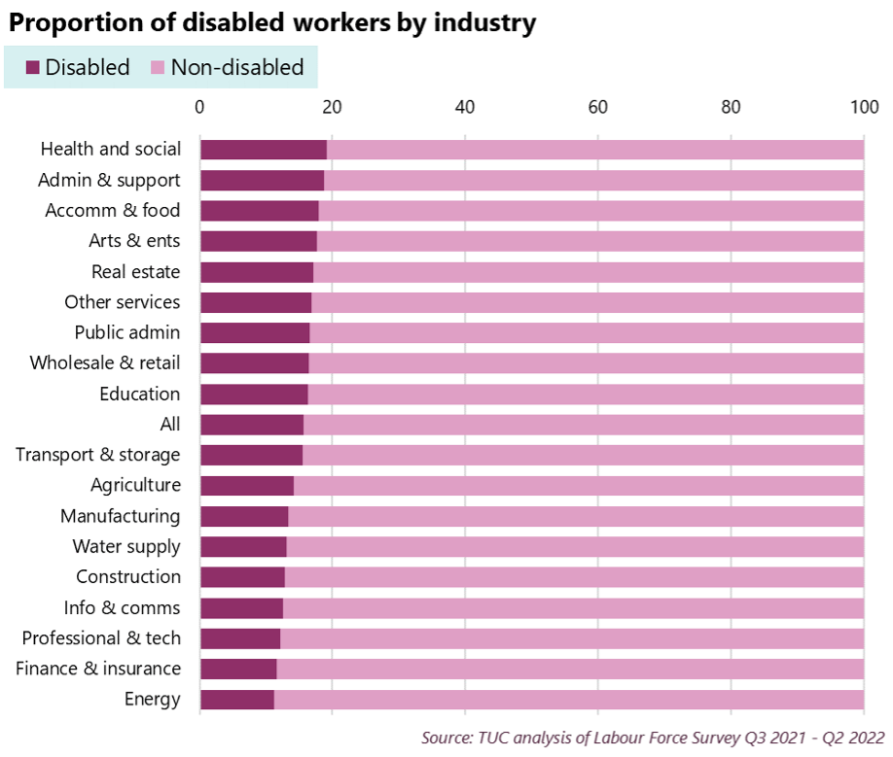

(TUC, 2022)

Appendix B
A mind map that shows the social model of disability.

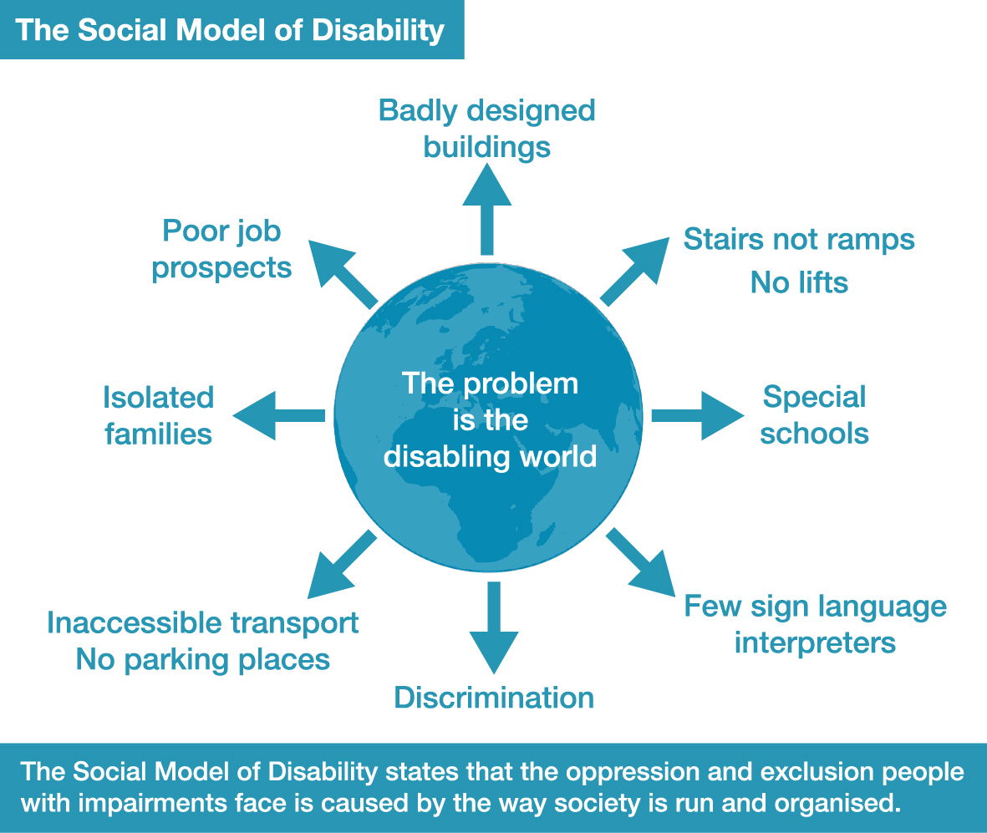

(Inclusion London, n.d.)

Appendix C:
The medical model of disability

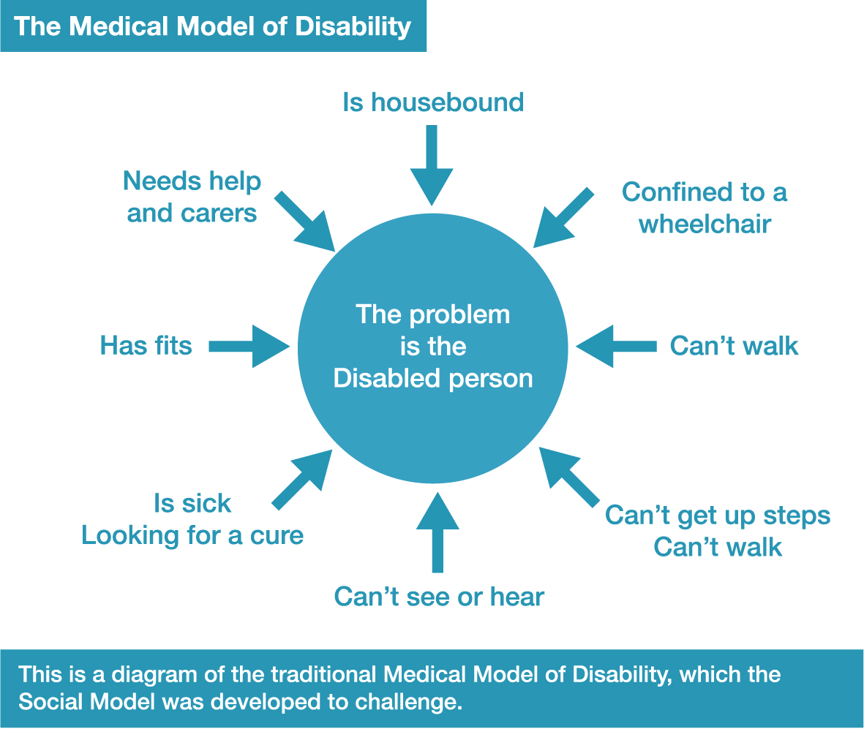

(Inclusion London, n.d.)

Appendix D:
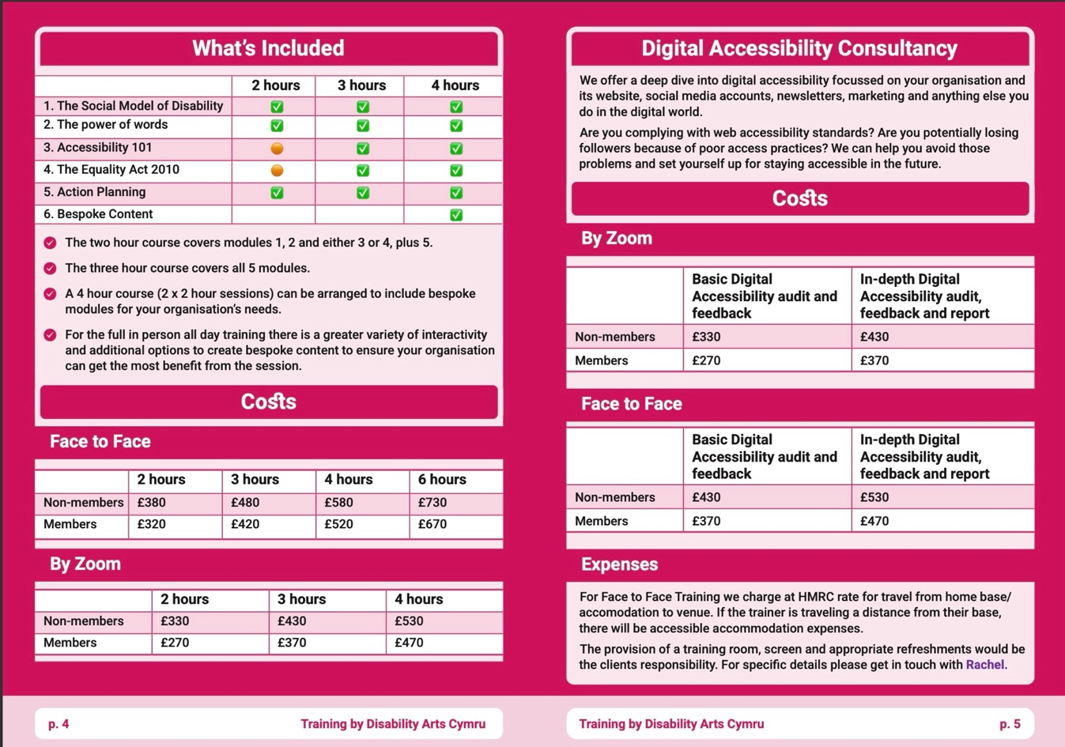
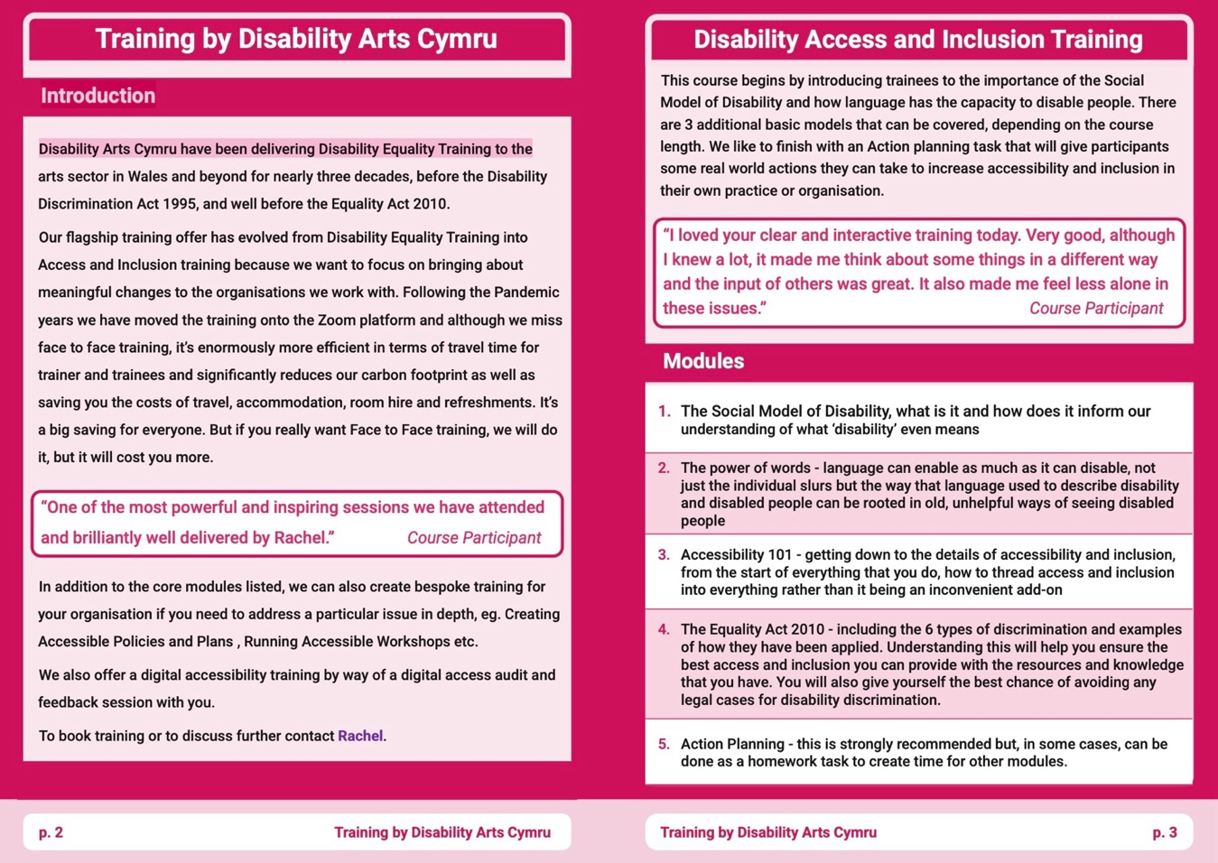
Disability Arts Cymru Training and Consultancy brochure
(Disability Arts Cymru, n.d.)

Appendix E:
RADA and Guildhall’s ‘Reasonable Adjustment’ Policy definitions of discrimination.

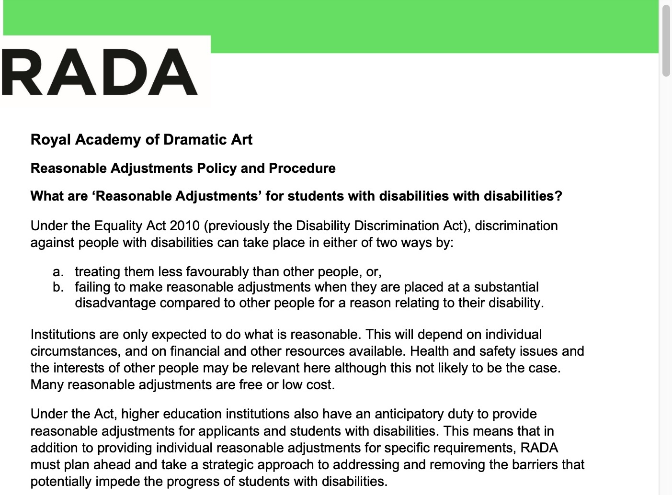
(RADA, 2021)

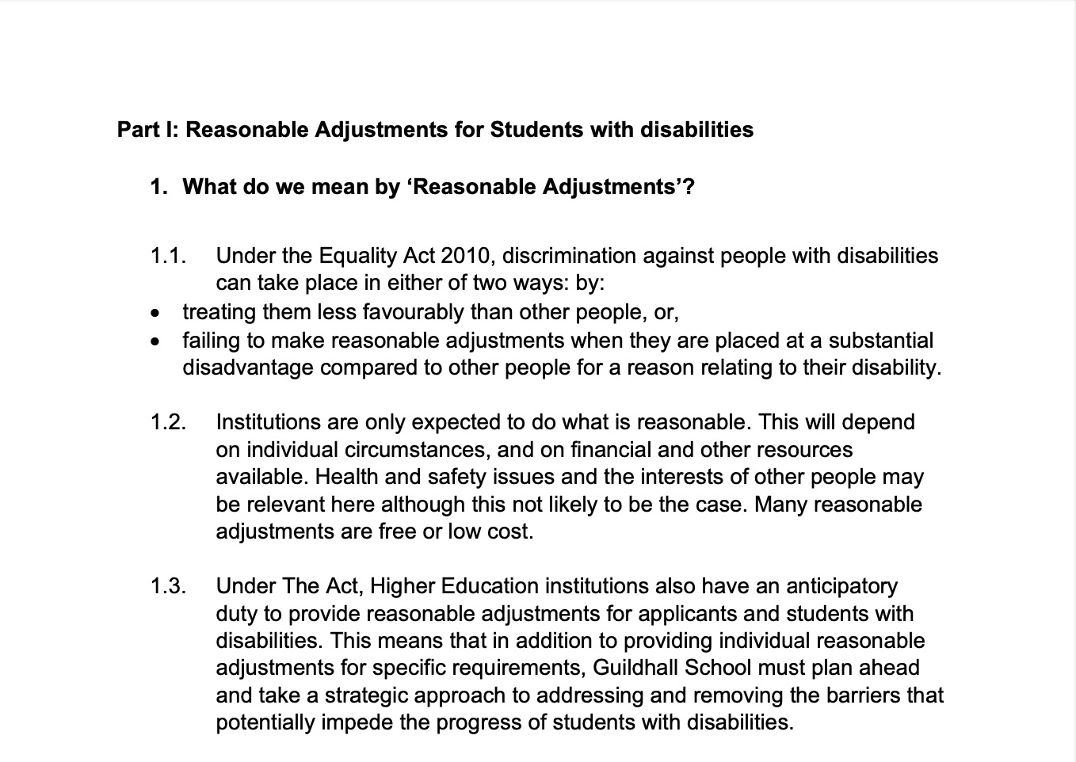
(Guildhall School, 2023)

Appendix F:
RADA and Guildhall ‘reasonable adjustments’ examples.

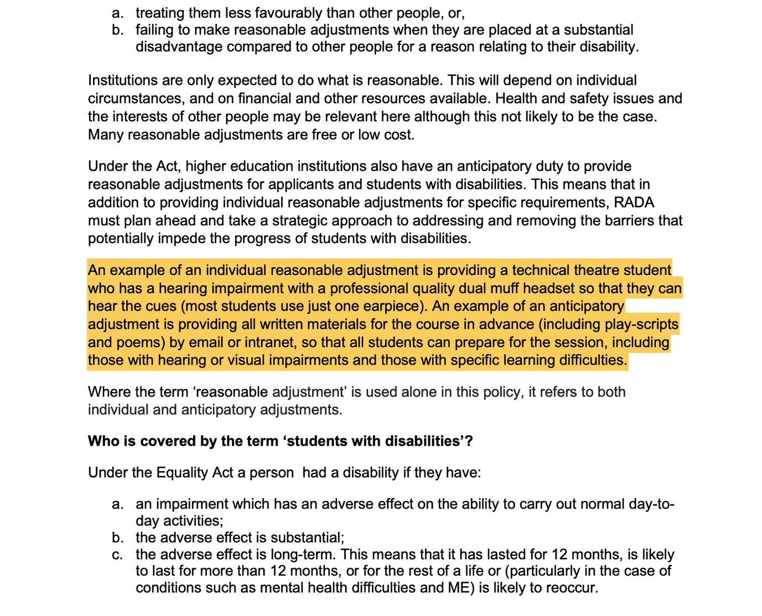

(RADA, 2021)

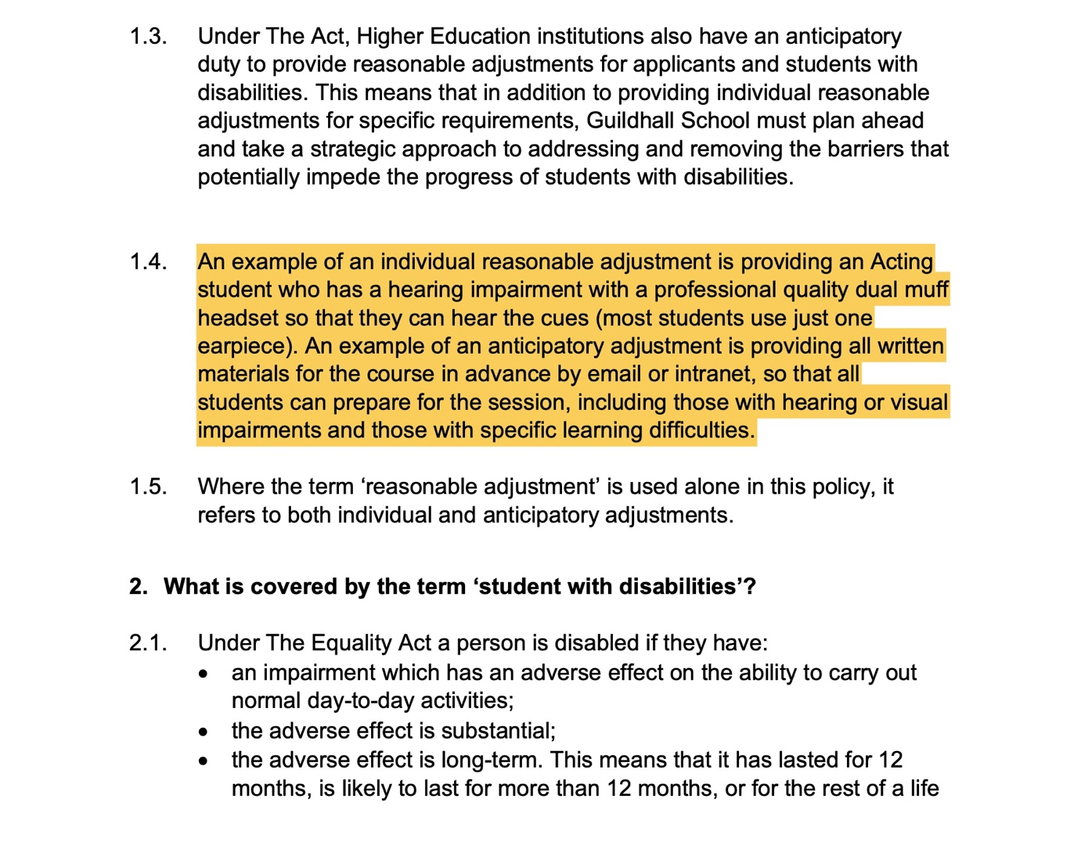

(Guildhall School, 2023)

Appendix G:
Case study example in ‘reasonable adjustment’ policies

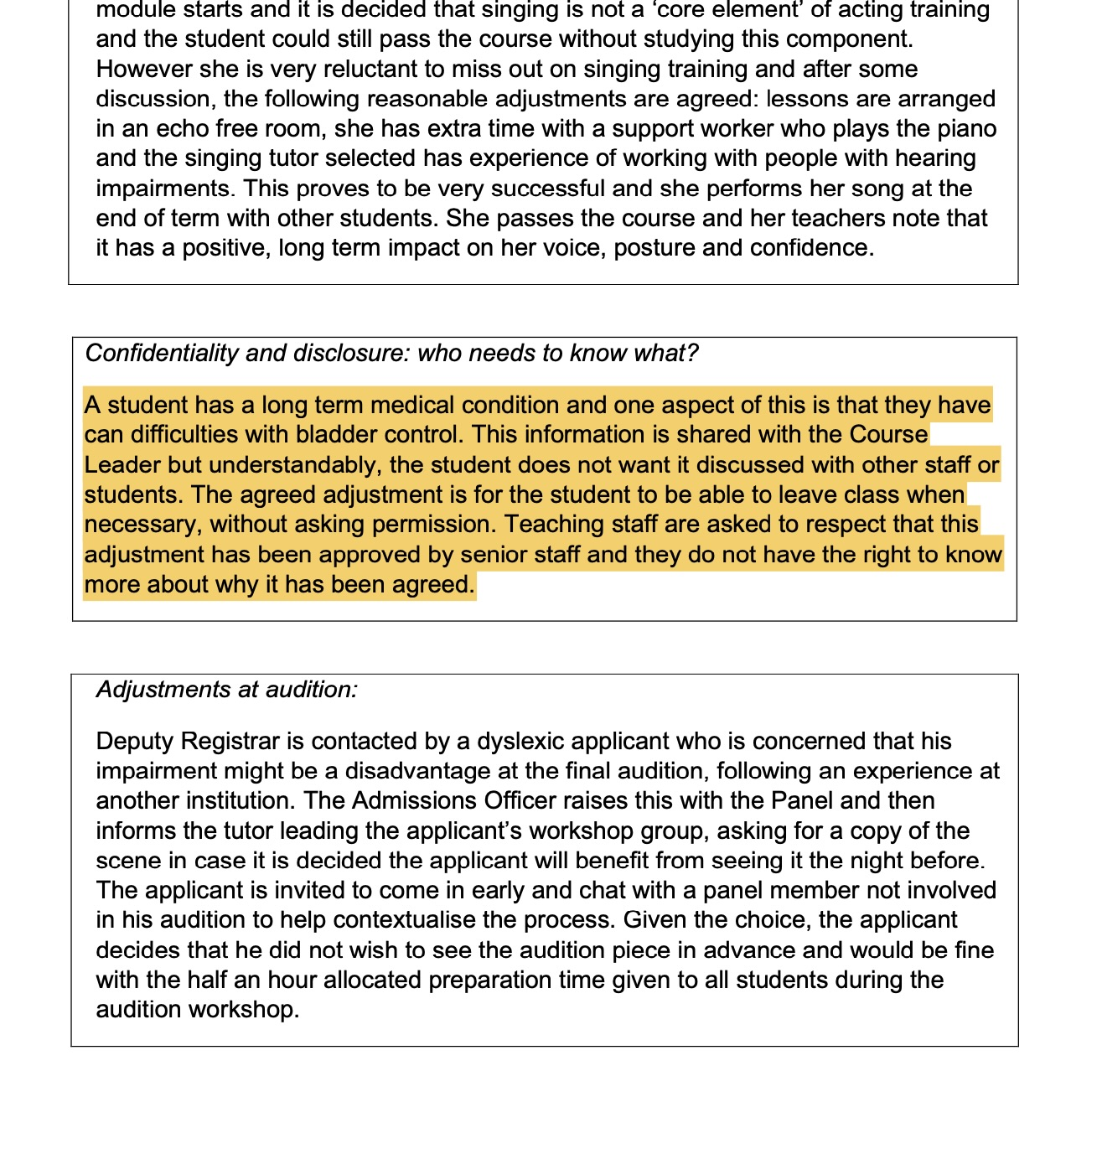(RADA, 2021)

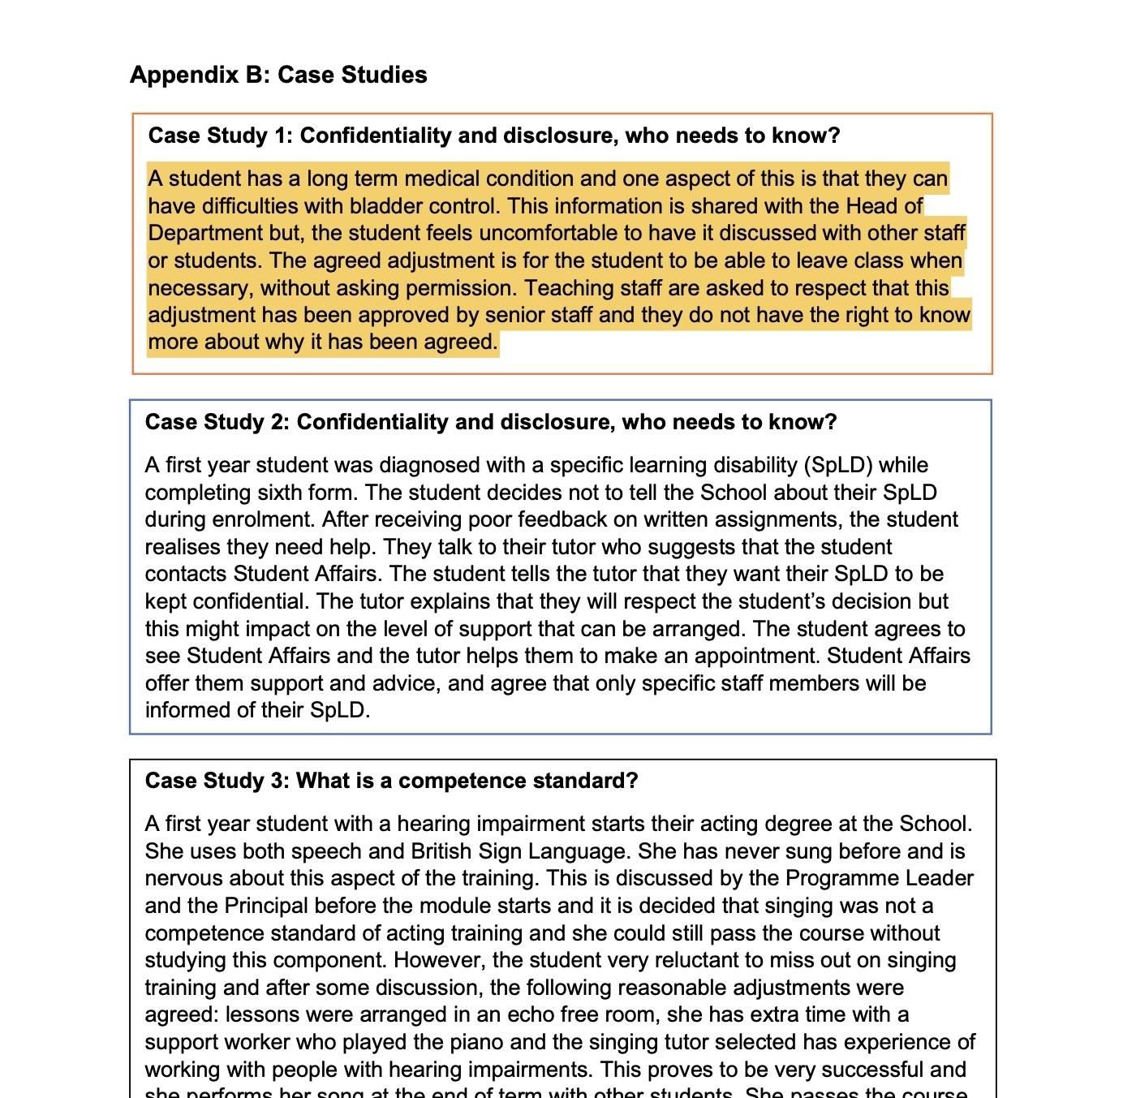

(Guildhall School, 2023)

Appendix H:
London Academy of Music & Dramatic Arts APP Disabled students %

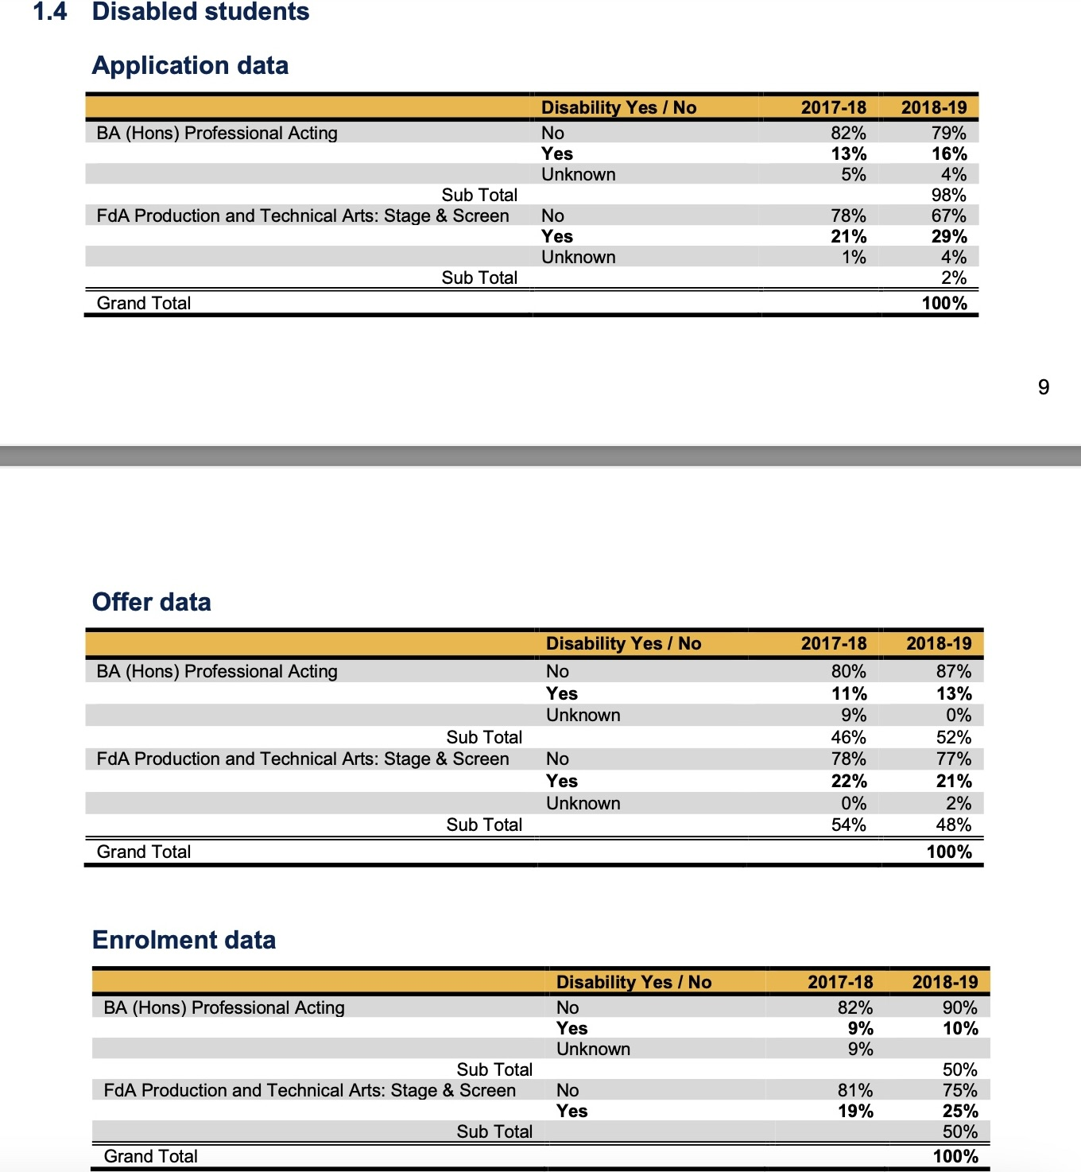

(London Academy of Music & Dramatic Arts, 2019)

Appendix I:
Transcript from Rachel Stelmach’s interview

Interviewer: would you be able to provide an overview of the training that you provide?

Rachel: so the training we do, is kind of centred on the social model. You know about the social model?

Interviewer: Yes.

Rachel: Great. That's good. So that's a good start. So, we talk about the social model, where it came from, what it means, why, you know, it's not our impairments that disable us. So that's important. Also, in one way or another, we talk about language and not sort of individual ways and phrases and why some of them are problematic, but also just the power of words to change people's understanding of what they're looking at. So, I do that by having the same slide three times, but each time it's got different words on it. So, the first one is a support group for, you know, people who've had trauma or something like that. And yeah, poor thing, brave all that. And then the next one it's an inclusive arts group and you know she's inspirational and he's a hero and this and that and the other. And then the last one, the real one is these people are devising a play. Writer, singer, whatever, proper job titles, it's not a pity party, But it's the same picture every time and people don't ever have a problem believing it the first time. The second time, you know, occasionally I'll get someone going, well, isn't that a bit patronizing? You know, anyway, So that's language and the power, the power of words. Then I talk about barriers and what makes up barriers and what you are supposed to do about barriers, and then it all goes into the sort of accessibility 101.

So if it's, for instance, if it's a festival organization, I go through why you need to include access in your funding and all the different steps along the way, the booking forms, the marketing, the site, everything, how you go about doing that.
And then, depends on how long a session it is, as long as we go into some bespoke content, like I was up with the Earth last week and we did a section on access riders.
So how to get the best information out of people and different ways to do it and all of that stuff.
And then the last bit, the important bit, that's all important, but the sort of bit that can potentially make a difference is some action planning tasks.
So, you know, that's usually just people getting into small groups and looking at different things that they can think of.
Now they've just had that training and they're kind of applying it to their context and coming up with ideas of what could be done.
And that, you know, I guess you mean this time which we did have last week because it was a four-hour session.
So, as they fed back to me I compiled that into a document so they've got a 14-step action plan to go over it so that's kind of it.

Interviewer: do you think that there's resistance among both arts educators and organisations to utilise the training services like the one you provide for teaching and working with disabled people?

Rachel: We don't do any kind of like direct selling marketing, anything like that. You know, you can go on our website you can find information about training but generally speaking, they're coming to us we're not going to them yeah and over the years I've been doing it there's definitely been kind of peaks and troughs depending on you know what was going on in the legislation, what was going on like you know the ecology act, the economy, all sorts of things make a big difference to how what people want and if they want to.

Interviewer: Why don’t you market the training courses you provide at DAC?
Rachel: The reason we don’t specifically market our courses, at this point in time, is I think, because it has not ever worked. There have been times when people were employed to do marketing around the courses, I think this happened a year or two after DETonate course had ended and maybe there hadn’t been many courses to go around for the trainees from DETonate. But it didn’t work out. After that person was hired there were so few courses booked that they did them all internally, presumably to recoup the money that they spent on the marketing person. Then we started going into a recession and that was followed by the Equality Act 2010 and nobody wanted single-issue courses after that, they just wanted generalised Equality Training that ticked every box in one go. It has only been in the last few years that things picked up again. During the pandemic, we moved to online training, and I guess there was an element of needing to find something for the still working-from-home workforce to do, so online training was the perfect thing. Even now we’re technically out of pandemic mode, there’s still a lot of call for online training.
So, I guess the short answer is, we tried, it didn’t work and now we don’t really need to – but we could do more.

Appendix J:
Transcript from interview with Kaite O’Reilly

Interviewer: Did you train anywhere before becoming a playwright?

Kaite: I did. I basically went through the whole of education in the so-called mainstream, because I didn’t have a diagnosis until later in my life, basically. I had a crisis in my last year at university where I lost my sight. I had to have a series of operations and so on. But that, so I came, you know, when I was in my last year at the university was when I became aware of being disabled. It made sense of all the things that had gone before in my life, only I’d always been told, you know, because I have a visual impairment as well as a physical impairment, and my sensory impairment is minor, it’s now thankfully you know. But I struggled all the way through education just being told from that kind of medical model perspective that you know, what’s the matter, you know, are you blind? Why can’t you… why are you falling over all the time? Are you really clumsy? It was always about my fault, and then all of a sudden they went, oh, actually, you’ve got a visual impairment, and we went, oh, well that makes sense – my whole life. But when I look back, I saw how discriminatory everything had been from my first day of school when I was a kid, or, you know, right the way through, I really realised that I had been constantly blamed and there had been no facilitation of any need that I might need that I might have myself to be able to participate along with everyone else. So yes, I went through mainstream education and a university, and in my final year, that’s when I was first diagnosed, and I then became involved with the disabled people’s political movement and began to identify as a disabled woman and what an experience that was. [she laughs]
And other training that I've had since then was through different organisations that gave training workshops. So in Wales, there used to be an organisation called the Centre for Performance Research, CPR, that I was actually also one of the directors on the board and I did a huge amount of training with them in (im)practical theatre. But at that time, I was still just looking after myself and working out what I needed or where I needed to be in the room etcetera to be able to access the experience as much as possible. It was still always my responsibility. (There was) nobody there facilitating, we certainly didn’t have any idea about an idea of you know, any access riders etcetera.

Interviewer: do you believe there is a reluctance in disabled people to apply for arts education courses because of the lack of accessibility?

Kaite: Absolutely 100%. And on the other side of that, I know a huge amount of phenomenally talented disabled and deaf people who kept insisting on applying and auditioning because they said this is my right to do this. So for example, a friend of mine who sadly died, Sam Boardman Jacobs in his 60s did an MA in choreography at Laban. He fought very hard to get in on the course and then he struggled all the way through because there weren’t accessible studios etc etc. but he got through and he graduated, and they probably learned a lot from his presence. And I think I mentioned in the workshop, and famously Sophie Stone, who is a wonderful deaf actor that I work with a lot, she’s a long-term collaborator of mine, she had to apply many times to RADA before they finally accepted her. Now they crow the fact that they trained her, but they didn’t accept her, I think it was three of four times and so you’ve got both of those, we’ve got both people being reluctant to apply because it’s just like well they’re not going to have any facilities for me, it’s going to be inaccessible, it’s just going to be a struggle all the way (so) why bother. But then you will have the counter of that which is those who are more politically minded and activist as well who will say I am actually going to insist that they give me the right to be considered for this. So, I think it’s a point for two sides.

Interviewer: I’ve done a lot of research into the disability policies of these big arts education institutes within London, well, within the whole country and I’ve found that a lot of them will give examples of what they’ve got and what they do to make these places accessible. But when they give examples of what they’ve done and how they’ve done it, they’re copied and pasted into every single policy.
Kaite: it’s, yeah, it’s problematic, it’s suspect…I used to teach myself at a university, and I know that there are often people who have a really great will in the world to be more inclusive etcetera. But sometimes you’re in an old building or you don’t have the power or the say to do things. And I think unfortunately within education in particular, in training, the ways that the administration has been taken away from talented staff and given extra roles to the teachers themselves. I think it’s a massive mistake, but I think people are barely keeping their heads above water anyway in education. I hate to say it but you know, I work a lot in education most of my friends are actor trainers or involved in some way in universities and they're all struggling so it's a very very very difficult position And I wish it was as easy to turn around and be able to go, here's the baddies and here's the goodies.
And unfortunately, it's never that polarized. But massive changes have got to happen, it's a really poor state of affairs but it's better than most places.

Interviewer: do you think it's possible to make an art Institute Accessible for all disabilities?
Kaite: I like to think so, I hope so. I've been involved with different experimentations that have been happening in Singapore. I've got a lot of colleagues, I work in Singapore quite often with access past productions. And they, for example, do the takeover of their museum, the National Museum of Singapore, where they had performances, they had installations, they had all sorts of interesting events going on.
There were short films that were made with disabled and neurodivergent artists that I did the audio description or creative audio description. They really kind of started to rigorously interrogate, you know, what might be needed or what could be possible in a public cultural institution like that to make it accessible.
So you know I know for a long time people have tried and been experimenting with different sensory points you know with sound, with texture, with things we can feel, or things that we might smell to enable an immersion into whatever the artwork might be.
Sometimes it's competing so you have I think that that requires consideration as well that there may be certain lighting that was brilliant and required for maybe people who are deaf or have certain visual impairments might be incredibly off-putting for other people that perhaps a neuro, atypical, etc.
So it's always, I think it will constantly need to be curated and considered to make sure that there is some kind of easy flow between.
But I, you know, I hope so. I think also I'm curious as he was going to happen at Battersea Arts Centre with Tourette's hero, with Jess Tom and her, you know, some of the developments that they've been doing there, trying to make it a relaxed performance area, to trying to actually challenge what a cultural institution might be like, what's available and what's possible, you know, with quiet rooms or, you know, kind of other places to rest or, you know, other considerations that they're exploring. So I'm very intrigued to see what will happen there. But I do think that the more creative and the more willing we are to explore the better the cultural provision is for everyone. Because it's exciting, It really is. You know, I wasn't able to be in Singapore during the takeover of the National Museum, but you know, seeing the friend, you know, doing it on Zoom or, you know, having videos that But seeing the friend doing on Zoom or having videos that try to share with me the experience or having me there, just seeing people who are not going because of any kind of particular access requirement. I said, you know, the kids are having a fantastic time and, you know, this, the inventiveness and the generosity and the experience that we could try and create, I think it's only limited by our imagination.

Me: So in our emails, you said about the research and development opera that you were doing and I just wondered if you could talk about that a bit more.

Kaite: Right yeah so basically, it's in its kind of third iteration. I wrote a performance text called The Nine Frida’s, which was about Frida Kahlo, and reclaiming her as a disability icon and as a queer icon. And that was a performance text, which My colleague, Gareth Churchill, who's a disabled composer, is based in Cardiff. He got some funding from Unlimited, which is a disability arts commissioner, which their mission is to embed disability arts in the cultural sector like never before. And he got some funding to start exploring whether it was possible, viable, to change it into an opera. So we've had a little bit of time together, we were working with all disabled musicians and singers and neurodivergent singers as well, which was fabulous…. So something that he was also doing as part of our R&D was he was working with a new instrument which is called the clarion. And the clarion is basically was developed it's it's a music it's it's sort of software that you can actually control through eye movement. So it was going to be useful. It's extraordinary. So he was using and experimenting this new instrument called a clarion, which came from Para Orchestra as part of our R&D. And he was doing it through, basically, it's almost blobs on the screen. And he would slide a finger and move it around. And that is the way that would bring in different notes, timbre, different kind of intensity and impact. So he was bringing in this new instrument to the experiment that we were making with violin and harp and human voices.

Appendix K:
Transcript from the interview with Ffion Harries.

Me: What adjustments have been made to support your learning?

Ffion: So I've had help from the DSA to get equipment to help with my learning, I've also been given a learning support tutor who I see most weeks for mainly an hour, sometimes an hour and a half. And I do get a bit of extra help, a bit of extra explaining when I do work as long as I, you know, as long as you ask, you seem to get really. This university is one of the top universities for help with dyslexia and ADHD and neuro divergencies and getting that extra help with DSA and getting it through as quickly as possible, so they’ll help you with that.
Me: What challenges do you think that well both neurodivergent and physically disabled classical singers often face in terms of representation in classical music?

Ffion: Well I do feel, I found out the other day there are a lot of singers who are neurodivergent and I didn't think that there would be because it's not said. Although they have it they're frightened of the sort of the comments they're going get like oh I can't believe you've done that that's amazing and you have all these challenges when they just want to be treated like a normal person for the singer, for the voice they had not the like not the challenges that they've had to overcome to be able to be that good. I think that when you like... If say if you're having an audition maybe or you sign up for a job and they see you know that you have a disability and it's on somewhere I think they go immediately to judge and just to make assumptions before you even get there and before they hear your voice.
So automatically they've got a question mark next to your name, sort of thing.
I think that's the main challenge is because of things like, well learning and stuff. That may take more time than most, but it gets done in terms of staging and stuff. If you're working with the right director it can be quite easy, in my experience.

Me: What barriers do you believe exist that might limit the participation of disabled classical singers in both the profession and in institutes?

Ffion: The stigma of it? You don't really see that many although there are like there are you know companies that are you know, especially for disabled people and people who have neuro divergencies and things. It’s also the mindset that it's hard to do that when really it's not. They could quite easily, instead of having opera companies and performance-based companies are especially for and aim towards including disabled people then surely why are they not integrated into like the main sort of mainstream like you know opera companies at WNO and the Scotland one, I can't remember it now, English national opera, I don't understand it can be quite easy to make those small adjustments and why they're different, I don't understand why they're different companies so I think that's, I think the mindset is a barrier

