Blog Submission: Crisis Student work
Student Name: Karla Flores Feltrin
Student ID: 2503091
Name of Students in Group:
Beth Wooley 2517506
Evelyn Jeannette Ramirez de Martinez 2520056
Karla Flores Feltrin 2503091
Omrakha Hassan 2500918
Selma Shnnib 2332494
Link to Individual Blog / Social Media Site: https://www.instagram.com/crisis.studentwork/
Words included in Individual’s Blog (including reference list): - Copy and paste the words from your Blog / Social Media site
Word count: 1645
Post 1:
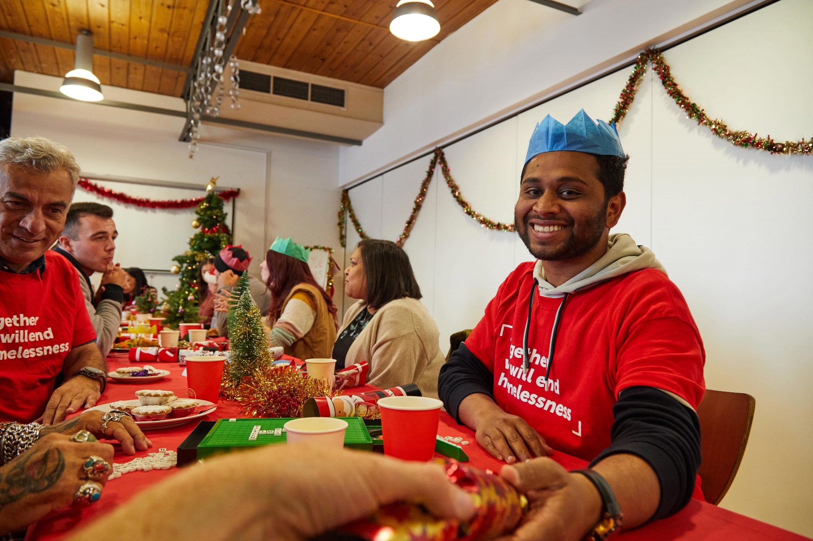
🎄A Season to Give, A Time to Belong🎄
Our volunteers come from diverse nationalities, ages, and genders, but each with the same motivation: to help all those who need to find a home.
Together, our volunteers cook, clean, listen, and share moments, bringing comfort and hope to all those who seek out Crisis, especially during the most difficult time of the year.
Volunteering makes it possible for lives to be transformed, and this is not only for those who receive help but also for those who are offering help.
You too can be part of this story by registering as a volunteer and helping to transform thousands of lives.
Click the link below and discover how you too can help.
We have several types of volunteering available, and surely one that suits you.
✨✨Join Crisis this Christmas and be part of something truly meaningful: https://www.crisis.org.uk/get-involved/volunteer/

POST 2:
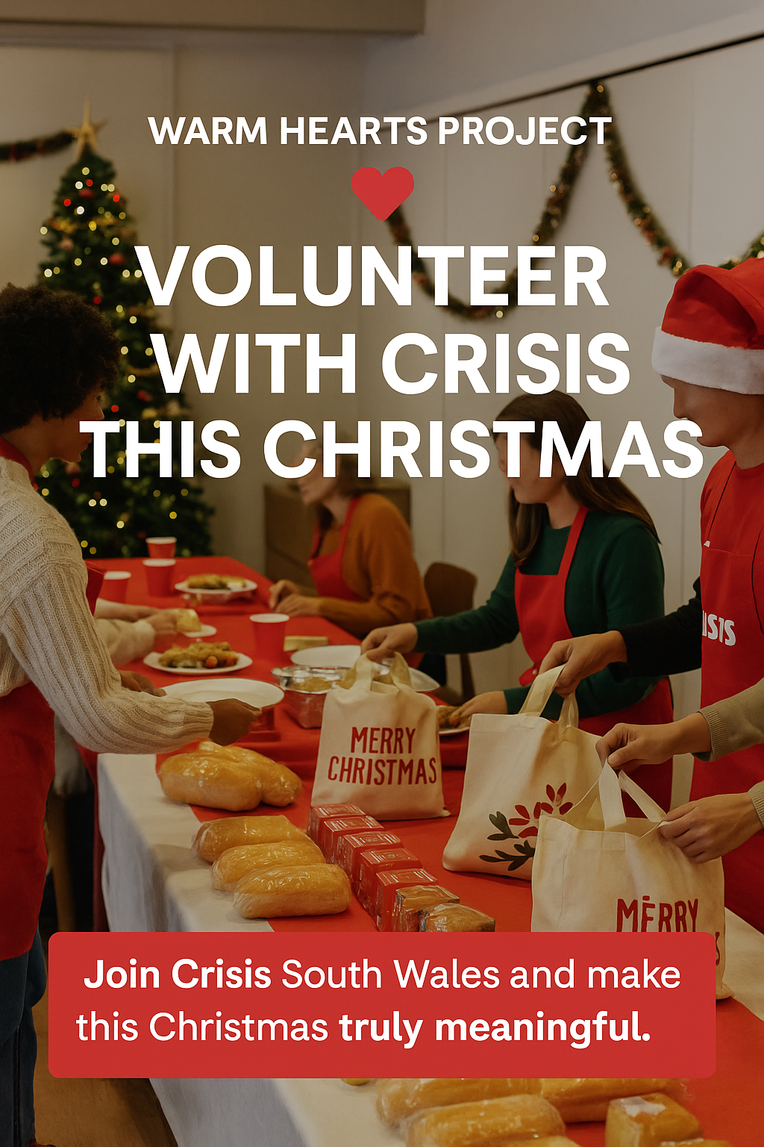
🚨🚨Volunteer Opportunities During the Christmas Crisis – South Wales🚨🚨
This Christmas, make a difference in the lives of those rebuilding their lives after homelessness. Crisis South Wales is inviting you to help us transform lives by joining our volunteer community.
📍In Swansea, Neath, and Port Talbot, we offer support and activities throughout the year — but December is when the work increases the most, and every volunteer makes a difference.
Every year, volunteers come together to create a welcoming, safe environment where the hope of those in need is renewed, and it is in this environment that homeless people can share meals, laughter, and create projects to restructure their lives.
‼️‼️Click the link and join Crisis South Wales this Christmas.‼️‼️
https://www.crisis.org.uk/get-involved/volunteer/volunteer-at-christmas/volunteer-at-christmas-in-south-wales/.
You have the power to change the world.
The connections you make can change lives — including your own. 🎄🎄
POST 3:

🎇🎇Cards that Change Lives🎇🎇
🎄Christmas cards, a simple purchase that makes all the difference.
This Christmas, take the opportunity to send your message to those you love and at the same time help a very important cause.
By buying your Christmas cards, you are enabling thousands of homeless people to have shelter, meals and support.
Every £5.99 spent brings warmth, affection and hope to someone who needs it most.
ℹ️ In 2024, the sale of our cards raised thousands of pounds, demonstrating that small gestures make a big difference in the lives of those in need.
This Christmas, you too can make a difference.
Click on the link below and secure your cards today:
https://shopfromcrisis.org.uk/collections/charity-christmas-cards.
Because every card carries hope. 🎁💝
POST 4:

🎆🎆The Meaning Behind Every Card 🎆🎆
A Christmas card is more than a message — it’s a moment of connection. 🎄
By purchasing your Crisis Christmas cards, you share affection and love not only with those you love, but with all those who are in a vulnerable situation.
By purchasing these cards, you are making it possible for thousands of people to have a safe, warm place and feel loved again.
Every purchase ensures that these people have a plate of food and a safe place to call home.
This year, let your words reach even further, from your heart to the hope of someone in need.
Christmas in Crisis is only possible thanks to all the help we receive, and you can be helping to transform thousands of lives during this time of year when people feel forgotten and even more vulnerable.
In addition to Christmas cards, there are also various gifts available in our online store.
Come join us and help us transform lives.
🚨Buy your card today at https://shopfromcrisis.org.uk/collections/christmas.
🎄Small cards. Big changes. 🎁
POST 5

✨✨The Power of Volunteering✨✨
As soon as the cold December nights arrive, Crisis volunteers help people experiencing homelessness, offering hope and warmth to those in need. Every year, thousands of people come together to serve meals, donate clothes, offer their time and, most importantly, help remind these people that they have not been forgotten.
Volunteering with Crisis is much more than donating time; it’s donating kindness, love and hope.
Last year, more than 4,300 volunteers helped open temporary centres across the UK, transforming empty spaces into safe and welcoming homes, full of love and Christmas spirit. And this was only possible thanks to people like you.
🌲🎅This Christmas, come be a part of it by becoming a volunteer.
Sign up at www.crisis.org.uk/volunteer.

Evaluation of marketing theory that underpins your blog: e.g. how your blog helps to market your charity, the target audience, the objective of each blog post, how you engage the target audience, the marketing metrics to evaluate each blog / social media post.
Introduction
This evaluation aims to discuss the Christmas marketing campaign for Crisis, which aims to help homeless people. In this project, we used Instagram as a means of disseminating this campaign. According to Mangold and Faulds (2009), social media plays a key role in modern promotional strategies, acting as a tool for communication and engagement. This campaign aiming to raise awareness about homelessness and encourage the public to help this cause through volunteering and purchasing Christmas cards. We chose this platform because it has an interactive visual, aiding in dissemination and facilitating emotional engagement, as explained by Kaplan and Haenlein (2010) who highlight the potential of social media to connect organisations with their audiences. The posts were written in a clear, motivational way, and without being too lengthy so that the target audience would not lose interest. This evaluation will help analyse how the theory discussed in class can be applied to the planning, development, and execution of projects, focusing on the marketing mix, audience segmentation, and emotional branding.
Planning and Audience Analysis
The campaign was developed to primarily reach individuals aged 18 to 40, residing in South Wales. This group was chosen because they are active on social media, which aligns with Kaplan and Haenlein’s (2010) argument that these platforms are widely used by younger generations. They also have greater awareness of the impact of homelessness on human life and are more likely to respond to calls to action, often becoming emotionally and financially involved.
The Christmas campaign was chosen to promote generosity and human connection at this time of year, when people tend to be more welcoming, allowing the campaign to reach a larger number of people. Each post was developed with accessible language instead of robotic and corporate messages, giving the campaign a more human voice. The posts were intended to reach the readers' emotions, encouraging the desire to contribute, belong, and make a difference while highlighting the incredible work that Crisis does as a trustworthy organization.
Application of Marketing Theory
Each post was developed based on the 4Ps marketing model. The product of this campaign was both physical and emotional, physical in the form of Christmas cards and emotional through the opportunity to help through volunteering. The price was not financial, but symbolic, representing the time, care, and empathy that each person could offer by becoming a volunteer. The chosen channel was digital because, through social media, organisations can reach their target audience efficiently and maintain an open and consistent communication channel. Finally, the promotion was applied through emotional narratives with visual resources and calls to action that allowed and contributed to immediate participation.
In addition to the marketing mix, the campaign used the principles of emotional branding suggested by Kotler and Keller (2016), who argue about the importance of creating emotional bonds between organisations and the public. All publications about volunteering helped in human connection and provided a purpose, allowing empathy and a sense of belonging to be key for people to become volunteers. The Christmas card publications demonstrated that each person could help make a difference even with a small purchase, generating a significant social impact; that is, anyone who helps, regardless of how, can transform lives.
This strategy also reflects the concept of social marketing. Kotler, Lee and Rothschild (2006) explain that social marketing aims to influence behaviours that benefit individuals and society. In addition, Andreasen (1995) highlights that social marketing focuses on creating behaviour change that contributes to social good rather than commercial profit. This aligns with the campaign’s goal to promote solidarity and societal involvement in causes as important as the fight against homelessness.
Execution and Engagement Strategy
Each post aimed to follow a clear and impactful structure, suitable for Instagram, containing a striking title, a narrative, and a call to action. Each image used was designed to create a presentation that symbolized compassion, diversity, and unity. The captions were approximately 180 to 200 words long, ensuring sufficient information without being lengthy, trying to avoid any loss of interest on the part of the readers.
Calls to action such as "Join Crisis this Christmas" and "Buy your cards today" were part of all posts, allowing for engagement. Research by Waters et al. (2009) shows that non-profit organizations are increasingly using social media to encourage stakeholder interaction through clear calls to action and accessible links. Each post provided links that directed to the Crisis website, allowing for tracking through clicks. If applied to a real-world scenario, we could obtain results through engagement metrics such as likes, comments, and shares.
The colour palettes, and consistency in tone and messaging, allowed for the construction of a brand identity aligned with existing Crisis UK standards, demonstrating an integrated marketing approach that ensured all messages, regardless of the platform used, had the same purpose.
Reflection and Learning
Developing these posts helped me improve my understanding of communication by having the opportunity to see how marketing theory and creative practice enable the success of a campaign. I also learned that marketing for non-profit organizations is based on authenticity and has higher returns when it reaches the emotions of the reader.
Applying theoretical frameworks, such as the marketing mix and emotional branding, helped structure decisions about target audience, message, and design.
Doing this group work allowed me to develop my time management skills, requiring coordination within the group and sharing of ideas. It was my first time undertaking marketing-focused work and creating posts that were visually appealing and comprehensive without being lengthy, while also expanding the text for academic purposes.
Overall, this campaign deepened my understanding of how social marketing can inspire significant behavioural change. Andreasen (1995) demonstrates that marketing is a powerful tool and can generate awareness, participation, and help provide hope for people experiencing homelessness.
Reference List
Andreasen, A.R. (1995) Marketing Social Change: Changing Behavior to Promote Health, Social Development, and the Environment. San Francisco: Jossey-Bass.
Kaplan, A.M. and Haenlein, M. (2010) ‘Users of the world, unite! The challenges and opportunities of social media’, Business Horizons, 53(1), pp. 59–68.
Kotler, P. and Keller, K.L. (2016) Marketing Management. 15th edn. Harlow: Pearson.
Kotler, P., Lee, N.R. and Rothschild, M.L. (2006) Social Marketing: Influencing Behaviors for Good. 3rd edn. Thousand Oaks: Sage Publications. Available at: https://books.google.co.uk/books?id=YUX8tqzI5OAC
Mangold, W.G. and Faulds, D.J. (2009) ‘Social media: The new hybrid element of the promotion mix’, Business Horizons, 52(4), pp. 357–365.
Waters, R.D., Burnett, E., Lamm, A. and Lucas, J. (2009) ‘Engaging stakeholders through social networking: How nonprofit organizations are using Facebook’, Public Relations Review, 35(2), pp. 102–106.

