Title: Performance Analysis & Data Acquisition
Student number: 2403675
Module details: ACHA5004 Motorcycle Dynamics
Total word count: 2691
Submission date: 29/ 03/ 2026

Table of Contents
The Comparison of Three Riders Around 1 Lap of Donington Park 3
Speed Trace: Rider Comparison 3
Front Brake Pressure Trace: Rider Comparison 4
Throttle Position Trace: Rider Comparison 5
Speed, Throttle and Brake Trace: Rider Comparison 6
Speed vs Throttle: Rider Comparison 7
Speed vs Front Brake Pressure: Rider Comparison 8
Overall Rider Comparison and Performance Insights 9
Conclusion 9
Data Acquisition System Design – Kawasaki ZXR750 10
System Overview 10
Sensor Selection 10
Data Logging and Sampling Rates 11
Wiring and Installation 11
Real World Considerations 11
Summary 12
Calibration, Setup and Testing 13
Analysis of Data and System Evaluation 14

Table of Figures
Figure 1 (multi rider speed vs distance trace) 3
Figure 2 (multi rider front brake pressure trace) 4
Figure 3 (multi rider throttle position trace) 5
Figure 4 (multi rider speed, throttle position and brake pressure trace) 6
Figure 5 (multi rider speed vs throttle position) 7
Figure 6 (multi rider speed vs front brake pressure) 8

The Comparison of Three Riders Around 1 Lap of Donington Park
The performance of three professional riders, Simon Crafar, John Hopkins, and Garry McCoy, was examined using telemetry data from a single representative lap at Donington Park. Multiple channels were used, including speed, throttle position, front brake pressure, and derived XY plots, to compare their riding styles and identify clear trends and possible areas for improvement. It should be noted that the analysis is based on a single representative lap per rider, limiting the ability to assess lap-to-lap consistency.

Speed Trace: Rider Comparison
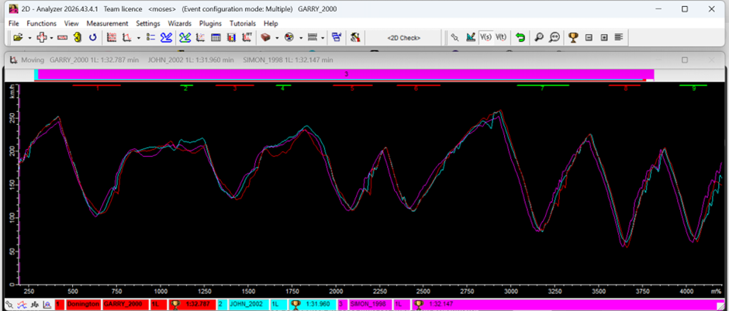
Figure 1 (multi rider speed vs distance trace)
The speed traces provide a good overall picture of how each rider tackled the lap and approached the corners. One noticeable difference is that Simon Crafar consistently carries slightly lower speed into most corner entries than the other two riders. This suggests he adopts an earlier braking strategy, trading some entry speed for better stability and control. Simultaneously, he returns to the throttle sooner on corner exit, which fits a classic “slow-in, fast-out” style.
By comparison, John Hopkins reaches the highest peak speeds on the straights. This indicates either later braking, better speed maintenance through corners, or smoother inputs that reduce rolling resistance. Regardless, he makes effective use of the acceleration zones and carries stronger speed between corners.
Garry McCoy’s speed trace is more uneven, with greater variation in both entry and exit speeds. He does not always reach the highest top speed, but his profile points to a more aggressive, less conventional approach, likely involving more rear tyre slip and active bike positioning.

Front Brake Pressure Trace: Rider Comparison
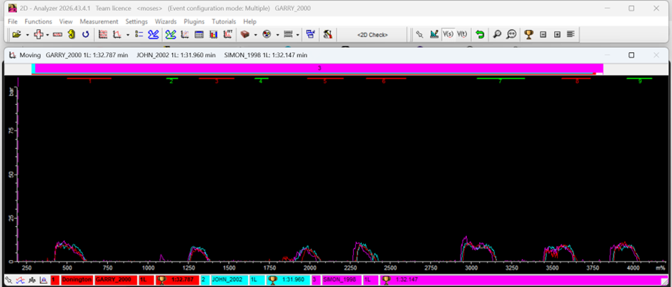
Figure 2 (multi rider front brake pressure trace)
The front brake pressure data reveals quite a lot about each rider’s braking strategy, confidence level, and how they manage weight transfer under deceleration.
John Hopkins brakes later than the others, with brake pressure building closer to the corner entry points. His traces also show high peak pressures and a very quick initial application. This suggests strong confidence pushing close to the limit of front tyre grip.
Simon Crafar initiates braking noticeably earlier across most corners. His pressure build up is more gradual and progressive, although he still reaches quite high peak forces. This supports the observation of a more conservative entry strategy combined with strong overall control.
Garry McCoy’s braking style stands out again. He builds brake pressure more gradually and generally uses lower peak forces, which suggests a smoother, less aggressive approach. However, he also stays on the brakes for longer, indicating that he is taking a different line into the corner, perhaps a tighter trajectory, which changes the bike’s grip limits as he turns and requires him to decelerate more gradually throughout the corner.

Throttle Position Trace: Rider Comparison
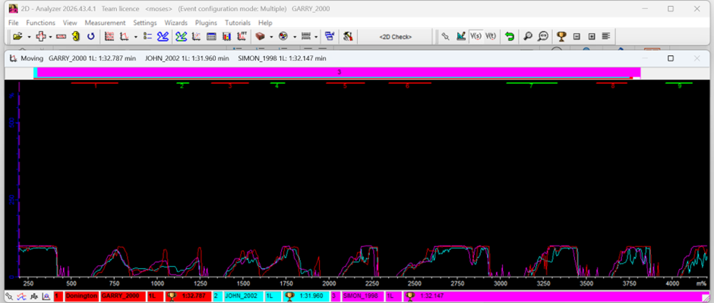
Figure 3 (multi rider throttle position trace)
Throttle position is a strong indicator of how riders manage traction and corner exit performance.
Crafar returns to the throttle earlier than both Hopkins and McCoy, further reinforcing his “slow-in, fast-out” approach, with earlier braking setting him up for earlier acceleration. His throttle inputs appear controlled, with a steady build rather than sudden jumps, indicating effective traction management.
Hopkins has the smoothest throttle trace of the three. Interestingly, he rarely closes the throttle completely, even mid-corner. He appears to maintain small amounts of throttle, likely to avoid adverse suspension characteristics, weight shifts and distribution, as the bike squats and accelerates. This seemingly refined technique contributes to his higher straight-line speeds and consistent drive from corners.
McCoy’s throttle behaviour is more aggressive but less consistent. Rapid fluctuations and high throttle openings held for longer, closer to corner entry, suggests he is often working at or beyond the rear tyre’s grip limit and partially relies on controlled slides of the rear wheel.

Speed, Throttle and Brake Trace: Rider Comparison
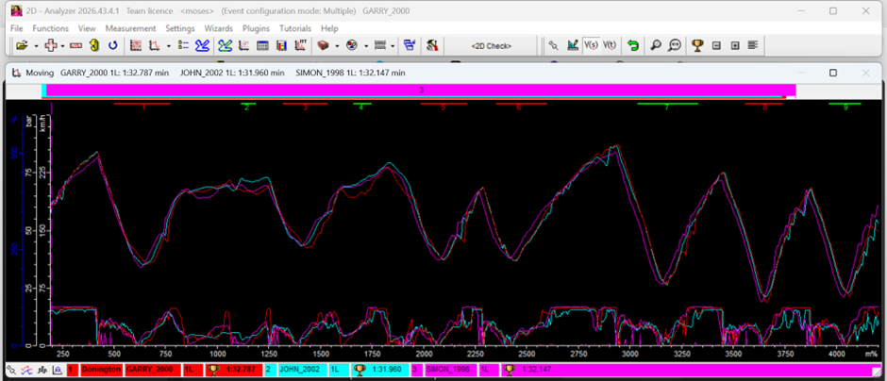
Figure 4 (multi rider speed, throttle position and brake pressure trace)
When all three traces are examined together, there differences in riding technique become clear.
Crafar maintains a clear separation between braking and throttle, either one or the other, with little overlap. This could indicate a more traditional, stable style focused on technique and timing. The early brake and throttle combination allows an earlier transition into acceleration and reduces the chance of instability, compared to aggressively engaging the throttle later in the corner.
Hopkins shows much smoother blending between braking and throttle. In places he even maintains a little throttle while still easing off the brakes, indicating that he is slower to transfer weight and load, with a less technical more playful cornering style. This may be what allows him to keep higher speeds throughout the lap.
McCoy has more overlap again between the inputs with noticeably sharper transitions. His style appears more dramatic with his inputs, and thus the bike is likely becoming unsettled and subsequently corrected mid corner. While this can allow for quick directional change and aggressive cornering, it likely comes at the cost of consistency, as seen across his corners on the lap, alongside higher tyre wear.

Speed vs Throttle: Rider Comparison
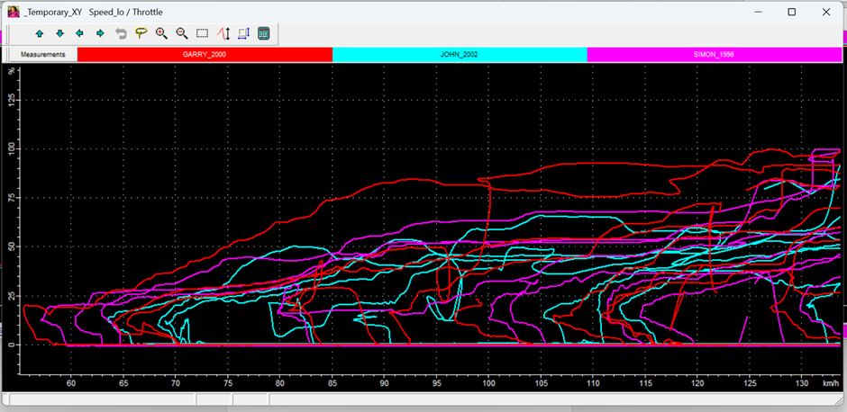
Figure 5 (multi rider speed vs throttle position)
The throttle vs speed XY plot shows how each rider applies power relative to their speed, especially on corner exit.
McCoy’s trace starts earlier and covers a wider speed range, with a steep and irregular shape that points to aggressive throttle inputs and likely wheelspin. This correlates with his erratic throttle trace and confirms a riding style that regularly tests traction limits.
Hopkins’ plot is smoother and more progressive, with a steadier increase in throttle as speed builds. This suggests careful power delivery and efficient use of available grip, reinforcing the image of a highly refined and repeatable technique.
Crafar’s trace is less steep overall. Although he applies throttle relatively early, he does so gradually to avoid upsetting the bike. This further supports his more controlled, conservative approach to corner exits.

Speed vs Front Brake Pressure: Rider Comparison
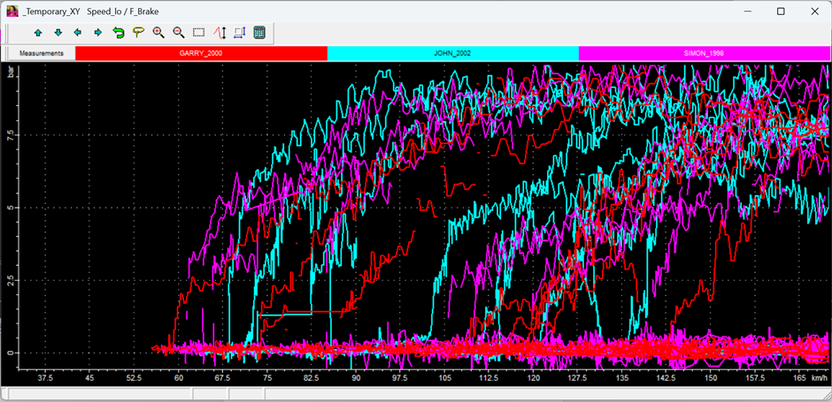
Figure 6 (multi rider speed vs front brake pressure)
The brake pressure versus speed plot highlights differences in how intensely and how early each rider brakes.
Hopkins shows a sharp rise in brake pressure while still at higher speeds, followed by effective modulation as speed drops. This matches a late, aggressive braking style.
McCoy’s pressure builds more slowly with lower peaks, but the trace stretches out longer, confirming extended trail braking into the corners.
Crafar sits somewhere in between moderate initial application but still reaching relatively high peak pressures. His braking appears more controlled than Hopkins’ yet firmer than McCoy’s, suggesting a balanced approach between aggression and stability.

Overall Rider Comparison and Performance Insights
Across the different telemetry channels, the three riders clearly show distinct styles and strategies.
Simon Crafar used a methodical, controlled approach with earlier braking, lower entry speeds, and earlier throttle pick up. His slower entry and faster exit method promotes stability and consistency, though it could potentially limit lap time as the acceleration phase isn’t aggressive enough.
John Hopkins comes across as the most efficient and polished of the three. Later braking, higher top speeds, and very smooth throttle work indicate strong confidence and excellent control. His ability to keep partial throttle through corners and blend inputs smoothly suggests he makes particularly good use of tyre grip and weight transfer.
Garry McCoy rides in the most aggressive and unconventional style. His variable speed trace, extended braking, and erratic throttle inputs indicate a technique built around tyre slip and constant dynamic adjustments. While this can be effective in some circumstances, it seems less consistent and likely puts more stress on tyres and mechanical components.

Conclusion
The telemetry data reveals three quite different riding philosophies, each with its own strengths and trade offs. Hopkins appears to deliver the most balanced and effective overall performance through late braking, smooth throttle control, and strong straight-line speed. Crafar prioritises stability and consistency, while McCoy’s aggressive style brings more variability and higher risk.
These observations underline how important it is to match riding technique to both the rider’s strengths and the motorcycle setup. Marginal gains may be achieved through slightly earlier throttle application for Hopkins, although his current strategy already demonstrates strong traction utilisation. Other possible areas for development could include helping McCoy smooth out his throttle inputs and consistency and working with Crafar to carry a bit more speed into corners without losing his stability.

Data Acquisition System Design – Kawasaki ZXR750
This section outlines the design of a data acquisition system for a track-prepared Kawasaki ZXR750. The aim is to capture meaningful performance data from both the rider and the motorcycle, enabling detailed analysis of riding behaviour, vehicle dynamics, and lap performance. Since the ZXR750 is carbureted and has no ECU outputs, all key parameters must be measured with external sensors. The design therefore focuses on suitable sensor selection, reliable data capture, and creating a system that is robust enough for real track use.

System Overview
The system monitors rider inputs and the motorcycle’s response, focusing on braking, throttle application, acceleration, and chassis behaviour. It is built around a motorsport-grade data logger from 2D Datarecording, which collects and stores signals from multiple sensors for post-session analysis using specialist software.

Sensor Selection
Wheel speed sensors, typically Hall effect type, will be fitted to both front and rear wheels to measure vehicle speed, acceleration, and wheel slip for traction and braking analysis.
A throttle position sensor (TPS) is mounted on the throttle assembly to record throttle opening as a percentage, allowing direct correlation with engine response.
Front brake pressure is measured with a transducer installed in the brake line, providing detailed information on braking force, application rate, and modulation.
Engine speed (RPM) is taken from the ignition coil and can be combined with wheel speed data to estimate gear position. A dedicated gear sensor may also be added to improve clarity during analysis.
Additional sensors can further enhance the system. An inertial measurement unit (IMU) supplies lean angle and multi axis acceleration data for better cornering analysis, while suspension potentiometers on the forks and rear shock allow study of weight transfer and suspension behaviour. A GPS module can provide lap timing and track position information for more accurate comparisons.

Data Logging and Sampling Rates
The data logger must handle several high frequency signals at once. Fast changing inputs such as wheel speed, brake pressure, and RPM typically need sampling rates of 100–200 Hz to capture rapid changes. Suspension movement may require up to 500 Hz due to its high-speed nature. Slower signals like throttle position can be sampled at 50–100 Hz, and GPS data at 10–20 Hz. Choosing the right sampling rates ensures sufficient detail without creating excessive data volume.

Wiring and Installation
Wiring must be carefully routed along the motorcycle frame, avoiding high heat areas like the exhaust and moving parts such as the chain and suspension. Protective sleeving and waterproof connectors help protect against vibration, moisture, and mechanical damage. Sensors need secure mounting to prevent movement or signal noise, while the logger itself should be placed in a low-vibration spot, such as inside the subframe, with good accessibility for quick data downloads between sessions.

Real World Considerations
Cost, reliability, and serviceability are important practical factors. Advanced sensors improve data quality but must be balanced against budget constraints. The system needs to withstand heat, vibration, and moisture with as few failure points as possible. Clear wiring routes and accessible connectors make maintenance easier, and keeping overall weight to a minimum helps avoid affecting the motorcycle’s performance.

Summary
The proposed system offers a practical and effective solution for capturing performance data from the ZXR750. By combining essential sensors with a reliable logging platform, it supports detailed analysis of rider behaviour and motorcycle dynamics while remaining well suited for real-world track use.

Calibration, Setup and Testing
This stage focused on the preparation and planning of the data acquisition system for the Kawasaki ZXR750. Due to time constraints, the system was not powered or tested; however, useful work was completed on hardware familiarisation and installation planning.
The data logging system from 2D Datarecording was assembled on the bench, including the main logger unit and extender modules. These extender modules increase the number of available sensor input channels and helped clarify how the overall system is structured and how sensors would connect to the logger.
Sensor placement and wiring routes were carefully planned to achieve accurate data capture while ensuring reliability in a motorsport environment. Attention was paid to avoiding heat sources such as the exhaust, steering clear of moving components like the chain and suspension, and using secure mounting methods to withstand vibration.
Calibration requirements were also identified. Sensors such as the throttle position sensor and brake pressure transducer need accurate scaling to convert raw signals into meaningful values, and this would be an essential step before any testing could begin.
The main limitation of this stage remains the lack of live testing, which meant that signal quality and overall system performance could not be validated. Future work will therefore involve full installation, sensor calibration, and proper track testing.

Analysis of Data and System Evaluation
This section evaluates the proposed data acquisition system for the Kawasaki ZXR750 in terms of expected performance, reliability, and track suitability. Although the system was not fully built or tested, the design still allows a realistic assessment of its strengths and limitations.
The selected sensors can produce high-resolution data, however, real-world track conditions, including electrical noise, vibration, and temperature changes are likely to affect signal accuracy. Wheel speed and RPM signals could pick up interference without proper shielding, while brake pressure readings might be distorted by sensor placement or vibration. Without accurate calibration, throttle position and brake pressure data could also become misleading and reduce analysis reliability.
System reliability remains a major concern in the harsh track environment. Heat, moisture, and constant vibration pose risks to sensors and wiring. Poor routing or inadequate protection could cause damaged cables or intermittent faults. Using multiple extender modules also adds complexity and creates extra potential failure points.
Despite these issues, the design offers good functionality and flexibility. The core sensors for throttle position, brake pressure, and wheel speed provide a solid base for analysing rider behaviour. Adding components such as an IMU or suspension sensors would significantly improve the ability to study chassis dynamics and weight transfer.
A few practical improvements would strengthen the system. High quality shielding and motorsport-grade connectors would reduce electrical noise and improve signal integrity. Thorough sensor calibration before use is essential for accurate data. Simplifying the wiring layout where possible would also help with reliability and maintenance.
Further work should include full installation followed by controlled testing on a dyno or at the track. This would validate sampling rates, identify noise issues, and refine sensor placement. The resulting data could then be used to optimise both rider technique and motorcycle setup.
Overall, although live testing has not yet taken place, the design demonstrates a clear understanding of data acquisition principles and provides a strong platform for future development and performance analysis.

