

Postgraduate/Distance Learning
Assignment coversheet & feedback form

THIS SHEET MUST BE THE FIRST PAGE OF THE ASSIGNMENT YOU ARE SUBMITTING (DO NOT SEND AS A SEPARATE FILE)

For completion by the student:
Student Name: Elizabeth Flynn

Student University Email: 1805402@student.uwtsd.ac.uk
Module code: HPCA7008  Module title: Heavenly Discourses | Student ID number:  1805402 |  |  | Educational support needs:  No
Assignment title: Sky Journal: Walking as a Vehicle to Experience the Sky

Assignment due date: 26th August 2019
This assignment is for the 1st 2nd 3rd 4th 5th 6th module of the degree
I confirm that this is my original work and that I have adhered to the University policy on plagiarism.
Signed ……………………………………………………………
Email submission: if you are submitting this form via email, please tick this box
(as a substitute for your signature) to confirm that you agree to the above declaration.
Assignment Mark
1st Marker’s Provisional mark
2nd Marker’s/Moderator’s provisional mark
External Examiner’s mark (if relevant)
Final Mark

NB. All marks are provisional until confirmed by the Final Examination Board.

For completion by Marker 1:
Comments:

Marker’s signature: |  |  | Date:
For completion by Marker 2/Moderator:

Comments:

Marker’s Signature: |  | Date:
External Examiner’s comments (if relevant)

External Examiner’s Signature: |  | Date:

Title: Sky Journal: Walking as a Vehicle for Experiencing the Sky
Word count: 3144

- Introduction

This research represents a personal phenomenological journey through which I investigated my relationship with the sky over a six-week period, from 10th June to 21st July 2019. This research was designed in a specific attempt to reorient my view of the sky as reliant upon my conceptualisation of the horizon to the possibility of a frame-free sky. I particularly explored conceptualisations of the sky presented by James J. Gibson and Tim Ingold, where the relationship between individual, horizon, and sky is a point of contention. By interweaving phenomenology, reflexivity, and process philosophy, I used walking as a methodological vehicle and attempted to immerse myself in the possibility of what the sky could be. During these ‘sky-walks’ I created the sky journal which formed the primary source material for this essay. Three themes recurred throughout my sky journal and will be explored in this essay: the construction of the sky, the immersive reorientation of perception, and the process of sky-walking.

- Academic Rationale

The impetus of this research was a personal goal to challenge my preoccupation with the horizon as being the dividing line between the sky ‘up there’ and myself ‘down here’. I chose to confront my personal construction of the sky through the act of walking outdoors, hoping to gauge whether – and, potentially, how – repeated interaction with the sky might influence my preconceptions. This ‘sky-walking’ was designed to allow me the opportunity to actively engage with the sky whilst potentially reorienting my personal outlook to be less horizon-based, to blur a perceived line between ‘up there’ and ‘down here’. In this way, I hoped to interrogate my own conceptualisation of the sky and attempt to enter the ‘weather-world’ described by Tim Ingold.

It is Ingold’s claim that the weather-world has ‘no walls, only the horizons progressively disclosed to inhabitants as they go their various ways’ and ‘no ceiling, only the sky arching overhead. This outdoors described by Ingold is irreconcilable with indoors: the latter is preconceived and therefore inherently conceivable, whereas the former is inconceivable due to its substantive erraticism. One example of this erraticism is the weather from which the weather-world takes its name. Ingold has taken a phenomenological approach to the sky by making explicit that it (the sky) cannot be harnessed, but rather felt and understood through each individual’s own experience. Modern phenomenology interacts with the theoretical foundations of Edmund Husserl, who introduced the ‘life-world’ – ‘the only real world…ever experienced and experienceable’ – as a fundamental consideration of human life. Following both Ingold and Husserl, this research describes my attempts to access the sky as a shared feature of both life-world and weather-world.

- Methodology

I initially envisaged my sky journal as a notebook with handwritten descriptions, thoughts, and doodles. Minutes into my first walk, however, it became clear to me that trying to capture my stream of consciousness in this way would not work for two reasons. Firstly, attempting to walk and write rather defeated the object of attempting to interact with the sky as the effort involved in not falling over surpassed every other consideration. Secondly, the act of stopping to write things down equally defeated the object of using ambulatory motion as an interactive vehicle. Instead, I recorded my observations vocally using my mobile phone whilst walking and then transcribed these recordings upon my return home. I also used my mobile phone to take photographs during my walks and integrated these within my typed sky journal file. I limited myself to three photographs maximum per walk as I wanted to experience the sky as fully as possible, not detach myself from it through the barrier of a screen.

As a record of my journey to get to know the sky, my journal formed a reflexive piece of qualitative research. Judith Bell has described this qualitative perspective as being ‘concerned to understand individuals’ perceptions of the world’. Reflexivity, according to Charlotte Aull Davies, is the ‘turning back on oneself’ for ‘self-reference’ and growth of personal understanding which is a particularly significant part of any research process involving the researcher as subject. Martyn Denscombe has argued that through self-awareness, the ‘inherent reflexivity’ of a researcher can be acknowledged and built upon. I have sought to explore why and how I personally relate to the sky, recognising that my background, assumptions, and past experiences are active parts of the lens through which I observe, understand, and interact with the world.

- Reflexive Considerations

I am a thirty-one-year-old white woman and have lived in Wales for my entire adult life. I have lived in my current home in Brecon, Wales, for the past three years, having previously spent five years each in Swansea and Cardiff. I grew up on the East Kent coast of England. Achieving familiarity with Brecon’s non-coastal sky was integral to the design and implementation of this research. I decided to sky-walk to attempt to integrate walking – a practice which I undertake daily – with an increased awareness of the sky. Adding sky journaling to an existing habit rather than attempting to fit something new into my schedule was particularly appealing as I am a full-time student with a young family.

- Literature Review
James J. Gibson has repeatedly referred to the horizon as ‘the margin between earth and sky’, a conceptualisation which aligned with my own understanding of the relationship between earth, sky, and horizon prior to undertaking this research. Ingold has repeatedly addressed the tension between his own weather-world – where ‘Horizons do not contain or enclose’ – and Gibson’s conceptualisation of earth and sky, drawing out the horizon as one feature of contention. If Gibson’s horizon is, as he has argued, a ‘dividing’ line between the hemispheres of earth and sky, it follows that at least one of these hemispheres is enclosed by such a boundary. Ingold has insisted that enclosure is not an attribute of the horizon or the weather-world, yet he has placed the sky ‘arching overhead’ and analogous to a constructed ceiling, suggesting both division and enclosure whilst necessitating an upward gaze. This inconsistency highlights the difficulty in both envisioning and describing the sky as being experienced anywhere but up. Whilst Ingold has supported the notion of walking through the weather-world, he has not presented a personal journey from a Gibsonian worldview to a version of his own. This essay falls within this void.
The horizon described by Gibson acts as a barrier between what is and is not considered by him to be sky. Gibson has argued that the sky is a world component within which other objects move – a multi-dimensional backdrop for action. Ingold, however, has claimed that this view is a human construct applied to the sky, not driven by experience of the sky. Maurice Merleau-Ponty’s sky, as encompassed in the horizon panoramas he has described, perhaps straddles these two theories as it includes a temporal enclosure of an active, receptive, world – with snapshots of ‘world instants’ experienced before they fall away like dominoes. Merleau-Ponty has asserted, too, that through awareness ‘the simultaneous patterning of body and world in emotion’ is not only possible but a state to strive for. My sky-walks represented just such a striving, where my perception of the sky’s limits informed my experience of the sky.
Ingold has described walking as a concurrent act of ‘moving, knowing’ and ‘describing’. That Ingold has pointed to walking, an active motion through time and space, as a way of gaining this descriptive knowledge suggests a link with process philosophy. Process philosophy, Johanna Seibit has argued, has roots in the mutually exclusive Platonic ‘Existent’ and ‘Becoming’ states developed through the theories of Heraclitus. In Timaeus, Plato specified that there can be no movement between these states, the former is ‘Existent always and has no Becoming’, whilst the latter is ‘Becoming always’ and never achieves Existence. Heraclitus wrote that ‘As they step into the same rivers, other and still other waters flow upon them’, suggesting that he did not understand a river to be a static constant. Rivers, by virtue of their flowing water, are in a state of flux, suggesting a state of Becoming – a state which Ingold’s weather-world appears to share. Through sky-walking, I hoped to discover whether I could experience the sky as process. I attempted to immerse myself in what the sky was during each step and to be open to the possibility of what the sky could be rather than rely upon what I felt I already knew about the sky.
Allice Legat has argued that walking can be viewed as an ‘experience that binds narrative to the acquisition of personal knowledge’ by allowing the walker to ‘become intimate with a locale, creating situations in which one can grow intellectually while travelling trails under the guidance of predecessors who have both followed and left footprints’. Envisioning the sky as my locale, my sky-walks represent an extension of Legat’s multi-layered walking – where the reflexivity of the walker is extended as they interact with themselves whilst both acknowledging and exploring the footsteps of previous walkers. In sky-walking, I utilised the medium of walking highlighted by Ingold and shifted the perceptions described by Legat from land to sky.
- Fieldwork Discussion

  - Construction
The horizon has been crucial to my relationship with the sky as, like Gibson, I understood it to be a divisive feature between what is and is not sky. During my first walk on 10th June I reminisced about the coastal skies of my childhood,
My sky has the sea and the horizon-blurring area, where you’re not quite sure where one starts and the other stops. Tasting salt, overly-aware of nostrils and ears. The horizon is the hinge, I suppose, and the sky and sea mirrors within a cosmic compact. How is this sky? It’s so still and far and crisp.
My starting point, then, was that ‘My sky’ was close enough to touch, to taste, whilst Brecon’s sky was not. The primary focus of this research was to discover whether I could escape this and instead immerse myself within an Ingoldian weather-world, regardless of my location. This proved challenging. Throughout the first four weeks of my sky journal, I mentioned the horizon daily. During the final fortnight, however, I only mentioned it once. On 11th June, I described the sky as
big this afternoon, all one thing from those peaks to these trees. Like it’s been cut from a larger sky-roll. Mid-shine, white to blue, and crisp to the horizon.
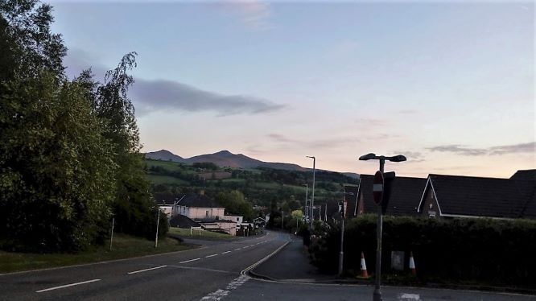
I took a photograph (fig. 1) during this description. I now recognise that my account of manufactured ‘sky-roll’ seemingly cut-to-order is reminiscent of Ingold’s description of Gibson’s sky as part of a theatrical set, constructed statically as opposed to experienced. Ingold refers to such a construction as the ‘as if’ world, diametrically opposed to the ‘open’ or weather-world which cannot be constructed or reconstructed as by its very nature it exists in a state of flux.
Figure 1: 11th June 2019. Photo: Elizabeth Flynn.
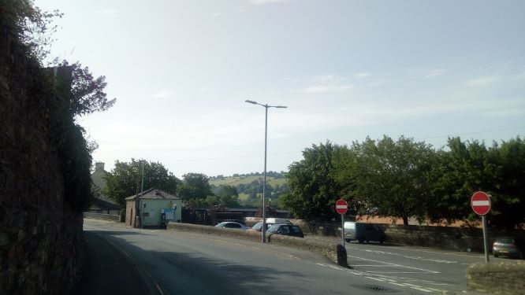
Another horizon I described as ‘crisp’ was part of my sky-walk of 28th June (fig. 2). Whilst it would take me approximately twenty-five minutes to walk between the locations pictured in figures 1 and 2, the photos are similar: high land in the extreme background, trees and houses lined up like a school class photograph, and a tall metal construct near-central. They appear static. Of the thirty-seven photos I took between 10th June and 4th July, twenty-eight closely followed this structure – at least one per outing. It is as if I was adhering to an internal template of what a photograph of the sky should be. This highlights the difficulty I experienced whilst attempting to theoretically grasp an active, changing world and the associated implications of this upon my conceptualisation of the sky. It set me within Gibson’s theoretical camp, focussing on the objects of the world and how crisply they were delineated from the sky. I clung to a preconceived, constructed sky rather than experiencing Ingold’s weather-world.
Figure 2: 28th June 2019. Photo: Elizabeth Flynn.
  - Immersion
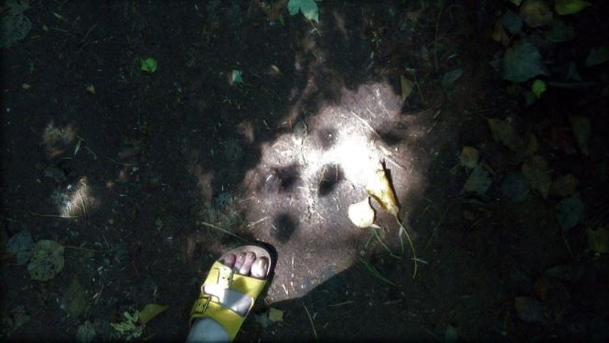
During my sky-walks of 11th and 28th June, I called light ‘sharp’ and shadows ‘solid’, concluding each time that this was likely due to their relationship with the sky. I made similar observations on 13th, 17th, 22nd, and 25th June as well as on 2nd July. I was disconnected from my own inclusion in such a relationship until a breakthrough walk on the morning of 4th July, when I excitedly realised
I’m stepping from the shadows – no, I’m stepping through the shadows into the sunlight now! Oh! Am I stepping into the sky? I am! How long have I been doing that?
Figure 3: 4th July 2019. Photo: Elizabeth Flynn.
I took an accompanying photograph (fig. 3) to mark the realisation that for me sky boundaries could be formed through motion, not just through observing the horizon. This in turn led me to begin to extend and interrogate the boundaries I perceived relating to the sky. Here, my sky-walks changed: no longer were ‘crisp’ horizons sought and outlined, instead I was open to the suggestion that, as I said on 4th July, ‘the sky might actually be everywhere after all’.
The realisation I experienced of stepping through shadow into light – through air into sky – reoriented my perception of boundaries. My change of language underscores this change of attitude: where I was thinking in terms of ‘from’ one phenomenon to another I now moved ‘through’ their immersion. On 5th July I took a photograph (fig. 4) seconds before noticing that

Even if I can’t see up very far, the sky has to still be there. Where? Here? I’m walking, the trees are waving, we’re all moving together. Right now, I feel as if we’re all involved in something: the sky, the trees, and me.
Figure 4: 5th July 2019. Photo: Elizabeth Flynn.
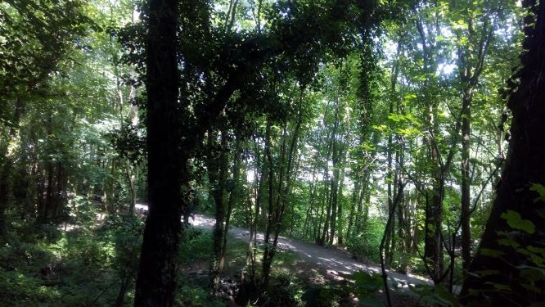
This communal act of movement, where I included myself in an interaction I perceived as occurring between trees and sky, made me happy. Perhaps this is an example of the ‘simultaneous patterning of body and world in emotion’ that Merleau-Ponty has described. If so, Ingold’s conclusion that walking amounts to ‘moving, knowing’ and ‘describing’ appears particularly relevant. It was only through movement that I noticed the synchronicity between myself, sky, and trees – and through this knowledge I described happiness and involvement in this shared experience of movement. That figure 4 is blurry due to both my own movement and that of trees and sky feels particularly apt.

  - Process
My daily sky-walks led me through a variety of Merleau-Ponty’s ‘world’s instants’ where the difference of time felt as significant as the difference in place. With only slight variation, I noted on all but eight of my sky-walks that whilst I was repeating the route of a walk ‘it all feels different today, the sky – everything’. It was not until 17th July that I became phenomenologically aware of sky-walking through an echo of Heraclitus’s theory of the ever-changing river. On 17th July, I took a photograph (fig. 5) when I was met with cut grass as it was an unexpectedly profound experience. I had taken a photograph in almost the same spot on the previous day (fig. 6) whilst talking about the difference in grass length and the feeling that
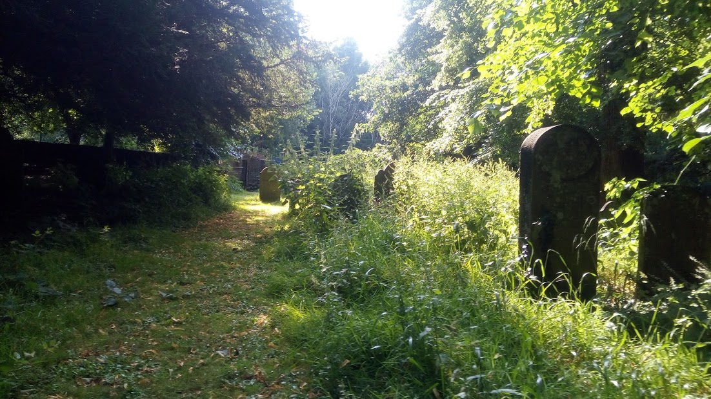
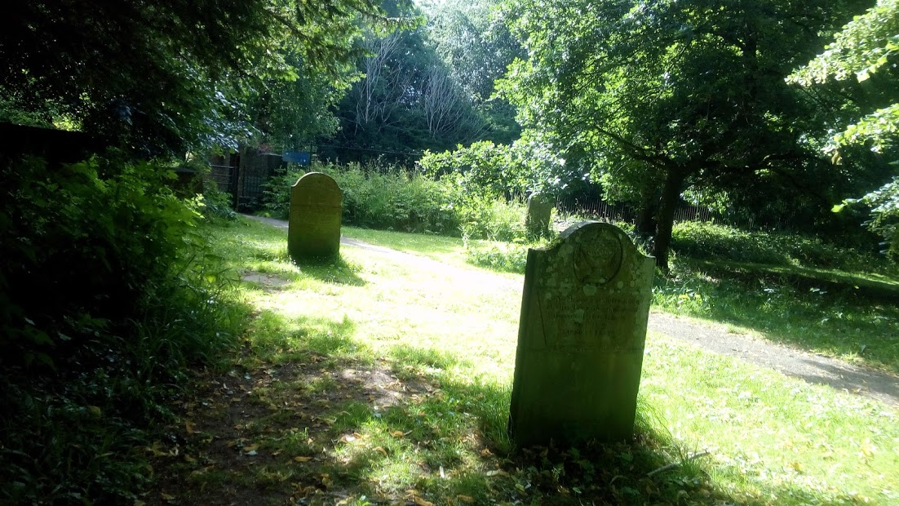
I’m part of something, here. Many feet keep this grass short, but not this grass. There, stinging nettles are reaching for sky. For me?
Figure 6: 16th July 2019. Photo: Elizabeth Flynn.
Figure 5: 17th July 2019. Photo: Elizabeth Flynn.
This feeling echoed Legat’s description of walking as a journey ‘under the guidance’ of those ‘who have both followed and left footprints’ – or, in this case, trampled grass – previously. More strikingly, it centred my awareness at my own feet and their new-found lack of connection to the previous footfall of both myself and others. It was jarring. Particularly as this sudden sense of disconnection between myself and those who had walked before found traction in my attitude towards Brecon’s sky. That I viewed it as Brecon’s and not my own was significant. ‘My sky’, as I had pointed out on my very first sky-walk, ‘has the sea’. Through that assertion, I distanced myself from inland skies. Through sky-walking I had begun to immerse myself within the changing sensations of the sky of the moment, but not integrated those moments with past sky-moments. I had not focussed upon the cohesive sky journey of childhood to adult, preferring to focus upon the distinctions between them. During my final sky-walk on 21st July, I said
I don’t think I have been walking the same route, or the same sky, at all. I don’t think anyone can. The sky is the sky but it’s not the sky. This everywhere-sky is real and I am – I must always have been – walking through it.
- Final Thoughts

The initial alteration of the form my sky journal took proved a microcosm for the research I have produced due to its material. It represents a cohesion of reflexivity, phenomenology, and process philosophy. My preconceived sky journal was to be written on notebook pages, but the experience of sky-walking led me to discover how unsuitable a methodology this would be. It was an inappropriate medium for the process of recording sky-walks. Similarly, my preconceived sky was a construction which relied upon what it was not – not my childhood sky, not existing past my subjective horizon, not anywhere except up – and yet the experience of sky-walking led me to discover that I was the limiting factor, not the sky. Just as I could not (re-)walk the same sky as either myself or anybody else, I could not (re-)walk the same route. I could sky-walk the same route every day for six weeks and, I would now argue, never sky-walk the same route twice. Too many processes ebb and flow like a Heraclitean river for that to be possible and my thoughts change – and change me – as much as the sky changes. With this in mind, clinging to a preconceived sky – or the memory of any previous sky – seems redundant. The experienced sky in each of Merleau-Ponty’s ‘world’s instants’ is as real, as valid, a sky as any other sky – past or present. Collected, all my experienced skies have been part of my Husserlian life-world.

- Conclusion

This essay has explored my changing relationship with the sky as reflexively discovered through the medium of sky-walking whilst recording my real-time observations vocally with accompanying photographs. It has offered a cohesive interpretation of my sky engagement through phenomenology, reflexivity, and process philosophy. I have explored the tension created between Ingold’s enclosure-free weather-world and Gibson’s horizon-tied conceptualisations of the sky, interrogating my own perception of what limits the sky. Ultimately, I found my own preconceptions to be more limiting than any subjective, external barrier. By utilising phenomenology and reflexivity in tandem, I was able to pinpoint a moment where I felt the ‘simultaneous patterning of body and world in emotion’ Merleau-Ponty has described. The process of sky-walking reflected the process of sky which I experienced, positively reinforcing Heraclitus’s observation that each river is in a constant state of flux. I felt immersed in a sky in flux, yet I missed the footprints of other walkers – and the continuity they represented, following Legat’s claim – when they were abruptly absent. By actively engaging with the sky on a daily basis over a six-week period, I was able to initially describe phenomena before reflexively revisiting and revising both similar and contradictory experiences. This continual process of self-reflection concurrent with sky-engagement ultimately led to a shift in perception. Where I once understood the sky with certainty, cutting it from an imagined ‘sky-roll’ in terms of what it was not and could not be, I now consider myself unable to escape the uncertainty of the every-changing ‘everywhere-sky’. I have not only sky-walked through the horizon-centric confines presented by Gibson and into Ingold’s weather-world, but fully reoriented my gaze to encompass a surrounding sky which, like me, changes instant by instant.

Bibliography

Aull Davies, Charlotte, Reflexive Ethnography: A Guide to Researching Selves and Others (London: Routledge, 1999).

Bell, Judith, Doing Your Research Project: a guide for first-time researchers in education, health and social science, 5th edn (Maidenhead, Berkshire: Open University Press, 2010).

Denscombe, Martyn, The Good Research Guide: for small-scale social research projects, 5th edn (Maidenhead, Berkshire: Open University Press, 2010).

Husserl, Edmund, The Crisis of European Sciences and Transcendental Phenomenology: An Introduction to Phenomenological Philosophy, trans. with intro. by David Carr (Evanston: Northwestern University Press, 1970).

Ingold, Tim, ‘Earth, sky, wind, and weather’, The Journal of the Royal Anthropological Institute, vol. 13, no. S1 (2007), S19-38.
- ‘Bindings against boundaries: entanglements of life in an open world’, Environment and Planning, vol. 40, no. 8 (2008), 1796-1810.
- ‘Footprints through the weather-world: walking, breathing, knowing’, The Journal of the Royal Anthropological Institute, vol. 16, no. S1 (2010), S121-39.
- Being Alive: Essays on movement, knowledge and description (London: Routledge, 2011).

Kahn, Charles H., The Art and Thought of Heraclitus: an edition of the fragments with translation and commentary (Cambridge: Cambridge University Press, 1979; repr. 2001).

Legat, Allice, ‘Walking Stories; Leaving Footprints’, in Tim Ingold and Jo Lee Vergunst (eds), Ways of Walking: Ethnography and Practice on Foot (Aldershot, Hampshire: Ashgate, 2008), 35-49.

Merleau-Ponty, Maurice, The Phenomenology of Perception, trans. by Colin Smith (London: Routledge, 1962).

Plato, Timaeus, trans. by R. G. Bury (Cambridge, MA: Harvard University Press, 1929).

Seibit, Johanna,‘Process Philosophy’, The Stanford Encyclopedia of Philosophy (2018), <https://plato.stanford.edu/archives/win2018/entries/process-philosophy/> [accessed 22 July 2019].

Tim Ingold, ‘Earth, sky, wind, and weather’, The Journal of the Royal Anthropological Institute, vol. 13 (2007), p. S32.
Ingold, ‘Earth, sky’, p. S32.
Ingold, ‘Earth, sky’, p. S32.
Ingold, ‘Earth, sky’, p. S32.
Ingold, ‘Earth, sky’, p. S32.
Edmund Husserl, The Crisis of European Sciences and Transcendental Phenomenology: An Introduction to Phenomenological Philosophy, trans. with intro. by David Carr (Evanston: Northwestern University Press, 1970), p. 49.
Judith Bell, Doing Your Research Project: a guide for first-time researchers in education, health and social science, 5th edn (Maidenhead, Berkshire: Open University Press, 2010), p. 5.
Charlotte Aull Davies, Reflexive Ethnography: A Guide to Researching Selves and Others (London: Routledge, 1999), pp. 3-4.
Martyn Denscombe, The Good Research Guide: for small-scale social research projects, 5th edn (Maidenhead, Berkshire: Open University Press, 2010), pp. 89-90.
James J. Gibson, The Ecological Approach to Visual Perception (New York: Taylor & Francis, 1986), pp. 33, 68.
Tim Ingold, ‘Bindings against boundaries: entanglements of life in an open world’, Environment and Planning, vol. 40, no. 8 (2008), p. 1797; Ingold, ‘Earth, wind’, p. S27.
Gibson, Ecological Approach, p. 84.
Ingold, ‘Earth, sky’, p. S32.
Gibson, Ecological Approach, pp. 33, 68.
Gibson, Ecological Approach, pp. 66-8.
Ingold, ‘Earth, wind’, p. S28.
Maurice Merleau-Ponty, The Phenomenology of Perception, trans. by Colin Smith (London: Routledge, 1962), pp. 330-1.
Merleau-Ponty, Phenomenology of Perception, p. 169.
Tim Ingold, Being Alive: Essays on movement, knowledge and description (London: Routledge, 2011), xii.
Johanna Seibit, ‘Process Philosophy’, The Stanford Encyclopedia of Philosophy (2018), <https://plato.stanford.edu/archives/win2018/entries/process-philosophy/> [accessed 22 July 2019]; Plato, Timaeus, trans. by R. G. Bury (Cambridge, MA: Harvard University Press, 1929), 27D-28A, p. 49.
Plato, Timaeus, 27D-28A, p. 49.
Charles H. Kahn, The Art and Thought of Heraclitus: an edition of the fragments with translation and commentary (Cambridge: Cambridge University Press, 1979; repr. 2001), L (D. 12), p. 53.
Allice Legat, ‘Walking Stories; Leaving Footprints’, in Tim Ingold and Jo Lee Vergunst (eds), Ways of Walking: Ethnography and Practice on Foot (Aldershot, Hampshire: Ashgate, 2008), p. 35.
Gibson, Ecological Approach, pp. 33, 68.
Ingold, ‘Earth, sky’, p. S28.
Ingold, ‘Earth, sky’, p. S28.
Merleau-Ponty, Phenomenology of Perception, p. 169.
Ingold, Being Alive, xii.
Merleau-Ponty, Phenomenology of Perception, p. 331.
Kahn, Art and Thought of Heraclitus, L (D. 12), p. 53.
Legat, ‘Leaving Footprints’, p. 35.
Kahn, Art and Thought of Heraclitus, L (D. 12), p. 53.
Merleau-Ponty, Phenomenology of Perception, p. 331.
Husserl, Transcendental Phenomenology, p. 49.
Gibson, Ecological Approach, pp. 33, 68; Ingold, ‘Bindings’, p. 1797; Ingold, ‘Earth, wind’, p. S27.
Merleau-Ponty, Phenomenology of Perception, p. 169.
Kahn, Art and Thought of Heraclitus, L (D. 12), p. 53.
Legat, ‘Leaving Footprints’, p. 35.

