A study of Gender norms in Ancient Egypt and whether they form a blueprint for Gender norms in Nineteenth Century Egypt
Contents
A study of Gender norms in Ancient Egypt and whether they form a blueprint for Gender norms in Nineteenth Century Egypt 1
Introduction 2
Gender norms in Ancient Egypt 4
Marriage and family 5
Law 9
Roles in society, education and occupations for men and women 12
Fashion and the representation of people 16
Gender norms in Nineteenth Century Egypt 20
Marriage and family 21
Law 25
Roles in society, education and occupations for men and women 28
Fashion and the representation of people 30
Conclusion 33
Word Count: 10,459 35
Images 35
Bibliography 40

Introduction

This dissertation aims to examine gender and its norms both in Ancient and Modern Egypt and if in any case the former acts as a blueprint for the latter.
In order to examine the gender norms of both Ancient and Nineteenth Century Egypt, there must be a basic understanding of the culture involved in each time period.

A strong effort has been made to not produce a work that has bias. It is possible that there will be a level of unconscious bias, however. It must be noted that my perspective will be that of a white, British young woman, who has been raised with her own gender norms, in a contemporary, pluralistic society.

This is an incredibly interesting area to examine in depth. gender is considered to be one of the fundamental aspects in many people’s lists when identifying a civilisation. Comparing how a civilisation began as opposed to what it is a later time period can show us the progress of the civilisation and the evolution it has gone through in the centuries since its beginning. I want to see how a civilisation as vast as Ancient Egypt can change, and what aspects are so integral to Egypt as a civilisation that they are still a part of it in the Nineteenth Century.
Gender norms within society, and in particular Ancient Egypt have both became an area of interest to me, which now leads to examining these areas in further detail as a topic for my dissertation.

My dissertation is split into two main sections: Ancient Egypt and Nineteenth Century Egypt. Within these two main chapters are smaller aspects which examine distinct areas of society in order to understand the gender norms for these distinct periods of Egyptian history. These segments are generally split by gender norms within the home, and gender norms within society, and will also have smaller categories.

In available literature, beyond a few minor comparisons that do not go much further than a few short sentences, no in-depth work and comparison has been done to link the Ancient and more modern periods of Egypt in terms of gender and its norms. This gives me a ‘niche in the market’ so to speak, which covers the criteria of looking at a new area of study for my dissertation. It certainly helps that this interests me.

I have used a wide variety of sources and in-depth research in order to fully investigate the topic of my dissertation and to make a clear comparison between the two time periods.

A timeline of events in Nineteenth Century Egypt has been made as a personal exercise in order to be able to understand the conditions and further setting to this time period. This has allowed me to gain a clearer understanding of the influences surrounding the gender norms of Nineteenth Century Egypt.

Gender norms in Ancient Egypt

Marriage and family

The first thing to understand is that Ancient Egypt typically followed the model of a ‘Nuclear family’, consisting of a husband, wife, two to three children, and elderly relatives such as parents to the husband and/or wife (Brewer, 2007). Polygamy did occur amongst the upper classes, more specifically among the royal lines (Brewer, 2007). This was done in order to expand the family and aim for a son, which was considered extremely important among these classes. Within these polygamous unions, particularly in the royal family, the wives would have had a rank and order. For example, the first woman to marry the man in question would be known as the First Wife and would have the highest rank over the other wives. A son from any of the wives would be considered legitimate and be able to be heir to the father.

Marriage in Ancient Egypt did not have religious connotations as in most civilisations but was a purely societal and economic relationship that seemed to exist in its basest form as a means of regulation for property (Brewer, 2007). In the sense of marriage as an economic tie, there was typically a contract that would have been, at its base, very similar to a pre-nuptial agreement of modern society, wherein the terms of the marriage and, should it come to it, divorce, would be laid out for both members of the union.

Marriage typically occurred after puberty for women. In the case of men, once they could support a family, meaning having a stable home, job, and public life so that the union would be safe and secure (Brewer, 2007), as was the duty of the husband, which typically put the age of marriage for men at sixteen. The connection between marriage and puberty was based around fertility. Whilst marriage was largely an economic union, the expectation of children to expand and carry on the family was a large part of it.

Ancient Egypt did not seclude its women. This is not to say that they had the same freedoms as men, but they did not lead controlled lives (Watterson, 2013). This gave them a measure of autonomy to pick their own husbands, though it is likely that the upper classes saw that there was some level of understanding between families.

Another freedom was that virginity was not a caveat for marriage (Brewer, 2007). Children from unmarried sex were cared for and were typically assigned to one of their parents. Bastards, such as they were, were not badly thought of in ancient Egypt. This was unusual, as most other civilisations, and indeed, nineteenth century Egypt, have not typically had a positive view on illegitimate children.

Marriage was expected to be a stable, lasting union. Due to this convention, adultery was very negatively reviewed, and divorce was not an easy process (Brewer, 2007).
Records from Deir el Medina (New Kingdom) indicate that divorce could be instituted by either member of the union but needed good reasoning (i.e.: adultery, infertility, abuse be it physical or mental) (Brewer, 2007). Another reason for divorce could come from the two people simply not working as a couple because, despite the social understanding that divorce was not a good thing in ancient Egypt, a marriage that did not work beyond the most basic level as an economic tie was not considered a good reason for marriage.

When a woman instigated the divorce and if the petition was uncontested, she could leave the marriage with whatever she had brought to the marriage and a share (around 1/3- 2/3) of the marital property she had held with her husband. From this we can infer that the husband would be amenable to taking whatever he had brought to the marriage as well as the remainder of the marital property (Brewer, 2007).
Sometimes, a wife instigation of divorce could see her lose her right to a share of the ‘marriage property’ (Watterson, 2013).
In contrast, if a husband divorced his wife, he had to return her dowry (or whatever would be equivalent) and give her the ‘marriage portion’ that had been agreed in their marriage settlement (Watterson, 2013).
Both men and women could remarry after a divorce or when they became a widow or a widower. A man could also marry and divorce a woman up to three times; divorce and remarriage beyond this number put an end to any recognised relationship between the two (Watterson, 2013).

There was clearly a level of inequality in marriage and divorce rights between men and women, which is further highlighted by the fact that women were given harsher punishments for adultery than men. This likely followed the understanding that women would be re-absorbed into their birth family for support and care, and that the men could support themselves more readily (Brewer, 2007). This divide would have been further compounded by the fact that conception and reproduction were considered important to a marriage, and adultery could trigger concerns about any children from the union. This would further affect the woman, as bearing a child gained a woman acknowledgement and something of a lift in status.

Concubines were permissible, though this did rather depend on the opinion of the women of the house and other members family (Watterson, 2013). For some wives, the idea of a husband taking a concubine constituted a divorce, although concubinage was an accepted aspect of infidelity, infidelity was not permissible in Ancient Egypt (Watterson, 2013).
Legally speaking, a concubine did not have the same status as a wife. This did not mean that she therefore had a lesser domestic influence and status: everyone was expected to contribute to the household if they could, though in this case it would be largely unofficial (Watterson, 2013). Despite the differences between a concubine and a wife, the agreement was typically considered a comfortable one, and wives and concubines could share a bond that on occasion could be almost sisterly. Although the legal situation and rights were different, it was not unusual for a concubine to have as much power, unofficially of course, that a wife had, and would help with keeping house and the childcare.

In terms of the childhood one would experience, there is evidence of dolls and other toys being used throughout the classes in Ancient Egypt, with a variation in quality depending on the status of the family (Brewer, 2007). An example of a toy for children in ancient Egypt would be a very basic, genderless doll, carved from wood, for both boys and girls. Clothes could be made from scraps of material to give the doll a gender and to make it work for both boys and girls.
Children could play, but once they were out of infancy (i.e.: weaned, which generally put the age of the child at around three years old) they were expected to begin training for adulthood. Daughters would assist their mother with their household tasks, of which their involvement grew as the child got older (Brewer, 2007). The sons would shadow their father in his occupation and assist him and do small jobs that would grow with their age. It was expected for a son to take the same job as his father or other male family member (Brewer, 2007).
Even from this very basic overview of marriage and family life in Ancient Egypt, it can be clearly seen that both girls and boys clearly had expected paths and roles set in their lives. The daughters of the lower classes would have more work to complete than the daughters in the upper classes, who would have had servants to do the more menial jobs, though the wealthier daughters would have still learned from their mothers. The jobs held by the fathers would have become more prestigious the higher up the social ladder they were, which would have meant a better life opportunity for the sons.
Regardless of the class however, it seems clear from this basic overview that women had the more passive roles in Ancient Egypt whilst the men had the more active roles and were the breadwinners of their families.

Law

There is varying testimony on women in relation to the law in Ancient Egypt, specifically in terms of their legal rights. On one hand is the suggestion that women in Ancient Egypt had equal legal rights to men, whilst on the other hand there are those that say that they did not have such legal equality.

In Pharaonic Egypt, women had a relatively high social status, and property not only passed through the female line, but rights to property devolved to women: they could own and administer land or possessions independently (Watterson, 2013).

Mothers of families had a level of authority at home and had a special place in society in general, but did not have the ability to hold important offices of state, beyond that held by women acting as Pharaoh, as regent and some priestesses (Watterson, 2013).
The economic independence given by rights to property and ownership gave women of Pharaonic Egypt, together with their legal status of being equal with men under law, a level of social freedom (Watterson, 2013).

A deeper exploration into the penal system, brings to light a system of corporal and revenge punishment, in which guilt or innocence could be judged or found by questionable methods, but in which there appears conflicting evidence around gender differentiation.

In the Middle Kingdom of Ancient Egypt, assault was punished by a beating. This, as an example, was a lightly punished crime (Brewer, 2007). Comparatively, the abuse of public office saw the criminal punished with mutilation- more specifically, with the cutting off the nose, almost along the lines of the famous saying about cutting off his nose in order to spite his face (Brewer, 2007).
As the worst crimes to be committed, murder and treason were both punished with death (Brewer, 2007). The scribes and administrators who revolted against King Osorkon in dynasty 22 were burned alive (Brewer, 2007). Capital crimes such as these were punished by the Pharaoh unless he delegated them to his Vizier, who was his second in command (Brewer, 2007).

Oracles were prominent in the judicial system of the New Kingdom and the third Intermediate Period (Brewer, 2007). A statue of a god or goddess, after a procession, would be asked a question pertaining to a crime- something along the lines of ‘did this person take that from me’ and so on. If the statues head moved in a nod, the accused was guilty (Brewer, 2007). Unsurprisingly, this judgement system led to a large amount of the corruption within the government of the New Kingdom. Unfortunately, beyond the basics of this system it does not give us any information on the crimes and punishments associated with judgement via oracle.

The facts within the legal section after this sentence have been taken from information on Deir el-Medina. Thankfully, official records were kept of crimes, and more specifically of tomb robbery and embezzlement (McDowell, 2010). Tomb robbery was one of the worst crimes to commit that led to the death penalty for the accused. For example, the suspects of the Great Tomb Robberies were imprisoned during their sentencing, but that was not the decreed punishment, which was death. Seven of the convicted robbers were impaled, whilst the rest were left to commit suicide (Brewer, 2007).

Assault was a rare crime in Deir el-Medina, though this may be due to the fact that the sources used for information are financial documents. Despite this, when assault did occur, it was punished with penal labour (McDowell, 2010). The lack of information in this area is unfortunate as it does not allow us to see if there were differences in the treatment of the crime if a man or woman was involved.

The worst crime in Deir el-Medina was considered to be the theft of copper. Copper was a state property and was part of the tomb making process as a strong metal that could be used for work. There was a case were a woman, called Herya, was accused of stealing a copper chisel from a workman called Heb-Nefer (McDowell, 2010). This case provides us with a rare example of a case in which a woman was accused of the theft of copper, and in which she appeared to be treated differently, based potentially on her gender: A search was conducted, and the people asked to swear an oath that they had not committed the theft (McDowell, 2010). Herya’s oath did not prove satisfactory, and after interrogation, she returned the chisel, which was found with other copper objects stolen from one of the local cults (McDowell, 2010). Her sentencing, which is unknown, was left to the Vizier, though death was suggested. The questioning and oaths that the people of Deir el-Medina took in order to solve the theft of the chisel was not a typical tactic for a civil case. Death was quite the serious punishment. Herya was the only woman sentenced, or who was probably sentenced, to death in Deir el-Medina (McDowell, 2010).

Beyond Herya and a minor piece of evidence of two women settling an agreement in front of a court, there is very little evidence regarding the treatment of women in the judiciary setting of Deir el-Medina. Much of the crimes committed there that have been made note of are tomb robberies and copper robberies. It is clear that women’s involvement was low in law, crime and punishment beyond being called as witnesses should that become necessary.
Due to this lack of information, it is unclear whether women would have received different punishments for the crimes noted above than the men did.

Roles in society, education and occupations for men and women

Beyond the basic work that men did there were several roles they took.
Being a husband and a father was the key role typically speaking, but they also took work as tomb makers, scribes, etc (McDowell, 2010). In contrast to this, women took the role of housekeeper and mother, though some also took other roles.

The role of Scribe, or at least having the training of one, was a male occupation, due to the fact that they needed to be able to read and write before a career of scribal administration of the palace, military, or priesthood. There was no formal system of schooling for everyone, but a boy would be sent to a specific scribal school, for example, in order to learn the required skills for that occupation. Whilst there was no official ban on girls getting an education, it was incredibly rare. Scribal schools taught reading, writing and arithmetic (Booth, 2007), giving boys more access to developing these skills.

Priesthood was possible for most, as literacy was not needed in every area of work. Women were allowed in the Priesthood, but generally only in lower positions or in connection with a Goddess. Men attained the higher positions within the temples and Priesthood as a whole (Booth, 2007).

Women were allowed in the Priesthood, but generally only in lower positions than their male counterparts or in connection with a Goddess. They played an important role in the worship of temple divinities. One of the most important functions they could have was to act as impersonators/conduits, etc, for the Goddesses. Each temple appears to have had attached to it a musician priestesses or chantresses (Watterson, 2013), giving women a role of at least some significance within all temples.

A role within the priesthood was considered the most prestigious job a woman could hold beyond those of female royalty. In the Old and Middle Kingdoms, women of upper class families were regularly appointed as High Priestesses, mainly of Hathor, but there were some in the same capacity in the temples of Neith, and at Beni Hasan (as the wives of the nobles who owned the tombs).
Despite this, Priestesses in general were neither administrators or specialists and had little influence beyond the temple (Watterson, 2013).

A position in the army became a main role that men could take after the expulsion of the Hyskos (New Kingdom) which saw the army become available as a full-time occupation. Women were in no way considered suitable for the army (Booth, 2007).

Comparatively to men, women could not hold bureaucratic positions, however in the Middle Kingdom, women could hold a range of positions such as treasurer, major doma, or superintendent of the dining room, but all in private houses. In the royal house or in independent workshops women could hold a number of positions such as ‘Overseer of the Singers’, ‘Overseer of Amusements’, ‘Mistress of the Royal Harem’ ‘Overseer of the House of Weavers’ and ‘Overseer of the Wigshop’ (Booth, 2007). All of these titles mesh with the other roles that a woman could take in ancient Egypt. The women who held these titles certainly had the most important roles within their domain but were not on the same level as the men in other domains.

Most women were essentially housewives, but farmers’ wives and the wives of landowners generally took an active role in the harvest season (Booth, 2007).
Women in Ancient Egypt were typically illiterate, although in the upper classes women were likely to have learnt from family members, not by any formal teaching (Watterson, 2013).

Within villages many women were midwives. There was a school of midwifery at the temple of Neith at Sais, but most learned by following another midwife in her work in an apprenticeship. Most other forms of medicine were dealt with by men, unless they involved keeping a woman’s honour and dignity (Booth, 2007). In these cases a female with some training, typically from a temple, would take care of the aspect of medicine that would not be proper for a man to see and then leave the rest to the doctor.
Medicine was generally, with only a few exceptions such as is noted above, a male occupation, likely to the intensive nature of it (Watterson, 2013).

Among the upper classes wet-nurses were used, Royal wet-nurses were held in high esteem, and generally held considerable influence over the child they nursed, which was very significant in royal circles. This also occurred if the mother died in childbirth, which was not uncommon, regardless of the class (Watterson, 2013).

Royal households, temples and other high-status establishments employed entertainers such as dancers and musicians. Women with a talent for dancing took it as a profession; tomb reliefs show male dancers to be less popular. Nothing is known about the level of training for professional dancers but from reliefs we can estimate that girls began dancing professionally from early childhood.
A career in music was available to women and girls. The Ancient Egyptians regarded music as a proper accompaniment to religious ceremonies and as something to be respected, listened to and enjoyed. Most people played some level of music (i.e.: rattles, basic pipes, etc) but professional musicians played many instruments (Watterson, 2013).

Mourning was a career followed by many Egyptian women and girls. Mourners were employed by those who could afford it to grieve in the home whilst the dead relative was being mummified (a process that took seventy days) and to follow the funeral cortège to the tomb. Judging from tomb-paintings, a mourner could start at an early age (Watterson, 2013).

Women seemed to dominate the weaving and textile industry, both as workers and as supervisors. Evidence of this can be found in the wooden model of a weaving workshop from the 11th Dynasty tomb of Meketre at Deir el-Bahri, and in reliefs in several of the 12th Dynasty nobles’ tombs at Beni Hasan. Linen was the staple fabric until the later periods when silk and cotton were introduced. Despite the basic methods used, the quality of linen could be very high (Watterson, 2013), affording some women within this industry a level of respect for their work.

Deir el-Medina breaks the mould of women taking the ‘passive’ jobs whilst men the ‘active’. Deir el-Medina was a purpose-built town for the tomb workers of The Valley of the Kings and their families. This meant that the men were all working as tomb builders, beyond the two chief workmen and the head scribe. The tomb builders would spend at least the week in huts by the tombs and only return to the town at the end of the working week. Due to this, all the jobs in the town typically done by men needed to be done by the women. With the state supplying foodstuffs such as grain, fish, vegetables, water, fuel and pottery, as well as a laundry service, this cut down the traditionally female jobs that needed doing and further freed up the women for other work.
They were however still blocked from positions of authority and administrative responsibility. They were also not allowed to join any sort of armed force that Deir el-Medina may have had in order to defend the town and the tombs.

It is unfortunate that Deir el-Medina appears to have been the only differently organised town in Ancient Egypt, and even within this, it is clear that women did not take authority and administrative authority beyond the basic role of ‘Overseer of…’ that they could get with certain roles. There are also no details on what the woman did in place of the men. It is unlikely, for example, that they became scribes, but more that they took up men’s roles in creative jobs and more perfunctory roles of men.

It is evident throughout Ancient Egypt women clearly held the more ‘passive’ roles whilst men the more ‘active’. The number and importance of roles that women had was certainly less than the number and importance of roles a man could take. There were however, a few interesting exceptions The most interesting subversion of this is visible in the female Pharaohs, who gained this prominent role due to the fact that Pharaoh is intrinsically male, and the woman in question is therefore male. The woman may be female on her own, but when a woman becomes Pharaoh, she is now male (Booth, 2007).
Beyond this, Mothers of families had a level of authority at home and had a special place in society in general, but did not have the ability to hold important offices of state, beyond that held by queens regent and some priestesses (Watterson, 2013).

Fashion and the representation of people

The information on fashion in Ancient Egypt is gleaned from tomb scenes, other forms of art, and jewellery as only the rare item of clothing has survived. The evidence points to similarities in attire between both men and women, in that the dress/skirt is commonplace for both genders as opposed to the trouser. Interestingly, the depiction of people within art, used to inform us about clothing, can in itself further inform us about equality. There is a suggestion of inequality represented by the various editing of male and female forms in Ancient Egyptian artworks.

The basic garment of women in the Old Kingdom and into the New Kingdom was the sheath dress, worn strapless or with two broad shoulder straps (Brewer, 2007).
The New Kingdom refined the sheath dress into more elaborate dresses with draped bodice, cape sleeves, or tight fitting with a shoulder bare, or with full skirts (Watterson, 2013).

Most examples shown reach the ankles. In most sources these dresses seem to be impossibly tight and impractical. It has been suggested that in art the shape of the dress is held to the body to emphasise the natural figure in an idealized form. The dresses were likely looser than art has shown them, whilst still forming as a sheath dress. The linen would have been white, so the outfit was given colour by the addition of heavy beaded collars and other jewellery, or sometimes a colourful sash (Brewer, 2007).

Men in Ancient Egypt are shown in a kilt made from a rectangular piece of linen cloth wrapped loosely around the hips, leaving the knees bare. The cloth was generally wrapped around the body from right to left so the edge of the skirt would be in front. The upper edge was tucked behind the tie or girdle that held the kilt together. This was the standard male clothing for all classes, though naturally the style of the kilt and the quality of the linen varied between the classes. The higher-class kilts had bias-cut edges, pleated decorative panels, or fringed edges (Brewer, 2007).

By Dynasty 4 and early Dynasty 5 it became the fashion to wear the kilt longer and wider or to wear it with an inverted box pleat that took the form of an erect triangular front piece. Men also wore beaded collars and carried staffs marking their status and social class (Brewer, 2007).

Neither Women nor men in Ancient Egypt wore anything resembling trousers (Watterson, 2013). In terms of our own gender norms, women not wearing trousers as a part of basic dress has over the years indicated a lesser position for them as opposed to men- with trousers being more functional and better for work. Ancient Egypt clearly did not have such distinctions. For sake of practicality, skirts would have been worn for work by both genders.

The cut of clothes throughout the classes were the same, so jewellery and quality of the linen were used as distinguishers between the classes (Watterson, 2013). Again, this was the same for men as it was for women.

In Ancient Egyptian art (tomb paintings and other wall paintings, reliefs, and statues), women are generally depicted as having a creamy-yellowish skin, whilst men are given a reddish-brown flesh. This has been thought to have been done for many reasons, such as social gender division, but the true use of it was as a means of discerning the difference between males and females in Egyptian art (Watterson, 2013).

This means of distinction was necessary due to the fact that the means of drawing did not allow for much difference between the two. Ancient Egyptian art was always created with the aim of showing the ideal Egyptian, be that male or female. This is unfortunate as it means that we do not get to see an actual person in whatever age, weight, etc they may be. For example, as mentioned above, Egyptian art depicts women in an impractically tight dress. This would have been done to properly showcase the figure of a perfect woman. If when examining a piece of Egyptian artwork of a group, the people all look the same age, it does not make such a truth (Watterson, 2013).

Height and size are also an important convention in Ancient Egyptian art. The taller and bigger a person is, the more importance they have. In many pieces of art, the women are smaller than the men. This would suggest a reflection of gender inequality in Ancient Egypt. Below is the description of an image of a woman in Ancient Egypt.

The image of a woman shown in a relief, Mastaba of Mereuka at Saqqara (Brewer, 2007), can be found as Image 2 in the Images section for this dissertation. The two-dimensional figure is in black and white (Brewer, 2007). As previously mentioned, Egyptian art aims to present the perfect Egyptian, which explains the tight dress and clear figure of the woman which can be seen through the outline of the dress, though there are no details of her body beyond showcasing her basic shape. The dress has a v-neck and reaches to the ankles. The hair is in a typical style in Egyptian art, reaching just past the shoulder blades, with a long strand in front of a shoulder. The face seems small in proportion to the long body, and is a little difficult to see, although it is clear that the figure is wearing makeup around her eyes. The only accessories are a wide, basic collar, and a fan in her hand. She is not wearing any shoes. The most interesting aspect about this figure is that her left breast is exposed. This is unusual but has clearly been done to emphasise the femininity of the woman. Judging by the proportions of this woman, she is of some importance and status, though she seems to only have basic accessories. There is no man next to her, which is unusual for ancient Egyptian art. That we do not have the entirety of the relief this figure is part of is an issue as it does not allow us to see the woman in the full view and comprehension of the mural. It does however suggest a woman of importance, whose femininity is being highlighted. It is questionable as to whether the highlighting of her femininity is being done as a means of objectification or out of recognition of her status as a woman.

Ancient Egyptian art tends to depict people in groups, though it is more likely to find a piece of Egyptian art of a male on his own than you are to find such of a female, especially at the beginning of Egyptian history, though this is not an impossible find (Watterson, 2013). This might suggest that the woman was to be accompanied in public, or that the male was considered more worthy of his own portrait.

The everyday scenes shown in Ancient Egyptian art do denote a level of social freedom to the women of the time. However, in general, Ancient Egyptian art holds focus on the upper classes, thus we cannot paint all of Egypt with the typicality we are then shown.

Another means of representation of women in Ancient Egypt can be found in the texts used to teach scribes. The Wisdom Texts contained advice to scribes in how to act in society and largely offer guidance about the behaviour and attitude expected of males towards mothers and wives (Robins, 1993). According to these texts, mothers are to be honoured for bearing them, as childbirth would have been dangerous to both mother and child. This was a typical instruction from these texts. Linking into this instruction is another from the Wisdom Texts, wherein the scribe is informed that it was his mother’s duty to bear children (Robins, 1993). Another role of women was as a wife in charge of keeping the household, as can be seen in the New Kingdom’s Instruction of Any (Robins, 1993) that informs a scribe that he is not to complain when his wife keeps the house properly, and that she is not there to wait upon his wants. Unsaid, however, was that the husband could complain and get angry at his wife if she does not keep house properly. The man did not keep the household, but was, overall, in charge of it and of his wife.

Overall, according to these texts, a woman was to be treated well and respected, with the expectation that she would fulfil the duties that were intrinsic with the idea of being a wife and a mother. She was, however, inherently subservient to her husband. The man was clearly allowed to have expectations of his wife and the mother of his child(ren) and was the one with authority within the marriage, no matter how important her role was. Clearly, a high level of respect of the woman did not lead to equality.

Gender norms in Nineteenth Century Egypt

Marriage and family

Marriage was encouraged and typically took place soon after puberty for girls. It was usual among the upper classes for a girl to be betrothed, or at least have some understanding of the role of marriage within her life at the age of sixteen. Puberty was considered the marker for eligibility of marriage because it meant that the woman was now fertile and able to bear children, which was an integral part of the union. Though not explicitly mentioned, a woman would likely have been considered responsible and able enough by sixteen to marry, have children, and run a home. The same concept of being of an age to be sufficiently responsible would also have set the marriage marker for men, who were typically older than a woman when they married.

It was considered good for a female to marry someone of the same profession or trade as their father or for the prospective groom to have a role that complemented the father of the bride, as marriage was used as a means of strengthening economic associations (Lane, 1871).

These aspects of marriage mark a similarity between the marriage customs of Ancient Egypt and Nineteenth Century Egypt.

Divorce was common in this time period, the most common means being the man declaring to his wife ‘I divorce you’ (Tucker, 1985), which was a legal means of divorce under the Islamic law of the time. Beyond this, divorce could also be enacted by the wife, or be a mutual agreement between the couple (Tucker, 1985).

In terms of family life, a man was responsible for his relatives, elderly members of the family, widowed or unmarried sisters, and their mother and father. The expectation appears to be that these people would live in the same household if possible, under the male head of the family. He was also allowed the right of polygamy, though it was somewhat rare (Tucker, 1985). This right could lead to destabilisation within the family and with the first wife, as she now had a competitor for her husband.

Peasant families changed over time in order to accommodate the new state of women as a working member of the family (see roles) and the taxes the changes brought (Tucker, 1985). This, naturally, changed the roles within the family, and the expectations for each member, though traditions were kept to. Family was still an economic unit, as it had been in Ancient Egypt but now the female position in the unit had changed: She was more likely to be a breadwinner and hold responsibilities to the family finances than she had been before. Whilst the men were still working, they were oftentimes not directly available for the family as a means of support, which remained a key role for the women (Tucker, 1985).

Women could work at home in occupations such as textile production, which put less of a gap between the roles of home and work, allowing women to share their time evenly between the two (Tucker, 1985). They would have also likely to have been taught their daughters their craft. Women who worked outside the home did face issues with social perceptions of what they were able to do. One craftswoman lost custody of her daughter to her child’s father, from whom she had previously divorced, under the claim that her working outside the home meant that she was a neglectful mother (Tucker, 1985). In Cairo, female artisans worked both at home and in shops concerning the major crafts.

Child custody was often prejudiced against the mother of the child(ren) as divorce typically stripped her of emotional and material gains that could be found in a marriage. These gains were considered necessary to the child(ren) and herself in order to support the family (Tucker, 1985). It also typically went the same way as the divorce did, so even if the woman won the divorce and custody, she would struggle, or if the husband won the divorce, she would lose her children (Tucker, 1985). As mentioned, a craftswoman lost custody of her daughter due to her craft, because it saw her working outside the home. The same issue applied to women working in the service industry, and there were also cases of them losing custody of their child(ren) due to their work requirements.

Nineteenth Century society did consider its women capable of managing property and other businesses due to their active role in economic production and distribution (Tucker, 1985). Women stood as founders, legatees, and administrators of property.

Children of upper and middle classes tended to dress like their parents, though without as much exact care as their parents. In the lower classes they typically wore a shirt, skull cap, typically known as a tatboosh, and were generally naked until the age of six, and had their heads were largely shaven from the age of three (Lane, 1871). In comparison to the boys, girls wore some sort of white veil from the age of four at least. From this age, only family could see them unveiled, and husbands once marriage occurred (Lane, 1871). The basics of child dress share similarities with children of Ancient Egypt, as both went naked until they were old enough (around five) for clothes to be considered necessary.

Women in the upper and middle classes tended to pamper their children, but the poor did not give so much attention as there were more difficulties in the lower classes that would hinder this. Much of a woman’s position in the family rested with the welfare of children. It was expected that the parents, mainly the father, was to ensure that the basic principles of religion were instilled into the children. Beyond this responsibility, the education of the children, with focus on the sons, was given tutors where possible. Female children were rarely taught to read and write, and sometimes did not even learn prayers (Lane, 1871). In the upper classes, both boys and girls grew within the hareem, which was the name given to a set of apartments for females (Lane, 1871). Due to this importance on the place of parents in the life of the child(ren), disobeying your parents was considered by Muslims to be one of the greatest sins one could commit.

As a typicality, husband and wife tended to share a bed, except among upper classes, wherein woman had their own quarters within the hareem (Lane, 1871). This was clearly a social distinction, as the upper classes would have been the ones able to afford and supply the separate quarters for the different sexes.

A key differentiation between Ancient Egypt and Nineteenth Century Egypt can be found in the fact that the women of Nineteenth Century Egypt were allowed to dress largely as they pleased within their home, but outside the home they were to cover their bodies as Muslim society dictated (Lane, 1871).

This section highlights several similarities between the gender norms of Ancient Egypt and Nineteenth Century Egypt. These aspects are similar to a point, but then differ. For example, marriage in Ancient Egypt was a purely economic union that took place after puberty, whereas in Nineteenth Century Egypt marriage was a religious union that took place after puberty, but that typically had economic connotations. Young children in both Ancient Egypt and Nineteenth Century were naked for much of toddlerhood but had different dress conventions for the children.

The main difference between the Marriage and Family aspects of Ancient Egypt and Nineteenth Century aspects can be found in the role of parents within the life of the child(ren) and the education received by the children. Children in Ancient Egypt received much, if not all of their education from their parents, following them in their lives and roles. In comparison, the children of Nineteenth Century Egypt learned a little from their parents before the sons were handed to tutors for the rest of their education where wealth allowed.

Law

The main point of note about law in Nineteenth Century Egypt is that much of the basis for it came from Islamic tradition, law, and morals, as religion was a large part of society.

A man was allowed to take four wives at once at the most and was allowed to marry a Christian or Jewish woman if unable to take a Muslim wife. He could divorce his wife twice, and both times remarry her. If he married and divorced the same woman a third time, there could be no official relationship between the two, a law which bears a strong similarity to the marriage and divorce laws of Ancient Egypt. Despite the man’s ability to marry and divorce a woman three times, a man was only allowed to take concubines with the permission of the wife, the mistress.

Legally speaking the man was clearly the head of the family (Lane,1871). Whilst being the head of the family was a role of clear importance, it was not the only authority a man could hold. Out of the two genders, the male was the one in charge, with the most power in society.

As a part of Islamic law, a woman could be legally declared rebellious against her husband, which could be taken as grounds for divorce, which leads to the understanding that the ‘rebelliousness’ of the wife was infidelity, or something of similar disobedience. The husband is not obliged to divorce the woman, which bars her from marrying any other men, after his death (Lane,1871). Even with divorce, it seems likely that being declared rebellious would cause issues with any further remarriage, as it would lay a stigma on the woman. A woman could take this charge to the Kâdee’s court to request separation from her husband for his charge of her (Lane,1871), but there is little information on such cases and their outcome: it seems likely that without proof that she was not rebellious, the woman would lose her case.

A man charging his wife of adultery needed to be able to present four witnesses of the adultery in order to see a conviction. If the wife was convicted of adultery, she faced the severe punishment of death by stoning (Lane,1871). A man, similarly charged, by contrast, would lose property brought into the marriage by the wife and face a fine for a charge of adultery (Lane,1871). The punishment for women was likely harsher because the women bore the children, which led to difficulties with inheritance and any succession if the parentage of the child(ren) was in any way contestable. Women clearly faced harsher punishment for adultery in Nineteenth Century Egypt than they did in Ancient Egypt, though the process of conviction for the crime also needed witnesses.

There was no legal distinction between the child of the wife and a child that was born to a slave, though this only held as a true statement if the child of the slave were acknowledged by the father. If such acknowledgement occurred, both the child of the wife and the child of the slave could legally inherit (Lane,1871). A bastard, more politely known as an unacknowledged child, however, could only inherit from the mother, and was hers to see raised. Children could be sold to families and left on doorsteps, particularly doorsteps of mosques, as a means of adoption if the mother could not care for the child (Lane,1871). This seems an entirely unorthodox means of adoption to my personal biases, but it did work.

As a crime, theft was instantly punished by cutting off the offender’s right hand for the first offence. Upon the second offence the left foot was taken, on the third the left hand, and the fourth the right foot. Further offences were dealt with by a flogging or beating, or long imprisonment. The punishment for theft was viable against both genders (Lane,1871). There is no evidence to suggest that women received any sort of leniency if they committed this crime.

Drunkenness was punished by flogging. The main difference in any kind of punishment for this crime was eighty lashes for a free man, but forty for a slave (Lane,1871). Women were expected not to get drunk, or at least to do so within an appropriate setting, meaning within the privacy of the home. By all accounts, disgracing oneself by getting drunk was attributed to men and not considered relevant to women.

Apostacy was the act of leaving your religion or form of belief, be it political or not. This was the main religious issue that could be punished by law. The punishment for apostacy was death, unless the apostate repented of such and re-joined their religion, political belief, and principle (Lane,1871). This would have been equally applicable to both genders and all religions in Nineteenth Century Egypt.

There were evident similarities in the crimes and punishments for Ancient Egypt and Nineteenth Century Egypt. Adultery was clearly intolerable in both time periods, and punished accordingly, though Ancient Egypt was more lenient in that stoning to death occurred only in the incredibly rare case. The legalisation and adoption of a child also followed along the same lines in both time periods. Despite these similarities, there were also differences, as influenced by Islamic law. There is no evidence for any punishment for drunkenness, for example, in Ancient Egypt, and theft was typically punished with a fine in Ancient Egypt, not with the removal of limbs.

Roles in society, education and occupations for men and women

In Nineteenth Century Egypt, the peasant woman was a working member of the family in her role in agriculture and craft production, within the lower orders (Tucker, 1985). The term lower orders referred to the roles that necessitate the act of labour, such as working the fields and making items for other aspects of the craft industry to sell. This is not to say that the working peasant woman did not take care of the children and family, only that her role was more varied than that of a housewife and mother. This kind of work for women grew as villages began to be comprised of women, children, the elderly, and the infirm as the men worked elsewhere (Tucker, 1985). This represents a growth of the model of Deir el-Medina in Ancient Egypt.

Beyond the lower orders of women working in agriculture and craft production, there were women who made their business in wandering trades. There were also those who owned, and therefore tended to run, small shops, sometimes as part of a family business (Tucker, 1985), which was a significant development of the role of women within the business classes. This was a logical development from women having a role in, as previously mentioned, agricultural and craft production in recognition of the abilities and skills a woman could bring to a family business. Women were known to have ability in economics, business, and production, but much of the time it was declared that men did most of the economic legwork, such as buying the premises for a business that a woman would run.

Throughout the Nineteenth Century, the rural and urban elite had a large part of the petty trade businesses, and women were a significant part of this. In the major market towns of Egypt, women and girls dominated. This allowed them wealth and a level of autonomy from the men of the time, previously unknown. In order to keep this autonomy, women tended to trade and loan between themselves. Cairo and other major regional towns supported a more affluent class of female traders, who supplied goods to women in the upper classes (Tucker, 1985).

Textile work, as in Ancient Egypt, was considered a good role for mothers to take as it tended to be carried out in the home. The women were able to work as modest producers. Female artisans worked in a similar way, producing at home and selling their work on. This made their work hours and production levels smaller than that of workers outside the home, but allowed them to manage the demands of family life alongside production (Tucker, 1985).

Whilst women could and did conduct their business as individuals in the Nineteenth Century, they also operated in association with a family business (Tucker, 1985). The role of family members in family run businesses were not clearly defined by gender or age. For example, men, women, and children would all have washed, cleaned, and spun yarn for making cloth and other items (Tucker, 1985). This was in clear contrast to Ancient Egypt, wherein family run businesses were not so genuinely ‘family run’; a family business in Ancient Egypt was more along the lines of all the men going into one occupation.

As in Ancient Egypt, service occupations provided work for many women, as it was only acceptable for women to perform certain tasks for other women due to propriety or special needs. Women were frequently contracted for domestic service, and midwifery, and soothsaying. Midwifery being the only medical role a woman could hold. Public baths also had a certain number of female attendants available for the days or times set aside for the women to use the baths (Tucker, 1985).

The biggest differences between Ancient Egypt and the Nineteenth century in terms of women’s occupations, were the increase in women’s roles in family businesses and that there were no women in trade in Ancient Egypt as there were in the Nineteenth Century. Beyond this, the occupations of women were similar. They were prominent as mothers and wives, as textile workers, in agriculture among the lower classes, and took work in service occupations.

Fashion and the representation of people

The information used in this section of the dissertation comes from black and white drawings in Edward William Lane’s first volume on the account of the manners and customs of the modern Egyptians, published in 1871 (Lane,1871). (See Images)

Image 3 contains a drawing titled ‘Men of the middle and higher classes’ (Lane,1871).
The men are wearing an outer robe over an inner robe, which is held with a cloth belt. They are wearing shoes. All of them have turbans and beards (Lane,1871).
The man at the front of the drawing is seemingly of a higher class than the two behind him, as his over robe is striped, which means either it was a better material or was made or dyed to look as if it is of a better material (Lane,1871). He is holding a very long pipe and something tucked into his belt that is likely a scroll (Lane,1871).
The figure on the right may be an older man of a different class or profession due to the difference in dress style to the other two (Lane,1871).

Image 4 displays a drawing of the ‘Men of the lower classes’ (Lane,1871). The man on the right is wearing an outer robe over an inner with a belt but no shoes, whereas the man on the left is only wearing one robe with belt, but is wearing shoes (Lane,1871). Both men have turbans and beards, which seems to be a staple part of style in Nineteenth Century Egypt (Lane,1871).

These images indicate a basic similarity in style of clothing between the classes, with a notable difference in quality of material and accessories.

Image 5 shows the image of ‘Lady in the dress worn in private’. She is evidently of the upper class due to the style and clear quality of the clothing she wears, which is patterned in areas. Her outfit consists of an outer robe over a dress, with a belt or sash around the waist, with long dress sleeves. Her feet are not visible, so there is no idea of any footwear she may be wearing (Lane,1871). A long, embroidered headscarf covers her hair and reaches to the back of her knees. The face is not covered, and the front part of her hair is visible around her face. She is wearing makeup. Her chest is visible, and shows minor cleavage. She seems to be wearing a necklace or amulet.

Image 6 shows ‘Ladies attired for riding or walking ‘(Lane,1871). The main figure in this image is covered by a hooded outer robe and long veil and shoes. The hints of clothing visible underneath the covering is likely her clothing that she would wear in private. The woman has makeup around her eyes, likely as her only visible means of expression. The covering of women outside the home was done as per Islamic tradition, as a means of protection for men and women. If the man could not see the woman, he could not be attracted to her, and therefore no damage could be done to either sex. This gives the impression that Muslim society thought the woman was at fault if a man found her attractive and turned his attention to her.

Image 7 shows ‘Women and children of the lower classes’. As the previous picture indicated, the women were covered when in public. The youngest child in the picture is only wearing a headdress, whilst an older boy is only wearing a long tunic (Lane,1871). The woman with her head turned is showing her chest a little. There is a slit by her cleavage, which was possibly for breathability or easy access for child feeding. The outfits of the women in this picture do not consist of full cloaks as the previous image do, but of long dark, loose dresses, with long veils and headscarves. Skin is visible at the neck, hands, and whilst much of the face is covered, the gap between the headscarves and the veils is bigger. This is likely due to the class difference between the two images. The picture described above is of a woman of the higher classes, so could afford the large amount of material needed for the full cloak, whilst the women of the lower classes could not. It is not possible to see the feet on all of the figures, but all feet visible are barefoot.

Image 8 shows a ‘woman of the southern province of upper Egypt’. She is clearly outside without covering her body. She is wearing a basic outfit of a dress and headdress, but has no shoes, no veil or anything similar. The dress is loose, held at shoulders and folds beneath her bust. The jewellery she wears consists of a necklace and bracelet on each wrist. There is a difference in the shape in face and body to the previous pictures of women, and she has darker skin (Lane,1871).

The men and women have different style choices and a presentation of themselves in Nineteenth Century Egypt, which were stylistically different from the clothing of Ancient Egypt. The men, both inside and out the house were able to wear patterned clothes and show expression and style. The women, in contrast were able to dress nicely, with patterning and style within their homes and personal chambers. In contrast when they were to go outside the home they were to cover themselves with a loose dark cloak and long veil so that all is visible is their eyes, which are highlighted with makeup, which in the outside world was their only means of expression. When putting the images of a man outside and a woman outside next to each other, the contrast in behaviours, positions, and roles is made clear.

The only discrepancy in the representation of social life can be found in the image of the woman from the southern province of upper Egypt. Her dress and presentation portray a distinctly more ancient Egyptian culture than the Muslim Egyptian that the time portrays. She clearly has more public freedom than the typical Muslim Egyptian, and my interpretation is that she may therefore hold to a different religion or sub-culture.

It is unfortunate that this aspect of Nineteenth Century Egyptian society, particularly the covering of women, is causing issues with my personal bias. The covering of women such as is displayed in the images and descriptions, clearly indicates that Nineteenth Century Egypt was a patriarchal society.

Conclusion

Ancient Egypt and Nineteenth Century Egypt are very different, both with their own rich cultures. Despite this, there are similarities in the gender norms for each time period, and aspects of Ancient Egyptian culture are still visible within Egypt’s Nineteenth Century.

Neither time period had what contemporary Britain would consider typical gender norms and male-female equality, but each culture has defined norms and roles that work well within themselves for the society as a whole. As in any culture and time period, status gave a level of freedom to women, as it gave them both wealth and power, regardless of whether it came through a husband or not. This gave them less dependence on men and more ability to make their own choices. There is however a contradiction to this statement, whereby the women in lower orders and business classes in the Nineteenth Century had varied occupations, but in the wealthier classes a woman’s role was once again reduced to that of wife and mother.

A general examination of the gender norms Ancient Egypt, such as in this document, shows that overall men were in charge and had the influence and power within society. The women had clear roles and importance within society, but were not on the same level as the men. Likewise, a general examination of the gender norms of Nineteenth Century Egypt indicates that women of the time were submissive to the men, and that each gender was restricted to their established roles within society.

It seems ironic, after choosing not to examine Ancient Egyptian religion, that the biggest influence on the changes, is the introduction of Islamic culture prior to the Nineteenth Century between the two eras. Among other things, this led to the visible difference of the presentation of women in society. Ancient Egypt did not seclude its women and allowed them to dress freely within the culture of the time. Nineteenth Century Egypt, on the other hand, did seclude its women, and had them cover themselves outside the home in order that the women did not tempt a man where she ought not be tempting.

Another key difference between the two cultures is in education. In Ancient Egypt, children learned from their parents, following in their footsteps into established roles in society, the sons only going further if they wanted to get a scribal position. In contrast, Nineteenth Century Egypt did have a broad system of education in its later years, but before that education was limited to the upper classes. Boys were formally educated, and girls were taught domestic arts. Educational opportunities in both time periods were more far-reaching for boys.

There are two significant similarities between the two time periods and their cultures. Both Ancient Egypt and Nineteenth Century Egypt were polygamous, mainly within the upper classes, with Ancient Egypt also allowing concubines. It is not clear, however that polygamy in Nineteenth Century Egypt stems from Ancient Egyptian culture or from Islamic culture. This similarity, therefore, provides no evidence of a blueprint.
The other similarity is more of a pervading cultural understanding that can be found in many cultures, including my own; that of women taking the more ‘passive’ and limited roles within society, such as caretaking and homemaking. Men took the more ‘active’ roles in both societies, having more opportunities and holding the balance of power.

Whilst there are both similarities and differences between the gender norms of Ancient Egypt and the gender norms of Nineteenth Century Egypt, I have come to the conclusion that the former could not serve as an effective blueprint for the latter. In organising myself to write this conclusion, I created a table of the similarities and differences between the gender norms of the two time periods (See Images, Image 1). There were more differences on the table than there were similarities. This did not tell me anything I had not become aware of during my research, nor change the conclusion that had become evident on examining Nineteenth Century Egypt. The recurring issue I have had with the idea of using Ancient Egypt’s gender norms as a blueprint for the gender norms of the Nineteenth Century is a simple one. Too much time has passed from one time period to the other, which has allowed for a litany of changes in culture, governmental systems, and overall setting of the two times.

Word Count: 10,459

Images

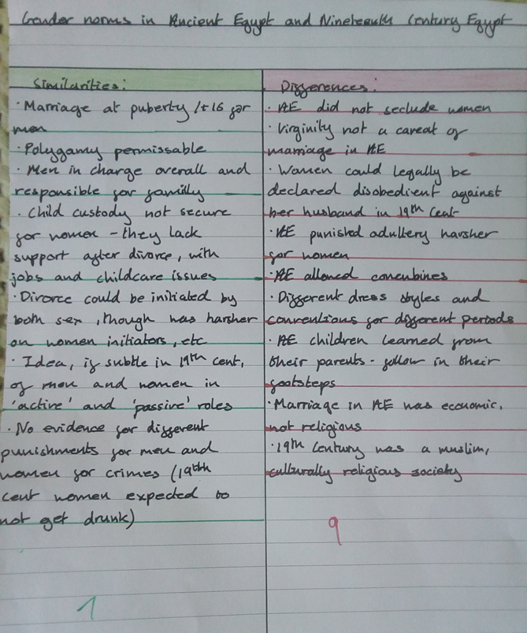 Image 1
Table of similarities and differences in the gender norms of Ancient Egypt and Nineteenth Century Egypt

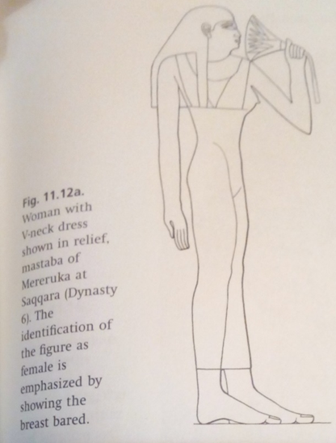Image 2 (Brewer, 2007),

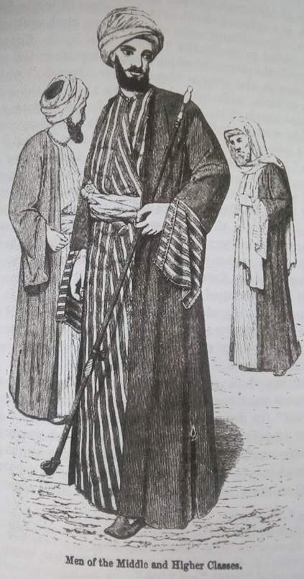Image 3 (Lane,1871)

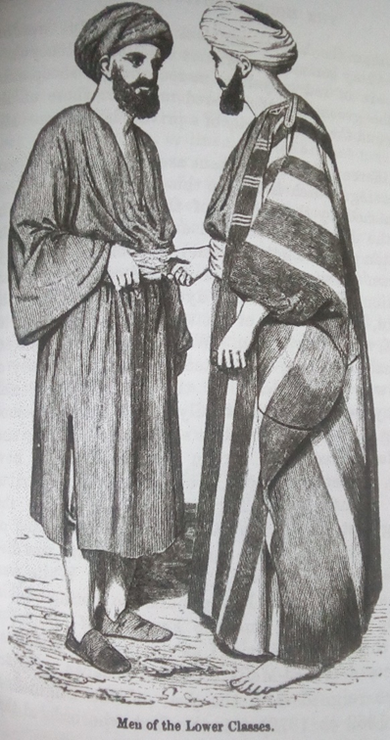Image 4 (Lane,1871)

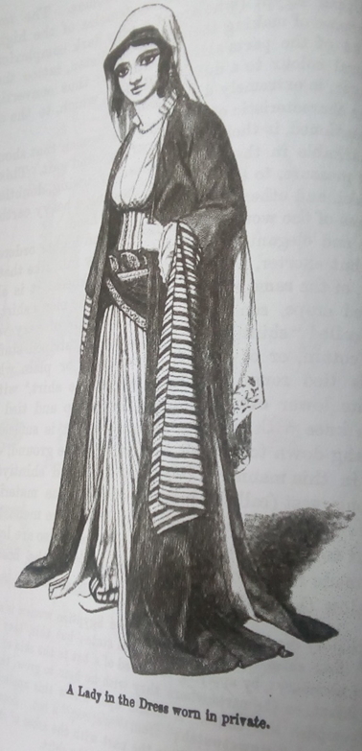Image 5 (Lane,1871)

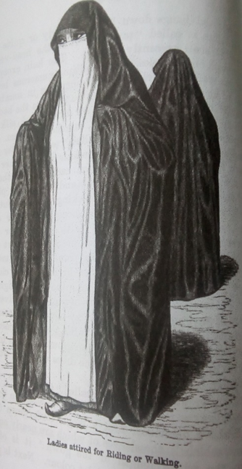Image 6 (Lane,1871)
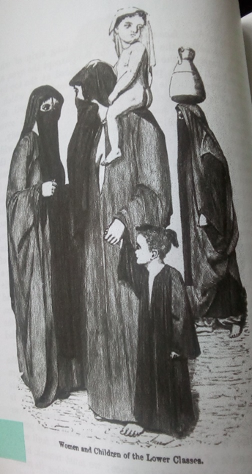Image 7 (Lane,1871)

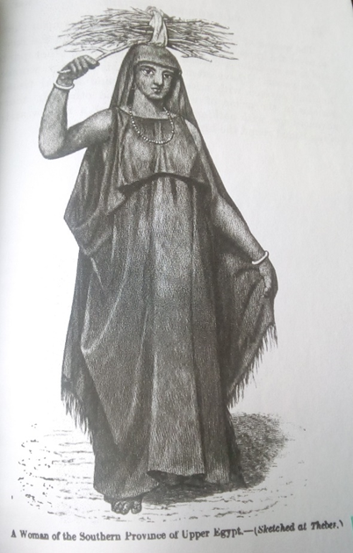Image 8 (Lane,1871)

Bibliography

Booth, C., 2007. People of ancient Egypt, Stroud: Tempus.

Brewer, D.J. & Teeter, E., 2007. Egypt and the Egyptians 2nd ed., Cambridge Univ. Pr.

Harris, J.R., 1971. The legacy of Egypt 2nd ed., Oxford: Clarendon Press.

Husain, E., 2019. The house of Islam: a global history, London, England: Bloomsbury Publishing.

Lane, E.W., 1871. Account of the manners and customs of the modern Egyptians volume 1, Stamford street and Charing cross, London: William Clowes and Sons.

McDowell, A.G., 2010. Village life in ancient Egypt: laundry lists and love songs, Oxford: Oxford University Press.

Robins, G., 1993. Women in ancient Egypt, London: British Museum Press.
Chapter Ten: Images of women in literature and art

Tucker, J.E., 1985. Women in nineteenth-century Egypt, Cambridge: Cambridge University Press.

Watterson, Barbara. Women in Ancient Egypt. Amberley, 2013

