Module NaMe: Databases and Application Development
Module Code: ACCA5026
Lecturer: Suresh Shanmugasundaram
Trinity saint david University of Wales (London Campus)
15/12/2025
BSc/HND Computing Portfolio
Student Name: Eric Marinho Nazare
Student ID: 2223750


Table of Contents
1. Overview 0
Database Architecture 0
Documentation of Implementation 0
Creation of Tables 0
INDEXING (Performance Tuning Requirement) 0
Insert Sample Data 0
Stored Procedures and Transactions 0
Testing the Transaction: 0
Features of Auditing (Triggers) 0
Optimising Performance (Indexing) 0
Supporting Literature for Design and Implementation Choices 0
Final Thoughts and Conclusion 0
Upcoming Enhancements 0
References 0
PART B 0
SQL Injection 0
Determining Susceptibility in Erc3Sports 0
Anti-SQL Injection Defence Implementation 0
Examining Effectiveness: 0
Validation and Testing 0
References 0

1. Overview
The University Students' Union's ineffective paper-based system was replaced with the Campus Club Management System (CCMS). Centralising information about clubs, student memberships, and event planning was the aim. The database design decisions [1], the normalisation procedure, and sophisticated implementation features like transactions and triggers that guarantee data integrity [2] are described in this study.

Database Architecture
In accordance with traditional relational database concepts, I normalised the schema to the Third Normal Form (3NF) to ensure the database is effective and free from redundancy [7].
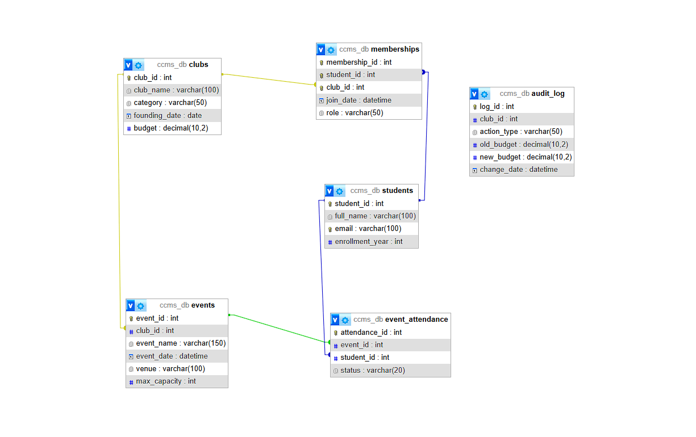

Design Choices:
I made the memberships table to fix this Many-to-Many relationship. By eliminating repetitive groups and guaranteeing that every attribute depends on the primary key, this fulfils 3NF [4].
Documentation of Implementation
MySQL was used to implement the database. Screenshots of the table structures and sample data are provided below as proof.

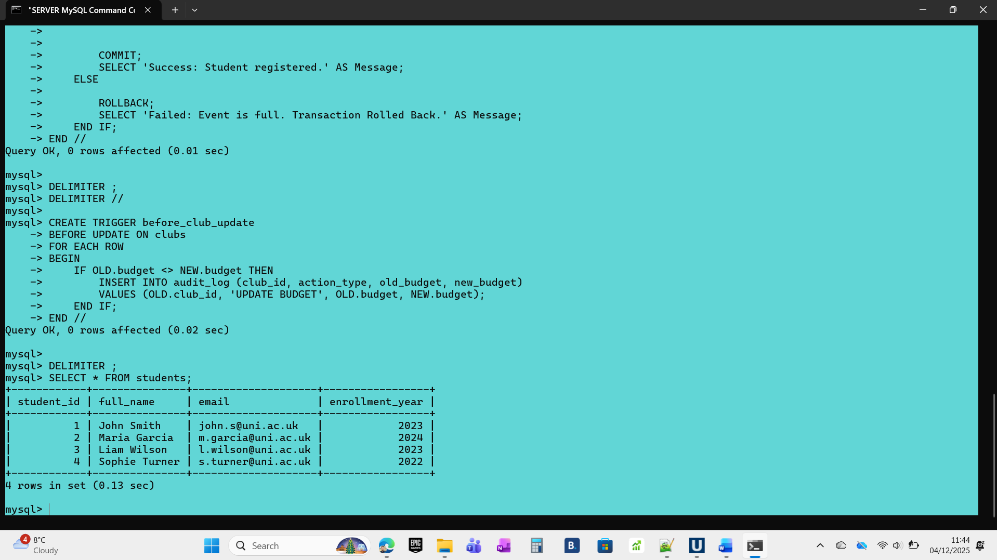

Creation of Tables
The Data Definition Language (DDL) in SQL was used to create the tables. To preserve referential integrity, restrictions like PRIMARY KEY, FOREIGN KEY, and NOT NULL were rigorously enforced.[2]

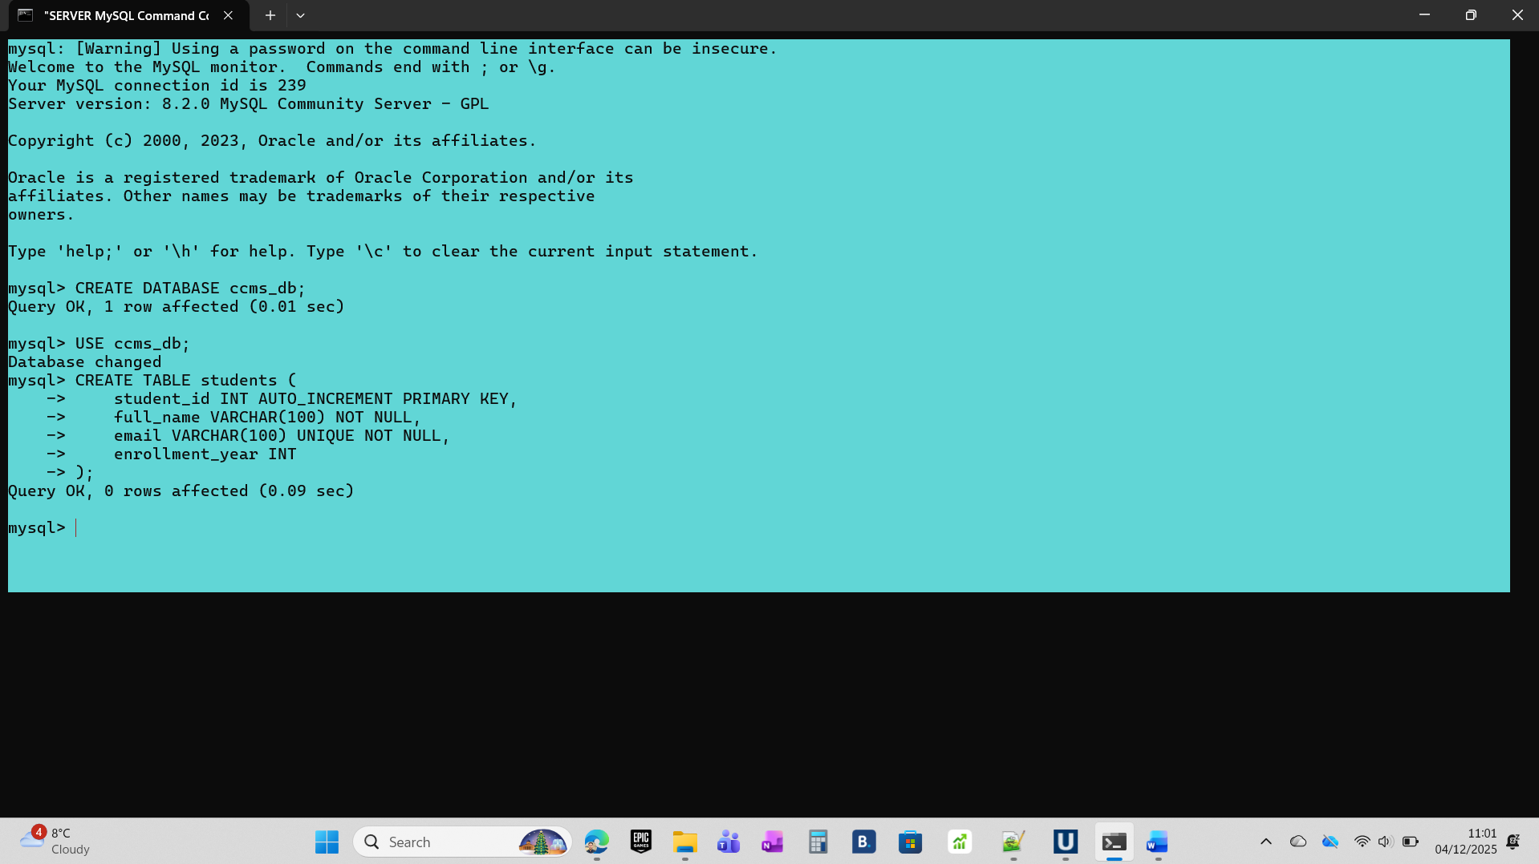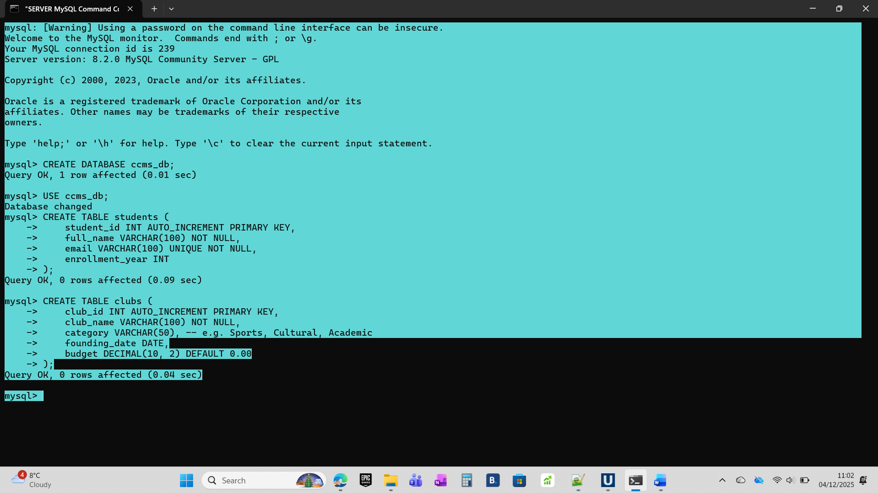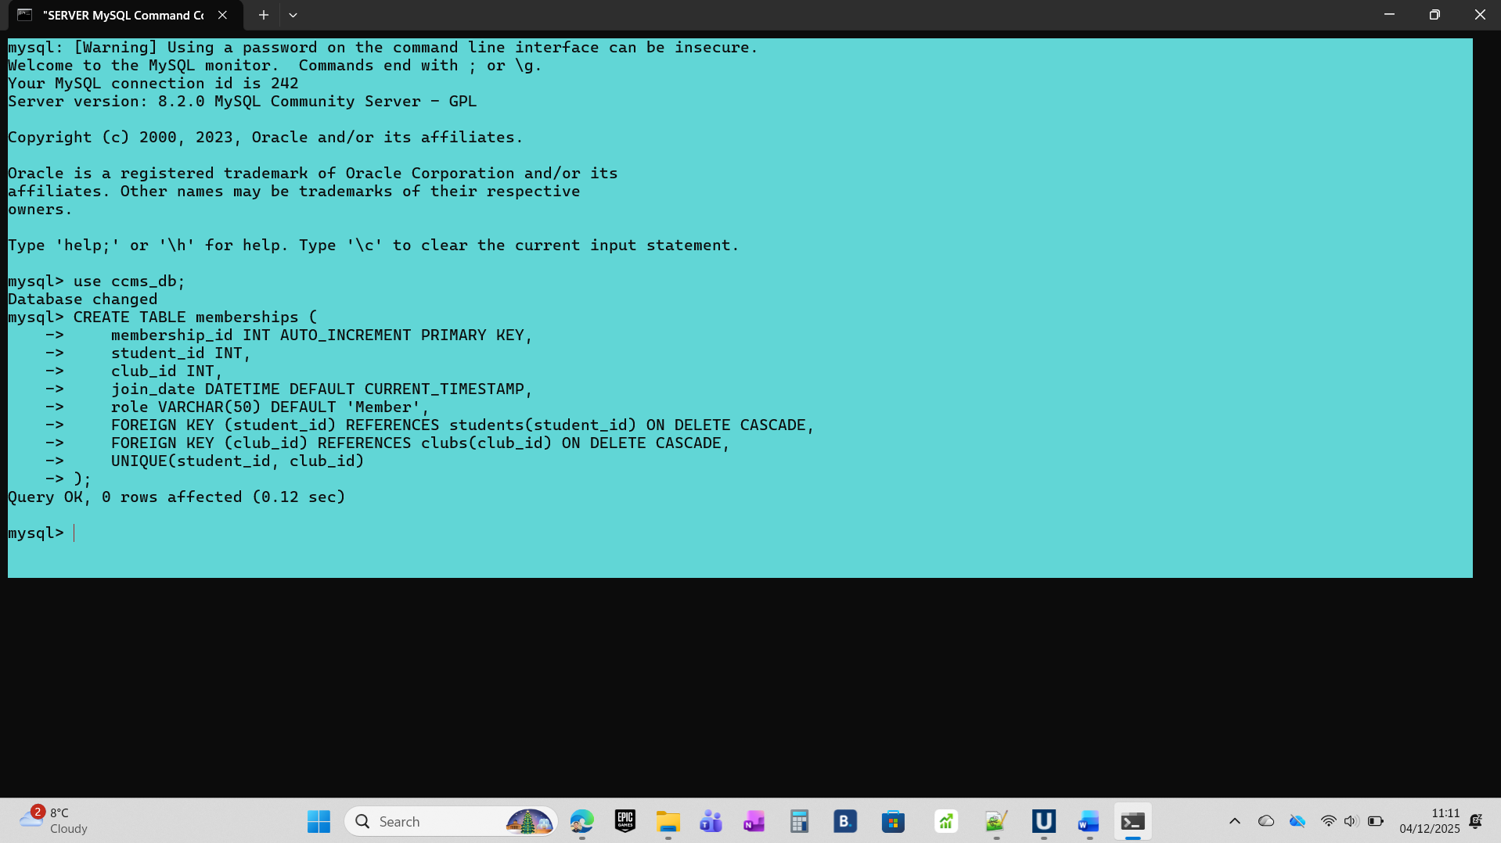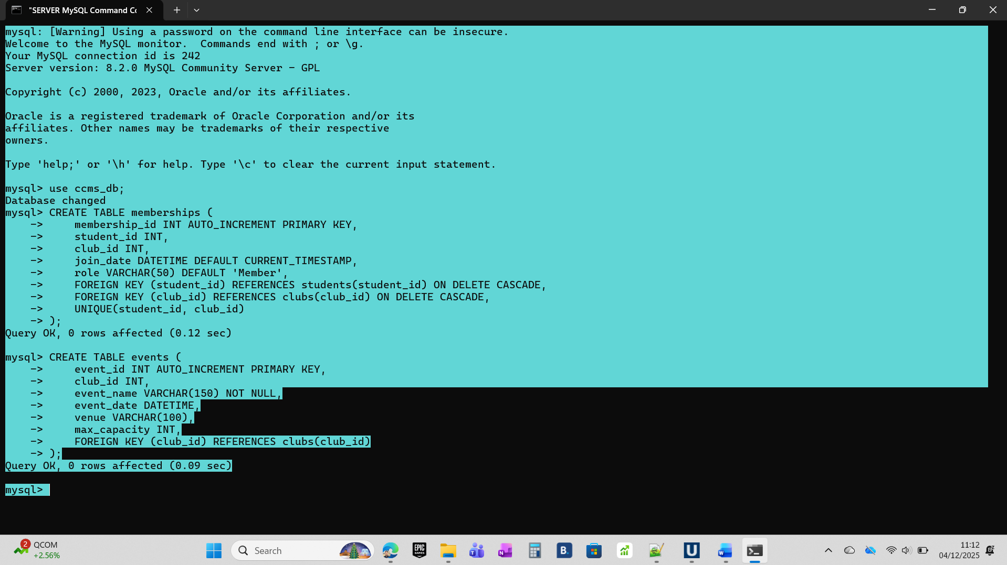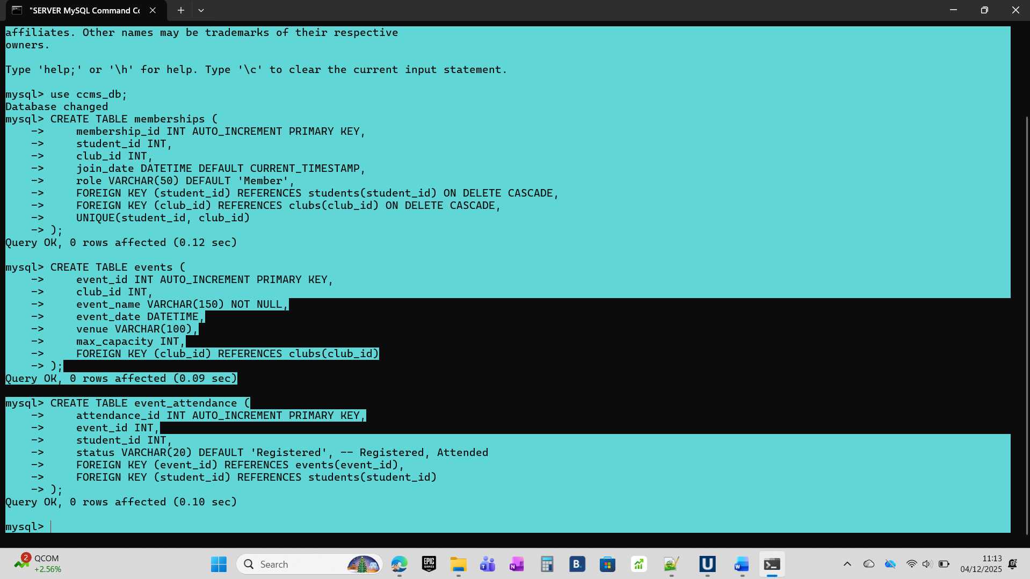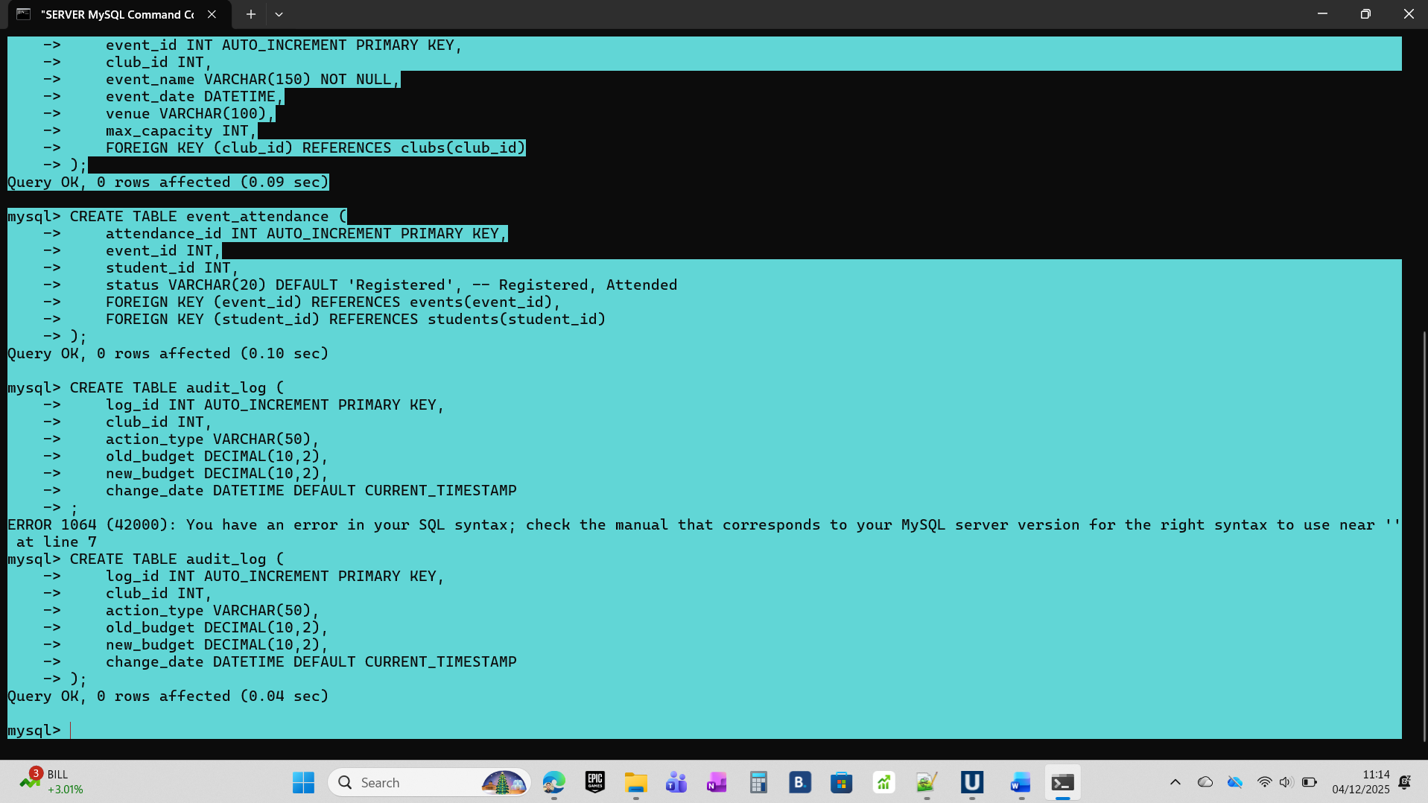

INDEXING (Performance Tuning Requirement)
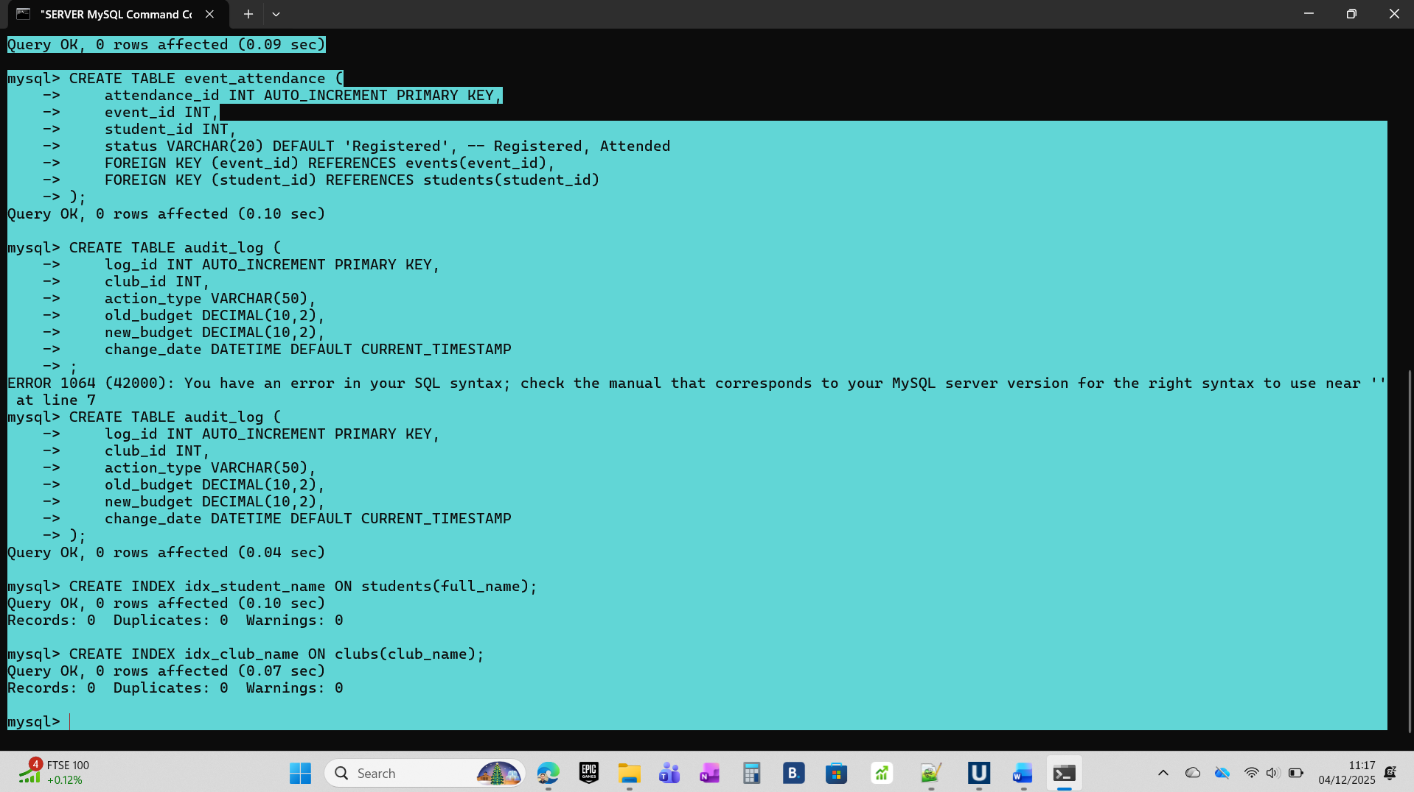

Insert Sample Data
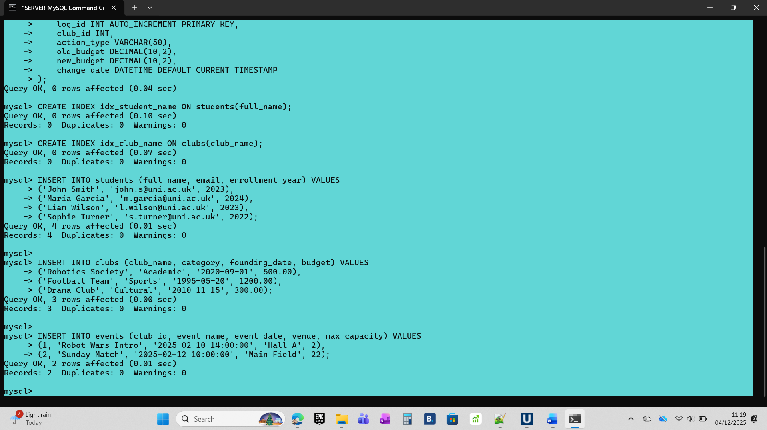

Stored Procedures and Transactions
To manage event registrations securely, I implemented a Stored Procedure called RegisterForEvent [3]. This procedure uses a Transaction to ensure the database remains in a consistent state, adhering to the ACID (Atomicity, Consistency, Isolation, Durability) properties described by A. Silberschatz. [5]
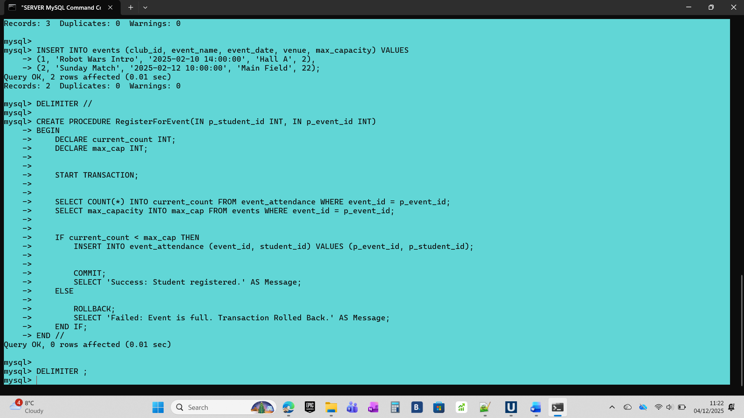

Testing the Transaction:
I attempted to register 3 students for the "Robot Wars Workshop", which has a capacity of only 2.
- Student 1: Success.
- Student 2: Success.
- Student 3: Failed (Rolled Back).
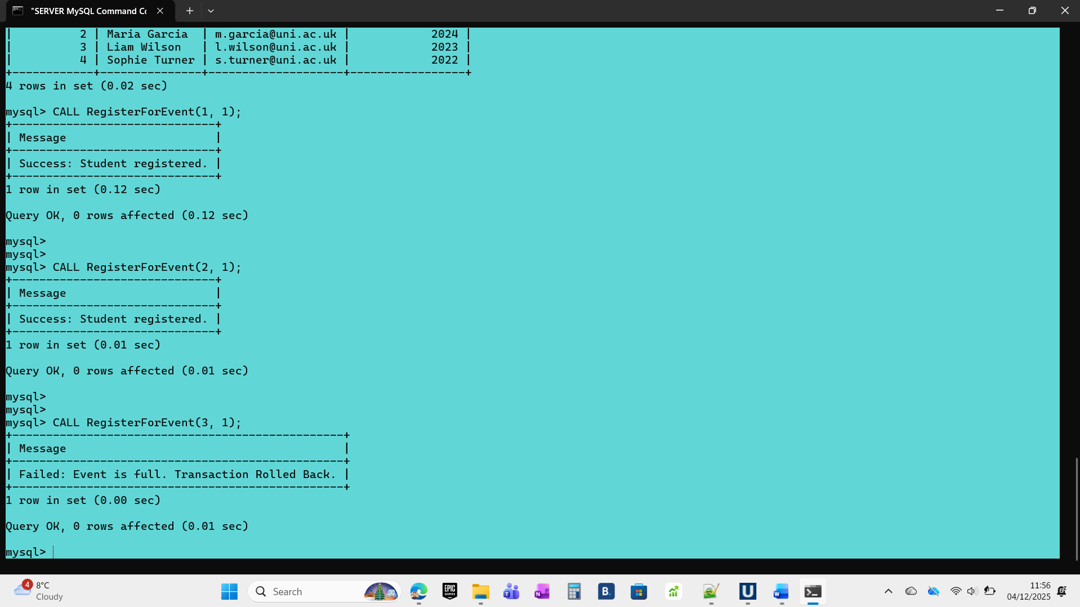

Features of Auditing (Triggers)
For financial data, data security is essential. I put in place a trigger called before_budget_update. Every time an administrator modifies a club's budget, this trigger is triggered automatically. Both the old and new budgets are recorded in a different audit log database.
Examining the Trigger.
I executed the SQL command: UPDATE clubs with a budget of $1,000.00 where club_id = 1. The audit_log table is automatically recording this modification, as seen in the snapshot below.[6]
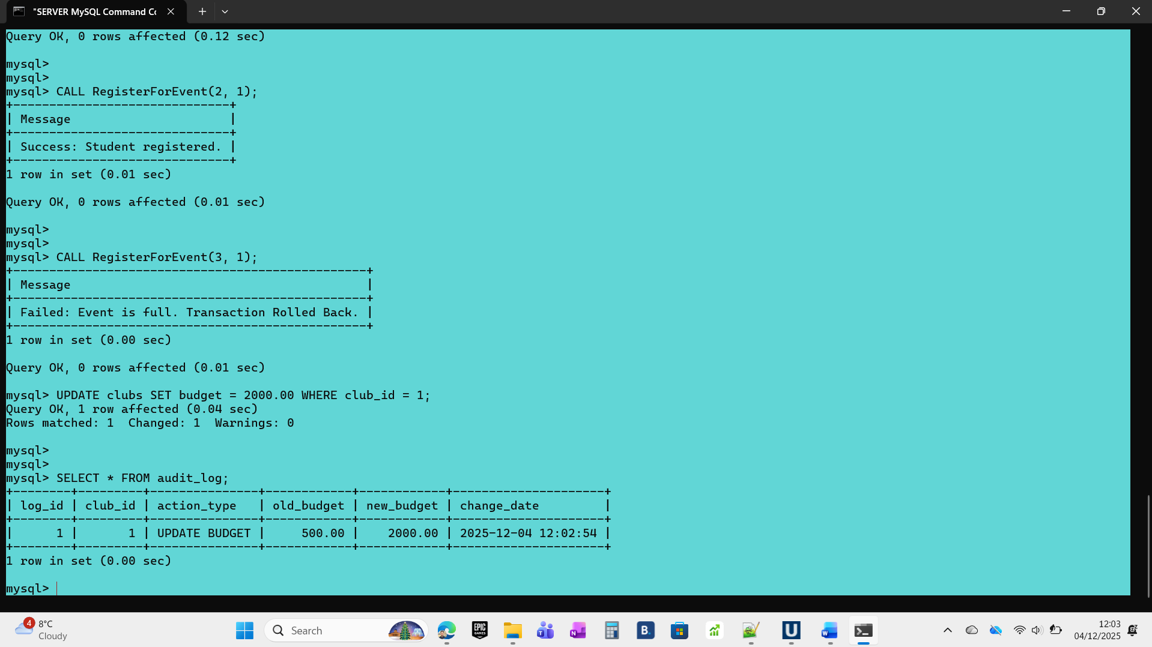
Optimising Performance (Indexing)
I used Secondary Indexes to increase the application's speed.
Students (full_name) index: The Student Union regularly looks up people by name. The database would execute a "Full Table Scan" (reading every row) in the absence of an index. A B-Tree index makes the search instantaneous.
Clubs (category) index: enables quick club filtering (e.g., displaying all "Sports" clubs).

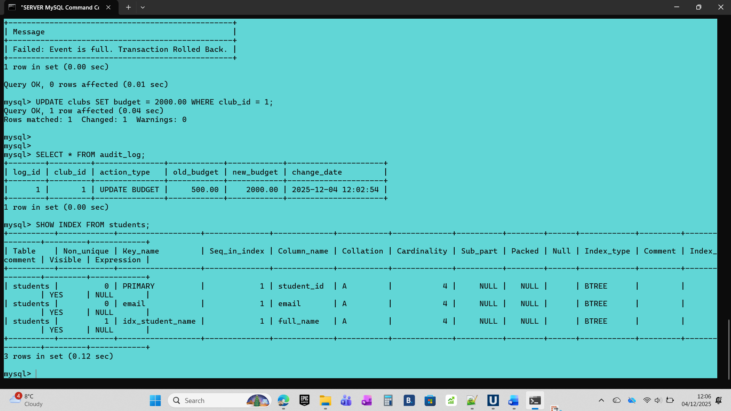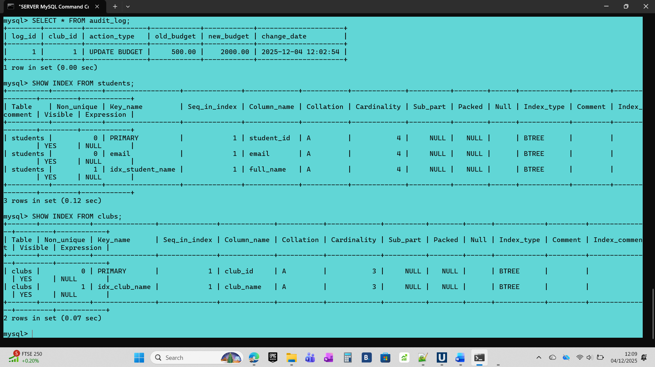
Supporting Literature for Design and Implementation Choices
Transaction Integrity (ACID Properties)
To encapsulate changes to mission-critical data in the CCMS, stored procedures were put in place. This strategy was selected to rigorously uphold the ACID principles (Atomicity, Consistency, Isolation, and Durability) of the database system—a key idea in dependable database architecture [5].
Commit and Rollback: The commands START TRANSACTION, COMMIT, and ROLLBACK are crucial for ensuring Atomicity. Only the COMMIT command permanently records all changes made inside the transaction block. On the other hand, the ROLLBACK instruction is activated if any step in the transaction fails, such as trying to register a student for a full event. This prevents data inconsistency by ensuring that the database reverts to its pre-transaction state [1].
Stored Procedures and Triggers
Stored Procedures (SPs): Due to their centralisation of business logic, SPs were preferred for data manipulation. Because the client application just transmits the procedure name rather than long SQL statements, SPs minimise network bandwidth, as mentioned in the MySQL documentation [3]. Additionally, by limiting direct table access, SPs enhance security.
Triggers: Triggers are crucial for the execution of non-bypassable business rules, such auditing. The inclusion of the auditing trigger ensures the data's durability and traceability by automatically storing changes (particularly, updates to the clubs budget) into a distinct audit_log table [6].
Reference Integrity (Foreign Keys)
The technique used to maintain the proper link between tables is called referential integrity. Foreign Keys (FKs), such the club_id in the events table, were defined throughout the schema to do this [2]. Because it stops the formation of "orphaned" records (such as an event linked to a nonexistent club), this approach is essential for data consistency [7].
Indexing Techniques and Optimising Queries
To enhance database performance, secondary indexes were purposefully created. By allowing the database to locate data rows directly without carrying out a "Full Table Scan," indexing aims to expedite data retrieval [4].
Implementation: Indexes were created for frequently used search and filtering columns, such as full_name in the students table and category in the clubs table. The research, which claims that B-Tree indexes greatly increase WHERE clause speed for high-cardinality data, supports this choice [4].

Final Thoughts and Conclusion
An overview of the solution
In conclusion, the Students' Union's data fragmentation problems are successfully resolved by the Campus Club Management System (CCMS). The method removes redundant data and guarantees consistency by centralising club activities and normalising the schema to the Third Normal Form (3NF). While Triggers guarantee accountability through automated financial auditing, Stored Procedures with transaction control offer a strong method for handling high-concurrency operations, such as event registration.
Contemplation of Difficulties
When considering the implementation, optimising the event_attendance table for transactional integrity was the most technical hurdle. Because the RegisterForEvent stored procedure depends on quick INSERT operations, I was worried that too much indexing might raise write latency and perhaps result in transaction locks during the COMMIT stage. To fix this, I concentrated optimisation efforts on high-cardinality read-heavy columns rather than indexing volatile columns like clubs, budget, which are regularly adjusted by the audit trigger. I used B-Tree indexes on clubs. category and students.full_name to handle the Union's most popular search patterns without sacrificing data entry performance.
Upcoming Enhancements
In the future, the system might be improved even more. Event and budget logic is now handled by the database, but future versions may incorporate Role-Based Access Control (RBAC) directly into the database to manage varying degrees of authority for Club Presidents compared to other members. Better insights into trends in student participation over time may also be obtained by extending the schema to capture comprehensive attendance metrics.

References
[1] T. Connolly and C. Begg, Database Systems: A Practical Approach to Design, Implementation, and Management, 6th ed. Harlow: Pearson, 2015.
[2] R. Elmasri and S. Navathe, Fundamentals of Database Systems, 7th ed. Hoboken: Pearson, 2016.
[3] Oracle Corporation, "MySQL 8.0 Reference Manual: Stored Procedures and Functions," dev.mysql.com, 2024. [Online]. Available: https://dev.mysql.com/doc/refman/8.0/en/stored-programs-views.html. Accessed: Dec. 4, 2025.
[4] C. Coronel and S. Morris, Database Systems: Design, Implementation, & Management, 13th ed. Boston: Cengage Learning, 2019.
[5] A. Silberschatz, H. F. Korth, and S. Sudarshan, Database System Concepts, 7th ed. New York: McGraw-Hill, 2020.
[6] Oracle Corporation, "Trigger Syntax and Examples," dev.mysql.com, 2024. [Online]. Available: https://dev.mysql.com/doc/refman/8.0/en/trigger-syntax.html. Accessed: Dec. 4, 2025.
[7] C. J. Date, An Introduction to Database Systems, 8th ed. Boston: Addison-Wesley, 2004.

PART B
SQL Injection
One of the most common and dangerous web security flaws is SQL Injection (SQLi). It happens when a web application takes user input, like a search term, username, or URL parameter, and inserts it straight into a database command string without doing the necessary sanitisation or validation.
The main issue with SQL Injection is that it enables the database engine to interpret untrusted user data as executable code. When an application is vulnerable, the database is unable to discern between the malicious commands injected by a hacker and the legitimate query logic defined by the developer.
If a SQL Injection attack is successful, the repercussions are dire:
Unauthorised Access: Attackers can get around authentication methods by, for example, logging in as an administrator without a password.
Data Theft: It is possible to obtain private information, including passwords, customer emails, and inventory prices. [1]
Data Integrity Loss: Attackers can alter data or erase the entire database by using destructive commands like DROP TABLE.
The "tautology" attack is a well-known illustration of SQL Injection. An attacker may enter ' OR '1'='1' if a login query checks WHERE username = '$user'. The database returns every record because 1=1 is always true, thereby logging the attacker in as the first user in the table (typically the Admin).[4]
Determining Susceptibility in Erc3Sports
During the creation of the Erc3Sports Inventory website, I found that the main dashboard's "Search" feature (index.php) was the main vulnerability. In order to filter results by Team, Category, or Colour, this feature takes text input. [2]
The code would resemble the fictitious example below if I had created this feature using outdated PHP coding standards, namely direct string concatenation:
// VULNERABLE CODE EXAMPLE (NOT USED)
$keyword = $_GET['search'];
$sql = "SELECT * FROM inventory WHERE team_name LIKE '%" . $keyword . "%'";
$result = $conn->query($sql);
The user's input is "glued" straight into the SQL command in this unsafe situation. The query's logic would change if a user entered a malicious string.

Anti-SQL Injection Defence Implementation
I decided to use PDO (PHP Data Objects) Prepared Statements to reduce this risk and guarantee the security of the Erc3Sports system. This is considered the industry standard for preventing SQL Injection in modern PHP applications. [3]
I went over my index.php code again and put the defence into practice, as seen in the screenshot below:
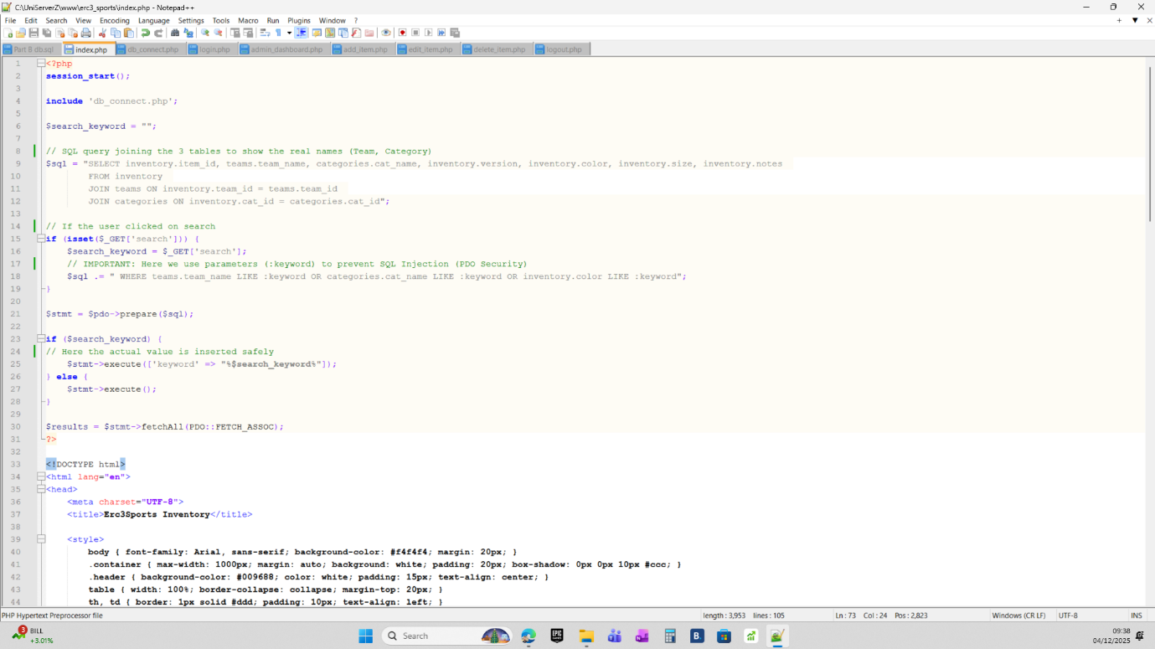

Examining Effectiveness:
I used the prepare() method with a named placeholder (:keyword), as can be seen in the code above. This defence works because Prepared Statements keep the user-supplied data and the SQL code structure apart.
First, the SQL query structure (SELECT... WHERE... LIKE :keyword) is compiled by the database.
Execution: The user's input is sent to the database separately as a literal value when $stmt->execute() is called.
The attack is neutralised because the database always treats the input as text data rather than executable code. The database will just look for a shirt with that particular name, even if the input contains SQL commands.

Validation and Testing
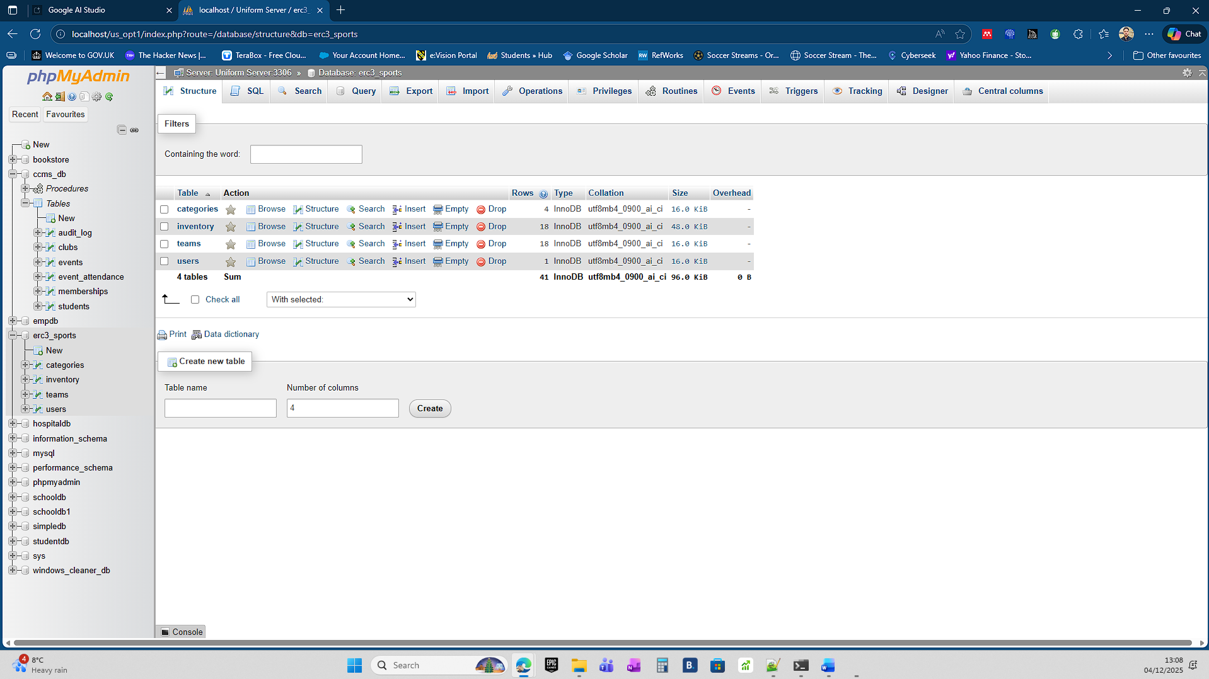
Typical System Performance
I made sure the system was properly showing the inventory and connected to the database before running the security test, as seen below:
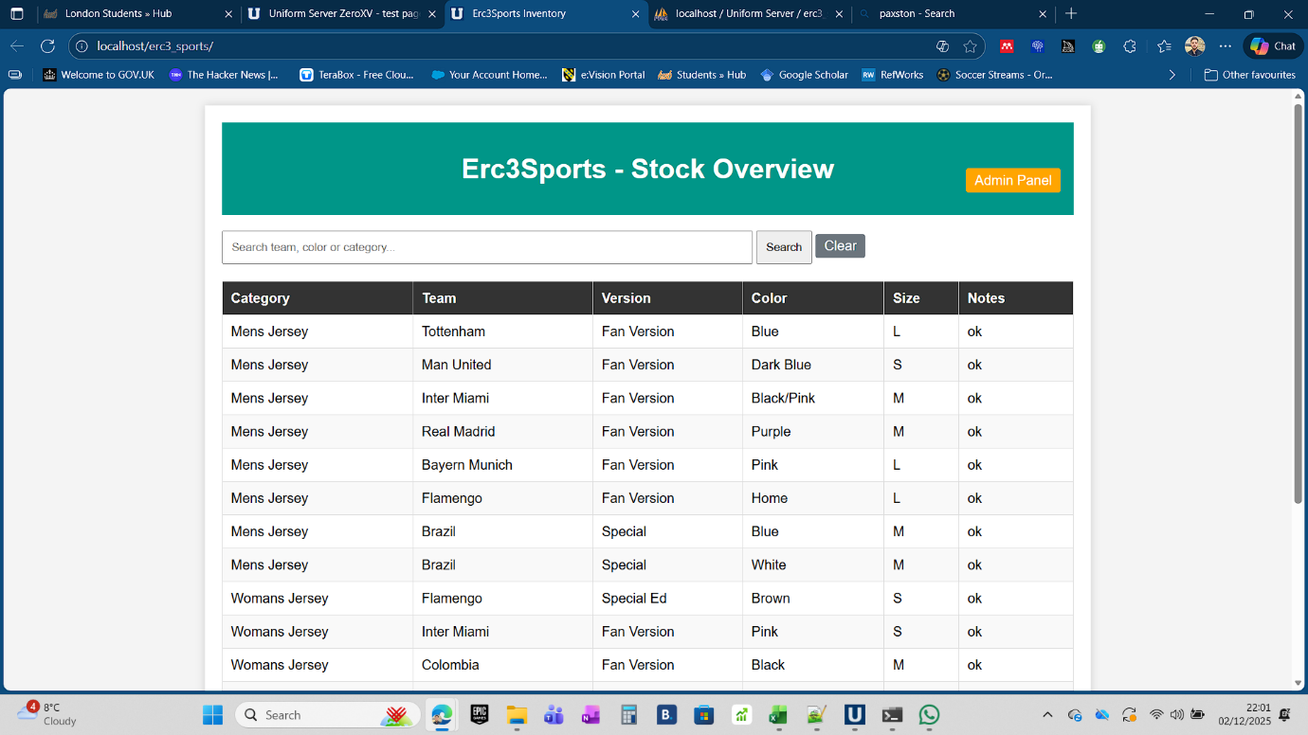

I conducted a manual penetration test on the live Erc3Sports website running on my local UniServer to confirm that my defences were operating as intended.
' OR '1'='1' is a popular SQL attack text that I tried to inject. Because the condition is logically true, this would fool the database on a vulnerable system into displaying every item in the table.
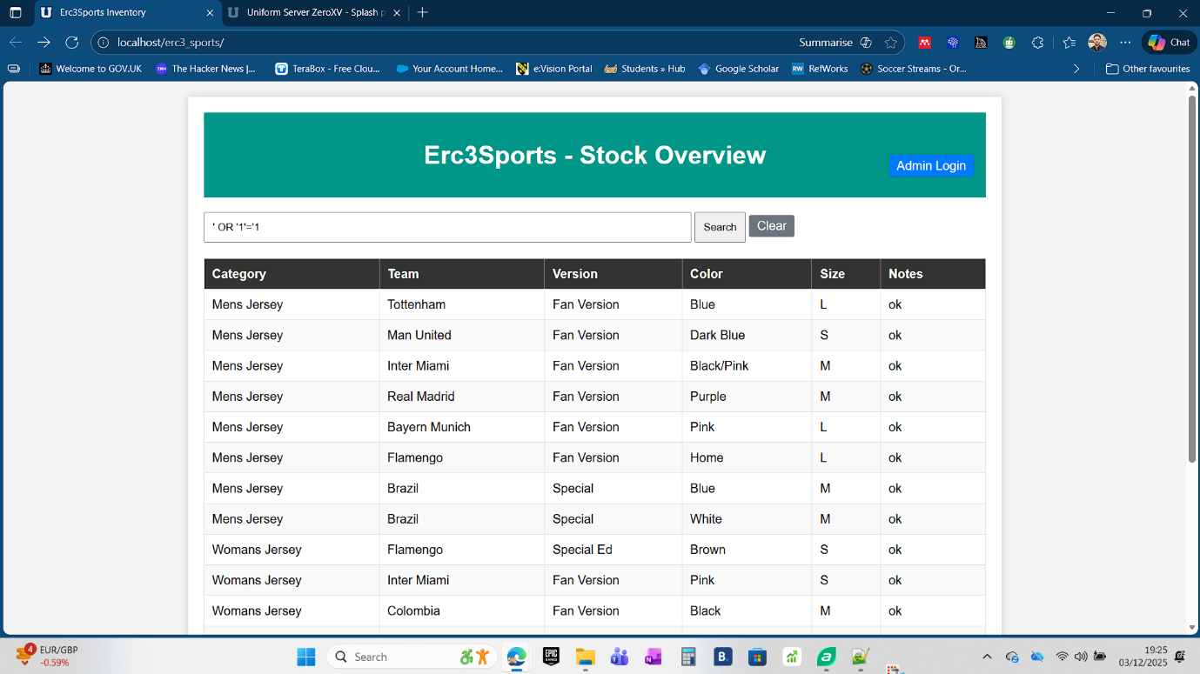
I executed the search, and the result is shown below:


Results: The program successfully stopped the attack, as shown in the screenshots. The system logic held steady rather than crashing or dumping the entire database. It looked for a team or colour that was literally titled ' OR '1'='1. It appropriately returned an empty result set because the database contains no such item. This demonstrates that the application has been successfully secured by the PDO Prepared Statements.

References
[1] OWASP Foundation, "SQL Injection," owasp.org, 2021. [Online]. Available: https://owasp.org/www-community/attacks/SQL_Injection. [Accessed: Dec. 4, 2025].
[2] L. Ullman, PHP and MySQL for Dynamic Web Sites: Visual QuickPro Guide, 5th ed. Berkeley: Peachpit Press, 2017.
[3] The PHP Group, "PHP: PDO::prepare - Manual," php.net, 2024. [Online]. Available: https://www.php.net/manual/en/pdo.prepare.php. [Accessed: Dec. 4, 2025].
[4] J. Clarke, SQL Injection Attacks and Defense, 2nd ed. Burlington: Syngress, 2012.

