University of Wales Trinity Saint David

Level 4 Engineering Skills Technical Report

Module code: ACHA4022A

Author: Joshua O’Rourke
Student ID: 2501321
Lecturer: Dr Kerry Tudor


Report Due Date: 07/12/2025

Contents
Introduction 2
Health and Safety 3
Security Risk Matrix 5
Engineers Role in Society 7
Problem Solving 8
Team Structure 9
Conclusion 11
Reference List 12

Introduction
This technical report will cover the risks and challenges found within an engineering workplace, presenting an overview of how to mitigate them. Additionally, the report will discuss engineers’ roles in society and how a team structure can make companies successful. In the modern day of automotive manufacturing, there is a variety of factors that come into the production of transport: problem solving, health and safety, sustainability and environmental impacts, and team dynamics. These must all be taken into consideration and this report will dive into the processes of covering all of these factors.

Health and Safety
Using the machine shop at university as an example, there are several factors that need to be considered in regards to health and safety. Before being allowed into the workshop, a health and safety induction form is required to be read and a test is to be taken at the end. Within the induction, relevant workshop safety information is delivered; including ‘WISA workshop rules’, signage meanings, and various videos about safety in the workshop. All of the machines in the workshop are only to be used alone when a person is competent and trained in the use and function of the particular machine, and also familiar with the machines health and safety legislations. Health and safety legislations, such as HSWA (1974) and COSHH (2002), are important legal laws created for employers to manage risks in the workplace, and to keep individuals safe. (State, 1998)

The use of a lathe is guided by the Provision and Use of Work Equipment Regulations 1998 legislation. An example of where a lathe falls under these regulations can be found in section 11, it states that “every employer shall ensure that measures are taken in accordance with paragraph (2) which are effective... to prevent access to any dangerous part of machinery or to any rotating stock bar;” (stock bar being part of the lathe). This relates to how a lathe has a safety function in which it will only be able to be operated once the protective lid is covering the chock. (State, 1998)

Below is a risk assessment for use of the lathe in the workshop.
Hazard | Risks | PPE required | Mitigation options
Swarf being spat out towards operator. | Cuts from sharp metal.  Blindness if caught in eyes. | Safety goggles.  Lab coat. | Install a protective screen.
Workpiece dropped when taking out of lathe. | Damage to toes or feet.  Damage to lathe. | Steal toecap boots. | Use a rag to wipe the workpiece to remove any debris or liquid. Take care when loosening the chock.
Getting caught in machine when in operation. | Severe injuries if arm gets caught in lathe during operation. | Safety goggles.  Lab coat. | Use emergency stop.  Be aware of sleeves of lab coat.  Stand in a safe position when operating.
Workpiece coming out when lathe is in operation. | Damage to the lathe.  Injury to user. | Safety goggles.  Lab coat.  Steal toecap boots. | Double check workpiece is fully tightened in place before operation.  Protective screen.

Security Risk Matrix
A risk matrix is used to determine the impact of an incident or threat in the workplace and in the wider world. Below is a simple risk matrix, indicating how the likelihood (rows) and the impact (columns) show the level of risk an incident has. Threats do not have to be physical, some risks come from cyber attacks or malware, however this does not necessarily mean they have lower impacts. A risk matrix is useful as it helps determine which risks need attention first, the higher the risk, the more important it is to be mitigated.

Impact  Likelihood  ↓ | Negligible | Low | Moderate | High | Severe
Very High
High |  | Mobile Equipment
Medium |  |  | Relay Theft |  | Cyber Attack
Low
Very Low |  |  |  |  | AEB

The matrix has a mixture of physical and digital risks, with the colour box they are in denoting the risk factor; green bring low risk, orange as medium risk, and red as high risk.
The first risk example is the Jaguar Land Rover cyber attack in mid 2025, in which a hacker group forced JLR to shut down major IT systems after invading their digital operations. This caused a huge monetary loss and put many jobs at jeopardy.
(Security, 2025)
The second risk example is keyless car entries. Many modern car keys make use of keyless fobs to start, unlock and lock cars. This poses a threat to consumers as thieves use a technique called ‘relay theft’ where the signal used from the key is intercepted and amplified to unlock the car. This can happen even when the key fob is inside a house and the car is parked on the drive.
(keysNews, 2024)
The third risk is mobile equipment in industry. Mobile equipment such as forklifts and other small vehicles have a chance of malfunctioning or becoming a hazard if not used and maintained properly. The direct risks are falling loads, trip hazards to pedestrians, and damage to company property.
The fourth risk is sensor malfunctions on cars. Many modern cars make use of sensors throughout to reduce the amount of collisions on the road by detecting traffic, pedestrians, and other obstacles. Braking sensors work by utilising an array of ultrasonic sensors, radar, cameras and more to identify obstacles on the road. A risk with these Autonomous Emergency Braking (AEB) systems is that if they fail, it could cause serious and potentially fatal collisions. (RAC, 2023)

Engineers Role in Society
Engineering companies make use of codes of conducts that are to be followed to ensure the welfare of employees, environment and the integrity of the company is prioritised. Without a code of conduct, an organisation can topple with no ethical behaviours, leading to conflict, legal risks, and no clear rules or regulations.
The organisation Engineering Council have a published online code of conduct, in which they label 4 specific principles:
- Honesty and integrity.
- Respect for life, law, the environment and public good.
- Accuracy and rigor.
- Leadership and communication.
(Council, 2017)
Specifically looking at “Respect for life, law, the environment and public good”, the Engineering Council believes that engineers should “[protect] the quality of built and natural environments.” As well as the obvious benefit of protecting the environment, this attributes to public relations, as contributing to the preservation of nature is valuable to providing healthy living standards.

Another organisation that has a published code of conduct is Formula 1, who express the significance of sustainability, with a goal of a Net Zero carbon footprint by 2030. This sustainability regulation is implemented to ensure F1 race teams do their part to minimise emissions and environmental impact. For F1 in particular, controversy on the sustainability of the races and manufacture of the cars is high, so it is stated that all teams must be compliant with the F1 Sustainability Strategy. By completing many tasks remotely, using renewable energy, and other techniques to maximise sustainability, the carbon footprint of Formula 1 is massively reduce. (F1, 2025)

Problem Solving
An integral part of engineering is being able to problem solve, particularly in a collaboration when developing products. There are different methods to use when problem solving, with one of the most common being flow charts. Problem solving flow charts can aid in finding the root of an issue during development by looking at where the problem occurred. Since many manufacturing processes are step by step, a flow chart will easily highlight where in the process the issue was raised. Flow charts also play a big part in helping to identify what actions need to take place in order for something else to happen. For instance, to manufacture a car, you must fit all of the bodywork before installing windows.
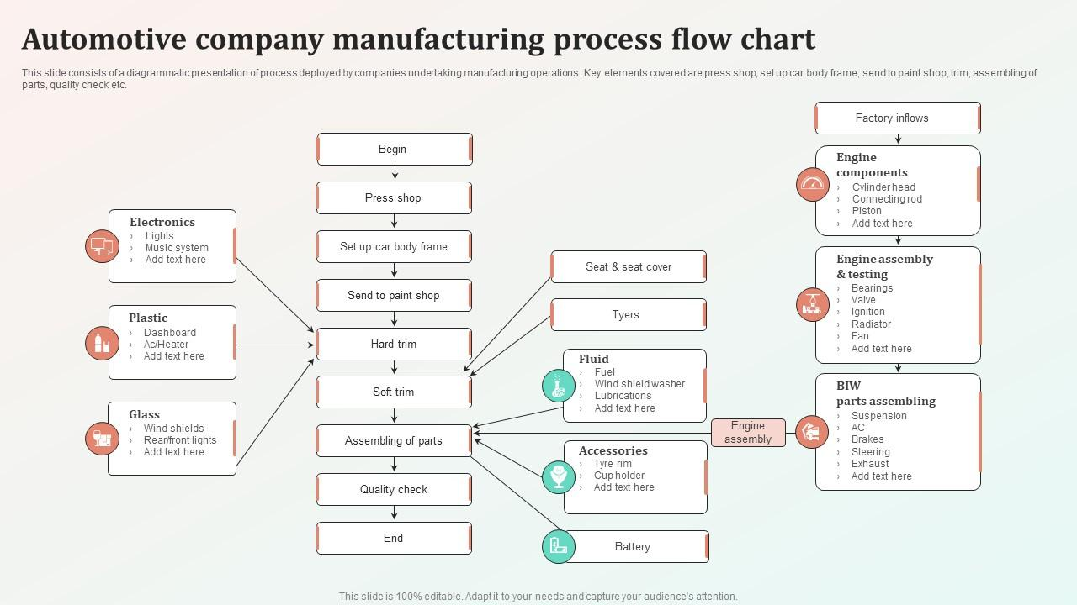
(SlideTeam, 2025)
The above flow chart is an example of the process of manufacturing an autonomous vehicle. This would be a similar process to many high production car manufactures, showing how each part of the operation has previous steps that need to be carried out, and also later steps that require a specific action to happen.
There are other problem solving methods that should not be overlooked, for example fault tree analysis. Fault tree analysis uses is a graphical method used to identify where a system has failed, this being the ‘TOP event’. This method can be used not only identify a failure, but also to predict when a failure might occur. Predicting issues in engineering is vital since it enables engineers to mitigate problems before they happen. (Andrews, 2025)

Team Structure
During college I was part of a group project that contributed to my final grade; our class was split into groups of four and our task was to design a robotic arm suitable to be mounted onto a rover in order to collect samples from the surface of mars. We used a modular team structure, having independent units for separate exercises, and aiding with flexibility and efficiency. My team divided out different tasks of the assignment to complete and create our final project, such as material research, finance, functionality and ergonomics. My role was to design the final prototype, using engineering drawings and CAD to create a small scale replica of the arm.
A positive aspect of our team structure was that the workload was divided out evenly so we weren’t overloaded, also meaning that our work wasn’t rushed, and completed to a good standard. We each took on parts of the assignment that we felt we were best at; for example, I am more proficient at designing products than researching materials and writing reports on finance.
A negative from our team structure would be not having a team leader. This meant that communication between members lacked, causing confusion about priorities and accountability. In addition, there was a mix up of roles, leading to unnecessary wasted time as multiple people did the same task. This was detrimental to our final report, putting strain on us to complete it in time.
We could have used a “flat team structure”, in which there is several employees that all report to one manager. This would have been more effective for communication and keeping track of progress. An explanation image is below to help visualise a flat team structure.
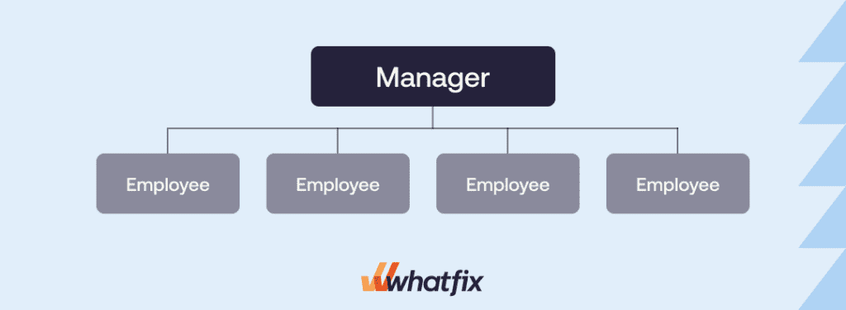
(Olmstead, 2025)
An issue with a flat team structure is if a team grows in numbers, responsibilities of each member can become confusing, compromising effectiveness of the structure.
If our team had more members, an alternative team structure may have been better suited, this being a Matrix organisational structure; where employees will have two different managers, one functional manager and one project manager. Having the two different managers will enable members to have feedback and guidance specifically for their individual task, creating less confusion of roles and better overall communication. (ChartHop, 2023)

Conclusion
This report has given an insight of how engineers use technical skills of a various manor to optimize the industry; highly regarding teamwork, problem solving, and sustainability, all while having proper health and safety regulations and legislations in place to provide a thriving workplace and environment. It has demonstrated how having the right health and safety measures directly impact a companies performance, and given examples of an engineers role in society – to be as beneficial to the environment and public as possible.

Reference List

Andrews, P. J., 2025. An Introduction to Fault Tree Analysis. [Online]
Available at: https://www.nottingham.ac.uk/research/groups/resilience-engineering/documents/nxgen/outputs/an-introduction-to-fault-tree-analysis.pdf
[Accessed 07 12 2025].
ChartHop, 2023. Organizational Structure Types You Should Know. [Online]
Available at: http://charthop.com/resources/org-structure-types#:~:text=1.,owns%20what%20in%20the%20business.
[Accessed 07 12 2025].
Council, E., 2017. Guidance on ethucal principles. [Online]
Available at: https://www.engc.org.uk/resources-and-guidance/guidance-for-the-profession/ethical-principles
[Accessed 07 12 2025].
F1, 2025. F1 Code of Conduct. [Online]
Available at: https://media.formula1.com/image/upload/v1701969109/content/dam/fom-website/manual/Misc/f1_code_of_conduct/F1_Code_of_Conduct_7_December_2023.pdf
[Accessed 05 12 2025].
IStructE, 2020. The Articles of the Code of Conduct and their principles. [Online]
Available at: https://www.istructe.org/about-us/istructe-code-of-conduct/#Articles%20of%20the%20Code%20and%20their%20principles
[Accessed 05 12 2025].
keysNews, C., 2024. What is keyless entry in a car?. [Online]
Available at: https://www.carkeyssolutions.co.uk/what-is-keyless-entry-in-a-car-security-risks-and-solutions/
[Accessed 05 12 2025].
Olmstead, L., 2025. 7 Types of Organizational Structures. [Online]
Available at: https://whatfix.com/blog/organizational-structure/#elementor-toc__heading-anchor-3
[Accessed 05 12 2025].
RAC, 2023. What are Anti-Lock Brakes and how to they work?. [Online]
Available at: https://www.rac.co.uk/drive/advice/road-safety/what-are-anti-lock-brakes-abs-and-how-do-they-work/
[Accessed 05 12 2025].
Security, P., 2025. JLR cyberattack. [Online]
Available at: https://www.pandasecurity.com/en/mediacenter/jlr-cyberattack-how-one-hack-devastated-britains-biggest-carmaker/
[Accessed 05 12 2025].
SlideTeam, 2025. Atomotive Company Manufacturing Process Flow Chart. [Online]
Available at: https://www.slideteam.net/automotive-company-manufacturing-process-flow-chart.html
[Accessed 07 12 2025].
State, S. o., 1998. The Provision and Use of Work Equipment Regulations 1998. [Online]
Available at: https://www.legislation.gov.uk/uksi/1998/2306/2018-07-30?utm_source=chatgpt.com
[Accessed 05 12 2025].
uwtsd, 2025. Workshop induction. [Online]
Available at: https://moodle.uwtsd.ac.uk/course/view.php?id=7024&section=1
[Accessed 05 12 2025].

