

Module Code: LCMB7003
Module Title: Strategic Management
Individual Report
Student Name: Dhruv Bhupendrabhai Solanki
Student ID: 2519348
Lecturer Name: Mr. Ghulam Mujtaba

Table of Contents
1. Organisation Overview 3
1.1 Industry Overview and Market Position 4
2. Internal and External Market Analysis 5
2.1 PESTEL Analysis 5
2.2 VRIO Analysis 9
2.3 SWOT Analysis 10
3. Comprehensive and Holistic View of the Organisation 12
3.1 CSR Strategy and Strategic Alignment 12
3.2 Balanced Scorecard for IKEA 13
4. Strategic Choices and Implementation 16
4.1 Strategic Choices 16
4.2 SAFe Framework Evaluation 16
4.3 Competitive Performance Analysis 17
4.4 Implementation Challenges and Mitigation 18
Section 2: Reflective Account 19
References 22

1. Organisation Overview
IKEA was started in 1943 by Ingvar Kamprad in the town of Älmhult, Sweden and has grown from a small mail-order company to one of the world's largest home furnishing retailers (IKEA, 2026). The company's self-assembly furniture concept was launched in 1953 allowing the firm to reduce transportation and production costs and provide customers with inexpensive furniture (IKEA, 2026). This business concept proved to be the key that enabled IKEA to expand globally and gain a competitive edge. Further, the IKEA brand is owned by Inter IKEA Group and most of the IKEA retail activities are handled by Ingka Group which uses a franchise system and has stores in many countries around the world.
IKEA's vision is to create a better everyday life for the many people and its business idea is to offer a wide range of well-designed and functional home furnishing products at low prices so that many people can afford them (IKEA, 2026). Besides the competing only through product quality or competitive pricing IKEA involves Scandinavian design, cost efficiency, large-scale sourcing, flat packing and customer self-service. Through its business model which combines product design, sustainable sourcing, global procurement, efficient logistics and the omnichannel retail approach the company can keep product prices low and ensure long-term environmental and social sustainability. In the financial year 2025, IKEA's retail network expanded with its 482 stores in 63 markets highlighting its wide reach and international presence (IKEA, 2025).
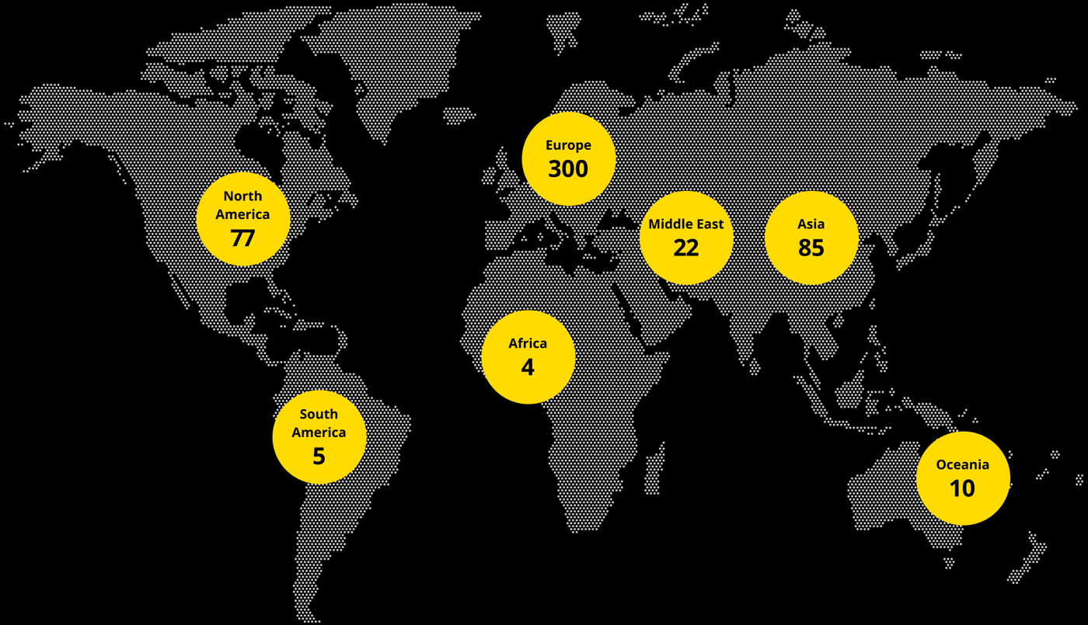
Figure 1: IKEA Stores Globally
(Source: IKEA, 2025)

1.1 Industry Overview and Market Position
The home furnishing and furniture retail sector is facing rapid changes with digitalisation, consumer tastes, preferences, sustainability, increasing costs of supply chains and IKEA are part of this global industry. Consumers demand affordable, sustainable and functional furnishings which has led retailers to adopt e-commerce, sustainability and new retail designs. Although inflation is impacting household spending in many economies, the demand for home improvement products is expected to be driven by urbanisation and a shift toward a more modern lifestyle. There are a number of other regional furniture retailers, online marketplaces and multinational retailers in certain product categories including Ashley Furniture, Wayfair, JYSK, Conforama and Home Depot. IKEA's unique value chain, distinctive Scandinavian product design, global supplier network, excellent sustainability strategy and cost leadership approach help in competitive advantage (IKEA, 2026).
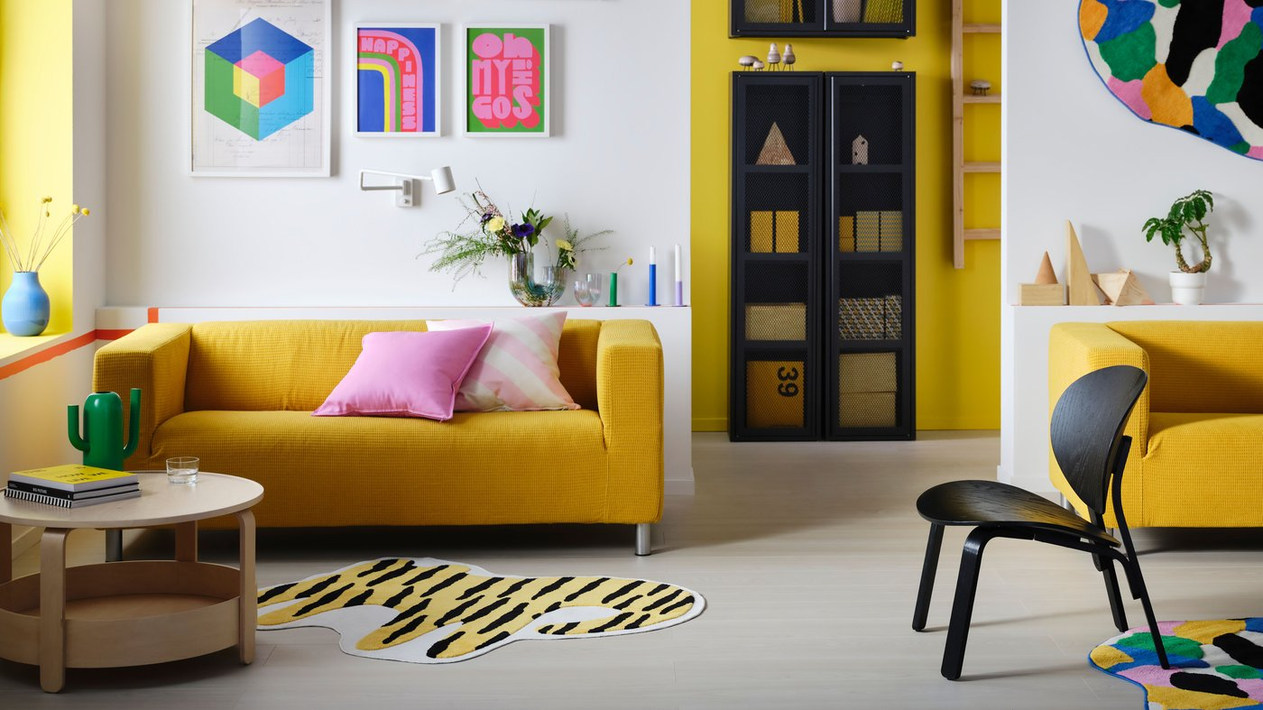
Figure 2: IKEA Scandinavian Product Design
(Source: IKEA, 2026)
The capabilities have facilitated the company's ability to maintain its market leadership despite growing competition from digital-first retail stores. IKEA experienced a robust increase in customer visitors to its stores by 822 million in FY22 and 4.3 billion visits to its digital platforms reflecting its robust omnichannel strategy and worldwide brand recognition (IKEA, 2022).

2. Internal and External Market Analysis

2.1 PESTEL Analysis
2.1.1 Political Factors
Political factors are important in determining the operations of IKEA as it is involved in sourcing materials, manufacturing products and servicing customers in many countries. Geopolitical conflicts have made shipping more expensive for global retailers with the Russia-Ukraine war and Red Sea shipping disruptions being two recent events that have caused delays in delivery times (Notteboom, et al., 2024). The developments have prompted IKEA to increase supply chain resilience by diversifying its sourcing and getting products from locally available suppliers. By investing in renewable energy, sustainable sourcing, and circular product design, IKEA is well-positioned to meet the evolving landscape of environmental regulations and build trust with its stakeholders (IKEA, 2024).
However, there are opportunities for IKEA's long-term growth from political support for climate action as well. Global government commitment to low-carbon economies is likely to see increased investment in clean energy reaching more than US$2.2 trillion by 2025, according to the International Energy Agency (IEA, 2026). These investments help drive businesses towards renewable energy and sustainable operations, closely aligned with IKEA's vision of becoming climate positive.
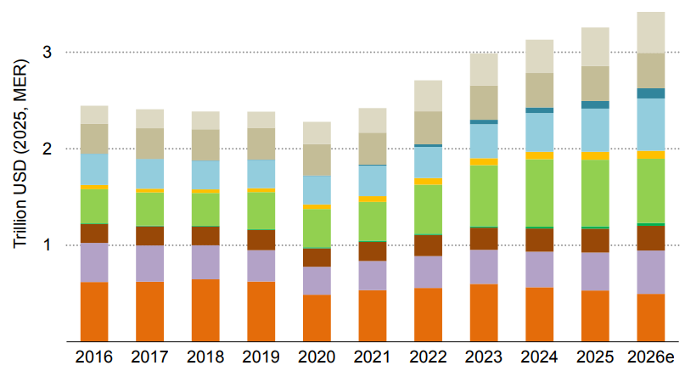
Figure 3: Investment in Energy during Economic and Geopolitical Conflicts
(Source: IEA, 2026)
2.1.2 Economic Factors
Demand for furniture is strongly linked to the household income, inflation, housing markets and consumer confidence which means that economic conditions have a significant impact on IKEA's performance. Global inflation has pressured retailers to deal with the higher prices for raw materials, transportation and energy which have challenged their operating margins. Additionally in 2026, the global inflation rate is 4.42% which is expected to decline by 3.2% in 2031 (Statista, 2026).
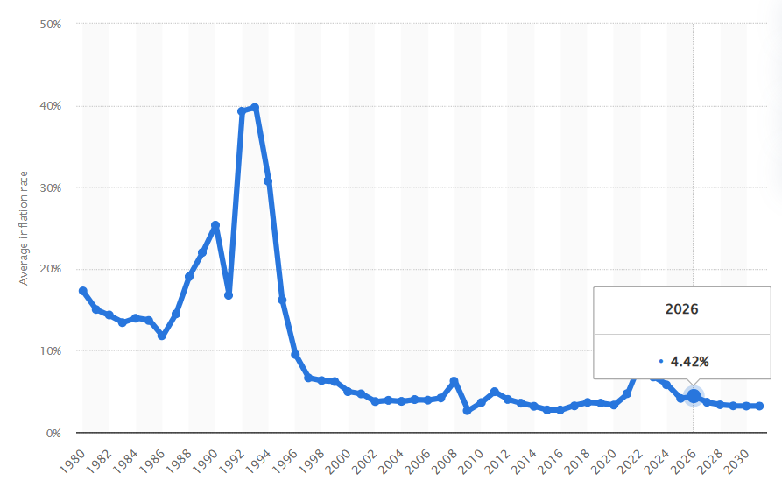
Figure 4: Global Inflation Rate
(Source: Statista, 2026)
Further the forecasted economic growth is at the level of 3.0% across the world in 2026 (IMF, 2026). When interest rates have increased and living expenses have decreased consumers have had less money to spend on their homes and are demanding affordable options when it comes to furniture. These economic factors pose both threats and opportunities to IKEA.
2.1.3 Social Factors
Consumers changing lifestyles and demographics are continuing to drive the transformation of the global furniture retail industry. The rising urbanisation is one of the factors that has a major impact on consumers purchasing trends along with the reduction of household size, hybrid working and an increased sense of responsibility for the environment. People are demanding home furnishings that are multifunctional, space-saving, environmentally friendly and can meet a variety of needs for flexible living. The rise in urbanisation with the United Nations estimating that around 68% of the world's population will live in cities by 2050 has led to an increase in demand for compact and affordable furniture pieces for smaller homes (United Nations, 2026). The trend is aligned with IKEA's product developments which are functional, inexpensive and convenient to store. Awareness of the environment has also emerged as a key factor when buying products. IKEA is investing in sustainable consumption by focusing on circularly designing products using renewable materials and ensuring responsible sourcing.
2.1.4 Technological Factors
Technology is continuing to transform the global furniture retail industry impacting the way customers interact with products, move around the store and deal with the supply chain. To enhance customer experience and boost operational efficiency IKEA has committed to a digital transformation, artificial intelligence (AI), automation and omnichannel retailing. The company brings digital and physical together by allowing customers to explore products online, plan their deliveries, have access to augmented reality apps and select flexible delivery or click-and-collect options (IKEA, 2026; IKEA, 2026).

Figure 5: IKEA Digital App and Click & Collect Service
(Source: IKEA, 2026; IKEA, 2026)
IKEA experienced over 4.0 billion visits to its digital platforms in FY25 a significant shift in the customer channels due to the growing value of digital channels in the company's customer engagement (Ingka, 2025). Technology also enhances visibility in the supply chain and inventory control through data analytics and automation. However, digitalisation brings with it risks of cybersecurity and higher technology investment expenses for retailers. The average cost of a data breach in the world is now at US$4.88 million that is the highest ever recorded (IBM, 2025). Therefore, IKEA needs to keep investing in cyber security, digital infrastructure and human capital to secure customers data and to enable future digital innovation.
2.1.5 Environmental Factors
Environmental sustainability is one of the most influential external factors that impacts IKEA's strategic environment. To tackle climate change, limited resources and new environmental laws furniture retailers must keep carbon emissions low, optimise resources and install circular business models. IKEA has made sustainability a priority in its business model including investing in renewables, sustainable purchasing, circular product design and low-carbon logistics. IKEA's total climate footprint reduced by 28% from the FY16 baseline and 81% of the electricity consumed by IKEA retail operations was generated from renewables during FY24 (IKEA, 2025).
2.1.6 Legal Factors
The legal landscape is increasingly complex with governments continuing to impose increasingly strict laws and regulations on sustainability, product safety, labour rights, consumer protection and data privacy. Legislation in several different countries around the world is a critical aspect of IKEA's business and is important to ensure continuity of operations and to safeguard the corporate reputation. IKEA's well-developed sustainability reporting and responsible sourcing policy are well-suited to meet these changing legal requirements. Labour rights and responsible sourcing legislation also have an impact on IKEA's global supply chain. IWAY Supplier Code of Conduct sets the minimum standards for working conditions, the environment, and ethical business practices in the eyes of the company for suppliers around the world (IKEA, 2025).

2.2 VRIO Analysis
Resource | Valuable | Rare | Inimitable | Organised | Advantage
Global brand reputation | ✓ | ✓ | ✓ | ✓ | Sustained
Cost leadership model | ✓ | ✓ | ✓ | ✓ | Sustained
Global supply chain and supplier network | ✓ | ✗ | ✓ | ✓ | Temporary
Sustainable sourcing and circular economy | ✓ | ✓ | ✗ | ✓ | Temporary
Digital and omnichannel retail capabilities | ✓ | ✗ | ✗ | ✓ | Competitive parity
IKEA is one of the most valuable brands with strategic assets across the world. The brand has been established since 1943 and is known for its affordability, Scandinavian design, quality and sustainability (IKEA, 2026). The brand establishes customer trust and loyalty in overseas markets, valuable and not easy to be reproduced by other competitors. This advantage can be maintained with strong organisational support including a consistent brand, product innovation and international retail operations. The company's cost leadership business model also creates a competitive advantage that can be sustained. IKEA's flat-pack design, economies of scale, efficient logistics, customer self-service and long-term supplier partnerships are essential to reducing costs of operation while maintaining product quality. IKEA has an average of 11 supplier partnerships in over 50 countries they source goods while working with around 2100 suppliers globally (IKEA, 2026). The strategic capability allows IKEA to keep prices at an affordable level despite inflation and the supply chain.
Operational flexibility and large-scale sourcing in many markets are achieved through IKEA's global supply chain and supplier network. The use of global sourcing is becoming more common among major competitors even though the extensive supplier network provides value and is supported by sophisticated logistics systems. Therefore, the capacity supports the efficiency of the operation but can only provide a short-term competitive advantage since parts of the network can be emulated by other multinational retailers. The organisation's sustainable sourcing and circular economy capabilities enhance its competitive position by helping to ensure responsible sourcing of materials, investments in renewable energy and the circularity of its products (IKEA, 2026). These capabilities meet the expectations and needs of stakeholders and regulatory requirements. On the other hand, sustainability practices maintaining company’s reputation in the furniture retail sector thus reducing the rarity of their implementation and IKEA's domination. Similarly, digital and omnichannel retail functions also enhance customer convenience by providing a seamless online and offline shopping experience (IKEA, 2026).

2.3 SWOT Analysis
Strengths  - A well-known brand with a strong customer loyalty and presence in 63 markets worldwide (IKEA, 2025).  - Competitive cost leadership through flat designs, economies of scale, efficient logistics and long-term supplier relationships which provide for low prices.  - Improved brand reputation and regulatory compliance from strong sustainability capabilities such as circular product design, renewable energy investments and responsible sourcing.  - IKEA has a proven omnichannel retail experience with digital platforms that drove more than 4.6 billion visits online during FY25 (Ingka, 2025). | Weaknesses  - Relying on a global supplier network brings the risk of geopolitical conflict, disruption of transportation and the volatility of raw material costs.  - Operating costs are under pressure due to the need for significant investment to stay on top of digital transformation and sustainability efforts.  - The company is highly reliant on imported materials results in vulnerability to exchange rate fluctuations and inflation.  - Standardised product designs may not adequately meet the needs of a variety of global customers.
Opportunities  - The world's rising demand for affordable home furnishings products and products that are environmentally friendly opens up opportunities for market expansion.  - The trend of increasing urban areas and the resulting reduced space is a driver for the market for multifunctional and space-saving furniture solutions (United Nations, 2026).  - Growth of e-commerce, Artificial Intelligence and Digital technologies can enhance the customer experience and operational efficiency (Upreti, et al., 2023).  - Government policies that encourage renewable energy and the circular economy are aligned with IKEA's sustainability strategy and long-term business goals. | Threats  - There is an intense competition with international furniture retailers and digital platforms, which can lead to a market share loss and pressure on prices.  - Consumer purchasing power and organisational profitability are affected by inflation, rising logistics costs and economic uncertainty (Chayjan, et al., 2025).  - Compliance and operational costs may be higher due to climate change and strict environmental regulations.  - Sourcing efficiency, product availability and business continuity may be affected by geopolitical instability and disruption to global supply chains.

3. Comprehensive and Holistic View of the Organisation

3.1 CSR Strategy and Strategic Alignment
Corporate Social Responsibility (CSR) is an initiative for the company to enhance its long-term strategy (ElAlfy, et al., 2020). IKEA maintains its commitment towards sustainability aligning various stages of product design, sourcing, production, logistics and retailing to create value for customers that addresses environmental and social challenges. This strategic initiative can help to strengthen the relationship with the stakeholders, enhance operational resilience and ensure long-term growth in the company for the sustainability-aware market. As part of IKEA's CSR policy the sustainability of the environment is one of the main pillars. The company has embraced a circular business model for developing products that are durable, are easily fixed, repurposed, refurbished and recycled to reduce the use of resources throughout their lifespan (IKEA, 2026).
The IKEA value chain climate footprint was reduced by 5% compared to FY23 and by 28% compared to FY16 through the increased consumption of renewable energy, decreased energy use intensity and increased electrification of transport. In addition within the business of the IKEA retail stores and other operations 71% of the energy is used from renewable sources and 81% of the electricity used was renewable in FY24 which shows measurable progress towards IKEA's climate commitments (IKEA, 2025). Responsible sourcing helps the company contribute its efforts to the environment. The company is constantly strengthening its IWAY supplier code of conduct with new environmental and social requirements for forestry, agriculture, biodiversity, water stewardship, animal welfare and labour rights throughout its supply chain (IKEA, 2025). These standards both promote sustainable production methods and minimise environmental risk at the source of raw materials.
Social responsibility is also a strategic part of IKEA's strategic agenda. The organisation encourages a diverse and inclusive workforce, high levels of employee wellbeing and fair working practices and expects the same from its suppliers. Ingka Group's commitment to fair employment practices is demonstrated by the fact that all its co-workers have an adequate wage benchmark in their local markets which is 100% (Ingka, 2025). Governance is the basis for carrying out IKEA's CSR commitments across international markets. Ethical business practice, reporting, risk management and supplier monitoring keep sustainability as part of business decisions and not as only projects. The company publishes a sustainability report and a climate report on a regular basis following internationally recognised reporting practices allowing stakeholders to keep track of efforts towards measurable environmental and social goals. In FY24, Ingka Group has decreased its total climate impact by 30.1% from the FY16 baseline and gained 23.7% in revenues showing that sustainable business action can support sustainable performance without compromising commercial growth (IKEA, 2025).

3.2 Balanced Scorecard for IKEA
Introduced by Kaplan and Norton, the Balanced Scorecard (BSC) offers a strategic perspective on performance management allowing organisations to define themselves with measurable goals and objectives from different perspectives (Bandono and Nugroho, 2023). It involves four perspectives including financial, customer, internal business processes and learning and growth perspective. Applicability of this model to IKEA the company's sustainability goals, its operational efficiency and value proposition for the customer is demonstrated.

Figure 6: Balanced Scorecard
(Source: By Author)
In terms of financial goals IKEA is committed to sustainable growth through a balance of profitability and long-term investments in digital transformation and sustainability. In FY23 Ingka Group's retail sales amounted to €45.1 billion and Inter IKEA Group's total revenue was €29.0 billion underlining the resilience of the businesses as they have faced inflationary pressure and shifting consumer preferences (IKEA, 2023).
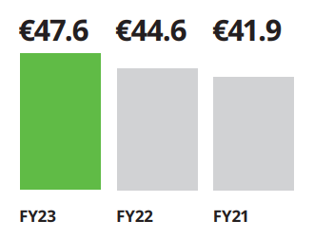
Figure 7: IKEA Group Retail Sales
(Source: IKEA, 2023)
Financial goals should thus be aligned to the expansion of revenues, better operating efficiency, lower logistics costs and better return on sustainability investments. Key performance indicators (KPIs) that are relevant involve annual revenue growth, operating profit margin, inventory turnover, cost savings due to the use of renewable energy and cost savings due to resource efficiency. These measures contribute to a consistent financial performance aligned with IKEA's long-term strategic goals. The Customer Perspective is about providing value to the customer in terms of affordability, quality, convenience and sustainability. IKEA keeps enhancing its omnichannel retail strategy by connecting offline and online channels to create a seamless customer experience. Online retailing was 26% of total sales highlighting the increasing significance of online engagement in addition to store-based formats (IKEA, 2023). The strategic goals are to improve customer satisfaction, boost digital sales, build customer loyalty and expand access to sustainable products.
Examples of KPIs are Net Promoter Score (NPS), customer satisfaction, growth in sales on the internet, repurchase rates and percentage of circular-designed products. These indicators allow IKEA to maintain customer satisfaction with the service by keeping IKEA's low-cost leadership approach. The internal business process perspective considers the efficiency of the value creation activities and processes that are relevant for the organisation's performance. IKEA is enhancing to have a more resilient supply chain, more innovative products, sustainable sourcing and inventory management in order to keep operational excellence. In FY24 96.5% of the wood used in IKEA products was sourced from FSC-certified forests or recycled materials showing a great effort towards responsible sourcing (IKEA, 2026). Key targets must be associated to improving supply chain efficiency, cutting back on greenhouse gas emissions, improving sustainable material use and strengthening delivery dependability (Ingka, 2025). The appropriate KPIs are delivery lead time, inventory availability, supply chain emissions, percentage of renewable, recycled materials and supplier adherence to the IWAY code of conduct. These measures contribute to IKEA's efficiency in operations and strengthen its environmental commitments.
The learning and growth perspective focuses on organisational capability, employee development, innovation and digital transformation. IKEA understands that learning and a non-excluding work environment are crucial to be competitive in a rapidly changing retail environment. The company invests in leadership development, digital capabilities, employee wellbeing and innovation in order to keep growth in the future (IKEA, 2026). The strategic goals are to enhance employee engagement, build digital skills, drive innovation and build future leaders. The measurable KPIs are the score of employee engagement, staff retention, training hours of each employee, innovation and participation in leadership development. These KPIs can help IKEA to enhance people and organisational capabilities by continuously supporting the strategic vision effectively.

4. Strategic Choices and Implementation

4.1 Strategic Choices
IKEA is involved in a very competitive food products sector and to be a leader in the market as it needs to be continuously adapting strategically. At the business level, there are three strategic options to help the business grow such as cost leadership through which IKEA can enhance its competitive landscape for the long term. Cost leadership strategy is defined as an approach where a firm sets goals to become the producer with lower costs in the industry and broad market (Jerab & Mabrouk, 2023). The company can offer low prices due to their product designs as flat-packs, economies of scale, efficient logistics and long-term partnership agreements with suppliers. The advantage of this strategy is that IKEA can provide a wide range of customers but at the same time has a high level of operational efficiency. Increased inflation, transportation costs and competition could decrease the long-term benefits of low-cost leadership only.
The second strategy is differentiation through which IKEA can also do better with sustainable product innovation, digital customer experience and premium home furnishing solutions. The demand for sustainable products remains strong with consumers stating that they are willing to pay 9.7% on average for sustainably produced products (PwC, 2024). Differentiating more would drive higher customer loyalty but could also lead to higher operating expenses and lessen the price advantage IKEA has as a retailer. A more appropriate strategic option is to pursue a mixed strategy such as cost leadership with differentiation. Through this way IKEA can maintain its affordability while adding value with the use of sustainability, digitalisation, smart home products and smart home experiences. The company's investments in renewable materials of €0.7 billion, circular business models including Preowned, artificial intelligence and digital retailing highlight its ability to innovate and achieve both cost efficiency and differentiation (Law, 2025). A hybrid approach can help IKEA to meet the customer's changing expectations, the increasing competition and the different environmental laws and regulations while keeping its competitive edge in the international furniture retail market.

4.2 SAFe Framework Evaluation
The SAFe framework that includes Suitability, Acceptability and Feasibility can be used to determine a suitable, feasible and competitive long-term strategy for a company (Scholes, et al., 2009). The hybrid approach is suitable and aligned with the opportunities and challenges found in the PESTEL and SWOT analyses from different perspectives. Demand for sustainable furniture, digital shopping experiences and affordable furniture for the home is growing worldwide. The ability to manage the environment, innovate products and services and online presence on channels used by customers makes IKEA able to meet consumer demands and comply with the environmental laws at a low cost. The strategy thus aligns with the existing market and the future market trends in the industry. According to acceptability, the strategy provides value to several essential stakeholder groups. Customers remain satisfied with the cost of the products they are buying and they have access to better sustainable products and digital services (IKEA, 2026). Investors gain from improved long-term profitability as a result of increased customer loyalty and improved operational efficiency.
IKEA's ongoing commitment to responsible sourcing and investments in renewable energy helps it to satisfy consumer demands and maintain a competitive reputation in the market (IKEA, 2026). The results enhance confidence amongst the stakeholders and boost long-term organisational performance. The strategy is also very achievable as IKEA has a lot of organisational resources and capabilities. The company has a well-known brand name and broad supplier base, sophisticated logistics, robust financial results and existing sustainability initiatives which will form the basis of its hybrid approach. Ingka Group's retail sales during FY24 reached €45.1 billion indicating that the group has good financial strength to invest in digital innovation, artificial intelligence and sustainable business practices (Ingka, 2024). The hybrid strategy is the best strategic option for IKEA according to the SAFe evaluation.

4.3 Competitive Performance Analysis
A cost leadership and differentiation mix is the recommended approach for IKEA to enhance their competitive position, providing it with customer value and being efficient which is aligned with Resource-Based View (RBV) theory. The theory states that organisations can gain sustainable competitive advantage by effectively leveraging valuable, rare, inimitable and well-organised resources (Olaitan and Mapanga, 2024). Competitors struggle to match IKEA's recognisable brand, supply chain, sustainable sourcing and digital retail infrastructure. By combining these resources in a hybrid approach the company can provide innovative, sustainable and differentiated products at a price that does not compromise the quality. For example, Apple offers a premium product and differentiates on innovation, integration, and brand loyalty allowing it to consistently beat the competition in a very competitive industry (Apple, 2024). Similarly, Toyota seeks to demonstrate its operational efficiency and continuous product innovation through the Toyota Production System enabling the company to maintain its global market leadership, cost efficiencies and product quality (Toyota, 2026).
A hybrid approach is beneficial for IKEA because it enables them to perform at their best, boost customer satisfaction and retention, broaden market possibilities and build their resilience in an economy that is volatile. The ongoing investments in circular economy, digital technologies and omnichannel retailing improve the customer value while maintaining affordability (IKEA, 2026). Further, there is an effective use of resources which enhances productivity and contributes to long-term profitability. Through the strategic leveraging of its resources, IKEA will be able to continue to enjoy its competitive strengths and secure sustainable business growth in the furniture retail sector in the global market in response to the evolving customer expectations and market dynamics.

4.4 Implementation Challenges and Mitigation
There are a number of challenges that IKEA will need to overcome whether they are to be successful in implementing a hybrid approach. A major challenge is to keep costs for investing in digital technologies, artificial intelligence and sustainability initiatives low while not compromising on product prices. Other challenges to operational efficiency and profitability could result from rising raw material prices and disruption to the value chain due to geopolitical risks. Further, new technologies, digital processes and sustainable measures could lead to resistance from employees towards organisational changes and delay the implementation (Ramadhani, et al., 2024).
To address the challenges, IKEA should spread out its suppliers to minimise its reliance on specific areas and enhance the resiliency of its supply chain. Committing resources to sophisticated data analytics and artificial intelligence can lead to better demand forecasting, inventory management and logistics capabilities to help manage increased operational costs. It is necessary to build employee training and change management programmes for developing digital skills, reshaping employee attitudes and embracing new working habits (Rustam, et al., 2024).

Section 2: Reflective Account
2.1 Description
This strategic management report was prepared through a systematic process of research, analysis and evaluation of IKEA's strategic management position in relation to the recognised strategic management frameworks. The initial phase was to analyse the assessment brief to gain an understanding of the learning outcomes and identify the analytical tools required. IKEA was chosen as the case organisation through its global reach, regular sustainability reports and comprehensive strategic programmes. The secondary data sources used included IKEA's Annual Summary, the Ingka Group's reports, industry publications, government reports and peer-reviewed academic journals to gather multiple credible data sources. Once the relevant information was collected then the information was organised based on the needs of each analytical framework. The external business environment was analysed with PESTEL analysis and the internal business environment with VRIO analysis. SWOT analysis combined findings from internal and external sources to determine strategic priorities. Organisational performance and strategic alignment were then measured using the Corporate Social Responsibility strategy and Balanced Scorecard.
2.2 Feelings
Initially I did not know how to handle all the information I had on IKEA and how to choose the most suitable evidence for the report. Despite the organisation having in-depth sustainability and annual reports, details of information that directly supported each strategic framework needed careful reading and comparison to multiple sources. As I moved through the research process and got to know the strategic frameworks my confidence slowly began to grow. It was interesting and relevant to understand how the principles of strategic management are applied to a real-life multinational organisation. My confidence gradually increased by successfully finishing each task through research and analytical skills.
2.3 Evaluation
There were a number of good aspects to the report preparation. Recent annual reports, sustainability reports and academic literature provided reliable information resulting in a credible analysis. The application of recognised strategic frameworks provided a logical structure which facilitated alignment between the external environment, IKEA's capacity and strategic proposals. In addition, the use of statistical facts from institutions such as the International Monetary Fund (IMF), the International Energy Agency (IEA) and the United Nations (UN) helped to develop the discussion with factual data to support statements. While there are positive attributes, there were several obstacles in this process. This was due to the large volume of data available and it was challenging to identify which data most relevantly answered the assessment objectives. The same information was given in multiple reports some with more detail than others so extra time was needed to ensure that it was accurate and selected with the most suitable evidence. The other challenge was to balance between theory and examples of practical organisations within the word limit.
2.4 Analysis
I realised that the process of strategic analysis relies on the ability to gather information as well as critically consider and synthesise evidence from different sources. The use of one report cannot be able to provide sufficient insights into IKEA's strategic environment. However, I selected academic papers, company reports and international publications to enable a more balanced and evidence-based evaluation. This helped to ensure that the results were more reliable and the overall quality of the report was enhanced. Use of various strategic frameworks such as PESTEL analysis revealed that IKEA's business environment had opportunities and threats whereas the VRIO framework helped the company to understand how its internal resources can lead to a competitive advantage. The SWOT analysis which combined the internal and external views, aligned with these findings, to establish key strategic priorities. Instead of completely relying on published information, I learned how to compare various sources of information, assess their relevance and consider the impact of current developments in the economy, technology and environment on strategic decision making.
2.5 Conclusion
In conclusion, it has been a reflective experience that has deepened my knowledge of strategic management and the implementation of analytical frameworks in a global organisation. It showed that strategic analysis is not possible on the basis of descriptive information only, the systematic research and critical evaluation of multiple sources of evidence. The assessment also helped me to gain more confidence to apply the strategic theories in real business situations and gave me more evidence to support the recommendations made.
2.6 Action Plan
In future assessments, I plan to start researching earlier to give more time for students to read academic sources and compare several sources of evidence. I will establish a set of research strategies to organise information more efficiently and employ a reference management tool to ensure accuracy and consistency in citations. I also intend to create a more robust critical evaluation skill by reading more diversified peer-reviewed journals and industry reports and then building conclusions.

References
Apple. (2024) Apple empowers developers and fuels innovation with new tools and resources. [Online]. Available at: https://www.apple.com/in/newsroom/2024/06/apple-empowers-developers-and-fuels-innovation-with-new-tools-and-resources/ [Accessed on: 23 July 2026].
Bandono, A. and Nugroho, S.H. (2023) The assessment of company performance target using balanced scorecard methods. International Journal of Professional Business Review: Int. J. Prof. Bus. Rev., 8(5), p.93.
Chayjan, K.A., Razmi, J. and Amin, S.H. (2025) An Analytical Investigation of Inflation’s Effects on Supply Chain Strategies. Supply Chain Analytics, p.100168.
ElAlfy, A., Palaschuk, N., El-Bassiouny, D., Wilson, J. and Weber, O. (2020) Scoping the evolution of corporate social responsibility (CSR) research in the sustainable development goals (SDGs) era. Sustainability, 12(14), p.5544.
IBM. (2025) Cost of a Data Breach Report 2025. [Online]. Available at: https://www.ibm.com/reports/data-breach [Accessed on: 22 July 2026].
IEA. (2026) World Energy Investment 2026. [Online]. Available at: https://iea.blob.core.windows.net/assets/64594543-cf6e-4fd9-8238-d3cae35daf48/WorldEnergyInvestment2026.pdf [Accessed on: 21 July 2026].
IKEA. (2022) IKEA continues to grow in a challenging business environment. [Online]. Available at: https://www.ikea.com/global/en/newsroom/corporate/ikea-continues-to-grow-in-a-challenging-business-environment-221013/ [Accessed on: 21 July 2026].
IKEA. (2023) Inter IKEA Group Financial Summary FY23. [Online]. Available at: https://www.inter.ikea.com/-/media/interikea/igi/financial-reports/inter_ikea_group_financial_summary_fy23_31-10-2023_.pdf?rev=84585725b85b450f838b465e735f95bd&sc_lang=en [Accessed on: 20 July 2026].
IKEA. (2023) Inter IKEA Group reports lower margins as retail sales recover. [Online]. Available at: https://www.inter.ikea.com/en/newsroom/inter-ikea-group-reports-lower-margins-as-retail-sales-recover [Accessed on: 20 July 2026].
IKEA. (2024) IKEA Sustainability Report FY24. [Online]. Available at: https://www.ikea.com/global/en/images/IKEA_Sustainability_Report_FY_24_2025_02_06_0aaa025249.pdf [Accessed on: 21 July 2026].
IKEA. (2025) How we work. [Online]. Available at: https://www.ikea.com/global/en/our-business/how-we-work/ [Accessed on: 21 July 2026].
IKEA. (2025) IKEA Sustainability and Climate Reports FY24: making progress towards climate goals and investing in the future. [Online]. Available at: https://www.ikea.com/global/en/newsroom/sustainability/ikea-sustainability-and-climate-reports-fy24-250130/?msockid=0e5c19b16f2162e50bfe0f036eae63ee&utm [Accessed on: 20 July 2026].
IKEA. (2025) Ingka Group Reporting – Reduction in climate footprint by 30.1% while growing the business. [Online]. Available at: https://www.ingka.com/newsroom/ingka-group-reporting-reduction-in-climate-footprint-by-30-1-while-growing-the-business/ [Accessed on: 20 July 2026].
IKEA. (2026) Building your career at IKEA. [Online]. Available at: https://www.ikea.com/jp/en/this-is-ikea/work-with-us/building-your-career-at-ikea-pub0990bef0/ [Accessed on: 20 July 2026].
IKEA. (2026) Click & Collect. [Online]. Available at: https://www.ikea.com/in/en/customer-service/services/click-and-collect-shopping-at-ikea-stores-pubada7dae3/ [Accessed on: 22 July 2026].
IKEA. (2026) Download the IKEA app. [Online]. Available at: https://www.ikea.com/in/en/customer-service/mobile-apps/ [Accessed on: 22 July 2026].
IKEA. (2026) From humble origins to global brand – a brief history of IKEA. [Online]. Available at: https://www.ikea.com/us/en/this-is-ikea/about-us/from-humble-origins-to-global-brand-a-brief-history-of-ikea-pubad29a981/ [Accessed on: 21 July 2026].
IKEA. (2026) Healthy, sustainable, affordable living for everyone. [Online]. Available at: https://www.ikea.com/global/en/our-business/sustainability/healthy-and-sustainable-living/ [Accessed on: 23 July 2026].
IKEA. (2026) How we work with our suppliers. [Online]. Available at: https://www.ikea.com/global/en/our-business/how-we-work/for-suppliers/ [Accessed on: 22 July 2026].
IKEA. (2026) Scandinavian style. [Online]. Available at: https://www.ikea.com/in/en/ideas/styles/scandinavian/ [Accessed on: 21 July 2026].
IKEA. (2026) The IKEA vision and values. [Online]. Available at: https://www.ikea.com/us/en/this-is-ikea/about-us/the-ikea-vision-and-values-pub9aa779d0/ [Accessed on: 21 July 2026].
IKEA. (2026) The IKEA way of retail. [Online]. Available at: https://www.ikea.com/global/en/our-business/how-we-work/ikea-retail/ [Accessed on: 22 July 2026].
IKEA. (2026) The story of IKEA. [Online]. Available at: https://www.ikea.com/global/en/our-business/how-we-work/story-of-ikea/ [Accessed on: 21 July 2026].
IKEA. (2026) The wood we use. [Online]. Available at: https://www.ikea.com/global/en/our-business/sustainability/wood-we-use/ [Accessed on: 20 July 2026].
IKEA. (2026) Transitioning towards a circular business. [Online]. Available at: https://www.ikea.com/global/en/our-business/sustainability/our-circular-agenda/ [Accessed on: 20 July 2026].
IMF. (2026) Global Economy in Crosscurrents of War and Technology. [Online]. Available at: https://www.imf.org/en/publications/weo/issues/2026/07/08/world-economic-outlook-update-july-2026 [Accessed on: 22 July 2026].
Ingka. (2024) IKEA sides with customers in an exceptional year, investing more than EUR 2.1 billion in lowering prices. [Online]. Available at: https://www.ingka.com/newsroom/ikea-sides-with-customers-in-an-exceptional-year-investing-more-than-eur-2-1-billion-in-lowering-prices/ [Accessed on: 23 July 2026].
Ingka. (2025) IKEA serves more customers and increases volumes in a challenging year. [Online]. Available at: https://www.ingka.com/newsroom/ikea-serves-more-customers-and-increases-volumes-in-a-challenging-year/ [Accessed on: 23 July 2026].
Ingka. (2025) Ingka Group Net Zero Transition Plan FY25. [Online]. Available at: https://www.ingka.com/static/climate-transition-plan-fy25-final.pdf [Accessed on: 20 July 2026].
Ingka. (2025) Social. [Online]. Available at: https://www.ingka.com/annual-summary-and-sustainability-report/social/ [Accessed on: 20 July 2026].
Ingka. (2025) Ingka Group Annual Summary and Sustainability Report FY25. [Online]. Available at: https://assets.site.ingka.com/ingka-com/reports/IngkaGroup_AnnualSummaryandSustainabilityReport_FY25.pdf [Accessed on: 22 July 2026].
Jerab, D., & Mabrouk, T. (2023). Achieving competitive advantage through cost leadership strategy: Strategies for Sustainable Success. Available at SSRN 4574945. https://dx.doi.org/10.2139/ssrn.4574945
Law, M. (2025) IKEA Parent Deploys AI in €41.8bn Sustainability Push. [Online]. Available at: https://aimagazine.com/articles/what-does-ingka-annual-report-say-about-ikea-sustainability [Accessed on: 23 July 2026].
Notteboom, T., Haralambides, H. and Cullinane, K. (2024) The Red Sea Crisis: ramifications for vessel operations, shipping networks, and maritime supply chains. Maritime Economics & Logistics, 26(1), pp.1-20.
Olaitan, O.O. and Mapanga, A. (2024) Unleashing the power of the 4IR in organisational value chains: A conceptual analysis. South African Journal of Information Management, 26(1), p.1805.
PwC. (2024) Consumers willing to pay 9.7% sustainability premium, even as cost-of-living and inflationary concerns weigh: PwC 2024 Voice of the Consumer Survey. [Online]. Available at: https://www.pwc.com/gx/en/news-room/press-re]]leases/2024/pwc-2024-voice-of-consumer-survey.html [Accessed on: 23 July 2026].
Ramadhani, W., Khuzaini, K. and Shaddiq, S. (2024) Resistance to change: Human resources issues in the implementation of Industry 4.0 technology. Proceeding: Islamic University of Kalimantan, pp.345-351.
Rustam, A., Astuti, I.Y. and Safitri, U.R. (2024) Strategies for improving employee competencies in the digitalization era through training and human resource development. The Journal of Academic Science, 1(7), pp.849-857.
Scholes, K., Johnson, G. and Whittington, R. (2009) Exploring Corporate Strategy: Text & Cases. London: Financial Times Prentice Hall
Statista. (2026) Average inflation rate worldwide 1980-2031. [Online]. Available at: https://www.statista.com/statistics/256598/global-inflation-rate-compared-to-previous-year/?srsltid=AfmBOooJZRXqOO9bcuEWfBRM81VUaltnVWa3Xg8-IFWGoAGvJuhsAUTR [Accessed on: 22 July 2026].
Toyota. (2026) Toyota Production System. [Online]. Available at: https://global.toyota/en/company/vision-and-philosophy/production-system/ [Accessed on: 23 July 2026].
United Nations. (2026) 68% of the world population projected to live in urban areas by 2050, says UN. [Online]. Available at: https://www.un.org/uk/desa/68-world-population-projected-live-urban-areas-2050-says-un [Accessed on: 22 July 2026].
United Nations. (2026) 68% of the world population projected to live in urban areas by 2050, says UN. [Online]. Available at: https://www.un.org/uk/desa/68-world-population-projected-live-urban-areas-2050-says-un [Accessed on: 23 July 2026].
Upreti, K., Gangwar, D., Vats, P., Bhardwaj, R., Khatri, V. and Gautam, V. (2023, August) Artificial neural networks for enhancing e-commerce: A study on improving personalization, recommendation, and customer experience. In International Conference on Electrical and Electronics Engineering (pp. 141-153). Singapore: Springer Nature Singapore.

