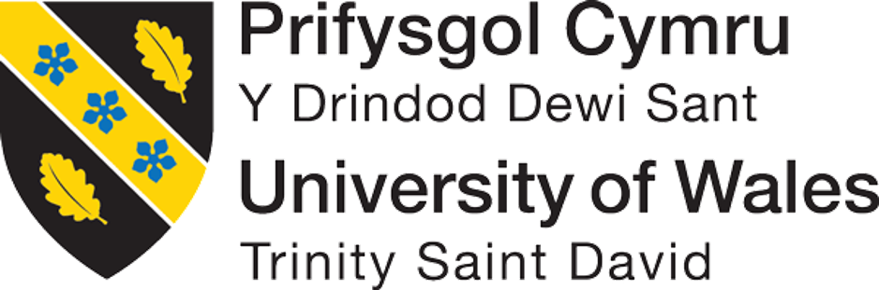

BA (Hons.) Business Management

Student Name: Marina Alina Manea

Student Number: 2412047

Module: Stakeholder Engagement LCBB4013

Lecturer Name: Zainab Atta

Session: February 2026 Term
Table of Contents
Element 1: Introduction 3
Element 2: In-Depth Analysis 5
Element 3: Ethical Considerations 13
Element 4: Conclusion and Reflection 15
References 17

Element 1: Introduction
Define the Project Scope, Purpose, and Objectives.
Scope and Purpose
The scope of the project involves designing, commissioning, planning and constructing a new public park with walking paths, native tree planting, landscape green spaces, recreational facilities, seating and lighting. The purpose of the project depends on offering an accessible, sustainable as well as safe recreational area that fosters the quality of the environment and wellbeing of the community (Friedman, 2026).
SMART Objectives
Specific | Measurable | Achievable | Relevant | Time-Bound
To construct a new infrastructure of public park with different recreational facilities. | Completed in an overall budget of 2 million GBP. | Using qualified sources of contractors as well as approved funding. | Enhancing creational facilities as well as local infrastructure. | 12 months
To plant around 150 native trees within the park. | Ensuring 150 tree plantation. | Following the approved plans of landscaping. | Enriching sustainability as well as biodiversity (Lazurko et al., 2025). | 12 months
To obtain high satisfaction among the community after the opening. | Obtaining 80% of positive feedback from the residents. | Conducting surveys among residents in six months. | Ensuring that the park deals with sustaining the needs of the community. | 6 months
Table 1: SMART Objectives
(Source: Self-Created)
Identify and Analyse Key Internal and External Stakeholders
The project will include external and internal stakeholders who are involved in supporting core delivery. The internal stakeholders are project managers and engineers who engage in overseeing designing, implementation, planning and budgeting. The external stakeholders are local councils that offer approvals as well as funding, local residents face an advantage and offer feedback based on the park (Kiss et al., 2022). The stakeholders also include local businesses that might face economic influence and local agencies that deal with compliance with planning, environmental as well as safety regulations. Potential stakeholder engagement encourages collaboration, conflict minimisation as well as supporting the effective outcomes of the project.
Examine Roles and Responsibilities of Each Stakeholder Identified
The internal stakeholders generally make a direct contribution to the business success. In that case, the internal stakeholders can influence the organisation’s financial abilities by increasing their demands. In terms of projects like the development of an eye-soothing and eco-friendly park, the internal stakeholders help in increasing the engagement of the visitors. On the other hand, the external stakeholders generally control the business externally (Sun et al., 2024). Depending on the engagement of the external stakeholders, it is possible to evaluate the external business environment and make adequate decisions. The stakeholders, like the local councils, help in developing effective regulations that may help in maintaining all the business ethics.

Element 2: In-Depth Analysis
SWOT Analysis
Strengths: The project will include effective financial support with the approval of 2 million GBP as a budget that will lead to project delivery. The project will enhance wellbeing among the community, public health and biodiversity through offering recreational facilities as well as planting of 150 native trees (Kiss et al., 2022). The objectives, project managers who are experienced as well as skilled engineers, foster quality and high completion likelihood of the project in 12 months.
Weaknesses: The project focuses on public funding that creates vulnerability towards the budget constraints and cost overruns. The construction activities might cause disruption among businesses and residents (Lakhouit, 2025). The delays caused due to poor conditions of weather, supply chain challenges and labour shortages might impact completion of the project and high costs.
Opportunities: The park can lead to high local tourism, promoting healthy lifestyles, enriching community engagement as well as foster environmental sustainability. The project might engage future funding by the government for certain facilities as well as develop opportunities for partnerships with different schools, community groups and environmental organisations (Albert et al., 2023). The high property values and wider business activity can lead to local growth in the economy.
Threats: The high inflation rate and increase of material prices might increase the budget allocation of the project. The changes in policies can lead to delay within approvals and minimise financial support. The environmental risks including extreme weather conditions and flooding might cause interruption in construction. The community opposition based on safety challenges, design choices and costs of maintenance might minimise public satisfaction (Friedman, 2026). The failure towards sustaining legal, health and safety and environmental regulations can cause penalties, reputational decline and delays in the project.
PESTLE Analysis
Political: The local infrastructure of the new public park will include wider support from the local council that can offer approval of planning, policy support and funding for the community projects (Kiss et al., 2022). The changes within political leadership, public spending and government priorities might minimise funding and approval delay.
Economic: The investment of 2 million GBP will lead to local employment, supporting contractors and might increase values of property as well as business activities after the completion of the project. The high inflation rate which is 2.6% as of June 2026, increasing construction materials prices and labour costs that might lead to budget overruns and delays of the project (Statista, 2026).
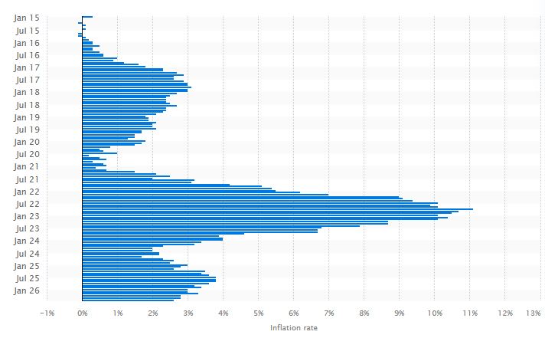
Figure 1: Inflation Rate in the UK
(Source: Statista, 2026)
Social: The new public park will enhance public health, social interaction as well as recreation and quality while offering inclusivity of space for older adults, families and children. Local communities might object to the noise of the construction process, temporary closure of roads, dissatisfaction and disruption within the facilities and design of the park (Veríssimo et al., 2024).
Technological: The advanced construction technologies, GIS mapping, energy-effective lighting and project management software can enhance quality of the project, maintenance and efficiency (Lakhouit, 2025). The focus on technology might need skilled professionals, high implementation costs and exposure of the project towards technical challenges or risks of cybersecurity.
Legal: The compliance through health and safety regulation, planning laws, “Environmental Protection Act 1990” as well as procurement needs will deal with lawful and safe delivery of the project (Legislation.gov.uk, 2026). The failure towards complying with legal needs might lead to penalties, suspension of the project, compliance costs and legal disputes.
Environmental: Planting around 150 trees will enhance biodiversity, enrich air quality, supporting resilience of climate as well as developing sustainable form of green space among the community (Lotfi et al., 2024). The extreme conditions of weather, soil contamination, habitat protection needs and flooding might lead to delay within construction and high mitigation as well as maintenance costs.
VRIO Analysis
The VRIO Framework evaluates the resources of the project in offering sustainable competitive benefits through the analysis of valuable, rare, inimitable and organised. Based on the project of the new public park, the budget of 2 million GBP offers a value of financial support and is not rare due to the same type of funding that is available for the public infrastructure. The valuables also include the project management team which is rare and difficult towards imitating that is caused due to expertise and effective governance deals with resources that are well organised (Veríssimo et al., 2024). The technical and engineering expertise lead high-quality process of construction as well as regulatory compliance that leads to highlighting important capability of the project. The programme on community engagement involves creating value through feedback from residents, project acceptance as well as success. The sustainable design of the park involves planting 150 trees, fostering environmental performance as well as wellbeing of the community.
Resources | Valuable | Rare | Inimitable | Organised
Project budget of 2 million GBP | Yes | No | No | Yes
Technical and engineering expertise | Yes | Yes | Yes | Yes
Project Management Team | Yes | Yes | Yes | Yes
Sustainable design of the park | Yes | No | No | Yes
Community engagement initiative | Yes | No | No | Yes
Table 2: VRIO Framework
(Source: Self-Created)
Power Matrix
Stakeholders | Power | Influence | Interest | Reason
Local Council | High | High | High | Offering funding on the project, approval of budgets, setting objectives and including authority towards approval and halting of the project.
Project Manager | Medium | High | High | Overseeing the planning of the project, allocation of resources, risk management and dealing with on time delivery of the project and budget (Lotfi et al., 2024).
Internal Engineers | Medium | High | High | Preparation of technical designs, dealing with engineering standard compliance, managing technical challenges and supervision of quality of construction.
Local Residents | Low | Medium | High | They offer feedback, impact the opinion of the public and analyse whether the park deals with the expectations of the community.
Planning Department | Medium | Medium | High | Reviewing the applications of planning and dealing with the project ensures local policies of planning as well as legal regulations (Das, 2023).
Environmental Agency | High | Medium | Medium | Assessing the influence of the environment, approving sustainability measures can delay and stop the project in case the standards are not sustained.
Local Businesses | Low | Low | Medium | Influenced by the activities of construction and might benefit from high visitor numbers and activity of the local economy after the completion.
Table 3: Power Matrix
(Source: Self-Created)
Stakeholders’ Map
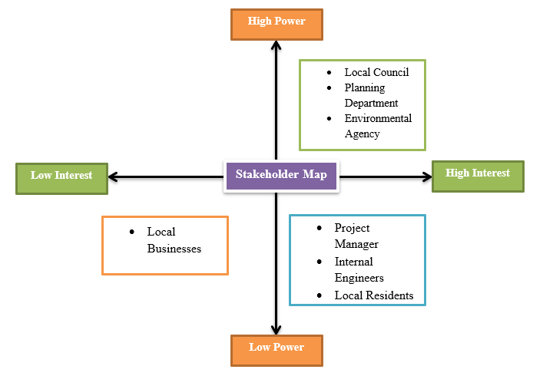
Figure 2: Stakeholders’ Map
(Source: Self-Created)
The stakeholder Map segments stakeholders based on the power (interest) and influence that the group analyses at a proper level based on communication. The Local Council will be managed thoroughly as it will include high influence and power based on approvals and funding (Eitan, 2025). The Planning Department, Project Manager and Internal Engineers will include their needs met as well as anticipated with the coordination of regular projects. The Environmental Agency will be highly kept completely informed towards dealing with compliance based on the environmental regulations. Local Businesses and Local Residents need regular minimal contracts as they include low power on decision-making and are significant for the acceptance of the project and engagement of the community.
Stakeholders | Frequency of Meeting | Communication Methods
Local Council | Every Month | Written Reports, Online Meetings and Emails
Internal Engineers | Weekly | Emails, Site Meetings and Technical Reports
Local Residents | Every Two Months | Community Newsletter, Public Meetings and Surveys
Project Manager | Twice a Week | Phone calls, Team Meetings and Progress Reports
Planning Department | Every Month | Review Meetings, Formal Reports and Email
Local Businesses | Every Two Months | Meetings, Updates on Emails and Local Business Forum
Environmental Agency | Every Month | Email, Compliance Reports and Inspections
Table 4: Communication Map of Stakeholders
(Source: Self-Created)

Element 3: Ethical Considerations
Method of Consultation
Online papers and surveys are crucial for attracting stakeholders towards the organisations. Depending on the online papers and surveys, the project manager will communicate with the internal and external stakeholders (Lehtinen and Aaltonen, 2022). Additionally, it will help in collecting feedback from the stakeholders and make effective decisions to reduce the possibilities of unwanted challenges. Following the engagement of the online papers, it is possible to understand the previous cases of a similar project along with the challenges experienced by the project managers. This consultancy method will help in making effective decisions that may positively influence the outcome of the project. Apart from that, the online surveys and the papers will work as a strategic document for the project managers in developing the overall plan of the project; it will also impact the execution process. On the other hand, stakeholder workshops will also work as a crucial method which will help in engaging the stakeholders in group discussions (Potthoff et al., 2023). Based on the strategy, the project will benefit from a wide range of suggestions for improvement.
Ethical Considerations
In terms of ethical considerations, informed consent and voluntary participation will be followed. In this regard, by ensuring informed consent, the project managers will be able to engage different stakeholders in the process (Oluwatosin, 2024). Additionally, it will work as an influential method for the project managers in maintaining every ethical aspect of the project. On the other hand, voluntary participation of the local communities will also help in ensuring community engagement and increasing its demand within the market. Following the engagement of the local communities, it will be possible to enhance the demand for the developed park enriched with refreshing elements (Abd Majid et al., 2023). It will also help in identifying the possible challenging aspects with the perceptions offered by the local people. All volunteers will be engaged with informed consent so that it may address the ethical standards of the project. In the data collection process, informed consent will help in preventing any kind of legal obligation.
Bias Control
In terms of bias control, elements like transparent reporting and balanced analysis help in preventing bias within the workplace. Depending on transparent reporting, it is possible for the project managers to provide every employee the opportunity to get engaged in any project (Zhang, 2024). On the other hand, transparent reporting is a process where employees can discover the business strategies implemented by their respective workplaces. On the other hand, balanced analysis of feedback helps in evaluating the perception offered by the stakeholders in response to any project. It helps in making adequate decisions that may facilitate the overall project.
Diversity, Equity & Inclusion (DEI)
In the context of diversity, equity and inclusion, the engagement of the underrepresented groups will be considered. In that case, most of the organisations in the contemporary environment have focused on empowering the underrepresented groups so that it may enhance community engagement (Odedina et al., 2024). On the other hand, translated materials help in preventing language barriers, which leads to transparent and direct communication with the local communities. The proposed project, which is a park that includes green spaces and walking paths, will benefit from inclusive engagement of the local communities. It will work as a strategic benefit for the project managers, which will lead to the satisfaction of the local people. Additionally, it will help in engaging the other stakeholders by highlighting the commitment of the arrangers towards their ethical responsibilities. Overall, it will uplift the ethical standards of the organisation and help in increasing satisfaction of the target audience, which will ensure its success.
Feedback Review
Feedback review works as another crucial element that helps in ensuring stakeholder engagement in any project. Especially for the presented project, the engagement of the feedback reviews will help in analysing both of the qualitative and quantitative databases, which will help in making adequate decisions. The survey databases, both of the qualitative and quantitative, help in analysing multiple factors and the possible challenges for any project (Taherdoost, 2022). For example, in the proposed project, the insights offered by the stakeholders in the feedback help in determining the modifications required in the project. It will help in analysing the challenges as well that can interrupt the project development strategies. On the other hand, the analysis of the feedback helps in identifying the gaps in the decision-making, which positively impacts the risk mitigation strategies (Turgay and Aydin, 2025). In the context of stakeholder engagement, it helps in developing interaction with them, which helps in collecting their feedback and perceptions.

Element 4: Conclusion and Reflection
In conclusion, the above discussion has indicated the importance of stakeholder engagement in organisations. In that case, the discussion has developed an innovative business plan which is the development of an eco-friendly park which will offer multiple services to visitors. It will include a walking path along with greenery scenarios which can help in attracting the visitors. On the other hand, the space will be suitable for various types of visitors, including tourists and regular people. Overall, before planning the project, it is important to understand the external and internal business environment. In terms of the internal business environment, the diversification of the services will work as a potential element. Apart from that, the external business environment can include financial fluctuations that may have a negative impact on its brand value. It has been highlighted that in engaging multiple stakeholders in the project, it has become essential to focus on transparent communication. Following strategies like the external environment analysis, the event strangers will be able to make the right decision that can benefit the outcome.
Apart from that, the ethical considerations will include diversity and inclusion so that it can engage multiple employees. Alongside this, a consent form along with transparent reporting will work as a potential strategy for the organisation, which will help in increasing trust. On the other hand, diversity and inclusion can work as a potential strategy that may positively impact innovation. Depending on the voluntary engagement of the local communities, it will be possible to increase their satisfaction and the market demand for the service. Comparatively, the emergence of ethical aspects like feedback and data analysis will help in modifying the decision-making approach. It will positively influence the ability of the project manager in making ethical decisions, which will influence its value within the community.
Based on the analysis, it can be stated that the engagement of multiple stakeholders helps in improving the business outcome. Depending on effective engagement of stakeholders, organisations can have the opportunity to enhance their adaptation to market challenges. Additionally, it has been discussed that stakeholder engagement requires transparent communication that helps in managing the demand within the market. Overall, for organisations or project managers, stakeholder engagement works as a crucial aspect that helps to manage market changes and increase consumer engagement. In my case, this module has helped me develop multiple skills such as leadership, conflict management and communication skills. In this project, I have presented a project which has helped me conduct multiple analyses, including external and internal market analysis. This analytical initiative has helped me develop leadership skills, as I have become able to manage complex issues within the market. Apart from that, I have also analysed the strategies that can be utilised for maintaining diversity and inclusion within the workplace. This planning has helped me in understanding the responsibility of a leader in managing sustainable engagement of multiple employees within the workplace.
In terms of diversity and inclusion, I have highlighted the process for bias control, which can help me in maintaining equality in my future workplace. On the other side, I have also developed conflict resolution skills through transparent communication with my team members. In this project, I have interacted with multiple team members so that I can collect feedback from them. In this regard, the lack of communication skills has created significant challenges for me in effectively interacting with them, which have led to conflict between them and them. Following the situation, I can say that I have managed the situation very well and have interacted with mentors and my team members, which have positively impacted my conflict resolution and communication skills. In my case, I can say that these skills can help me in improving my leadership position in my future workplace. It will also help in managing any kind of conflict and developing a strong position among my followers. Apart from that, I would also like to mention that in future I can pursue a career as a leader by using the understanding that I have collected from the module. Overall, the module will work as a strategic opportunity for me in identifying the weaknesses and developing leadership and employability skills.

References
Abd Majid, T.Z.N.R., Anuar, A.N.A., Ramli, R. and Whyte, D., (2023). The potential of public parks for business activity in an urban community. International Journal of Sustainable Construction Engineering and Technology, 14(5), pp.1-15.
Albert, A., Islam, S., Haklay, M. and McEachan, R.R., (2023). Nothing about us without us: A co‐production strategy for communities, researchers and stakeholders to identify ways of improving health and reducing inequalities. Health Expectations, 26(2), pp.836-846.
‌Das, D.K., (2023). Project management as an anti-planning measure for the effective preparation and implementation of the urban development plans in the Global South. Cogent Engineering, 10(1). doi:10.1080/23311916.2023.2215570.
‌Eitan, A., (2025). Navigating sustainability trade-offs in wind energy governance: The role of environmental regulators. Energy Policy, 203, p.114645.
Friedman, A., (2026). Fundamentals of Community Design for Wellbeing: Fostering Sustainability and Livability. Taylor & Francis.‌
Kiss, B., Sekulova, F., Hörschelmann, K., Salk, C.F., Takahashi, W. and Wamsler, C., (2022). Citizen participation in the governance of nature‐based solutions. Environmental Policy and Governance, 32(3), pp.247-272.
Lakhouit, A., (2025). Revolutionizing urban solid waste management with AI and IoT: A review of smart solutions for waste collection, sorting, and recycling. Results in Engineering, 25, p.104018.
Lazurko, A., Kim, H., Linney, G., Díaz-General, E., Vaňo, S., Harmáčková, Z.V., Rounsevell, M. and Harrison, P.A., (2025). Enriching the European shared socio-economic pathways with considerations of biodiversity and nature using a nexus approach. Climate Risk Management, p.100741.
‌Legislation.gov.uk. (2026). Environmental Protection Act 1990. [online] Available at: https://www.legislation.gov.uk/ukpga/1990/43/contents [Accessed 7 Aug. 2026].
Lehtinen, J. and Aaltonen, K., (2022). Project Organizations’ Roles in Using Social Media for External Stakeholder Engagement. Social media for project management, p.137.
‌Lotfi, R., Vaseei, M., Ali, S.S., Davoodi, S.M.R., Bazregar, M. and Sadeghi, S., (2024). Budget allocation problem for projects with considering risks, robustness, resiliency, and sustainability requirements. Results in Engineering, [online] 24, p.102828. doi:10.1016/j.rineng.2024.102828.
Odedina, F.T., Wieland, M.L., Barbel-Johnson, K. and Crook, J.M., (2024), January. Community engagement strategies for underrepresented racial and ethnic populations. In Mayo Clinic Proceedings (Vol. 99, No. 1, pp. 159-171). Elsevier.
Oluwatosin, E.A., (2024). Ethical considerations in construction project management. International Journal of Novel Research And Development (IJNRD), 9(6).
Potthoff, S., Finch, T., Bührmann, L., Etzelmüller, A., van Genugten, C.R., Girling, M., May, C.R., Perkins, N., Vis, C., Rapley, T. and ImpleMentAll consortium, (2023). Towards an Implementation‐STakeholder Engagement Model (I‐STEM) for improving health and social care services. Health Expectations, 26(5), pp.1997-2012.
Statista. (2026). UK inflation rate 2026| Statista. [online] Available at: https://www.statista.com/statistics/306648/inflation-rate-consumer-price-index-cpi-united-kingdom-uk/?srsltid=AfmBOoo6vyKXq900kxvPDaxwXwQH7qdryszKXQv5mc2oUV07qceMv_Vn [Accessed 7 Aug. 2026].
Sun, J., Pellegrini, M.M., Dabić, M., Wang, K. and Wang, C., (2024). Family ownership and control as drivers for environmental, social, and governance in family firms. Review of Managerial Science, 18(4), pp.1015-1046.
Taherdoost, H., (2022). What are different research approaches? Comprehensive review of qualitative, quantitative, and mixed method research, their applications, types, and limitations. Journal of management science & engineering research, 5(1), pp.53-63.
Turgay, S. and Aydin, A., (2025). Improving decision making under uncertainty with data analytics: Bayesian networks, reinforcement learning, and risk perception feedback for disaster management. Journal of Decision Analytics and Intelligent Computing, 5(1), pp.25-51.
‌Veríssimo, C., Pereira, L., Fernandes, A. and Martinho, R., (2024). Complex problem solving as a source of competitive advantage. Journal of Open Innovation: Technology, Market, and Complexity, [online] 10(2), p.100258. doi:10.1016/j.joitmc.2024.100258.
Zhang, Y.F., (2024). Too little or too much transparency? Influencing accountability in project management through the practices of using digital technologies. International Journal of Project Management, 42(6), p.102636.

