

Assessment 1 – Reading Task Template
PART 1: Upload your photo of your A3 in-class notes here:

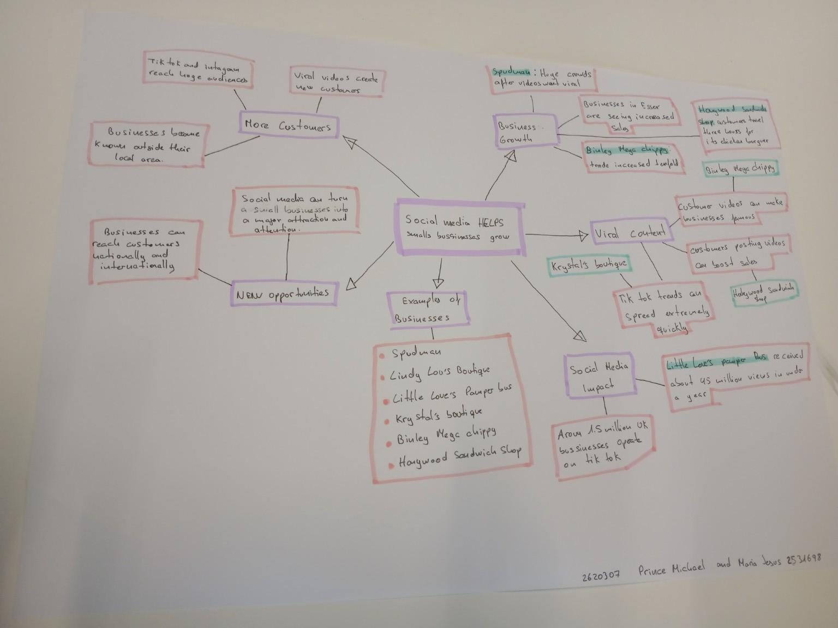

PART 2:
- Answer every question below in 1-3 full sentences.
- Use your own words. Do not use generative AI to answer these questions.
- Include a specific detail from the text when asked.
REMINDER
- The main idea is the overall message of the whole text.
- A key point helps to explain the main idea.
- A specific detail or example from the text shows that the key point is true.

- What is the main idea of the whole text?
The main idea is that social media helps small businesses grow. It can help them reach more customers, increase sales and create new opportunities.

- What is one key point that supports the main idea, and which specific example from the text shows this?
One key point is that social media can help businesses increase sales and promote their services. For example, the notes say that businesses in Essex are seeing increased sales through social media.

- What is a different key point that supports the main idea, and which specific example from the text shows this?
Another key point is that viral content can give a small business a much wider audience. A specific example in the notes is Little Love’s Pampas Bus, which received about 45 million views in under a year.

- Which part of the text do you think is most important, and why?
I think the most important part is that social media can help businesses reach customers outside their local area. This matters because a small business is not limited to only the people who live nearby.

Reflection:
- What did you find difficult in this task (including in-class components), and why was it difficult?
I found it difficult to turn the information from the in-class mind map into short answers and decide which points were the main idea and which were supporting details. There were several examples, so I had to choose the ones that best matched the questions.

- The mind map helped because the information was grouped into sections such as business growth, viral content, new opportunities and social media impact. The examples of real businesses also made it easier to understand how the points connected to the main idea.

