Community Engagement

Module name: Community Engagement
Module ID: LCBB4002
Assessment Title: Assessment 2 Community Engagement

Student Name: Florentina Fistoleanu

Student ID: 2115309

Table of Contents

Introduction 2
Reflective Summary of Assessment 1 2
Personal Reflection through Gibbs Reflective Cycle 3
Description 3
Feelings 4
Evaluation 4
Analysis 5
Conclusion 5
Action Plan 6
Conclusion 7
References 8

Introduction
Using the methods of reflective learning, reflective assessment is a form of evaluation. Reflective learning exercises are simply adapted for the purpose of gauging a student's progress in his or her educational endeavors. The capacity to reflect on one's own educational pathway is a powerful tool for recalling the inside and out of one's learning career, as well as the knowledge gained along the journey. The focus of this paper is to provide feedback on the assessment 1 work that was completed. In this paper, I intend to self-reflect on whether or not I am increasing my marketable skills while conducting the evaluation and learning about community participation. The Gibbs reflective cycle will prove to be a great tool for me as I conduct a thorough analysis of my abilities and expertise.

Reflective Summary of Assessment 1
An organization and its constituents must work together to achieve mutual goals through a strategic approach to their relationships and interactions and this is called community engagement (Day, 2016). It is possible to make a crucial role in the prosperity of the community and its residents through the successful implementation of such engagement. With regard to community engagement, I addressed a wide range of issues and applied my theoretical concepts to case studies involving the British Heart Foundation during the first assessment.
For an organization to work effectively, there are a number of elements that need to be taken into account. An appropriate command of community participation may allow for a broad range of possibilities, which in turn may assist the advancement and expansion features of the organization in the near (Gardinier, 2019). In the first assessment report, organizational descriptions were provided along with information on various stakeholders and their roles in the organization as well as the use of social media to benefit business operations and train employees who may be involved in community engagement. In order for any organization to be successful, it is critical to maintain positive relationships with its stakeholders and the local community (Potter, 2015).

Personal Reflection through Gibbs Reflective Cycle
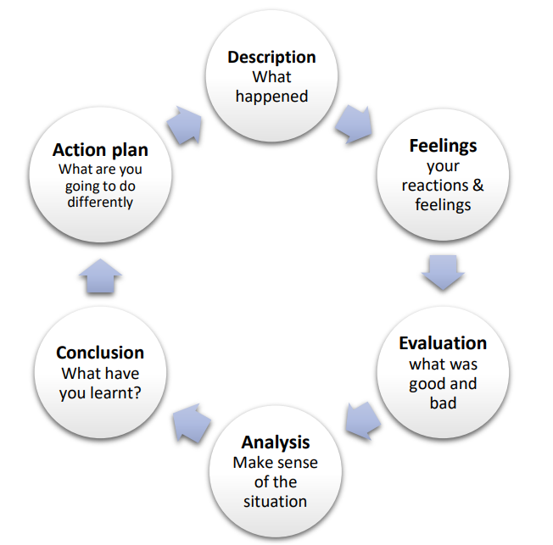
Gibbs' reflective model is comprised of a series of stages, each of which necessitates the completion of a series of questions in order to get to the core of someone's thought process (Ellis, 2017). According to Gibbs, the steps are outlined: description, feelings, evaluation, analysis, conclusions, and action plan (Bhattarai, 2020). Reflections and sentiments can be organized using this technique. To avoid jumping to conclusions too fast, I might use the distinct stages to calm down my mental processes.

Figure: A diagram of Gibb's Reflective Cycle stages

Description
Professionals who participate in a community can create relationships with others in their field or who share their interests, according to the findings of an early study on this topic (Flower, 2018). In order to develop a solid community, it is essential to build relationships with people in the surrounding area and with local organizations. An empathetic friendship can be formed when two people are in close proximity to one (Potter, 2015). Several of us students, as well as our professor, were immediately impacted by these events in the course. Despite the fact that I found the course fascinating in the first place, I'm concerned that my lack of background knowledge and sluggish learning style would prevent me from fully comprehending certain sections (Gardinier, 2019). My community participation assignment required me to apply what I had learned in class to any real-world group I came across. When compared to the previous project, this is an excellent option.

Feelings
The expression of feelings in the reflection illustrates how the students were feeling prior to, throughout, and after the occurrence they encountered (Day, 2016). This also provides insight into how others perceive the learners as well as how the learners themselves perceive the current situation. Prior to enrolling in the course, I had little prior awareness of community participation or the notion that it might have a substantial impact on a company's bottom line. I was also unfamiliar with the term "social enterprise." In the field of community engagement, I've learned a great deal of theoretical, model-based, and practical knowledge and experience. Following completion of the course material and the given activities, it is now abundantly evident to me that community involvement is essential for businesses to operate (Flower, 2018). We opted to enroll in the program because our mentor believed that being involved in the community would help us develop our communication and bargaining abilities, and we agreed with him. I'm pleased with myself now that I've learned something new about becoming involved in the community.

Evaluation
While participating in this reflective learning cycle, students can gain a more nuanced picture of the overall effectiveness of the educational process by sharing both their accomplishments and shortcomings with one another (Roux, 2015). As a result of our professor's great teaching skills, I thoroughly liked learning about the course topic in class. He used a wide range of real-world examples to teach us about the course topic. It was an incredible honor to be able to learn from him. On my behalf, every effort has been made to ensure that I fully comprehend the content in question. As a result, I'm continually falling behind on a variety of duties because I'm unable to process new information quickly enough. My time was taken up with obtaining material from the internet and completing the project as a result of my efforts in this regard. A job seeker who is required to write quickly has been informed that in order to be considered for any open positions, he or she must also be a competent writer. Accidental circumstances provided me with the assistance of acquaintances and a teacher, who may have assisted me in completing the project successfully because they provided me with motivation.

Analysis
Identifying the reasons why something is ethical or nonethical is an example of analytical thinking (Bhattarai, 2020). While beginning the process of grading events, I made an effort to incorporate both nice and negative contacts into the picture. I've decided to establish a blog in order to document my own journey, including both the good and the terrible situations along the way. As I've previously indicated, I'm not particularly gifted when it comes to picking up new skills. What you're witnessing is the result of my inability to pick up new talents quickly enough as a result of a scarcity of training time. In all likelihood, this was my first project of this nature, and there was no way to tell for certain whether or not I had worked on any other such projects in the past or in the future. As a result, I had to spend a significant amount of time attempting to seek down the information I required. The task and the Microsoft Office word processing program were unfamiliar territory for me, and this resulted in an abnormally lengthy project completion time for me. Ever since I was accepted into one of the most prestigious schools in the United Kingdom, I have developed a close relationship with one of the most competent mentors who was easily accessible to me. Because I have a great deal of experience with organizational strategies and approaches, it is doubtful that this project will encounter any difficulties.

Conclusion
It is the end of the reflective cycle that reveals how the situation could be improved in the future and what areas need further development (Ellis, 2017). I've gained a better understanding of how to communicate with the community, how to use social media, and so on as a result of the course. As a result of working on this assignment, I've improved my web search techniques, my proficiency with Microsoft Word, and my ability to organize material in a Word document. If I want to be able to operate effectively and efficiently in my line of work, this knowledge may be useful. Even though I've identified several areas where I need to improve, such as my capacity to learn quickly, my internet searchability, and my proficiency with Microsoft Word, I still need to devise a strategy for doing so. My future career performance will skyrocket if I can master self-correction.

Action Plan
Students must build a strategy for developing and attempting to implement a specific range of capabilities they identified during the learning experience as part of the action plan for the reflective cycle (Bhattarai, 2020). There are numerous ways to strengthen one's ability to reflect on wisdom and insight. I'll explain how I intend to ensure that the next time I find myself in a similar situation, I can perform to my maximum ability in the paragraphs that follow. The time constraints for each work in the course, I hope, will allow me to develop my abilities while also learning new stuff throughout my time there. A good action plan should include a method of determining how much progress has been made in order to ensure that the development continues indefinitely (Sen, 2021).

Developing Capabilities | Activities that improve the abilities | Timeframe | The evaluation of the accomplishment
Learning  Skills | One of the most important talents for doing efficiently well in the workplace is the ability to learn promptly. To grasp this skill I will do the following tasks:  - Every day, I'm going to put in the effort required to improve my ability to swiftly acquire new information, and I'm going to do so with a positive attitude.  - I want to focus on materials such as newspapers and instructional technologies to help me along the way to achieve my goals, | 3 Months | If I am able to learn about any task swiftly and complete the task within the specified time frame, I will consider myself to have successfully acquired the ability.
Improving computer  expertise | Every industry has a high demand for computer skills. So I'll need to learn more about Microsoft Office Suite. I need to perform the following:  - I’ll find out how to use the software to its fullest extent from my acquaintances.  - I’ll register for a course that offers me the chance to educate myself from specialists with years of expertise in the field of computer skills. | 5 Months | The ability to operate successfully with software such as Microsoft Word, Microsoft Excel, and Microsoft PowerPoint will be the benchmark by which this competence will be measured.
Strengthening the  command of writing | Writing ability is required in almost every profession. As a result, in order to improve this quality, I must do the following:  - I intend to keep up a regular writing routine for blogs, journals, and articles.  - I intend to read a variety of publications and books, both online and in print. | 4 Months | My proficiency will be determined by my ability to produce any content without making any grammatical or punctuation errors.

Conclusion
Reflective learning should be introduced to students at the primary age in order to boost their possibilities of better academic performance later on. I'll be able to reflect on my own productivity and learning in the classroom while working on this assignment. It was only when I was doing the homework that I realized how many mistakes I had made. This research has led me to formulate a plan for developing my skills and enhancing my overall efficiency. It was an excellent opportunity for me to learn a lot of new things and get some hands-on experience after finishing the project and getting evaluated. Taking this test has given me an opportunity to gain knowledge and skills that may help me land a job in a field that values the growth of persons with these qualities.

References
Bhattarai, A., 2020. Action Research: A Reflective Cycle. Journal of NELTA, 10(1).

Day, C., 2016. Effective Leadership and Reflective Practice. Reflective Practice, 1(1), pp.113-127.

Ellis, A., 2017. Teaching, learning, & assessment together. 1st ed. New York: Routledge.

Flower, L., 2018. Community literacy and the rhetoric of public engagement. 4th ed. Carbondale: Southern Illinois University Press.

Gardinier, L., 2019. Skill-learning through community engagement. 1st ed.

Potter, C., 2015. Leadership development: an application of Gibbs’ Reflective Cycle. Industrial and Commercial Training, 47(6), pp.336-342.

Roux, D., 2015. A reflective assessment process for promoting multi-agency cooperation. 2nd ed. Gezina [Pretoria]: Water Research Commission.

Rovers, M., 2016. The helping relationship: community engagement. 3rd ed. Ottawa: University of Ottawa Press.

Sen, B., 2021. Reflective writing: a management skill. Library Management, 31(1/2), pp.79-93.

Smith, H., 2017. The age of entrepreneurship. 2nd ed.

