To what extent do the policies of mainstream political parties in parliament differ to those of the far-right that are not officially in parliament?
The UK has a wide variety of political forces that appear in the forms of political parties that are in parliament and those that are not officially active in parliamentary politics. These usually take the form of groups that have not gained sufficient support or votes to form an established political party and thus take the form of groups such as the English Defence League, Britain First, and the United Kingdom Independence Party. On the other hand, the major players within Parliament with electoral support are the Conservative Party, the Labour Party, and the Liberal Democrat Party. All these political entities project power in different ways and do not always share the same interests and ambitions. At times though, some of their policies do overlap. These shared interests and differences become clearer when looking at the party manifestos, legislation and through speeches and interviews.
Immigration and Migrant Crisis

Mainstream political parties and far right groups sit on different sides of the political spectrum on immigration. While mainstream political parties are more careful on how to tackle this issue, far-right groups have a more stern and anti-immigration stance. The Labour Party, currently in opposition, has taken a centrist approach on immigration. They believe that immigration has its benefits in the form of skilled labour and making up for labour shortages in certain sectors of economy. Kier Starmer, the Labour Party leader has stated, that he would prefer to use something similar to the EU quota system with the option to return immigrants while at the same time expressing his desired aim to stop housing asylum seekers in government funded accommodation. The Conservative party has made it clear that they want to make ‘the biggest ever cut to net migration’ and to stop the boats bringing illegal immigrants to the shores of Britain. They have stated in their recent manifesto that they wish to implement ‘laws to make it clear that if you come to this country illegally, you will be swiftly removed.’ Far right groups such as UKIP and the EDL share the view that immigration needs to be stopped completely and that asylum seekers and refugees living in Britain should be repatriated to their countries of origin. They believe that immigrants take away job opportunities from local indigenous Brits and ‘pose a threat to national security.’

Foreign Policy, European Union and Brexit
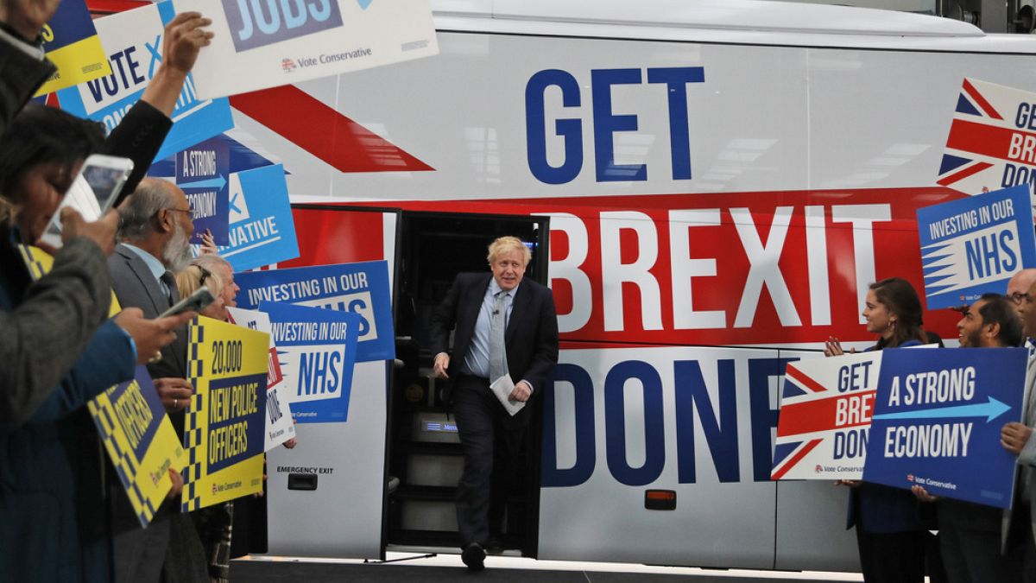
When it comes to foreign policy, mainstream political parties are the forces that form government and thus have to work with other countries. They tend to take a more pragmatic approach especially since they understand the importance of the requirement of peace on the continent after the horrors of the Second World War but also because of the shared and mutual economic and security benefits for all the countries on the continent. These shared concerns are what initially helped the UK join the EU. Having said that, it was the Conservative Party that held the ‘Brexit’ referendum to leave the EU. This was in part due to decades of effort made by more nationalistic forces such UKIP under the leadership of Nigel Farage who argued for Britain to regain control of its borders and laws. Far-right parties take a more nationalistic and euro-sceptic approach. Aside from general xenophobia, the EU was blamed and was seen as a key reason for increased immigration in recent decades and thus, the issue of having to give up sovereignty in certain areas to multi-national organisations was linked to immigration and a weakening economy and thus further shaped policy in Britain. The leave campaign, spearheaded by Nigel Farage who argued that Britain would be stronger out of the EU, was not necessarily true and shows how far-right groups are not always in touch with reality and do not always take into account the full picture of possibilities and consequences.
Family Values
The mainstream political are in favour of gender equality. They challenge the traditional gender roles. Labour achieved this by promoting gender equality, closing the pay gap and supporting women’s reproductive rights. Their manifesto states ‘increasing paid maternity leave from nine to 12 months, doubling paternity leave to four weeks and extending pregnancy protection.’ The Conservative Party takes a more traditional approach. Rishi Sunak recently stated ‘a man is a man and a woman is a woman, that's just common sense…. we shouldn't get bullied into believing that people can be any sex they want to be.’ Far right groups tend to hold even more conservative views on traditional gender roles. UKIP’s position leans towards scepticism on LGBTQ+ rights and with a focus on the traditional nuclear family, ‘most emphasize biological differences between men and women and traditional gender norms that fulfil these biological attributes.’ Britain First has expressed conservative views on what they consider to be traditional family structures.
‘We will implement a return to traditional family values, with a focus on traditional marriage, procreation of children and the nurturing of a healthy moral framework throughout society that will replace the present tsunami of selfish liberal degeneracy and sexual promiscuity.’
This is also opposite to the views of the mainstream parties which do not support family values that go against the traditional male and female marriage for procreating; anything outside this is considered as very low moral standards and individualistic. The Labour party is more supportive and favourable to embrace these as they are inclusive and try to include them in their manifesto, ‘abolished Section 28, equalised the age of consent, created civil partnerships… committed to reforming the Gender Recognition Act 2004 to introduce self-declaration for transgender people.’ Labour also claims the Conservatives have been slow to understand the scale of abuse and discrimination that LGBT+ people continue to face in our society.
Education
Mainstream parties are more focussed on inclusion, tolerance and have a diverse curriculum. They offer more funding to support a larger spectrum of students that includes BAME and the underprivileged. Conservative state ‘we will back heads and teachers on discipline. We will expand our programme to help schools with the worst behaviour learn from the best – and back heads to use exclusions.’ They also plan on increasing funding ‘by £14 billion, with those areas historically underfunded receiving the greatest increase.’ The mainstream parties are more inclusive towards other cultures. On the other hand, far right groups emphasise a traditional curriculum, with the perspective of a nationalist view and stricter immigration controls and want to ‘reintroduce Christian assemblies, Christian hymns and Christian prayers at all levels of the education system’ and also want the ‘removal of state indulgence in phoney 'social' education subjects.’ They ‘oppose the left-wing drive to eradicate centres of advanced learning in education due to their ideological obsession with 'equality'.’

Conclusion
It can be said that the Conservative party, tends to give a more nuanced and milder approach to policies that seem to pander to far right groups since ‘there is growing concern about the threat from far-right groups in the UK’ and the mainstream political parties are aware that their power is a force that cannot be overlooked and needs to be catered to. The Labour Party on the other hand is somewhere on the centre-right of the political spectrum. These approaches tend to take into consideration public discontent, humanitarian considerations, potential risks to the status quo and the potential impact on the economy. Far-right elements on the other hand, take a more radical and extremist view with little or no consideration to these ethical considerations. They have no experience of the political system from a parliamentary and governmental approach and so are not concerned of repercussions to the outcomes of their policy aims. Populism is a driving force in politics and even if far-right groups cannot hold seats in office, they can at times set the mood and agenda on certain policies especially when it comes to national security, national borders, nationalism and the preservation of a white European homogenous culture. This further impacts the even the parties that have been traditionally seen as leftist in that it forces them to adopt more centrist approaches or even centre-right approaches at times. It seems on the whole, ‘mainstream parties across Europe are shifting their positions on immigration in the hopes of impeding the rise of the far-right’ but this in itself is ‘self-defeating’ and a reflection of the sway of the power of populism.

Bibliography
Gallardo, Cristina, Why Britain’s Migration Problem Isn’t Going Away, Politico, 2022. <https://www.politico.eu/article/why-britains-migration-problem-is-the-hardest-crisis-to-solve/> [date accessed 04/01/2024]

5 Griffiths Clare and Trebilcock Julie, Continued and Intensified Hostility: The Problematisation Of Immigration In The UK Government’s 2020 New Plan for Immigration, Critical Social Policy, Sage Journals, 2022 <https://journals.sagepub.com/doi/10.1177/02610183221109133> [date accessed 04/01/2024]

7 History of the European Union 1945-59, European Union website. <https://european-union.europa.eu/principles-countries-history/history-eu/1945-59_en#:~:text=With%20the%20aim%20of%20ending,in%20securing%20a%20lasting%20peace.> [date accessed 04/01/2024]

9 Labour Party Manifesto, 2019 <https://labour.org.uk/wp-content/uploads/2019/11/Real-Change-Labour-Manifesto-2019.pdf> [date accessed 04/01/2024]

13 Labour Party Manifesto, 2019 <https://labour.org.uk/wp-content/uploads/2019/11/Real-Change-Labour-Manifesto-2019.pdf> [date accessed 04/01/2024]

3 Manifesto, Our Plan to Cut Immigration, Conservative Party Website, 2023. https://www.conservatives.com/news/2023/our-plan-to-cut-immigration#:~:text=That%20is%20why%20today%2C%20the,salary%20needed%20to%20get%20visas.

4 Manifesto, Your Priorities Are Our Priorities: Rishi Sunak Sets Out Our Vision For You, Conservative Party Website, 2023. <https://www.conservatives.com/news/2023/your-priorities-are-our-priorities> [date accessed 04/01/2024]
15 Manifesto, Investing In Schools, Convervative Party Website, 2023 <https://www.conservatives.com/our-plan/schools> [date accessed 04/01/2024]

16 Manifesto, UKIP Education policy, UKIP website, <https://www.ukip.org/ukip-policies/policy-education> [date accessed 04/01/2024]

17 Manifesto, UKIP Education policy, UKIP website, <https://www.ukip.org/ukip-policies/policy-education> [date accessed 04/01/2024]

14 Manifesto, Investing In Schools, Convervative Party Website, 2023 <https://www.conservatives.com/our-plan/schools> [date accessed 04/01/2024]

6 O’Donoghue Saskia, Has Brexit Been A Failure? A Majority Of Brits Think So, Euro News, 2023. <https://www.euronews.com/2023/12/31/has-brexit-been-a-failure-a-majority-of-brits-think-so> [date accessed 04/01/2024]

2 Sky News, Keir Starmer Rejects ‘Nonsense’ Claims That Labour’s Immigration Plans Would Increase Asylum Seeker Numbers, 2023 <https://news.sky.com/story/keir-starmer-rejects-nonsense-claims-that-labour-immigration-plans-would-increase-asylum-seeker-numbers-12962891#:~:text=News%20%7C%20Sky%20News-,Keir%20Starmer%20rejects%20'nonsense'%20claims%20that%20Labour's%20immigration%20plans%20would,if%20it%20gets%20into%20power.> [date accessed 04/01/2024]

11 Skelsboek Inger et al, What role does gender play in the Far Right, 2020 <https://www.sv.uio.no/c-rex/english/groups/compendium/what-role-does-gender-play-in-the-far-right.html> [date accessed 04/01/2024]

12 Right-Wing or Left-Wing? Britain First Website <https://www.britainfirst.org/rightwing_or_leftwing> [date accessed 04/01/2024]

10 Sunak Rishi: ‘A Man Is A Man And A Woman Is A Woman, That’s Just Common Sense’, The Independent, 2023 <https://www.youtube.com/watch?v=g5kQhhgK6T8> [date accessed 04/01/2024]
18 Taylor Matthew and Walker Peter, EDL Supporters Are Young, Male And Anti-Immigration, Says Survey, Guardian News, 2011 <https://www.theguardian.com/uk/2011/oct/30/english-defence-league-membership> [date accessed 04/01/2024]

8 The “Brexit” Referendum, Britannica Encyclopaedia Online < https://www.britannica.com/place/United-Kingdom/The-Brexit-referendum> [date accessed 04/01/2024]

19 Vohra Anchal, The Far Right Is Winning Europe’s Immigration Debate, Foreign Policy, 2023 < <https://foreignpolicy.com/2023/11/01/the-far-right-is-winning-europes-immigration-debate/#cookie_message_anchor> [date accessed 04/01/2024]

Cristina Gallardo, Why Britain’s Migration Problem Isn’t Going Away, Politico, 2022. <https://www.politico.eu/article/why-britains-migration-problem-is-the-hardest-crisis-to-solve/> [date accessed 04/01/2024]
Sky News, Keir Starmer Rejects ‘Nonsense’ Claims That Labour’s Immigration Plans Would Increase Asylum Seeker Numbers, 2023 <https://news.sky.com/story/keir-starmer-rejects-nonsense-claims-that-labour-immigration-plans-would-increase-asylum-seeker-numbers-12962891#:~:text=News%20%7C%20Sky%20News-,Keir%20Starmer%20rejects%20'nonsense'%20claims%20that%20Labour's%20immigration%20plans%20would,if%20it%20gets%20into%20power.> [date accessed 04/01/2024]
Manifesto, Our Plan to Cut Immigration, Conservative Party Website, 2023. https://www.conservatives.com/news/2023/our-plan-to-cut-immigration#:~:text=That%20is%20why%20today%2C%20the,salary%20needed%20to%20get%20visas.
Manifesto, Your Priorities Are Our Priorities: Rishi Sunak Sets Out Our Vision For You, Conservative Party Website, 2023. <https://www.conservatives.com/news/2023/your-priorities-are-our-priorities> [date accessed 04/01/2024]
Clare Griffiths and Julie Trebilcock, Continued and Intensified Hostility: The Problematisation Of Immigration In The UK Government’s 2020 New Plan for Immigration, Critical Social Policy, Sage Journals, 2022 <https://journals.sagepub.com/doi/10.1177/02610183221109133> [date accessed 04/01/2024]
Saskia O’Donoghue, Has Brexit Been A Failure? A Majority Of Brits Think So, Euro News, 2023. <https://www.euronews.com/2023/12/31/has-brexit-been-a-failure-a-majority-of-brits-think-so> [date accessed 04/01/2024]
History of the European Union 1945-59, European Union website. <https://european-union.europa.eu/principles-countries-history/history-eu/1945-59_en#:~:text=With%20the%20aim%20of%20ending,in%20securing%20a%20lasting%20peace.> [date accessed 04/01/2024]
The “Brexit” Referendum, Britannica Encyclopaedia Online < https://www.britannica.com/place/United-Kingdom/The-Brexit-referendum> [date accessed 04/01/2024]
Labour Party Manifesto, 2019 <https://labour.org.uk/wp-content/uploads/2019/11/Real-Change-Labour-Manifesto-2019.pdf> [date accessed 04/01/2024]
Rishi Sunak: ‘A Man Is A Man And A Woman Is A Woman, That’s Just Common Sense’, The Independent, 2023 <https://www.youtube.com/watch?v=g5kQhhgK6T8> [date accessed 04/01/2024]
Inger Skelsboek et al, What role does gender play in the Far Right, 2020 <https://www.sv.uio.no/c-rex/english/groups/compendium/what-role-does-gender-play-in-the-far-right.html> [date accessed 04/01/2024]
Right-Wing or Left-Wing? Britain First Website <https://www.britainfirst.org/rightwing_or_leftwing> [date accessed 04/01/2024]
Labour Party Manifesto, 2019 <https://labour.org.uk/wp-content/uploads/2019/11/Real-Change-Labour-Manifesto-2019.pdf> [date accessed 04/01/2024]
Manifesto, Investing In Schools, Convervative Party Website, 2023 <https://www.conservatives.com/our-plan/schools> [date accessed 04/01/2024]
Manifesto, Investing In Schools, Convervative Party Website, 2023 <https://www.conservatives.com/our-plan/schools> [date accessed 04/01/2024]
Manifesto, UKIP Education policy, UKIP website, <https://www.ukip.org/ukip-policies/policy-education> [date accessed 04/01/2024]
Manifesto, UKIP Education policy, UKIP website, <https://www.ukip.org/ukip-policies/policy-education> [date accessed 04/01/2024]
Matthew Taylor and Peter Walker, EDL Supporters Are Young, Male And Anti-Immigration, Says Survey, Guardian News, 2011 <https://www.theguardian.com/uk/2011/oct/30/english-defence-league-membership> [date accessed 04/01/2024]
Anchal Vohra, The Far Right Is Winning Europe’s Immigration Debate, Foreign Policy, 2023 < <https://foreignpolicy.com/2023/11/01/the-far-right-is-winning-europes-immigration-debate/#cookie_message_anchor> [date accessed 04/01/2024]

