Strategic Property Maintenance in 4 to 5 Star Hotels
Focusing on Hotels within South Wales, UK

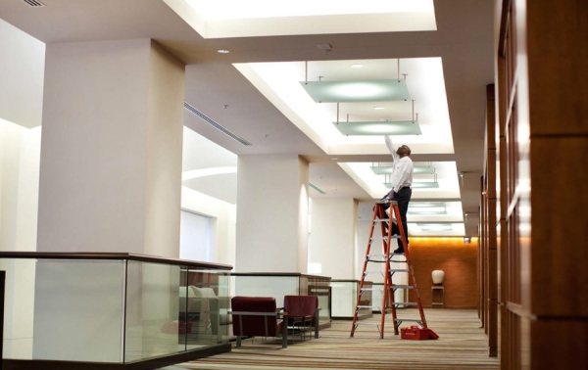

Author: Brad Hunter Supervisor: Chris House/Trevor Francis
Cardiff 2020

Table of Contents

- - Working Title 6
  - – Rationale 6
- – Research Goals 7
  - – Aim 7
  - – Objective 7
  - – Key Questions 7
  - – Methodology Road Map 8
- – Literature Review 9
- – Data Collection 11
- – Results and Analysis 14
  - – Introduction 14
  - – Part A Outsourcing vs In-house 15
    - - A1. From the following, do you outsource or keep in-house? 15
    - - A2. What is the reason for you to outsource the works? 16
    - - A3. What do you consider in keeping the maintenance in-house? 17
    - - A4. How long do you run the maintenance contract?, QA5. Are they centrally controlled? 18
    - - A7. Through your knowledge and experience, what are your
thoughts on outsourcing? Is it beneficial to the business? 19
  - - Part B - Inspection and Repair 20
    - - B1.Why do you think it’s important to carry out maintenance activities 20
    - - B2. Could rank the items below according to importance? 21
    - - B3. Do you have issues in implementing your maintenance plans? 23
    - - B4.When does the accurate competition of historic reactive works assist with future maintenance plans? 24
    - - B5. When does accurate recording of annual labour and parts used,
allow for increase or decrease of future budgets cost? 25
    - - B6. When does accurate records of assets, allow for a deferred maintenance program (end of life replacement)? 26
    - - B7. If you must put a percentage to proactive and reactive works,
B8. In your professional opinion is this right? 28
    - - B9. How would you optimize the hotel operations in maintenance to achieve a successful strategy? 29
  - - Part C – Budgets 29
    - - C1. Do you have a set budget for maintenance, what input do you
have in setting the budget and then implementing? 29
    - - C2. As a breakdown of cost, what percentage would you give to each? 30
    - - C3. Are your budgets set on Predictive, Routine Preventive, or Emergency Corrective (Failure)? 31
    - - C4. Can you recruit maintenance engineers easily to fit into
the hotel industry? Why or why not? 32
    - - C5. What do you consider when employing new engineers? 32
    - - C6. Do you do any in-house training? If so, what is it about
and how often? 32
    - - C7. Do you recognize engineers by their accomplishment due to exemplary completion for their works? How? What type of
incentives are they given? 33
  - - Part D: Energy in Hotels 34
    - - D1. How do you rank the importance of energy consumption within
the hotel? 34
    - - D2. How much capital investment did you invest to improve energy reductions during 2019? 35
    - - D3. Where were the investments? If possible, can you put a
percentage to each of the following? 36
    - - D4. Do you activity analysis your energy data, by comparing YOY,
How and When, D5. Do you highlight high consumption assets
and look to replace before end of life or just wait till beyond repair? 37
    - - D6. In your professional opinion, is energy reduction within your
hotel optimised or can more be done? If yes, what improvements
should be done? 37
    - - D7. Do you have a sustainability policy? Does it follow the 17
global goal listed below? Tick each section 38

- – Evaluation 41
- - Limitation, Problems, Further Research 44

References 45
Appendices 49
Appendix 1 – Questionnaire/Survey Form

Figures
Figure 1: Methodology Road Map
Figure 2: Categories of Maintenance
Figure 3: AA list all 4 to 5 star hotels in the Welsh region
Figure A1: Total In-House vs Out Source
Figure A2: Area of In-House or Out Source
Figure A3: Data Collected Out Sourced vs In-House
Figure A4: Total Data Collected Out Sourced vs In-House
Figure A5: Reason of Important per Hotel
Figure A6: Mean Reason of Important of Out Sourced Work
Figure A7: Data Collected For Out Sourcing
Figure A8: Why Change Contracts – Per Hotel
Figure A9: Mean On Why Change Contracts
Figure A10: Data Collected On Why Change Hotels
Figure B1 Total Importance of Maintenance Role
Figure B2 Importance of Maintenance Roles
Figure B3 Data Collected Importance of Maintenance Role
Figure B4 Restrictions in Implementing Maintenance Plans
Figure B5 Mean Restrictions in Implementing Maintenance Plans
Figure B6 Data Collected in Restrictions in Implementing Maintenance Plans
Figure B7 Competition of Historic Reactive Works Assist with Future Maintenance Plans
Figure B8 Data Collected Competition of Historic Reactive Works Assist with Future Maintenance Plans
Figure B9 Accurate Recording of Annual Labour and Pars Used Formula
Figure B10 Data Collected Accurate Recording of Annual Labour and Pars Used Formula
Figure B11 Accurate Records of Assets, Allow for a Deferred Maintenance
Figure B12 Data Collected Accurate Records of Assets, Allow for a Deferred Maintenance
Figure B13 Works which are Proactive verse Reactive
Figure B14 Data Collected Works which are Proactive verse Reactive
Figure C1 Value of Set Budget
Figure C2 Percentage in set Section
Figure C3 Data Collected Valve of Budget
Figure C4 Percentage of Cost to Each Area
Figure C5 Total Percentage of Cost Used in Each Area
Figure C6 Data Collected of Cost to Each Area
Figure C7 What is the Budgets Set Against?
Figure C8 Data Collected What the Budget is set against
Figure D1 Importance of energy Consumption
Figure D2 Data Collected Importance of Energy Consumption
Figure D3 Capital Investment into Energy 2019
Figure D4 Data Collected Capital Investment into Energy 2019
Figure D5 Areas of Capital Investment
Figure D6 Data Areas of Capital Investment
Figure D7 What are the 17 Sustainability Global goals that are currently within the Hotel Policy
Figure D8 Data collected what are the 17 Global goals that are currently within the Hotel Policy
Figure D9 Hotels that currently adopt 17 Sustainability Global Goals

1.0 Working Title

Strategic Property Maintenance in 4 to 5 Star Hotels – focusing on hotels within the South Wales Section of the UK.

1.1 Rationale
I have worked directly within property maintenance (primarily within the Hospitality employment context) for 16 years and have used a number of different strategies of maintenance. From my industry experience it seems that there isn’t one concise direction that hospitality facilities use. Inevitably maintenance in any building is complex and a vast subject and perhaps none more so than in the hospitality sector. The significance of having effective and efficient maintenance programmes cannot be underestimated and can when in operation prevent large-scale disruptions to business but also the repartition of the company. For instance, the incorrect maintenance of the heating system could lead to failure, preventing the building having hot water and heating, thus causing a large-scale disruption to service quality for guests. It could also delay in the repair of equipment, as it hasn’t passed the correct statutory requirement checks. This can lead to further damage through the loss of reparation in the business market, and without the correct statutory checks being completed legal action could follow. Finally, the loss of revenue implication may be too great and the business will need to foreclose. Maintenance within hospitality must look past the physical element of maintenance and also consider the forever changing guest expectations that are driven by market trends and new technology enhancements. Creating a balance between guest expectation and the effectiveness of the maintenance strategies is essential for the smooth running of any hotel operations.
Despite the direct importance of maintenance to any building, in particular the hospitality sector there seems to be a lack of proactive maintenance strategies. Ideally this could be related to the large amount of maintenance manpower being used to preform corrective maintenance. Currently research shows that there is no maintenance strategy suitable to all hotel facilities mainly due to variable design, locations, construction, and building services. Chan et al (2001) highlighted the over reliance within hospitality context on corrective maintenance and the concept of “five strategic bases of maintenance” and advocates a more top-down planned managerial approach. He continues to say that an appropriate maintenance strategy is a decision that the managerial and engineering team needs to formulate, and if the right strategy is to be formulated this will require further research.
‘Planned maintenance’ need to focus on maintenance strategies that work more effective and efficient in the hotel environment and should as a pre-requisite consider variables within each building, from it design, manpower and guest demands. Being able to indicate the best practice for maintenance strategies will increase the life cycle of the building, enhance the business reputation in the industry, and increase knowledge into the hospitality sector to enable management to make the correct choices in the efficiencies and effectiveness of maintenance that will in turn help uphold the overall operational needs and objectives of the business.
Research Goals

Aim
To propose a guideline for implementing a strategic maintenance programme for hotels

Objective
- To review different concepts and principles of strategic planned maintenance with 4 to 5-star hotels
- Verify what type of maintenance strategy works efficiently in hotels operations
- Highlight the current challenges that maintenance managers struggle within the current market
- Formulate a plan of best used maintenance strategies to better enhance efficiencies within the hotel operations

Key Questions
- What is the current maintenance strategies?
- What is the level of priority given to maintenance PPM?
- What is the main criteria that would influence maintenance strategic plans?
- To what extent does experience of the FM have on the successful application of maintenance programmes?
- What impact does resource, time and cost have in successful strategic plans?
- Does any consumer trends and views impact direction of maintenance schedules/programmes?

Methodology Road Map

Figure 1
2.0 Literature Review
In order to research and propose more effective management strategies within hospitality context it is crucial to explore the meaning of ‘maintenance’. The oxford dictionary defines ‘maintenance’ as being “The process of preserving a condition or situation or the state of being preserved. The process of keeping something in good condition”, (Oxford dictionary, 2018). The British Standards Institution defines maintenance as “the effort in connection with different technical and administrative action to keep a physical asset in or restore it to a condition where it can perform a required function” (British Standard Institution 1993). In other industries this can be directly applied but in hospitality the term ‘maintenance’ can be used as a board statement. For instance it isn’t just the physical upkeep of the facilities that need to be considered but also the administrative elements of legal requirements and the keeping up with the technological enhancement for better efficiency’s in energy. Francis et al (2001) defines building maintenance as “an operation involving the interaction or combination of technical, social, legal, and fiscal determinants that governs and manages the use of the building” (Francis WH, Yik WL, 2001). Borsenik and Stutts (1997) continue to add extra elements of the management of maintenance and engineering systems for hospitality buildings in particular “the design, construction, occupancy and use, repair, renovation, and disposal. Hospitality building engineering and maintenance systems include: life safety; heating; ventilation; and air condition; electrical; water; transportation; exterior; environment; and special facilities equipment ( Borsenik and Stutts 1997). If we just look at these definitions that means maintenance can be boxed off in the simple element of keeping all items in good condition of repair, care of the building structure, and equipment within. To keep the building in good condition for the attended purpose. The only problem with these definitions is that it doesn’t consider other factors in maintenance like emergency brake downs, renovations through guest expectations with changing market trends. Seeley (1987) first raised that renovation is classed as maintenance “any works that consist of restoring a structure, services and equipment by a major overhaul to the original design and specification, or to improve on the original design”(Seeley 1987). Lind and Muyingo (2009) also wrote that maintenance can be defined as “restoring it to or retain a state in which an item can perform an initially specified functions and all action” (Lind and Muyingo 2009). This can be through renovation works to the building including various things like new equipment, soft fixtures and fittings, removal of walls and designing new layouts, adding new extensions to the building due to increase of business functionality. Stipanuk and Roffmann added different prospective of renovation which included ‘renewing and updating the property to meet the needs of the changing markets to meet customers satisfaction’ (Stipanuk and Roffmann 1996).
Through these variable definitions it is clear that maintenance isn’t as simplistic and straightforward as first described (i.e. oxford dictionary definition) linking in variable factors that determine how a building is maintained. Chanter and Shallow believe that there are various categories to maintenance also detailed by Seeley (Seeley 1987) as per seen in Figure 1. This type of format has been used throughout the maintenance world and a clear way to keep a facility in good working condition to meet its required purpose. Various other categories have been formulated like Chan et al 2001 suggests that maintenance can be classified as “Routine Maintenance, Corrective Maintenance, Preventive Maintenance, and Emergency Maintenance” (Chan KT, Lee RHK, Burnett J, 2001).
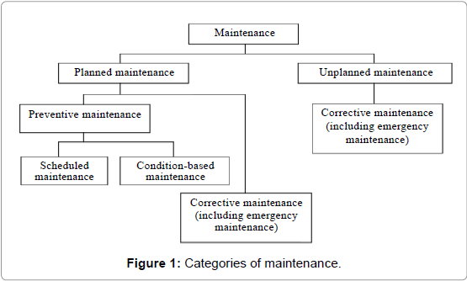
Figure. 2

- Planned maintenance: “The maintenance is well organized and carried out with forethought, control and the use of records to a predetermined plan.”
- Unplanned maintenance: “The maintenance implemented without predetermined plan.”
- Preventive Maintenance: “The maintenance carried out at predetermined intervals of time or period and intended to reduce the probability of failure or unsatisfactory performance of an item.”
- Corrective maintenance: “The maintenance implemented as failure has occurred and intended to restore or repair an item to the state that can perform its required function.” No active maintenance is been kept on this equipment only when there is a breakdown, this could be a heating plate exchange unit cracks and requires replacement or repair
- Emergency maintenance: “The necessary maintenance to be implemented immediately in order to prevent further damage or serious impacts on an item.” This is generally an item or structure that will cause major issue to the building or business that requires immediate repair or renewal
- Condition-based maintenance: “The preventive maintenance initiated as a result of knowledge of the condition of an item from routine or continuous monitoring and inspection.”
- Scheduled maintenance: “The preventive maintenance implemented to a predetermined interval of time, number of operations, mileage and others.” This is optimizing the use of equipment and replacing it before the effectiveness is up, an example could be, chlorine probes for swimming pools, the efficiencies are reduced with age so are replaced as per manufactures guidelines.
Figure 2. (Seeley 1987)
With these clear categories that have been defined in figure 1 is there a way to gauge the performance of maintenance and introduce a best practice procedure to optimize the efficiency and effectiveness of building management?. Hicks and McNay (1999) and Chan et al (2001) look at various performance indicators related to hotels, the areas covered are “business availability, manpower utilisation index, urgent repair and request index, failure frequency and unit repairing time, preventative maintenance ratio and energy use index”. Although the information provided within the report can be used in context, are there different elements, which need to be considered? For instance, the location of the hotel may affect the general conception within the report done by Chan, Lee, and Burnett. This is why there needs to be extra in-depth research into which maintenance strategies best works in hotels, in the conclusions of Chan, Lee, and Burnett they write “A concept of five strategic bases of maintenance applicable to the hospitality engineering system is present. The adoption of the appropriate strategy for individual system is an engineering and managerial decision and further studies are required to make a methodical process of making the decision” (Chan KT, Lee RHK, Burnett J, 2001).
3.0 Data Collection
To make this research practical and relevant it would be unrealistic to look at all hotels globally and how they implement maintenance strategies. Instead for this research I’ll be focusing on typical hotels within Wales, United Kingdom area, using a multi method of data collection. It will be both qualitative and quantitative. To give the research an accurate reflection of maintenance strategies and due to cooperate budgets and expectations of the customers, the intended focus will be targeting 4 to 5 star hotels.
I will be using the accredited professional bodies including AA and Visits Wales identified hotels in the area where both use a recorded auditing and reviewing criteria where hotels are awarded points for each area of the hotel including both service and product. This star rating criteria will form a baseline to start my research. The hotels listed in the research will need to be maintained to the highest standard to be able to obtain or hold on to its 4 – 5 star rating, as stated by AA (2019) “Highly recommended hotels offering a superior level of quality within their star rating, high standards of hotel keeping in particular hospitality, service and cleanliness” (AA, 2019). A limitation here is where either professional body haven’t accredited the hotel in which case I’ve discounted the hotel from the research.
See Figure 1 from AA list all 4 to 5 star hotels in the Welsh region. (2019, AA)

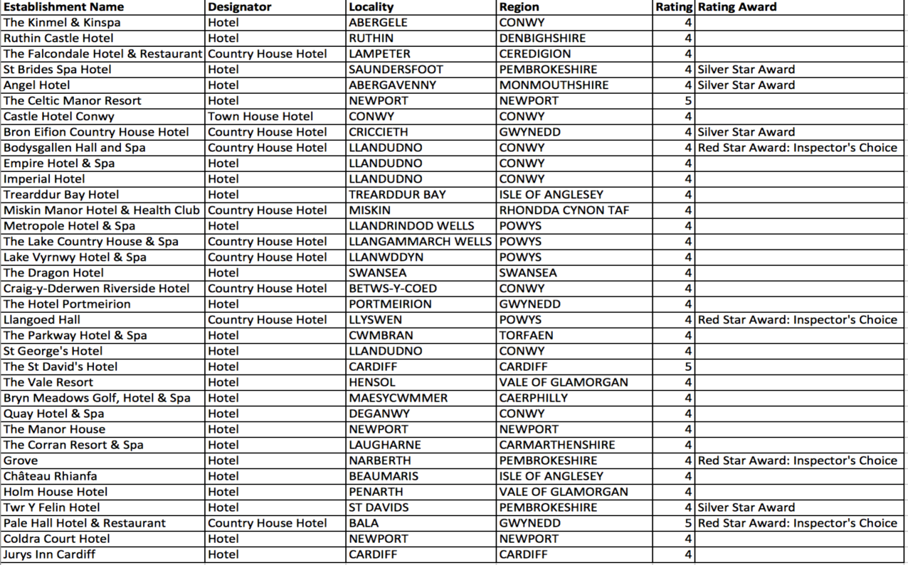
Figure. 3
Both use a recorded auditing and reviewing criteria where hotels are award points for each area of the hotel including both service and product. This star rating criteria will form a baseline to start my research, as the hotels listed in the research will need to maintain their properties to the highest standard to be able to obtain or hold on to its 4 – 5 star rating.
The Star rating is as summarized in the ‘AA standard guidelines’ web page and clearly outlines that the hotel must meet these mandatory criteria:
1 star: Courteous staff provides an informal yet competent service. All rooms are ensuite or have private facilities. A designated eating area serves breakfast daily and dinner most evenings.
2 stars: A restaurant or dining room serves breakfast daily and dinner most evenings.
3 stars: Staff are smartly and professionally presented. The restaurant or dining room is open to residents and non-residents.
4 stars: Professional, uniformed staff respond to your needs or requests. Well-appointed public areas. The restaurant or dining room is open to residents and non-residents. Lunch is available in a designated eating area.
5 stars: Luxurious accommodation and public areas. A range of extra facilities and a multilingual service available. Guests are greeted at the hotel entrance. High quality menu and wine list.
Although these points above do not directly reflect the maintenance standards, in order to achieve a star rating the hotel is inspected as a whole and that also includes the maintenance standards, the quality of the fixtures and fittings and general appearance of the hotel. In section 2.1 of the AA star guide it highlights the basic level standard requirements for both legal obligation, security and maintenance that need that needs to be met but also the mandatory level that all hotels must achieve before any star rating can be awarded. With these maintenance guidelines it states:
- Buildings, their fixtures, furnishings, fittings, exterior and interior décor maintained in a sound, clean condition and fit for the purpose intended.
- All electrical and gas equipment in good working order and regularly serviced to ensure guests’ safety.
- Monitoring procedure in place for reporting of broken/damaged items in guests’ bedrooms.
(AA Hotel & Hospitality Services 2018)
The first method of research will be reviewing data with books, journals, articles and data already collected on the subject. This information will be the secondary source of data required (Sekaran U, Bougie R, 2013). The primary source of information will be a questionnaire and interviewing maintenance managers or any relevant maintenance personnel on site. I have chosen to conduct my research using a qualitative style of data gathering (in the form of interview and questionnaires) that will later be analysed and broken down into measurable quantified results from the answers obtained. Following data collection it was my focus to analyse all of the information obtained from the interviewees whereby I have transcribed and analysed them to help determine key themes and views relating to maintenance management and strategizing.
For all participants I plan on providing an overview of the purpose of the study and to discuss with them the scope and objectives of my research so that they have a full understanding of the background context. I will be asking questions based on their difficulties, which can be subjective and political however by conducting face-to-face interviews I would hope to get a personal response and being a maintenance manager get a true count of the issues highlighted from their own employment role and remit experiences. 10 interviews will be conducted with maintenance managers and 40 questionnaires sent out as this format can reach a large number of respondents within a limited time frame (Robson C, 2002), with an expected return of 75-80 responded questionnaires. Within the interviews and questionnaires, it will become evident the types of maintenance problems which are occurring and enable me to categorise them into areas to enable further research some of the categorises are as follows AC – air conditioning faults, ELE – electrical faults, PLU – Plumbing Faults etc. Assess what types of maintenance strategies the hotel is currently running and assess the efficiency through emergency brake downs and corrective maintenance within a daily operation. This information can be generally found through the in-house maintenance reporting system, which should be electronically backed up. Other factors to take into consideration will be business availability, manpower, and renovation works. Once all the data is collected and previous documentation is reviewed I will be able to formula data statistics to form a concept of a relation between different maintenance strategies, the efficiencies and effectiveness of the different maintenance strategies within the hotels.

5.0 Results and Analysis

5.1 Introduction

The data collected took place over the months January and February 2020, the objective was to conduct a 10 face to face interview/ questionnaire with current maintenance managers within the south wales regions. With my experience in the hospitality industry and having understanding of how hotels operate, I felt it was beneficial to talk directly to the individual. The goal has been to extract a more accurate first-hand account of maintenance strategies that potentially will allow me more insight of operations which are currently are taking place. Looking at the best maintenance practises and the applied efficiencies can be converted into a statistical analysis. Does the importance of each maintenance strategy, (e.g proactive or reactive maintenance) have a direct impact on improving maintenance efficiency’s? These will look at the different values; statistically mean, minimum and maximum of maintenance performance by using to varied data analysis tools, for example the correlation which can use to look at the different relationship between the efficiencies of each strategy. A stand error bar can be used to see the which maintenance practices are used the most, this doesn’t necessarily mean this will have a direct impact on the final study but will show trends in the hotel maintenance, forming discussions on whether traditionally its best to follow market trends of maintenance strategy’s is correct versus should it be decided on an individual process local within the hotel.

From the original objection of 10 interviews to current maintenance managers to be completed, 8 were completed successfully. With the 2 potential applicants failing to response in the timeframe set.

The interviews/questionnaire was divided into 4 key area of maintenance looking at –

- Outsourcing
- Inspection/Repair
- Budgets
- Energy

By looking at a combination of both statistical information, and professional opinions. This enabling an insight to the related issues that maintenance manager are facing, and where current strategies may not be working.

5.2 Part A: Outsourcing vs In-house

5.2.1

A1. From the following, do you outsource or keep in-house?

The information in this section is statistical data looking at the tasks the maintenance manager outsourced or keep in-house. The results will help explore what tasks are completed by the in-house team, what skills and tools are required, recruitment requirements, budgets and generally how maintenance is executed throughout the individual sites.

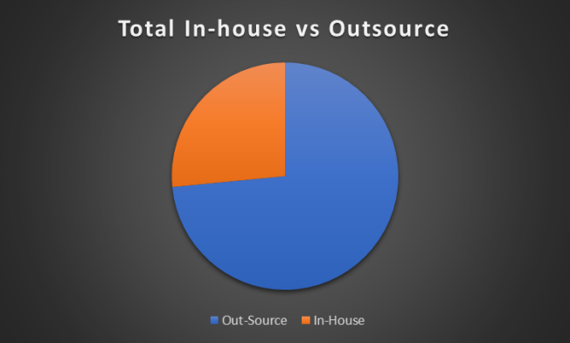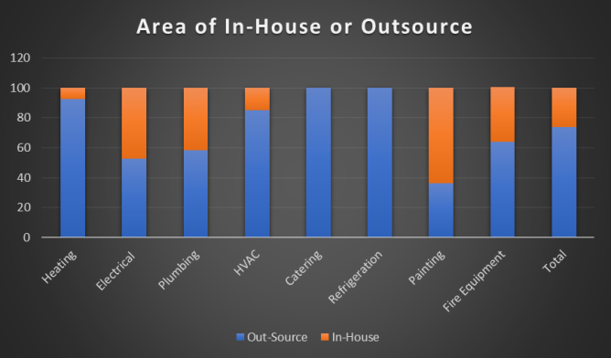
Figure A.1 Figure A.2

 | Mean | Med | Mode | H1 | H2 | H3 | H4 | H5 | H6 | H7 | H8
Out Source - Heating | 92.50 | 100 | 100 | 100 | 100 | 50 | 100 | 100 | 90 | 100 | 100
In-House - Heating | 7.50 | 0 | 0 | 0 | 0 | 50 | 0 | 0 | 10 | 0 | 0
Out Source - Electrical | 52.50 | 50 | 40 | 40 | 30 | 80 | 50 | 40 | 60 | 70 | 50
In-House - Electrical | 47.50 | 50 | 60 | 60 | 70 | 20 | 50 | 60 | 40 | 30 | 50
Out Source - Plumbing | 58.13 | 60 | 60 | 50 | 65 | 80 | 60 | 40 | 60 | 60 | 50
In-House - Plumbing | 41.88 | 40 | 40 | 50 | 35 | 20 | 40 | 60 | 40 | 40 | 50
Out Source - HVAC | 85.00 | 85 | 90 | 90 | 70 | 100 | 80 | 90 | 70 | 100 | 80
In-House - HVAC | 15.00 | 15 | 10 | 10 | 30 | 0 | 20 | 10 | 30 | 0 | 20
Out Source - Catering | 100.00 | 100 | 100 | 100 | 100 | 100 | 100 | 100 | 100 | 100 | 100
In-House - Catering | 0.00 | 0 | 0 | 0 | 0 | 0 | 0 | 0 | 0 | 0 | 0
Out Source - Refrigeration | 100.00 | 100 | 100 | 100 | 100 | 100 | 100 | 100 | 100 | 100 | 100
In-House - Refrigeration | 0.00 | 0 | 0 | 0 | 0 | 0 | 0 | 0 | 0 | 0 | 0
Out Source - Painting | 36.25 | 25 | 20 | 20 | 20 | 100 | 30 | 10 | 30 | 0 | 80
In-House - Painting | 63.75 | 75 | 80 | 80 | 80 | 0 | 70 | 90 | 70 | 100 | 20
Out Source - Fire Fighting Equipment | 63.75 | 60 | 50 | 50 | 70 | 80 | 60 | 90 | 50 | 50 | 60
In-House - Fire Fighting Equipment | 36.25 | 40 | 50 | 50 | 30 | 20 | 40 | 10 | 50 | 50 | 40
Figure A.3

 | Heating | Electrical | Plumbing | HVAC | Catering | Refrigeration | Painting | Fire Equip | Total
Out-Source | 92.5 | 52.5 | 58.13 | 85 | 100 | 100 | 36.25 | 63.75 | 73.51
In-House | 7.5 | 47.5 | 41.88 | 15 | 0 | 0 | 63.75 | 36.75 | 26.49
Figure A.4

From the information in figure. A1 it’s clear a high percentage of 73.51% of maintenance works is out-sourced where only 26.49% in kept in-house. This goes against the finding of Chan, (2008) where the figures for 4 star hotels for outsourcing verse in-house were 48% in-house to 52% out-sourced. In 5-star hotels this percentage was much higher to keeping maintenance in-house of 65% verse 35% outsourced (Chan,2008). The common trend as seen in figure A2 is that tasks that require a qualified tradesperson or specialized tools like shown in catering and refrigeration is outsourced. Where some of the less complex tasks like painting and decorating task are picked up in-house. In the interview the both plumbing and electrical were discussed in two different levels, whereas low skilled non certificated works like changing a light bulbs or a like for like replacement of a tap fitting, all these works were picked up in house, but works requiring certification like install of power outlets are out-sourced.

5.2.2

A2. What is the reason for you to outsource the works?
Not Important Very Important
1 2 3 4 5

Interviewees were asked to categorize the purpose of outsourcing the related to the tasks as shown in QA1. Although this was statistical information, some elements are formed from opinion.

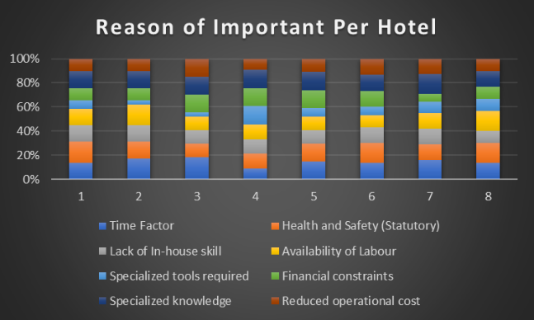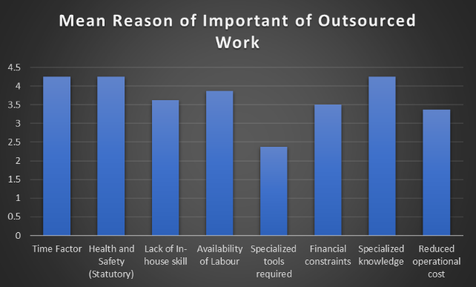
Figure A.5 Figure A.6

 | Mean | Med | Mode | Hotel 1 | Hotel 2 | Hotel 3 | Hotel 4 | Hotel 5 | Hotel 6 | Hotel 7 | Hotel 8
Time Factor | 4.25 | 4 | 4 | 4 | 5 | 5 | 3 | 4 | 4 | 5 | 4
Health and Safety (Statutory) | 4.25 | 4 | 4 | 5 | 4 | 3 | 4 | 4 | 5 | 4 | 5
Lack of In-house skill | 3.625 | 4 | 4 | 4 | 4 | 3 | 4 | 3 | 4 | 4 | 3
Availability of Labour | 3.875 | 4 | 4 | 4 | 5 | 3 | 4 | 3 | 3 | 4 | 5
Specialized tools required | 2.375 | 2 | 2 | 2 | 1 | 1 | 5 | 2 | 2 | 3 | 3
Financial constraints | 3.5 | 3.5 | 3 | 3 | 3 | 4 | 5 | 4 | 4 | 2 | 3
Specialized knowledge | 4.25 | 4 | 4 | 4 | 4 | 4 | 5 | 4 | 4 | 5 | 4
Reduced operational cost | 3.375 | 3 | 3 | 3 | 3 | 4 | 3 | 3 | 4 | 4 | 3
Figure A.7

Reasons for outsourcing varied but 3 key areas were highlighted in figure A6 were time factor, health and safety and specialized knowledge having the highest mean of 4.25 (scale 1 – 5). Specialized knowledge for a particular piece of equipment would form a small element of a hotels maintenance engineer daily duties, with specialized task added training and resources will be needed to maintain that skill this would be an added expense. It would be deemed unnecessary to have such a highly skill engineer to be standing around waiting for this specialized equipment to break down. With all the various statuary requirements that any building needs to conform to, as per set standard either by the government or insurance companies, health and safety will not be compromised standard. Outsourcing of these standards ensures that they are done as per periodic inspection, by a specialized engineer who will be up to date with current legislation. With time factor been one of the highest with a mean of 4.25 (scale 1 -5) and reduction of operation costs been one of the lowest with a mean of 3.375 (scale 1-5) would be interpreted in that a speedy response is required to repair faults quickly, with only some consideration given to reduce operational cost. This could follow the trend that Stipanuk and Roffmann raised the point that properties needs to meet customers satisfaction’ (Stipanuk and Roffmann 1996), and in recent years with the sergeants in the impact of social media. As said by Verma et al. (2012) found that when a hotel has negative comments, it is less likely for prospective travellers to book the hotel, while Almana and Mirza (2013) highlighted that higher ratings of guest reviews influence future guest in making further booking. So if a hotel has a high number of negative reviews about equipment been faulty, it may have a potential backlash in further increased revenue. So the balance to have to the faults repaired quicker to reduce the impact on guest remains a high priority although that hampers the operational cost.

5.2.3

A3. What do you consider in keeping the maintenance in-house?

Although it’s clear that out-sourcing of tasks in hotels forms a high proportion of the maintenance strategies, I wanted to understand the factors and reasoning for keeping maintenance in-house. This was broken in 3 areas to the interviewee, health and safety regulations, strategic value of services and availability of labour/parts, to rank them in order of importance. All interviewee said that a hazard free site is importance to maintain, and by having in-house maintenance this can be achieved better with site knowledge and consistency. As Chan et al (2001) highlights no matter how good the maintenance system are you will always have brake down and having the ability to call on knowledge about site and past experiences to repair the faults will promptly reduce the any system down time (Chan, 2001). Strategic valve of services was also rated important as the hotel require the flexibility and ability to quickly reduce hazards and guess impact on faults are can occur without warning. All the interviewee regarded the need for in-house maintenance, although outsourcing maybe is potential cheaper, the strategic valve in-house bring to site shouldn’t be unrated. This is also agreed by Wathne et al (2000) that outsourcing of sites is largely driven by cost saving, but he importance of monitoring opportunism by in-house maintenance team should be overlooked (Wathne and Heide, 2000).

5.2.4

A4. How long do you run the maintenance contract?
A5. Are they centrally controlled?

All 100% of the interviewee reviewed there contracts were over a 12 month period. Further asked why the 12 months review they all highlighted is wasn’t generally due to poor performance but an cost review exercise generally controlled centrally with little input from site managers. Most of the hotels used one national company that covered a number of speaclised task, then the remaining out sourced to local dependent contractors. When questioned on not using local sourced contractors as they are a number of different benefits like quicker response time, a better commit to completing to works to better standard as local contractors will have a personal interest on repeat works. 80% on the hotel reviewed were part of a bigger hotel organization so group contract deals have been made to optimize the cost benefit for the whole estates not always to the benefit to the individual hotels.

A6. What reason would make you want to renew a contract?

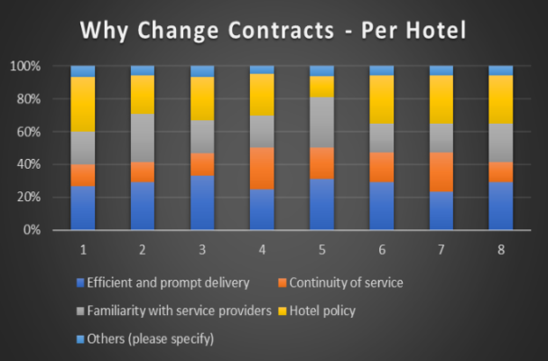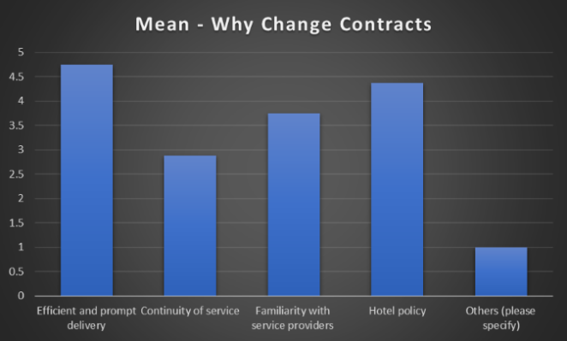
Figure A.8 Figure A.9

 | Mean | Med | Mode | H1 | H2 | H3 | H4 | H5 | H6 | H7 | H8
Efficient and Performance of Contractor | 4.75 | 5 | 5 | 4 | 5 | 5 | 5 | 5 | 5 | 4 | 5
Continuity of Contractor | 2.875 | 2.5 | 2 | 2 | 2 | 2 | 5 | 3 | 3 | 4 | 2
Familiarity with Site | 3.75 | 3.5 | 3 | 3 | 5 | 3 | 4 | 5 | 3 | 3 | 4
Hotel Requirements and Policys | 4.375 | 5 | 5 | 5 | 4 | 4 | 5 | 2 | 5 | 5 | 5
Others (please specify) | 1 | 1 | 1 | 1 | 1 | 1 | 1 | 1 | 1 | 1 | 1
Figure A.10

The results shown in QA4/QA5 that the renewal of the contract has been removed from a site level and national contracts are in place. The question was asked in their professional opinion.

The interviewees all considered efficient and performance of contractors for both routine and reactive maintenance as the highest reason to renew the contract with the mean of 4.75 (scale 1 – 5) followed closely by hotel policy at 4.3 (scale 1 -5) as seen in figure A9. The lowest mean was the continuity of contractor, which all site interviewed had in-house maintenance in which site knowledge could be passed on easily to new contractors. If in-house maintenance wasn’t available this may change the current figure, but further research would need to be carried out to determine if this is correct.

5.2.5

A7. Through your knowledge and experience, what are your thoughts on outsourcing? Is it beneficial to the business?

Outsourcing is hotels aren’t new and it’s been around for some time. By all accounts it’s been regarded as hugely successful for business. “Outsourcing is one of the most important management ideas and practices of the past 75 years” (Bromage, 2000, p. 23). Outsourcing is one of the growth industries of our time (Winterton 2000). With this in mind is outsourcing in the practical application of a hotel beneficial or should there is be more resource allocated to in-house maintenance. The overall consensus was a balance of both is required and essential for effective and efficient maintenance strategy. Although having full team of in-house specialists’ engineers to hand would be beneficial to react instantly to untimely break downs and the slight benefit of consistency in engineers on site not having to conduct site inductions due to outsourced contractor retention of engineers. The operational cost and increased skillfulness of out-source contractors outweighs the benefit to have engineer on site awaiting break downs. With these specialized contractors comes increased training requirements, there are annual update to be undertaken which can be costly. Some of the points highlighted by the interviewee were the better technical knowledge, flexible manpower in able to cover holiday and sickness, ability to have expensive specialized equipment to hand. The ability to be able to have both in-house and outsource engineers is essential to the complete operation of the maintenance strategy and a balance between both needs to be constantly reviewed for best practice and outcome for the business needs.

5.3 Part B - Inspection and Repair

5.3.1

B1. Why do you think it’s important to carry out maintenance activities?

The common view was that maintenance activities were important to keep the site safe, comfortable and effective for it purpose in welcoming guests to relax and enjoy their fault free stay within the hotel. With out and robust maintenance program with constant action, auditing and reviewing the hotel would unable to generate any profit as the site would become unsafe to occupy. With continued maintenance programs the building can be more efficient in it operation and as maintenance has become more eco-friendly over the reason years mainly due to legalization and an increase in energy costs, maintenance can have an influence on profitability of the business through there action of maintenance plant and equipment. Maintenance should be considered an investment and not an expense as it will reduce costs in both the medium and long-term. Highlighted was the need to operate the equipment all the way through its expected life cycle, getting the maximum years out of a boiler or other large plant, allows for a staged replacement program without impacting the guest experience. Without a strong maintenance strategy it was discussed that the job would become very stressful, for example if a lift isn’t maintain continually, people are getting trapped and panicking this would add undue stress to not only the guest but the maintenance team in dealing with the emergency situation constantly. All interviewees indicated that maintenance is as important as any of the other departments in the hotel setup, indicating the doors of the property wouldn’t be able to open with maintenance. Ghazi, Karma. M( 2016) highlighted in his research of hotels that there are 12 key areas of which maintenance in hotels is essential these are

- 1 ) To increase safety and security of hotel guests and employees
by ensuring the building, services and facilities are safe and fit
for use

- 2) To ensure the availability/reliability of all the assets and services
required by the customers

- 3) To keep or increase market share by satisfying the current or
impending guests

- 4) To conform with the new trends and technology in the market
(e.g. the green movement)

- 5) To conserve corporate image, appearance, historical and
architectural values

- 6) To increase the operational stability and efficiency of the
facilities and systems

- 7) To ensure energy expenditure (improving energy efficiency)

- 8) To mitigate the consequences of a natural disaster such as
hurricanes and earthquakes

- 9) To meet governmental requirements like Disability Act, health
and safety regulations

- 10) To carry on with the competition,

- 11) To ensure operation readiness of all equipment required for
emergency use at all time

- 12) To increase the life cycle of the property and achieve minimum
breakdowns or deteriorations.

(Ghazi, Karma. M, 2016)

These 12 important reasons correspond to the points raised by the interviewee, highlighting the importance of maintenance activities to maintain the building and equipment at any location. In the hospitality sector the importance of maintaining equipment is vital key in the effective running of all hotels operations including accommodation, food, and other guest related services. Without maintenance activities it will direct negative expression for the guest resulting in loss of revenue.

5.3.2

B2. Could rank the items below according to importance?

Not Important Very Important
1 2 3 4 5

For this question wanted to see what the interviewee though was more important in their maintenance strategies. As the term maintenance in its simplest term is “The process of preserving a condition or situation or the state of being preserved. The process of keeping something in good condition”, (Oxford dictionary, 2018).

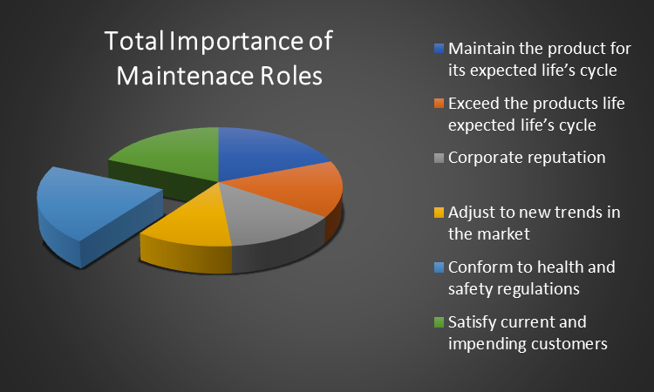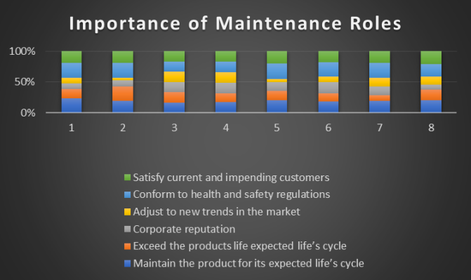
Figure B.1 Figure B.2

 | H1 | H2 | H3 | H4 | H5 | H6 | H7 | H8 | Total | Mean | Med | Mode
Maintain the product for its expected life’s cycle | 5 | 4 | 5 | 5 | 4 | 4 | 4 | 5 | 36 | 4.5 | 4.5 | 5
Exceed the products life expected life’s cycle | 3 | 5 | 5 | 4 | 3 | 3 | 2 | 4 | 29 | 3.625 | 3.5 | 3
Corporate reputation | 2 | 2 | 5 | 5 | 3 | 4 | 3 | 2 | 26 | 3.25 | 3 | 2
Adjust to new trends in the market | 2 | 1 | 5 | 5 | 1 | 2 | 3 | 3 | 22 | 2.75 | 2.5 | 2
Conform to health and safety regulations | 5 | 5 | 5 | 5 | 5 | 5 | 5 | 5 | 40 | 5 | 5 | 5
Satisfy current and impending customers | 4 | 4 | 5 | 5 | 4 | 4 | 4 | 5 | 35 | 4.375 | 4 | 4
Figure B.3

All the interviewee highlighted the importance of the conforming to health and safety regulation, with all 8 stating this as ‘very important’ as seen in figure. Similar research done Aryee,S (2011) highlighted the same results within hotel is Stockholm that health and safety plays a very important role in why maintenance tasks are carried out (Aryee,S , 2011). So that would suggest that maintenance is a process of keeping something in a good safe condition to laminate risk of harm to those using the building. The Royal Institution of Chartered Surveyors (RICS) also the highlights the importance of health and safety as a pivotal point in building maintenance strategies. With the introduction for the corporate manslaughter and corporate homicide act 2007 and company facing huge fines the focus for a maintenance manager has turn to complaints of regulations and policy’s to maintain building to safe condition

As with any building there is a degree of wear and tear, through either natural wear or misuse. The interviewee indicated the maintaining the product to it expected life cycle was the second most important with a mean of 4.5 (scale 1-5), exceeding its life cycle below with only a mean of 3.6 (scale 1-5). This was relates to Atkin (1997) five objectives of facilities management where it was to sweat the asset to make them highly cost effective, this meant extracting more output form the asset than is was expected running the asset past it life expectancy. As shown in figure B3 the interviewees were happy to maintain the product to expected life cycle as opposed to excessing them.

Unsurprisingly was the response that adjusting to newer market trends with a mean of 2.75 (scale 1-5) where customer satisfaction was at 4.375 (scale 1-5). Research has shown that the two areas move hand in hand an article written by Growth Works highlights the important of hotels moving with market trends namely the integration of newer technology which has seen a increase in guess satisfaction by 14% and increased profit return of 5%. As a hotelier the concept of happy guests makes for happy hotels is not far from the truth but the concept of continually updating solution trying to keep up with market trends is properly deemed costly and an operational battle to maintenance managers ranking it of lower importance to other responsibilities.

5.3.3

B3. Do you have issues in implementing your maintenance plans?

Not Important Very Important
1 2 3 4 5

With the forever changing field of maintenance management felt this question was important to find out what hampers the effective and efficient running of maintenance strategies. As already highlighted in figure A1 which shows that there is a combination of both in-house and out-soured maintenance solution across all properties. Was this due because of lack of budget or resources to enable better distribution of in-house to out sourcing

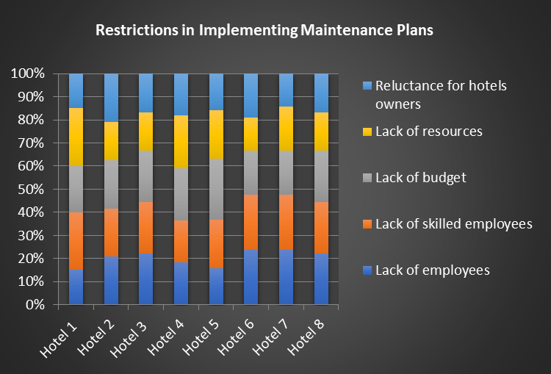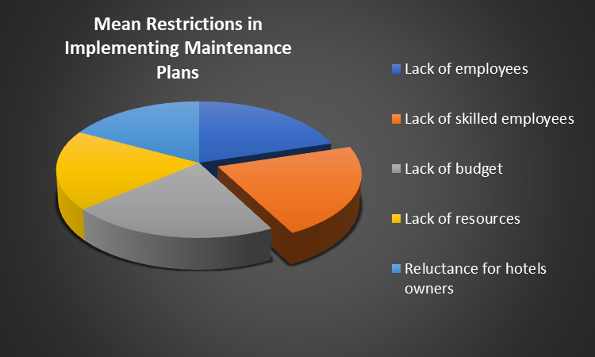
Figure B.4 Figure B.5

 | H1 | H2 | H3 | H4 | H5 | H6 | H7 | H8 | Total | Mean | Med | Mode
Lack of employees | 3 | 5 | 4 | 4 | 3 | 5 | 5 | 4 | 33 | 4.125 | 4 | 5
Lack of skilled employees | 5 | 5 | 4 | 4 | 4 | 5 | 5 | 4 | 36 | 4.5 | 4.5 | 5
Lack of budget | 4 | 5 | 4 | 5 | 5 | 4 | 4 | 4 | 35 | 4.375 | 4 | 4
Lack of resources | 5 | 4 | 3 | 5 | 4 | 3 | 4 | 3 | 31 | 3.875 | 4 | 4
Reluctance for hotels owners | 3 | 5 | 3 | 4 | 3 | 4 | 3 | 3 | 28 | 3.5 | 3 | 3
Figure B.6

The Interviewee rated the lack of skilled employee as the main contributing factor with a mean of 4.5 (scale 1 -5) in not enabling them to fulfil their maintenance plans. This was closely followed by lack of employee and lack of budget with a mean of 4.375 (scale 1 -5). When questioned further on the why they felt it was a lack of skilled employee, the common answer was based around payroll and the lack of budget available. A skilled tradesperson can almost earn double working in other industries, so spending time and resource on training good employees will only lead to the natural progression of the now skilled engineer to move on. There is literature that highlights that hotels in both upper and middle sectors heavily rely on low-skilled and casual workers, insecurity and low pay (Baum, 2019: Wood, 1997). These factors will always push for the more skilled application of the job to be out sourced, but why should this hamper the effectives of the maintenance strategies. When questions further it was clear it wasn’t any one factor but a combination of factor. Although the lack of resources was rated in the bottom two least important interviewee, responded by saying that lack of budget contributed to the lack of budget. Chan et al (2001) indicated to the over –reliance in hotels on corrective maintenance plans, and not looking for the appropriate strategy for each property which need to be decided on a engineering and managerial level (Chan, 2001). This is clear in the interviews that the current property are operated by a blanket maintenance strategy covering the whole estates instead of looking to the individual needs of each hotel, listening to what best maintenance solution would work. That is brought out in the lack of understanding in which the property requires. The results show that a change in budget levels and employment of skilled employee will enhance the performance implementing a successful maintenance strategy.

5.3.4

B4. When does the accurate competition of historic reactive works assist with future maintenance plans?

Companies are always looking for the next best solution to enhance business performance by gauging the overall performance of the building by reviewing it historic data will enable the property to be more efficient and effective in its operation. I was keen to understand if the interviewer used this information to improve the building performance.

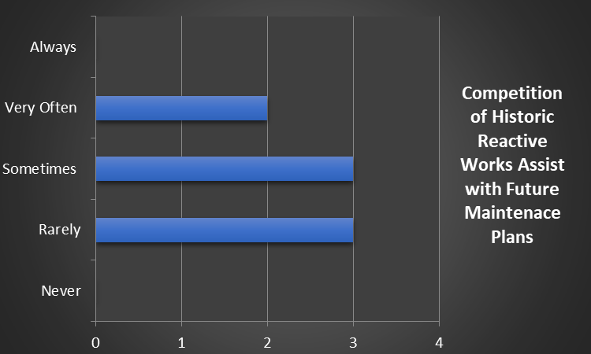
Figure B.7

 | Hotel 1 | Hotel 2 | Hotel 3 | Hotel 4 | Hotel 5 | Hotel 6 | Hotel 7 | Hotel 8 | Total
Never |  |  |  |  |  |  |  |  | 0
Rarely | 1 |  |  |  |  | 1 | 1 |  | 3
Sometimes |  | 1 |  |  | 1 |  |  | 1 | 3
Very Often |  |  | 1 | 1 |  |  |  |  | 2
Always |  |  |  |  |  |  |  |  | 0
Figure B.8

It shows in figure B6 that 0% of the hotel always refer to their historical data where only 25% of hotels very often reuse the information to assist with future maintenance plans. 37.5% of interviewees indicated that they rarely review the reactive works. To formulate future maintenance plans an understanding of the how the building is preforming would be essential. There is information documented that a direct link between the requirements of identifying performance issues to achieve goal and objectives to further enhance the business profitability and performance (Amaratunga and Baldry 2002: Tangen, 2003). Without the understanding of reactive break downs that continues to occur, how a maintenance strategy can be implemented to enhance property, Hon and Scott (2008) highlighted that “there is a direct link between facilities management and performance management”. If you can measure the performance of the property by reviewing it historical data the management team can strategies to enable a better produced. With less reactive works comes better customer satisfaction as shown in figure B3 is an important factor in the maintenance person responsibility.

5.3.5

B5. When does accurate recording of annual labour and parts used, allow for increase or decrease of future budgets cost?

Within the make-up of the hotels there are key members of staff that allow for smooth operation of the business, to limit unnecessary disturbance to guests of the hotel. Engineering team form part of these key roles, they are reasonable for the daily maintenance of the hotel looking at both forms for reactive to proactive tasks. Resulting in the variable natural of the hotels the complex diverse of task the engineers are generally multi skilled which enhances the performance of reducing salary cost as one engineer can cover variable trades. These works generally take place throughout the day, but maintenance in hotels especially in the 4 to 5 star area would expect to have a 24 hour cover. Using an either a combination of on call or night engineer roles. This engineer would only be reasonable for reactive works that may occur, which will directly hamper the guests stay. To understand if the maintenance strategy is preforming to its potential and resources are used correctly it was important to see if labour and parts were reviewed and if the budgets corresponded, it what was happening within the hotel.

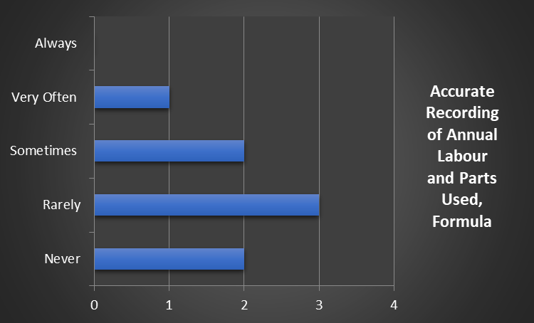
Figure B.9

 | Hotel 1 | Hotel 2 | Hotel 3 | Hotel 4 | Hotel 5 | Hotel 6 | Hotel 7 | Hotel 8 | Total
Never |  |  |  |  |  | 1 |  | 1 | 2
Rarely | 1 |  |  | 1 | 1 |  |  |  | 3
Sometimes |  | 1 |  |  |  |  | 1 |  | 2
Very Often |  |  | 1 |  |  |  |  |  | 1
Always |  |  |  |  |  |  |  |  | 0
Figure B.10

Results showed that only 37.5% of the hotel interviewed had rarely used the records to set future budgets and a further 25% of hotels never used their historical data. When the interviewee was questioned further on why this wasn’t a pivotal factor in setting new budgets and how was the budgets set. The general consensus was senior management within the hotel structure from centralized office considered that the rate inflation would optimize the setting of the budget. This could vary in an independent hotels but further research would be needed. The consideration of age, location, occupancy levels weren’t factors, which naturally the increase in age the building there would be increase in operating cost by depreciation. The review of data and input from site operators form a strong platform for implementing maintenance strategies. Unfortunately without the review will affect efficiency of the implementation of the maintenance strategy.

5.3.6

B6. When does accurate records of assets, allow for a deferred maintenance program (end of life replacement)?

“Deferred maintenance is the practice of postponing maintenance activities such as repairs on both real property (i.e. infrastructure) and personal property (i.e. machinery) in order to save costs, meet budget funding levels, or realign available budget monies. The failure to perform needed repairs could lead to asset deterioration and ultimately asset impairment. Generally, a policy of continued deferred maintenance may result in higher costs, asset failure, and in some cases, health and safety implications.” (SFFAS 40, Issued May 2011 U.S. Federal Accounting Standards Advisory Board). With implementing an effective maintenance structure the understanding the condition of the equipment and assets will play an essential role in deploying the right amount of resources in maintenance the building through it expected life cycle, as highlighted in figure B1 this forming the highest priority for a maintenance manager.

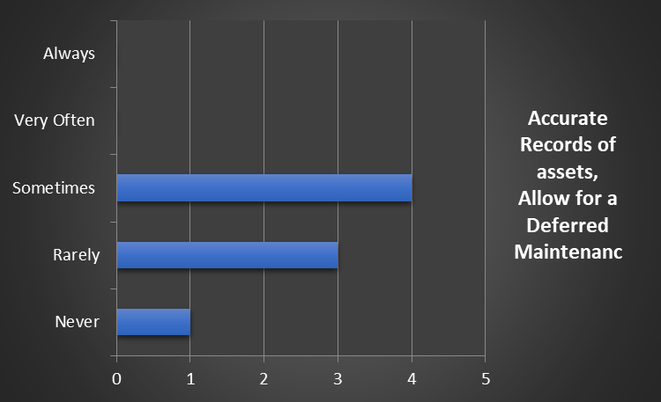
Figure B.11

 | Hotel 1 | Hotel 2 | Hotel 3 | Hotel 4 | Hotel 5 | Hotel 6 | Hotel 7 | Hotel 8 | Total
Never |  |  |  | 1 |  |  |  |  | 1
Rarely |  | 1 |  |  |  | 1 |  | 1 | 3
Sometimes | 1 |  | 1 |  | 1 |  | 1 |  | 4
Very Often |  |  |  |  |  |  |  |  | 0
Always |  |  |  |  |  |  |  |  | 0
Figure B.12

Results show that 0% interviewee uses historical data very often or always to form a deferred maintenance program, or a plan of when assets or equipment will be replaced, With 50% of the interviewees never or rarely using this information. This indicates the properties run on emergency corrective maintenance program with its assets, waiting for complete failure before replacement regardless of age. This approach is making use of sweat the asset (Atkins, 1997) example and cost effective. Unfortunately this strategy can come at a cost of massive disruption to current and future business. As already shown in figure B3 the high important of customer satisfaction. A maintenance strategy needs to consider a balance between effective uses of the asset which prolongs is life expectancy but have a plan forged to consider a replacement program to limit the impact of guest experience. Chan et al (2001) implies maintenance is a simple process that broken items get repaired or a logical approach of highlighting potential failure and the proposed consequences if they occur. This defining the maintenance actions that should be taken. While deferred maintenance is unavoidable, taking a multi maintenance strategy approach is critical to prevent a backlog that would be impossible to control. Enabling the business organization to foresee potential risks in failure of equipment will provide better costs savings, better safety, and a larger role in planning for the future.

5.3.7

B7. If you must put a percentage to proactive and reactive works,
B8. In your professional opinion is this right?

Looking the how the hotel operates on performance of reactive to proactive is a key function to be able to set future maintenance strategies. Where reactive is strategy preforming maintenance tasks after the asset or equipment has failed. As opposed to proactive where maintenance tasks reply’s on routine maintenance checks to be completed to reduce the risk of failure. As indicated in an article by Hotelier and design (2018) “As a general rule of thumb, most facilities in the hospitality industry follow the 80:20 rule. This means that your maintenance approach should be 80% preventative maintenance (proactive) plan and 20% for unexpected jobs (reactive maintenance).” (web, Hotelier and Design, 2018)

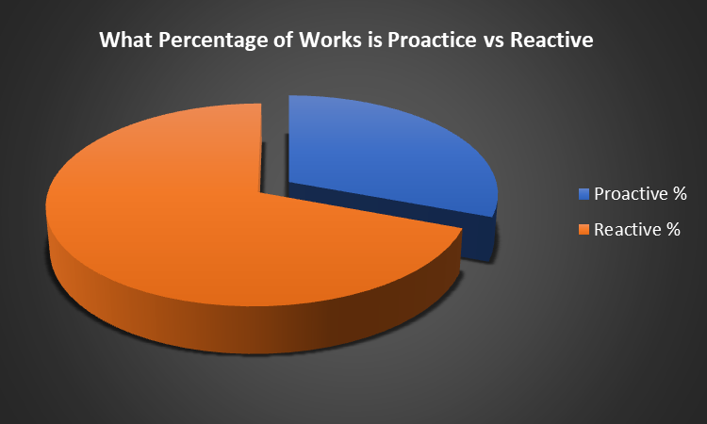
Figure B.13

 | H1 | H2 | H3 | H 4 | H 5 | H 6 | H7 | H8 | Mean | Med | Mode
Proactive % | 35 | 25 | 40 | 35 | 30 | 40 | 30 | 35 | 33.75 | 35 | 35
Reactive % | 65 | 75 | 60 | 65 | 70 | 60 | 70 | 65 | 66.25 | 65 | 65
Figure B.14
Over the interviews taken a mode percentage of 35% was proactive and 65% was reactive. When asked the reason behind the variation to proactive verse reactive as the pros behind proactive maintenance strategy include better profit/productivity, reduced down time cause by emergency repairs, extended life of equipment . It was clear that there was maintenance structures in place but have difficulties in rolling out the strategy correctly, included the lack of work force, senior management buy in to provide the correct resources, lack of budget. The large proportion of the proactive maintenance was centered on the aspect of regulations and requirements set by the governing bodies. As shown in figure A7 that health and safety plays a high priority on the order of how maintenance is undertaken. There seems to be a continued battle between how the building management should be untaken verse the business objective (Lo et al. 2000: Loosemore and Hsin 2001).

5.3.8

B9. How would you optimize the hotel operations in maintenance to achieve a successful strategy?

The interviewee’s feedback was although there is a corporate estates strategy in place focusing mainly on health and safety, not much consideration is given to the individual aspect of the property assets and equipment, resulting in potential business risk. The focus on producing large profits and overturn was hampering the building performance in upkeep and maintenance. The gauge of looking at how well the property is doing financially (Olsen et al, 1992) isn’t always the best approach in building maintenance in hotels. There isn’t one approach that can be taken to gauge good performance of the business (Peacock 1995), and Teare (1996) states that it’s an individual manager subjective measure of success that must be used. As hotel as are individually different when it comes to assets and equipment, more valued input from the in house maintenance manager should be considered to optimize the running of the business.

5.4 PART C Budgets

5.4.1

C1. Do you have a set budget for maintenance, what input do you have in setting the budget and then implementing?

By using a genuine maintenance strategy can offer a clear and effective guide to tracking costs, and how to disrupt budgets in the hotel. The involvement of the maintenance manager through this process will allow the business to optimize those resources and to be able to introduce a robust planned maintenance program. In the tough market of hoteliers there is little to no movement for mistakes, otherwise the hotel wont remind competitive in the market or receive further funding (Cokins, 1998)

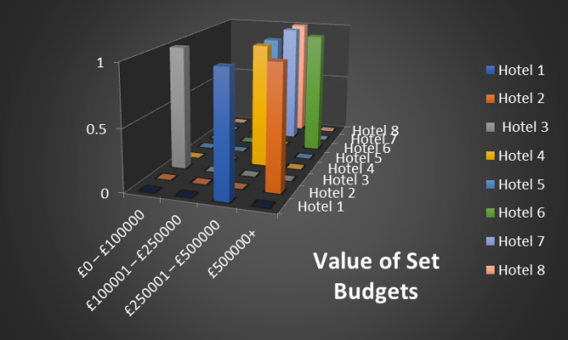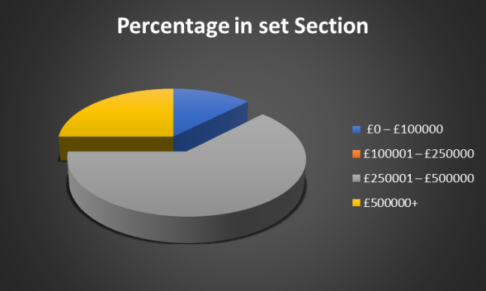
Figure C1 Figure C2

 | Hotel 1 | Hotel 2 | Hotel 3 | Hotel 4 | Hotel 5 | Hotel 6 | Hotel 7 | Hotel 8 | Total
£0 – £100000 | 0 | 0 | 1 | 0 | 0 | 0 | 0 | 0 | 1
£100001 – £250000 | 0 | 0 | 0 | 0 | 0 | 0 | 0 | 0 | 0
£250001 – £500000 | 1 | 0 | 0 | 1 | 1 | 0 | 1 | 1 | 5
£500000+ | 0 | 1 | 0 | 0 | 0 | 1 | 0 | 0 | 2
Figure C3

All interviewee indicated that there is a fixed budget for maintenance, but like cover in question B5 the budget had very little input by the maintenance manager. One of the hotels showed a much lower budget then rest, they was due to the hotel only been open for 1 year and in the first year to building was still covered by the contractors that built the property. As the remaining hotels were of similar age and size the budgets corresponded accordingly. 62.5% of hotels within the £250001 – £500000. These included the utilities, waste and IT cost.

5.4.2

C2. As a breakdown of cost, what percentage would you give to each?

As covered before maintenance tasks can be sectioned in groups these consist of routine, corrective, preventive and emergency maintenance. Chan, K (2008) documented on his finding in hotels based in Hong Kong that the distribution across that 4 different task follows 37% routine maintenance, 31% corrective maintenance, then preventive at 21% and finally emergency maintenance at 11%. Chan highlighting in his studies that the hotels are running at a 48% higher cost for corrective verse preventative. This showing the importance for a planned maintenance program giving a higher significance in the hotels maintenance strategy (Chan. K, 2008).

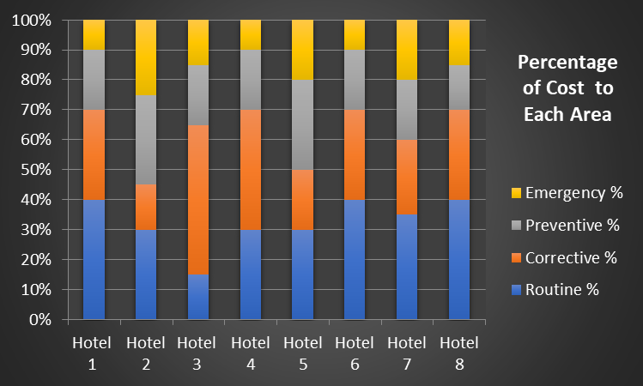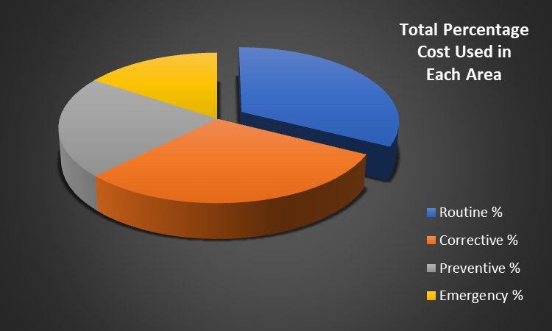
Figure C4 Figure C5

 | H1 | H2 | H3 | H4 | H5 | H6 | H7 | H8 | Mean | Med | Mode
Routine % | 40 | 30 | 15 | 30 | 30 | 40 | 35 | 40 | 32.5 | 32.5 | 40
Corrective % | 30 | 15 | 50 | 40 | 20 | 30 | 25 | 30 | 30 | 30 | 30
Preventive % | 20 | 30 | 20 | 20 | 30 | 20 | 20 | 15 | 21.875 | 20 | 20
Emergency % | 10 | 25 | 15 | 10 | 20 | 10 | 20 | 15 | 15.625 | 15 | 10
Figure C6
All the interviewees have a good understanding of where the budget was spent in each of the 4 categories. Its shows that routine maintenance was 35.5%, corrective at 30%, with preventive 21.87% and emergency 15.62%. As corrective maintenance can be planned or scheduled generated by routine and emergency task been completed it would deemed that in these results show 48.125% higher than preventive maintenance. This proving as previously highlighted that maintenance is in these hotels are based around a corrective maintenance strategy.

5.4.3

C3. Are your budgets set on Predictive, Routine Preventive, or Emergency Corrective (Failure)?

To enable the business to operate at its full potential it’s important that the budget is set around the maintenance strategy as actuate costs can be spread around the various categories including predictive, preventive, routine, and emergency this optimizing the resource allocation. As shown in figure C5 the true maintenance expenditure is used on corrective maintenance strategy with a spread of cost around all other categories.

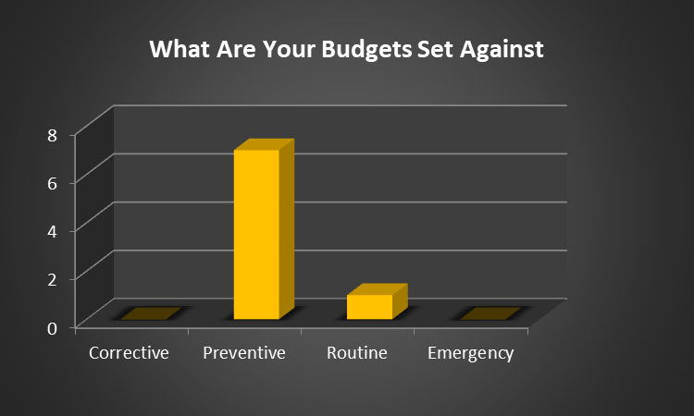
Figure C.7

 | Hotel 1 | Hotel 2 | Hotel 3 | Hotel 4 | Hotel 5 | Hotel 6 | Hotel 7 | Hotel 8 | Total
Corrective |  |  |  |  |  |  |  |  | 0
Preventive | 1 |  | 1 | 1 | 1 | 1 | 1 | 1 | 7
Routine |  | 1 |  |  |  |  |  |  | 1
Emergency |  |  |  |  |  |  |  |  | 0
Figure C.8

When asked the question to the interviewees there was a high response of 87.5% that indicated that their budget was set against a preventive maintenance strategy. In which a preventive maintenance focuses on routine inspection of equipment assessing the condition and planning down time of when the equipment to have replacement or adjustment while having little to no effect for the guest. This is to prevent unnecessary breakdowns and interruption to business. This type of maintenance requires a full understanding of plant and equipment and current condition to be able to maximize it’s potential. As shown in figure B.9 the reviewing of assets to roll out deferred maintenance program, is only rarely or sometimes reviewed. This contradicts the approach that should be taken for a preventive maintenance strategy. Although there are benefits in having preventive maintenance strategy including reduced cost as unnecessary brake down can be costly, full compliance with legislation, and happy guests.

5.4.4

C4. Can you recruit maintenance engineers easily to fit into the hotel industry? Why or why not?

Chan et al (2001) writes that it essential for any business to have a maintenance and engineering systems in place for it to succeed, one of these key areas is have competent team of engineering staff (Chan et al, 2001). All interviewee indicated that they have all experienced difficulties through the recruitment of hotel engineers. Some of the points that were raised through the open discussion where lack of skills, low salary offers and flexibility in work hours

5.4.5

C5. What do you consider when employing new engineers?

The key phase that was raised continually was competent multi skilled engineer. When asked to explain a definition of a multi skilled engineer the simplest term was an engineer that had the ability to perform various maintenance tasks as part of their daily duties. Engineers those are able to cover various tasks covering multiple trade skills, checking and adjusting motors to small plumbing tasks. As opposed to a single skilled engineer which will be less able to cover various task deeming them not as versatile, this increase maintenance cost more staff will be required. There was also a perception that when considering new engineers that you review the current strengths with in your team and try and employee a new engineer that can cover other tasks. This will enable the team to be more varsities in covering emergency brake down without calling in expensive contractors. Not only does this save costs but the guest benefits by the efficient repair of equipment that could have impacted the guest stay resulting in refunds. This will be a double blow for the business loss of revenue followed by a call out cost for a contractor.

5.4.6

C6. Do you do any in-house training? If so, what is it about and how often?

With any business that is going to be successful, key utilization of its employees is a must. Having highly trained and competent employees is a great asset for any business. That does not change when it comes to maintenance and the engineers that are employed to do the work. As mentioned C.4 the difficulties in hiring of suitable engineer to fulfil the multi tasked range of a maintenance engineer. There was various platform of training including online, face to face, tool box talks in which all interviewee had accesses to inform to the information to roll out to the employee. When asked if this benefitted the company, the answer was yes as generally the information was about the brand and how to improve guest satisfaction. Tool box talks covered standard operating procedures and health and safety topic. All these beneficial for the company to tick the corporate banner and health and safety responsibilities, but in CIBSE Guide M Maintenance Engineering and Management part 18 identifies that skills and knowledge to operate and maintain the building effectively and efficiently will be found in the building operating and maintenance manuals, drawing records and final commissioning sheets (CIBSE, Guide M). When asked the interviewee on if these records are obtainable and have formed part of you training plan. The general consensus was that operating manual are incomplete either from when the building was open, or with the turn over management and out sourced contractor operating manuals have been removed form site, this making it difficult to identify site specific training needs. Although tool box talks were carried out a basic task like replacement of toilet seat, replacement of key card switches, these were unrecognizable training skills to outside that building. 80% of the interviewee highlighted that they don’t offer external skills based qualification that are recognized as a trade. The main fear was retention of staff, as engineers become more skill and qualified they tend to move to other industries due to better pay. It was reported by trade union congress that “In some regions, between 60 and 70 per cent of employees are not paid the real Living Wage. In three regions (Wales, Yorkshire and the Humber, and the East Midlands), it’s between 70 and 75 per cent of employees”( Web Trade union Uk, 2017). With the low pay in the industry and little movement in management structures the now newly skilled engineer moves on to seek better pay.

5.4.7

C7. Do you recognize engineers by their accomplishment due to exemplary completion for their works? How? What type of incentives are they given?

In the hotel industry maintenance can be under rated as they are not a direct revenue generator and can be deemed a costly expense. Generally the maintenance department is small in comparison to other departments like housekeeping who are generally the largest. For this reason engineers achievements can be looked over as brushed aside easily by a revenue target based business or by simply the smallest number of employees. Maintenance still holds a high sense responsibility by maintaining a building to a safe, comfortable and effective standard. Drucker, Peter (2009), believes in the bakers dozen with it come to hotel maintenance management strategy’s, number 7 in the baker dozen is about recruitment and paying attention to your most valuable resources, which is your workforce, and in particular the maintenance team “As Chief Engineer, recognize your team regularly with "thank you's "and expressions of appreciation. Retain the champions by whatever it takes to keep them. Give them the training to succeed and then share in their successes with incentives and the chance to be part of a very cohesive and proud team”. (Hogan .J , 2009), Interviewees gave a 50/50 mix in incentive driven recognition for their teams accomplishment. Some just used the brand standard way of recognizing job well done about going above and beyond, and either receiving and star card and been highlighted in the employee of the month scheme. Some had departmental incentives in which was target based centered on planned plant maintenance program and team having to achieve 10 -15% above the brand standard of checks. Although these incentives were in place the interviewees felt they were little benefit and short lived as the engineers found that achieving the targets were not practical as the department was already stretched. Generally the incentive are in place to recognized employees good work, happier work force and then better productivity, and less staff turnover. The interviewee felt staff retention would be if the rate of pay was in line with the other sectors.

5.5 Part D: Energy in Hotels

5.5.1

D1. How do you rank the importance of energy consumption within the hotel?

Management of utilities has become an importance factor in the role of a maintenance manager. As hotelier are becoming more environmentally conscious looking at ways the business operates in reducing energy consumption due to increased energy cost and complying to legalization, where the European Hospitality Industry Guidelines to Improve
Energy Efficiency is looking to reduce energy consumption down by 40%. Chan, K (2007) highlights the factors that influence maintenance strategy. The second highest on the list was energy consumption with an average score of 4.12 (Scale 1 – 5). In Figure D.1 it shows a common trend that the interviewees regarded energy of high important, for the successful operation of a hotel. With over 62.5% catorgising energy as very important and 37.5% listing energy consumption as most importance. The high important of energy related directly maintenance isn’t of a surprise. As over the past years energy management has been closely related to maintenance management. If the maintenance works are not carried out routinely for example the inspection of temperature sensors or run times of plant equipment, energy consumption will naturally increase. Studies by Piette and Nordman (1996) within 60 buildings showed that all the building had temperature control issues, 40% with HVAC issues and 33% had sensors that weren’t working correctly (Piette and Nordman, 1996). This highlighting the importance of routine checks.

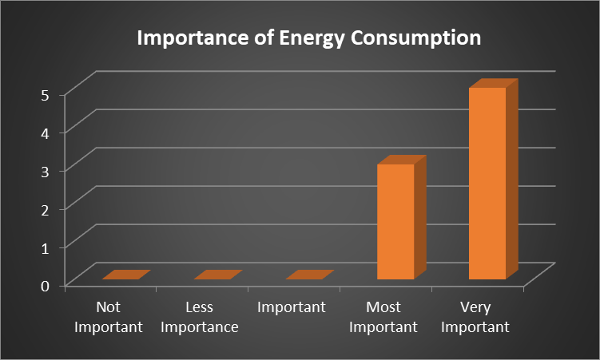
Figure D.1

 | Hotel 1 | Hotel 2 | Hotel 3 | Hotel 4 | Hotel 5 | Hotel 6 | Hotel 7 | Hotel 8 | Total
Not Important |  |  |  |  |  |  |  |  | 0
Less Importance |  |  |  |  |  |  |  |  | 0
Important |  |  |  |  |  |  |  |  | 0
Most Important | 1 |  |  |  | 1 |  |  | 1 | 3
Very Important |  | 1 | 1 | 1 |  | 1 | 1 |  | 5
Figure D.2

5.5.2

D2. How much capital investment did you invest to improve energy reductions during 2019?

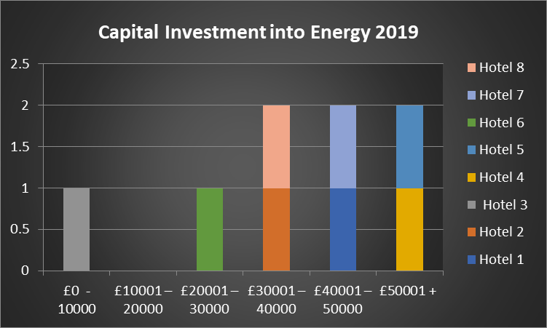
Figure D.3

 | Hotel 1 | Hotel 2 | Hotel 3 | Hotel 4 | Hotel 5 | Hotel 6 | Hotel 7 | Hotel 8
£0 - 10000 |  |  | 1
£10001 – 20000
£20001 – 30000 |  |  |  |  |  | 1
£30001 – 40000 |  | 1 |  |  |  |  |  | 1
£40001 – 50000 | 1 |  |  |  |  |  | 1
£50001 + |  |  |  | 1 | 1
Figure D.4

5.5.3

D3. Where were the investments? If possible, can you put a percentage to each of the following?

Typical saving for the hospitably sector by implymenting newer technology for lighting can reach 40%, hot water 20% and heating and air conditioning 30-50% (Kapiki, Soultana , 2010), The most common install is light upgrades to LED as its generally a low investment cost with a quick return, and has little to no impact to guests. As reported by the American Hotel & Lodging Association that 90% of hotels have already made the switch to LED lighting.

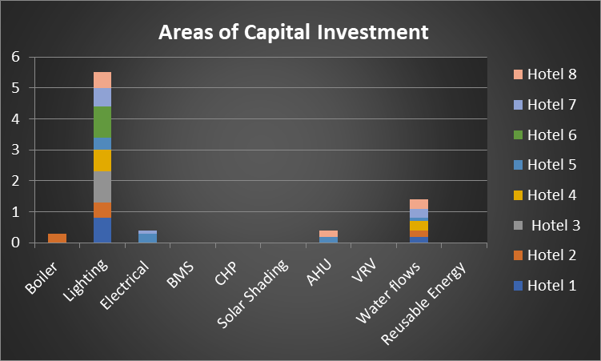
Figure D.5

 | Hotel 1 | Hotel 2 | Hotel 3 | Hotel 4 | Hotel 5 | Hotel 6 | Hotel 7 | Hotel 8
Boiler |  | 30%
Lighting | 80% | 50% | 100% | 70% | 40% | 100% | 60% | 50%
Electrical |  |  |  |  | 30% |  | 10%
BMS
CHP
Solar Shading
AHU |  |  |  |  | 20% |  |  | 20%
VRV
Water flows | 20% | 20% |  | 30% | 10% |  | 30% | 30%
Reusable Energy
Figure D.6
5.5.4

D4. Do you activity analysis your energy data, by comparing YOY, How and When
D5. Do you highlight high consumption assets and look to replace before end of life or just wait till beyond repair?

All interviewees reported that consumption of energy data was reviewed in one form or another by comparing daily, weekly, monthly analysis against year on year comparisons . The data reviewed was variable were some sites had multiple metering where they could review usage of energy by department where other just reviewed their main meters. As the comparison was linked between maintenance management and energy management in question D1, was there a comparison with how the maintenance strategy was rolled out. Does the company look to replace the equipment before the end of life as it’s become inefficient? The over response was there was a reactive outlook to energy with reacting to energy either by reviewing historical data showing that energy needs to increase first for a period before adjustments are made. Equipment is pushed to end of life then consideration was given to the install of newer and more efficient equipment would indicate that energy was a reactive strategy. Lewis and Riley (2010) highlighted in there case studies that they undertook showed that maintenance and energy management both carried out reactively (‘fire fighting’) practice in their strategy. Secondly, they also showed a theme the cost and energy savings are not a powerful enough persuasion for a company to charge their current reactive strategy to a proactive practice. As shown in B.11 the hotel operates to a reactive strategy which highlights further that senior management need to support the function of any strategy to enable it to become successful.

5.5.5

D6. In your professional opinion, is energy reduction within your hotel optimised or can more be done? If yes, what improvements should be done?

Interviewee gave perception that energy management within hotel is already interlinked to maintenance management. Although the investments have been researched and rolled out the number of hotels haven’t seen the impact of energy savings that was stated upon the return of investment within the business case. Although saving have been seen the interviewees don’t believe the energy is been optimized. For a couple of reason the predicted saving isn’t calculating into actual saving were actual saving were far less than estimated. This questioning efficiencies of the energy saving equipment and as a business the return of invest becomes prolonged which hampers further development. It was also highlighted that with investment of new energy saving controls and devices. These require specialized servicing like Co2 meters that monitor air quality within the duct work that increase or decrease the Air Handling Units fans speeds to optimizes both air quality and energy, this equipment requires continued monitoring and recalibration by spealised engineers. Although the initial energy savings were as estimated over time the equipment became inefficient because the budget structure wasn’t put in place to allow continued motioning and service of expensive equipment, until finally the equipment becoming obsolete sometimes even before the return of investment has paid off.

5.5.6

D7. Do you have a sustainability policy? Does it follow the 17 global goal listed below? Tick each section

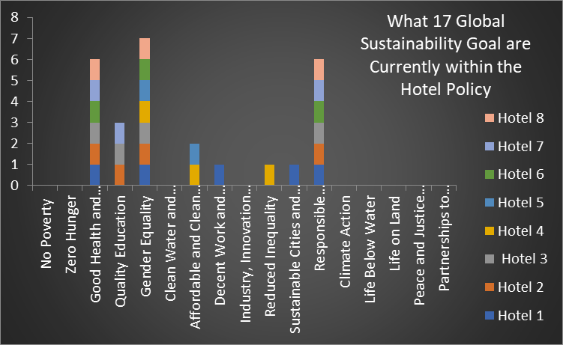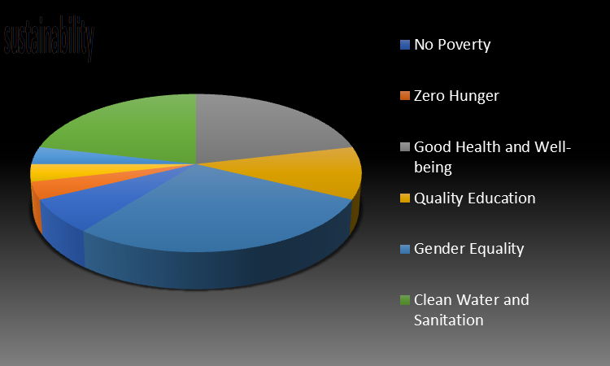
Figure D.7 Figure D.8

 | H 1 | H 2 | H 3 | H4 | H 5 | H 6 | H 7 | H 8 | Total
No Poverty |  |  |  |  |  |  |  |  | 0
Zero Hunger |  |  |  |  |  |  |  |  | 0
Good Health and Well-being | 1 | 1 | 1 |  |  | 1 | 1 | 1 | 6
Quality Education |  | 1 | 1 |  |  |  | 1 |  | 3
Gender Equality | 1 | 1 | 1 | 1 | 1 | 1 | 1 | 1 | 8
Clean Water and Sanitation |  |  |  |  |  |  |  |  | 0
Affordable and Clean Energy |  |  |  | 1 | 1 |  |  |  | 2
Decent Work and Economic Growth | 1 |  |  |  |  |  |  |  | 1
Industry, Innovation and Infrastructure |  |  |  |  |  |  |  |  | 0
Reduced Inequality |  |  |  | 1 |  |  |  |  | 1
Sustainable Cities and Communities | 1 |  |  |  |  |  |  |  | 1
Responsible Consumption and Production | 1 | 1 | 1 |  |  | 1 | 1 | 1 | 6
Climate Action |  |  |  |  |  |  |  |  | 0
Life Below Water |  |  |  |  |  |  |  |  | 0
Life on Land |  |  |  |  |  |  |  |  | 0
Peace and Justice Strong Institutions |  |  |  |  |  |  |  |  | 0
Partnerships to achieve the Goal |  |  |  |  |  |  |  |  | 0
Figure D.9

As there is perception that energy management and control of consumption are associated to maintenance strategy as discussed early in this section? The thought was how the management of energy related to the 17 global goals of sustainability and what of the 17 goals has actually been implemented into the hotel and if the maintenance manager is a driving force in the sustainable goals. There is plenty of information on various hotel websites claiming that they cover a number of the sustainable development goals Figure D.9 (Jones, Peter & Comfort, Daphne. 2019). Although the corporate bander and saying the right information on the web there is information PWC (2018) that highlights ‘companies are engaging at a more superficial level.’

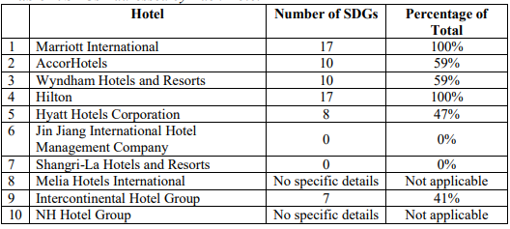
Figure D.10
(Jones, Peter & Comfort, Daphne. 2019)

The interviewee indicated that some of the goals have been set on a cooperate level and suggested that there is little to no input from site level that influences the sustainability goals and how implement , this hampering its growth as ownership on the goal is depleted. Looking at the results 100% of the hotel had an Gender equality policy in which is implemented, followed by 75% of hotels following the good health and well-being targets and 75% of hotels looking at ways they can be responsible for consumption and production. Out of the 17 goals only 8 were recognised by the maintenance manager in which they are key figure in energy and sustainability in the building with 75% of the interviewer chairing the various forms of green committees. This slightly goes against figures in figure D.9 where some hotels indicated that they follow all 17 global goals. Green committees are the driving force in hotels achieving sustainability goals. It was clear there needs to be a collective approach to achieving these goals, as the maintenance manager is a pivotal figure in how the building is controlled and run the sharing of information is essential and a realistic approach of what is achievable needs to be considered.

6.0 Evaluation
Throughout the stages of the literature review there seems very little data and written information on hotels within the UK, and even less information on hotels based in Wales and best used maintenance strategies. There was plenty of information on maintenance of building and different strategies on how to maintain but these are not directly related to the hotel industry and in particular nationally within the UK. The objective of the study was to provide a regional focus specifically looking at hotel maintenance strategies in South Wales UK. Leading on from this the goal has been to review the current maintenance strategies within the hotels within the South Wales regional context to see if they are effective and practical for the current climate. Furthermore another key aspect of my research has been to research the potential and actual challenges that maintenance managers have in implementing their chosen maintenance strategy. This led onto a more thorough analysis of factors impacting challenge for managers including budget restraints, staffing issues or external influences. If energy management is directly linked to maintenance management of a hotel and implemented into their strategy.
For a hotel to operate as a viable business guest satisfaction is a perhaps the most significant priority where management need to consider not just the ‘face to face’ or ‘front-door’ customer services, but the complete guest journey. With this in mind management need to ensure that guests receive a safe, comfortable and fault free stay. This will inevitably help enhance the guests experience to hopefully welcoming the guest back time and time again and in doing so provides repeat custom for the hotel. Promoting optimum customer/guest return and satisfaction will also promote the on-going reputation (and subsequent business) for the hotel when talking to friends and family generating more revenue, which is essential for a successful business in the current world of social media. To achieve this complete guest journey and smooth operations for the hotel it is essential that a correct maintenance strategy is formulized setting in place appropriate maintenance controls and support for all equipment and plant.

It was clear from the results that if a hotel is going to be successful through its operation of maintenance that there is a balance between out sourcing and in-house works. The research has shown that 80% of out souring of works included catering, heating, HVAC, and refrigeration. The main reason was cost and quality assurance where management wanted to ensure the use of expert skills and thus promote longer term investment than using in-house workers where quality and safety could not be ensured. To carry out these types of work generally require certification for health and safety purposes, to enable to certify works specialized knowledge and training is required which can also come with a high cost for constant retraining. With specialized equipment no matter how often it is checked and serviced there is always untimely break downs and if kept in house there would be a requirement for multiple staff to be trained in that task to cover holidays and sickness making it unviable for the business to maintain cost effectiveness. Whereas the day to day tasks like painting, small electrical and plumbing works are more likely to remain in house, this enabling the hotel to react quickly to untimely faults to cause little interruption to the guest experience. To enable the site to be hazard free, safe and comfortable for guest, maintenance needs to have routine and consistency if you have a complete out sourced resource operational consistency isn’t fixed as routine checks like emergency lighting can be delayed due to external contractors having issues on other sites that have taken priority, and potentially sending varied engineers to site, with no site knowledge this slowing the operation. The consistence factor of having site knowledge and ability to attended untimely breakdowns to limited negative guest experiences is beneficial to the business to enable routine check to be carried out in a timely fashion and completing the smaller task that are not specialized is cost effective as direct labour costs are cheaper than external costs.

In today’s environment of quick changing markets and trends demanded by customers, and the impacts of negative social media. As shown in the research that maintenance manager considered the satisfactory of the guest as one of the most important with health and safety topping the importance of the maintenance role followed closely by maintaining the equipment for its expected life cycle. The importance is to have a robust preventive maintenance program that can pick up on issues before they become a problem to guests and proactively maintaining the equipment to it maximum expected life cycle. This subsequently reduces the risk of costly emergency repairs - although inevitably this is sometimes unavoidable. This will enable the best possible cost effective of the equipment. Unfortunately the result showed a high dependence on corrective maintenance with 65% of hotel carrying out reactive maintenance works compared to 35% of proactive. These figures are opposite to what has been recommended by the hospitality of an 80/20 rule of proactive to reactive maintenance. In reality performance of maintenance can only be gauged site to site by developing its individual maintenance strategy against the business requirements. As building are varied in age, size, location and structural design this poses variable challenges, as the age of the building increase as does the increase in maintenance tasks. If the hotel is located by the sea or center city these area both have different degrees of natural wear and tear, which needs to from a contributing factor in how to building a maintain. To enable the best effectiveness of the maintenance strategy an understanding of the individual building needs to be reviewed, by reviewing operating manuals, as built records and maintenance historical data including reactive works, parts used and labour then a maintenance strategy can start to be formulated. Through the research it showed a lack of understanding of critical information whereby historical data wasn’t been reviews to best decide how the maintenance department should be controlled. These potentially highlighting the current strategy of the high level of corrective maintenance, corrective maintenance is can be categorized through unplanned maintenance including emergency maintenance or planned maintenance where through routine checks failure of equipment is highlighted and repaired or replaced. By involvement by senior management to collectively deicide the requirements of what the hotel maintenance strategy needs to be to allow for efficiency in both operation and budget controls and shift the current trend away from reactive maintenance and draw focus to preventive maintenance. The benefits of preventive maintenance can include major equipment down time is decreases causing less impact to operations and expensive refund cost to guest and reputation of the hotel, increasing the life expectancy of the equipment, workforce costs are reduce as you’ll have less unscheduled/emergency repairs to be done as the engineers can focus on their routine tasks and improved environment for all guests and employees to enjoy. Unfortunately, the implementation of a preventive maintenance program can be time consuming and costly. This creates constant debate as to whether a full preventive maintenance strategy is worth implementing. Will all the manpower and money invested in implement the new strategy that will require a complete buy in from owners down to the operators? To find the balance between what is operationally viable and cost effective will be down to individual hotels and their budgets.

The research shows that the divide between maintenance operation and senior management was apparent, this was also highlighted in implementation and control of the budget. Where perception was given that 87.5% of budgets were set on a preventive maintenance strategy, to quantify this further more research will need to be done by interviewing the senior manager that controlled and distributes the budgets. This works well from a control issue, whereas if the hotel was operating from a preventive scheme then cost wouldn’t vary away to the budgeted amount. As there would be little emergency repairs carried out. In reality from the purpose of this research the interviewees showed that actually the budget was been used on corrective maintenance tasks. As the maintenance manager had little input to the budget would only suggest that maintenance budgets are built from business on the books or past costs. If maintenance budgets are structured around business revenue coming in then regardless of how the building is aging by location or natural wear and tear budgets are not in line with the what actually is required to maintain the build, so when the hotel is new and making good revenue maintenance is at its most effectiveness but as the market trends charge and the hotel is fighting for revenue in a completive market funds for maintenance are reduced where in fact that when the maintenance preventive strategy requires enhanced investment.

Due to the complex nature of a building the variable equipment and assets that the role of a maintenance engineer needs to maintain, it’s important for the hotels owners and maintenance manager to employee the right person to carry out the day to day tasks that are associated to the maintenance department. From routine maintenance of daily, monthly and 1/4ly checks including room planned maintenance through to statuary health and safety checks in which records need to be clear and precious to allow the maintenance manager to review and allocate extra resources if required to comply with legalization. The engineer then has to have the ability to carry out small repairs and upkeep of the hotel including task like replacing leaking taps in bedrooms, to touching up painted walls in reception and replacing faulty key card switches in rooms. The multi task engineers have to have the ability to turn their hand to a practical sense in the forever changing market of hotels and the newer technical equipment to enhance the operation of the hotel but also what guest demands. Having the ability within the business to call upon array of multi skilled engineer to even assisting guest with IT issues in the middle of a conference with 200 pairs of eyes adding extra pressure on the engineer, can only benefit the businesses expected smooth operation impacting in a positive experience for the guest. As highlighted to find these engineers the maintenance managers struggle to find and then kept and highly skilled tradesmen and having the ability to pay the rate these engineers can demand. Although companies are great in rolling out there cooperate brands and the requirements for the brand, more emphasis is needed on in-house training and the ability to diversify your manpower to cover all maintenance related elements within the hotel to allow for a more efficient and cost effective operation. Drucker, Peter (2009) writes this about training staff “When running high occupancy, many managers claim to be “too busy” to train. When occupancy is flat or declining, cutting ongoing training to “save money” will really cost more as it will drive the good staff to consider leaving and the loyal customers to the competition because it appears you don’t care. Remember “the only thing worse than a trained staff that leaves, is an untrained staff that stays to service your customers.” (Drucker. P, 2009). Gone of the days when hotel maintenance engineers are considered as one foot in retirement, the maintenance departments have been trimmed down as the engineers need to be more effective and efficient and have the ability to diversify to any given task.

As energy consumption is directly linked to bottom line profits, it becomes an essential part of the building operations, a role in which maintenance managers have adopted and showing in the research it’s become and high priority to the maintenance manager. The key responsibility is how the business can optimize the performance of the equipment and reducing energy costs but having the balance of not effecting operations. With newer more efficient resources available the reduction for energy consumption can be gained with capital investment following a case study of a return on investment program. Quick wins were highlighted through the research with install of LED lighting been the most proactive in investment, part of the reason been the simple swap over of fitting causing little impact to guests but coaxing a reasonable return on investment. It’s clear that theirs is direct link within the operations of the hotel between maintenance management and energy management. The maintenance strategy needs to emphasis this by allowing extra resource available to maintain the more specialized equipment to allow the newer equipment to be fully optimized and the business to profit from the capital outlay.

7.0 Limitation, Problems, Further Research

- Some of the limitation with this study is that its focus is only in Wales, UK, within the 4 to 5-star hotel market so can’t be directly related to all hotels.
- 2 of the hotel selected were unreachable, a large a varied hotel select maybe more beneficial
- Some information within the study can be personal option from the maintenance managers interviewed therefore not totally accurate.
- As the buildings sizes and location are so variable not all suggested findings will be able to be directly applied or relevant.
- The research has the potential to be bias to the close connection to the studies, further studies should be adopted to confirm and reduce any researcher’s bias point of view.
- Not all hotels had electronic records for planned plant maintenance, for better accuracy of record will enhance the data collection.
- Through completing this research, the information can be used by maintenance mangers and hoteliers to enhance their knowledge in evaluating the most effective and reliable maintenance strategies. General benchmarks can be set, although further studies will need to be completed due to limitation.

References

Atkin, B (1997), Effective Facilities Management, A good practice guide, further education funding council, London

Amaratunga, D. and Baldry, D. (2002) Moving from performance measurement to performance management. Facilities 20 (5/6): 217–223.

Amaratunga, D., Baldry, D. and Sarshar, M. (2000) Assessment for facilities management – What next?. Facilities 18 (1/2): 66–75.

Aryee, Susan. (2011), “HOTEL MAINTENANCE MANAGEMENT” : Strategic Practices in Hotel Operation . 2011,

Almana, A., M. and Mirza, A. (2013), “The Impact of Electronic Word of Mouth on Consumers’ Purchasing Decisions”, International Journal of Computer Applications, Vol. 82 No. 9, pp. 23-31.

Baum, T. (2019) Hospitality employment 2033: A backcasting perspective (invited paper for
‘luminaries’ special issue of International Journal of Hospitality Management), International Journal of Hospitality Management, 76(B): 45-52

British Standards Institution (1993). BS 3811: Glossary of Terms Used in Terotechnology, British Standards Institution, London

BSI (1991) Glossary of maintenance management terms in terotechnology. British Standards

Borsenik F, Stutts A (1997) The management of maintenance and engineering systems in the hospitality industry (4thedn). USA

Bromage, N. (2000). ‘Outsourcing: To do or not to do, that is the question’.
Management Accounting (UK), (January): 22-23.

Carbon Trust. (2018). Hospitality, Saving energy without compromising comfort (UK)

Chan, K. (2008) An empirical study of maintenance costs for hotels in Hong Kong. J Retail Leisure Property 7, 35–52 (2008).

Chan, K.T., Lee, R.H.K. and Burnett, J. (2001), "Maintenance performance: a case study of hospitality engineering systems", Facilities, Vol. 19 No. 13/14, pp. 494-504

Chan K (2008) An empirical study of maintenance costs for hotels in Hong
Kong. Journal of Retail and Leisure Property. 7: 35-52.

Cokins, G. (1998). Why is traditional accounting failing managers? Hospital Material Management Quarterly. 20 (2), 72–80.

Ghazi, Karam. (2016). Hotel Maintenance Management Practices. 5. 13. 10.4172/2169-0286.1000136.

Head, J. and Lucas, R. (2004), "Employee relations in the non‐union hotel industry: a case of “determined opportunism”?", Personnel Review, Vol. 33 No. 6, pp. 693-710

Hogan John. (2009), “Bakers Dozen” of Strategies for Hotel Chief Engineers, Lessons from the Field, A Common Sense Approach to Success in the Hospitality Industry Journal Hospitality Net

Hinks, J. and McNay, P. (1999), “the Creation of a Management
‐by‐variance Tool for Facilities Management Performance Assessment”, Facilities, Vol. 17 No. ½, pp. 31–53.

Hon Yin Lee, H., Scott, D. Strategic and operational factors' influence on the management of building maintenance operation processes in sports and leisure facilities, Hong Kong. J Retail Leisure Property 8, 25–37 (2009). https://doi.org/10.1057/rlp.2008.29

Hui, E.Y.Y. and Tsang, A.H.C. (2004), "Sourcing strategies of facilities management", Journal of Quality in Maintenance Engineering, Vol. 10 No. 2, pp. 85-92

Jones. P, Comfort. D (2019), “Sustainable Development Goals and the World’s Leading Hotel Groups”, Athens Journal of Tourism - Volume 6, Issue 1 – Pages 1-14

CIBSE, J Armstrong, 2008, Chartered Institution of Building Services Engineers, Guide M Maintenance engineering and management

K. T. Chan, R. H.K. Lee & J. Burnett (2003) Maintenance Practices and Energy Performance of Hotel Buildings, Strategic Planning for Energy and the Environment, 23:1, 6-28,

Lankford, W.M. and Parsa, F. (1999) Outsourcing: A Primer. Management Decision, 37, 310-316

Lind H, Muyingo H (2009) Investment theory and why do we need the concept of maintenance, Licentiate Thesis in Building and Real Estate Economics. Stockholm.

Lewis, A., Riley, D. & Elmualim, A. 2010. Defining High Performance Buildings for Operations and Maintenance. International Journal of Facility Management, Vol. 1(2), 1-16.

Lo, S.M., Lam, K.C. and Yuen, K.K. (2000) Views of building surveyors and building services engineers on priority setting of fire safety attributes for building maintenance. Facilities 18 (13/14): 513–523

Loosemore, M. and Hsin, Y.Y. (2001) Customer-focused benchmarking for facilities management. Facilities 19 (13/14): 464–476.

Okoroh, Michael & Jones, C. & Ilozor, D.. (2002). FM application in the hospitality sector. Facilities. 20. 239-250.

Olsen, M. Ching-Yick Tse, E and West, J (1992) – Strategic Management in the Hospitiality Industry, Van Nostrand Reinhold, New York, NY

Oxford Dictionaries (2018), [on-line] Available at: https://en.oxforddictionaries.com/definition/maintenance [Accessed 4 Jan.2018]

Peacock, M. (1995), “ A job well done: Hospitality managers and success”, International Journal of Contemporary Hospitality Management, Vol 7 No 2/3, pp. 48-51

Piette, M.A and Nordman, B (1996), “Cost and benefits of utility funded commissioning of energy-efficiency measures in 16 building”, ASHRAE Transaction, Vol. 102, Part 1, pp. 482-91

PWC (2018) SGD Reporting Challenge SDG Prioritisation – Is Business on the Right
Track. Retrieved from https://bit.ly/2FwXbTn. [Accessed 12 November 20

UKEssays. November 2018. Outsourcing in the Hotel Industry. [online]. Available from: https://www.ukessays.com/essays/business/outsourcing-within-hotel-industry.php?vref=1 [Accessed 18 July 2020].

RICS. (1990) Planned Building Maintenance: A Guidance Note. London: Royal Institution of Chartered Surveyors

Robson, C. (2002). Real World Research: A Resource for Social Scientists and Practitioner-researchers. Oxford: Blackwell

Sieburgh, J. (1992). ‘The time is right for outsourcing’. Lodging Hospitality, 48 (6): 57.

Seeley H (1987) Building Maintenance (2ndedn) New York.
Sekaran, U. and Bougie, R. (2013) Research Methods for Business: A Skill-Building Approach. 6th Edition, Wiley, New York
Sultana F (2018) An (Other) geographical critique of development and SDG’s. Dialogues in Human Geography 8(2): 186-190
Stipanuk DM, Roffmann H (1996) Facilities Management. Educational Institute of American Hotel & Motel Association.
Tangen, S. (2003) An overview of frequently used performance measures. Work Study 52 (7): 347–354.
Teare, R. (1996) “Hospitality operations: patterns of management service improvement and business improvement”, International Journal of Contemporary Hospitality Management, Vol 8, pp. 63 - 74
Verma, R., Stock, D. and McCarthy, L. (2012), “Customer preferences for online, social media, and mobile innovations in the hospitality industry”, Cornell Hospitality Quarterly, Vol. 53 No. 3, pp. 183-186.
Varkaris, Eleftherios & Neuhofer, Barbara. (2017). The influence of social media on the consumers’ hotel decision journey. Journal of Hospitality and Tourism Technology. 8. 101-118. 10.1108/JHTT-09-2016-0058
Wathne, K.H., Heide, J.B. (2000). Opportunism in interfirm relationships: forms, outcomes, and solutions, Journal of Marketing, 64(4), 36-51.
Web https://www.centricabusinesssolutions.com/blogpost/hotels-need-energy-management-solutions
Web, https://www.tuc.org.uk/sites/default/files/Nostarslowpayaccommodationsector.pdf
Wood, R. (1997). Working in Hotels and Catering, London: International Thomson Business Press
Winterton, A. (2000), "Why outsourcing could be good for you", Balance Sheet, Vol. 8 No. 6, pp. 17-19
Yik, F.W.H., Lee, W.L. and Ng, C.K. (2002), "Building energy efficiency and the remuneration of operation and maintenance personnel", Facilities, Vol. 20 No. 13/14, pp. 406-413

Appendix

Appendix 1 – Copy of the Interview/ Questionnaire

My name is Brad Hunter and I am currently studying for a Masters in Facilities and Property Management at the University of Wales Trinity Saint David’s. I’m conducting research into strategic property maintenance within hotel in the South Wales area, to enable a consistency in hotel maintenance to become more efficient and effective in the way we maintain our building. The questionnaire/interview consists of 4 parts looking at the key areas of maintenance. It will take no longer than 45 Mins to complete. All responses will be kept anonymous and no one will be identifiable in the research. The whole research paper and results will not be published and information will be disposed of accordingly once research is completed

Please tick the box provided to show your consent to be part of the research
Part A: Outsourcing
A1. From the following, do you outsource or keep in-house?

In house Outsourced
Heating
Electrical
Plumbing
HVAC
Catering
Refrigeration
Painting
Fire Fighting Equipment
A2. What is the reason for you to outsource the works?
Not considered Extensively consider
1 2 3 4 5
Time Factor
Health and Safety (Statutory)
Lack of In-house skill
Availability of Labour
Specialized tools required
Financial constraints
Specialized knowledge
Reduced operational cost

A3. What do you consider in keeping the maintenance in-house?

Strategic value of service
Health and safety regulation
Availability of resource in the marker
Others (please specify)
A4. How long do you run the maintenance contract?

A5. Are they centrally controlled?

A6. What reason would make you want to renew a contract?

Efficient and prompt delivery
Continuity of service
Familiarity with service providers
Hotel policy
Others (please specify)

A6. Through your knowledge and experience, what are your thoughts on outsourcing? is it beneficial to the business?

Part B : Inspection and Repair

B1. Why do you think it’s important to carry out maintenance activities?

B2. Could rank the items below according to importance?
Not Important Very Import
1 2 3 4 5
Maintain the product for its expected life’s cycle
Exceed the products life expected life’s cycle
Corporate reputation of the business
Adjusting to better trends
Conform to health and safety regulations
Satisfy current and impending customers
B3. Do you have issues in implementing your maintenance plans? Can you rank the following below?
Not Important Very Important
1 2 3 4 5
Lack of employees
Lack of skilled employees
Lack of budget
Lack of resources
Reluctance for hotels owners

B4. When does the accurate competition of historic reactive works assist with future maintenance plans?
Never
Rarely
Sometimes
Very Often
Always

B5. When does accurate recording of annual labour and parts used, allow for increase or decrease of future budgets cost?
Never
Rarely
Sometimes
Very Often
Always
B7. When does accurate records of assets, allow for a deferred maintenance program (end of life replacement)?
Never
Rarely
Sometimes
Very Often
Always

B8. If you must put a percentage to proactive and reactive works,
Proactive –

Reactive –

B9. In your professional opinion is this right?

B10. How would you optimize the hotel operations in maintenance

B11. How do you track your PPM? do you use a full electronic system (tablets), or manual calendar set up?

Part C: Budgets and Skills

C1. Do you have a set budget for maintenance, what input do you have in setting the budget and then implementing?
- 0 – 100000
- 100001 – 250000
- 250001 – 500000
- 500000+

C2. As a breakdown of cost, what percentage would you give to each area ?

- Routine
- Corrective
- Preventive
- Emergency

C3. Are your budgets set on Predictive, Routine Preventive, or Emergency Corrective (Failure)?

C4. Have you got a deferred maintenance program set which capital expenditure to raise from?

C5. Can you recruit maintenance engineers easily to fit into the hotel industry? Why or why not?

C6. What do you consider when employing new engineers?

C7. Do you do any inhouse training? If so, what is it about and how often?

C8. Can employees have the time to increase their skill-based knowledge?

C9. Do you recognise engineers by their accomplishment due to exemplary completion for their works? How? what type of incentives are they given?

Part D: Energy in Hotels

D1. How do you rank the importance of energy consumption within the hotel
Not Important Very Important
1 2 3 4 5
D2. What capital investment did you do to improve energy reductions during 2019?
- 0 - 10000
- 10001 – 20000
- 20001 – 30000
- 30001 – 40000
- 40001 – 50000
- 50001 +
D3. Where were the investments? If possible, can you put a percentage to each of the following?
Boiler
Lighting
Electrical
BMS
CHP
Solar Shading
AHU
VRV
Water flows
Reusable Energy
D4. Do you activity analysis your energy data, by comparing YOY, how do you do this and how often

D5. Do you highlight high usage assets and look to replace before end of life or just wait till beyond repair?

D6. In your professional opinion, is energy reduction with your hotel optimised or can more be done? If yes, what improvements should be done?

D7. Do you have a sustainability policy? does it follow the 17 global goal listed below? Tick each section
No Poverty
Zero Hunger
Good Health and Well-being
Quality Education
Gender Equality
Clean Water and Sanitation
Affordable and Clean Energy
Decent Work and Economic Growth
Industry, Innovation and Infrastructure
Reduced Inequality
Sustainable Cities and Communities
Responsible Consumption and Production
Climate Action
Life below Water
Life on Land
Peace and Justice Strong Institutions
Partnerships to achieve the Goal

