Module: Information Engineering

Student: Shaun Fox 1150748
Title: Database Design (The Book Store)

Lecturer: B Holland

Module Code: ACCB4013

ERD

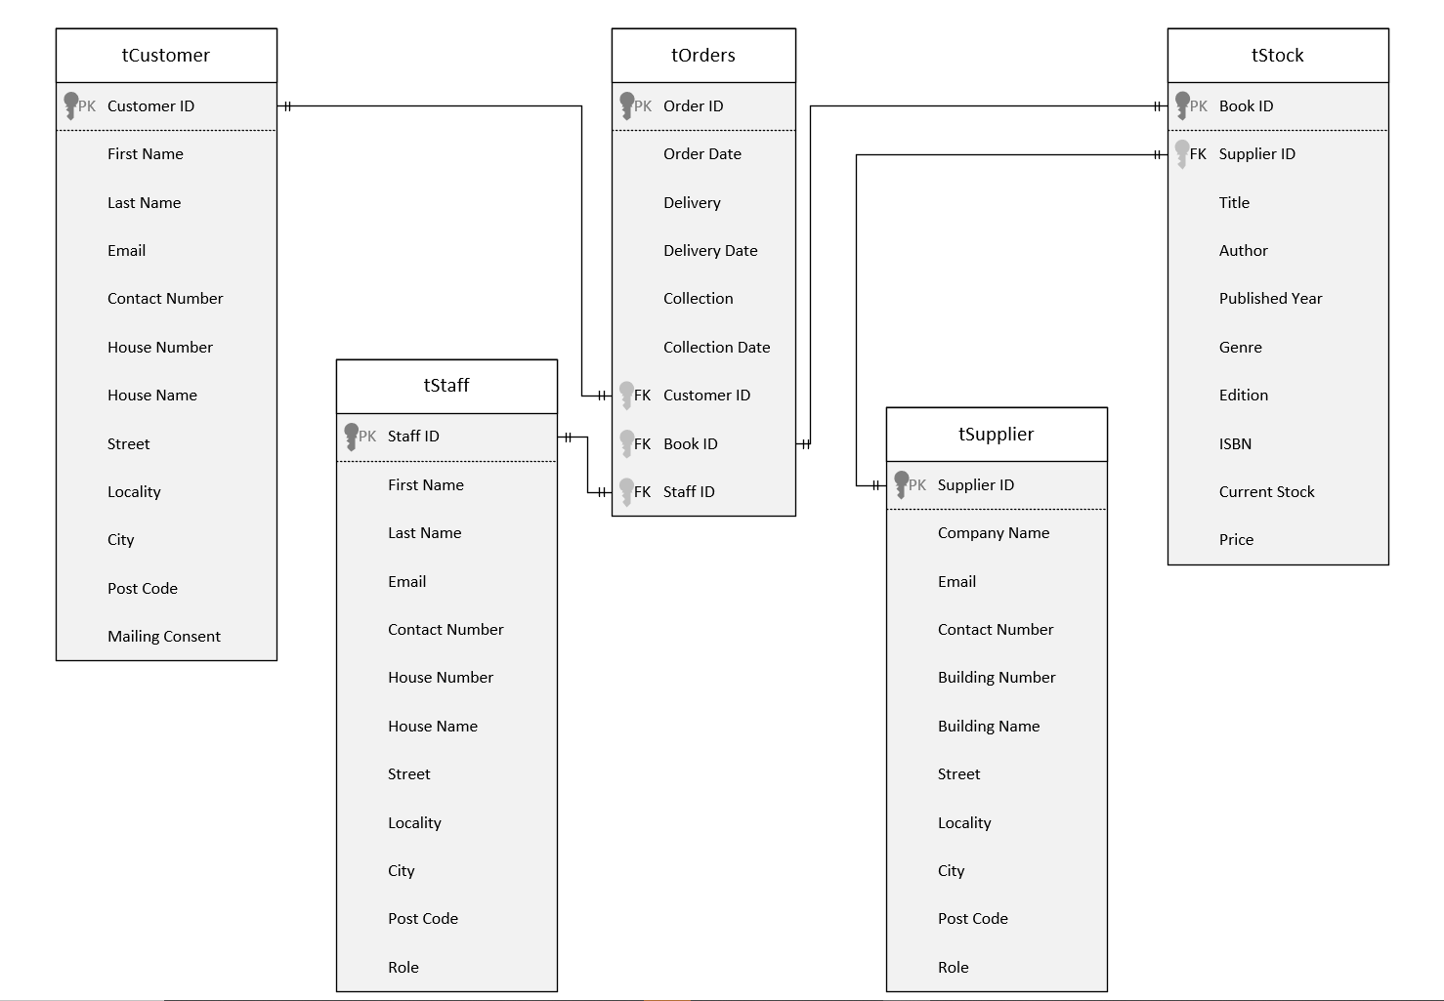

Evidence

Reports

First Editions
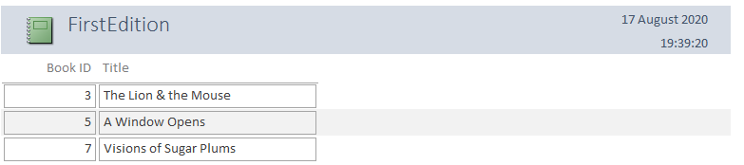

Available Stock
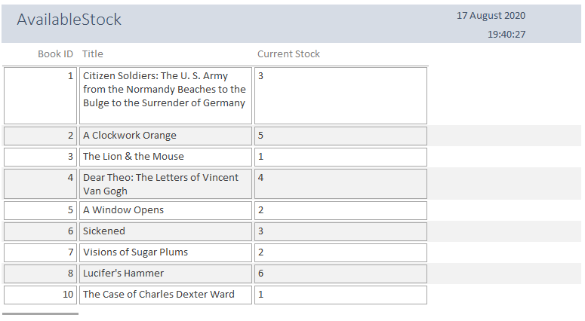

Sales
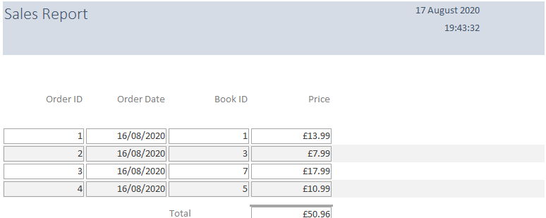
Forms

Customer
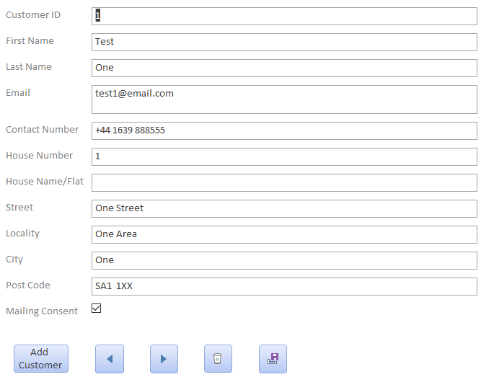

Main Menu
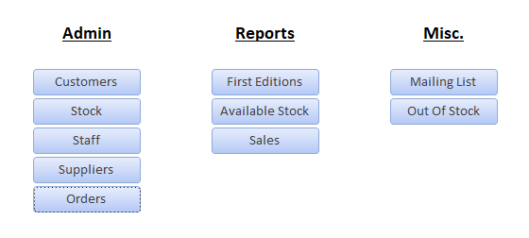

Orders
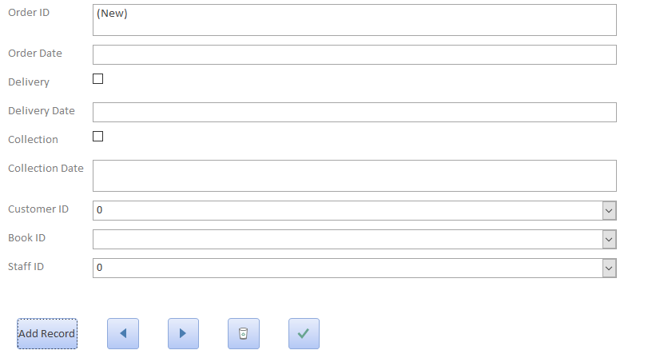

Staff
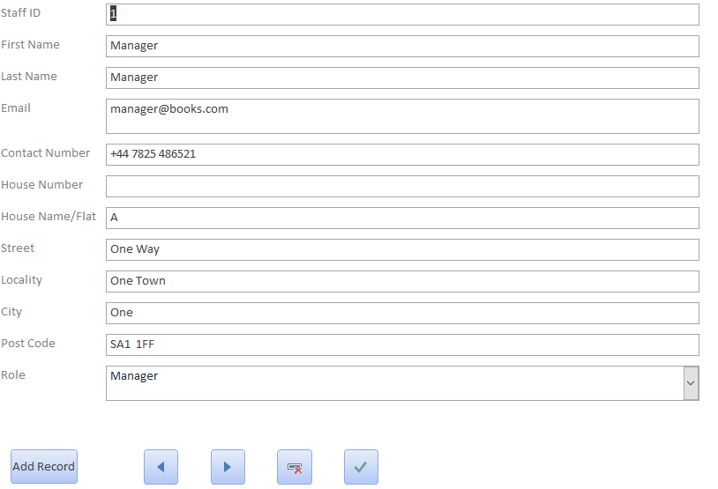

Stock
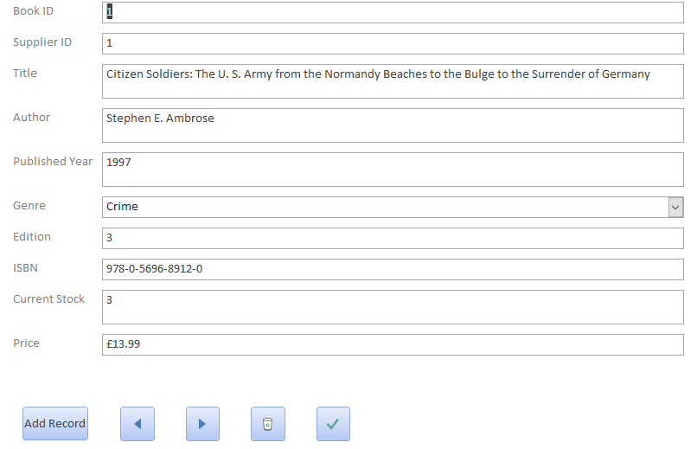

Supplier
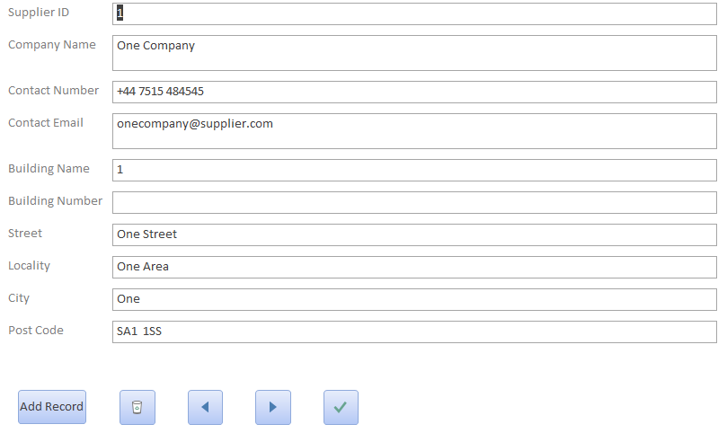

SQL

User Guide

Start

Once you open the database from the saved location on the desktop or the start menu, it will automatically open the main menu of the database. This is where you will choose any of the actions or information you need in the workplace.

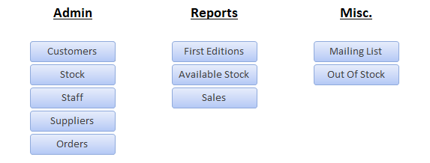

Viewing and Managing Records
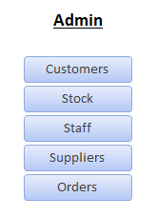
From main menu, click on the relevant button on the Admin side of the menu.


Use the left and right arrows to choose from the previous and next records.

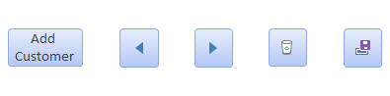
The add customer (or relevant) button will allow you to add a new record, use this if you ever need to add new details for customer, staff, suppliers, or books.

The button on the left is the delete record button. Use that if you ever need to delete a record of a customer, staff member, book, or supplier.
The button on the right is for saving a record. If you need to change details for any of the above, delete the incorrect information, update the information with the correct detail, and then click the save button to permanently save the changes made.

Placing Customer Orders

To place a new order with a customer, click on the Orders button from the main menu, and you will see the below screen in front of you.
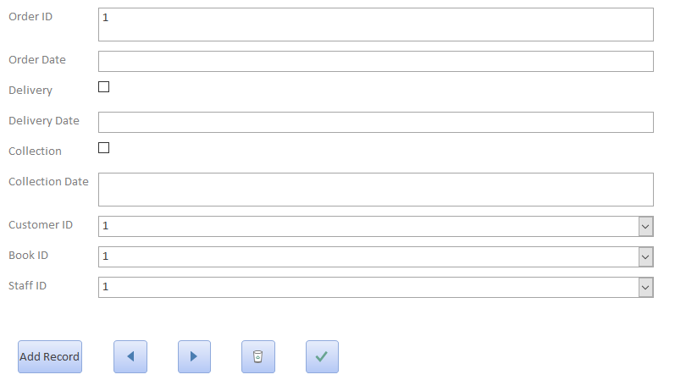

The Order ID will auto fill, so you do not need to enter an order number. Add the information required to the order, the bottom 3 fields you must select from the drop-down boxes by clicking on the relevant down arrow.
Once all this information has been entered and the order is ready to be submitted, click Add Record, and the order will be saved into the database.

