Latimah Shoukat
2319062
BMHP5014
Changemakers: Creativity and value creation
Component 2: Written Assignment (Report)

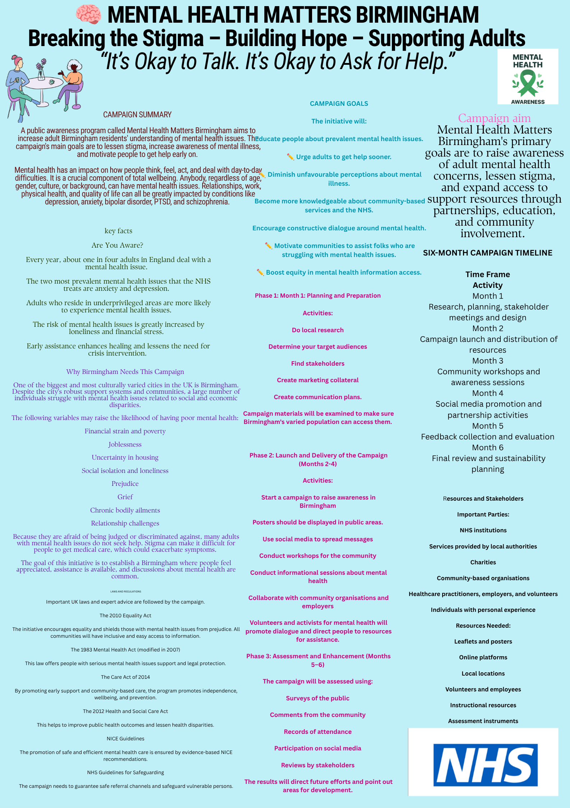Written Pitch: Mental Health Matters Birmingham Campaign
Directed to: NHS Birmingham and Solihull integrated care board
I'm writing to ask for your support for the Mental Health Matters Birmingham Campaign, a community-based mental health awareness project aimed at enhancing the wellness and mental health of Birmingham's adult population. One of the biggest public health issues our city faces is mental health. Despite the fact that one in four people encounter a mental health issue annually, many adults put off getting help due to stigma, prejudice, low mental health literacy, and uncertainty about where to turn for assistance (Mind, 2023). At the same time, demand for NHS mental health services is still rising, which puts further strain on medical staff and lengthens wait times (NHS England, 2019). I think that funding early intervention and prevention through the Mental Health Matters Birmingham Campaign will enhance current mental health services in Birmingham, improve health outcomes, and lessen inequality.
The mental health matters campaign has been designed to complement existing NHS services rather than replace them. Increasing mental health awareness, lowering stigma, promoting early help-seeking, and expanding access to local support services are the main goals of my plan. The campaign backs the goals of the NHS Long Term Plan, which places a high priority on community-based healthcare, prevention, and better access to mental health services (NHS England, 2019). In order to enhance population mental health, it also reflects the Community Mental Health Framework for Adults and Older Adults, which encourages collaboration between health providers, local governments, and nonprofits (NHS England, 2023).
The campaign's four main pillars serve to raise awareness and promote early intervention.
A citywide awareness campaign is the first element. Expertly crafted posters, pamphlets, digital displays, bus stop ads, local radio campaigns, and social media platforms will convey uplifting messages that dispel stigma and promote candid discussions about mental health. In order to reach adults throughout Birmingham, campaign materials will be exhibited in GP offices, pharmacies, hospitals, libraries, universities, businesses, and community centres. Every poster will have a QR code that will take users directly to information about mental health and local support services.
The development of a mobile-friendly digital platform and website for Mental Health Matters Birmingham is the second element. In addition to self-help guidelines, wellbeing advice, and direct links to NHS Talking Therapies, crisis support services, and voluntary organisations like Mind and Rethink Mental Illness, the website will offer reliable information about anxiety, depression, stress, and other common mental health conditions. A list of nearby mental health services in Birmingham will help facilitate people's prompt access to the right kind of assistance.
The provision of free workshops on community wellbeing across Birmingham is the third element. Stress management, emotional resilience, mindfulness, healthy lifestyles, suicide awareness, and useful coping mechanisms will all be covered in these courses. Mental health specialists and those who have personally experienced mental illness will conduct workshops. Promoting candid conversation strengthens social relationships and peer support in local communities while lowering stigma.
Establishing a Community Mental Health Ambassador Program is the fourth element. Mental health awareness training will be provided to volunteers, employers, university employees, religious leaders, and community representatives so they can identify early indicators of emotional distress and confidently refer people to the right support services. Increasing community capacity in this way guarantees that everyone takes responsibility for mental health awareness rather than depending only on medical professionals.
I think Birmingham citizens will benefit from this effort for a long time. Raising awareness of mental health issues will boost mental health literacy and motivate folks to get help before their conditions get worse. Early intervention has been demonstrated to enhance recovery, cut long-term healthcare expenditures, and decrease hospital admissions (World Health Organization, 2022). Additionally, the campaign will promote community resilience, lessen stigma, and enhance cooperation between voluntary organisations, local government, and healthcare providers.
This innovation is particularly pertinent today. Many people are feeling greater worry, sadness, and financial stress as a result of the COVID-19 pandemic and the ongoing cost-of-living issue. Birmingham, one of the most culturally diverse cities in the UK, nonetheless has serious health disparities. By making information and assistance available to all communities, community-based preventative initiatives can aid in the reduction of these disparities (Department of Health and Social Care, 2022).

Value, Viability, and Suggestions
Because it emphasises prevention over crisis assistance, the Mental Health Matters Birmingham Campaign offers great value. Early intervention enhances wellbeing, lowers the need for specialised mental health care, and improves long-term results. Because the campaign makes use of already-existing NHS services, community spaces, and collaborations with the voluntary sector rather than developing completely new healthcare services, it is financially viable.
Digital exclusion, ongoing stigma around mental health, and a lack of finance are among potential obstacles. These obstacles can be overcome by obtaining financing from several groups, enlisting the help of reputable community leaders to encourage involvement, and making sure that printed materials and in-person seminars are still accessible to people with limited digital access. Improvements throughout implementation will be made possible by ongoing evaluation.
If this campaign is effective, it might be extended throughout the West Midlands and modified for minority ethnic populations, young adults, and elderly persons. Because of its adaptable nature, the model can support broader NHS preventative measures while lowering health disparities.
In conclusion, I think the Mental Health Matters Birmingham Campaign offers a practical, empirically supported, and long-lasting way to enhance adult mental health in Birmingham. The initiative will lessen stigma, promote earlier intervention, and increase access to mental health support by fusing education, digital innovation, community participation, and partnership working.
In order to carry out the Mental Health Matters Birmingham Campaign throughout Birmingham, I kindly need your approval and funding for a trial project. Together, we can build a city where everyone has the chance to live a happier and more satisfying life, where mental health is valued equally with physical health, and where stigma no longer keeps people from getting help.

Reference list

Birmingham City Council (2022) Joint local health and wellbeing strategy 2022–2030. Birmingham: Birmingham City Council.
Department of Health (2011) No health without mental health: A cross-government mental health outcomes strategy for people of all ages. London: Department of Health.
HM Government (1983) Mental Health Act 1983. London: The Stationery Office. (Amended by the Mental Health Act 2007).
National Institute for Health and Care Excellence (2022) Depression in adults: treatment and management (NG222). London: NICE. Available at: https://www.nice.org.uk/guidance/ng222 (Accessed: 19 July 2026).
NHS England (2024) Mental health. Available at: https://www.england.nhs.uk/mental-health/ (Accessed: 19 July 2026).
Office for Health Improvement and Disparities (2023) Public mental health profile. Available at: https://fingertips.phe.org.uk/profile-group/mental-health (Accessed: 19 July 2026).
World Health Organization (2022) World mental health report: Transforming mental health for all. Geneva: World Health Organization. Available at: https://www.who.int/publications/i/item/9789240049338 (Accessed: 19 July 2026).
Department of Health and Social Care (2022) Mental Health and Wellbeing Plan: Discussion Paper. London: Department of Health and Social Care.
HM Government (2010) Equality Act 2010. London: The Stationery Office. Available at: https://www.legislation.gov.uk/ukpga/2010/15/contents (Accessed: 16 July 2026).
HM Government (2014) Care Act 2014. London: The Stationery Office. Available at: https://www.legislation.gov.uk/ukpga/2014/23/contents (Accessed: 16 July 2026).
HM Government (2018) Data Protection Act 2018. London: The Stationery Office. Available at: https://www.legislation.gov.uk/ukpga/2018/12/contents (Accessed: 16 July 2026).
Mind (2023) Mental Health Facts and Statistics. London: Mind. Available at: https://www.mind.org.uk (Accessed: 16 July 2026).
NHS England (2019) The NHS Long Term Plan. London: NHS England. Available at: https://www.longtermplan.nhs.uk/ (Accessed: 16 July 2026).
NHS England (2023) Community Mental Health Framework for Adults and Older Adults. London: NHS England. Available at: https://www.england.nhs.uk/mental-health/adults/community-mental-health-framework/ (Accessed: 16 July 2026).

