ORGANISATIONAL CONSULTANCY
BMIH6005
CONSULTANCY REPORT - PREMIER INN COUNTY HALL HOTEL by FINANCE CONSULTANCY
STUDENT NAME: NICUSOR FLORIN MISTODE
STUDENT NUMBER: 2246469
WORD COUNT: 5710
TUTOR: NATALIE BRAILSFORD



I confirm that I have not used any AI tools in the research and creation of this assignment. I confirm that I have not presented any AI generated materials as my own work. I confirm I have copies of my drafts, notes, and other resources I used, which I may be asked to provide in evidence.

Executive Summary
This consultancy report has evaluated the current business dynamics of Premier Inn County Hall Hotel by Finance Consultancy. It is a section of the renowned hotel chain Premier Inn, powered by the Whitbread Group, the leading business in the hospitality industry. It has been revealed that the hotel offers diversified services to its consumers, including a wide range of rooms. Also, it includes complementary offers, including Wi-Fi, a comfortable mattress and various breakfast, lunch and dinner options, which can make the travel journey of the consumers joyful. Alongside this, it has customised the services according to the affordability and preference of the travellers to increase their engagement and interest. Despite being located in the prime location of London, this organisation needs to deal with poor consumer reviews and a lack of qualified employees. Most of the consumers have highlighted that the organisation has an inconsistency in its service quality, which conflicts with the preferences of the consumers. Also, its values indicate a mixed quality that might not be sufficient for the consumers. It is required to note that poor consumer reviews and inconsistency in Service delivery can interrupt the hospitality industry and reduce consumer engagement because of the negative public perception and reduced organisational values.
The consumers have highlighted that the organisation has a lack of focus on cleanliness, which directly conflicts with the product safety policy of the hospitality industry. On the other hand, some of the consumers have highlighted that the organisation lacks employees, which is causing inconsistency in its service and reducing consumer engagement. In that case, the evidence has shown that the parent organisation of Premier Inn is facing a lack of employees, a high turnover rate, supply chain management issues and financial loss due to the pandemic. After the pandemic situation, the perceptions and needs of modern employees and consumers have changed, which is causing trouble for Premier Inn County Hall Hotel. Additionally, the consumers face a lack of availability in its product delivery, which has also reduced their engagement with its services. According to the perception of Premier Inn. The supply chain issues are reducing the availability of its products in every branch, including the London County Hall hotel. From this perspective, it has been highlighted that based on supply chain management issues and a lack of skilled employees has been reduced consistency and quality in its services and contributed to poor consumer reviews.
From the external and internal environment analysis of Premier Inn. At County Hall Hotel, it can be stated that the organisation has various abilities that can effectively reduce the challenges associated with service inconsistency. The most potent strength of this business it is backed by the resources of Whitbread Group, which can be a potential support in any uncertainties. On the other side, the organisation has integrated many technical solutions that have increased pressure on the employees to work more with reduced resources. Based on these factors, it has become extremely challenging for Premier Inn. County Hall Hotel to keep all its employees and provide the best services. Negative public perceptions can significantly impact the brand value of the hospitality industry that can be mitigated by modifying the employee management Strategies and adopting innovative solutions. In order to remove the barriers and ensure a strong employee engagement, the organisation might consider using the digital learning platforms and resources of Whitbread Group so that it is possible to increase the employees skills. In that case, Whitbread LMS can work as a great resource for providing employees with learning and development opportunities. It will also help to measure the progress of the employees and ensure the continuous development of the business.
The second recommended strategy includes the implementation of reward and recognition programs to celebrate every success of the employees. It can be measured by assessing the employee satisfaction score and their progress to understand the success of this initiative. In that case, the leaders can establish short-term goals for the employees and encourage them to achieve in order to receive rewards and recognition. On the other side, it has been suggested to increase flexibility in the operations to support the employees in getting job satisfaction. After the pandemic, flexibility has become a great concern for employees who can ensure their engagement and detachment from any business. In order to enhance employee engagement, it has been suggested to provide employees with flexible working opportunities. Apart from that, by modifying the housekeeping protocols and work arrangements, it will be possible for the business to prevent the chances of burnout. It will also ehance work-life balance and reduce stress among employees for better productivity and employee engagement. In that case, Kotter's 8-step change model can be implemented to apply the changes in a structured way. This model significantly influences businesses to focus on urgency and clear communication to ensure the engagement of every employee in the change management initiatives. Adaptation of this model will help the business to maximise the benefits and develop strong Strategies and visions which will make the initiative worthwhile and support in understanding its progress.

Table of Contents
Executive Summary 3
Introduction 8
Analysis 10
Identified issue and its impact 10
Causes of the issues 12
STEEPLED Analysis 13
SWOT Analysis 17
TOWS Analysis 19
Recommendation and change management 20
Recommendation 20
Strategy 20
Structure 20
Systems 21
Shared Values 21
Skills 21
Style 22
Staff 22
Change management initiative 23
“Create a sense of urgency” 24
“Form a guiding coalition” 24
“Develop a vision and strategy” 25
“Communicate the vision” 25
“Remove the barriers” 25
“Generate short-term wins” 25
“Build on the change” 26
“Secure the changes” 26
Possible benefits 26
Action Plan 27
Conclusion 34
References 36

Introduction
It is required to understand that the Consultancy organisation Finance Consultancy is situated in the UK and offers the best services to its consumers. In this regard, the consultancy organisation will demonstrate a consultancy report for Premier Inn. County Hall hotel so that the business can overcome the challenges. London County Hall Hotel is one of the most promising properties of Premier Inn, which is part of the Whitbread group. In London, Premier Inn entered during the early 20th century and has established this property. Premier Inn County Hall Hotel is in London and includes multiple facilities for consumers, including excellent rooms and complimentary services. It is important to note that the London County Hall hotel does not include any onsite parking area, but the chargeable parking area can be booked online (Premier Inn. (2025). On the other side, it has enhanced room design, complimentary wi-fi service, a great view and an updated workspace. In that case, it has multiple packages including Premier Plus, Premier Plus with a view, standard double and standard double with a view. Each of the rooms has its benefits according to the affordability of the clients. Along with premium design rooms, it offers the consumers excellent breakfast, lunch and dinner with great deals. Based on these strategies and complementary services, this organisation has become the flagship property of Premier Inn. For the hospitality industry, diversified and high-quality services have become the cornerstone that increases consumer engagement (Fatma and Kumar, 2024). Apart from that, the County Hall Hotel of Premier includes standard twin rooms that include a double bed and a sofa bed and the family rooms include a range of standard family and standard family with a view. Additionally, the standard accessible room includes a huge space and a comfortable mattress and accessible features for people with disability.
Despite offering affordable and accessible services to consumers, Premier Inn London County Hall needs to deal with multiple challenges associated with consistency in service quality and employee retention. In relation to the consistency in service quality, the lack of parking area and cleanliness has been encountered as the most potential challenge for the organisation. In that case, the consumer reviews highlight that even if the hotel atmosphere is welcoming, but the service is inconsistent, and its cleanliness, value and noise level are mixed. It indicates that the organisation needs to focus on enhancing the quality of its service so that it is possible to meet the consumer demand. On the other side, employee retention has become the most significant challenge for Premier Inn, which has impacted its County Hall hotels as well. Depending on labour shortage and supply chain issues, it can be challenging for the tourism industry to evaluate the market demand and retain its employees to provide the consumers the best services they are looking for (Liu-Lastres et al., 2023). In that case, the inconsistency in its services occurred because of the labour shortage and the supply chain management issues. Following the challenges, Premier Inn has dealt with intense challenges while recovering from the pandemic era.
The challenges highlight the need for enhancing the employee management strategies of Premier Inn to enhance the services of its County Hall hotels. Depending on the issues, this report will evaluate the impact on the brand by considering its income and reputation. In that case, it will include a STEEPLED analysis, SWOT analysis and TWOS analysis to understand the dynamics of the hospitality industry and the future direction for the chosen hotel (Buttrick, 2009). Based on the evaluation, it will provide recommendations and Strategies for implementing change management initiatives so that it is possible for the business to address the issues and maintain a strong competitive advantage among the competitors. Additionally, it will include an action plan so that the business can implement the changes and regain its brand value by meeting all the consumer demands. It is important to note that the recommendation will also include the key performance indicators so that the success rate of the change management initiative can be evaluated (Burnes, 2014). These key performance indicators will consider the external and internal forces that can be helpful to compare the current dynamics of the hotel and the possible outcomes that can contribute to success. Overall, this consultancy report will focus on the current performance management efforts of the chosen organisation and the possible ways to improve them for better consumer and employee retention.

Analysis

Identified issue and its impact
Firstly, inconsistency in service quality has been identified from the consumer reviews of Premier Inn County Hall hotels. In that case, most of the consumers have reported that the rooms of Premier Inn County Hall hotels are not clean enough and the employees are comparatively low not enough for assisting the consumers effectively. It has significantly impacted the consumer reviews of the organisation, which can influence other people while considering the hotel for accommodation. Also, the unavailability of food and other products has been highlighted in the consumer review, which indicates a lack of focus on consumer demands (Tripadvisor, 2025). It is important to note that the decoration of the Premier Inn County Hall hotel is outdated, which has influenced the negative reviews of the organisation. From this perspective, it can be stated that inconsistent service in the hospitality industry works as the most significant challenge that reduces consumer demand (Järvi et al, 2020). In relation to Premier Inn. County hall hotels reduced consumer demand can create significant barriers in enhancing innovation and introducing new services for a better market range. Additionally, the lack of focus on cleanliness can also conflict with the safety regulations for the hospitality and tourism industry and introduce legal obligations.
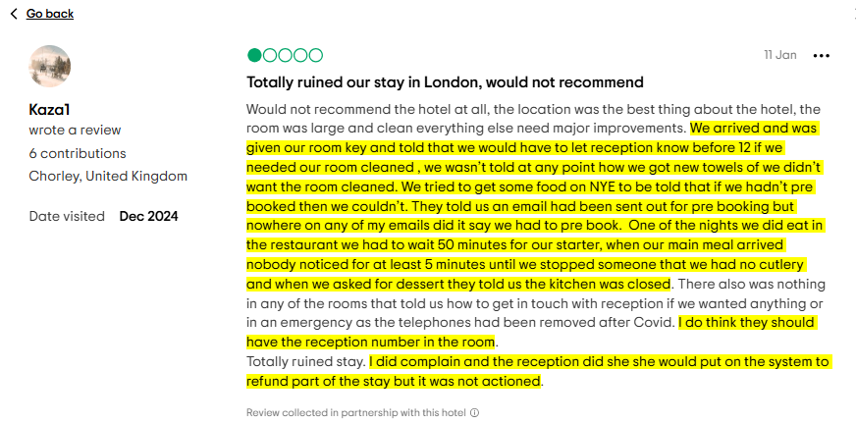
Figure 1: Customer review
(Source: Tripadvisor, 2025)

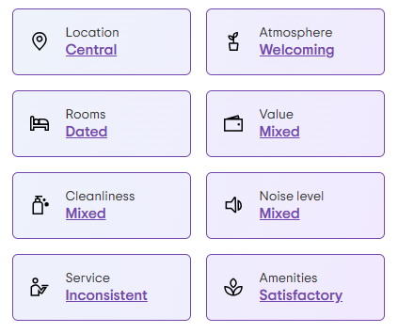
Figure 2: Summary of Consumer reviews for Premier Inn. County Hall Hotel
(Source: Tripadvisor. 2025)
In relation to the hospitality industry, consistent service with cleanliness works as the primary success criterion that can ensure legal stability and great revenue generation. In that case, the regulatory policy of the hospitality industry includes great hygiene policies that can ensure the safety of its services or products (Rodríguez and Puertas, 2023). The lack of focus on hygiene, cleanliness and safety of the hospitality services can significantly introduce legal obligations, and it can be challenging for tourism businesses to overcome the reputation (Achmad and Yulianah, 2022). From this perspective, it can be stated that poor consumer reviews for cleanliness and consistency of services can significantly reduce the brand perception of Premier Inn County Hall Hotel. It can also reduce consumer engagement and hinder the opportunity for enhancing employee skills and the service quality. Based on inconsistent and unsafe products, it might be challenging for Premier Inn County Hall Hotel to ensure profitability and focus on the areas of development because of the lack of financial and human resources. Additionally, it can negatively influence the brand reputation and reduce the competitive advantage among potential competitors. Overall, the Premier Inn County Hall hotel needs to concentrate on enhancing its consistency in service by integrating all the required regulatory policies to maintain a great and safe Service delivery.

Causes of the issues
The primary reason behind inconsistent service is labour shortage and supply chain management issues. In 2021, Premier Inn declared that Whitbread is facing supply chain management issues and labour shortage, which is impacting its entire Hotel chain, including Premier Inn. In order to address the challenge, it has concentrated on offering different financial benefits to its existing employees and hiring new people with competitive benefits (Ambrose, 2021). It has also been uncovered that Premier Inn and Whitbread have faced losses for more than 26 weeks, which has significantly impacted their revenue generation. After the pandemic, labour shortage has become very relevant for the hospitality and tourism industry because of the need for a convenient and flexible working schedule (Dempster and Zimmer, 2020). In that case, it has become challenging for Premier Inn to evaluate the needs of modern employees and ensure great service in every segment. Similarly, the consumer reviews for Premier Inn County Hall hotel have also revealed that the organisation has reduced employees, which has impacted its service quality. Additionally, the unavailability of the products indicates supply chain management issues, which can impact the service delivery of the hospitality industry (Aigbedo, 2021). From this perspective, it can be stated that employees work as the key stakeholders for the hospitality business, which can measure the consumer engagement and profitability.
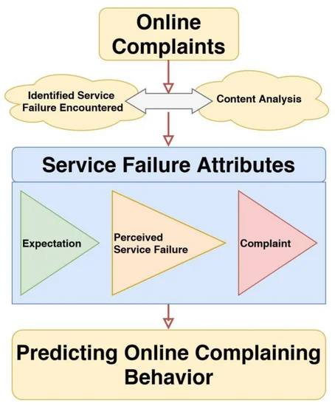
Figure 3: Influence of Inconistent service in the Hospitality industry
(Source: Sann et al, 2022)
Apart from that, the lack of focus on market demand can lead to inconsistency in service quality, which can significantly reduce the user reviews. For the hospitality industry, it is extremely required to focus on market demand for sustainable accommodation with all the safety concerns (Legrand et al, 2022). In that case, Premier Inn County Hall Hotel has a lack of implementation of sustainable accommodation service, which has become challenging to meet consumer demands. Also, this hotel does not have an on-site parking area and includes off-site areas for parking, which are chargeable, which can conflict with the affordability concerns of its consumers. From this perspective, the County Hall Hotel of Premier Inn needs to work on its infrastructure to enhance its convenience and affordability for better consumer engagement.

STEEPLED Analysis
Factors | Impact
Social | The changing employee demands for flexible and diversified work opportunities have influenced the entire hospitality and tourism industry to adopt an innovative employee management approach (Davidescu et al., 2020). In that case, the failure of Premier Inn London County Hall Hotel to meet this need has reduced employee engagement. Also, during the pandemic, it has become challenging for Premier Inn to ensure the availability of skilled employees within the workplace, which has reduced its community development and consumer engagement.
Technological | Premier Inn has implemented automation in the check-in and check-out process, which has improved its efficiency (Giousmpasoglou and Hua, 2020). On the other hand, it has increased pressure on the employees to work with reduced resources, including insufficient technical skills. In that case, the lack of digital skills can cause delays in the service delivery and reduce consumer satisfaction.
Economic | In London, the cost of living has increased due to its enhanced infrastructure and technical integration (Hayes, 2024). In that case, it has become challenging for every employee to find affordable accommodation near their workplace. The lack of affordable accommodation for employees is one of the most significant challenges for employee retention. Based on this challenge, Premier Inn County Hall Hotel has faced reduced employee engagement and poor reviews from consumers.
Environmental | In the hospitality industry, it is required to implement adequate measures to follow all the sustainability protocols, including eco-friendly cleaning (Prakash et al., 2023). In that case, the eco-friendly cleaning protocols in the hospitality industry can be time-consuming and might require a great human resource (Hussain and Soni, 2025). For the Premier Inn County Hall hotel, the lack of skilled employees has hindered its potential to address environmental concerns and has led to inconsistent service.
Political | Post-Brexit immigration policies have reduced the availability of hospitality employees from the European Union (Taylor et al., 2020). In that case, the hospital industry in the UK needs to heavily depend on under-trained and temporary employees, which can impact its consistency. It has also influenced the services of the Premier Inn County Hall Hotel and has reduced its consumer engagement.
Legal | The changes in the employment regulations can significantly impact the hospitality industry of the UK and interrupt the operations of the Global organisations, including Premier Inn (Ioannou and Dukes, 2021). In that case, the changing employment regulations have influenced Premier Inn to cut off the existing employees from its every hotel, including Premier Inn County Hall Hotel. This cause cutting initiative can increase stress among its employees and affect the quality of service.
Ethical | In the hospitality sector, ethical labour practice has become one of the most important success criteria because of consumer awareness (Franzoni et al, 2021). In that case, the cost-cutting initiative for the existing employees can damage the branding and hinder the opportunity to collaborate with the highly performing employees.
Demographic | The workforce of London’s hospitality industry is becoming diverse because of cultural sensitivity and inclusive training opportunities (Mistry et al., 2023). In that case, the High turnover of the Premier Inn County Hall hotel indicates less experienced employees, which can significantly provide consumers with poor quality and inconsistent service.
Table 1: STEEPLED Analysis of Premier Inn London County Hall Hotel
(Source: Self-Created)

SWOT Analysis
Strengths  - Situated in prime locations with iconic landmarks.  - Resources from Whitbread Group.  - Integration with artificial intelligence and automation. | Weakness  - Labour shortage.  - High turnover rate.  - Inconsistent service.
Opportunities  - Expansion of flexible working hours.  - Investment in the upskilling programme.  - Improvement of consumer engagement. | Threats  - Lack of long-term employment.  - Unavailability of skilled employees.  - Damaged brand reputation.
Table 2: SWOT Analysis
(Source: Self-Created)
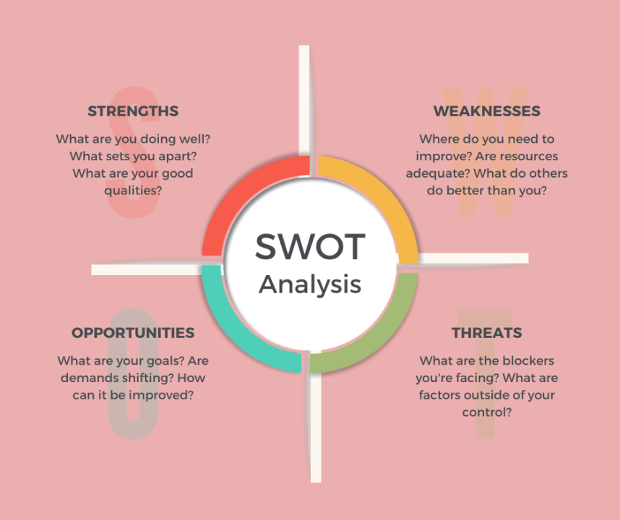
Figure 4: Elements of SWOT Analysis
(Source: LinkedIn, 2021)
Premier Inn County Hall Hotel is a part of the international hotels in Premier Inn hotels, backed by Whitbread Group, its parent organisation, which has increased its resources and supported in establishing a strong place. Also, this organisation is situated in prime locations with iconic landmarks such as the London Eye and Westminster. Apart from that, Premier Inn has implemented automation and artificial intelligence into its process, which has increased its efficiency (Huang et al., 2022). In comparison, the Premier Inn County Hall hotel needs to deal with a high turnover rate, which has increased its labour shortage. Depending on the lack of skilled employees, the organisation fails to provide consumer-based services, resulting in inconsistent service quality (Kleisari and Markaki, 2020). The opportunities of the Premier Inn County Hall hotel include expansion of the flexible working hours that can be implemented by evaluating the strategies of the Whitbread group. Also, the resources obtained from its parent organisation can support investing in the upskilling programs to enhance the ability of its employees. Depending on highly qualified employees, it will be possible for the hospitality business to improve its consumer engagement and reviews (Chen et al., 2021). In comparison, the rising living costs in London can highlight the lack of long-term employment in its hospitality industry. Additionally, it can reduce the availability of skilled employees and damage the brand reputation with poor consumer reviews.

TOWS Analysis
Strengths/Opportunities  - Excellent resource of the parent organisation.  - Prime location to engage multiple consumers. | Weaknesses/Opportunities  - Reduced employee engagement.  - Lack of training and development opportunities for the employees.
Strengths/Threats  - Use the financial resources for employee development.  - Interact with the consumers by using artificial intelligence. | Weaknesses/Threats  - Poor consumer review.  - Lack of highly skilled employees.
Table 3: TOWS Analysis
(Source: Self-Created)
From the above discussion, it can be stated that by using the resources of Whitbread Group, which is a parent organisation of Premier Inn, it will be possible for the business to regain its brand reputation. On the other side, the prime locations of London, including Westminster and the London Eye, can engage different consumers and enhance its financial dynamic. In comparison, the Premier Inn County Hall hotel needs to focus on enhancing its employee engagement and providing them with relevant training and development opportunities (O’Mahoney, 2021). Responsible utilisation of the financial resources can support the business in reducing its turnover by ensuring employee development (Michael and Fotiadis, 2022). Also, by interacting with the consumers through artificial intelligence, the organisation will be able to ensure consistency in its service. It is important to note that artificial intelligence has become one of the most promising media for the hospitality sector to interact with consumers and provide them with customised and affordable service (Buhalis and Moldavska, 2022). Additionally, the weaknesses of Premier Inn County Hall Hotel include poor consumer reviews because of the lack of highly skilled employees. In this regard, by upskilling the existing employees, it will be possible for the organisation to rebuild its brand reputation.

Recommendation and change management

Recommendation

Strategy
In order to address the challenges, the organisation can introduce a structured internal training program to enhance the digital literacy skills of its employees (Mavridopoulou, & O’Mahoney, 2020). Depending on a training program, the hospitality industry can increase the digital skills of its employees and ensure seamless service that can increase consumer engagement (Suwanda et al., 2022). On the other side, it will help to reduce early-stage turnover for the organisation and support in establishing long-term commitment among its employees. In that case, the organisation can develop 3–6-week modular training programs by combining blended learning.

Structure
Currently, employee reward and recognition programmes have received much attention from modern employees because of their well-being outcomes. Most of the hospitality organisations have implemented reward and recognition programmes to increase the motivation of their employees (Tahiri et al., 2022). For the chosen organisation to introduce reward and recognition schemes so that they can be motivated, and it can enhance their engagement with the work process. In that case, the organisation can empower the employees by providing them the opportunities to take part in the decision-making process (Noordzife, 2014). Also, the employees must report to their line managers and team leaders to collect feedback over their performance.

Systems
In order to evaluate the success of this initiative, it is recommended to implement effective feedback loops as a part of its daily activities and collect the perspectives of its employees. In recent times, online feedback loops have become the most potent tool for the hospitality industry that can help in understanding the perspectives of the consumers and employees (Narayan et al., 2022). Following this perspective, it will be possible for the business to maintain consistency in its service. It is important to note that the hospitality industry needs to ensure highly skilled and motivated employees so that it is possible to provide the best services (Ohunakin, 2020). In relation to the expense, the organisation might invest £10,000 as part of its reward and recognition programme, including bonuses and paid time off. Additionally, the organisation can celebrate the short-term successes to encourage the employees to work hard and collaborate.

Shared Values
The organisation can adopt a flexible schedule to increase the motivation of its employees. Depending on a flexible schedule, the hospitality industry can support employees to maintain a work-life balance and increase their engagement (Patrick, 2023). In that case, the organisation can provide the managers, and team leads with the policy changes so that they can manage the employees efficiently. On the other hand, the organisation conducts a survey among the employees to understand their flexible schedule patterns. Also, the organisation can demonstrate the shared value of working collaboratively and increase employee motivation.

Skills
Premier Inn County Hall Hotel can collaborate with Whitbread Group to utilise its digital sources to provide training opportunities for its employees (Whitbread PLC, 2022). Whitbread Group has implemented industry-leading training and development programmes by integrating with advanced technical infrastructure. The collaboration with this organisation will support the business to get access to the Whitbread LMS and provide the employees with the relevant training opportunities that can improve their skills. The estimated cost of this initiative might include £8,000 for trainer fees and LMS licensing. It can also include the ongoing content update in its cost and help to enhance the operational consistency with a great service. Additionally, the key performance indicators of this initiative can include the turnover rate and employee satisfaction percentage to measure the success of this initiative.

Style
The organisation can revise the daily room allocation and the cleaning methods to reduce the chances of burnout and change its leadership style. It has been identified that excessive workload for the employees of the hospitality industry can lead to burnout and reduce employee engagement (Abd Hadi et al., 2023). In that case, the organisation can reschedule its daily allocation and adopt a transformational approach to support the employees to manage their workload. In that case, the business can offer incentives for overtime service during the seasonal time. Depending on this strategy, the organisation will be able to manage its employees efficiently and reduce the percentage of turnover. On the other side, it will contribute to a better resource allocation effort and help to manage the human capital effectively. In the hospitality sector resource allocation process works as the most important function that ensures the success and profitability of the business (Parsakia, 2023). Premier Inn County Hall hotel can evaluate the success of this initiative by evaluating the quality score, employee feedback on physical workload and the consumer feedback about their experience. Additionally, the utilisation of the technical infrastructure, including artificial intelligence, supports the hospitality industry to manage different employees effectively by customising the business strategy (Ruel and Njoku, 2021). The organisation can invest £5,000 to implement a mobile checklist app and incentives for the housekeeping employees.

Staff
It is important to note that work-life balance has become the most relevant concern for modern employees, which can enhance the service quality of the hospitality industry (Bello et al., 2024). Also, it will increase transparency and motivation of its employees for understanding their roles within the organisation (Whittington, et al, 2020). The success of this initiative can be measured by evaluating the employee satisfaction rate and turnover. In this regard, the estimated cost might be £ 7,000 for the expenses associated with providing the employees' training and conducting an employee survey. In comparison, the organisation can transparently communicate with its employees to understand their preferences and build trust among them. In the context of the hospitality industry, transparent communication can enable collaboration and help in discovering new Strategies for managing different employees (Delgado, 2024). Following the relevance of transparent communication, the business can connect with its employees and identify the areas of development in its employee management approach.
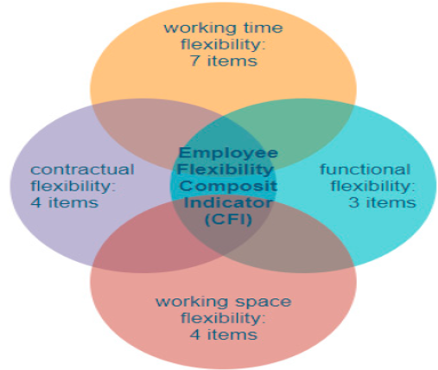
Figure 5: Impact of Flexible work opportunities in the hospitality industry
(Source: Davidescu et al, 2020)

Change management initiative
The above evaluation has indicated a strong need for a change management model that Premier Inn County Hall Hotel can include to modify its employee management strategies. Kotter's 8-step change model can be applied to the business to apply the modifications to its practice. In that case, Kotter's 8-step change model provides a structured approach that organisations can implement any changes successfully (Laig and Abocejo, 2021). It includes eight stages such as Create a sense of urgency, Form a guiding coalition, develop a vision and strategy, communicate the vision, remove the barriers, generate Short-term wins, build on the change and secure the changes (Trawick and Carraher, 2023). Based on these stages, the business can significantly improve its employee management strategies and increase its engagement.
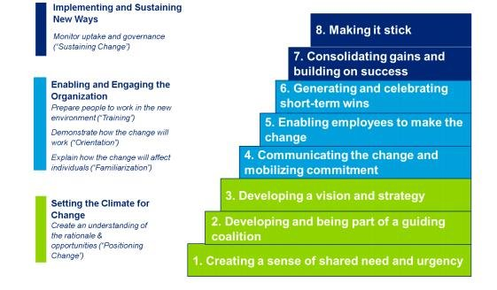
Figure 6: Kotter's 8-step change model
(Source: Dorel Mihai Paraschiv et al, 2019)

“Create a sense of urgency”
Firstly, the organisation will need to understand the need for change and connect with the stakeholders to apply the changes. In that case, clear communication between the organisation and its potential stakeholders can help to implement any change successfully (Errida and Lotfi, 2021). Premier Inn County Hall hotel can conduct meetings to discuss the changes and collect their perspective for innovative solutions.

“Form a guiding coalition”
After that, it is important to develop a guiding team to influence the employees to take part in the modification process to make it successful. In that case, the accumulation of multiple influential leaders can contribute to the successful implementation of any change initiative (Ford et al., 2021). Following this stage, the chosen organisation might create a separate leadership team to guide its employees about their responsibilities in this initiative.

“Develop a vision and strategy”
It is extremely required to develop relevant visions and strategies connected to the change management initiative along with the goals. In that case, it is important to design the future goals and develop vision and strategies to improve the employee Management process (Paroli, 2024). This strategy will support the business to engage its employees in the process and enhance their motivation to work hard for the business.

“Communicate the vision”
After developing the vision and strategy, Premier Inn County Hall Hotel needs to convey the vision to its stakeholders. For the hospitality industry, it is required to clearly define the roles and responsibilities of its stakeholders to ensure the successful incorporation of the change management initiatives (Mwakuduwa et al., 2024). In that case, the business can empower its employees to understand their perspectives on this initiative and reduce the chances of conflict.

“Remove the barriers”
Premier Inn can face significant barriers in implementing the changes because of the conflict between the traditional environment and the changes. In relation to the hospitality sector, conflict management works as the most potential success criterion that supports in removing all the external and internal barriers to ensure a high-quality service to the consumers (Skordoulis et al., 2024). In this stage, the chosen organisation needs to identify the team dynamics and measure the possible challenges, including resistance from the employees and team conflict and design relevant strategies to prevent the barriers early.

“Generate short-term wins”
Once the challenges are identified, Premier Inn. County Hall Hotel needs to generate short-term wins to encourage the employees to actively participate to the business success. The development of short-term goals and their celebration benefits the hospitality industry by increasing the encouragement of its key employees (Xu et al., 2020). In that case, the business will benefit by linking the short-term goals with the broad objectives.

“Build on the change”
After completion of the short-term goals, the Premier Inn. County Hall Hotel needs to build strategies for improving the current dynamics and moving forward. In that case, performance management tools can support the hospitality industry to understand the progress of its change management initiative and identify the key areas of development (Fatima and Elbanna, 2023). The organisation can implement a performance management system and evaluate the performance of its employees to measure the progress of its change management initiatives. It will help the organisation to remove the current barriers and identify the possible risk factors that can impact the brand value and employee engagement.

“Secure the changes”
Lastly, Premier Inn County Hall Hotel needs to secure the changes by meeting all the employees' and consumers' needs. Kotter’s 8-step change model suggests incorporating new strategies for improving the organisational culture and securing the changes for a better outcome (Burton, 2024). It is recommended for the organisation to focus on innovation by collaborating with diverse talents and identifying innovative solutions to increase employee engagement. Based on this strategy, it will be possible for Premier Inn County Hall Hotel to overcome the barriers and ensure a great engagement of its potential employees, supported by diversity and inclusion.

Possible benefits
Implementation of employee development programme, reward and recognition initiative, flexible schedule and modification in housekeeping protocols and workload will benefit the business by enhancing employee motivation. In that case, training and development programme in the hospitality industry holds the most influential place that significantly increases the engagement and motivation of their employees (Singh and Ansari, 2024). The training and development initiative also benefits the hospitality industry by providing consumers with the best quality service, along with convenience and affordability. In order to regain its employee motivation, the organisation can implement a reward and recognition initiative to celebrate its success. In relation to the hospitality industry, reward and recognition programs significantly identify the contribution of employees in business success, which encourages their loyalty (Ada et al., 2023). Additionally, the adaptation of a transactional leadership approach can enhance the quality and outcome of the reward and recognition program. It is important to note that a transactional leadership approach influences business leaders to provide rewards and recognition to their employees depending on their performance (Syaharudin et al., 2022). This approach will support the business to encourage the employees by celebrating their success and recognising their improvement. On the other side, Premier Inn. County Hall Hotel will be able to ensure an employee-friendly work environment where productivity is the priority.
Apart from that, the implementation of flexible schedules and the changes in the workload and housekeeping protocols will support the employees in maintaining their work-life balance. After the pandemic, flexible working schedules in the hospitality industry have become very crucial as they impact the mental health of the employees (Elshaer and Azazz, 2023). In that case, by integrating this strategy, the organisation will be able to meet the concerns of the modern employees and enhance their engagement with the work process. It will enhance the organisational culture and contribute to a collaborative work environment to ensure a highly performing team according to the business objectives. Also, the implementation of flexible working opportunities will help to ensure innovation by enabling strong collaboration between different team members (Weideman and Hofmeyr, 2020). In relation to the hospitality industry, innovation contributes to business success by supporting in identifying of innovative solutions to manage different team members. On the other hand, changing the housekeeping protocols and the workloads will reduce the chances of burnout. In the context of the hospitality industry, burnout works as the most significant challenge that negatively influences the motivation of employees (Abubakar et al., 2022). In this regard, by dividing the workloads for the housekeeping employees, the organisation will be able to prevent the chances of burnout and establish a productive work environment.

Action Plan
Number | Problem | Solution | Desired Outcome | Time-scale | Completion date | Planned Budget
1 | High employee turnover. | Implement a virtual employee development programme. | Digital learning platform helps to enhance the training and development initiatives of the hospitality industry (Szpilko et al., 2021). In that case, it is expected for the Premier Inn County Hall hotel to reduce its employee turnover by 20%. It will influence the revenue generation of the organisation and support in strengthening its human capital. | 3 months | 15.07.2025 | £8,000
2 | Lack of employee engagement and motivation. | Include an employee reward and recognition programme. | Implementation of a reward and recognition system in the hospitality industry not only encourages employees but also supports in establishing a collaborative business environment (Kakarougkas and Stavrinou, 2021). Depending on this strategy, it is expected to enhance collaboration within the Premier Inn County Hall Hotel and increase productivity. | 4 months | 10.08.2025 | £10,000
3 | Burnout and workload. | Adopt a flexible schedule. | The adoption of a flexible working schedule is expected to enhance employee engagement, depending on their preference (Parveen and Rizq, 2024). In that case, Premier Inn County Hall hotel will be able to ensure flexibility within the workplace and ensure a great engagement of its employees. | 2 months | 12.06.2025 | £ 7,000
4 | Inconsistent service quality and unavailability of employees. | Revise housekeeping protocols and workload. | This strategy is expected to reduce burnout and divide the entire work among relevant employees. It is important to note that burnout is the most significant challenge in the hospitality industry that interrupts the experience of the consumers and service quality (Grobelna, 2021). Based on this process, the organisation will be able to prevent the chances of inconsistent service and enhance the consumer reviews. | 3 months | 13.07.2025 | £5,000
Table 4: Action plan
(Source: Self-Created)

Conclusion
In conclusion, this report has evaluated the current market dynamics of Premier Inn. County Hall Hotel. Premier Inn, which is a significant part of the Whitbread group, has established its business in different countries. County Hall Hotel is the most influential hotel for this organisation, which has the potential to enhance consumer satisfaction. Despite situating in a prime location with iconic landmarks, this organisation needs to deal with intense challenges while ensuring a great service quality because of the lack of skilled employees. The consumer reviews have revealed that the organisation has a lack of focus on providing consistent service. Also, it has a lack of cleanliness, which impacts consumer perceptions heavily. In that case, the primary reason behind this challenge is the labour shortage and supply chain management issues. In 2021, Premier Inn announced that its parent organisation is planning to hire new people and provide the existing employees with perks and financial benefits. It has also been announced that during the pandemic, the organisation has started to face supply chain issues and labour shortages, which have significantly reduced its service quality, including the services of Premier Inn. In response to this challenge, the organisation has started to enhance its employee management strategies and understand their motivational factors.
The market analysis of Premier Inn County Hall Hotel reveals that the organisation needs to deal with difficulties because of the lack of digital skills among its employees. This organisation has integrated multiple technical solutions to increase its service, but the gap remains the same because of the lack of qualified employees. Also, this organisation has a great resource as it is a part of the Whitbread Group, which is the leading organisation within the hospitality industry. Depending on the resources of its parent organisation, it will be possible to identify the challenges and regain the trust of the market. On the other hand, it can enhance its brand value among consumers and increase their engagement. Additionally, it has been identified that the business faces a high turnover rate, which has significantly reduced its productivity and contributed to inconsistent service. In that case, flexibility and recognition work as the most potential strategies that can enhance the productivity of the business and contribute to a collaborative workplace. The recommendations for the business include the implementation of digital learning platforms to provide comprehensive training opportunities to employees.
Apart from that, by integrating reward and recognition programs along with a flexible work environment, the business will be able to enhance its employee motivation and encourage them to take part in the success. In order to implement these strategies, the organisation can integrate Kotter's 8-step change model to create the agency of this change and continue the modification with a structured approach. The possible benefits of this strategy might include an enhancement in consumer and employee satisfaction. Additionally, it is expected that the business will be able to maintain consistency in its service by adopting flexibility and encouraging the employees by celebrating their short-term and long-term success.

References
Abd Hadi, A., Talhah, H.F.T., Md Nor, N. and Mohd Karim, N.L., (2023). The impacts of low pay and work overload on emotional exhaustion among hotel food and beverage staff. ESTEEM Journal of Social Sciences and Humanities, 7, pp.66-80.
Abubakar, A.M., Rezapouraghdam, H., Behravesh, E. and Megeirhi, H.A., (2022). Burnout or boreout: A meta-analytic review and synthesis of burnout and boreout literature in hospitality and tourism. Journal of Hospitality Marketing & Management, 31(4), pp.458-503.
Achmad, W. and Yulianah, Y., (2022). Corporate social responsibility of the hospitality industry in realizing sustainable tourism development. Enrichment: Journal of Management, 12(2), pp.1610-1616.
Ada, J.A., Angioha, P.U., Ije, U.U., Otosi, F.B., Enamhe, D.C., Ngbodin, C.S., Ishie, E.U.I. and Eno, U., (2023). Evaluating the Symbiotic Relationship: Wage Policies, Recognition Programs, and Employee Productivity in Cross River State's Hospitality Industry. Journal of Public Administration, Policy and Governance Research, 1(3), pp.127-136.
Aigbedo, H., (2021). Impact of COVID-19 on the hospitality industry: A supply chain resilience perspective. International Journal of Hospitality Management, 98, p.103012.
Ambrose, J. (2021). Premier Inn warns over staff shortages as hotel bookings recover. The Guardian. Available at: https://www.theguardian.com/business/2021/oct/26/premier-inn-staff-shortages-hotel-salaries-bonuses (Accessed 11 May 2025).
Bello, B.G., Tula, S.T., Omotoye, G.B., Kess-Momoh, A.J. and Daraojimba, A.I., (2024). Work-life balance and its impact in modern organizations: An HR review. World Journal of Advanced Research and Reviews, 21(1), pp.1162-1173. Available at: https://doi.org/10.30574/wjarr.2024.21.1.0106
Buhalis, D. and Moldavska, I., (2022). Voice assistants in hospitality: using artificial intelligence for customer service. Journal of Hospitality and Tourism Technology, 13(3), pp.386-403.
Burnes, B. (2014) 4th Edition, Managing Change, Great Britain, Prentice Hall.

Burton, S.L., (2024). Securing tomorrow: Synergizing change management and cybersecurity in the digital era. Holistica, 15(1), p.1.
‌Buttrick, R. (2009) The Project Workout, London: Prentice Hall.
Chen, S., Han, X., Bilgihan, A. and Okumus, F., (2021). Customer engagement research in hospitality and tourism: a systematic review. Journal of Hospitality Marketing & Management, 30(7), pp.871-904.
Davidescu, A.A., Apostu, S.-A., Paul, A. and Casuneanu, I. (2020). Work Flexibility, Job Satisfaction, and Job Performance among Romanian Employees—Implications for Sustainable Human Resource Management. Sustainability, 12(15), p.6086. Available at: https://doi.org/10.3390/su12156086. (Accessed: 11 May 2025)
Davidescu, A.A., Apostu, S.A., Paul, A. and Casuneanu, I., (2020). Work flexibility, job satisfaction, and job performance among Romanian employees—Implications for sustainable human resource management. Sustainability, 12(15), p.6086. Available at: https://www.mdpi.com/2071-1050/12/15/6086/pdf
Delgado, I.T., (2024). How Gender Diversity in Leadership Shapes Employee Collaboration: A Study of Spain’s Hospitality Sector. Frontiers in Management Science, 3(6), pp.1-8.
Dempster, H. and Zimmer, C., (2020). Migrant workers in the Tourism Industry: how has COVID-19 affected them, and what does the future hold?’. CGD Policy Paper, 173, p.31.
Dorel Mihai Paraschiv, Maria Niţu and Mihai Savin. (2019) Figure 1. John Kotter’s Eight Step Process for Leading Change Source:... Available at: https://www.researchgate.net/figure/John-Kotters-Eight-Step-Process-for-Leading-Change-Source-Change-Management-best_fig2_337815090. (Accessed: 11 May 2025)
Elshaer, I.A. and Azazz, A.M., (2023). Mental health of tourism employees post COVID-19 pandemic: A test of antecedents and moderators. European Journal of Investigation in Health, Psychology and Education, 13(3), pp.626-641.
Errida, A. and Lotfi, B., (2021). The determinants of organizational change management success: Literature review and case study. International Journal of Engineering Business Management, 13, p.18479790211016273. Available at: https://doi.org/10.1177/18479790211016273
Fatima, T. and Elbanna, S., (2023). Advancing sustainable performance management in the hospitality industry: A novel framework based on a health-inclusive balanced scorecard. Tourism Management Perspectives, 48, p.101141. Available at: https://doi.org/10.1016/j.tmp.2023.101141
Fatma, A. and Kumar, M., (2024). Exploring the correlation between service quality and customer satisfaction in the hospitality industry. The International Journal of Indian Psychology, 12(1), pp.1400-1410.
Ford, J., Ford, L. and Polin, B., (2021). Leadership in the implementation of change: Functions, sources, and requisite variety. Journal of Change Management, 21(1), pp.87-119. Available at: https://doi.org/10.1080/14697017.2021.1861697
Franzoni, S., Sarwar, H. and Ishaq, M.I., (2021). The Mediating Role of HRM in the Relationship between CSR and Performance in the Hospitality Industry. Sustainability, 13(24), p.13699.
Giousmpasoglou, C. and Hua, T.T., (2020). The use of self-service technologies in budget hotels: the case of Bournemouth. European Journal of Tourism, Hospitality and Recreation, 10(3), pp.251-261.
Grobelna, A., (2021). Emotional exhaustion and its consequences for hotel service quality: The critical role of workload and supervisor support. Journal of Hospitality Marketing & Management, 30(4), pp.395-418. Available at: https://doi.org/10.1080/19368623.2021.1841704
Hayes, L., (2024). How can we address the cost of living crisis?.
Huang, A., Chao, Y., de la Mora Velasco, E., Bilgihan, A. and Wei, W., (2022). When artificial intelligence meets the hospitality and tourism industry: an assessment framework to inform theory and management. Journal of Hospitality and Tourism Insights, 5(5), pp.1080-1100.

Hussain, S. and Soni, G., (2025). Sustainable Waste Management Practices in the Hospitality Industry: Towards Environmental Responsibility and Economic Viability. In Sustainable Waste Management in the Tourism and Hospitality Sectors (pp. 91-124). IGI Global Scientific Publishing.
Ioannou, G. and Dukes, R., (2021). Anything goes? Exploring the limits of employment law in UK hospitality and catering. Industrial Relations Journal, 52(3), pp.255-269.
Järvi, H., Keränen, J., Ritala, P. and Vilko, J., (2020). Value co-destruction in hotel services: Exploring the misalignment of cognitive scripts among customers and providers. Tourism Management, 77, p.104030.
Kakarougkas, C. and Stavrinoudis, T., (2021). Examining the interrelationships among reward systems, organizational climate, and cultural changes in the hospitality industry. Tourism Review International, 25(1), pp.31-46.
Kleisari, L. and Markaki, E.N., (2020). The impact of the perceived service quality on revisit intention in the tourism industry: A conceptual framework of strategic approach and analysis. European Journal of Interdisciplinary Studies, 6(2), pp.84-100.
Laig, R.B.D. and Abocejo, F.T., (2021). Change management process in a mining company: Kotter’s 8-step change model. Journal of Management, Economics, and Industrial Organization, 5(3), pp.31-50.
Legrand, W., Chen, J.S. and Laeis, G.C., (2022). Sustainability in the hospitality industry: Principles of sustainable operations. Routledge.
LinkedIn,(2021), 2021 In Review: SWOT Analysis. Available at: https://www.linkedin.com/pulse/2021-review-swot-analysis-sonya-shaykhoun-esq-ll-m- [Accessed: 11 May 2025]
Liu-Lastres, B., Wen, H. and Huang, W.J., (2023). A reflection on the Great Resignation in the hospitality and tourism industry. International Journal of Contemporary Hospitality Management, 35(1), pp.235-249.
Mavridopoulou, & O’Mahoney, J. (2020). Elitism in Strategy Consulting: How Institutional Prestige Influences Recruitment. Management Consulting Journal, 3(1), 12–22.
Michael, N. and Fotiadis, A., (2022). Employee turnover: The hotel industry perspective. Journal of Tourism, Heritage & Services Marketing, 8(1), pp.38-47.
Mistry, T.G., Okumus, F. and Orlowski, M., (2023). Employee perceptions of diversity management in the hospitality industry. International Hospitality Review, 37(2), pp.265-285.
Mwakuduwa, E.N., Njeri, I. and Makungu, T., (2024). Change management strategies and operational performance of the hospitality industry in selected coastal counties, Kenya. International Academic Journal of Economics and Finance, 4(2), pp.389-423. Available at: http://iajournals.org/articles/iajef_v4_i2_389_423.pdf
Narayan, R., Gehlot, A., Singh, R., Akram, S.V., Priyadarshi, N. and Twala, B., (2022). Hospitality feedback system 4.0: Digitalization of feedback system with integration of industry 4.0 enabling technologies. Sustainability, 14(19), p.12158.
Noordzife, G. (2014) Project Management of Hotel Opening Processes: Exploring Better Ways to Manage New Hotel Openings, CreateSpace
O’Mahoney, J. (2021). How Small Consultancies Grow: Challenging Problem-Based Theorising. Management Consulting Journal, 4(1), 5–20
Ohunakin, F., Adeniji, A.A., Ogunlusi, G., Igbadumhe, F. and Sodeinde, A.G., (2020). Talent retention strategies and employees’ behavioural outcomes: empirical evidence from hospitality industry. Business: Theory and Practice, 21(1), pp.192-199. Available at: https://doi.org/10.3846/btp.2020.11061
Paroli, P., (2024). Implementation of strategic planning as an organizational human resources management process. Jurnal Ekonomi, 13(01), pp.1834-1841.
Parsakia, K., (2023). Resource Management Strategies in the Hospitality Industry: Balancing Profit and Sustainability. Journal of Resource Management and Decision Engineering, 2(4), pp.17-23.
Parveen, M. and Rizq, A.T., (2024). Striking the Balance: How Workplace Flexibility Enhances Engagement and Performance of Employees working in Public and Private settings. Management, 28(2).
Patrick, M., (2023). OPTIMIZING EMPLOYEE SCHEDULING: IMPACTS ON PRODUCTIVITY, SATISFACTION, AND WORK LIFE BALANCE IN THE HOTEL INDUSTRY. Shaping the Sustainable Future: Trends and Insights in Economics, Business, Management, and Information Technology, p.110.
Prakash, S., Sharma, V.P., Singh, R. and Vijayvargy, L., (2023). Adopting green and sustainable practices in the hotel industry operations-an analysis of critical performance indicators for improved environmental quality. Management of Environmental Quality: An International Journal, 34(4), pp.1057-1076.
Premier Inn. (2025). London County Hall Hotel | Premier Inn. Available at: https://www.premierinn.com/gb/en/hotels/england/greater-london/london/london-county-hall.html [Accessed 11 May 2025].
Rodríguez, D. and Puertas, V.B.S., (2023). Hygienic management in hotel facilities, food safety, and service quality. Journal of Advances in Education, 1(2), pp.26-33.
Ruel, H. and Njoku, E., (2021). AI redefining the hospitality industry. Journal of Tourism Futures, 7(1), pp.53-66. Available at: https://www.emerald.com/insight/content/doi/10.1108/jtf-03-2020-0032/full/pdf
Sann, R., Lai, P.-C., Liaw, S.-Y. and Chen, C.-T. (2022). Predicting Online Complaining Behavior in the Hospitality Industry: Application of Big Data Analytics to Online Reviews. Sustainability, 14(3), pp.1800–1800. Available at: https://doi.org/10.3390/su14031800
Singh, A. and Ansari, A.I., (2024). Role of Training and Development in Employee Motivation: Tourism and Hospitality Sector. In Enhancing Employee Motivation Through Training and Development (pp. 248-261). IGI Global.
Skordoulis, M., Patsatzi, O., Kalogiannidis, S., Patitsa, C. and Papagrigoriou, A., (2024). Strategic Management of Multiculturalism for Social Sustainability in Hospitality Services: The Case of Hotels in Athens. Tourism and Hospitality, 5(4), pp.977-995. Available at: https://doi.org/10.3390/tourhosp5040055
Suwanda; Nugroho, Bernardus Yuliarto, (2022). Literature reviews: McKinsey 7S model to support organizational performance. Technium Soc. Sci. J., 38, p.1.
Syaharudin, M., Titisari, P. and Susanto, A.B., (2022). The Effect of Transactional Leadership, Compensation, Motivation and Work Experience Through Job in Security on The Performance of Employees. Quality-Access to Success, 23(188). Available at: https://doi.org/10.47750/QAS/23.188.34
Szpilko, D., Szydło, J., Glińska, E., Kobylińska, U., Rollnik-Sadowska, E. and Ryciuk, U., (2021). Theoretical and practical aspects of business activity. Business planning.
Tahiri, A., Kovaci, I., Dimoska, T. and Meha, A., (2022). Impact of motivation on employee performance in the hospitality industry. QUALITY Access to Success, 23(187), pp.58-64. Available at: https://doi.org/10.47750/QAS/23.187.07
Taylor, H., Florisson, R. and Wilkes, M., (2020). Post-Brexit Labour Supply and Workforce Planning. Work Foundation.
Trawick, S. and Carraher, T., (2023). Contextualising Kotter’s 8-step model to a sustainable digital transformation: A qualitative study from the perspective of organisational change.
Tripadvisor. (2025). Tripadvisor. Available at: https://www.tripadvisor.in/Hotel_Review-g186338-d210361-Reviews-Premier_Inn_London_County_Hall_Hotel-London_England.html (Accessed 10 May 2025).
Weideman, M. and Hofmeyr, K.B., (2020). The influence of flexible work arrangements on employee engagement: An exploratory study. SA Journal of Human Resource Management, 18(1), pp.1-1 8.
Whitbread PLC. (2022). Training & development - Whitbread PLC. Available at: https://www.whitbread.co.uk/sustainability/opportunity/training-and-development/ (Accessed 10 May 2025).
Whittington, R. et al (2020) Exploring Strategy. Harlow: Pearson Education Limited.
Xu, S., Wang, Y.C., Ma, E. and Wang, R., (2020). Hotel employees’ fun climate at work: Effects on work-family conflict and employee deep acting through a collectivistic perspective. International journal of hospitality management, 91, p.102666. Available at: https://doi.org/10.1016/j.ijhm.2020.102666
‌

