Teaching Singing to Children and Adolescents
Fundamentals and Considerations for Private Singing Teachers
Patty Pai 2029973
Module 5 BMPF7013
8 May 2024

Table of Contents

Teaching Singing to Children and Adolescents: Fundamentals and Considerations for Private Singing Teachers 3
Part 1: Portfolio 3
Introduction and Rationale 3
Study Program 4
Methods 5
Reflection 10
Part 2: Assignment 22
Teaching Singing to Children and Adolescents: Fundamentals and Considerations for Private Singing Teachers 22
References 44
Appendix 1 51
Appendix 2 52

Tables
Table 1 Rutkowski's Singing Voice Development Measure (SVDM) for Child Voices (Rutkowski, 1990, p.88) 30
Table 2 Kemp's recommendations for elementary-aged voices (Brunssen, 2018, pp.44–45) 32
Table 3 AATS Child Singer Categories (Anon., 2003) 37
Table 4 Stages of Voice and Psychology in Boys and Girls (Adapted from Yarnall, 2006) 42

Figures
Figure 1 Proposed Project Timeline 11
Figure 2 Kolb's Experiential Learning Cycle (Gibbs, 1988, p.15) 13
Figure 3 Gibbs Reflective Cycle (Gibbs, 1988, p.50) 14
Figure 4 Driscoll's Reflective Framework (Mulryan-Kyne, 2020, p.509) 14
Figure 5 Vocal-tract development during growth (Brunssen, 2018, p.31) 29
Figure 6 Infant vs. adult larynx (Williams, 2019, p.29) 30
Figure 7 Pitch ranges of children (Williams, 2019, p.53) 32
Figure 8 Voice change stages for females and males (Welch, 2016, p.524) 40
Figure 9 Female Tanner stages with corresponding Gackle voice stages (Ballantyne and Brunssen, 2018, p.79) 41
Figure 10 Male Tanner stages with corresponding Cooksey stages (Ballantyne and Brunssen, 2018, p.77) 42

Teaching Singing to Children and Adolescents: Fundamentals and Considerations for Private Singing Teachers

Part 1: Portfolio

Introduction and Rationale
Private singing teachers who aim to have as broad a pool of clients as possible must be prepared to teach singing to students of all ages. Some singing teachers may have had some experience teaching adults but no exposure to teaching singing to children or adolescents. Also, if a singing teacher possesses a strictly classical vocal background, the tacit understanding that she may have absorbed from her teachers is that formal voice instruction is not for children, and formal instruction is suitable for adolescents only after the voice has settled into its general, adult voice type. This paper therefore aims to explore the recommendations in the literature on whether to teach children and adolescents, and on the research and knowledge in the area of teaching singing to these populations. This exploration of the rationale and fundamentals pertaining to teaching singing to these groups may help future aspiring teachers to explore whether or not they wish to work with this population, and will provide pertinent information to guide pedagogical decisions.
Apart from voice and singing pedagogy, teaching children and adolescents means being aware of needs of these populations in terms of social-emotional aspects and the impact of hormones. Singing embodies emotion and expression, so some basic knowledge and acknowledgement of these issues may be helpful. It will be interesting to see if this is reflected in the literature.

Study Program
Aims:
- Understand current recommendations on whether to teach singing to children and adolescents
- Achieve proficiency in the knowledge of physical and vocal aspects in teaching singing to children and adolescents
- Understand the child’s and adolescent’s voice and vocal structure, the impact of adolescence on the voice, and become familiar with the respective pedagogical considerations
Objectives:
- Identify and closely read the available, relevant literature and resources on teaching children and adolescents singing
- Study the issues related to teaching children’s voices and adolescent voices
- Understand the typical developmental changes experienced by adolescents that affect singing and voice, and learn best practices to help teach singers during this phase
Learning Outcomes:
- By the end of the project, I will understand the justifications for teaching children and adolescents and understand the major areas to consider in teaching developing and changing young voices. I will be well-prepared to teach singing to children and adolescents

Methods
Literature Review
This independent project is conducted via a survey of available and relevant literature regarding teaching singing to children and adolescents as well as the wisdom of doing so.
Literature reviews are generally conducted with one of five goals in mind: to develop new theories, to evaluate existing theories, to summarize the research on a certain field of knowledge, to identify problems in an area of research, or to present a history and analysis of research into a specific field of investigation (Baumeister and Leary, 1997).
No matter the goal, there are three main ways to conduct literature reviews: the systematic review, the narrative review, and the integrative review (Snyder, 2019). The systematic review can be conducted quantitatively or qualitatively on quantitative or qualitative studies and data (Snyder, 2019), and what makes it systematic is the rigor of the literature search and the inclusion and exclusion process of the studies found in the search (Jahan et al., 2016; Mengist, Soromessa and Legese, 2020). The systematic review is generally considered to be the most rigorous of the three literature review types and calls for meticulousness in the search process and recordkeeping (Piper, 2013; Mengist, Soromessa and Legese, 2020; Mertens, 2024); this transparency imparts reproducibility and objectivity, crucial aspects of the systematic review. The narrative review synthesizes existing published research to present an overview of a field of knowledge and can be good educational resources, as long as attention is paid to literature selection processes that minimize author bias (Green, Johnson and Adams, 2006). The integrative review is similar in process to the narrative review, but its purpose is to assess and synthesize existing research in order to formulate a new theory or perspective of viewing said research (Snyder, 2019). In both narrative and integrative reviews, literature inclusion and exclusion criteria should be transparent so that the reader may evaluate the probity of the process and appropriateness of the literature reviewed and, consequently, of the conclusions reached (Snyder, 2019; Mertens, 2024).
The purpose of this project is to enhance one’s knowledge base, so this literature review is an “end in itself” (Mertens, 2024, p.91) and belongs to the third of the five aforementioned literature-review goals from Baumeister and Leary (1997): to summarize the existing research on this topic. This goal also places this literature review solidly in the realm of the narrative review, as the literature search, selection, and assessment processes and criteria are less rigorously documented than in a systematic review.
In any research endeavor, the paradigm of the investigation is reflected in the investigators’ approach and perspective. Views on scientific inquiry begin with positivism, an objectivist perspective (Walliman, 2020) most closely associated with the scientific method and emphasizes a knowable world that relies on observable and quantifiable data to reach a generalizable conclusion (Cohen, Manion and Morrison, 2017). As in most dialectic processes over time, criticism and reaction to this perspective and to subsequently acknowledged world views led to the development of paradigms from post-positivism—which acknowledges a role for subjectivity in research but remains rooted in the tenets of positivism—to interpretivist paradigms (Cohen, Manion and Morrison, 2017; Walliman, 2020) such as constructivism, which incorporates and acknowledges individual perspectives and multiple, possible realities whose meanings are continually constructed based on individual experiences (Leavy, 2017). Additional paradigms that have evolved include the critical, transformative, and indigenous paradigms, all of which view research as a way to cast light on current shortcomings or blind spots in certain fields of knowledge in order to bring about change and awareness, with an emphasis on social justice (Leavy, 2017). In the case of indigenous paradigms, the approach additionally incorporates indigenous spirituality and perspectives into the inquiry (Mertens, 2024). There is also the pragmatic paradigm, in which the approach and world view depends on the nature of the inquiry itself, and may combine elements of other paradigms as deemed necessary by the researchers themselves (Leavy, 2017; Mertens, 2024). This narrative literary review adopts a fundamentally post-positivist perspective, as it strives to be an objective survey of existing literature.
Literature Search Process
I utilized the University of Wales Trinity Saint David (UWTSD) library’s search engine to look up the terms “teaching child singing” and included all available online resource types in the search. I excluded terms indicating that the resultant article’s topic or area of study was unrelated to singing and teaching children singing, such as studies that related to singing as a supplement to storytelling, singing as a medical intervention, or singing as a measure of learning outcomes in other academic areas. After 120 entries, relevance exclusive to the field of voice and singing pedagogy progressively declined to zero results per 20 entries reviewed, and the search was discontinued (Appendix 2). Certain search results were articles in books that were already part of my personal library (McPherson, 2016; Welch, Howard and Nix, 2020). These included articles pertaining to voices in the process of development (Sergeant, 2020), the male voice and its changes during adolescence (Williams and Harrison, 2019), the female singing voice in adolescence (Gackle, 2019), and singing and vocal development in general among children and adolescent males and females (Welch, 2016).
Apart from these, around 20 additional articles were accessible online and were collected. These included an article about voice registers in 5-to-7-year-olds and an article about the necessity of melody transmission by peer modeling in choirs with early primary-school-aged children were written in a Cyrillic language despite English-language titles and abstracts (Nikolaeva, 2019; Rodina, 2021) and were consequently omitted from the review.
The remaining collected research included papers that, from the abstracts and titles, appeared relevant to the issue of teaching singing to children and adolescents. These included statements and articles encouraging and justifying teaching singing to children as being pedagogically sound (Edwin, 1997, Anon., 2003; Phillips, 2014). Articles by Hedden investigated the impact of teacher factors in the music classroom pertaining to teaching singing to young children (2020) and provided a meta-analysis of current research into children’s singing as well as insights derived from that research, including strategies to improve accuracy in pitch, rhythm, and melody such as the use of modeling, doubling, solo singing, and accompaniment (2012). Kenney shared observations of teaching singing to young children in one school (2011) and discussed music instruction that takes neurological development into consideration (2009). Brenner and Strand (2013) studied the pedagogy of musical expression in young performers, including instrumentalists and singers, and provided recommendations for teaching expressiveness in child musicians. The impacts of assessment, instruction, and instructor factors on children’s singing in terms of accuracy and abilities were studied by Akuno (2015), Svec (2018), and Gallo (2019). Liao and Davidson (2007; 2016) studied several types of gestures and movement that helped improve children’s pitch accuracy, while Maerker Garner (2009) studied the use of singing instruction as a tool to teach musical listening skills among young children.
Additionally, the Voice Study Centre’s (VSC) online library contained resources pertaining to teaching children’s voices and were also added to my review. These resources were more specific to voice pedagogy specific to child and adolescent singers. Phillips (1985) and Smith (2006) discussed pedagogic methods to develop singing skills in child singers, and Phillips, Williams and Edwin (2012) provided an overview of issues pertaining to young singers. Several articles focused on the phenomena of singing and vocal development in adolescent girls (Gackle, 2006; Decoster, Ghesquiere and Van Steenberge, 2008) and adolescent boys (White and White, 2001) and provided recommendations for same.
These research articles were further supplemented with two mass-market books (Brunssen, 2018; Williams, 2019), which were selected because of their relatively contemporaneous nature, having been published within the last 6 years, and their well-researched content as well as the authors’ authoritativeness in voice research and pedagogy for young and evolving voices, as evidenced by their research publications (Phillips, Williams and Edwin, 2012; Howard, Williams and Herbst, 2014; Williams and Harrison, 2019), pedagogical experience, and more (Anon., 2024a, Anon., 2024b).
Timeline and Review Dates
My proposed timeline for this independent study project is as shown in Figure 1. It includes target dates for completion of research, reading, and composition of sections. Success or failure of adherence to this timeline is included in the reflection section, below.

Figure 1 Proposed Project Timeline

Reflection
The effective and purposeful application of the process of reflection is crucial to the process of professional development and continued learning (Helyer, 2015). Reflective practice is a process centered around thoughtful, honest analysis and critique of each facet of professional practice, emphasizing self-aware analysis and enabling the implementation of future improvements (Habib, 2017). It has its foundation in the work of Dewey (1933), whose work is distilled accessibly by Rodgers (2002) as follows: Reflection is the process of deriving meaning from learners’ series of experiences such that there is an undercurrent of understanding that connects these experiences, and facilitates progress in the learners and in society as a whole. The foundation of reflection is scientific inquiry, and as such, reflection must be systematic, structured, and disciplined. Reflection cannot be conducted in isolation and must involve interactivity with the world outside of the learners, and it requires that reflective practitioners approach reflection with respect and regard for learning and growth in oneself and in others (Rodgers, 2002). Schon (1983) extended the work of Dewey (1933) and introduced the ideas of reflection-on-action and reflection-in-action, providing a framework for reflective practitioners to follow in their reflection process. Reflection-on-action is associated with an evaluation of a practitioner’s knowledge and experiences, and the act of planning future, effective actions in response to past experiences. Reflection-in-action is the utilization of knowledge and past experience in the moment, the process of making informed decisions during professional practice (Rigney, Ferland and Dana, 2019). Its application is a hallmark of professionals when compared with non-professionals (Hatton and Smith 1995, as cited in Rigney, Ferland and Dana, 2019).
In the implementation of reflective practice, frameworks can help guide a practitioner to reflect more successfully. Commonly utilized frameworks include Gibbs’s reflective cycle (Gibbs, 1988), which has its basis in Kolb’s (1984) experiential learning cycle. Another straightforward framework is the Driscoll/Borton question series of “What? So What? Now What?” (as cited in Mulryan-Kyne, 2020). Further reflection frameworks that have been applied to teacher training include reflective journaling (Applebaum, 2014), the Korthagen and Vasalos onion model, and Farrell’s framework, which are complex and may not be as well suited for those who are new to reflective practice (Suphasri and Chinokul, 2021).

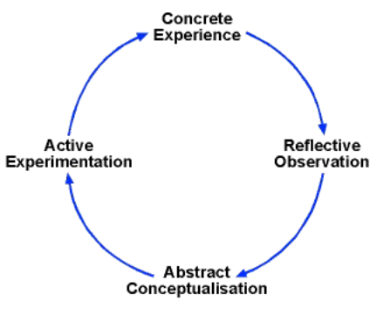
Figure 2 Kolb's Experiential Learning Cycle (Gibbs, 1988, p.15)
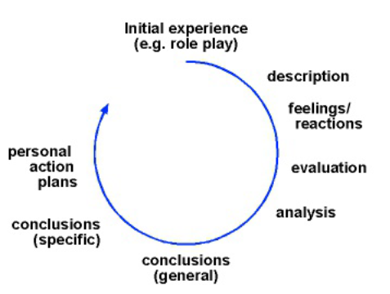
Figure 3 Gibbs Reflective Cycle (Gibbs, 1988, p.50)

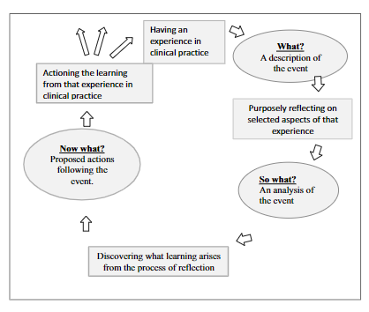
Figure 4 Driscoll's Reflective Framework (Mulryan-Kyne, 2020, p.509)
Effective and successful reflections require the practitioner to be skilled in the process and also possess the capacity for growth (Applebaum, 2014). In the context of teacher training, successful reflective practice can influence a teacher’s sense of self-identity and improve teacher quality (Suphasri and Chinokul, 2021) and is now generally considered crucial in the training of teachers (Rigney, Ferland and Dana, 2019; Suphasri and Chinokul, 2021). Culturally responsive reflection among teachers can contribute to elevating justice by prompting reflections along social, racial, economic, gender, and ability dimensions and allowing teacher to uncover and acknowledge biases (Rigney, Ferland and Dana, 2019).
York, Yamagata-Lynch and Smaldino (2016) recommend providing clear frameworks or such as guided reflections for adult online learners to practice and engage in effective reflection, to facilitate success in their online studies. Without stipulated guidelines in the Master of Arts in Voice Pedagogy program through the Voice Study Centre (VSC), affiliated with the University of Wales Trinity St. David (UWTSD), other than a requirement to include a “reflection” section, it is up to each student to determine the most suitable framework for their individual purpose and circumstance. In the context of this project, I identify the most with the papers on reflective practice for pre-service teachers and have elementary proficiency on reflection. Therefore, I believe that Driscoll’s model of reflection would be the most pragmatic and effective for me to follow.
What?
As a former aspiring opera singer, I have had extensive private training in classical voice and have expanded into other genres over the past decade. I currently perform informally and sing classical, sacred, jazz, pop, and folk repertoire. My primary profession for the past twenty years has been in language translation and translation instruction. Mid-pandemic, I found myself inspired to teach singing in order to share my passion with others. I felt ill-prepared to take this step because I did not attend conservatory or receive formal music training apart from basic, college-level music theory courses. I therefore enrolled in the M.A. Voice Pedagogy program at VSC and UWTSD to increase my knowledge base so that I am pedagogically prepared to teach singing. As a career development step, this is a common reason among adult learners for enrolling in graduate school programs (Almeda, 2014) while working full-time (O’Connor and Cordova, 2010).
During my own formative training years as a young adult in the early 1990s, I may have inadvertently assumed the attitudes against formal singing instruction for children and adolescents from my own singing teachers, who were active as professional singers and teachers during the mid- to late-20th century and may have espoused the rejection of teaching children, an attitude that was generally accepted at the time in the United States. Therefore, in preparing to work with a clientele that may include children and adolescents, I needed to supplement my existing knowledge base to include current research and recommendations for teaching singing to these populations.
I embarked on my research process to look for articles and books that I felt would answer my rather general inquiry. I believed that a straightforward search in the UWTSD library catalogue and the VSC library would yield the available and necessary resources, and I sought out additional mass-market books on the topic of teaching children and adolescents that were written for singing teachers. From reading the materials, I was able to gain a clearer sense of what could be implemented in the private studio setting when teaching children and adolescents, and I now have a good foundation of reliable resources to refer to when deciding on pedagogical practices for teaching singing to children and adolescents in the future.
One issue that the literature did not touch upon was the importance of safety in the private singing studio context. This issue was briefly discussed in a VSC voice pedagogy course conducted by Kerrie Obert in May 2023. When working with children and adolescents, Obert recommended recording sessions not only for pedagogical purposes, but also for both student and instructor safety. I was unsure how to formally include this in the assignment, but I believe the topic of child safety is important for all private singing teachers to keep in mind. I also believe that instructors working with children and adolescents should have some rudimentary knowledge of being trauma-informed and understand how to identify and detect indications of abuse. Laws vary in each region and country, and this becomes even murkier if lessons are conducted online, so private singing instructors should research whether they are categorized as legally mandated reporters in their area of residence. Beyond legal requirements, there is a moral aspect to this issue that each private singing teacher must be aware of, also.
So What?
For my research into this topic, I engaged in what I believed was the typical research process among graduate students (Blummer, Watulak and Kenton, 2012), including library and internet searches and, to an extent, following research trails found within the sources that were collected. However, tutor feedback rightly noted that this was not a sufficiently documented or rigorous process. What I lacked was a deep dive into the resources that I had found, by backward chaining and forward chaining the references. That is, I needed to also document and search for relevant sources referenced by a selected article as well as sources that cited a selected article. There were organic occurrences of this, as articles I read would cite the same foundational works. For example, Rutkowski (1990) was a frequently cited work, as were Gackle (1991; 2006; 2019) and Cooksey (1977), so I collected those works in my research. However, the process of referencing these from selected articles needed to be documented and described in the literature review portion to reflect true rigor. Furthermore, I needed to address grey literature and justify my selection of grey literature in the form of mass-market books. These were shortcomings in my literature review section that unfortunately could not be addressed due to time constraints largely arising from circumstances related to being an adult learner with full-time employment (O’Connor and Cordova, 2010; Shepherd and Mullins Nelson, 2012).
The articles and books I found for this project were ultimately enlightening and educational, and I believe that I am now much better prepared to work with children and adolescents than before I undertook this narrative review, even though the research process was much less systematic and rigorous than it should have been.
However, even with the satisfaction of having learned a great deal of pragmatic and actionable information, the intense process of studying and writing was accompanied by an immense weariness from not being able to practice learned information for the time being, since my current work is in an unrelated field. I believe this is similar to the sense of dissonance regarding lack of relevance in the academic coursework among adult graduate students with full-time jobs (O’Connor and Cordova, 2010). Although very relevant to my future intended practice, my newly gained knowledge cannot be utilized in my present work, and this lends a sense of futility to my studies, however unfounded they may be.
In terms of the project overall, I have joined an increasing number of motivated adults working full-time and studying part-time for professional advancement (O’Connor and Cordova, 2010). I faced a number of situational and dispositional issues, which were described in and confronted by the female adult learners in Shepherd and Mullins Nelson (2012). Specifically, my situational barriers comprised: the need to work full-time to sustain a single-income household in an area with extremely high cost of living; caring for two neurodivergent children as a divorced parent; separating from a partner with substance-dependency; and adjusting to reduced cognitive stamina due to long Covid and aging. These in turn led to my dispositional barrier in the form of a crisis in confidence and an increasing mental and emotional fatigue throughout this program’s modules. As a result of these issues, I was unable to adhere to my proposed schedule for researching and writing my assignment and portfolio. However, much like the subjects of O’Connor and Cordova (2010) and Shepherd and Mullins Nelson (2012), my passion for learning persists, as does my faith that the work put into completing this program will be worthwhile both professionally and personally. Phenomenologically, acknowledgement of the barriers faced by adult learners with full-time work who are in graduate programs is important, and institutional support and understanding of non-academic factors that can be barriers to learner perseverance can be helpful for learner success (Shepherd and Mullins Nelson, 2012). Therefore, I believe inclusion of these aspects in the reflection is indeed valid and relevant to discussions regarding the learning process.
Now What?
An inventory of what I have learned from this and previous modules will help me apply the lessons to my final module in this program and future learning experiences.
- The knowledge gained from each module is pragmatic and actionable, and this work is not futile. Even if I feel disheartened that I cannot apply what I learn in each module immediately due to my current full-time work in another field, I will be prepared to apply this knowledge when I do start teaching singing. This can commence as soon as I have completed this program and can devote time and energy to starting my private singing studio.
- Sustained motivation is crucial to this endeavor. To combat the potential demotivation from my existing dispositional and situational barriers, it may be helpful to consider motivation in terms of my future self (Leondari, Syngollitou and Kiosseoglou, 1998; Nurra and Oyserman, 2018). Proximal subgoals can help a learner stay focused and on task better than a distant final goal (Miller and Brickman, 2004). This means I should set better-defined milestones along the way to the end goal as a way to stay motivated throughout the duration of the upcoming module. This may require a different way of framing the timelines in my project schedule proposal. Rather than rough estimates by weeks, specific dates for each milestone may be more useful. Also, life happens: Work gets busy. Family members get sick. Everyday responsibilities abound. Priorities must shift as needed to handle life-related issues, but staying motivated and focused on the milestones and goals will be crucial.
- You are not alone. Module 5 is one of the only modules in which I submitted very rough, incomplete drafts for feedback, and even then, it was beyond the deadline for draft submission. Time-management issues resulting from work, life, and time zone issues prevented me from seeking input and feedback during my research and writing process for all of my modules. Feeling disheartened and embarrassed about my work made me feel that perhaps it would be best to just complete my projects without assistance: the thought of asking the preeminent VSC tutors to review my shoddy work made me avoid the tutorial process. This is not very conducive to effective learning. I should understand that the tutors are there to support my learning goals and that their feedback and advice are crucial to my reaching those goals, and are not intended to be personal indictments.
- There is a difference between study for practice and implementation and study for research publication. I am by disposition more suited to praxis than to academic research. I read more articles than I could include in my assignment because of time pressure and lack of mental energy, but the failure to include the materials doesn’t equal failure of absorbing the information therein. I may never be a published researcher or academician, but there is a place in all professions and fields for those who focus on being practitioners as well as those who focus on scholarship and research. Accepting my self-identity as practitioner will help me alleviate the perceived pressure of scholarship and publication, and will make it less daunting for me to complete my work in this program.
In this program, I have felt it necessary to set aside my academic standards time and again, just to make each deadline amidst all of my obligations. My output may not reflect the amount and quality of knowledge that I have gained, but I choose to focus on that gained knowledge and ability to update that knowledge through the research methods and source assessment strategies that I have gained in this program. This is because my duty in pursuing this study program is to my future students.
Ultimately, for this project, I achieved my proposed aims, objectives, and learning outcomes in this project, and I additionally have a solid understanding of what I will need to carry forward from this project to persevere and successfully complete module 6.

Part 2: Assignment

Teaching Singing to Children and Adolescents: Fundamentals and Considerations for Private Singing Teachers
For my studies with the Voice Study Centre (VSC), my areas of inquiry are selected in order to expand my teacher knowledge base, a concept described in the Comprehensive Voice Pedagogy Framework (CVPF) presented by Rollings Bigler et al. (2021) and detailed in my Module 1 paper (Pai, 2021). For this independent study project, I opted to explore the literature on teaching singing to children and adolescents. This is because teacher knowledge and teachers’ facility in implementing sound pedagogical approaches are incredibly important in the process of teaching young children to sing (Hedden, 2020). Throughout my training and performance experiences in classical voice and modern singing styles, I have lacked opportunities to work with pre-adult voices. Those who teach young singers in an instructional or performance-oriented setting should have “teaching ability and expertise that relates to children” (Brunssen, 2018, p.52), and this applies to working with adolescents, as well. As a private singing teacher, I wish to be prepared to work confidently with children and adolescents by equipping myself with that ability and expertise, and this project is an investigation into the fundamentals that singing teachers should master for this purpose. This project may also serve as a guidepost for others who wish to teach singing to children and adolescents or who may be uncertain of the wisdom of teaching singing to this population.
Prior to my readings of the literature pertinent to teaching singing to children and adolescents, I was hesitant about taking on the heavy responsibility of possible life-long impacts on students, particularly in light of my own experiences as an adult student and the lasting impressions made by my singing teachers throughout my training. I am based in the United States, where Phillips (2014) noted that the avoidance of formally teaching singing to children and adolescents appeared to have begun in the early 20th century. Whereas the instruction of vocal technique based on the bel canto tradition was incorporated into formal school curricula in the U.S. from the early 19th century to the early 20th century, there was a shift away from teaching children vocal technique and singing starting in the 1930’s, when the prevailing view was that vocal instruction in the school system had become too heavily focused on technique to the detriment of song-literature knowledge (Phillips, 2014). Furthermore, he noted that a concept had taken root by the 1950s that formal instruction was “dangerous to young voices” (p.50). Interestingly, Phillips argued for teaching children singing—focusing on pitch and rhythm accuracy and some fundamentals of voice technique, as opposed to teaching song literature without an emphasis on the elements of singing—as early as 1985 (Phillips, 1985).
A new perspective appeared to have taken shape around the turn of the new millennium. Edwin (1997) argued for the pedagogical approach of “vocal parenting” in encouraging the teaching of children and adolescents in the setting of the private voice studio. The exhortative tone of his article indicated the desire to convince fellow voice teachers to engage in teaching young singers, and he ends his article with: “…I sincerely hope more of my pedagogical colleagues will join me in this worthwhile endeavor” (Edwin, 1997, p.137). In November 2002, the American Academy of Teachers of Singing (AATS) had approved and issued an official statement in favor of teaching young singers, and this statement was in turn published in the Journal of Singing of the National Association of Teachers of Singing (Anon., 2003). There were numerous research papers investigating issues within the larger category of teaching young children how to sing, among which were works by Kenney (2009; 2011), Phillips, Williams and Edwin (2012), Hedden (2012)—which was itself a review of the research on teaching children singing—and Brenner and Strand (2013), all of which and more will be discussed in further detail below. Interestingly, the aforementioned entreaty by Phillips (2014) was published amidst many of these, as if attitudes against formal singing instruction for children (focused on the mechanics and process of singing, as opposed to instruction in children’s song literature) had remained entrenched even after the presentation of copious, supportive research. Perhaps this is because much of the research into teaching children singing has been in the context of school music classes rather than private voice lessons, and the teachers involved in these studies were by and large music teachers working in school settings rather than private voice or singing teachers, such that private teachers had less exposure to current research as a whole. Additionally, working outside of school systems, private teachers are typically not employer-mandated to pursue continuing education in the field and update their knowledge base, no matter how many years they’ve been teaching.
Regardless, since singing “is a learned behavior” (Kemp, 1985, as cited in Phillips, 2014, p.50 and Brunssen, 2018, p. 43; Kenney, 2011, p. 52), it would make sense for private singing teachers to include children and adolescents in their target population of students. In fact, Kenney (2011, p. 52) insists that the earlier children learn to sing, the better. Maerker Garner (2009, p.50) echoes this attitude in discussing the benefits of teaching audiation—defined by Edwin E. Gordon (as cited in Phillips, Williams and Edwin, 2012, p.3) as the foundational process leading to pitch discrimination skills—to children in the context of using singing and movement in music lessons. Smith (2006) is even more impassioned, insisting that singing is a “birthright” as much as it is a teachable skill (p.34). Williams (2019) frames singing instruction for children as a safety issue: proper vocal technique training provided by a competent teacher helps children avoid vocal injury from improper use of their voices and allows children to use their voices more efficiently (p.8–12).
Thus, reassured of the rationale for the endeavor of teaching children and adolescents, the private singing teacher should proceed by becoming familiar with the pertinent research into the relevant vocal characteristics of this population as well as the pedagogical methods for working with children and adolescents. In this way, the private singing teacher can be equipped with the knowledge and skills to be an effective instructor to children and adolescents, and be confident in having sufficiently supplemented her knowledge base in the context of the CVPF.
Fundamentals of the Child Voice and the Adolescent Voice
For the purposes of this paper and across most of the voice-related research cited, in the context of singing, children are defined as boys and girls from preschool until the onset of puberty (Hedden, 2012), and adolescents are defined as boys and girls in the midst of pubertal changes until physical maturation (Williams, 2019). Williams (2019) states that pubertal onset is typically around age 10 for girls and age 12.5 for boys. Phillips, Williams and Edwin (2012) say that adolescence is generally from the ages of 12 through 17, though variable in either direction. Tanner Staging is a medical reference for determining the stages of puberty, and as cited in a report from the World Health Organization (2010), the age range for Tanner Stage II—during which first pubertal changes occur—is age 8 through 15 for girls and age 10 through 15 for boys (World Health Organization, 2010). Age alone cannot accurately predict the vocal stage of an individual as affected by pubertal changes, as different stages of development may be found among children in the same age group (Welch, 2016). Whatever the student’s calendar age, private singing teachers should be mindful that the young singer can present as a child’s voice if pubertal changes have not begun and as an adolescent voice once puberty has begun and should proceed accordingly.
Children’s Voices
Vocal Apparatus Characteristics
In order to effectively teach singing to children, private singing teachers should understand the fundamentals of children’s voices, beginning with the vocal apparatus. Phillips, Williams and Edwin (2012) and Williams (2019) summarize the anatomical differences of the vocal apparatus in children, both boys and girls, compared to that of adults. Brunssen (2018) provides much greater detail regarding anatomical measurements of the vocal structures in children and adults. Their descriptions are summarized as follows: Much of the differences between the two populations is due to the proportional size differences between the child and full-grown adult. In children, the lungs are smaller, the vocal tract is shorter, and the larynx is smaller. Smaller lungs mean less vital lung capacity and correspondingly reduced phrase duration in children’s singing compared to adults: children’s lungs can’t hold as much air, so they can’t hold their sung notes as long as adults. The smaller larynx in children means that the vocal folds, found within the larynx, are correspondingly shorter as well as thinner and less-defined in tissue layers that constitute the vocal folds. Thus, the folds have less vibrational amplitude, meaning that child voices have limited dynamic range in terms of volume, and children’s attempts to increase volume tends to lead to intonation issues. In the child, the larynx is also situated higher in the vocal tract relative to the cervical vertebrae than in adults. This higher laryngeal position, combined with the shorter vocal tract, affects vocal timbre and restricts resonance. Furthermore, the cartilages of the child’s larynx are soft and unwieldy compared to the adult’s, leading to restrict pitch ranges and reduced agility in pitch changes. (Phillips, Williams and Edwin, 2012; Brunssen, 2018) Figure 5 and Figure 6 illustrate the differences between the child’s and adult’s vocal tract and larynx. In summary: due to these physiological differences in the child’s vocal apparatus, when compared to adults, the child sings with less volume, less agility, smaller pitch range, less richness, and shorter phrase durations (Phillips, Williams and Edwin, 2012; Williams, 2019).
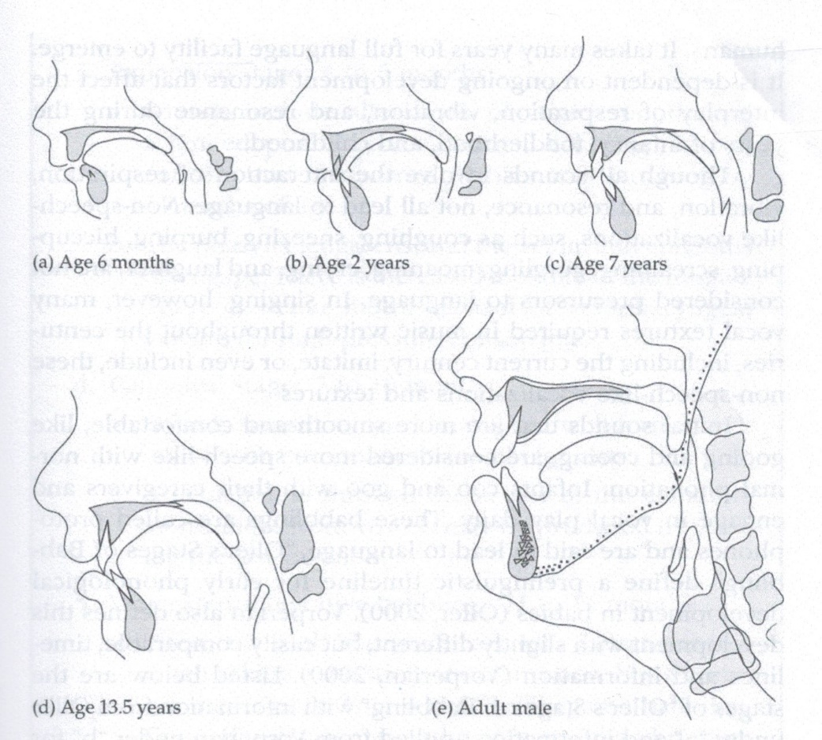
Figure 5 Vocal-tract development during growth (Brunssen, 2018, p.31)

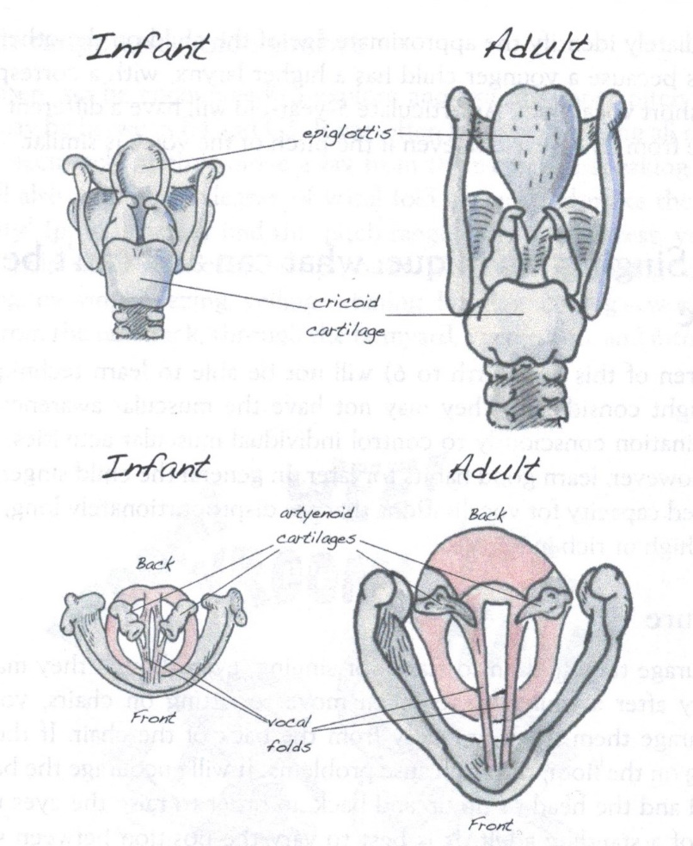
Figure 6 Infant vs. adult larynx (Williams, 2019, p.29)

Singing Characteristics
Apart from understanding the general physical characteristics of child’s voices as described above, it is also crucial for singing teachers to understand the ranges of the child’s voice as well as specifics regarding the practice of teaching singing to children.
As the act of learning any instrument requires the learner to first understand how to use the instrument and its fingerings to make the desired sounds, children must learn how to use the voice before learning how to produce voiced sounds that are accurate in note pattern (or melody), intonation, and rhythm (Rutkowski, 1990). Rutkowski’s (1990) Singing Voice Development Measure (SVDM) provides the singing teacher with categorizations of a child’s voice usage abilities. These can help the teacher determine the appropriate pedagogical approach, literature selections, and singing goals for each child.
Table 1 Rutkowski's Singing Voice Development Measure (SVDM) for Child Voices (Rutkowski, 1990, p.88)
1 | "Pre-singer" does not sing but chants the song text
2 | "Speaking range singer" sustains tones and exhibits some sensitivity to pitch but remains in the speaking voice range (usually A2 to C3)
3 | "Uncertain singer" wavers between speaking and singing voice, uses a limited range when in singing voice (usually up to F3)
4 | "Initial range singer" exhibits use of initial singing range (usually D3 to A3)
5 | "Singer" exhibits use of extended range (sings beyond the register lift: B♭3 and above)

Vocal Range
In the research literature, descriptions of vocal range in children vary. Studies cited by Hedden (2012) variously indicated ranges for preschool children, elementary-school-aged children, first- and sixth-grade children, children between 8 and 11 years of age and between 5 and 7 years of age, and 10-year-olds. Despite inconsistencies in the stated specific ranges of similar age groups, the general idea from these studies is that children’s vocal ranges are limited in their younger years to perhaps one octave or less, but that these ranges extend in the upper end as the children mature. Figure 8 (Welch, 2016, p.524) presents a visualization of Cooksey’s (2000, as cited in Welch, 2016) and Gackle’s (2019) typical ranges for male and female voices at each stage of development. It shows a significant overlap between the unchanged male and female voices, and shows the notes around C4 (middle C) as a consistent low end of the range. Phillips, Williams and Edwin (2012) state that a one-octave range from C4 to C5 would be expected of children in first grade if they have had formal vocal instruction.
Williams (2019) recommends that young children before the age of 6 be helped to differentiate their speaking voice from their singing voice by encouraging them to sing in their upper range, which she notes as between E4 and C5. From 8 to 11 years, the change in range is relatively small, from one to one-and-a-half scale steps lower in the low end to a half to a one scale step higher (Figure 7).
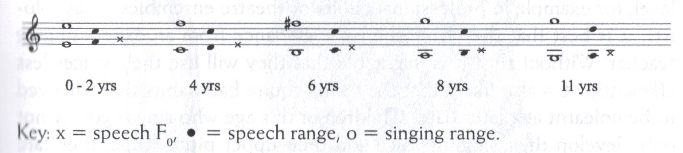
Figure 7 Pitch ranges of children (Williams, 2019, p.53)

Helen Kemp (1985, as cited in Brunssen, 2018) provides recommendations for children in the elementary grades as shown in Table 1. Despite the recommendations being listed by age, however, the singing teacher is advised to adapt to each individual student based on the student’s specific vocal stage and development.
Table 2 Kemp's recommendations for elementary-aged voices (Brunssen, 2018, pp.44–45)
5 to 6 years old | Become accustomed to the sensations of singing. Use head voice from D4 to B4
7 to 8 years old | Maintain the sense of a single register, without using chest voice. Range: B♭3 to F5
9 to 10 years old | Stay within tessitura (predominant range) of B♭3 to G5, avoid extended durations singing in extremes of range. Aim for purity of vowels and energy. No forced or strained vocal production
11 to 12 years old | Same as 9 to 10 years old, with pure vowels allowing for increased volumes. Diction becomes better and range expands. Recommend part singing for better fit with lower female voices. Tessitura is A♭3 to C6.

With the above recommendations on pitch range, singing teachers working with children can expect students to vocalize comfortably around C4 and within one octave above, keeping in mind the research showing that further upper range expansion comes from maturation and proceeding as is appropriate to each individual student’s stage of vocal development.
Intonation (Pitch Accuracy) and Tone Pattern Accuracy
Research into teaching children singing appears to revolve around using accuracy in pitch, rhythm, and melody as proxies for singing ability. Generally, such research has been conducted in the music classroom setting with generalist music teachers rather than with a singing-specialist teacher or in a private voice studio context (Kenney, 2011; Hedden, 2012; 2020; Akuno, 2015; Svec, 2018; Gallo, 2019). Their results are applicable in the private singing studio context, as well, and worth exploring.
Research concerning intonation, or accuracy of sung pitches, show inconsistent results as to whether boys and girls differ in this area. Phillips, Williams and Edwin (2012) and Williams (2019) state that girls are more likely to sing pitches accurately than boys, who tend to lag behind girls in development, although pitch accuracy problems decrease with age in both boys and girls. Welch (2016) also states that singing ability tends to develop and improve with age, but this was a finding among children who participated in a singing instruction curriculum (Welch, 2016; Williams, 2019). Contrarily, Hedden (2012) states that some studies show boys’ singing accuracy worsening with maturation, possibly due to sociological factors and exposure to media. Regardless of gender differences, her meta-analysis suggests that both solo singing and group singing can be ways to improve singing accuracy, with various studies arriving at different conclusions: some state that children demonstrated better pitch accuracy in solo singing, while others found better pitch accuracy among children in group singing (Hedden, 2012). Svec (2018) found that solo and small-group singing had more influence on improving singing accuracy than group singing as a class alone. Phillips, Williams and Edwin (2012) attribute accuracy issues to factors relating to teachers’ vocal instruction and to children’s inherent vocal range limitations and difficulty navigating register changes when moving into their upper range. In a separate meta-analysis, Svec (2018) concluded that singing instruction was effective in both boys and girls, and discouraged comparisons of singing accuracy and ability between genders. Instead, she encouraged the instruction of self-assessment, comparing one’s singing only to oneself and encouraging empowerment through awareness of vocal self-development. This is echoed by Gallo (2019), who found that singing accuracy may decrease over time into adulthood, and early singing instruction may give individuals the self-assessment skills to become vocally independent beyond childhood.
In terms of tone pattern accuracy, it is perhaps unsurprising that age appears to be a determining factor in the length of a tone pattern that children are able to match accurately. This suggests that the teaching of complete songs may be difficult among children of kindergarten age (Hedden, 2012) but may be more feasible with older children. Svec (2018) found that instruction in tonal patterns affected children’s singing ability, and the effects were greater when skilled instructors taught both pentatonic and diatonic tonal patterns rather than either pattern only.
Instructional Methods for Improving Accuracy
Hedden (2012) evaluated studies that investigated the effectiveness of various types of instruction on teaching singing skills to children and also assessed factors regarding the children themselves, such as typical vocal range for age, that may affect singing ability. For example, her analysis showed the varying effects of different types of models. Higher voices without vibrato (such as female voices, male falsetto voices, or child voices) were more accurately reproduced by students than lower, male voices until the typical age of student voice changes. A study with students in kindergarten through eighth grade showed that they had a tendency of mimicking the timbre and tone of vocal models. Similar conclusions were reached by Svec (2018), who additionally examined the method of vocal modeling, whether demonstrating solo, singing along with students, or both. Her analysis showed that the combination of solo demonstration and singing along was the most impactful, followed by singing along with students only. The least impactful of the three was solo demonstrations only. However, this conclusion was based on one study and its validity awaits further research. Additionally, Nichols and Lorah (2020) analyzed studies on solo versus doubled singing, and concluded that the outcomes of the studies were contextually specific to generalize. Regardless, the findings may encourage singing teachers to try demonstrating and singing along when teaching children, as a possible strategy in a repertoire of tools and not as a mandatory exercise; flexibility and adaptability may be more achievable in the context of a private singing lesson than in a music classroom. Excessive dependence on modeling may be undesirable when teaching adolescents, given the increased emphasis on individual vocal quality in developing voices as opposed to singing accuracy among children, as well as the possibility of students attempting to mimic their vocal model’s timbres and vocal qualities.
The effect of accompaniment in instruction was also studied. From the results of her meta-analysis, Hedden (2012) recommends limiting constant accompaniment in early elementary grades until children are vocally stable enough to not be distracted from their part by the accompaniment. This is reinforced by the findings of Svec (2018), who found that the differences in effectiveness between accompanied instruction and unaccompanied instruction were small, but enough to justify a similar recommendation.
In terms of the effects of text (the lyrics that are sung in the note patterns presented) on singing accuracy in children, the SVDM does not take into account the impact of text in its levels of singing accuracy. Williams (2019) states that young children before the age of 6 have an easier time matching pitch if there is no text. Hedden’s (2012) review of research into children’s singing showed that results as to whether text may impact pitch accuracy among preschool- and kindergarten-aged children were inconclusive. During these early childhood stages, children develop rapidly and experience dramatic changes in their motor abilities (Piek et al., 2012), and neuromotor abilities can vary greatly among same-aged individuals (Kakebeeke et al., 2018). Since the studies included in the meta-analysis by Hedden (2012) were conducted in populations that were in the midst of developmental changes with high levels of inter-individual variation, generalizations were difficult to reach.
Reference to formal voice technique instruction in children, such as breath management and voice quality, is glossed over in most of the resources referenced. This is perhaps due to the setting of most of the studies being the music classroom rather than the private studio, and generalist music teachers are not expected to be experts in voice or singing pedagogy. One of the exceptions is Phillips, Williams and Edwin (2012), who note the impacts on singing of traditional vocal pedagogy aspects such as motor coordination, breath management, physical alignment, and tongue tension. In the private voice context, it is assumed the voice teacher understands the fundamentals of teaching healthy breathing and phonation, and these apply no matter what the age of the student.
The above findings from research on teaching children singing in the group or music-classroom setting may also be useful for the private singing teacher for teaching singing one-on-one or in small groups. The private singing teacher should adapt to the child singer’s vocal age according to the Rutkowski (1990) SVDM and should take into account the lesson setting (whether individual lessons or small-group lessons) and individual goals, as per the AATS categories and singing goals (Anon., 2003) in Table 3. Additionally, the private singing teacher should take care not to teach children like mini-adults (Phillips, Williams and Edwin, 2012).
Table 3 AATS Child Singer Categories (Anon., 2003)
Category | Description
1 | Focus of singing experiences: Recreational and spiritual appreciation of singing.  Environment of singing experiences: home, school, places of worship
2 | Focus of singing experiences: Still recreational interest, but more intense interest. Private singing lessons may be sought for improvement of technique, exposure to repertoire  Environment of singing experiences: Choirs, choruses, solo opportunities in school, community, sporting events, etc.
3 | Focus of singing experiences: Pre-professional or professional public performance where all aspects of their singing and performance are subject to scrutiny. Highly demanding physically and emotionally. Private singing lessons are considered a must.  Environment of singing experiences: Opera and music theater, pageants, recording, film, radio, television, internet

Adolescent Voices
Akuno (2015) states that aural discrimination is the most important skill in a singing teacher. Although this statement was made in the context of teaching singing to children in classrooms, it is equally applicable in the private singing studio, and Brunssen (2018) echoes this sentiment, particularly for working with adolescent students. It is up to the teacher to aurally identify if a student has begun to undergo vocal changes due to maturation, and if so, what to identify what vocal stage of development a student is in and adapt accordingly. If an adolescent singer is seeking out private singing lessons, the singing teacher can assume that the student is an AATS Category 2 or 3 singer (Table 3). The following information will help guide the singing teacher in this process.
Male and female prepubertal voices seem similar in vocal quality (Gackle, 2019); as seen in the previous section on children’s voices, instruction at this stage tends to focus on teaching singing accuracy. Once pubertal changes begin to take effect, however, the singing teacher must consider the differences between changes in male adolescent voices and in female adolescent voices, not only in terms of timeframes but also in terms of changes in range and vocal qualities as tone, timbre, breathiness, and vibrato. Adolescence is a time of rapid growth and changes in the male and female body and vocal apparatus. By referring to the Tanner staging (Appendix 1) and Figure 8, which contains the ranges of adolescent male and female voices in their respective stages of development from Cooksey and Gackle as cited by Welch (2016), singing teachers can make informed pedagogical decisions for their adolescent students. Welch’s (2016) visualization in Figure 8 has ranges visualized along a piano keyboard. Figure 9 and Figure 10 list the Tanner Staging alongside Gackle’s female vocal stages and Cooksey’s male vocal stages, respectively. These three figures can serve as a quick reference for singing teachers when working with adolescent students. An important thing to keep in mind is that many vocal imperfections during adolescence are normal and not pathological, and to allow time and nature to take their course (Ballantyne and Brunssen, 2018).
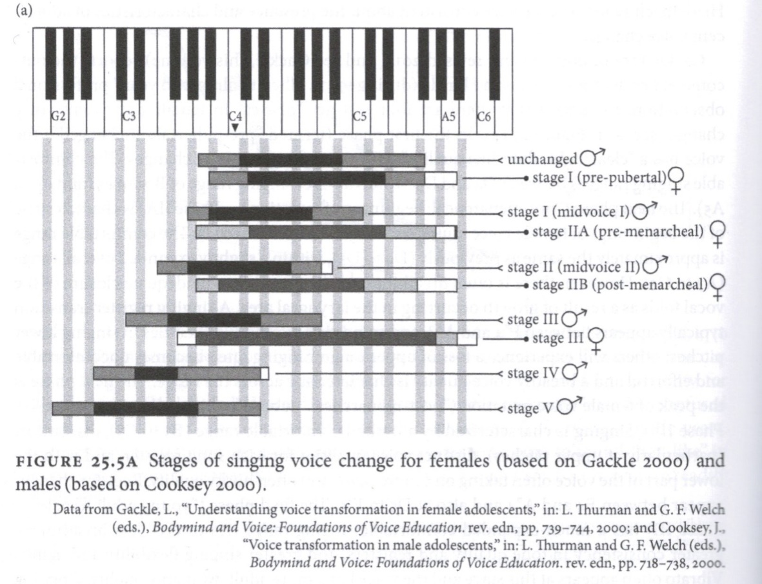
Figure 8 Voice change stages for females and males (Welch, 2016, p.524)

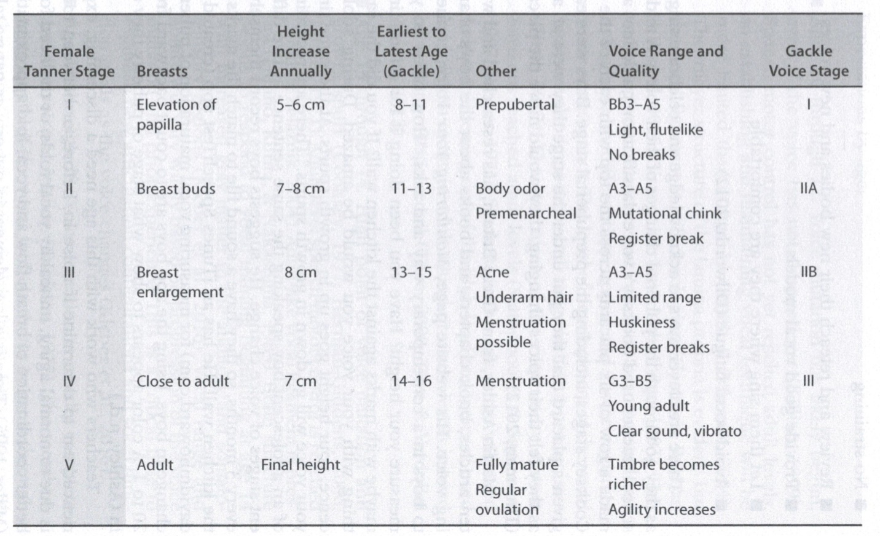
Figure 9 Female Tanner stages with corresponding Gackle voice stages (Ballantyne and Brunssen, 2018, p.79)

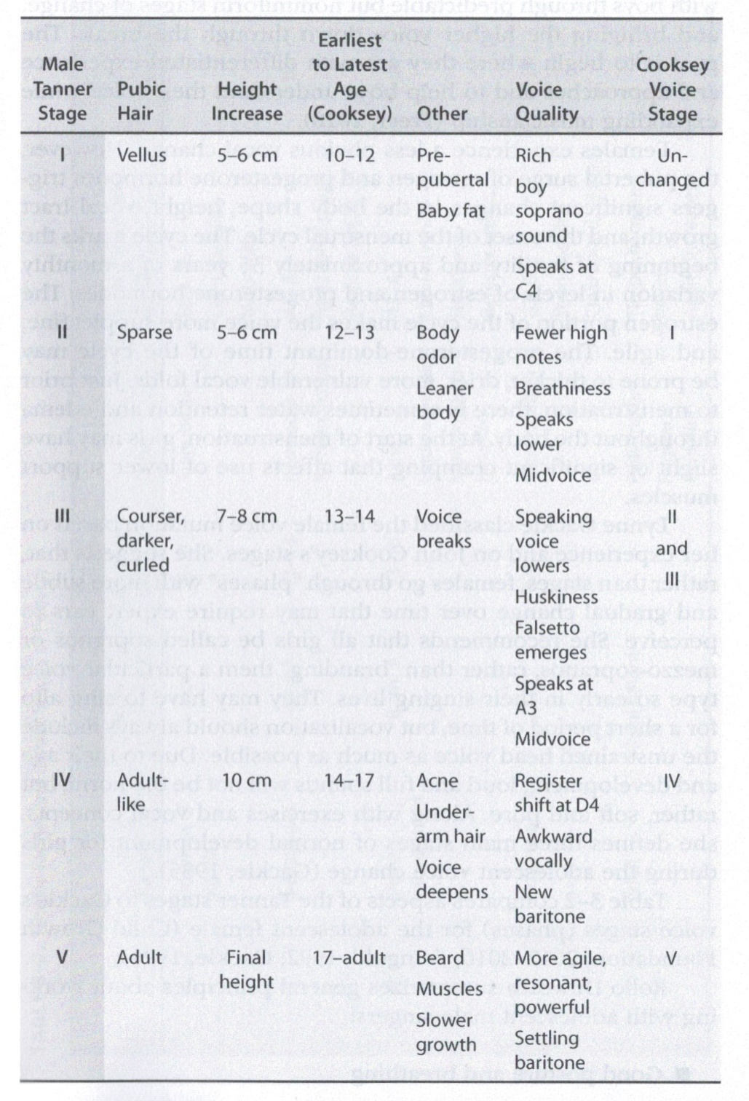
Figure 10 Male Tanner stages with corresponding Cooksey stages (Ballantyne and Brunssen, 2018, p.77)
Generally speaking, voice changes in adolescent girls are not as pronounced as in adolescent boys, mostly due to anatomy. Between pre-puberty and adulthood, the female vocal apparatus does not change in size as dramatically as the male vocal apparatus. The differences between female adolescent vocal stages and changes in range are consequently more subtle than for adolescent males (Ballantyne and Brunssen, 2018; Gackle, 2019). In adolescent males, the voice range moves lower, corresponding to the increase in vocal tract length and laryngeal size that occurs as the boys mature (Welch, 2016). For practical application in the private singing studio, Ballantyne and Brunssen (2018) comprehensively present issues pertaining to teaching the adolescent voice, both male and female. They discuss vocal pedagogy considerations of voice quality and vocal production in adolescents, and also suggest techniques and exercises to promote healthy singing and provide private singing teachers with a solid overview of issues pertaining to the developing adolescent voice.
In addition to voice pedagogy specifics, it is important to keep the experiences and self-identity of young singers in mind. Yarnall (2006) identified five stages of psychological development that corresponded to the vocal development stages among adolescents, and these can inform the private singing teacher’s practice and focus for each student, depending on their sense of self-esteem as relating to these stages (Table 4). Also, since singer self-esteem and confidence affect the physical instrument in terms of posture and its consequent impacts on breath management, singer psychology can have significant effects on vocal production (Yarnall, 2006), so the private singing teacher should not neglect the adolescent student’s psychological state.
Table 4 Stages of Voice and Psychology in Boys and Girls (Adapted from Yarnall, 2006)
First Stage | Age 11–12 | Girls: confident, wide vocal range that is comfortable throughout. Good breathing but not too deep, good projection and resonance until the end of this stage. Boy/girl vocal quality differences due to training instead of anatomical differences in this stage.
Second Stage | Age 12–13 | Instrument is reliable, singing experience is positive. Breathiness may emerge in some singers due to anatomy and maturation.
Third Stage | Age 13–14 | Vocal fold changes cause airiness in tone of most singers. Some do not experience this airiness and continue to have small, flute-like sound. Belting to overcome these issues is tempting but ill-advised because this stage of vocal growth is delicate. Students may become demotivated because of vocal changes. Psychological aspects of singing, such as self-esteem and confidence, are crucial to be aware of in this stage.
Fourth Stage | Age 14–15 | Singers’ voices develop more color, and developing breath management abilities allow better vocal control. Girls are confident in this stage, but boys can be very frustrated by their reduced vocal range and control issues. Singers’ sense of agency over their voices begins to develop.
Fifth Stage | Age 16–17 | Boys start becoming more comfortable in their baritone range. Both boys and girls develop more color in their voices. Some boys feel they have their child voices back, just one octave lower. Voices don’t fully develop and settle until mid-twenties, so avoid assigning voice types at this stage.

Summary Pedagogical Considerations
Teachers who work with adult voices must adapt pedagogy for adolescent voices by paying attention to adolescent ranges of females and males, stages and phases of vocal changes, chest-voice vs head-voice dominant styles, and age-appropriate styles and repertoire (Phillips, Williams and Edwin, 2012). Adolescents, particularly as their voices mature, can begin to take on more adult-like singing tasks and expectations. Singing teachers can help children and adolescents develop their singing skills and vocal quality regardless of age, as long as the singing tasks given by the teachers are appropriate for their vocal stage (Welch, 2016). A common theme among the literature is the importance of vocal play in teaching both children and adolescents (Phillips, 1985; Yarnall, 2006; Phillips, Williams and Edwin, 2012; Welch, 2016), so the private singing teacher should remember also to keep singing activities engaging and fun for their students.

References
Akuno, E.A., 2015. The Singing Teacher’s Role in Educating Children’s Abilities, Sensibilities and Sensitivities. British Journal of Music Education, 32(3), pp.299–313. https://doi.org/10.1017/S0265051715000364.
Almeda, J. V, 2014. GRADUATE STUDENTS’ LEARNING EXPERIENCES.
Anon. 2003. NATS Visits AATS. Journal of Singing, [online] 59, pp.377–378. Available at: <https://www.americanacademyofteachersofsinging.org/wp-content/uploads/2020/08/43-Teaching-Children-to-Sing-2003.pdf> [Accessed 18 April 2024].
Anon. 2024a. Jenevora Williams Profile. [online] Available at: <https://vocalpedagogy.com/vocal-pedagogue/jenevorawilliams/> [Accessed 29 April 2024].
Anon. 2024b. Karen Brunssen Profile. [online] Available at: <https://www.music.northwestern.edu/faculty/profile/karen-brunssen> [Accessed 29 April 2024].
Applebaum, L., 2014. From Whining to Wondering: Reflective Journaling With Preservice Educators. Journal of Jewish Education, 80(1), pp.5–23. https://doi.org/10.1080/15244113.2014.880140.
Ballantyne, C. and Brunssen, K., 2018. The Adolescent Years. In: The Evolving Singing Voice. pp.61–138.
Baumeister, R.F. and Leary, M.R., 1997. Writing narrative literature reviews. Review of General Psychology, 1(3), pp.311–320. https://doi.org/10.1037/1089-2680.1.3.311.
Blummer, B., Watulak, S.L. and Kenton, J., 2012. The Research Experience for Education Graduate Students: A Phenomenographic Study. Internet Reference Services Quarterly, 17(3–4), pp.117–146. https://doi.org/10.1080/10875301.2012.747462.
Brenner, B. and Strand, K., 2013. A case study of teaching musical expression to young performers. Journal of Research in Music Education, 61(1), pp.80–96. https://doi.org/10.1177/0022429412474826.
Brunssen, K., 2018. The Evolving Singing Voice. San Diego, CA: Plural Publishing.
Cohen, L., Manion, L. and Morrison, K., 2017. Research Methods in Education. 8th ed. Eighth edition. | New York: Routledge, 2018.: Routledge.
Cooksey, J.M., 1977. The Development of a Contemporary, Eclectic Theory For The Training And Cultivation of The Junior High School Male Changing Voice: PART I: EXISTING THEORIES. Source: The Choral Journal.
Decoster, W., Ghesquiere, S. and Van Steenberge, S., 2008. Great talent, excellent voices - No problem for pubertal girls? Logopedics Phoniatrics Vocology, 33(2), pp.104–112. https://doi.org/10.1080/14015430802015498.
Dewey, J., 1933. How we think: a restatement of the relation of reflective thinking to the educative process. Chicago, IL: Henry Regnery Co.
Edwin, R., 1997. The Three Ages of Voice: The Singing Teacher as Vocal Parent. (2), pp.135–137.
Gackle, L., 1991. The Adolescent Female Voice: Characteristics of Change and Stages of Development. Source: The Choral Journal.
Gackle, L., 2006. Finding Ophelia’s Voice: The Female Voice During Adolescence. Source: The Choral Journal.
Gackle, L., 2019. Adolescent Girls’ Singing Development. In: The Oxford Handbook of Singing. Oxford University Press. pp.550–570. https://doi.org/10.1093/oxfordhb/9780199660773.013.22.
Gallo, D.J., 2019. Formative assessment practices and children’s singing accuracy: A mixed methods inquiry. International Journal of Music Education, 37(4), pp.593–607. https://doi.org/10.1177/0255761419852172.
Gibbs, Graham., 1988. Learning by doing : a guide to teaching and learning methods. 2013th ed. Oxford: Oxford Brookes University.
Green, B.N., Johnson, C.D. and Adams, A., 2006. Writing narrative literature reviews for peer-reviewed journals: secrets of the trade. Journal of Chiropractic Medicine, 5(3), pp.101–117.
Habib, H., 2017. A STUDY OF REFLECTIVE PRACTICE AND ITS ROLE FOR TEACHERS. [online] Available at: <www.ijcrt.org>.
Hedden, D., 2012. An Overview of Existing Research About Children’s Singing and the Implications for Teaching Children to Sing. National Association for Music Education, 30(2), pp.52–62.
Hedden, D.G., 2020. Lessons from Lithuania: Teacher beliefs and behaviors in teaching young children to sing. International Journal of Music Education, 38(4), pp.593–612. https://doi.org/10.1177/0255761419888015.
Helyer, R., 2015. Learning through reflection: the critical role of reflection in work-based learning (WBL). Journal of Work-Applied Management, 7(1), pp.15–27. https://doi.org/10.1108/JWAM-10-2015-003.
Howard, D.M., Williams, J. and Herbst, C.T., 2014. ‘ring’ in the solo child singing voice. Journal of Voice, 28(2), pp.161–169. https://doi.org/10.1016/j.jvoice.2013.09.001.
Jahan, N., Naveed, S., Zeshan, M. and Tahir, M.A., 2016. How to Conduct a Systematic Review: A Narrative Literature Review. Cureus, 8(11). https://doi.org/10.7759/cureus.864.
Kakebeeke, T.H., Knaier, E., Chaouch, A., Caflisch, J., Rousson, V., Largo, R.H. and Jenni, O.G., 2018. Neuromotor development in children. Part 4: new norms from 3 to 18 years. Developmental Medicine and Child Neurology, 60(8), pp.810–819. https://doi.org/10.1111/dmcn.13793.
Kenney, S., 2009. Brain compatible music teaching. General Music Today, 23(1), pp.24–26.
Kenney, S., 2011. Teaching Young Children How to Sing: One Schools Experience. General Music Today, 24(2), pp.52–56.
Kolb, D.A., 1984. Experiential Learning: Experience as the Source of Learning and Development.
Leavy, P., 2017. Research Design. New York: The Guildford Press.
Leondari, A., Syngollitou, E. and Kiosseoglou, G., 1998. Academic achievement, motivation and future selves. Educational Studies, 24(2), pp.153–163. https://doi.org/10.1080/0305569980240202.
Liao, M.Y. and Davidson, J.W., 2007. The use of gesture techniques in children’s singing. International Journal of Music Education, 25(1), pp.82–94. https://doi.org/10.1177/0255761407074894.
Liao, M.Y. and Davidson, J.W., 2016. The effects of gesture and movement training on the intonation of children’s singing in vocal warm-up sessions. International Journal of Music Education, 34(1), pp.4–18. https://doi.org/10.1177/0255761415614798.
Maerker Garner, A., 2009. Singing and Moving: Teaching Strategies for Audiation in Children. Music Educators Journal, [online] 95(4), pp.46–50. https://doi.org/10.1177/0027432109335550.
McPherson, G.E. ed., 2016. The Child As Musician. Oxford: Oxford University Press.
Mengist, W., Soromessa, T. and Legese, G., 2020. Method for conducting systematic literature review and meta-analysis for environmental science research. MethodsX, [online] 7, p.100777. https://doi.org/10.1016/j.mex.2019.100777.
Mertens, D.M., 2024. Research and Evaluation in Education and Psychology: Integrating Diversity With Quantitative, Qualitative, and Mixed Methods. 6th ed.
Miller, R.B. and Brickman, S.J., 2004. A Model of Future-Oriented Motivation and Self-Regulation. Educational Psychology Review, 16(1), pp.9–33.
Mulryan-Kyne, C., 2020. Supporting reflection and reflective practice in an initial teacher education programme: an exploratory study. European Journal of Teacher Education, pp.1–18. https://doi.org/10.1080/02619768.2020.1793946.
Nichols, B.E. and Lorah, J., 2020. Does doubled singing increase children’s accuracy? A re-examination of previous findings. Psychology of Music, 48(2), pp.315–324. https://doi.org/10.1177/0305735618799171.
Nikolaeva, E. V., 2019. “ONE-VOICE COLLECTIVE-DISTRIBUTED SINGING” AS A NECESSARY ATTRIBUTE OF THE INITIAL STAGES OF TEACHING CHILDREN OF PRIMARY SCHOOL AGE CHORAL SINGING. Musical Art and Education, 7(3), pp.163–177. https://doi.org/10.31862/2309-1428-2019-7-3-163-177.
Nurra, C. and Oyserman, D., 2018. From future self to current action: An identity-based motivation perspective. Self and Identity, 17(3), pp.343–364. https://doi.org/10.1080/15298868.2017.1375003.
O’Connor, B.N. and Cordova, R., 2010. Learning: The Experiences of Adults Who Work Full-Time While Attending Graduate School Part-Time. Journal of Education for Business, 85(6), pp.359–368. https://doi.org/10.1080/08832320903449618.
Pai, P., 2021. Examining modern voice pedagogy literature and degree programs: the training of 21st-Century voice teachers. Voice Study Centre.
Phillips, K.H., 1985. Training the Child Singer. Source: Music Educators Journal, 72(4), pp.19–22.
Phillips, K.H., 2014. Another Perspective: Every Child a Singer. Music Educators Journal, 100(3), pp.49–51. https://doi.org/10.1177/0027432113516511.
Phillips, K.H., Williams, J. and Edwin, R., 2012. The Young Singer. [online] Oxford University Press. https://doi.org/10.1093/oxfordhb/9780199730810.013.0036.
Piek, J.P., Hands, B., Licari, M.K. and Piek, J., 2012. Assessment of Motor Functioning in the Preschool Period. Neuropsychology Review, 22, pp.402–413.
Piper, R.J., 2013. How to write a systematic literature review: a guide for medical students. National AMR, [online] 1(2), pp.1–8. Available at: <http://cures.cardiff.ac.uk/files/2014/10/NSAMR-Systematic-Review.pdf%0Acures.cardiff.ac.uk/files/2014/.../NSAMR-Systematic-Review.pdf>.
Rigney, J., Ferland, T. and Dana, N.F., 2019. Understanding Teacher Reflectivity in Contemporary Times: A (Re)Review of the Literature. New Educator, 15(4), pp.305–326. https://doi.org/10.1080/1547688X.2019.1631923.
Rodgers, C., 2002. Defining Reflection: Another Look at John Dewey and Reflective Thinking. Teachers College Record, 104(4), pp.842–866.
Rodina, O.A., 2021. Problem of Voice Register Adjustment in 5 to 7-Year-Old Children. Musical Art and Education, 9(3), pp.171–182. https://doi.org/10.31862/2309-1428-2021-9-3-171-182.
Rollings Bigler, A., Osborne, K., Ballantyne, C., Horne, B., James, K., Manternach, B., Redman, Y. and Treinkman, M., 2021. Voice Pedagogy for the 21st Century: The Summation of Two Summits. Journal of Singing, [online] 78(1), pp.11–28. https://doi.org/10.53830/CXBG6722.
Rutkowski, J., 1990. The Measurement and Evaluation of Children’s Singing Voice Development. The Quarterly, 1(1 and 2), pp.81–95.
Schon, D.A., 1983. The Reflective Practitioner. New York: Basic Books.
Sergeant, D., 2020. The Developing Voice. In: G.E. Welch, D.M. Howard and J. Nix, eds. The Oxford Handbook of Singing. Oxford: Oxford University Press. pp.189–223.
Shepherd, J. and Mullins Nelson, B., 2012. Balancing Act: A Phenomenological Study of Female Adult Learners Who Successfully Persisted in Graduate Studies. The Qualitative Report, [online] 17, pp.1–21. Available at: <http://www.nova.edu/ssss/QR/QR17/shepherd.pdf>.
Smith, J., 2006. Every Child a Singer: Techniques for Assisting Developing Singers. Music Educators Journal, [online] 93(2), pp.28–34. Available at: <http://www.jstor.org/stable/3878468> [Accessed 18 April 2024].
Snyder, H., 2019. Literature review as a research methodology: An overview and guidelines. Journal of Business Research, [online] 104(July), pp.333–339. https://doi.org/10.1016/j.jbusres.2019.07.039.
Suphasri, P. and Chinokul, S., 2021. Reflective Practice in Teacher Education: Issues, Challenges, and Considerations. PASSA Journal of Language Teaching and Learning, 62(July-December), pp.236–264.
Svec, C.L., 2018. The effects of instruction on the singing ability of children ages 5 to 11: A meta-analysis. Psychology of Music, 46(3), pp.326–339. https://doi.org/10.1177/0305735617709920.
Walliman, N., 2020. Your Research Project. Fourth ed. Los Angeles: SAGE Publications, Ltd.
Welch, G.F., 2016. Singing and Vocal Development. In: G.F. Welch, D.M. Howard and J. Nix, eds. The Oxford Handbook of Singing. Oxford: Oxford University Press. pp.509–532.
Welch, G.F., Howard, D.M. and Nix, J. eds., 2020. The Oxford Handbook of Singing. Oxford: Oxford University Press.
White, C.D. and White, D.K., 2001. Commonsense Training for Changing Male Voices. Music Educators Journal, (May), pp.39–53.
Williams, J., 2019. Teaching Singing to Children and Young Adults. 2nd ed. Compton Publishing Ltd.
Williams, J. and Harrison, S., 2019. Boys’ Singing Voice Change in Adolescence. In: The Oxford Handbook of Singing. Oxford University Press. pp.532–550. https://doi.org/10.1093/oxfordhb/9780199660773.013.44.
World Health Organization, 2010. ANNEX H, SEXUAL MATURITY RATING (TANNER STAGING) IN ADOLESCENTS. [online] Antiretroviral Therapy for HIV Infection in Infants and Children: Towards Universal Access: Recommendations for a Public Health Approach: 2010 Revision. Available at: <https://www.ncbi.nlm.nih.gov/books/NBK138588/table/annexh.t1/?report=objectonly> [Accessed 18 April 2024].
Yarnall, S., 2006. Vocal and Aural Perceptions of Young Singers Aged Ten to Twenty-One. Journal of Singing, 63(1), pp.81–85.
York, C.S., Yamagata-Lynch, L.C. and Smaldino, S.E., 2016. Adult reflection in a graduate-level online distance education course. Reflective Practice, 17(1), pp.40–58. https://doi.org/10.1080/14623943.2015.1123686.

Appendix 1 Tanner stages of male and female pubertal changes (World Health Organization, 2010)
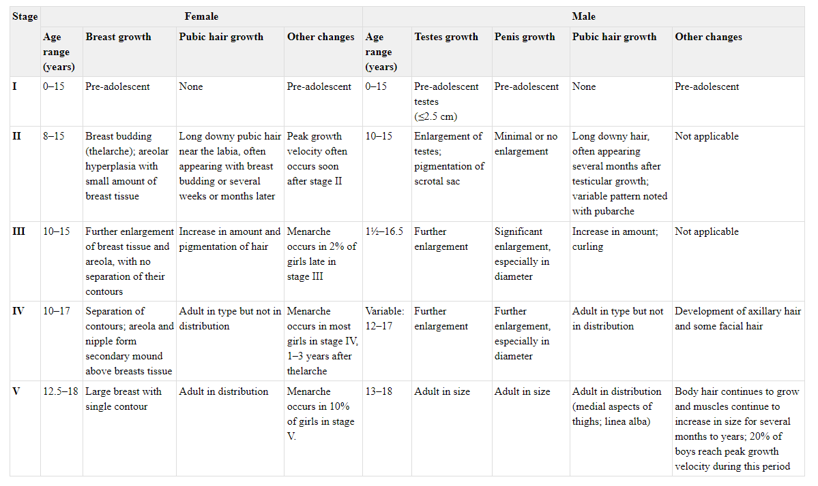

Appendix 2 Research Terms and Results
Search Source | Terms | # of Results Returned | Exclude Results About | Harvest | Stopping Point
UWTSD library site | teaching child singing, all resources | 894 | storytelling, religion, medical intervention, sociology, singing as tool to improve learning outcomes in other academic areas | see Sheet "Harvest 1" | Stopped reviewing results after 120, when relevance of entries declined and no harvests were found after the last 20 entries

Hedden, D. (2012) ‘An Overview of Existing Research About Children’s Singing and the Implications for Teaching Children to Sing’, Update : applications of research in music education, 30(2), pp. 52–62. Available at: https://doi.org/10.1177/8755123312438516.
Elena V. Nikolaeva (2019) ‘“One-Voice Collective-Distributed Singing” as a Necessary Attribute of the Initial Stages of Teaching Children of Primary School Age Choral Singing’, Музыкальное искусство и образование, 7(3), pp. 163–177. Available at: https://doi.org/10.31862/2309-1428-2019-7-3-163-177.
McPherson, G. (ed.) (2016) The child as musician : a handbook of musical development. Second edition. New York: Oxford University Press.
Garner, A.M. (2009) ‘Singing and Moving: Teaching Strategies for Audiation in Children’, Music educators journal, 95(4), pp. 46–50. Available at: https://doi.org/10.1177/0027432109335550.
Howard, D.M., Williams, J. and Herbst, C.T. (2014) ‘“Ring” in the Solo Child Singing Voice’, Journal of voice, 28(2), pp. 161–169. Available at: https://doi.org/10.1016/j.jvoice.2013.09.001.
‘NATS Visits AATS [Teaching Children to Sing]’ (2003) Journal of singing, 59(5), pp. 377–378.
Green, C.W. (1969) An Investigation of Essential Factors Related to the Teaching of Sight Singing to Elementary Children. North Texas State University.
Oksana A. Rodina (2021) ‘Problem of Voice Register Adjustment in 5 to 7-Year-Old Children’, Музыкальное искусство и образование, 9(3), pp. 171–182. Available at: https://doi.org/10.31862/2309-1428-2021-9-3-171-182.
Phillips, K.H. (2014) ‘Another Perspective: Every Child a Singer’, Music educators journal, 100(3), pp. 49–51. Available at: https://doi.org/10.1177/0027432113516511.
Hedden, D.G. (2020) ‘Lessons from Lithuania: Teacher beliefs and behaviors in teaching young children to sing’, International journal of music education, 38(4), pp. 593–612. Available at: https://doi.org/10.1177/0255761419888015.
Liao, M.-Y. and Davidson, J.W. (2007) ‘The use of gesture techniques in children’s singing’, International journal of music education, 25(1), pp. 82–94. Available at: https://doi.org/10.1177/0255761407074894.
Kenney, S. (2011) ‘Teaching Young Children How to Sing: One School’s Experience’, General music today, 24(2), pp. 52–56. Available at: https://doi.org/10.1177/1048371310385803.
Kenney, S. (2009) ‘Brain-Compatible Music Teaching’, General music today, 23(1), pp. 24–26. Available at: https://doi.org/10.1177/1048371309342700.
Svec, C.L. (2018) ‘The effects of instruction on the singing ability of children ages 5 to 11: A meta-analysis’, Psychology of music, 46(3), pp. 326–339. Available at: https://doi.org/10.1177/0305735617709920.
Gallo, D.J. (2019) ‘Formative assessment practices and children’s singing accuracy: A mixed methods inquiry’, International journal of music education, 37(4), pp. 593–607. Available at: https://doi.org/10.1177/0255761419852172.
Edwin, R. (1997) ‘The singing teacher as vocal parent’, Journal of voice, 11(2), pp. 135–137. Available at: https://doi.org/10.1016/S0892-1997(97)80068-9.
Liao, M.-Y. and Davidson, J.W. (2016) ‘The effects of gesture and movement training on the intonation of children’s singing in vocal warm-up sessions’, International journal of music education, 34(1), pp. 4–18. Available at: https://doi.org/10.1177/0255761415614798.
Greschner, D. (2019) ‘The Evolving Singing Voice: Changes Across the Lifespan’, Journal of singing, 75(5), pp. 613–615.
Robinson, K.M. (2018) ‘Improving Children’s Singing Through the Song Teaching Process’, A Fine FACTA, 16(1), pp. 29–32.
Simeon, J.J.C. and Ku, A.C.M. (2015) ‘Effects of Music Instruction With Bamboo Xylophone Accompaniment on Singing Achievement Among Second-Grade Children’, Update : applications of research in music education, 33(2), pp. 13–19. Available at: https://doi.org/10.1177/8755123314540660.
Akuno, E.A. (2015) ‘The Singing Teacher’s Role in Educating Children’s Abilities, Sensibilities and Sensitivities’, British journal of music education, 32(3), pp. 299–313. Available at: https://doi.org/10.1017/S0265051715000364.
Brenner, B. and Strand, K. (2013) ‘A Case Study of Teaching Musical Expression to Young Performers’, Journal of research in music education, 61(1), pp. 80–96. Available at: https://doi.org/10.1177/0022429412474826.

Rutkowski uses C3 to denote middle C, which is C4 in scientific pitch notation. Reference to the SDVM’s notes and ranges should take this into account.

