Call:-
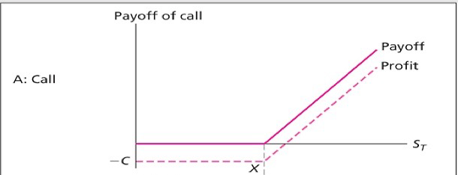
X = 11.50
C = 0.40
St = 19
Put:-
X =11.50
P = 0.20
St =8.80
Straddle:-
X = 11.50
P = 0.20
C = 0.40
(P+C)= 0.60
X-P-C = 10.90

