Mustafa Nassir Student No: 1708461

Advanced Web Development
Advanced Web

- 

RESULT

School of Applied Computing ASSIGNMENT SPECIFICATION

Student name: | Mustafa Nassir | Student P number: | 1708461
Programme: | Web Development
Lecturer: | Michael Dacey | Internal Verifier: | Gaynor Thomas
Assignment Title: | Advanced Web, Part 2
Hand Out Date: |  | Submission deadline: | 26/01/18
Referencing: | In the main body of your submission you must give credit to authors on whose research your work is based. Append to your submission a reference list that indicates the books, articles, etc. that you have read or quoted in order to complete this assignment (e.g. for books: surname of author and initials, year of publication, title of book, edition, publisher: place of publication).
Disclosure: | I declare that this assignment is all my own work and that I have acknowledged all materials used from the published or unpublished works of other people. All references have been duly cited.
Student’s Signature: | Hardcopy assignments will not be accepted without a signature here  Mustafa Nassir | Date: | 19/01/18
Late submission will result in a late penalty mark, as follows:
Up to one week late, maximum mark of 40% for first attempts. No late submission for resit work.
(Academic Quality Handbook 2017/18 7.5 (5))
Only the Extenuating Circumstances Committee may grant an extension.

Learning Outcomes tested
(from module syllabus)
Develop a systematic understanding of the syntax, semantics, concepts and principles of web programming for complex web applications
Deploy web programming techniques, design patterns, frameworks and/or application platforms
Critically evaluate the techniques and technology used in the development of web applications

Part A (Understanding)
Investigate the Use of Design Patterns in the Development of Web Application and Provide PHP Examples
In the last two decades, one may observe a steadfast increase in the number of users surfing the web. Such an increase has led to a greater demand for web application developers, hence the need to develop reusable programs and constructs. Such requirement has necessitated the reuse of already existing software aspects to accelerate the process of software and application development. Al-Ahmad (2006, p. 155) notes that the two common reuse forms are object-oriented and component-oriented paradigms. The introduction of design patterns and software development methodologies that are pattern-oriented has made design reuse possible. Previous scholars have depicted that most software design predicaments are repetitively solved instead of reusing already existing code.
According to Paikens and Arnicans (2008, p. 54), design patterns represent hypothetical material that is collected by experts with an aim to determine the principles for use in attaining a solution to a given problem. There exist many design patterns applied in web application development. Current design patterns include abstract, factory, application controller, model view controller, model view presenter, model-view-view-model, transform view, table data gateway, strategy, visitor, and view helper among many others. Different design patterns are applicable for different development frameworks. This section discusses strategy and factory design patterns as used in structuring web application codes.
Strategy
The strategy pattern encapsulates groups of algorithms thereby allowing classes responsible for instantiating specific algorithms to gain knowledge of actual implementation. The strategy pattern exists in various variations. The PHP snippet below depicts a family of algorithms as presented in the strategy design pattern using both a serialized array and JSON for encapsulation purposes. Encapsulation makes the code readable and enables other developers extend it by adding new types of output without altering the client code.
<?php
//Begin family
interface OutputModule
{
public function load();
}
class SerializedArrayOutputModule implements OutputModule
{
public function load()
{
return serialize($anarrayOfData);
}
}
class JsonStringOutputModule implements OutputModule
{
public function load()
{
return json_encode($arrayOfData);
}
}
class ArrayOutputModule implements OutputModule
{
public function load()
{
return $arrayOfData;
}
}
//end family
?>
Each concrete class executes the OutputModule. The purpose of the pattern is to give an effortless convention to be respected by all existing implementations. The second purpose is that through the use of a common interface, a developer is able to use a TypeHinting to enable the client utilize behaviors of correct type of the OutputModule. The snippet below shows how a client class utilizes and sets an algorithm at execution.
<?php
class ClientImplementer
{
private $output;

public function setOutput(OutputModule $outputModuleType)
{
$this->output = $outputModuleType;
}

public function loadOutput()
{
return $this->output->load();
}
}
?>
In the above snippet, the client sets a private property "output" that has to be set at runtime using the type OutputModule. The OutputModule calls the loadOutput() method that then calls the load() method of the concrete class. A sample snippet to create an array or JSON using the above strategy is presented below.
<?php
$client = new ClientImplementer ();
// To get an array
$client->setOutput(new ArrayOutputModule());
$data = $client->loadOutput();

// To get JSON
$client->setOutput(new JsonStringOutputModule());
$data = $client->loadOutput();
?>
Factory
Factory is a design pattern greatly applied in object-oriented paradigm to represent a class or object for creating other objects. Consider the PhP snippet below representing a class created using the factory format.
//Start of Snippet
<?php
class Vehicle
{
private $Make;
private $Model;
public function __construct($vehiclemake, $vehiclemodel)
{
$this->Make = $vehiclemake;
$this->Model = $vehiclemodel;
}
public function getVehicleMakeAndModel()
{
return $this->Make . ' ' . $this->Model;
}
}
class VehicleFactory
{
public static function create($vehiclemake, $vehiclemodel)
{
return new Vehicle($vehiclemake, $vehiclemodel);
}
}
// have the factory create the Vehicle object
$lancer = VehicleFactory::create('Mitsubishi', 'lancer');
print_r($lancer->getVehicleMakeAndModel()); // outputs "Mitsubishi lancer"
?>
// End of snippet
The snippet above represents a factory that creates the Vehicle object. There are two merits of using the factory approach. First, a developer can change or replace the Vehicle class by simply modifying the code in the factory without replacing any other code in their application. Secondly, the factory method reduces the time needed to create multiple objects since a developer places or creates codes in the factory and only calls it later when in need. Web application developers have to differentiate when to use a factory design pattern. Factory pattern is important when dealing with large and complex projects to save time, resources, and to enable ease of debugging.
Discuss the Purpose of MVC Design Pattern as well as its Benefits and Drawbacks
The Model-View-Controller design pattern is an object-oriented paradigm with three distinct and interrelation layers of Model, View, and Controller. The MVC pattern decouples the model and controller domain logic from the user interface model, the view, thereby making the testing and maintenance process of an application running on this pattern easy and simple.
Components of MVC Design Pattern
Model. The model is a representation of classes describing the business logic. The model domain encapsulates the required system and business logic together with data. This domain also offers the definition of business rules implying how to change and manipulate data.
View. The view domain comprises the components responsible for transforming the model into user interface. View components include jQuery, CSS, Html, among many others.
Controller. The controller domain processes user requests. It accepts input passed via the view domain and transfers them to the model domain. Additionally, the controller presents the results of the model domain back to the user interface. According to Thung, Ng, Thung and Sulaiman (2010, p. 4), the controller interprets the events generated by the view domain as well as translate model results back to the view. Figure 1 below represents features and interrelation of the components of the MVC design pattern as presented by Jithin (2016).
Figure 1: The MVC Design Pattern Interrelation
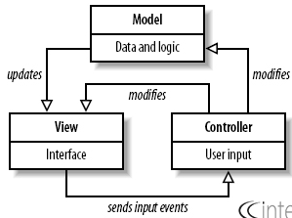
Source: https://www.interserver.net/tips/kb/mvc-advantages-disadvantages-mvc/
According to Solanki, Shah and Shah (2017, p. 155), a user accesses a website via the view by invoking the controller. The controller needs to access the database to return user requests thereby calling functions stored in the model domain. The model then handles the queries and gives feedback to the controller.
Benefits of MVC Design Pattern
Most PHP frameworks such as the CodeIgniter, CakePHP, and Laravel use the MVC design pattern due to the benefits presented by the pattern.
Ability to provide multiple views. A model domain can have multiple views. This implies that there is little code duplication as all logics and data are separate from user display. Developers can create multiple views using single model.
MVC returns data without formatting. The MVC design pattern returns data without any formatting to allow for use and calling of the same components by the interface.
Faster development process. With MVC pattern, developers can create applications through rapid and parallel development. Multiple developers can work on the same module where one develops the view and the other develops the controller domain. Development using MVC pattern in a collaborative environment is three times faster than other development patterns (Solanki, Shah and Shah 2017, p.156).
Modification does not affect the entire model. Changes made to the model domain do not affect the whole architecture since model does not depend on views.
SEO friendly. MVC pattern allows the ease of developing SEO-friendly URLs. The ability to integrate with site-scripting languages like jQuery and JavaScript ensures the development of feature rich web applications.
Supports asynchronous techniques. Asynchronous development ensures fast loading of an application. The MVC design pattern allows for asynchronous development through integration with JavaScript Framework. As such, MVC applications can be site-specific, widgets, and work with PDF files.
Disadvantages of MVC Design Pattern
Even though MVC design pattern is easy to use to develop PHP web applications, developers and users face some hurdles. First, due to the different folder structures where a single module has to be developed in three separate domains of model, view, and controller, MVC introduces increased complexity in development (Liang and Wu 2012, p. 538). The second drawback of using MVC design pattern lies is the inefficiency of accessing data from the view. A web application has to request data from the database via the controller file which requests the model on its behalf. As such, a view requiring multiple different data from a database may end up lagging the presentation of such data due to multiple callings to the controller and model. Thirdly, the MVC pattern is not suitable for small objects.
Additionally, the fourth major drawback of using MVC design pattern is in its capacity to allow for isolated development. Since UI, controller, and business logic developers can develop domains separately, there is likelihood of delay in module completion due to periodic consultations and interdependency. Likewise, even though different developers develop different domains, each developer requires to understand how the client side and server side operates. A controller domain developer has to understand how the view requests the data and how it presents it on the frontend.
PART B (IMPLEMENTATION)
The web application presented in my study uses PHP 5.6 as the server scripting language and MySQL as the database backend. The application utilizes an observer pattern where user/log in are logged and users are able to search for information in real time from their views. The system runs on localhost. It represents a pharmacy selling point with the following functionalities.
- Ability to log user logins - the system logs both successful and failed logins and the logs are visible from the administration panel
- Multiple pages of navigation including customer, supplier, sales, and user log pages
- CRUD functions through insertion, retrieval, update, and deletion of records
- Ability to perform Sales
- Ability to delete customers, suppliers
- Ability to update sales records, customer details, and supplier details
- User log reporting tool
- Real time search for products, customers, and suppliers
Below are a few screenshots of the supposed system. Further, the Appendix section provides the underlying code for the log in feature of the system. The whole system code is attached as a zip file labelled 'sourcecode'
Screenshots
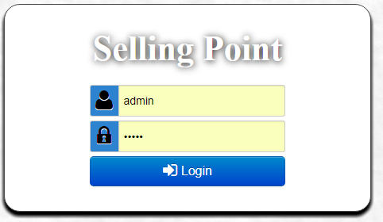
Figure 1: User Log In module
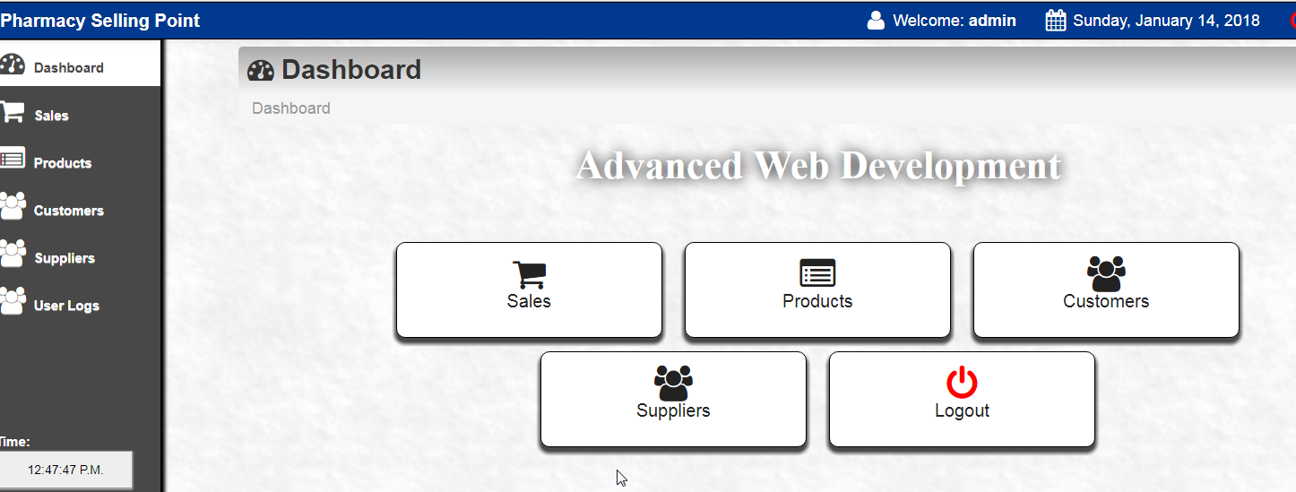
Fig 2: Multiple Navigation screens

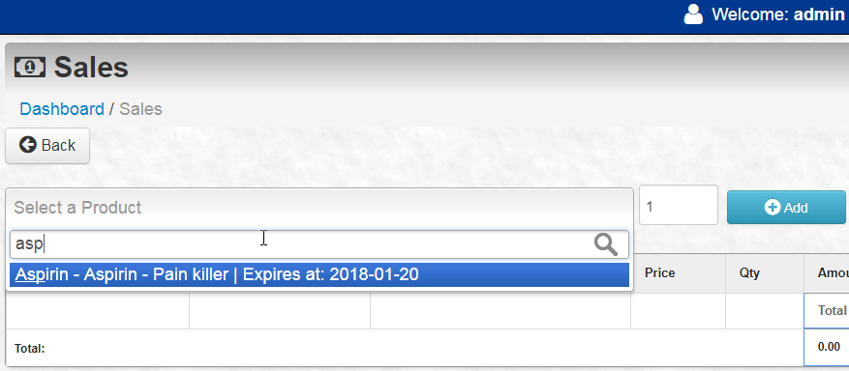
Figure 3: Autosearch feature for products

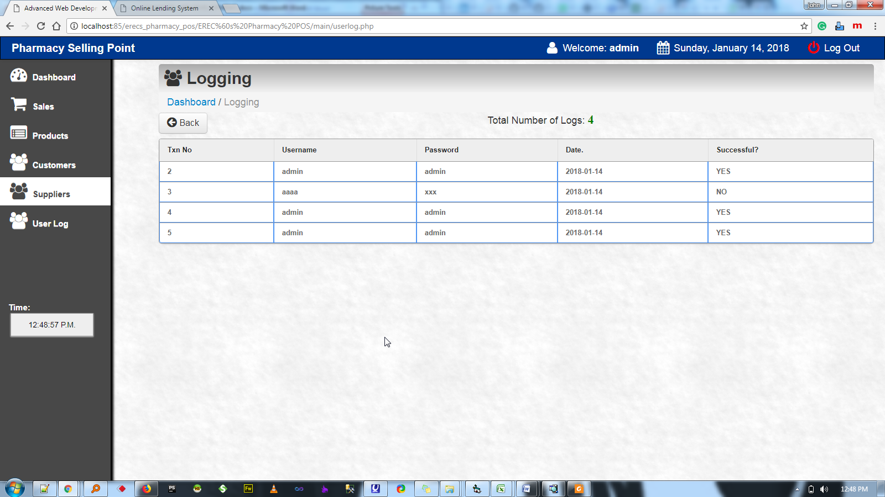
Figure 4: User Log Reporting

References
Al-Ahmad, W., 2006. Object-Oriented Design Patterns for Detailed Design, Journal of Object Technology, vol. 5, no. 2, pp. 155-169.
Jithin, 2016. What is MVC? Advantages and Disadvantages of MVC. [Online] Available at: https://www.interserver.net/tips/kb/mvc-advantages-disadvantages-mvc/
Lian, J.Y. and Wu, P.X., 2012. MVC Pattern Based on Java, Applied Mechanics and Materials, vols.198-199, pp. 537-541.
Paikens, A. and Arnicans, G., 2008, Use of Design Pattern in PHP-Based Web Application Frameworks, Datorzinātne Un Informācijas Tehnoloģijas, pp. 53-71.
Solanki, N., Shah, D. and Shar, A., 2017. A Survey on Different Framework of PHP, International Journal of Latest Technology in Engineering, Management & Applied Science( IJLTEMAS), vol. 6, no. 6, pp. 155-158.
Thung, P. L., Ng, C. J., Thung, S. J. and Sulaiman, S., 2010. Improving a web application using design patterns: A case study. Information Technology (ITSim), 2010 International Symposium in. 1, pp. 1 - 6. IEEE

Appendix
User Log in Code
This code has a function that sanitizes the inputs that logs the user attempts.
<?php
// session begins at this point
session_start();
//we introduce an array to keep track of errors during validation
$errormessage_arr = array();
// error flag for validation
$errorflag = false;
//Connecting to the server
$linkdatabase = mysql_connect('localhost','root',"root");
if(!$linkdatabase) {
die('Failed to gain access to server: ' . mysql_error());
}

//passing the database for selection
$db = mysql_select_db('sales', $linkdatabase);
if(!$db) {
die("Unable to find the database");
}

//This function cleans strings to avoid SQL injection
function clean($str) {
$str = @trim($str);
if(get_magic_quotes_gpc()) {
$str = stripslashes($str);
}
return mysql_real_escape_string($str);
}

//Clean all the POST values
$login = clean($_POST['username']);
$password = clean($_POST['password']);

// Validate all inputs both login and password
if($login == '') {
$errormessage_arr[] = 'Username does not exist;
$errorflag = true;
}
if($password == '') {
$errormessage_arr[] = 'Password mismatch;
$errorflag = true;
}

//if inputs are wrong redirect to login page
if($errorflag) {
$_SESSION['ERRMSG_ARR'] = $errormessage_arr;
session_write_close();
header("location: index.php");
exit();
}
date_default_timezone_set('America/New_York');
$Today = date('y:m:d');
//Create select query
$qry="SELECT * FROM user WHERE username='$login' AND password='$password'";
$result=mysql_query($qry);

//Check whether the query was successful or not
if($result) {
if(mysql_num_rows($result) > 0) {
//Login Successful
session_regenerate_id();
$member = mysql_fetch_assoc($result);
$_SESSION['SESS_MEMBER_ID'] = $member['id'];
$_SESSION['SESS_FIRST_NAME'] = $member['name'];
$_SESSION['SESS_LAST_NAME'] = $member['position'];
//$_SESSION['SESS_PRO_PIC'] = $member['profImage'];
session_write_close();
//log user details
loguser($login,$password,$Today,'YES');
header("location: main/index.php");
exit();
}else {
//Login failed
//log user details
loguser($login,$password,$Today,'NO');
header("location: index.php");
exit();
}
}else {

die("Query failed");
}
function loguser($usr,$pass,$dat,$stat
{
//logs in user log in attempts
$sql="Insert into userlog (usrname, pass,datetim,issuccess) values ('$usr','$pass','$dat','$stat')";
$resultx=mysql_query($sql);
}
?>

