Difficult Heritage and the Comfort Women Memorials

One of the most basic functions of memorials and monuments is to bring attention to a specific topic, spreading awareness about events and people to wider society. There are many reasons for this to be desirable, and in the case of the ‘comfort women’, memorials have helped to raise global awareness and support for victims. Since the first testimonies against the Japanese Imperial Government about the experiences of the ‘comfort women’, there has been a marked increase in discussion, evidence and commemoration of the slavery perpetrated by the Japanese Military in the Second World War. The spread of this solidarity can be seen physically through the rise in memorials to ‘comfort women’ across various countries. As awareness of the ‘comfort women’ increases internationally, the difficulties of interacting with uncomfortable histories also becomes explicitly clear. Throughout this essay I will discuss the impact of memorialisation on the historical narratives of difficult and contested heritage by analysing the growth of, and reaction to, monuments of ‘comfort women’. My intention is not to condemn the continued denial of the ‘comfort women’, but to highlight the positive impacts that monuments can have in reversing the impact of the erasure of history and protecting the narrative of the victims of systematic colonial sexual slavery. In this way, my aim is to show that the re-consideration of monuments does not necessarily have to be accomplished in a physical sense. Instead, I assert that physical monuments can create the opportunity for meta-physical re-negotiation by creating discussion and global awareness.

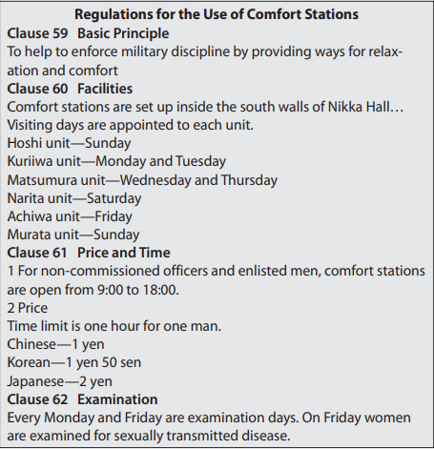
The focal monuments of this essay, and the various other examples that I will refer to, are all in commemoration of the ‘comfort women’ of the Imperial Japanese Army in the 1930’s and 40s. In the run up to, and during, the Second World War, Imperial Japan introduced a system of brothels throughout its military for its officers and soldiers. In order to prevent the mass rape of occupied territories by Japanese soldiers, and to maintain both morale and control the spread of venereal disease, senior staff officers of each branch of the army would oversee the construction of so called ‘comfort stations’. Within these ‘comfort stations’ women were regularly raped, beaten, and exposed to sexually transmitted diseases. Though there is no universally agreed upon ratio, it's commonly accepted that each ‘comfort women’ would be assigned to between 30-50 men in following with the strict infrastructure of the military.
Figure 1 Digital Museum Team,‘English translation of the 2nd Independent Heavy Siege Artillery Battalion’s “Regulation for the Use of Comfort Stations.” March 1938, Shiryoshusei’. <https://tinyurl.com/y3roaafs>
The first of these stations was established in 1932 in Shanghai by the Japanese military and would be succeeded by the creation of at least 125 known stations. Over the course
of their operational years, these ‘comfort stations would contain abducted women from Japan, Taiwan, the Philippines, Indonesia, Malaysia, Việt Nam, Thailand, East Timor, and the Dutch East Indies. The most popular estimate among scholars for the number of women trafficked into these stations is over 200,000; of these, an estimated 90% did not survive.

The euphemistic term ‘comfort women’ is a translation of the Japanese word ianfu, meaning a
“comforting, consoling woman”, and does much to gloss over the severity and cruelty that defines
the existence of these establishments. Much of the dialogue from those who deny the existence of
these ‘comfort stations’, asserts that all comfort women signed contracts of willing employment in
service of the military. Indeed, in the early 1930’s many of these stations were filled with prostitutes
from Japan who had volunteered. What this dialogue fails to acknowledge, however, is that the
expansion of conflict and the increasing number of ‘comfort stations’ (and the demand for women
to staff them) led to the increased use of coercive recruitment. It is in this failure of understanding
that the majority of contention surrounding this history lies. In reality, the expansion of Japanese
territory and the establishment of new stations led to large-scale government sanctioned sexual
slavery. There are many documented descriptions of women applying to work in domestic,
secretarial, and industrial positions for the Voluntary Labour Service Corps, only to be confined
against their will and forced into sexual slavery.

Introducing the focal memorials.

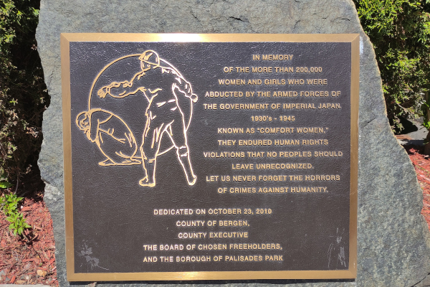
The history of the ‘comfort women’ is highly politicised, and the memorials erected to demand justice for their treatment are now central parts of the contested narrative. To highlight the extent of contention surrounding this topic and the memorials associated with it, I will primarily be discussing the San Francisco Column of Strength monument and the New Jersey Comfort Women Memorial. The New Jersey Comfort Women Memorial (Fig.2), placed in 2010, was the first memorial on the topic to be erected in the United States. This Memorial is dedicated specifically to South Korean victims; as I will discuss in later sections of this essay, this specific site inspired the creation of a similar memorial in Seoul, copies of which would then appear across Europe. Funding for this monument was raised by the Korean American Civic Empowerment organisation and supported by the growing Korean population residing in Palisades Park, New Jersey.
Figure 2 Wander Women Project team, ‘Comfort Women Memorial’ https://wanderwomenproject.com/places/comfort-women-memorial-in-palisades-park-nj/

The Column of Strength, pictured (Fig. 3), was unveiled in 2017 by the civil society organisation Comfort Women Justice Coalition in commemoration of all women compelled into sexual slavery in service of the Imperial Japanese Military. The final proposal for the design of the monument was picked from 30+ submissions to a public exhibition. Depicted are three young women, representing Chinese, Korean and Filipina girls, and an elderly figure reflecting the work of the activist Kim Hak-soon. The monument is located between San Francisco’s Financial District and Chinatown, and embodies the hope of beginning the “healing process in the Asian-American community”
Figure 3 Stephen Whyte, ‘Column of Strength <‘https://www.codaworx.com/projects/comfo>
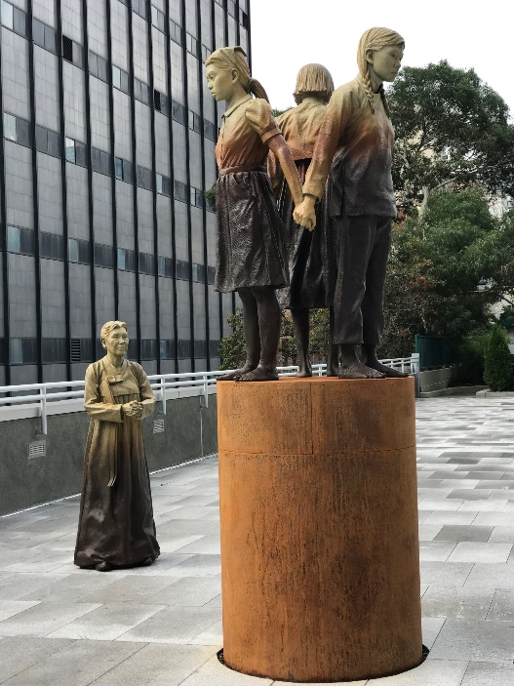
Collectively, these monuments represent the global drive for justice and recognition of the horrific experiences and conditions that these ‘comfort women’ were subjected to by the Imperial Japanese government. Their creation brings a neglected period of history and heritage to the forefront of international discussion by giving the victims a platform of recognition from which they are able to combat the erasure of their experiences. The material significance of these monuments to ‘comfort women’ is aptly summarised by David Shim, who argues that that ‘the politics of memory cannot be fully understood in isolation from memory’s materialized enactment’. In following with this line of thought, it can be asserted that the significance of memories and records of difficult heritage are best understood when considered alongside the ways that those events are represented in a commemorative context. When it comes to handling difficult heritage, having a physical representation of an event helps those with limited knowledge, or experience, of a situation to understand the ways in which others have been impacted.

Both the Column of Strength and the Comfort Women Memorial are physically significant not only because they represent the reclamation of difficult history made manifest, but also because of the statement they seek to make about how society should approach victims of sexual slavery in a modern context. Though the primary aim of these monuments is remembrance and education, they are also seen to be representative of the need for justice and as ‘speaking to transnational feminist movements’.
Contention Surrounding the Monuments and Narrative.

Over the last few decades, the accuracy of the experiences and testimonies of surviving ‘comfort women’ has been regularly called into question by deniers of the ‘comfort women lie’. The monuments that commemorate the victims of Japanese sexual slavery have done much to shed light on a largely suppressed period of history.
In doing so, these monuments make it necessary for uncomfortable events to be acknowledged and discussed; it is through the necessity for this discussion that contention arises. The erection of memorials to the ‘comfort women’ has elicited significant resistance from the Japanese government, especially in relation to the focal monuments of this essay.
After the creation of the Comfort Women Memorial in New Jersey, there was minimal international attention given to its creation. It was not until the Statue of Peace memorial in Seoul was unveiled opposite the Japanese embassy in 2011(the creation of which was inspired by the monument in New Jersey) that the global discussion of human rights violations committed by the Imperial Japanese Government began. It is at this point that the Comfort Women Memorial became the subject of controversy. An article published in 2012 by the Journalist Okamoto Akiko claiming, with no evidence, that the monument had led to Japanese children in US schools being bullied, and intervention from the Japanese government followed in short succession. It is important to note here the distinct time gap between the creation of the Comfort Women Memorial and the formal response after it gained international attention. The delay and subsequent extremity of reaction demonstrates how difficult heritage most commonly causes contention when it becomes the centre of investigative discussion, especially if the subject is one that has previously been supressed.

In comparison, the Column of Strength in San Francisco was unveiled several years later in 2017. By this point, 37 other statues commemorating the ‘comfort women’ had already been established, and discussions over the issue were already taking place. During the approval process for this memorial, over 20 local higher education faculties submitted an affirmation in favour of its creation, reflecting on the ‘unparalleled scale and brutality’ of Japanese military sexual slavery, and the ongoing unwillingness of the Japanese government to provide an official apology. The difference in the speed of reaction to the Column of Strength when compared to the Comfort Women Memorial is a comment on the relationship between increasing awareness and increasing contention. The ‘comfort station’ framework in which these women were forced to work went largely undiscussed and unacknowledged until 1987. After the democratization of the Republic of Korea, research into the ‘comfort women’ issue was first presented by Yun Chung-OK of the Ewha Women’s university at the International Conference on Women and Tourism. Following this presentation and a demonstration protesting plans to send Korean emissary to the funeral of Emperor Hirohito, a list of demands was submitted by activists to be made to the Japanese government; one of these issues being that Japan investigate and formally apologise for its involvement in the ‘comfort women’ issue. The first example of Japanese political denial occurred when, after Emporer Akihito expressed regret for the suffering caused by Japanese Colonial rule, the government refused to conduct investigations into the issue. Instead, the Japanese government re-asserted the official position of all “institutions of military ‘comfort stations’ [being] private enterprises”.
In the following year, Kim Hak-soon gave the first survivor to give public testimony about her ordeal. The most sustained statement against the denial of the Japanese government is undoubtedly the ‘weekly Wednesday demonstrations’ that have taken place in Seoul since 1992. The very first Wednesday demonstration took place outside the Japanese embassy in Seoul two days before Japanese Professor Yoshimi presented the first hard evidence proving that the Japanese Imperial Military had direct involvement in the running of ‘comfort stations’.

These events were key to beginning the global discussion of the existence and treatment of the comfort women and are therefore important to consider when discussing the wider social context of the Column of Strength and the Comfort Women Memorial. Before 2010 and the unveiling of the Comfort Women Memorial in Palisades Park, discussions and protests regarding the ‘comfort women’ issue were largely centred in Korea. In the following years, statues condemning Imperial Japan’s actions and commemorating its victims appeared all over Europe, effectively catapulting the narrative into the public eye. It is not surprise, then, that the creation of another US monument, the Column of Strength, caused direct intervention by the Japanese government far quicker than the first. The socio-political atmosphere surrounding discussions of ‘comfort women’ by the time the Column of Strength was created had elevated the issue to an international stage, and it is unsurprising that the efforts of the Japanese government to control the narrative also increased. The creation of monuments in the US, particularly the Comfort Women Memorial, helped to elevate the discussion to a global stage. With the continual lack of full acknowledgement from the Japanese Government, the solidarity offered through international support helps prevent the erasure of history, and supports attempts to re-negotiate the accepted narrative to give recognition to the victims.
The most common rebuttal by Japanese delegations in efforts to have ‘comfort women’ memorials removed is the rejection all assertions of forced sexual labour and coercion in recruitment, and the conditions and numbers of women impacted. Even these claims are concessions after the initial complete denial of Military involvement. It took the collective work of Professor Yoshimi and the eventual involvement of the United Nations to firmly establish the factuality of the ‘comfort women’ and the infringements on human rights perpetrated by the Imperial Japanese government. In a 1996 United Nation report, Radhika Coomaraswamy defined the actions of the Imperial Japanese government and the ‘comfort stations’ as “a clear case of sexual slavery and slavery-like practice in accordance with the approach adopted by relevant international human rights bodies and mechanisms". In the face of these accusations, the Japanese Government instead began to insist that any women who worked in ‘comfort stations’ were there of their own free will, and that no means of coercion had been implemented. Arguments against the number of ‘comfort women’ and the conditions they were exposed to form the backbone of opposition to these memorials. In responses to plaques placed on the Column of Strength, the Mayor of Osaka criticised the use of “uncertain and one-sided claims”, arguing against the use of the widely accepted number of 200,000 victims.
After the previously mentioned article by Okamoto Akiko was published, the City of Palisades Park was contacted both by the Japanese Consulate in New York and later by a delegation of representatives from the Japanese Liberal Democratic Party who sought to have the monument removed. After two failed diplomatic visits to the site, a petition was started on the White House website by two of the delegates, with the request that “President Obama to remove the monument and not to support any international harassment related to this issue against the people of Japan”. Similarly, the Column of Strength led to vocal opposition from the Japanese government, with many correspondences requesting the removal of the monument and criticising the ‘regrettable’ memorials for their antagonism. Opposition to the continued display of the Column of Strength eventually led to an international dispute and had major economic impacts when Osaka ended its sister city relationship with San Francisco. Economic sanctions resulting from the memorialisation of the ‘comfort women’ issue have also caused political tension beyond the US. After the installation of a second memorial in South Korea in 2016, economic negotiations between the South Korean and Japanese governments began to break down, and the Japanese ambassador was withdrawn.

Re-Negotiating Difficult Heritage and Memorialisation.

In dealing with contentious periods of history and remembrance, it is also interesting to note the attempts to sanitise the narrative of the ‘comfort women’ in varying ways. The responses of the Japanese government alternate regularly between complete denial of any existence of the ‘comfort women’, insistence on such infrastructure being entirely private ventures, and stressing that any women brought in by the military did so of their own volition. The prominence of right-wing revisionism in Japanese responses to the ‘comfort women’ issue is evident in the attitudes adopted in both physical and social responses. The Conservative Liberal Democratic Party has vocally opposed ‘comfort women’ memorial projects as one-sided and unjust attacks on the global standing and image of Japan. Right-wing activists have led many calls to have history books and compensation for Korean Labourers revised, as well as territorial disputes. In one instance, Shinzo Abe, then head of the Liberal Democratic Party, signed his name to the right-wing ad ‘Yes, We Remember the Facts’. The ad was placed six months after requests to remove the Comfort Women Memorial were denied and opposes the South Korean narrative of the ‘comfort women’.
The varying responses to these memorials effectively demonstrate the difficulties that must be faced when representing and memorialising difficult heritage, especially histories of international and colonial relevance. In bringing a topic to the forefront of conversation, especially one so deeply rooted in both national pride and the protection of human rights, contention is both unavoidable and an opportunity for progression.
The increasing dialogue around the ‘comfort women’ issue demonstrates how the erection of memorials and monuments can facilitate contention, but also lead to opportunities for the re-negotiation of historical narratives and painful heritage. The establishment of memorials to the ‘comfort women’ in the US, and the 30+ monuments erected across Europe and Asia in the following years, are physical markers showing the reclamation of a previously hidden history. As more information and public support comes to light, the opportunity for cultural progression and the negotiation of a shared history in a way that prevents further atrocities through public awareness. In line with the concepts presented by Raphael Samuel, the heritage brought to light by ‘comfort women’ memorials presents an opportunity for social change through education and re-negotiation of accepted (or in this case, denied) narratives. Indeed, such co-operation is far from un-obtainable; by the time of the unveiling of the Column of Strength, the Comfort Women Justice Coalition received many letters from citizens of Osaka who supported the creation of the monument.

The existence of monuments that represent the victims of contested history can, and should, be viewed as a beneficial tool. Such memorials simultaneously show solidarity with those impacted and serves to unearth continued denial and opposition that stems from a defensive standpoint. By removing control of the narrative from previously dominant power structures, the voice of the suppressed can be shared. This, alongside investigation prompted by rising awareness, allows heritage to be examined in a way that contributes to global cultural understanding, and the decolonialisation of history.

Bibliography:
- Blakemore, Erin, ‘The Brutal History of Japan’s ‘Comfort Women’, History, (2019), <https://www.history.com/news/comfort-women-japan-military-brothels-korea>
- Contested History Initiative, ‘’Comfort Women’ Column of Strength in San Francisco, California’, Contested Histories, (2021), <USA: Comfort Women Column of Strength in San Fransisco (contestedhistories.org) >
- Coomaraswamy, Radhika, Report of the Special Rapporteur on violence against women, (Geneva: UN Commission on Human Rights 1996)
- Editors at Digital Museum, ‘How did the Comfort Women Issue come to light?’ in The Comfort Women Issue and the Asian Women’s Fund <https://www.awf.or.jp/e2/survey.html#:~:text=It%20cannot%20be%20said%20that,issue%20as%20a%20social%20problem>
- Editors at Education for Social Justice Foundation, ‘Wednesday Demonstration’, Education for Social Justice Foundation, (2017), < https://www.e4sjf.org/wednesday-demonstration.html>
- Fortin, Jacey, ‘‘Comfort Women’ Statue in San Francisco Leads a Japanese City to Cut Ties’, New York Times, 25 November 2017, < https://www.nytimes.com/2017/11/25/world/asia/comfort-women-statue.html>
- Kim, Jimin, Bisland, Beverly Milner, Shin, Sunghee, ‘Teaching about the Comfort Women during World War II and the Use of Personal Stories of the Victims’, Education About Asia, 24(2019), 58-63
- Kim, Woohee, ‘Breaking the Silence and Inspiring Activism on Japanese Military Sexual Slavery: Legacy of Kim Hak-soon’, in Thanks for Typing: Remembering Forgotten Women in History, ed. by Juliana Dresvina ([London]:Bloomsbury Publishing, 2021)
- Kim-gibson, Dai Sil, Silence Broken: Korean Comfort Women (Parkersburg: Mid-Prairie Books, 1999)
- Korea Herald, ‘Seoul Faces Dilemma Over ‘Comfort Women’ Statue in Busan’ Korea Herald, 3 January 2017, <https://www.koreaherald.com/view.php?ud=20170103000764>
- Shim, David, ’Memorials’ Politics: Exploring the material rhetoric of the Statue of Peace’, Memory Studies, (2021)
- Soh, Chunghee Sarah, ‘The Korean “Comfort Women”: Movement for Redress’, Asian Survey, 36(1996), 1226-1240
- Tanaka, Yuki, Japan’s Comfort Women: Sexual Slavery and Prostitution during World War II and the US Occupation (New York: Routledge, 2002)
- Ward, Thomas J., and Lay, William D., Park Statue Politics: World War II Comfort Women Memorials in the United States (Bristol: EInternational Relations Publishing, 2019), p. 53
- Ward, Thomas J., Lay, William D., ‘The Origins and Implementation of the Comfort Women System’, E-International Relations, (2018) <https://www.e-ir.info/2018/12/14/the-origins-and-implementation-of-the-comfort-women-system/>
- Yamaguchi, Tomomi, ‘The History Wars and the Comfort Women Issue: Revisionism and the Right-wing in Contemporary Japan and the U.S.’, The Asia-Pacific Journal, 18(2020), 1-23 <https://apjjf.org/2020/6/Yamaguchi.html>
- Yoon, Rangsook, ‘Erecting the “Comfort Women” Memorials: From Seoul to San Francisco’, De Arte, 53(2018), 70-85

Yuki Tanaka, Japan’s Comfort Women: Sexual Slavery and Prostitution during World War II and the US Occupation (New York: Routledge, 2002), p. 21
Erin Blakemore, ‘The Brutal History of Japan’s ‘Comfort Women’, History, (2019), <https://www.history.com/news/comfort-women-japan-military-brothels-korea>
Jimin Kim, Beverly Milner Bisland, Sunghee Shin, ‘Teaching about the Comfort Women during World War II and the Use of Personal Stories of the Victims’, Education About Asia, 24(2019), 58-63
Dai Sil Kim-gibson, Silence Broken: Korean Comfort Women (Parkersburg: Mid-Prairie Books, 1999), p.40
Thomas J. Ward, William D. Lay, ‘The Origins and Implementation of the Comfort Women System’, E-International Relations, (2018) <https://www.e-ir.info/2018/12/14/the-origins-and-implementation-of-the-comfort-women-system/>
Woohee Kim, ‘Breaking the Silence and Inspiring Activism on Japanese Military Sexual Slavery: Legacy of Kim Hak-soon’, in Thanks for Typing: Remembering Forgotten Women in History, ed. by Juliana Dresvina ([London]:Bloomsbury Publishing, 2021) pp.102-113
David Shim, ’Memorials’ Politics: Exploring the material rhetoric of the Statue of Peace’, Memory Studies, (2021)
Thomas J. Ward, and William D. Lay, Park Statue Politics: World War II Comfort Women Memorials in the United States (Bristol: EInternational Relations Publishing, 2019), p. 53
Contested History Initiative, ‘’Comfort Women’ Column of Strength in San Francisco, California’, Contested Histories, (2021), <USA: Comfort Women Column of Strength in San Fransisco (contestedhistories.org) >
Kim Hak-soon was a Korean Human Rights activist, and the first former ‘comfort woman’ to publicly testify about her experiences under the Imperial Japanese Military. Though she inspired hundreds more women to come forward about their experiences, she died in 1997 before her court case was settled. For further information on the tragic and inspirational legacy of Kim Hak-soon, see Woohee Kim, ‘Breaking the Silence and Inspiring Activism on Japanese Military Sexual Slavery: Legacy of Kim Hak-soon’, in Thanks for Typing: Remembering Forgotten Women in History, ed. by Juliana Dresvina ([London]:Bloomsbury Publishing, 2021) pp.102-113
Contested History Initiative, ‘’Comfort Women’ Column of Strength in San Francisco, California’
David Shim, ’Memorials’ Politics: Exploring the material rhetoric of the Statue of Peace’
Rangsook Yoon, ‘Erecting the “Comfort Women” Memorials: From Seoul to San Francisco’, De Arte, 53(2018), 70-85 (p.83)
Tomomi Yamaguchi, ‘The History Wars and the Comfort Women Issue: Revisionism and the Right-wing in Contemporary Japan and the U.S.’, The Asia-Pacific Journal, 18(2020), 1-23 <https://apjjf.org/2020/6/Yamaguchi.html>
Korea Herald, ‘Seoul Faces Dilemma Over ‘Comfort Women’ Statue in Busan’ Korea Herald, 3 January 2017, <https://www.koreaherald.com/view.php?ud=20170103000764>
Contested History Initiative, ‘’Comfort Women’ Column of Strength in San Francisco, California’
Editors at Digital Museum, ‘How did the Comfort Women Issue come to light?’ in The Comfort Women Issue and the Asian Women’s Fund <https://www.awf.or.jp/e2/survey.html#:~:text=It%20cannot%20be%20said%20that,issue%20as%20a%20social%20problem>
Chunghee Sarah Soh, ‘The Korean “Comfort Women”: Movement for Redress’, Asian Survey, 36(1996), 1226-1240(p.1232)
Ibid.
Ibid.
These rallies were listed in the 2002 Guinness World Records for the world’s oldest rally on a single theme.
Editors at Education for Social Justice Foundation, ‘Wednesday Demonstration’, Education for Social Justice Foundation, (2017), < https://www.e4sjf.org/wednesday-demonstration.html>
Radhika Coomaraswamy, Report of the Special Rapporteur on violence against women, (Geneva: UN Commission on Human Rights 1996)
Tomomi Yamaguchi, p.6
Ibid.
Jacey Fortin, ‘‘Comfort Women’ Statue in San Francisco Leads a Japanese City to Cut Ties’, New York Times, 25 November 2017, < https://www.nytimes.com/2017/11/25/world/asia/comfort-women-statue.html>
David Shim, ’Memorials’ Politics: Exploring the material rhetoric of the Statue of Peace’
Ibid.

