

Student Attendance Tracking and Analytics System

Cheng CHEN

Supervisor: Dr Nigel Davies
Second Marker: James Williams

Project submitted as part of the requirements for the award of BSc (Hons) Applied Computing

May 2026

DECLARATION

I, Cheng CHEN, declare that I am the sole author of this Project; that all references cited have been consulted; that I have conducted all work of which this is a record, and that the finished work lies within the prescribed word limits.

This work has not previously been accepted as part of any other degree submission.

Date : 1 May 2026

FORM OF CONSENT

I, Cheng CHEN, hereby consent that my Project, submitted in candidature for the BSc (Hons) Applied Computing degree, if successful, may be made available for inter-library loan or photocopying (subject to the law of copyright), and that the title and abstract may be made available to outside organisations.

Date : 1 May 2026

ABSTRACT
Student attendance is widely recognised as a key indicator of academic engagement and performance in higher education. However, many institutions continue to rely on manual or fragmented attendance management approaches, which are time-consuming, prone to human error, and offer limited analytical capabilities.

The aim of this project was to design and develop a web-based Student Attendance Tracking and Analytics System to support efficient attendance recording and basic data analysis for academic monitoring. The objectives included automating attendance submission, enabling session management for lecturers, and providing visual representations of attendance data.

This project adopted a development-based methodology following a Design Science approach, supported by iterative development practices. The system was implemented using modern web technologies, incorporating a cloud-based backend for data storage and a user-friendly interface designed for both students and lecturers.

The final system enables lecturers to create attendance sessions and access attendance summaries, while students can submit attendance digitally using session codes. In addition, basic analytical features, such as attendance rates and session summaries, were implemented to support the monitoring of student engagement.

Overall, the project demonstrates that a low-cost, web-based attendance system can improve the efficiency and transparency of attendance management processes. The system also provides a foundation for future development, including the integration of advanced analytics and predictive features to support early academic intervention.
CONTENTS
ABSTRACT 3
LIST OF FIGURES 4
LIST OF TABLES 4
CHAPTER 1 – INTRODUCTION 5
CHAPTER 2 – LITERATURE REVIEW 7
CHAPTER 3 – METHODOLOGY 17
CHAPTER 4 – DESIGN & IMPLEMENTATION 20
CHAPTER 5 – EVALUATION 30
CHAPTER 6 – CONCLUSIONS 38
CHAPTER 7 – REFLECTION 41
REFERENCES 43
APPENDICES 44

LIST OF FIGURES
Figure 1 System Architecture of the Attendance Tracking System 21
Figure 2 Login Interface with Role Selection and Accessibility Settings 22
Figure 3 Lecturer Interface for Managing Attendance and Viewing Analytics 23
Figure 4 Student Interface for Attendance Submission 24
Figure 5 Lecturer dashboard for session creation. 25
Figure 6 Student check-in interface. 26
Figure 7 Lecturer analytics dashboard. 27
Figure 8 Student analytics dashboard. 28
Figure 9 System Architecture Diagram 30
Figure 10 Summary of system rating and willingness to use the system 32
Figure 11 Email provided to participants containing incorrect lecturer login credentials 34
Figure 12 Updated clearer lecturer login credentials 36
Figure 13 Before and after improving the attendance confirmation message 36
Figure 14 Improvements in layout and responsiveness 37

LIST OF TABLES
Table 1. Comparison of Attendance Management Technologies 9

CHAPTER 1 – INTRODUCTION
  - Background and Context

Student attendance is widely recognised as a key indicator of academic engagement, learning behaviour, and overall performance in higher education [1]. Regular attendance has been associated with improved understanding of course material, higher academic outcomes, and increased student retention [2]. As a result, attendance monitoring plays an important role in supporting both teaching practice and academic decision-making.

Despite the critical importance of attendance management, it remains inefficient in many educational institutions. Traditional attendance methods, such as paper registers or spreadsheet systems, are time-consuming, error-prone, and difficult to scale. Even with digital systems, many focus solely on recording attendance without providing meaningful insights into attendance patterns or student engagement. This limits teachers' ability to identify low attendance early and provide appropriate academic support.

Advances in web technologies and cloud-based platforms have created opportunities to improve attendance management through automation and data analysis. Modern web applications can provide role-based access, real-time data storage, and simple analytical visualisations, enabling lecturers and students to interact with attendance systems more effectively. However, there remains a need for accessible and low-cost solutions that combine attendance tracking with basic analytics in a single, user-friendly system.

  - Problem Statement

Although numerous attendance systems exist, many suffer from limitations related to usability, cost, and analytical capability. Some systems rely on specialised hardware or complex infrastructure, making them unsuitable for smaller institutions or individual modules. Others provide only basic attendance recording without offering analytical features that support monitoring of engagement or identification of students at risk due to low attendance.

As a result, lecturers may lack timely and actionable information to support academic intervention, while students receive limited feedback on their own attendance behaviour. This highlights the need for a web-based attendance system that is simple to use, affordable to deploy, and capable of providing basic attendance analytics to support both teaching and learning.

  - Aim and Objectives

Aim
The aim of this project is to design and develop a web-based Student Attendance Tracking and Analytics System that supports efficient attendance recording and provides basic analytical insights for academic monitoring.

Objectives
The objectives of this project are to:
- Investigate existing approaches to student attendance management and analytics in higher education.
- Design a user-friendly, role-based web interface for lecturers and students.
- Implement digital attendance recording using a cloud-based backend.
- Provide basic attendance analytics and visualizations to support monitoring of student engagement.
- Evaluate the system’s functionality and usability through testing and demonstration.

  - Scope of the Project

This project focuses on the development of a web-based attendance system intended for academic demonstration purposes. The system supports two primary user roles: lecturers and students. Lecturers can create attendance sessions, view attendance summaries, and identify students with low attendance, while students can check in to sessions and view their own attendance information.

This project is limited to basic attendance tracking and descriptive analytics, such as attendance rates and visualizations. Advanced predictive analytics, integration with institutional systems, and biometric or location-based tracking are not within the scope of this project. To ensure ethical and privacy protections, this project uses only anonymized or sample data and does not collect any real student data.

  - Structure of the Report

This report is organised as follows. Chapter 2 presents a review of relevant literature on attendance management systems, supporting technologies, and attendance analytics in higher education. Chapter 3 describes the methodology adopted for the project, including the development approach, system architecture, and ethical considerations. Chapter 4 details the design and implementation of the proposed system. Chapter 5 evaluates the system based on functionality and usability. Chapter 6 provides conclusions and recommendations for future work, and Chapter 7 reflects on the learning outcomes achieved during the project.

CHAPTER 2 – LITERATURE REVIEW
2.1 Attendance Management in Higher Education

Attendance management plays a significant role in higher education, as student attendance is widely recognised as an indicator of academic engagement, learning behaviour, and overall academic performance. Previous studies have shown that student engagement, including attendance, is associated with improved learning outcomes [1], while reduced engagement in online learning environments may negatively affect academic performance [2]. As a result, monitoring student attendance has become a common practice in universities seeking to support academic progress and identify students who may require additional academic assistance.

Despite its importance, traditional approaches to attendance management are often inefficient. Many institutions have historically relied on manual attendance registers or spreadsheet-based systems, which require substantial administrative effort and are prone to errors such as inaccurate data entry and missing records [5]. These limitations reduce the reliability of attendance data and make it difficult for lecturers to effectively monitor patterns of student engagement over time.

In response to these challenges, a range of digital attendance systems has been proposed in recent years. Many of these systems utilise technologies such as QR codes or mobile devices to automate the attendance recording process. For example, Abd Rahni et al. [3] developed an online attendance monitoring system based on QR codes and mobile devices, demonstrating how digital approaches can simplify attendance collection and improve data management. Such systems reduce administrative workload and enable attendance information to be stored and accessed electronically.

Furthermore, the increasing availability of educational data has encouraged the development of learning analytics approaches that analyse student behaviour to support teaching and learning. Research in learning analytics suggests that attendance data can provide valuable insights into student engagement and can help identify patterns associated with academic success or risk of disengagement [4]. However, many existing implementations remain technically complex or require substantial institutional infrastructure, which may limit their accessibility, particularly in smaller educational contexts.

Therefore, there remains a clear need for simple and accessible attendance management systems that not only record attendance efficiently but also present meaningful insights into attendance behaviour in an intuitive manner. This need provides strong motivation for the development of web-based attendance systems that combine automated data collection with basic analytical visualisation.

2.2 Traditional and Digital Attendance Systems

Traditional attendance management methods in educational institutions have historically relied on manual processes, such as paper-based registers or spreadsheet-based recording systems. In these approaches, lecturers typically record student attendance during each class session and, in some cases, transfer the data into digital formats at a later stage. Although such methods are relatively simple to implement, they are often inefficient and susceptible to human error, including inaccurate data entry and lost or incomplete records [5]. Furthermore, manual approaches make it difficult to analyse attendance patterns or generate meaningful reports over time.

To address these limitations, many institutions have gradually adopted digital attendance management systems. Early digital solutions focused on replacing manual registers with electronic databases, enabling attendance records to be stored, accessed, and managed more efficiently. However, these systems still relied heavily on manual data entry, which limited their overall effectiveness and reduced potential efficiency gains.

More recent developments have introduced automated attendance technologies. One widely studied approach involves the use of QR codes or mobile devices to facilitate attendance recording. For example, Abd Rahni et al. [3] proposed a QR-code-based attendance monitoring system that allows students to register their attendance using mobile devices. Such systems can significantly reduce the administrative workload for lecturers while improving the accuracy and accessibility of attendance data.

In addition to QR-code-based systems, other technologies have been explored for attendance management, including biometric identification methods such as fingerprint recognition and facial recognition. While these approaches can provide higher levels of authentication and security, they often require specialised hardware and may raise privacy and ethical concerns [1]. As a result, many educational institutions continue to favour web-based attendance solutions that offer a more balanced trade-off between usability, cost, and accessibility.

Overall, the literature indicates a clear shift towards automated and web-based attendance systems. These systems not only simplify the process of attendance recording but also enable further analysis of attendance data, supporting improved academic monitoring and enhanced student engagement. However, while these systems improve efficiency, they often fail to address issues such as data integrity, user behaviour, and system usability in real-world environments.
2.3 Technologies Used in Attendance Systems

A range of technologies has been proposed to improve the efficiency and accuracy of attendance management systems in educational institutions. These technologies aim to automate the process of attendance recording, reduce manual administrative workload, and enhance the reliability of attendance data.

Among the most studied approaches are QR-code-based systems, biometric identification systems, and RFID or Internet of Things (IoT)-based attendance solutions. QR-code-based systems are widely recognised for their low cost, ease of implementation, and compatibility with mobile devices. In contrast, biometric systems, such as fingerprint and facial recognition, provide higher levels of authentication but often require specialised hardware and raise privacy concerns. RFID and IoT-based solutions enable automated and real-time attendance tracking; however, they typically involve higher implementation costs and infrastructure requirements.

A comparison of these commonly used attendance technologies is presented in Table 1.

Table 1. Comparison of Attendance Management Technologies
Technology | Advantages | Limitations
QR Code Systems | Low cost, easy deployment | Proxy attendance risk
Biometric Systems | High authentication accuracy | Privacy concerns, hardware required
RFID / IoT Systems | Automated detection | High infrastructure cost

2.3.1 QR-Code-Based Systems

QR-code-based attendance systems have become a widely adopted solution due to their simplicity of deployment and minimal infrastructure requirements. In these systems, a unique QR code is generated for each class session, which students scan using mobile devices to register their attendance.

Abd Rahni et al. [3] proposed an online attendance monitoring system based on QR codes and mobile devices, demonstrating that QR-based approaches can simplify attendance recording and reduce administrative workload. Similarly, Amir et al. [6] developed a web-based QR attendance system that enables students to record attendance via mobile devices while storing attendance data in a digital database.

Despite these advantages, QR-code-based systems may still present certain limitations. In particular, they are susceptible to proxy attendance, as students may share session codes or scanned information, potentially compromising the reliability of attendance records.

Digital attendance systems have been widely adopted in educational environments to replace traditional manual methods, which are often time-consuming and prone to errors [9]. For example, QR code-based attendance systems enable fast and efficient recording of student participation, while also improving data accessibility and management.
2.3.2 Biometric-based Systems

Biometric technologies have been widely explored in attendance management systems. These systems rely on unique physical characteristics, such as fingerprints or facial recognition, to verify student identity during the attendance process.

Ali et al. [1] highlight that biometric attendance systems can reduce impersonation and improve authentication accuracy. In particular, face recognition technologies have gained increasing attention in recent years. Bhatti et al. [7] developed a smart attendance management system that utilizes face detection and deep learning techniques to automatically identify students and record their attendance.

Although biometric approaches can significantly improve authentication reliability, they often require specialized hardware and may raise privacy and ethical concerns due to the collection and storage of sensitive biometric data.

2.3.3 RFID and IoT-Based Systems

RFID and Internet of Things (IoT) technologies have also been applied in attendance management systems. In RFID-based systems, students carry identification cards embedded with RFID tags, which are automatically detected by readers installed within classroom environments.

According to Al-Dabbagh [5], RFID attendance systems can automate the attendance recording process and reduce the need for manual interaction. However, such systems require dedicated hardware infrastructure, which may increase implementation and maintenance costs when compared with web-based attendance solutions.
2.4 Cloud-Based and Web Technologies

The development of cloud computing technologies has significantly influenced modern web applications, including educational management systems such as attendance tracking platforms. Cloud-based architectures enable applications to store and process data on remote servers, allowing real-time access to information from multiple locations. Compared with traditional locally hosted systems, cloud platforms offer improved scalability, availability, and ease of maintenance.

Many recent attendance management systems adopt web-based architectures that combine browser-based interfaces with cloud-hosted databases. In such systems, attendance records are stored centrally and accessed through web applications without requiring specialised software installations. This approach enhances accessibility for both lecturers and students while reducing the need for complex local infrastructure. Amir et al. [6] demonstrate that web-based attendance systems integrated with cloud storage can simplify attendance management and improve the availability of attendance records.

Cloud platforms also provide integrated services for authentication and secure data storage. These services enable developers to implement user authentication and role-based access control without the need to build complex security mechanisms from scratch. As a result, cloud-based development frameworks are widely used in applications that support multiple user roles, such as lecturer and student accounts in attendance systems.

In addition to cloud databases, modern web development frameworks support the creation of responsive and interactive user interfaces across a range of devices and platforms. These frameworks enable developers to build dynamic front-end applications that communicate with cloud services through secure connections. The integration of web-based interfaces with cloud-hosted databases therefore provides a flexible and scalable foundation for modern attendance tracking systems.

Overall, cloud-based architectures and modern web technologies offer an effective solution for developing accessible and scalable attendance management systems. By combining web interfaces with cloud authentication and database services, such systems can support real-time data storage, remote access, and efficient system deployment.
2.5 Attendance Analytics

The increasing availability of educational data has led to growing interest in the use of analytics within learning environments. Learning analytics refers to the collection, analysis, and interpretation of data related to learners and their activities to improve learning outcomes and support educational decision-making. Siemens and Long [4] describe learning analytics as a process that enables educators to gain insight into student behaviour and engagement through the analysis of educational data.

Attendance records represent one of the most readily available forms of student data within educational institutions. When analysed appropriately, attendance data can provide valuable insights into patterns of student participation and engagement. For example, lecturers can identify students with consistently low attendance and provide early academic support or intervention.

Many modern attendance systems therefore incorporate analytical features that enable attendance data to be visualised and interpreted more effectively. These systems may include dashboards, charts, and summary statistics that assist educators in monitoring attendance trends over time. Visualisation tools make attendance data easier to interpret compared with raw numerical records stored in spreadsheets or databases. However, many existing systems only provide basic data visualisation and lack deeper analytical capabilities, limiting their usefulness in supporting academic decision-making.

However, while advanced predictive analytics techniques are increasingly explored in educational research, many institutions require simpler analytical tools that are easy to implement and understand. Basic visualisations of attendance rates and session statistics can still provide meaningful insights for both lecturers and students. As a result, many modern attendance management systems incorporate lightweight analytics features that support the monitoring of student engagement without requiring complex data analysis infrastructure.

Learning analytics has been widely applied to analyse student behaviour and engagement through data-driven approaches [10]. These approaches can support decision-making and improve academic monitoring; however, they may not fully capture qualitative aspects of learning, highlighting the need for careful interpretation of analytical results.
2.6 Accessibility and Usability Considerations

Usability and accessibility are critical considerations in the design of educational technology systems. In addition, usability evaluation methods such as the System Usability Scale (SUS) have been widely used to assess the effectiveness of interactive systems [8]. Usability plays a crucial role in user acceptance, particularly in systems that require frequent interaction. Digital learning tools should be accessible to users with varying levels of technical experience, language backgrounds, and visual abilities. Systems that are difficult to use or navigate may discourage user adoption and reduce their overall effectiveness in supporting learning activities.

Accessibility features can significantly enhance the usability of web-based applications. For example, multilingual interface options enable users to interact with systems in their preferred language, improving understanding and usability for international students. Similarly, adjustable interface elements, such as scalable text sizes, can support users with visual impairments or those accessing systems across different devices.

Modern web technologies provide a wide range of tools that enable developers to incorporate accessibility features into educational platforms. Responsive design, adjustable interface settings, and clear visual layouts all contribute to an improved user experience. These features are particularly important for systems intended for regular use by both lecturers and students.

Considering usability and accessibility during the design process helps ensure that attendance management systems are practical, inclusive, and easy to use in real educational environments.
2.7 Limitations of Existing Attendance Systems (Critical Evaluation)

Existing research on attendance management systems has demonstrated significant progress in automating attendance recording and improving data accuracy. However, despite these advancements, several important limitations remain, particularly in terms of scalability, usability, cost, and analytical capability.

Firstly, many QR code-based attendance systems, such as the web-based solution proposed by Amir et al. [6], focus primarily on improving efficiency and reducing manual errors. While these systems provide real-time attendance recording and are relatively low-cost, they often rely on predefined infrastructures and lack robust validation mechanisms. For instance, issues such as QR code sharing or proxy attendance are not fully addressed, which raises concerns about data integrity. Additionally, these systems typically prioritise data collection rather than deeper analysis, limiting their usefulness for decision-making.

Secondly, broader reviews of attendance technologies highlight that many systems are either overly complex or require specialised hardware. Al-Dabbagh [5] categorises attendance systems into biometric and non-biometric approaches and notes that biometric systems, such as facial recognition and fingerprint scanning, provide higher accuracy and security. However, these solutions introduce significant challenges, including high implementation costs, infrastructure requirements, and privacy concerns. In educational environments, the storage and processing of biometric data raise ethical issues, which may restrict adoption despite their technical advantages.

Furthermore, while cloud-based and web-based systems have improved accessibility and scalability, many existing implementations still lack comprehensive usability evaluation. The System Usability Scale (SUS), discussed by Lewis [8], provides a standardised method for assessing user experience, yet many attendance system studies do not incorporate formal usability testing. As a result, systems may be technically functional but fail to meet user expectations in terms of interface design, feedback mechanisms, and overall interaction quality.

Another critical limitation identified in the literature is the lack of integrated analytics. As highlighted by Siemens and Long [4], learning analytics plays a crucial role in understanding student engagement and supporting data-driven decision-making. However, most attendance systems focus solely on recording attendance rather than analysing patterns or providing visual insights. This creates a gap between data collection and meaningful interpretation, reducing the potential impact of these systems in educational contexts.

In addition, many proposed systems remain at the prototype or experimental stage, with limited real-world validation. This lack of empirical evaluation makes it difficult to assess their scalability, reliability, and long-term usability in practical environments. Without sufficient user testing and deployment in real educational settings, the effectiveness of these systems remains uncertain.

To address these limitations, this project adopts a lightweight, web-based approach using Firebase and modern web technologies. Unlike traditional systems that require dedicated infrastructure, the proposed solution emphasises accessibility and ease of deployment. In addition, the system integrates basic analytical visualisations to support interpretation of attendance data, addressing the gap identified in previous research. Furthermore, usability considerations are incorporated through user feedback and evaluation methods, including questionnaire-based assessment, to ensure the system meets user expectations.

Overall, while existing attendance systems provide valuable foundations, they often lack a balance between cost, usability, security, and analytical capability. This project aims to contribute by delivering a practical and scalable solution that addresses these gaps within the constraints of a small-scale academic system.

In summary, the literature review has examined a range of attendance management approaches, including traditional manual methods, automated digital systems, and emerging technologies such as QR codes, biometric identification, and cloud-based platforms. These studies demonstrate that while significant progress has been made in improving attendance recording efficiency, many existing systems still face limitations related to cost, usability, scalability, and data analysis.

In addition, research in learning analytics highlights the importance of transforming raw attendance data into meaningful insights that support student engagement and academic decision-making. However, many current attendance systems focus primarily on data collection rather than interpretation, resulting in limited practical value for educators.

However, although various attendance systems have been developed, many existing solutions focus primarily on attendance recording and often involve complex implementations, additional hardware requirements, or privacy concerns. Furthermore, limited attention has been given to simple web-based systems that integrate attendance tracking with real-time analytics and usability evaluation. This highlights a gap in the development of lightweight, accessible, and user-friendly attendance systems with built-in analytical capabilities.

CHAPTER 3 – METHODOLOGY
3.1 Research Approach

This project adopts a development-based research approach, focusing on the design and implementation of a functional software system to address a practical problem within an educational context. The objective is not only to develop a working attendance system but also to demonstrate how modern web technologies can be applied to improve attendance management and provide basic analytical insights.

A Design Science methodology was selected as the most appropriate approach for this project. Design Science emphasises the creation and evaluation of artefacts designed to solve identified problems. In this context, the artefact is a web-based attendance tracking and analytics system. The methodology follows an iterative process in which the system is designed, implemented, tested, and refined based on feedback and evaluation outcomes.

This approach is suitable as the project involves both technical development and practical evaluation. It allows the system to evolve throughout the development process while ensuring that the final solution effectively addresses the limitations identified in existing attendance systems.

3.2 System Architecture

The system follows a web-based architecture that separates the user interface from data storage and authentication services. This design enables the system to be accessed through standard web browsers without requiring installation on user devices.

The front-end is implemented as a web application that provides interfaces for both lecturers and students. Users interact with the system through functionalities such as session creation, attendance submission, and attendance visualisation.

The back-end functionality is supported by a cloud-based platform, which manages user authentication and data storage. Authentication services are used to control user access and ensure that only authorised users can access specific features. A cloud-hosted database is used to store attendance records, session data, and user information.

Communication between the front-end and cloud services is handled through secure connections, enabling real-time data updates. This architecture supports multiple concurrent users and ensures that attendance data remains consistently synchronised across the system.

3.3 Technologies Used

The system was developed using modern web technologies to ensure accessibility, scalability, and ease of deployment. A JavaScript-based web framework was used to implement the front-end application, enabling the development of a responsive and interactive user interface.

Cloud-based services were utilised to manage user authentication and data storage. These services provide built-in functionality for user management, secure data access, and real-time database operations. This approach reduces the need for complex server-side development and allows the system to be deployed efficiently.

In addition, data visualisation tools were incorporated to present attendance information in a clear and intuitive format. Charts and summary statistics are used to display attendance rates and session data, assisting users in interpreting attendance patterns more effectively.

The system was managed using a version control platform, which supported structured development and enabled tracking of changes throughout the project. Deployment was carried out using a cloud hosting platform, allowing the system to be accessed online and tested within a real-world environment.

In this project, the front end was implemented using Next.js, React, TypeScript, and Tailwind CSS. Firebase Authentication and Firestore were used to support user authentication and cloud-based data storage. Chart.js was used to implement attendance visualisations, while GitHub and Vercel were used for version control and deployment.

3.4 Development Process

An iterative development process was adopted to guide the implementation of the system. The development was carried out in multiple stages, including planning, design, implementation, testing, and refinement.

Initially, system requirements were identified based on the limitations of existing attendance systems and the objectives outlined in Chapter 1. A preliminary system design was then developed to define the core features and overall system structure.

The implementation phase focused on developing key functionalities, including user authentication, attendance session creation, and attendance recording. Additional features, such as attendance analytics and user interface enhancements, were introduced incrementally.

Testing was conducted throughout the development process to ensure that the system operated correctly and met the defined requirements. Feedback from users was used to identify usability issues and inform further refinements.

This iterative approach enabled continuous improvement of the system and ensured that the final implementation aligns with the overall project objectives.

3.5 Ethical Considerations

Ethical considerations were addressed throughout the development and evaluation of the system. The project does not involve the collection or use of real student data; instead, anonymised or sample data is utilised to demonstrate system functionality.

User privacy and data security are key considerations in attendance management systems. The system is designed to ensure that user data is stored securely and accessed only by authorised users. In a real-world deployment, additional measures such as role-based access control and institutional data governance policies would be required to further ensure data privacy and compliance. Authentication mechanisms are implemented to control access to different parts of the system and to protect sensitive information.

In addition, participation in system testing and feedback collection is voluntary. Participants are informed about the purpose of the evaluation, and no personal data is collected without consent. These measures ensure that the project adheres to fundamental ethical principles related to data protection and user privacy.

In addition to system-level considerations, ethical aspects of data collection during the evaluation process were also addressed. The questionnaire was designed to ensure participant anonymity, and no personally identifiable information was collected. Participation was voluntary, and all participants were informed of the purpose of the study prior to taking part.

All collected responses were stored securely and used solely for academic analysis within this project. The data was not shared with any external parties, ensuring compliance with fundamental data protection principles. These measures ensure that both system usage and evaluation processes adhere to ethical standards related to privacy, consent, and responsible data handling.

CHAPTER 4 – DESIGN & IMPLEMENTATION
4.1 System Overview

This chapter presents the design and implementation of the proposed Student Attendance Tracking and Analytics System, including system architecture, user interface design, core functionality, and analytical features.

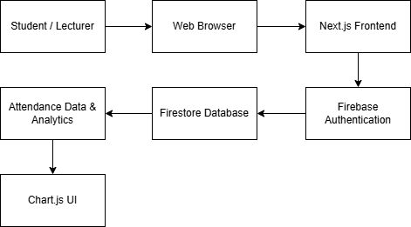
Figure 1 System Architecture of the Attendance Tracking System

As illustrated in Figure 1, the system follows a client–cloud architecture. Users interact with the system through a web-based interface, while data processing and storage are handled by cloud services. This architecture enables real-time data access and simplifies deployment by eliminating the need for a dedicated backend server.

The system is designed to support two primary user roles: lecturers and students. Each role is provided with a dedicated interface tailored to their specific tasks, ensuring a clear separation of functionality.

In addition, the system integrates basic analytical features that transform attendance data into visual insights, supporting both lecturers and students in understanding attendance patterns.

4.2 User Interface Design

The user interface of the system was designed to be simple, intuitive, and accessible for both lecturers and students. The system is implemented as a web-based application, allowing users to access it through a standard web browser without requiring additional software installation.

The login interface is illustrated in Figure 2. This page enables users to select their role (student or lecturer) and sign in using their account credentials. The role selection ensures that users are directed to the appropriate interface following authentication. The interface also incorporates accessibility features, such as language selection and adjustable text size, allowing users to customise their experience according to their preferences.

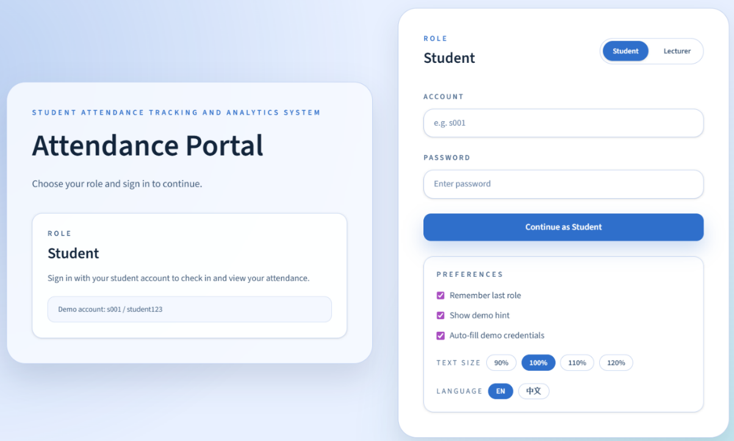
Figure 2 Login Interface with Role Selection and Accessibility Settings

The system supports two primary user roles: lecturers and students. Each role is provided with a dedicated interface that presents only the relevant features required for their tasks, improving usability and reducing interface complexity.

The lecturer interface is illustrated in Figure 3. Lecturers can create attendance sessions, view attendance records, and access attendance analytics. The layout is designed to present key information in a clear and organised manner, enabling lecturers to quickly identify attendance patterns and monitor student engagement.

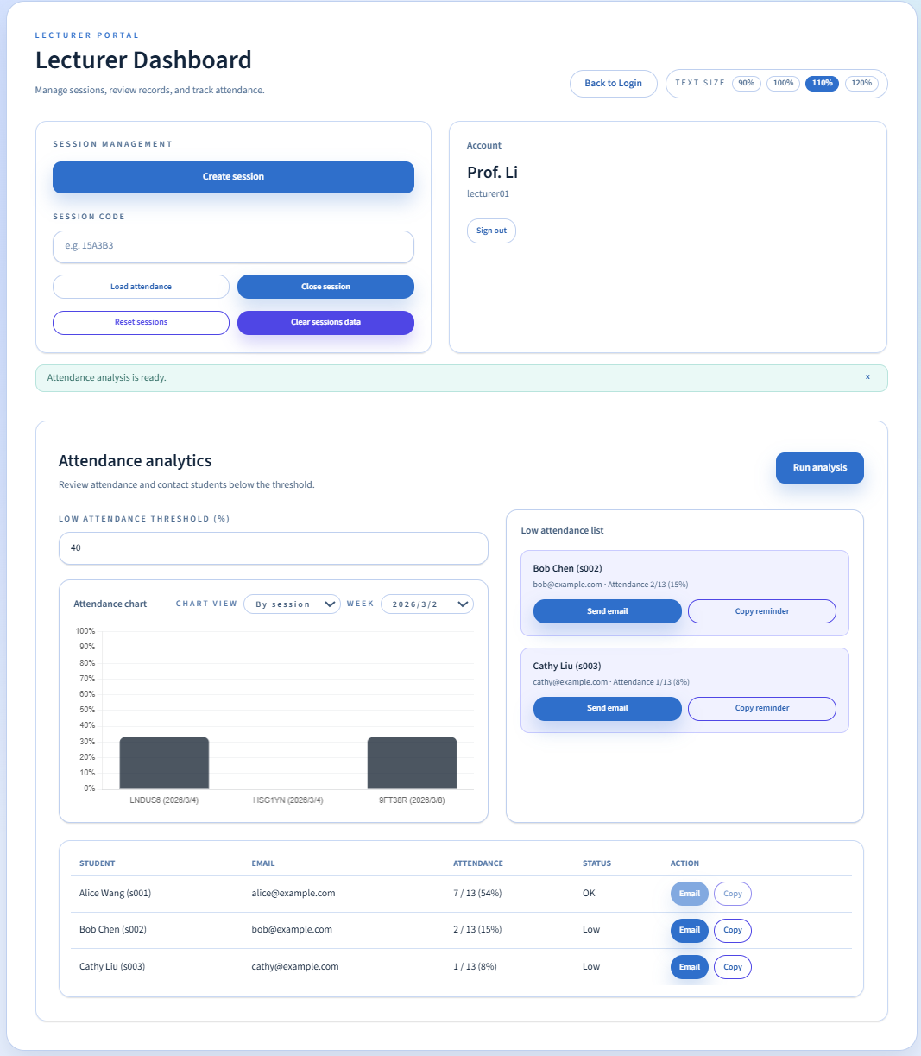
Figure 3 Lecturer Interface for Managing Attendance and Viewing Analytics

The student interface is illustrated in Figure 4. Students can submit attendance for active sessions and view their own attendance records. The check-in process is designed to require minimal user interaction, ensuring efficiency during class sessions.

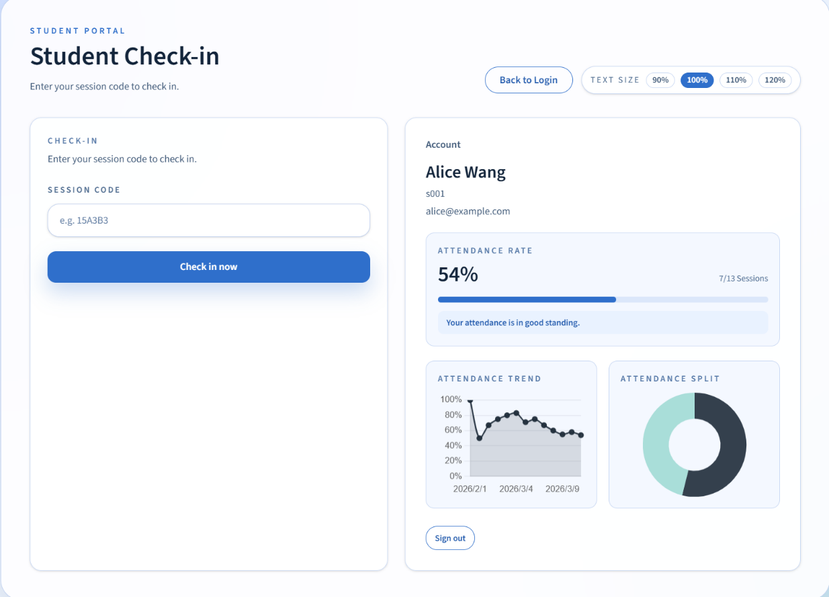
Figure 4 Student Interface for Attendance Submission

The interface follows responsive design principles, allowing the system to be used across a range of devices, including desktops, tablets, and mobile phones. This flexibility enhances usability in real-world educational environments.

Overall, the user interface design aims to balance functionality and simplicity, ensuring that users can efficiently complete key tasks while maintaining a clear and accessible layout.
4.3 Attendance Functionality

The core functionality of the system is centred on attendance session creation and student check-in. The system is designed to support a simple workflow in which lecturers create active attendance sessions and students submit attendance by entering a valid session code.

For lecturers, the attendance recording process begins with the creation of a session.

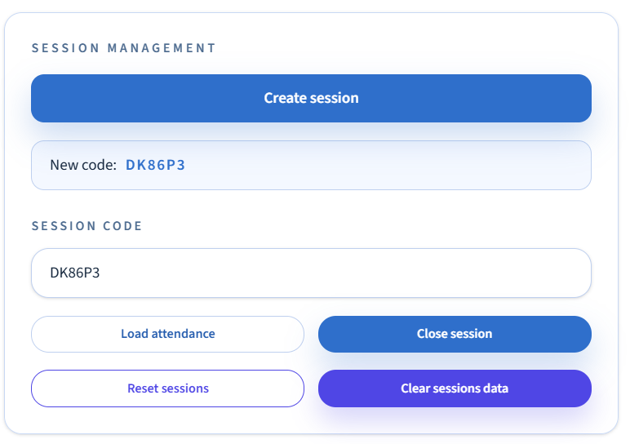
Figure 5 Lecturer dashboard for session creation.

When a lecturer selects the session creation option, the system first ensures that Firebase anonymous authentication is available. A six-character uppercase session code is then generated on the client side, and a new session document is created in the Firestore database. Each session record includes the session code, creation timestamp, session status, and the identifier of the authenticated lecturer. This design enables the system to track which lecturer created each active session.
For students, attendance submission is performed through the student portal. The student enters a session code into the check-in interface, after which the front-end queries the sessions collection to verify whether a session with the given code exists and is currently active. If a valid session is identified, the system then checks the attendance collection to determine whether the same student has already submitted attendance for that session.

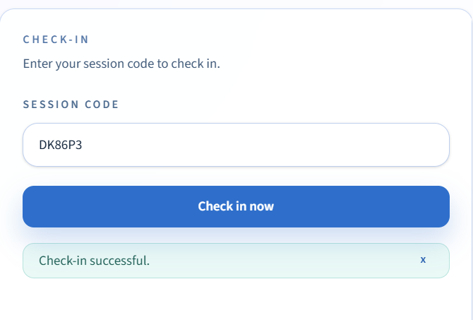
Figure 6 Student check-in interface.

A new attendance document is created only if no existing attendance record is found. Each attendance record includes the session identifier, session code, student identifier, student name, student email, and the check-in timestamp. This structure ensures that attendance records are linked to both the session and the individual student.

The system therefore implements a two-stage validation process during attendance submission. First, the session code must correspond to an active session. Second, duplicate attendance entries for the same student and session are prevented at the application level by verifying the absence of an existing record prior to insertion.

From a technical perspective, this implementation relies on sequential client-side validation and Firestore queries. However, since duplicate prevention is not enforced at the database level (e.g., through unique constraints), concurrent submissions could still result in duplicate attendance records. This represents a potential race condition scenario. This limitation may affect data integrity under concurrent usage conditions and should be addressed in future development.

Despite this limitation, the approach provides a practical balance between implementation simplicity and functional correctness within the scope of a prototype system.

Overall, the attendance functionality is designed to provide a clear and efficient workflow for both lecturers and students, while maintaining a basic level of validation and data consistency.

4.4 Analytics Features

In addition to basic attendance recording, the system provides a set of analytical features designed to support lecturers in monitoring student engagement and identifying potential attendance issues.

For lecturers, the system includes an attendance analytics dashboard that presents attendance data in both visual and tabular formats. As illustrated in Figure 7, attendance data can be displayed using a bar chart, allowing lecturers to compare attendance rates across different sessions. The system also supports filtering by session and week, enabling more focused analysis of attendance patterns over time.

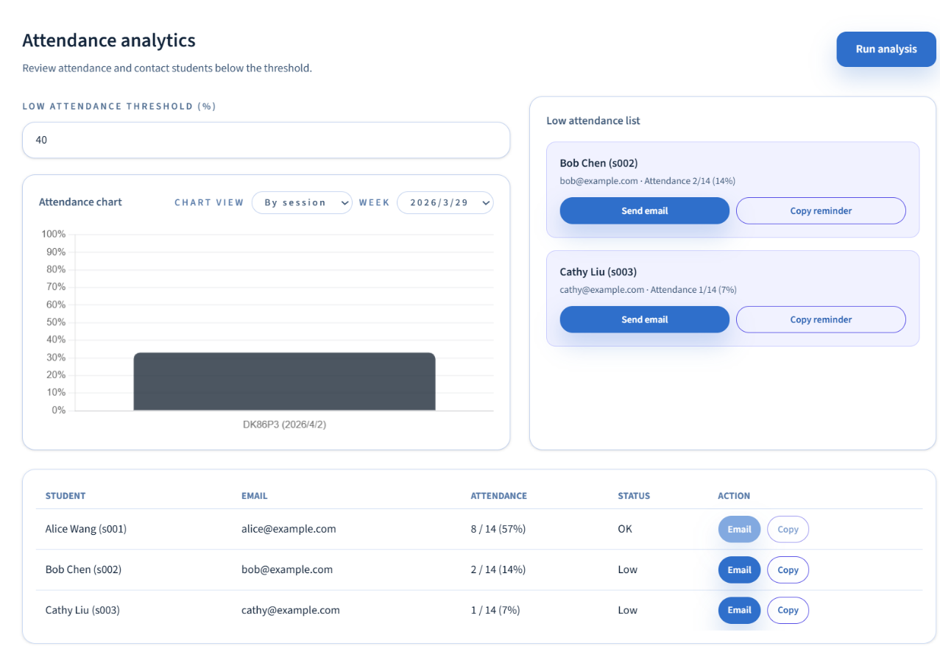
Figure 7 Lecturer analytics dashboard.

To further support decision-making, the system provides a configurable attendance threshold. Lecturers can define a minimum attendance percentage, and students who fall below this threshold are automatically identified. As illustrated in Figure 7, these students are presented in a low-attendance list, together with their attendance records. The system also provides simple interaction options, such as sending reminder emails or copying notification messages, to facilitate communication with students who may require additional support.
In addition to lecturer-focused analytics, the system also provides individual attendance insights for students. As illustrated in Figure 8, the student dashboard displays the overall attendance rate, allowing students to quickly understand their current standing. A progress bar is used to visually represent attendance completion, making the information clear and easy to interpret.

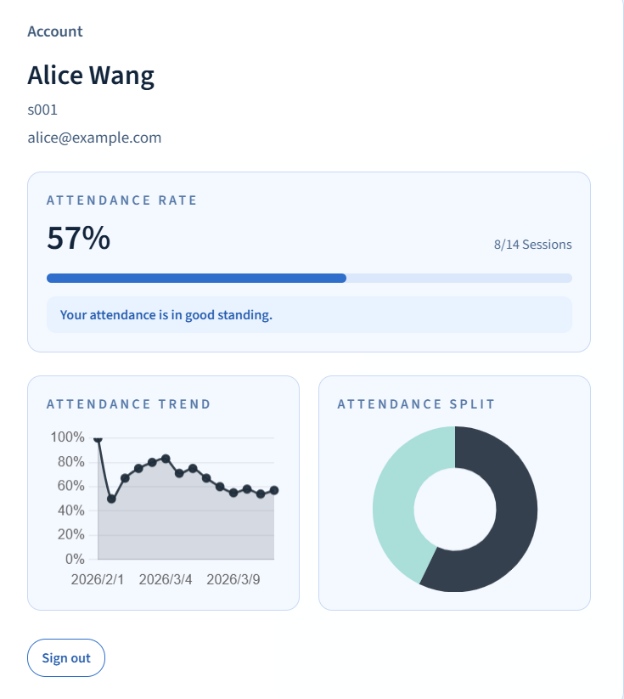
Figure 8 Student analytics dashboard.

The system also includes additional visualisations, such as an attendance trend chart and an attendance distribution chart. The trend chart illustrates how attendance changes over time, enabling students to identify patterns in their engagement. The distribution chart provides an overview of attended and missed sessions, offering a clear summary of attendance behaviour.

These analytical features enhance the functionality of the system by transforming raw attendance data into meaningful insights. This supports lecturers in managing attendance and enables students to reflect on their own engagement, thereby contributing to improved academic monitoring.
The analytical features are primarily based on aggregating attendance records stored in Firestore. Attendance rates are calculated by comparing the number of attended sessions with the total number of available sessions for a given period.

However, the current implementation has limitations. The analytics are relatively basic and do not incorporate advanced techniques such as predictive modelling or behavioural analysis. In addition, the accuracy of analytics depends on the completeness and correctness of recorded attendance data, which may be affected by issues such as proxy attendance.

Nevertheless, the inclusion of these features demonstrates how attendance data can be transformed into meaningful insights, aligning with the concept of learning analytics discussed in the literature.
4.5 Implementation Details

The system was implemented using a front-end-driven architecture based on Next.js, with Firebase providing backend services including Authentication and Firestore database.


Figure 9 System Architecture Diagram

Unlike traditional web applications that rely on a dedicated backend server and RESTful APIs, this system directly integrates the front-end with Firebase services. This design reduces development complexity and supports rapid prototyping, but also introduces certain trade-offs, such as reduced control over backend logic and limited enforcement of complex constraints.

Data is stored in two main Firestore collections: "sessions" and "attendance". The structure is designed to support efficient querying, particularly for validating session codes and retrieving attendance records. However, due to the NoSQL nature of Firestore, relationships between collections are not strictly enforced, which may affect data consistency in edge cases.

A basic validation mechanism is implemented at both the application and database levels. At the application level, session codes are verified and duplicate attendance submissions are checked before data insertion. At the database level, Firestore security rules restrict access to authenticated users and enforce document structure, including required fields and format constraints.

However, these mechanisms do not fully guarantee logical correctness. For example, duplicate attendance prevention is primarily enforced at the application level rather than through database-level constraints, meaning that concurrent or bypass submissions may still result in duplicate records. In addition, while security rules validate document structure, they do not fully enforce that each attendance record corresponds to a valid and active session.

Despite these limitations, the implementation provides a functional and realistic prototype that demonstrates how a cloud-based attendance system can be developed using lightweight web technologies.

The application was managed using GitHub for version control and deployed via Vercel, enabling the system to be tested both online and within a local development environment.

CHAPTER 5 – EVALUATION
5.1 Evaluation Overview

To evaluate the effectiveness of the developed system, a questionnaire was distributed to a small group of participants, including both students and lecturers. The purpose of this evaluation was to assess usability, functionality, and overall user satisfaction with the system.
A total of six responses were collected. Although the sample size is relatively small, the feedback provides useful insights into user experience and highlights both strengths and areas for improvement.

5.2 Questionnaire Results
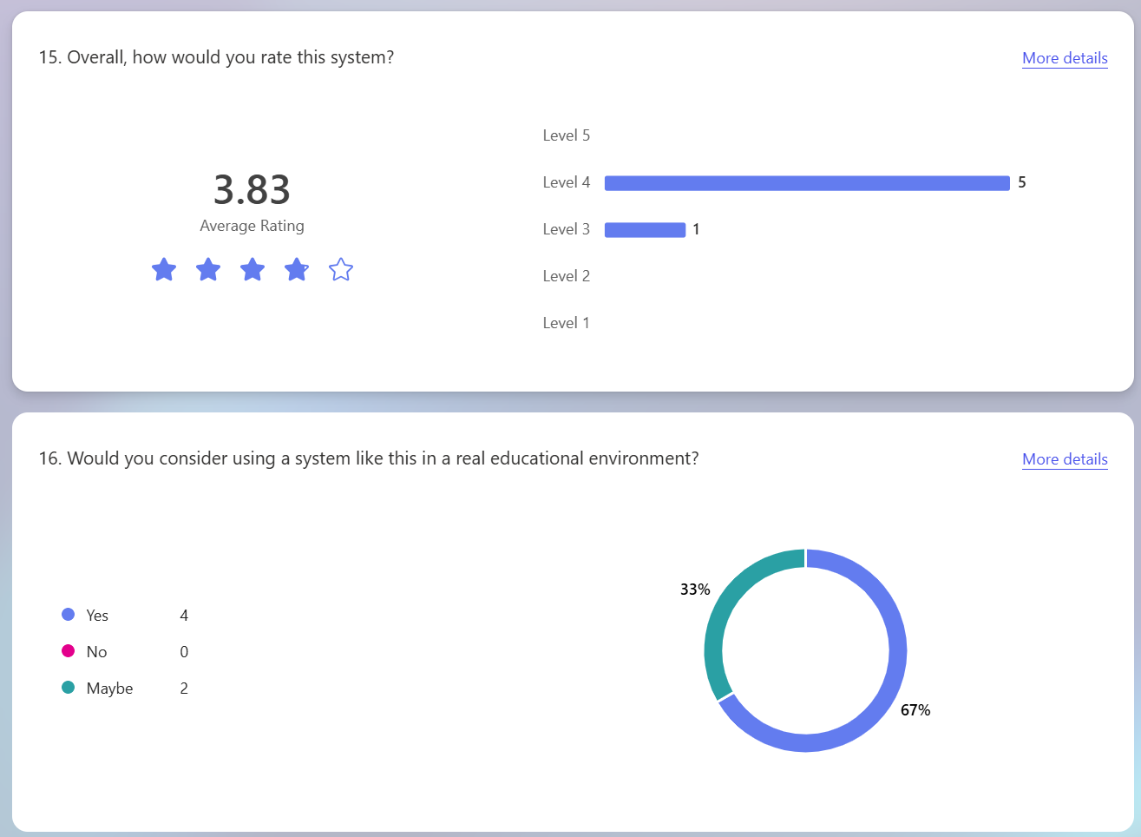
Figure 10 Summary of system rating and willingness to use the system

These results indicate that the system is generally well received, achieving an average score of 3.83 out of 5. Most responses were at level 4, suggesting good usability and functionality.

In addition, as illustrated in Figure 10, 67% of participants indicated that they would consider using the system in a real educational environment, while the remaining 33% selected “Maybe”. No participants selected “No”.

These results suggest that the system is not only functional but also sufficiently user-friendly for practical use. The willingness of participants to adopt the system in a real educational environment indicates that the design meets basic user expectations. However, the presence of “Maybe” responses also suggests that further improvements, particularly in interface design and usability clarity, are required before full adoption. This indicates that while the system is functional, user experience improvements are necessary to increase confidence and adoption.
5.3 Usability Evaluation

The questionnaire used in this evaluation was informed by general usability evaluation principles, including ease of use, interface clarity, navigation, feedback, and user confidence. Although the System Usability Scale (SUS) is a widely used standardised questionnaire for assessing perceived usability [8], this project did not apply the full standard 10-item SUS instrument. Therefore, the results are interpreted as general usability feedback rather than a formal SUS score.

The questionnaire results indicate a generally positive user experience. The system achieved an average rating of approximately 3.83 out of 5, and most participants rated the system positively. This suggests that users generally found the system understandable, accessible, and suitable for basic attendance tracking tasks. However, the feedback also identified areas for improvement, including clearer confirmation messages, improved interface design, better guidance for users, and stronger validation mechanisms.

5.4 Strengths of the System

Several strengths were consistently identified from the questionnaire responses.

Firstly, users found the system easy to use. This is particularly important in educational environments, where systems must support quick interaction without disrupting teaching activities. The attendance process was described as simple and efficient, allowing students to quickly check in using a session code without confusion. This aligns well with the objective of creating a user-friendly system.

Secondly, the system was considered responsive and accessible. Participants appreciated that the system could be used across different devices without requiring installation, making it convenient in an educational context.

In addition, the analytics and visual displays were positively received. Users mentioned that the charts and dashboards were useful for understanding attendance patterns, which supports the aim of integrating analytical features into the system. This supports the goal of transforming attendance data into meaningful insights, as highlighted in learning analytics research [4], [10]

These strengths demonstrate that the system successfully achieves its primary objective of providing a simple and accessible attendance solution. The positive feedback on usability and accessibility suggests that the system is suitable for real-world educational environments, particularly where ease of use is a priority.

5.5 Identified Issues

Despite the positive feedback, several issues were identified during the evaluation.

5.5.1 Lecturer Login Issue

Some users reported that they were unable to log in as a lecturer and therefore could not test the lecturer dashboard functionality.

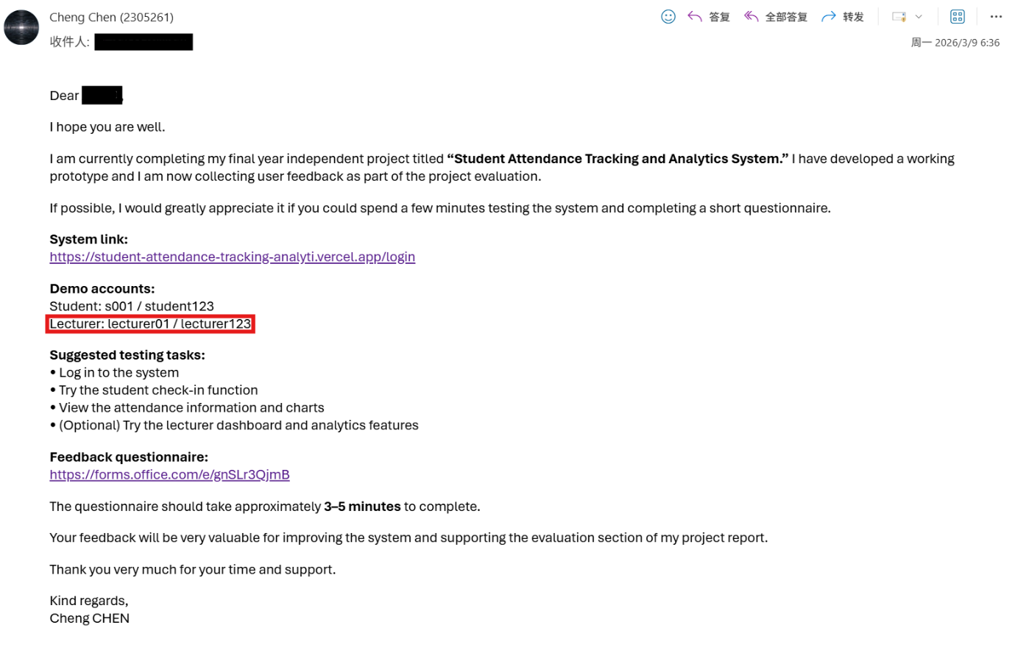
Figure 11 Email provided to participants containing incorrect lecturer login credentials

This issue was traced back to incorrect login credentials provided in the testing email. As a result, users were unable to access the lecturer interface, which affected the completeness of the evaluation. After correcting the credentials in the testing email, the lecturer interface was re-tested and confirmed to function correctly.

5.5.2 Lack of User Feedback

Users noted that after submitting attendance, there was limited feedback to confirm whether the action had been completed successfully. This reduced user confidence in the system.

5.5.3 User Interface Design

Some participants felt that the interface design was too basic and lacked visual appeal. While the system was functional, it could be improved to provide a more engaging user experience.
5.5.4 Mobile Responsiveness Issues

It was also observed that some interface elements extended beyond screen boundaries when accessed on mobile devices. This indicates that the layout was not fully responsive.

5.5.5 Other Observations

Additional feedback included:
- The analytics charts required clearer explanations or labels
- The system lacked guidance for new users
- Potential security concerns, such as the ability to enter a session code remotely
These issues highlight areas for future improvement but were not critical to the core functionality of the system.

5.6 Improvements Implemented

Based on the feedback received, several improvements were made to enhance the system.

5.6.1 Lecturer Login Issue Resolution

The lecturer login issue was resolved by correcting the login credentials provided to users. After this correction, users were able to successfully log in and access the lecturer dashboard. The updated format explicitly separates the username and password, reducing confusion for users.
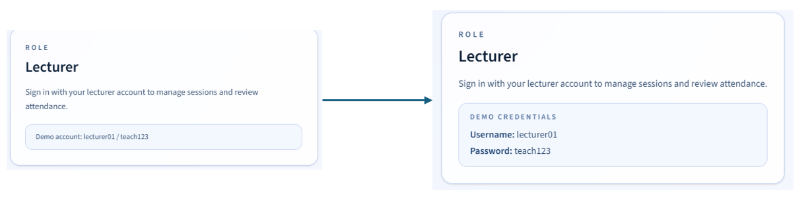
Figure 12 Updated clearer lecturer login credentials

5.6.2 Improved User Feedback

The confirmation message shown after attendance submission was improved to clearly inform users that their attendance had been successfully recorded. The updated message is more specific than the previous version and helps users confirm that the check-in action has been completed. This improves usability and user confidence.
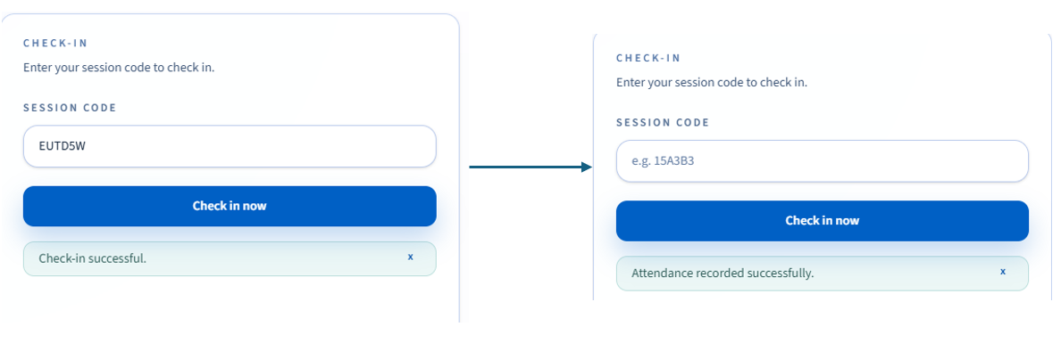
Figure 13 Before and after improving the attendance confirmation message

5.6.3 UI and Responsiveness Improvements

Adjustments were made to improve the layout and ensure better responsiveness across different screen sizes. This helps prevent interface elements from exceeding screen boundaries, particularly on mobile devices.
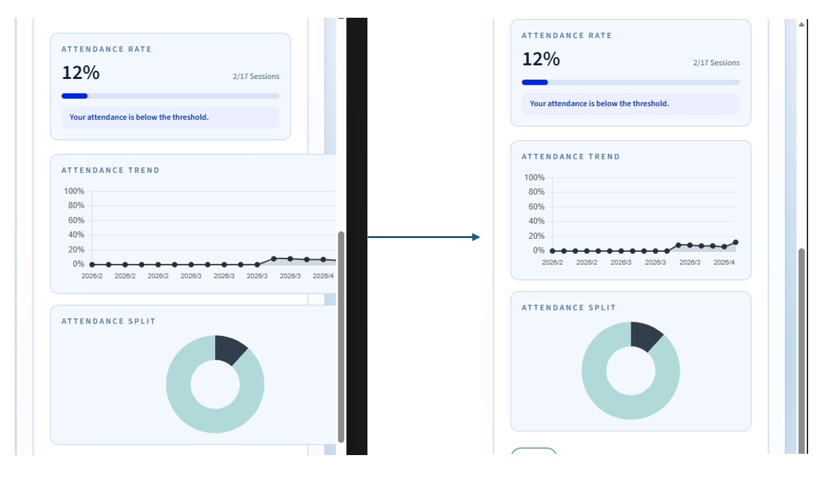
Figure 14 Improvements in layout and responsiveness

These improvements were implemented directly in the system interface to enhance usability and user feedback clarity.

5.7 Limitations of the Evaluation

This evaluation has several limitations.
Firstly, the sample size was small (n=6), which limits the generalizability of the findings. A larger and more diverse group of participants would provide more reliable results.

Secondly, due to the login issue mentioned earlier, not all participants were able to fully test the lecturer functionality initially. Although this was later resolved, it affected the completeness of the initial evaluation.

Finally, the questionnaire design itself had some limitations, such as unclear labelling of certain questions, which may have affected the consistency of responses. These limitations suggest that the evaluation results should be interpreted with caution and primarily reflect initial user perceptions rather than comprehensive system validation.

5.8 Future Improvements

Based on the evaluation results, several areas for future development have been identified.
These include:
- Enhancing the visual design of the user interface
- Providing clearer instructions and guidance for users
- Improving analytics features with better labelling and insights
- Introducing security mechanisms, such as location or time-based validation
- Expanding system functionality with more advanced reporting features
These improvements would further enhance the usability, reliability, and effectiveness of the system.

5.9 Evaluation Summary

Overall, the evaluation demonstrates that the system successfully meets its main objectives. It provides a simple, efficient, and functional solution for attendance tracking, while also offering basic analytical capabilities.

Although some issues were identified, these were either resolved or recognized as areas for future improvement. The results indicate that the system has strong potential for use in real educational environments, with further refinement. Overall, the evaluation provides evidence that the system is a functional prototype with practical potential, while also highlighting clear directions for further refinement and development.

The full set of questionnaire responses is included in Appendix B for reference.

CHAPTER 6 – CONCLUSIONS
6.1 Project Summary

This project aimed to design and develop a web-based Student Attendance Tracking and Analytics System. The main objective was to provide a simple and efficient way to record student attendance while also offering basic analytical features to support monitoring and decision-making.

The system was successfully implemented using a web-based approach, allowing users to access it through a browser without requiring installation. Core functionalities, including lecturer session creation, student attendance submission, and attendance visualisation through charts, were developed and integrated into a working prototype.

6.2 Achievement of Objectives

The objectives defined at the beginning of the project have largely been achieved.

Firstly, the system provides a functional attendance recording mechanism using session codes. This allows students to check in quickly and enables lecturers to track attendance efficiently.

Secondly, the system includes basic analytics features, such as attendance rate and visual charts, which help users understand attendance patterns. This addresses the identified gap in existing
systems that often focus only on recording attendance without analysis.

Thirdly, the system was designed with usability in mind. Feedback from the evaluation indicates that users found the system easy to use and accessible across different devices.

Overall, the system meets its intended purpose and demonstrates the feasibility of a simple, low-cost attendance tracking solution.

This demonstrates that the proposed system successfully addresses the research gap identified in Chapter 2.

6.3 Development Challenges

Throughout the development process, several challenges were encountered.

One key challenge was ensuring that the system functioned correctly across different user roles, particularly between students and lecturers. Issues such as login access highlighted the importance of clear testing procedures and accurate communication with users.

Another challenge was balancing simplicity and functionality. While the system needed to remain easy to use, it also required enough features to provide meaningful insights through analytics.

In addition, time constraints limited the extent to which advanced features could be implemented. This required prioritisation of core functionalities over more complex enhancements.

Despite these challenges, the project provided valuable experience in web development, system design, and user-centred evaluation.

6.4 Limitations of the System

Although the system is functional, it has several limitations.

Firstly, the analytics features are relatively basic and could be expanded to provide more detailed insights.

Secondly, the system currently lacks advanced validation mechanisms, meaning that attendance could potentially be recorded without strict verification of physical presence.

Thirdly, the evaluation was conducted with a small sample size, which limits the reliability of the findings.

These limitations indicate that while the system is effective as a prototype, further development would be required for real-world deployment.

6.5 Future Work

There are several opportunities for future improvement.

The system could be enhanced by improving the visual design of the user interface and making the analytics more interactive and informative. Additional features, such as automated alerts for low attendance, could also be introduced.

Security could be improved by implementing mechanisms such as location-based validation or time restrictions to prevent misuse.

Furthermore, expanding the system to support larger datasets and integrating it with existing educational platforms would increase its practical applicability.

6.6 Final Remarks

In conclusion, this project demonstrates that a web-based attendance tracking and analytics system can be developed as a simple, accessible, and cost-effective solution.

The system successfully meets its core objectives and has been positively evaluated by users. While there are areas for improvement, the project provides a strong foundation for further development and highlights the potential of combining attendance tracking with analytical features.

CHAPTER 7 – REFLECTION
7.1 Personal Reflection on the Project

This project provided valuable experience in designing and developing a real-world web-based system. Throughout the process, I gained a deeper understanding of both technical implementation and user-centred design.

One of the most important lessons learned was the importance of simplicity in system design. Initially, there was a tendency to consider adding more advanced features; however, through development and evaluation, it became clear that a simple and intuitive system is more effective for users. The final system reflects this approach by focusing on ease of use and accessibility.

7.2 Technical Learning

From a technical perspective, this project significantly improved my skills in web development. I gained practical experience using modern tools and technologies, including frontend development and integration with a backend service.

Working with Firebase for authentication and database management helped me understand how cloud-based systems operate. In addition, implementing features such as real-time data storage and retrieval strengthened my understanding of system architecture.

I also developed problem-solving skills when dealing with issues such as login errors and user interface behaviour. These challenges required debugging, testing, and iterative improvements.

7.3 Reflection on Evaluation and User Feedback

The evaluation process highlighted the importance of user feedback in system development. Feedback from participants helped identify usability issues that were not immediately obvious during development.

For example, the lack of confirmation messages and unclear login details demonstrated that even small design decisions can significantly impact user experience. Addressing these issues improved the overall quality of the system.

This experience emphasised the value of iterative development, where feedback is used to refine and improve the system over time.

7.4 Challenges and How They Were Addressed

Several challenges were encountered during the project.

One challenge was managing time effectively alongside other academic commitments. This required prioritising core features and ensuring that the system remained functional within the given timeframe.

Another challenge was ensuring that different parts of the system worked together correctly, particularly in handling user roles and data consistency.

These challenges were addressed through iterative testing and gradual refinement of the system.

7.5 What Could Be Improved

Although the project was successful, there are several areas that could be improved.

More advanced features could be implemented, such as enhanced analytics and stronger validation mechanisms. In addition, the visual design could be further improved to provide a more engaging user experience.

Given more time, the system could also be tested with a larger group of users to obtain more comprehensive feedback.

7.6 Overall Reflection

Overall, this project provided practical experience in developing a real-world system from initial design through to implementation and evaluation.

The project not only improved technical skills but also highlighted the importance of user experience, testing, and continuous improvement. These lessons will be beneficial for future projects and professional development.

This project has strengthened both my technical and analytical skills, which will be valuable for future academic and professional work.

REFERENCES
[1] N. S. Ali, A. H. Alhilali, H. D. Rjeib, H. Alsharqi, and B. Al-Sadawi, “Automated attendance management systems: systematic literature review,” International Journal of Technology Enhanced Learning, vol. 14, no. 1, pp. 37–65, 2022.

[2] K. A. Bird, B. L. Castleman, and G. Lohner, “Negative impacts from the shift to online learning during the COVID-19 crisis: Evidence from a statewide community college system,” AERA Open, vol. 8, no. 1, 2022.

[3] A. A. Abd Rahni, N. Zainal, M. F. Zainal Adna, N. E. Othman, and M. F. Bukhori, “Development of the online student attendance monitoring system (SAMSTM) based on QR-codes and mobile devices,” Journal of Engineering Science and Technology, Special Issue on UKM Teaching and Learning Congress 2013, pp. 28–40, 2015.

[4] G. Siemens and P. Long, “Penetrating the fog: Analytics in learning and
education,” EDUCAUSE Review, vol. 46, no. 5, pp. 30–40, 2011.

[5] M. M. Al-Dabbagh, “A Review of Students Attendance Management Systems,”
Eurasian Journal of Science and Engineering, vol. 10, no. 3, pp. 136–145, 2024.

[6] Amir, V. Sharma, and S. Kumar, “Development of QR Based Attendance System Using Web App,” International Journal on Science and Technology (IJSAT), vol. 16, no. 1, 2025.

[7] K. L. Bhatti, L. Mughal, F. Y. Khuhawar, and S. A. Memon, “Smart Attendance Management System Using Face Recognition,” EAI Endorsed Transactions on Creative Technologies, vol. 5, no. 17, 2018.

[8] J. R. Lewis, “The System Usability Scale: Past, Present, and Future,” Int. J. Hum.-Comput. Interact., vol. 34, no. 7, pp. 577–590, 2018.

[9] A. Nuhi, F. Imeri, A. Memeti, and B. Cico, “Smart attendance system using QR code,” in 2020 9th Mediterranean Conference on Embedded Computing (MECO), 2020, pp. 1–4.

[10] M. Papamitsiou and A. A. Economides, “Learning analytics and educational data mining in practice: A systematic literature review,” Educational Technology & Society, vol. 17, no. 4, pp. 49–64, 2014.

APPENDICES

Appendix A – Questionnaire

This appendix presents the questionnaire used for system evaluation.

The questionnaire was created using Microsoft Forms and is available via the submitted hyperlink in the project materials.

A summary of the key questions is provided below:

Q1. The system was easy to understand and use.
Q2. The interface layout was clear and visually organised.
Q3. Navigation between different pages was straightforward.
...
Q13. Would you consider using a system like this in a real educational environment?

Appendix B – Questionnaire Results

This appendix presents the full questionnaire results collected from participants.

Due to the volume of responses and detailed feedback, the results are provided as a separate PDF document.

See: Appendix B - Questionnaire and Responses.pdf

Appendix C – Additional System Information

Additional system interfaces and design elements are discussed in Chapter 4.
To avoid duplication, figures are not repeated in this appendix.

Live demonstration system: available via the submitted project materials / QR code / hyperlink


Appendix D – Source Code

Due to the size and complexity of the implementation, the full source code is not included in this report. Instead, it is available in the following GitHub repository:

Source code repository: available in the submitted accompanying materials. Alternatively, access the GitHub repository via a hyperlink.

The repository includes the full implementation, configuration details, and deployment instructions.

