Learning in the digital era – E-Portfolio

Harriet Adams
229657

Contents

3 - Article Summary

4 - PowerPoint presentation

5 - Academic poster

6 - Summary

7 - Reference list

Task 1 - Article summary – A focus on fathers in child mental health interventions

Fathers have been found to have less engagement in the mental health treatment and interventions of their children compared to the children’s mothers (Tully et al, 2022). There are many possible reasons for this, with the main one being the underrepresentation and encouragement for fathers to be present (Tully et al, 2022). Committed parents and a supportive family environment are crucial to a child’s wellbeing and to the success of evidence-based interventions, however, research by Fletcher et al (2011) has found that 80% of an evidence-based intervention included only mothers (Tully et al, 2021). This may be due to several reasons, including personal, organisational and practitioner factors (Tully et al, 2017., Tully et al, 2018). Personal factors can include the father-child relationship, their personal views and attitudes towards the treatment and the relationship between both parents, as Allen & Hawkins (1999) found that ‘maternal gatekeeping’ or the discouragement from mothers can be a big personal influence on a father’s involvement (Tully et al, 2018., Tully et al, 2022). Organisational and practitioner factors can include poorly scheduled appointments that may be inconvenient due to work commitments, or practitioners who are less familiar and confident with working with fathers (Tully et al, 2022).
There are many benefits to having fathers involved their child’s mental health care as it increases the likelihood of successful outcomes, especially with children who have conduct issues such as aggression (Lundahl et al, 2008). Parental engagement allows the practitioner to collect family history and information about parent-child relationships, as well as personal experiences and beliefs (Tully et al, 2021). It is therefore important that practitioners emphasize the importance of having both parents present and explain the value of their involvement in the intervention if they want to encourage fathers (Lechowicz et al, 2019., Tully et al 2022).

Video presentation – power point

Meeting with Harriet Adams (2219657)-20230110_120721-Meeting Recording.mp4

Task 3 – Poster

Summary

Through creating this poster, I felt that I took on the team leader role although we did not assign roles. Both myself and Rhys agreed to do equal amounts of work by giving ourselves three topics to discuss each, where I chose to discuss Information literacy, critical thinking and effective communication. We both struggled to find good academic references for these topics however we managed to include a few, although not as many as I would have liked. As we have many other assignments due, we both left this task quite last minute and did not spend as much time on this compared to other aspects of this E-portfolio. I believe we worked very well as a group as there were no issues, we discussed our plans through WhatsApp and kept in touch regularly to check on our progress. I offered to be responsible for creating the poster itself and for inputting Rhys’ information.

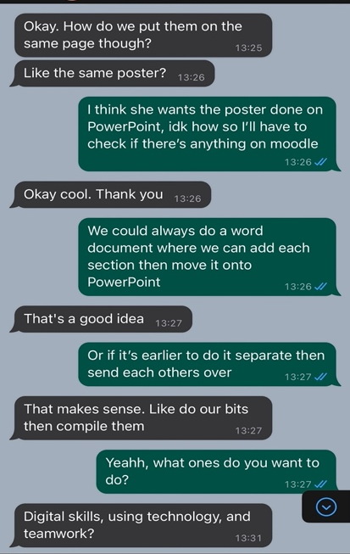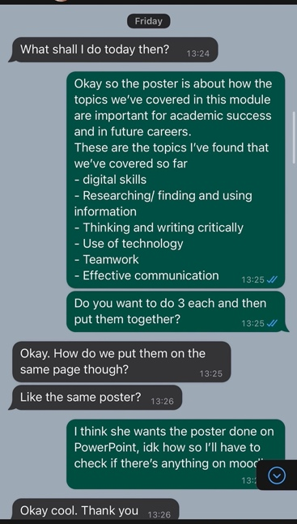

Reference list

5 effective counselling skills and techniques. Arizona State University. (2022).

Allen, S.M., Hawkins, A.J. (1999). Maternal gatekeeping: Mother’s beliefs and behaviours that inhibit greater father involvement in family work. Journal of Marriage and the Family, 199-212.

Australian Institute of Professional Counsellors. (2009). Principles of active listening in counselling. Counselling Connection. https://www.counsellingconnection.com/index.php/2009/06/02/principles-of-active-listening/

Basic Counselling Skills. Perinatal Mental Health Project. (2022). https://www.mhinnovation.net/sites/default/files/downloads/innovation/tools/PMHP-Basic-Counselling-Skills.pdf

Beaven-Marks, K. (2020). Helping clients develop problem-solving strategies. Hypnotic. https://hypnotc.com/helping-therapy-clients-develop-problem-solving-strategies/

Bodie, G.B., Vickery, A.J., Cannava, K.., Jones, S.M. (2015). The role of “Active listening” in informal helping conversations: Impact on perceptions of listener helpfulness, sensitivity, and supportiveness and discloser emotional improvement. Western Journal of Communication, 79:2, 151-173. https://doi.org/10.1080/10570314.2014.943429

Cottrell, S. (2017). Critical thinking skills: Effective analysis, argument and reflection. https://books.google.co.uk/books?hl=en&lr=&id=K_NGEAAAQBAJ&oi=fnd&pg=PT8&dq=critical+thinking+skill+for+students&ots=V8xmHyRKAT&sig=E_A2dAM0Inl1Me9HBc7Mkq6Q_TE#v=onepage&q=critical%20thinking%20skill%20for%20students&f=false

Counselling. NHS Wales. (2020). https://www.nhs.uk/mental-health/talking-therapies-medicine-treatments/talking-therapies-and-counselling/counselling/

Developing effective communication skills. Journal of oncology practice. (2007). 3(6), 314–317. https://doi.org/10.1200/JOP.0766501

Erstad, W. (2018). 6 Critical thinking skills you need to master now. Rasmussen University. https://www.rasmussen.edu/student-experience/college-life/critical-thinking-skills-to-master-now/

Fletcher, R., Freeman, E., Matthey, S. (2011). The impact of behavioural parent training on father’s parenting: A meta-analysis of the triple P-Positive Parenting Program. Journal of Family Psychology, 21 (4), 683.

Gysbers, N.C. (2014). Some important core qualities of counselling professionals: A personal perspective. American Counselling Association. https://www.counseling.org/docs/default-source/vistas/article_02.pdf?sfvrsn=d8813bbd_16

Julien, H & Barker, S. (2009). How high-school students find and evaluate scientific information: A basis for information literacy skills development. Library & Information Science Research, 32(1), 12-17. https://www.sciencedirect.com/science/article/pii/S0740818808001382?casa_token=MrEL7vec5I4AAAAA:WsOgF13CFVhPMjnm3yO6JilsbShTw0aFIvTt8KqKOzkI-gJ27hTBlVxgf5lEvpaM4bFRg1iXWQ

Lechowicz, M.E., Jiang, Y., Burn, M.T., Collins, D.A., Hawes, D.J., Dadds, M.R. (2019). Enhancing father engagement in parenting programs: translating research into practice recommendations. Australian Psychologist, 54(2), 83-89.

Lundahl, B.W., Tollefson, D., Risser, H., Lovejoy, M.C. (2008). A meta-analysis of father involvement in parent training. Research on Social Work Practice, 18(2), 97-106.

Miles, J. (2015). The importance of building resilience. Counselling Directory. https://www.counselling-directory.org.uk/memberarticles/the-importance-of-building-resilience

Ranaweera, P. (2008). Importance of information literacy skills for an information literate society. Sri Lanka Library Association. https://core.ac.uk/download/pdf/11884153.pdf

The benefits of having strong communication skills as a tech professional. Tulane School of Professional Advancement. (2022). https://sopa.tulane.edu/blog/benefits-having-strong-communication-skills-tech-professional

Tully, L.,A Collins, D.A., Piotrowska, P.J., Mairet, K.S., Hawes, D.J., Moul, C., Dadds, M.R. (2018). Examining practitioner competencies, organisational support and barriers to engaging fathers in parenting interventions, Child Psychiatry & Human Development, 49(1), 109-122.

Tully, L., Hawes, D., Dadds, M. (2022). A focus on fathers in child mental health interventions. The British Psychological Society.

Tully, L.A., Hawes, D., Dadds, M. (2021). Engaging Fathers in Family-Based Interventions for Child Mental Health. Family-Based Intervention for Child and Adolescent Mental Health: A Core Competencies Approach, 53.

Tully, L.A., Piotrowska, P.J., Collins, D.A., Mairet, K.S., Black, N., Kimonis, E.R., Dadds, M.R. (2017). Optimising child outcomes from parenting interventions: Father’s experiences, preferences and barriers to participation. BMC Public Health, 17(1), 1-14.

