[Date]
Guest 1
[company name]
IWD : Database Design and Development
Assignment 01

Module Name: Introduction to Web and Database Concepts
Module Code: ACCA4023
Student Name: Milana Hemalova
Student ID: 24398742
Group: 3

Lecturer’s Name: Suneth Fernando

Contents

Introduction to the case study 2
Entity Relationship Diagram (ERD): 2
Entities interact within the database 4
Logical Design 4
Table Creation in MS – Access 4
Relationships between tables 6
Testing and Validation 7
Normalization Process 7
MS- Access 8
Forms Creation 8
Queries Creation 9
Carculations 13
Dashboard Creation 13

Introduction to the case study
EcoRide is a small local organisation and aiming to encourage community for more environmentally friendly travel. It offers an electric bike rental services in parks, university districts and at major transit stations. It’s main goal is to provide people with simple and environmentally friendly way to travel short distances by allowing then to rent an electric bike and return it to another EcoRide location. Organisation is responsible for registering customers, managing bikes availability and tracking rental and return. EcoRide also regularly maintains bikes, conducts inspections and repairs. Currently all of this is done by paper records and simple spreadsheets which often leads to errors and makes it difficult for staff to see what is happening with each bike.
My task is to create a clear and well-structured database to help the organisation to run their business more smoothly. This includes developing tables and links that will be saving correct information about users. The database should make it easy for staff to enter and retrieve information, reduce errors and to provide the organisation with better understanding of how the system works.

Entity Relationship Diagram (ERD):

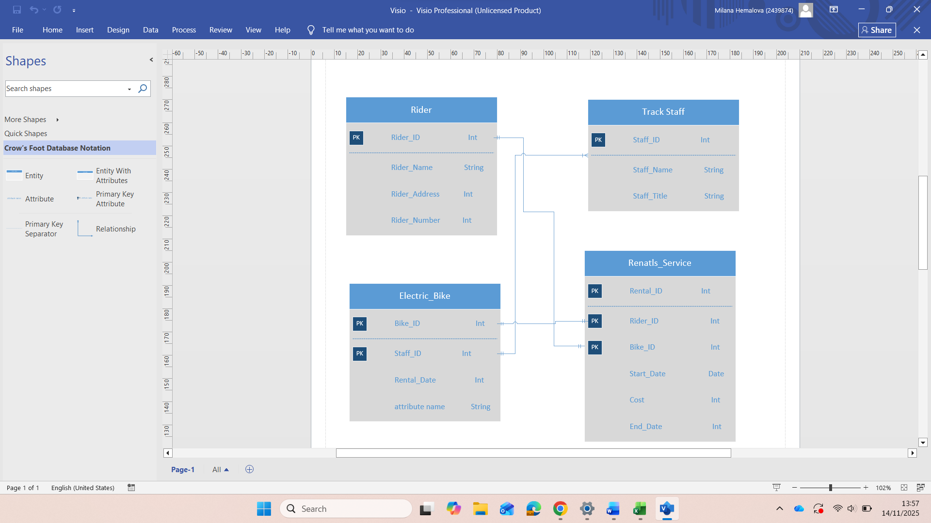

One – to – One
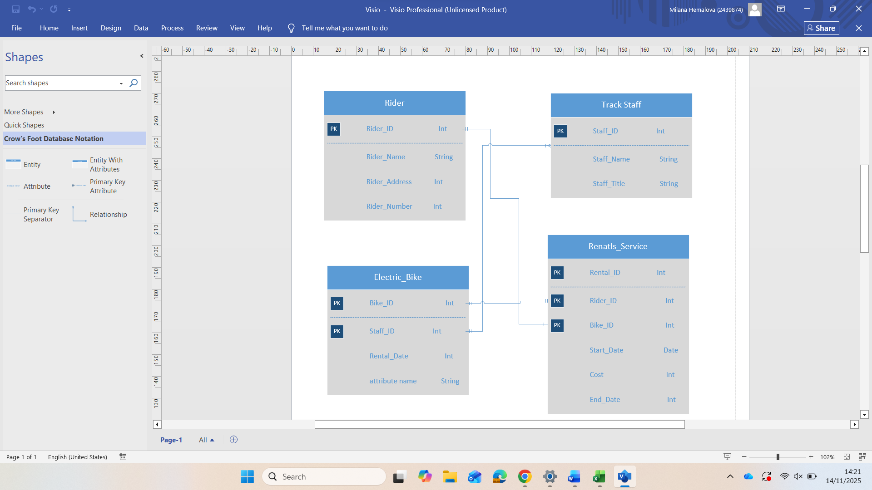
One rider can ride only one bike at the time and one bike can be ridden by only one rider at the same time

One – to – Many
One staff member can operate many bikes but every bike is assigned to one staff member

Many – to – Many
One doctor can treat many patients and one patient can be treated by many doctors.

Unfortunately for this task I couldn’t make an example in Visio because the programme suddenly stopped working on my computer. But I do have an understanding of the relationship.

Entities interact within the database
ER modelling is useful when creating a database because it helps you to visualise how everything should be connected before you start working on it. When you are creating an ER diagram you see all main parts of the system and also the information that is needed to each part of the system. It gives you clear idea of what data you need to store. ER modelling also help to identify mistakes in the very beginning of creating your database. If something is wrong you can easily fix it instead of deleting the whole database later on. ER modelling also helps to change ideas in tables because the entities and attributes make it easier to understand what fields to include and what tables to connect.
One more advantage of ER is easy sharing with others. It helps to show the design so anyone can understand the structure.
Overall ER modelling gives clear plan, helps to avoid problems and guarantees that the database is organised and makes sense.

Logical Design
Table Creation in MS – Access
Electro Bikes Details table
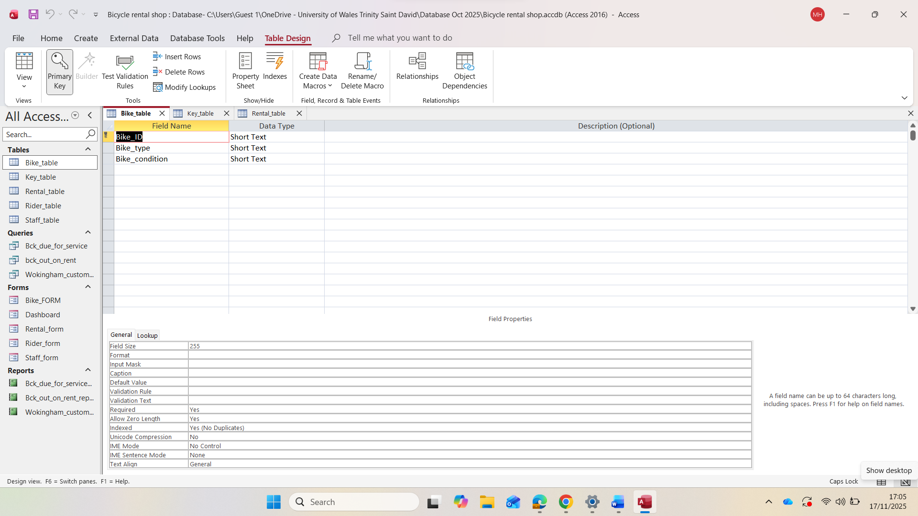
This screenshot presents design view
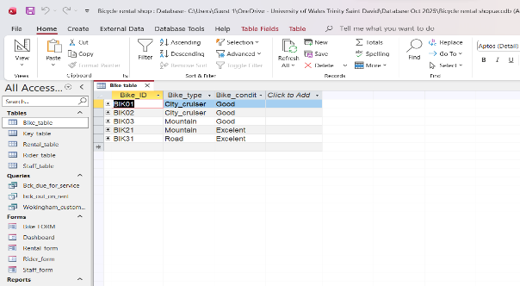
This screenshot presents datasheet view

Rental Details Table
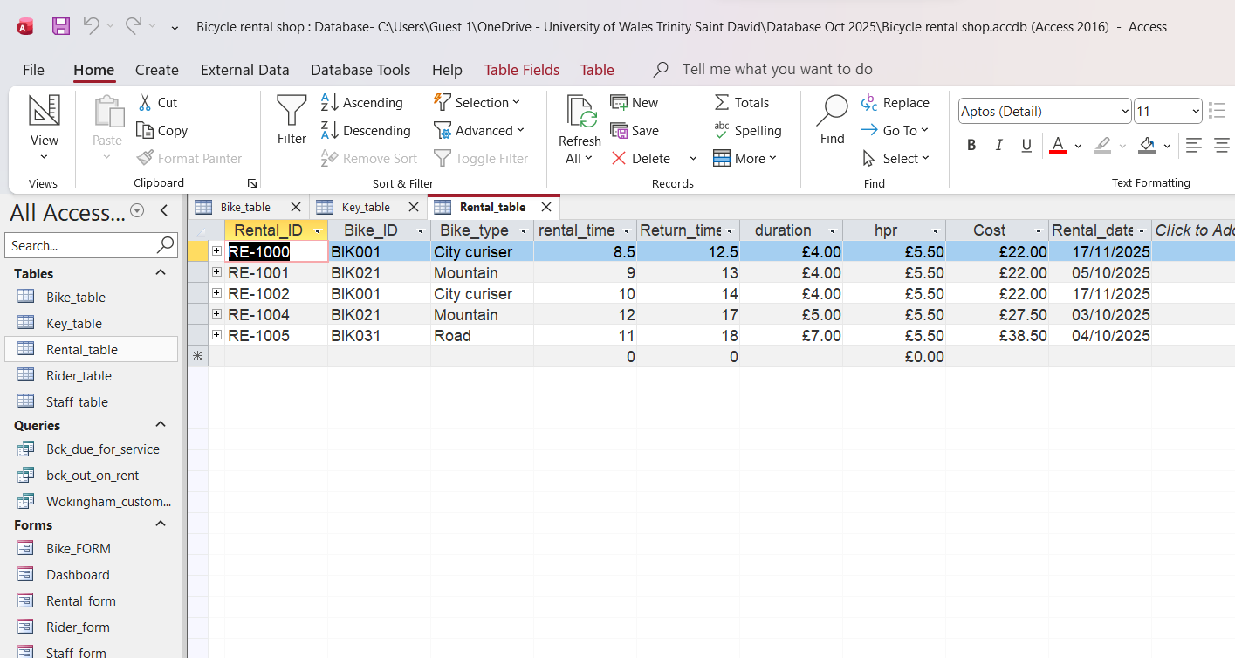
This screenshot presents datasheet view

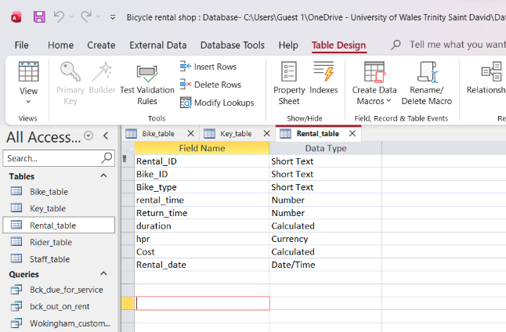
This screenshot presents design view

Rider Details Table
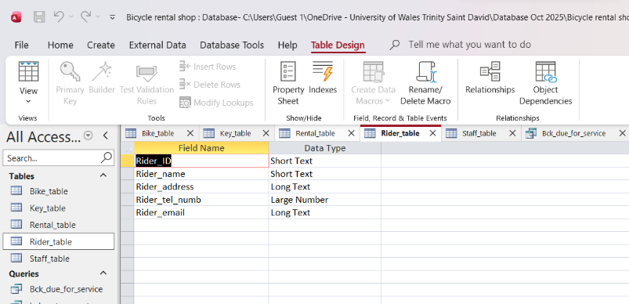
This screenshot presents design view

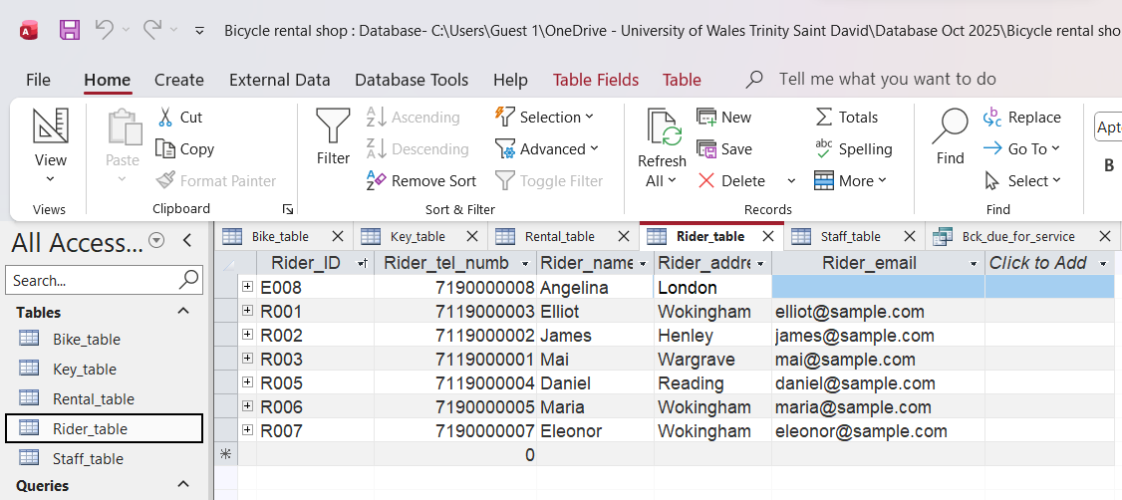
This screenshot presents datasheet view

Staff Details Table
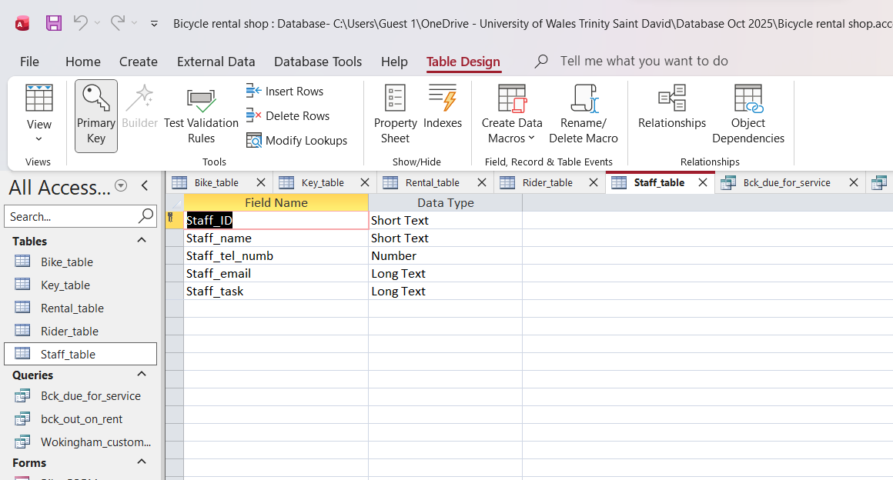
Staff table design view
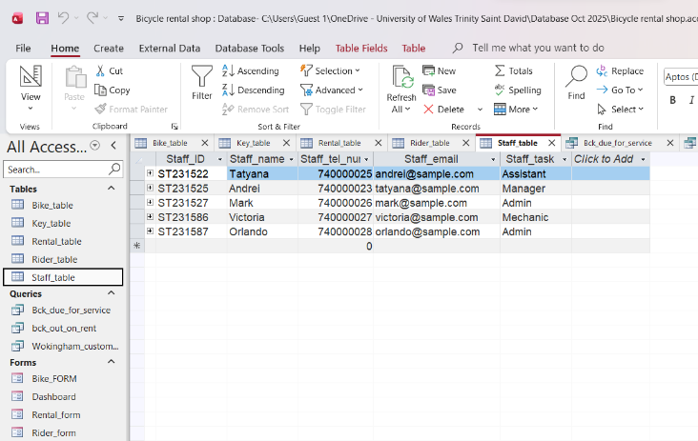
Staff table datasheet view

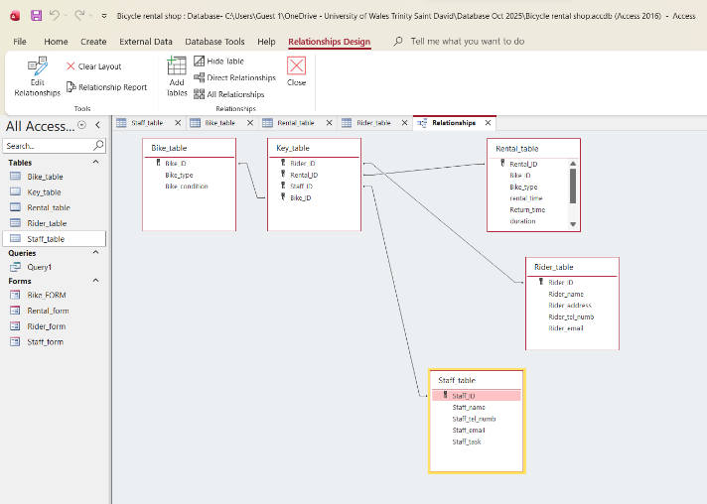
Relationships between tables
Each box represents a table and shows how the are relate to each other

Each table in database uses primary key to identify and make every record unique. These keys are then used as foreign keys in other tables to link them and create relationships.
For Bike_Table primary key is Bike_ ID that whish identifies each bike and is used to connect rental records to specific bicycles.
For Rider_Table primary key is Rider_ID which identifies each rider and helps to link rental information to the correct person
For Staff_Table primary key is Staff_ID which identifies each staff member which allows system to record who handled a rental.
For Rental_Table primary key is Reantal_ID which identifies each rental transaction which links rental details with the correct rider, bike and staff member

Testing and Validation

Test Cases | Expected Results | Actual Results | Any Discrepancies
Bikes currently out of rental | It is expected to filter rental table to find out the bikes on rental at the moment | Specific query was created to filter data on this query | No
Bikes due to service | It’s expected to filter the maintenance table to find out all bikes due to service | Specific query was created to filter and display bikes required service | No
Rentals by a particular rider | It is expected to filter the rental records and return all bookings associated with the selected rider | Specific query was created to retrieve every rental linked to specific rider | No

Normalization Process
Screenshots show stage where data are separated into tables so each table includes only fields that depend directly on primary key without repeated groups or duplication.
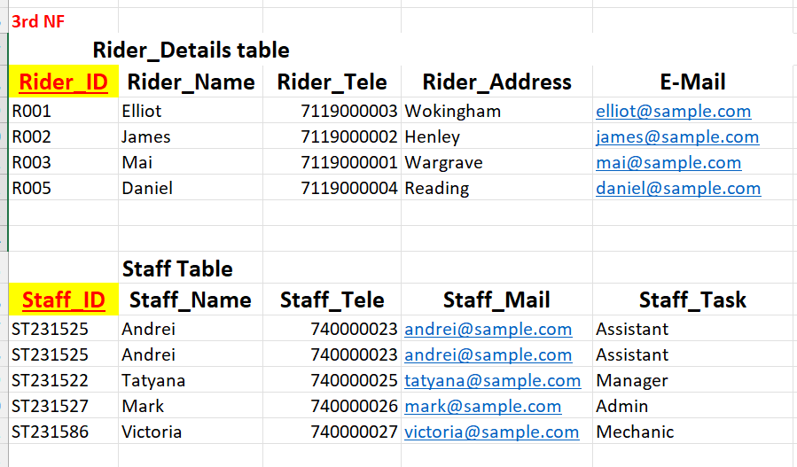
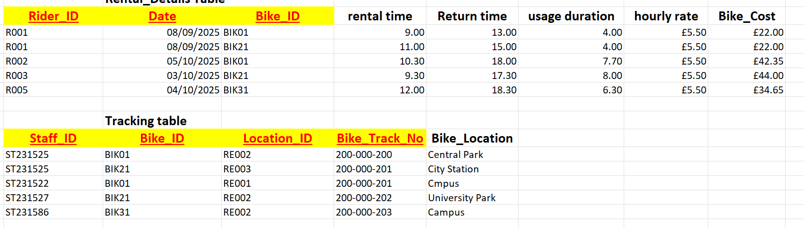
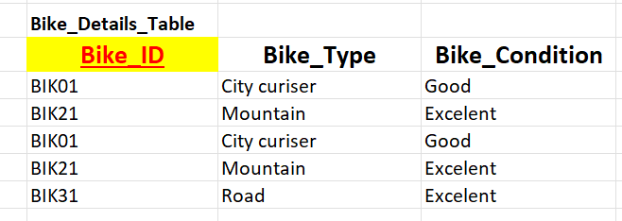

MS- Access
MS- Access is a tool from Microsoft that helps to create and manage database. It allows users to store data, link them between each other and after use forms and reports for easier way to enter and view information. MS Access is mainly used by individuals and small businesses because it’s simple in use and doesn’t require advanced database skills.

Forms Creation
Screenshot represents bike records form. The form allows to add, edit or delete records.
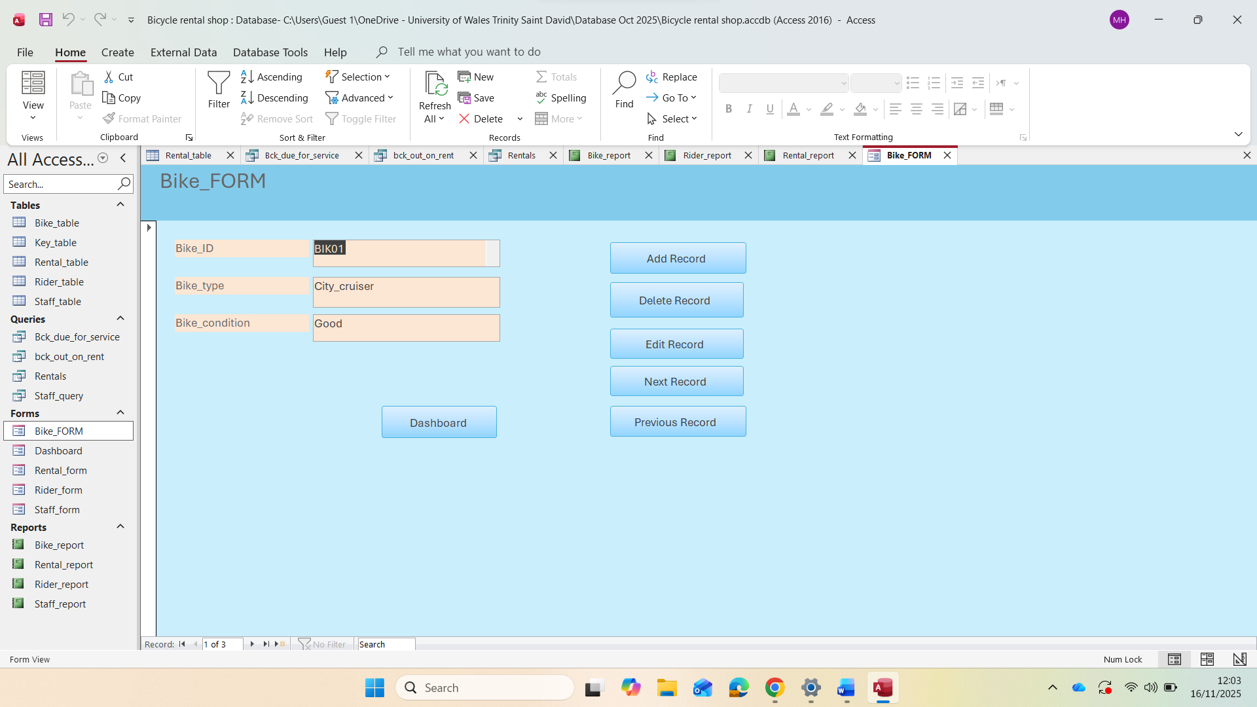=
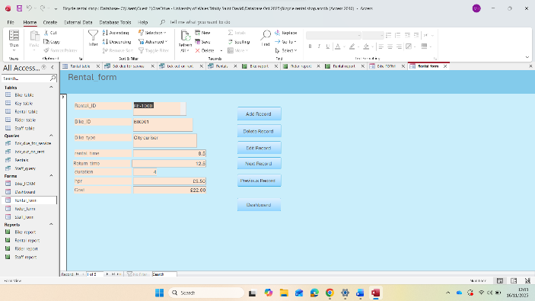
Screenshot represents rental form. Also allows to add, edit or delete the records.
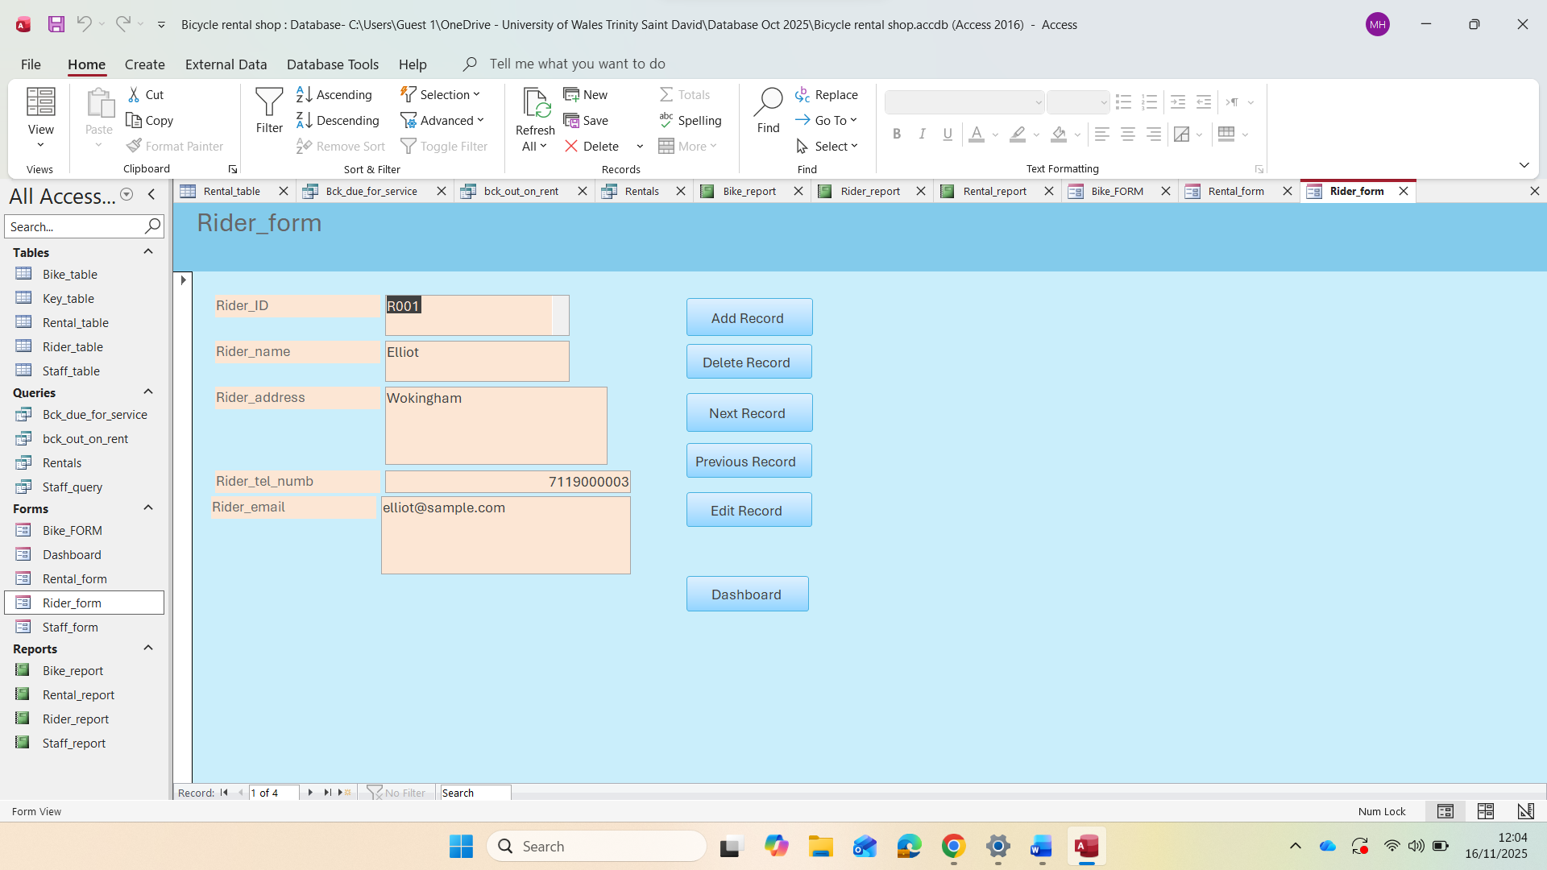
Screenshot represents rider form with the same option as previous ones.
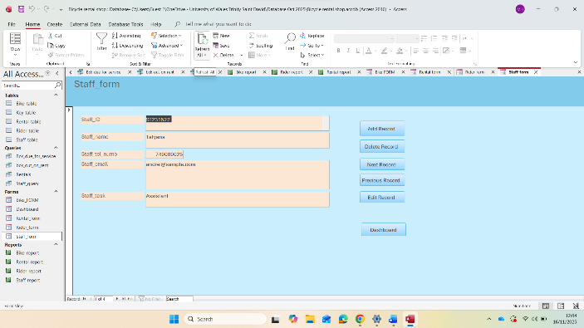
---
Screenshot represents staff form with the same options to add, edit or delete records.

Queries Creation

Bikes due for service Query
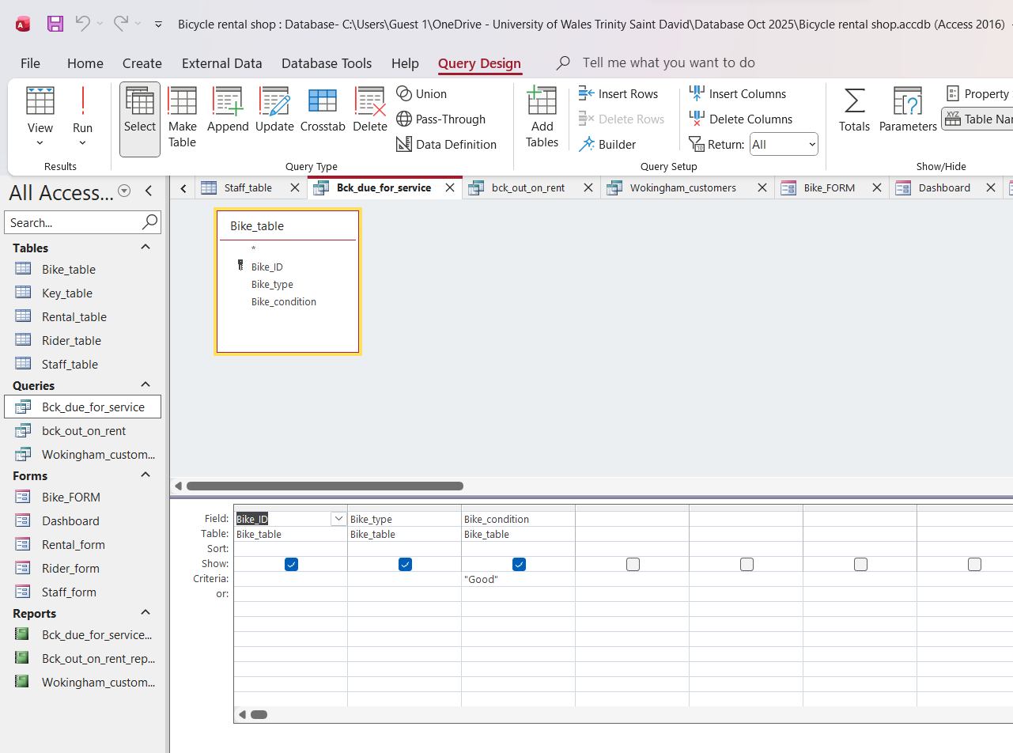
Query screenshot identifies bikes that are due for service.
Screenshot shows the results of query.
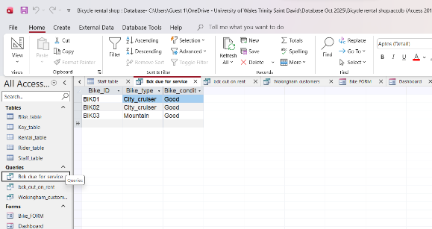

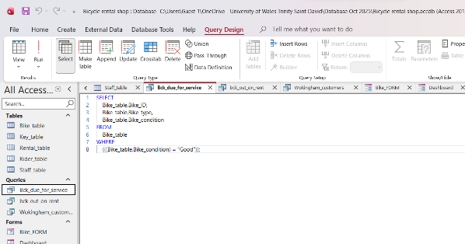
SQL View shows how the query works behind the scenes.

Bikes out of rent Query
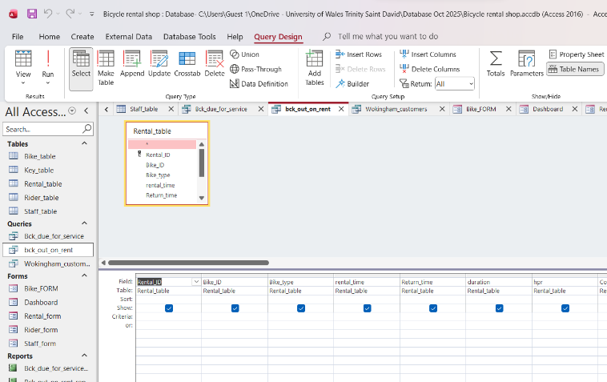
Query screenshot that identifies bikes currently out on rent.

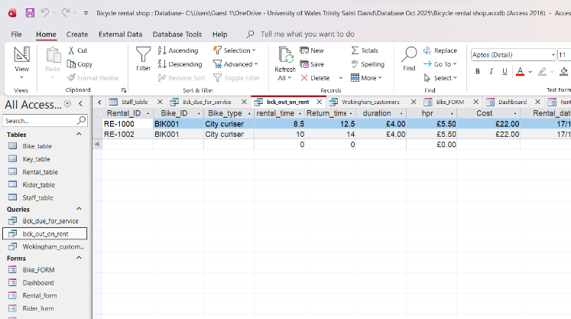
Screenshot shows the results of query.

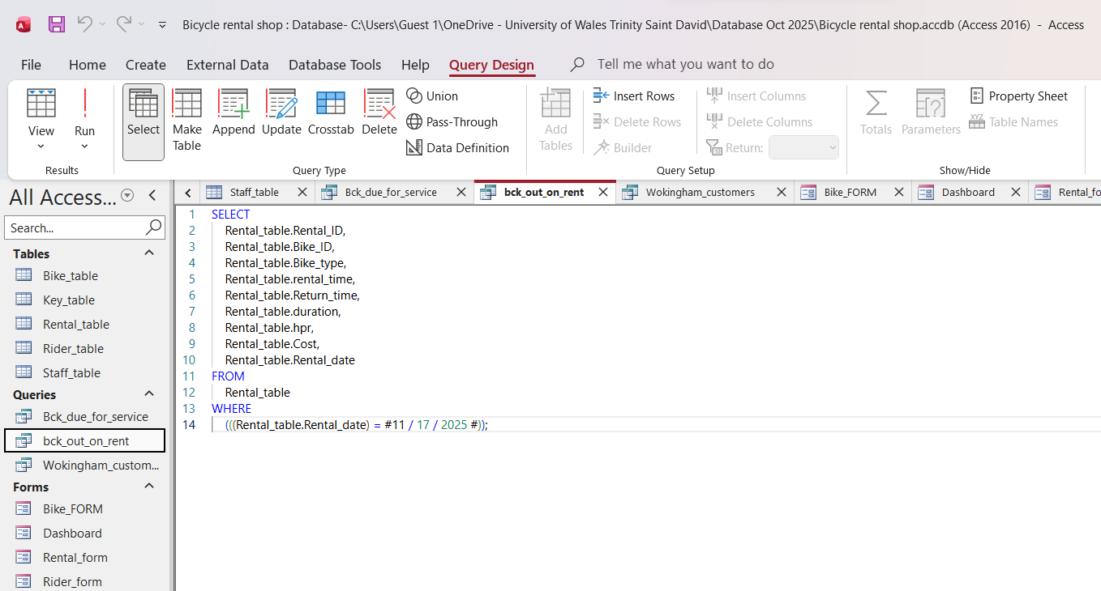
SQL View shows how the query works behind the scenes.

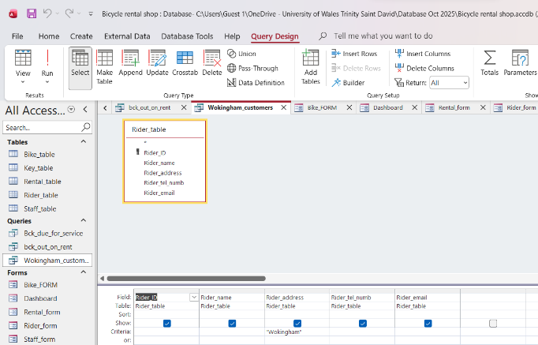
Wokingham customers query
Query screenshot shows rentals by a particular riders in my case they are customers from Wokingham town.

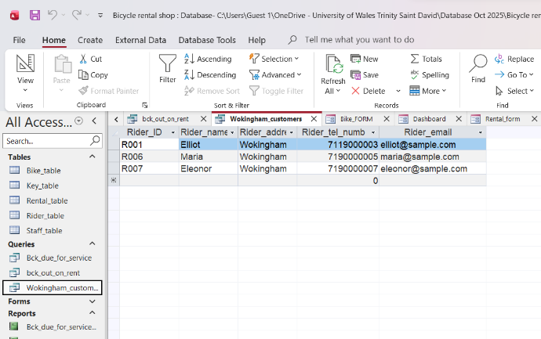
Screenshot shows the results of query.

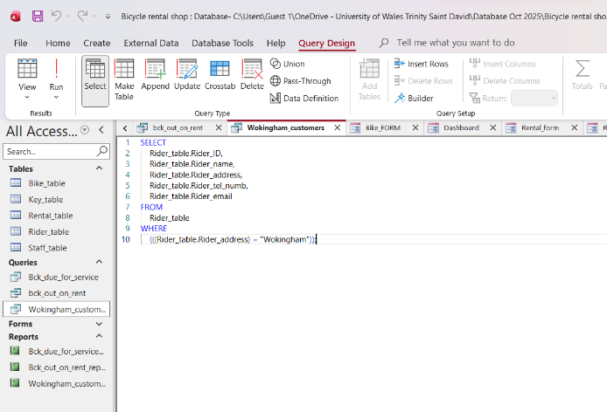
SQL View shows how the query works behind the scenes.

Report Creation
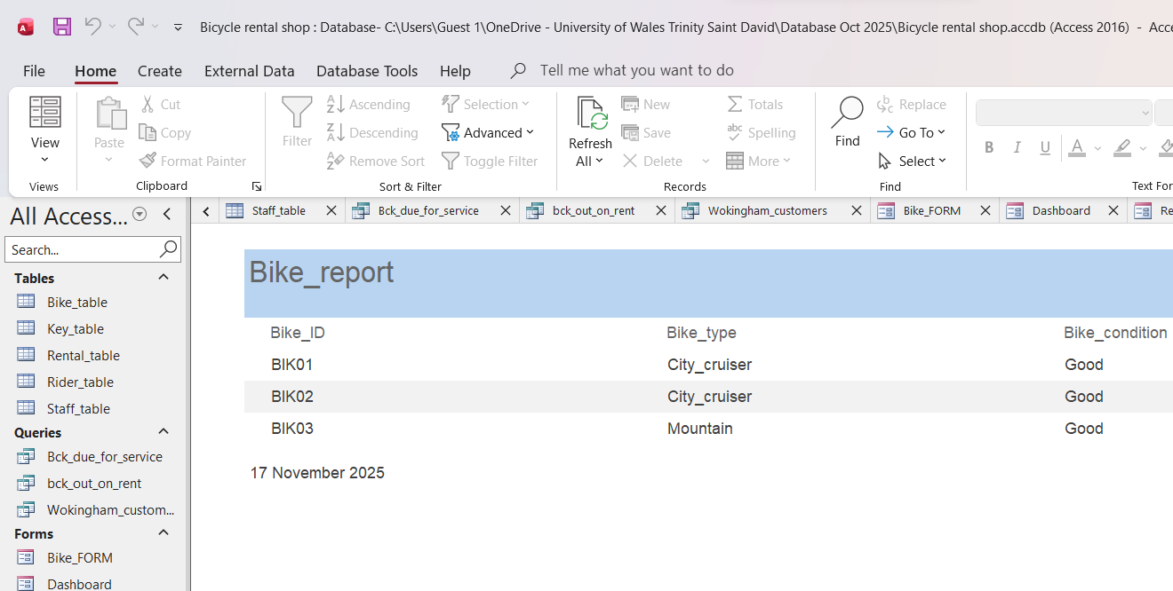
Bike_report screenshot. It demonstrates the report creation stage.
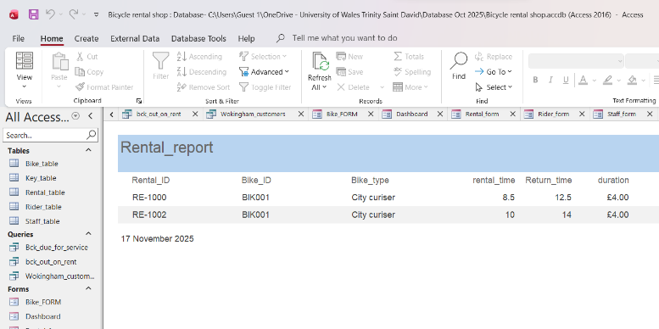
Rental_report screenshot suitable for reviewing or printing.

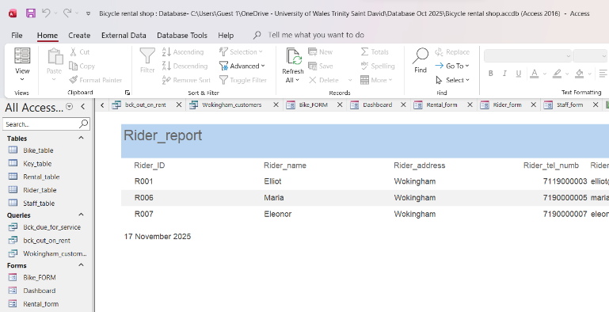
Rider_report screenshot shows the data in organised format suitable for viewing.

Carculations
Screenshot of the Rental_table showing calculations to find final cost of the bike. Formulas that were used:
=[Return_time]-[rental_time]
=[duration]*[hrp]
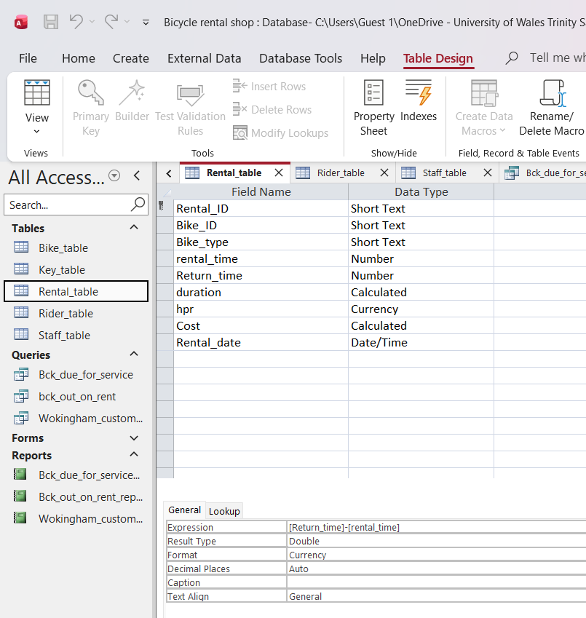

Dashboard Creation
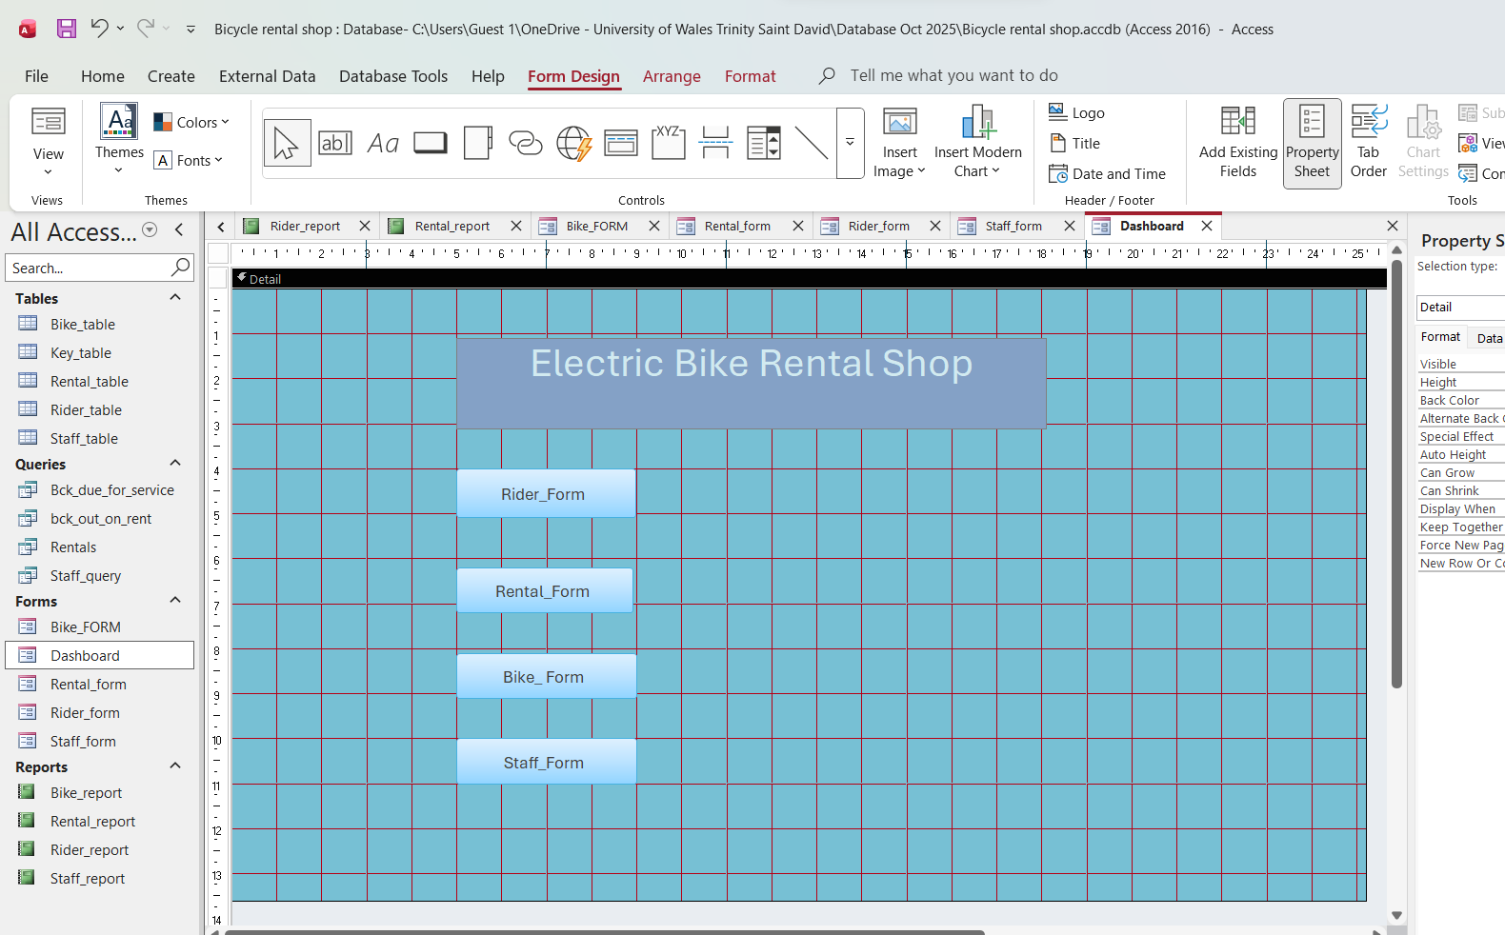
Each individual form includes dashboard button.
Form => click Dashboard button => returns to Dashboard
Dashboard => click a Form button => opens that form

