Methodology

Introduction.
After carefully reviewing the previous sections of this dissertation, it investigated currently used approaches to community engagement and how previous research has emphasised its importance, methods, and positive effects. To gain a more comprehensive understanding, this chapter will identify the most appropriate data collection method and foster collaboration by taking advantage of the most beneficial available resources.
Research refers to any information that has been gathered, discovered, generated, or created in order to validate the initial results of a study (University of Leeds 2024). There is two main ways of gathering data for research one is to gather the data personally and the other is to gather information obtain from previous studies.
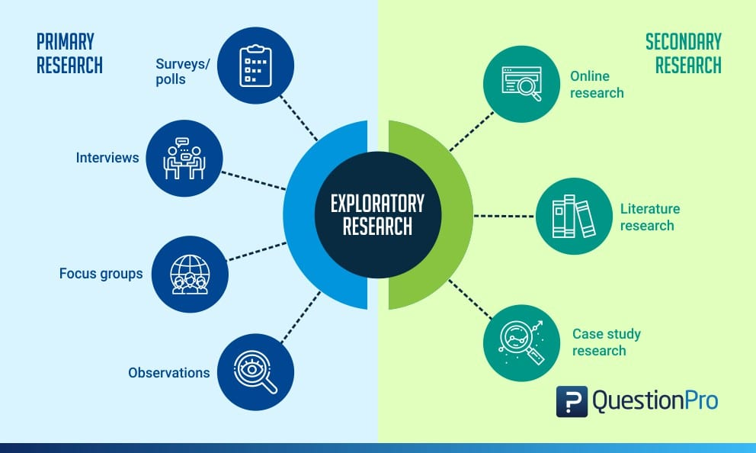Figure - Exploratory Research: Types & Characteristics (Source: QuestionPro 2024)

Figure clearly depicts the two different methods of exploratory research: primary and secondary. The primary method, shown on the left, is data gathered personally by means of surveys, interviews, focus groups, and personal observations. Secondary is described on the right-hand side of the figure this shows data or information gathered from the internet, literature, and previous studies. Due to a lack of academic research into the direct impact of the confidence cycle and the OSARA model on community engagement.

Developing a research method.

When deciding which research approach to take, the research onion developed by Saunders et al in 2007 is the most practical and well-established method.
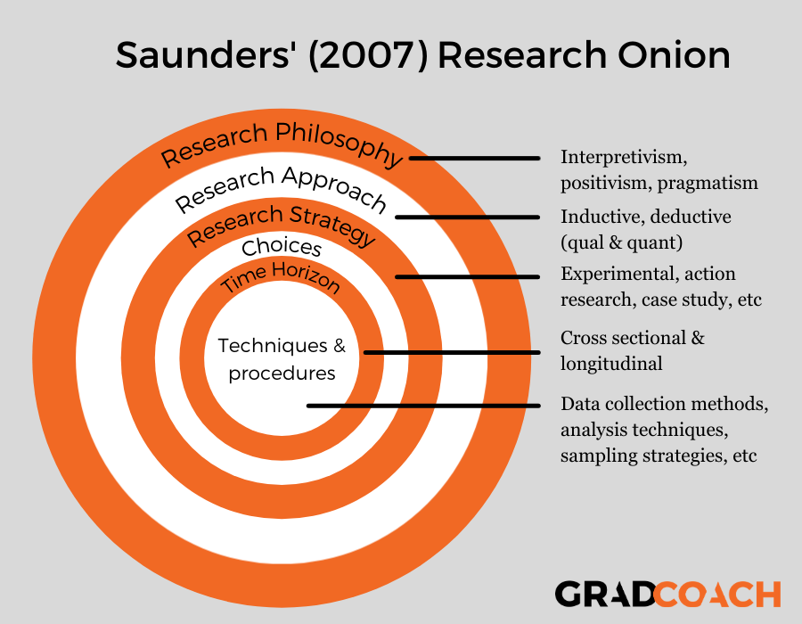

Figure - Saunders’ Research Onion: Explained Simply (Source: David Phair and Kerryn Warren January 2021)

With the research onion, you work from the outside in, each step developing and shaping the research approach to answering the dissertation's question.
The outer layer examines the research philosophy, and when considering an exploratory look at community engagement and the efficacy of commonly used methods and techniques. Alharahsheh, Husam and Pius, (2020) explains that the Interpretivism emerged as a critique of positivism based on subjective perspectives. Interpretivism focuses on in-depth variables and factors related to a context. It distinguishes humans from physical phenomena by emphasising their ability to create deeper meanings. Social sciences research requires a distinct approach from natural science research. Interpretivism considers cultural, contextual, and temporal differences that shape social realities. The research method I consider best represents the subject is an interpretivism approach offers nuanced and diverse perspectives.
Working in to the second layer, this looks at the research approach as already described in the literature review, there is a distinct lack of research into the direct result in community engagement of methods such as OSARA.
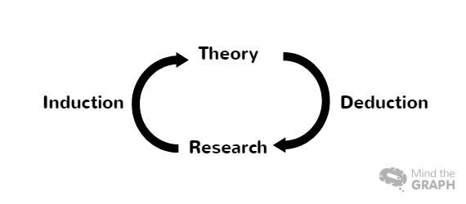
Figure - Inductive vs Deductive Research: Two Approaches to Data Analysis (Source: Salomao, Anglica 2023)
Figure shows how an inductive approach develops the theory, whereas a complete reversal deduction approach develops the theory. Given the theory surrounding this topic, an inductive approach would aid in the development of understanding, allowing the data to serve as a foundation for future research. Phair, David, and Warren, Kerryn (2021) explain how an inductive approach could be used to investigate a previously unknown topic. There is extremely little knowledge about this topic, so research would be required to learn more about it, resulting in the formation of theories.
The third layer of Saunders' (2007) research onion focuses on the research strategy, known as the practical or action stage. Because this is an exploratory investigation into community engagement, the best strategy is an action research approach. According to Phair, David, and Warren, Kerryn (2021), action research is concerned with learning by doing. Action research takes place in real-world settings rather than controlled environments, as in a science experiment. Researchers use action research to identify problems or weaknesses in real-world interactions.
The choices layer of the research onion aids in deciding which of three data collection methods to employ: mono, mixed, or multi-method. A single approach would lack the understanding required to conduct a more conclusive exploratory look; thus, with larger data sets, a mixed or multi-method approach would be preferable. Following this consideration, a survey will be administered first, followed by an interview with an experienced senior member of the neighbour team to discuss and validate the findings.
Layer five considers the time horizon; when this is taken into account, you must consider how long the study will be conducted over. Due to the time constraints of this study, a snapshot in time will be used to provide the best data set.
When arriving at the centre, all of the outer layers must be considered in order to implement the most appropriate research methods and conducting the practical steps. As a result, the research method developed from the research onion will be interpretivism with an induction approach, action research in a snapshot of time using surveys with members of Gwent police neighbourhood officers at all levels, and discussion and analysis of the results with an experienced senior leader member of a Gwent neighbourhood team.

Limitations
A survey will be conducted using a tool such as Survey Monkey, the data will be analysed, and the results will be used to develop a question set for an interview with a senior leader. The survey results will be displayed in a graphical format, allowing for visual interpretation of the data. The questions and responses will be transcribed and presented. Due to time constraints and the survey being conducted on perceived opinions of the administrators of the actions described, future studies from the perspective of the wider community could present differing views or results, so the data collected will have obvious limitations.

Ethical considerations

The research data that will be collected will consider ethical considerations; before conducting this research, A completed a comprehensive ethics form and received approval. The data will be collected using two primary research methods, and all participants will be informed and aware of how the data will be used during the data analysis process; this information is also highlighted in the pre-approved ethics form, which was submitted prior to the project's start. All survey results will be anonymous, and no personal information will be collected; all interviewee information will be kept confidential and anonymised, at any point participants will have the right to withdraw their contribution from the project.

Conclusion

This methodology chapter discussed both primary and secondary types of data collection before applying Saunders et al's 2007 research onion to develop the appropriate research method. Following that, the project's limitations and ethical considerations were discussed in detail. A comprehensive methodology has now been established to lay the groundwork for data collection and analysis, which will be presented in the project's subsequent section.

Alharahsheh, Husam and Pius, (2020) A Review of key paradigms: positivism VS interpretivism Available at: https://gajrc.com/media/articles/GAJHSS_23_39-43_VMGJbOK.pdf (Accessed 10th March 2024)

Phair, David and Warren, Kerryn (2021) Saunders’ Research Onion: Explained Available at: https://gradcoach.com/saunders-research-onion/ (Accessed 10th March 2024)

QuestionPro (2024) Exploratory Research: Types & Characteristics Available at: https://www.questionpro.com/blog/exploratory-research/ (Accessed 6th March 2024)

Salomao, Anglica (2023) Inductive vs Deductive Research: Two Approaches to Data Analysis Available at: https://mindthegraph.com/blog/inductive-vs-deductive-research/ (Accessed 10th March 2024)

University of Leeds (2024) Research data management explained Available at: https://library.leeds.ac.uk/info/14062/research-data-management/61/research-data-management-explained (Accessed 6th March 2024)

